Numerical solutions to PDEs PhL 7.2.14

I did some web searching on this subject a while ago, but have no notes in my PDE area. A quick scan did not turn up anything so here I will just start over. There is a hint that Maple might now have a numeric capability with pdsolve, but I don't have that.

Here is the first offering I notice:

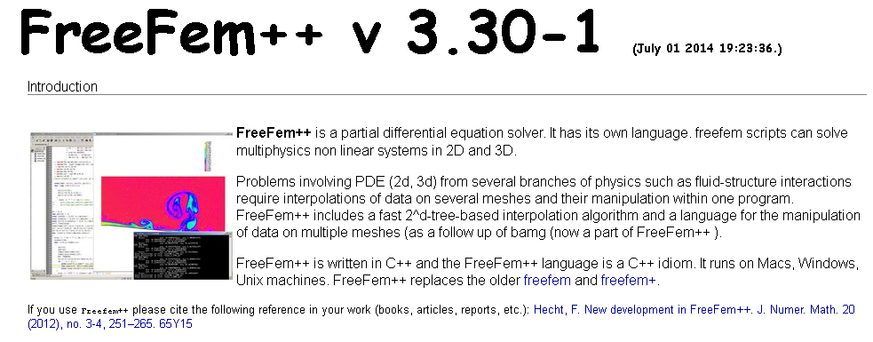

It looks very promising, but I would have to take a lot of time just learning how to make it do something. Here is an example they give

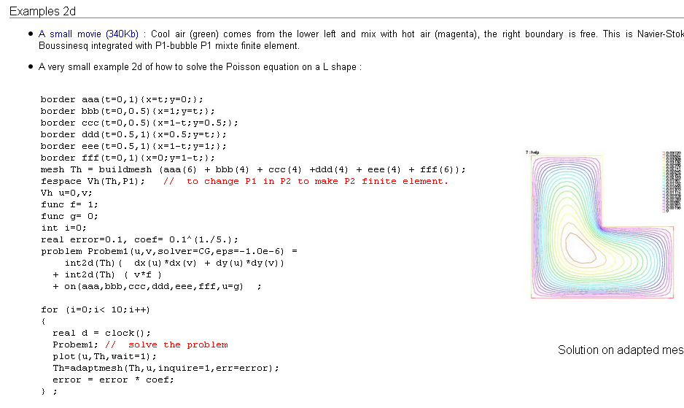

So I will just put this hold for a while.

