Partial Differential Equations PhL 9.26.13

Although I have dealt with many such equations (eg, Stakgold heat and wave equations), I have never studied the basic concept of a PDE. I know there is something called "the method of characteristics" for example, but I don't know what it is. I have a nice Polyanin book which is a catalog of PDE's and their solutions. I found a PDF with some good notes, but I got lost right off the bat, author lost me, but it does have many examples.

Today my particular interest is just a first order PDE of the form ∂xu(x,t) = f(x,t). That is to say, I am given just one partial derivative of u(x,t). Is this enough to solve for u(x,t)? How many solutions are there? I know very little!

Courant volume 2 has as lot of stuff, but it is somewhat hard to read, being in the form of rough notes I would say. I don't seem to have even a single doc on the PDE subject in general! There are lots of good looking PDF's on line, maybe I can find someone I like. Some notes are too heavy duty for me out of the box, others don't have any theory. Here is pde notes 3 that offers a reasonable start:
The "quasi" linear thing means that u can be a variable inside functions a and b. If it is not a variable, then equation is "regular" linear. I suspect that having u in their does not complicate things much, so we might as well do the most general case that a little chunk of theory supports. So here we go:

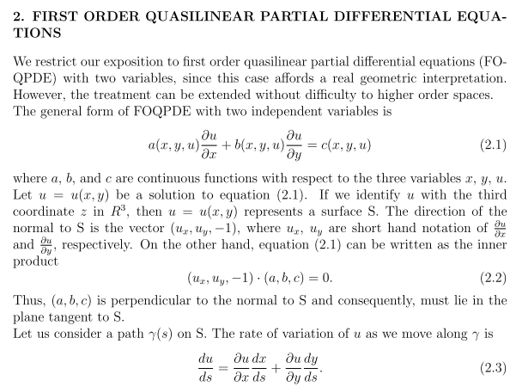

In my (very good I think) notes "surface geometry questions.doc" I show early on that

∇3d(g) = (gx, gy, gz) = (fx, fy, –1) = ( ∇2Df, –1).

is either normal to the surface g(x,y,z) = 0 or z = f(x,y) which is the same surface. You then see the form for the normal (fx, fy, –1) which our author above writes as (ux, uy, –1). I understand everything in the above quote (so far), so let's continue. This is a very "geometrical" subject I see.
In the above, notice that γ(s) is a parametric curve lying on the surface z = u(x,y). My same set of notes doesn't talk much about curves, but I am used to this notion

du = ∂xu dx + ∂yu dy = uxdx + uydu (**)

Imagine the plot of u = u(x,y). If we move dx and dy in the ground plane, this is how much the height of the surface changes. How do I know this fact? One way is to think of the tangent plane at a point and I could no doubt draw a picture which shows this is true. Or thing of a two stage operation. First move just with dx and get the du from that. I will add something on this later to my surface geo notes, but let's move on since I know the above is true. Then divide by ds to get (2.3) above. We continue.

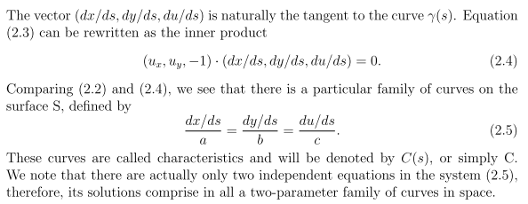

Well, consider little vector dt = (dx,dy,du) for its x,y,z components. If we make dx and dy and use our above expression for du arising from these changes, then yes, dt is tangent to the curve. I agree completely. Then divide each component by ds and the claim is still true, q ≡ (dx/ds,dy/ds,du/ds) will be tangent to the curve at x,y on the surface. Thus q • n = 0 where n = (ux, uy, –1), so (2.4) is obviously true. Write it out.

uxdx/ds + uydy/ds - du/ds = 0
or
(dx/ds)ux + (dy/ds)uy = (du/ds)
a ux + b uy = c

One possible way to make these equations both be true (given a,b and c) would be to arrange to have

dx/ds = a(x,y,u)* F(x,y,u) (*)
dy/ds = b(x,y,u)* F(x,y,u)
du/ds = c(x,y,u)* F(x,y,u)

where F(x,y,u) is some unspecified function. For any selected F, these three equations give q which is a vector tangent to some curve γ(s) on the surface. So let's pick some F and compute q. We find which way q points, and then we move to a new point x+dx,y+dy on the ground plane and we get to a new point on the curve and we compute its q. In this manner, starting at any point, we trace out some full curve on the surface. For any (x,y) not on this curve, we get some other curve, so that is what the author means by a family of curves. I show some of these curves in red. Probably if everything is smooth, they gradually morph from one to the adjacent next one etc.

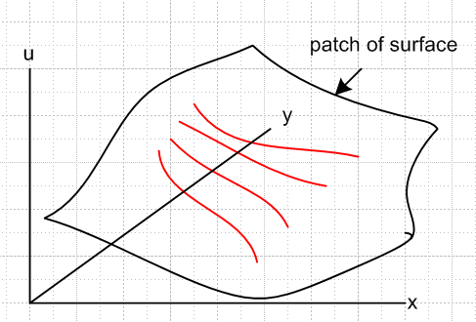

Now looking at my triplet of equations above, they can be written as

(dx/ds) /a(x,y,u) = (dy/ds) /b(x,y,u) = (du/ds) /c(x,y,u) = F(x,y,u)

So his statement (2.5) is the above equation set without explicitly stating the F(x,y,u). So there is my derivation of (2.5). I agree that it defines a "family of curves" as I show in red which for close spacing are parallel to each other, so to speak. They nest together when close if all is smooth.
There are "two parameters" because, for each red curve, one parameter s varies along the curve, while a second parameter is used to label the separate curves. It all makes sense.

Comments:
(1) note from (2.2) that vector (a,b,c) lies in the tangent plane at a point
(2) note that q ≡ (dx/ds,dy/ds,du/ds) also lies in that tangent plane, being tangent to a curve γ(s) on surf

In order for (a,b,c) and q to be co-linear, it would have to be true that

q = α (a,b,c) for some real α (either sign).

But we know from my (*) that

q = (dx/ds,dy/ds,du/ds) = (aF,bF,cF) = F(a,b,c)

Thus if F is a real function (or even if not), the vectors q and (a,b,c) are co-linear.

Author's last sentence is confusing me above. I do agree that in this thing

(dx/ds) /a(x,y,u) = (dy/ds) /b(x,y,u) = (du/ds) /c(x,y,u)

there are only two independent equations. It is A = B = C and perhaps A = B and B = C are the two. I guess I will just need to see some examples.

Now we come to the author's Theorem 1:

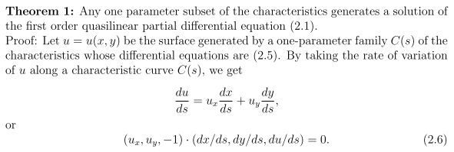
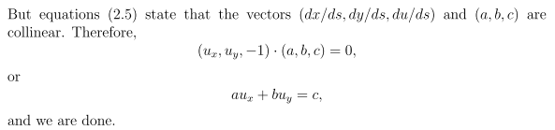

Now I don't know what he means by "one parameter subset of the characteristics", but let's see what in his proof is a "solution" to the PDE. His C(s) is the set of red curves I have drawn, where s is a parameter along the curves. So I agree that C(s) is a "one parameter family of the characteristics". My family above was associated with a particular choice of function F. Equation (2.6) is so because q and (a,b,c) are co-linear as I already showed above, though his logic runs backwards. The two equations (2.6) and above are the same, and the first is my (**) divided by ds. So OK, this is another proof that q and (a,b,c) are collinear, same as mine I am sure. I like all the equations,
... but what has he proved here? What is the "solution" here? It is the function u(x,y) certainly. And yes, u(x,y) can be thought of as the composite of all those C(s) curves, the set of all my red lines.
So OK, I guess there is a family of characteristic curves for any F you choose and we pick some C(s) and that defines the surface. But I don't see yet the practicality of this "theorem".

I now skip for the moment his corollary and to right to the first example:

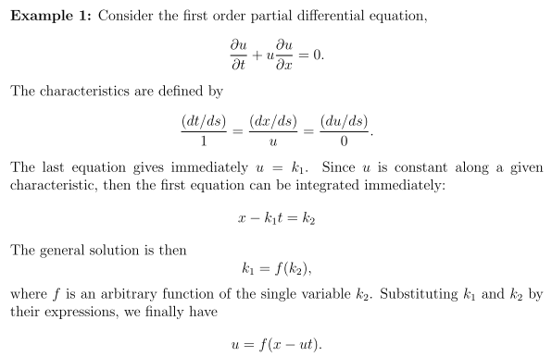

I agree with the characteristic triplet -- it is a left and a right equation if you like. The right equation says

(du/ds) = 0 * (dx/ds)/u => du/ds = 0 => u = k1

Agreed! Now the left equation says

k1 dt/ds = dx/ds => k1dt = dx => x = k1t + k2

Agreed! So notice that we have two constants here k1 and k2. But where does his next line come from, that the "general solution is then..." ? Here is his step that completely loses me, I just drop out of his logic flow

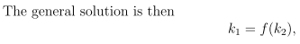

Where is he getting this from, it seems to have no connection to anything. Prior to this point, we have k1 and k2 being completely arbitrary constants. Perhaps k1 = 4 and k2 = 2. I could write k1 = k22 if I wanted, yes, or k1 = f(k2) for any function I wanted. Then u = f(x-k1t), that is true. But why do I expect this to be a solution to the PDE?
I will try jumping to another PDF to see if the missing link is provided. My "good PDE note 1" quotes a theorem that involves these two constants, but gives no proof of that theorem.
Try pdebook2. This one is too fancy for me right now. I just want to understand the simplest case.

Well, I will hold off once again on this subject, but I will try to use the claimed theorem to solve my equation of interest which is this, where c(r,t) is some given function

∂ru(r,t) = c(r,t)

Change to official names

∂xu(x,y) = c(x,y)

Put in standard form

ux = f standard is aux + buy = c

So we have a = 1 and b = 0 and c = c. So we get

dx/1 = dy/0 = du/c

Here are the three possible equations:

left: 0 dx = 1 dy or dy = 0 => y = k1

right: 0 du = cdy or c(x,y)dy = 0 => dy = 0, same as result of left

straddle: cdx = 1du or c(x,y)dx = du => u = $^{\int_{}^{x}{}}$c(x,y)dx + k2

OK, then the theorem says that

f( u - $^{\int_{}^{x}{}}$c(x,y)dx, y) = 0 gives a solution for any function f

Now I think you can restate this last equation as

u - $^{\int_{}^{x}{}}$c(x,y)dx = g(y) for any function f

Then here would be a candidate general form for a solution

u(x,y) = $^{\int_{}^{x}{}}$c(x,y)dx + g(y)

Let's test it. We find at once

∂xu(x,y) = c(x,y)

But I don't think that is really my equation of interest. Try this

$\frac{∂E(r,ω)}{∂r}$ = jωB(r,ω) ≡ c(r,ω)

Then solution would be

E(r,ω) = $^{\int_{}^{r}{}}$ jωB(r,ω)dr + g(ω) = jω $^{\int_{}^{r}{}}$B(r,ω)dr + g(ω)

Then obviously

∂rE(r,ω) = jωB(r,ω) + 0.

So I guess I have at least answered my question, but my study of PDE's did not get far.

Suppose you have these two PDE's:

∂xu(x,y) = c1(x,y)
∂yu(x,y) = c2(x,y)

The general solutions to these are:

u(x,y) = $^{\int_{}^{x}{}}$c1(x,y)dx + g1(y)
u(x,y) = $^{\int_{}^{y}{}}$c2(x,y)dy + g2(x)

Comparing these one would conclude that the only solution to this system of two PDE's was

u(x,y) = $^{\int_{}^{x}{}}$c1(x,y)dx + $^{\int_{}^{y}{}}$c2(x,y)dy + K [ why so? 3/11/14 ]

So I would say that declaring the two partial derivatives in this manner nails down the solution pretty well.

