Maple index for Scrambler doc PhL 8.31.13

I will scan through scrambler looking for Maple stuff

Above 1.2.8: Don't have these 3 lines anywhere:

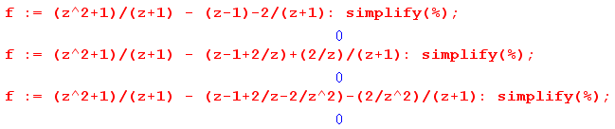
Below 1.2.9: in scram support 4.mws

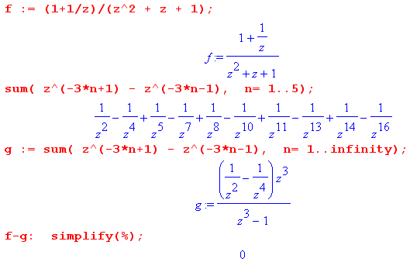
Below 2.3.11: Probably from some GA mws file

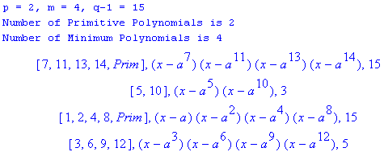

in GF512charseq.mws

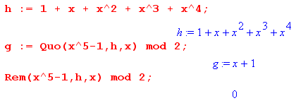

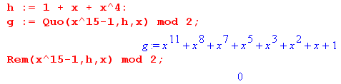
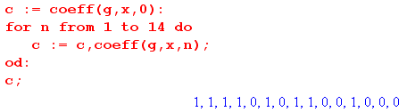

in GF512charseq.mws

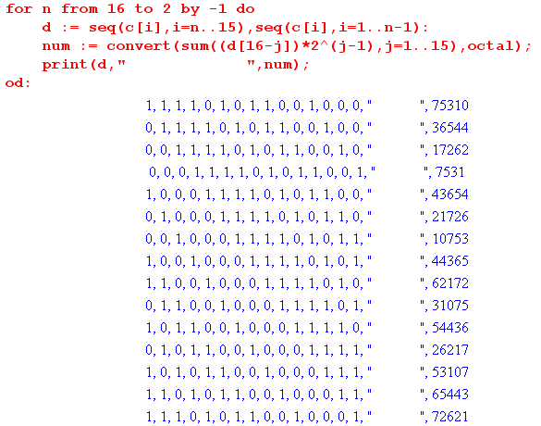

Below 2.3.17: in GF512charseq.mws

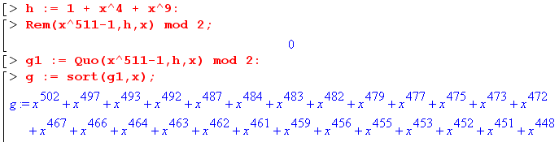

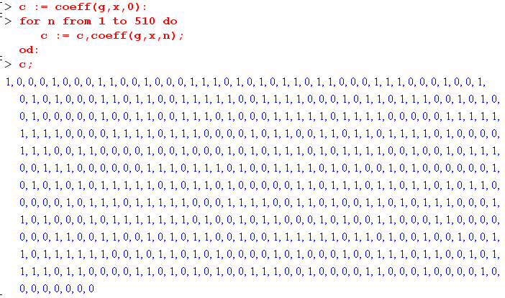

Below Fig 3.1: in scrambler 3_6.mws

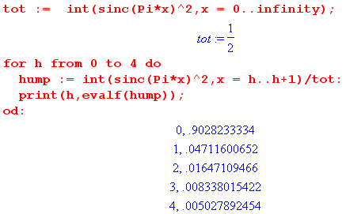
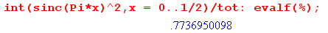

In Appendix A:

The following is in temp1.mws:

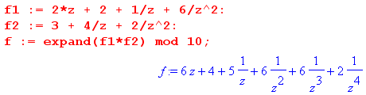

The following is in recur1.mws:

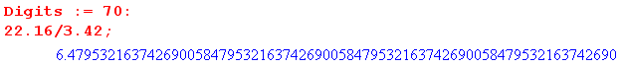

The following is in recursion.mws:

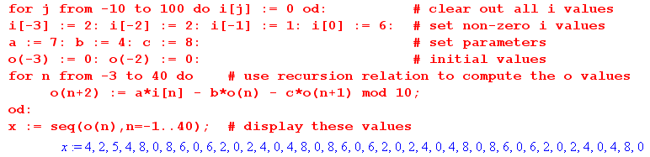

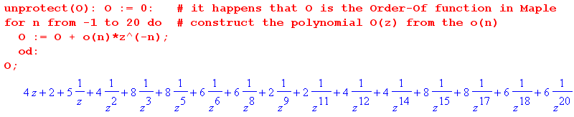

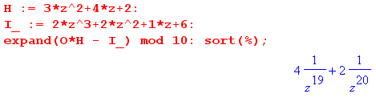
The following is in recur1.mws:

