This is the Title PhL 3.26.05

2.5 The MLS Spectral Power Density and Autocorrelation Sequence 1
(a) Spectral Power Density of a White Sequence 1
(b) The general power formula for an infinite P-repeated sequence 2
(c) Case 1: The Spectral Power Density of an MLS Sequence with symbols in {1,0}. 3
(d) Case 2: The Spectral Power Density of an MLS Sequence with symbols in {1,-1} 5
(e) Summary, MLS correlation, and graphs of the autocorrelation sequences 8

2.5 The MLS Spectral Power Density and Autocorrelation Sequence

Before looking at the MLS spectra, it is useful to review the characteristics of a white power spectrum.

(a) Spectral Power Density of a White Sequence

The spectral power density of an infinite uncorrelated statistical pulse train which has amplitudes taken from the set {A,B} is shown in FT (35.37) to be

<P(ω)> = Ppulse(ω) [ σ2 + μ2 $\sum_{m = -∞}^{∞}{}$2π δ(ωT1- 2πm) ]
where (2.5.1)

σ2 = [ p(1-p)] (A-B)2 σ2 = (β-α)
μ = [p]A + [1-p]B μ2 = α

Here p is the probability that yn takes value A, and p-1 is the probability that yn takes value B.

A white sequence is such a sequence in which p = 1/2, so that

σ2 = (1/4)(A-B)2
μ2 = (1/4)(A+B)2 (2.5.2)

so our general white sequence <P(ω)> is given by

<P(ω)>white = Ppulse(ω) [(1/4)(A-B)2 + (1/4)(A+B)2 $\sum_{m = -∞}^{∞}{}$2π δ(ωT1- 2πm) ] . (2.5.3)

If {A,B} = {1,0} we find the following mixed spectrum (partially continuous, partially discrete),

<P(ω)>white = Ppulse(ω) [(1/4) + (1/4) $\sum_{m = -∞}^{∞}{}$2π δ(ωT1- 2πm) ] // {1,0} (2.5.4)

and {A,B} = {1,-1} produces instead the following purely continuous spectrum,

<P(ω)>white = Ppulse(ω) . // {1,-1} (2.5.5)

If the pulse is a square pulse of amplitude 1 and width T1, then

Ppulse(ω) = (1/ω1) sinc2(ωT1/2) ω1 = 2π/T1 FT (36.1)

and one then finds for the {1,0} case that

<P(ω)>white = (1/ω1) sinc2(π $\frac{ω}{ω1}$) [(1/4) + (1/4)$\sum_{m = -∞}^{∞}{}$ δ( $\frac{ω}{ω1}$ - m) ]
= (1/ω1) sinc2(π $\frac{ω}{ω1}$) [(1/4) + (1/4) δ( $\frac{ω}{ω1}$) ] // {1,0} (2.5.4a)

since the sinc function kills off the lines for m ≠ 0. For the {1,-1} case

<P(ω)>white = (1/ω1) sinc2(π $\frac{ω}{ω1}$) . // {1,-1} (2.5.5a)

The first spectrum has a DC line and a continuous sinc2 spectrum as shown. The second spectrum has no DC line of course and has four times the continuous spectrum since the peak-to-peak swing is double that of the {1,0} case.

(b) The general power formula for an infinite P-repeated sequence

Consider an infinite pulse train with underlying pulse xpulse(t) whose amplitudes yn are an MLS sequence of period P,

x(t) = $\sum_{n = -∞}^{∞}{}$ yn xpulse(t -tn) // infinite pulse train

We are interested in determining the spectral power density P(ω) of this pulse train.
First, we define the autocorrelation sequence rs of a sequence as the following horizontal average across the sequence:

rs ≡ <yn yn+s>1 (2.5.6)

For an infinite sequence this can be written

rs ≡ limN→∞ [$\frac{1}{(2N+1)}$$\sum_{n = -N}^{N}{}$ yn yn+s ] . FT (F41.a)

If the sequence yn is periodic with period P, then it is shown in FT that

rs = $\frac{1}{P}$$\sum_{n = 0}^{P-1}{}$ yn yn+s FT (F41.b) (2.5.7)

Now, in FT Appendix F it is shown that for any pulse train constructed from a repeating subsequence of length P, the following theorem applies:

Theorem : For an infinite statistical sequence made of repeated subsequences of length P : FT (F.54)
If the following is found to be true concerning the autocorrelation sequence elements,

<ymyn>1 = α for m ≠ n + NP N = any integer (2.5.8)
<ymyn>1 = β for m = n + NP

then the spectral power density is given by :

P(ω) = Ppulse(ω) ω1 $\sum_{m = -∞}^{∞}{}$[ (β-α) $\frac{1}{P}$δ(ω - ω1m/P) + α δ(ω - ω1m) ] . (2.5.9)

One can break out the DC term in (2.5.9) and write this alternative form ( FT (F.52d) )

P(ω) = Ppulse(ω) ω1 [ (β-α) $\frac{1}{P}$$\sum_{m ≠ 0}^{}{}$δ(ω - ω1m/P) + α $\sum_{m ≠ 0}^{}{}$δ(ω - ω1m) + {(β-α) /P + α} δ(ω) ]
(2.5.9a)
where m≠0 means that both positive and negative integers should be included in the sums.

We will now show that the above Fact applies to any MLS sequence of period P.

(c) Case 1: The Spectral Power Density of an MLS Sequence with symbols in {1,0}.

Consider once again our "compressed" chart (3.4.8) which collected facts about the product of a specific MLS sequence and a shifted version of itself,

The Counts Column 3 Column 4 Shifted n's Unshifted n's
n1 = number of (0,0)'s sum = 0 product = 0 (2k - 1) - 3•2k-2 2k-1 - 1
n2 = number of (0,1)'s sum = 1 product = 0 2k-2 0
n3 = number of (1,0)'s sum = 1 product = 0 2k-2 0
n4 = number of (1,1)'s sum = 0 product = 1 2k-2 2k-1 (2.5.10)

where P = 2k-1. First of all, the mean value for an MLS sequence is given by ( see (2.4.5)' )

<yn>1 = Prob(1)*1 + Prob(0)*0 = Prob(1) = [number of 1's]/P = 2k-1/P = (1/2)(1+1/P) .

If the shifted version of our MLS sequence is shifted by s bits, then for s ≠ 0,

<ynyn+s>1 = 1 * 1 * Prob(1,1) + 1*0* Prob(1,0) + etc = Prob(1,1) = n4/P = 2k-2/ P.

Only facing bits of the pattern (1,1) contribute to <ynyn+s>1, and the count of those is n4 = 2k-2 as shown in the chart above (Shifted n's column), while the total number of bit pairs is P. Now

2k-2/ P = (1/4)2k/P = (1/4)(P+1)/P = (1/4)(1 + 1/P)

so we have just shown that

<ynyn+s>1 = (1/4)(1 + 1/P) for s ≠ 0 . (2.5.11)

For s = 0, there is no shift and, since there are 2k-1 one's in any MLS sequence, this is also the number of (1,1) matching pairs and n4 = 2k-1 as shown in the last column of the chart, bottom row. Thus

<ynyn+0>1 = 1 * 1 * Prob(1,1) + etc = Prob(1,1) = 2k-1/P = 2 [2k-2/ P]
= (1/2)(1 + 1/P) . (2.5.12)

We have now established that

rs = <yn yn+s>1 = N = any integer
where (2.5.13)
α = (1/4)(1 + 1/P)
β = (1/2)(1 + 1/P) => (β-α) = α = (1/4)(1 + 1/P)

Since this meets the condition (2.5.8), the spectral power density of a pulse train which uses this MLS sequence as its amplitudes is given by (2.5.9a)

P(ω) = Ppulse(ω) ω1 [ (β-α) $\frac{1}{P}$$\sum_{m ≠ 0}^{}{}$δ(ω - ω1m/P) + α $\sum_{m ≠ 0}^{}{}$δ(ω - ω1m) + {(β-α) /P + α} δ(ω) ]
= Ppulse(ω) ω1 [ α $\frac{1}{P}$$\sum_{m ≠ 0}^{}{}$δ(ω - ω1m/P) + α $\sum_{m ≠ 0}^{}{}$δ(ω - ω1m) + α{1+1/P} δ(ω) ]
= Ppulse(ω) ω1 [ (β/2) $\frac{1}{P}$$\sum_{m ≠ 0}^{}{}$δ(ω - ω1m/P) + (β/2) $\sum_{m ≠ 0}^{}{}$δ(ω - ω1m) + β2 δ(ω) ] . (2.5.14)

where β = (1/2)(1 + 1/P) . In the case of a box-shaped pulse Ppulse(ω) ω1 = sinc2(π $\frac{ω}{ω1}$), the entire second sum is killed off by the zeros of the sinc function leaving this result

P(ω) = (β/2) sinc2(π $\frac{ω}{ω1}$) $\frac{1}{P}$$\sum_{m ≠ 0}^{}{}$δ(ω - ω1m/P) + β2 δ(ω), β = (1/2)(1 + 1/P) (2.5.15)

Here is a graphical representation of this MLS P(ω) drawn for P = 4 :

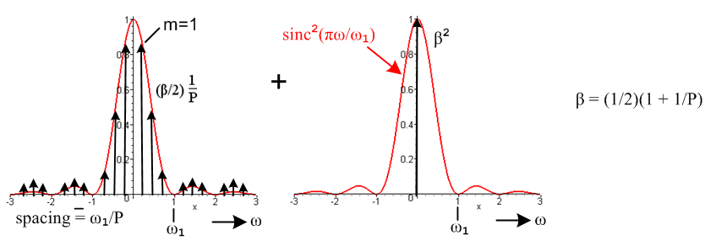
Spectrum of an MLS sequence with symbols in {1,0} and a box pulse shape. Fig 2.8

Each vertical arrow represents a spectral δ line. The height of the arrow is the value of the red envelope curve times the quantity shown. The little arrows are drawn too long so they can be seen. As P gets larger, the density of arrows on the left increases, but the height of the arrows (β/2) $\frac{1}{P}$ sinc2(πm/P) decreases. Remember that each arrow represents a delta function which is infinite in "height", so this infinite height is being scaled down by 1/P as P increases. In the limit P→∞, FT (F.38) shows that

limP→∞ [ $\frac{ω1}{P}$$\sum_{m = -∞}^{∞}{}$δ(ω - ω1m/P)] = 1 FT (F.38)

so the P→∞ limit of the above MLS power spectrum becomes

P(ω) = (1/4) sinc2(π $\frac{ω}{ω1}$) (1/ω1) + (1/4) δ(ω), β = (1/2) (2.5.16)

which agrees with the white power spectrum (2.5.4a). Thus, the densely packed lines have coalesced into the continuous sinc2 spectrum shown.
More generally, for any pulse shape it is easy to verify from our equations above that

limP→∞ [P(ω)MLS] = <P(ω)>white. // {1,0} (2.5.17)

(d) Case 2: The Spectral Power Density of an MLS Sequence with symbols in {1,-1}

Our starting point to carry out this program is to consider once again our "compressed" chart which collected facts about the product of a specific MLS sequence and a shifted version of itself. However, we now draw the chart for our new choice of symbols: (the right two columns are unchanged)

The Counts Column 3 Column 4 Shifted n's Unshifted n's
n1 = number of (-1,-1)'s sum = -2 product = 1 (2k - 1) - 3•2k-2 2k-1 - 1
n2 = number of (-1,1)'s sum = 0 product = -1 2k-2 0
n3 = number of (1,-1)'s sum = 0 product = -1 2k-2 0
n4 = number of (1,1)'s sum = 2 product = 1 2k-2 2k-1
(2.5.10)'
First of all, the mean value for an MLS sequence of this type is given by ( see (2.4.5)' )

<yn>1 = Prob(1)*1 + Prob(-1)*(-1) = [number of 1's]/P - [number of -1's]/P

= [2k-1]/P - [(2k-1 - 1)]/P = 1/P .

Our new computation for <ynyn+s>1 goes like this, assuming s ≠ 0,

<ynyn+s>1 = 1*1*Prob(1,1) + 1*(-1)*Prob(1,-1) + (-1)*1* Prob(-1, 1) + (-1)*(-1)Prob(-1,-1) .

For s ≠ 0, the "shifted n's" column tells us that

Prob(1,1) = Prob(-1,1) = Prob(1,-1) = 2k-2/P
Prob(-1.-1) = [(2k - 1) - 3•2k-2]/P

Then for s ≠ 0,

<ynyn+s>1 = 2k-2/P – 2k-2/P - 2k-2/P + [(2k - 1) - 3•2k-2]/P

= - 2k-2/P + [(2k - 1) - 3•2k-2]/P = [(2k - 1) - 4•2k-2]/P

= [P - (4/4)•2k]/P = [P - (P+1)]/P

= -1/P . (2.5.11)'

For s = 0 we get instead

<ynyn+0>1 = 1*1*Prob(1,1) + 1*(-1)*Prob(1,-1) + (-1)*1* Prob(-1, 1) + (-1)*(-1)Prob(-1,-1)

= Prob(1,1) + Prob(-1,-1) = 2k-1/P + (2k-1-1)/P = (2k-1)/P = P/P = 1 . (2.5.12)'

This result is fairly obvious since <yn2> = 1 for both yn in {1,-1} .
We have now established that

rs = <yn yn+s>1 = N = any integer
where (2.5.13)'
α = -1/P
β = 1 => (β-α) = (1+1/P)

Since this meets the condition (2.5.8), the spectral power density of a pulse train which uses this MLS sequence as its amplitudes is given by (2.5.9a)

P(ω) = Ppulse(ω) ω1 [ (β-α) $\frac{1}{P}$$\sum_{m ≠ 0}^{}{}$δ(ω - ω1m/P) + α $\sum_{m ≠ 0}^{}{}$δ(ω - ω1m) + {(β-α) /P + α} δ(ω) ]
= Ppulse(ω) ω1 [ (1+$\frac{1}{P}$) $\frac{1}{P}$$\sum_{m ≠ 0}^{}{}$δ(ω - ω1m/P) – $\frac{1}{P}$ $\sum_{m ≠ 0}^{}{}$δ(ω - ω1m) + $\frac{1}{P2}$ δ(ω) ] (2.5.14)'

In the case of a box-shaped pulse Ppulse(ω) ω1 = sinc2(π $\frac{ω}{ω1}$), the entire second sum is again killed off by the zeros of the sinc function leaving this result

P(ω) = sinc2(π $\frac{ω}{ω1}$)[(1+$\frac{1}{P}$) $\frac{1}{P}$$\sum_{m ≠ 0}^{}{}$δ(ω - ω1m/P) + $\frac{1}{P2}$ δ(ω) ] (2.5.15)'

Here is a graphical representation of this MLS P(ω) drawn for P = 4 :

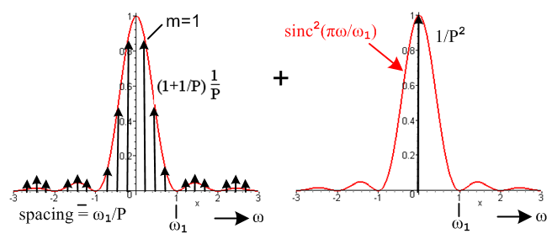
Spectrum of an MLS sequence with symbols in {1,-1} and a box pulse shape. Fig 2.9

Using the same FT (F.38) limit limP→∞ [ $\frac{ω1}{P}$$\sum_{m = -∞}^{∞}{}$δ(ω - ω1m/P)] = 1, we find for P→∞
P(ω) = (1/ω1) sinc2(π $\frac{ω}{ω1}$) (2.5.16)'

which agrees with the white power spectrum (2.5.5a). The DC line has gone away and the closely spaced lines on the left have again coalesced into the continuous sinc2 spectrum shown.
More generally, for any pulse shape it is easy to verify from our equations above that

limP→∞ [P(ω)MLS] = <P(ω)>white. // {1,-1} (2.5.17)'

(e) Summary, MLS correlation, and graphs of the autocorrelation sequences

We have seen from (2.5.6) and (2.5.7) that the autocorrelation sequence is given by

rs = $\frac{1}{P}$$\sum_{n = 0}^{P-1}{}$ yn yn+s = <yn yn+s>1 , yn+NP = yn

We may gather up our results of the last three sections to construct this table

Case 1 {1,0} $\underline{<yn> = μ}$ $\underline{r0 = β = <yn2>}$ $\underline{rm-n = α = <ymyn>}$ uncorrelated μ μ μ2 0 ≤ μ ≤ 1
MLS (1/2)(1+1/P) (1/2)(1+1/P) (1/4)(1+1/P)
white 1/2 1/2 1/4

Case 2 {1,-1} $\underline{<yn> = μ}$ $\underline{r0 = β = <yn2>}$ $\underline{rm-n = α = <ymyn>}$
uncorrelated μ 1 μ2 -1 ≤ μ ≤ 1
MLS 1/P 1 -1/P
white 0 1 0 (2.5.18)

Is the MLS sequence correlated or uncorrelated?

For {1,0} here is what we know (see FT Appendix G (c)) :

σ2(Yn) = E(Yn2) - E(Yn)2 = <yn2> - <yn>2 = (1/2)(1+1/P) - (1/2)2(1+1/P)2 FT (G.30)

= (1/4)(1-1/P2)

cov(Yn,Ym) = E(YnYm) - E(Yn)E(Ym) = <ynym> - <yn>2 = (1/4)(1+1/P) - (1/2)2(1+1/P)2

= – (1/4) (1/P) (1+1/P) FT (G.24b)
Therefore
corr(Yn,Ym) = $\frac{cov(Yn,Ym)}{σ(Yn) σ(Ym)}$ = $\frac{cov(Yn,Ym)}{σ2(Yn)}$ = $\frac{– (1/4) (1/P) (1+1/P)}{(1/4)(1-1/P2)}$ = $\frac{-1/P}{1+1/P}$ {1,0}

Since the result is not zero, the {1,0} MLS sequence is correlated. As P→∞ it becomes uncorrelated.

For {1,-1} we find instead:

σ2(Yn) = E(Yn2) - E(Yn)2 = <yn2> - <yn>2 = 1 - (1/P)2

cov(Yn,Ym) = E(YnYm) - E(Yn)E(Ym) = <ynym> - <yn>2 = -1/P - (1/P)2 = -(1/P)(1+1/P)

Therefore
corr(Yn,Ym) = $\frac{cov(Yn,Ym)}{σ(Yn) σ(Ym)}$ = $\frac{cov(Yn,Ym)}{σ2(Yn)}$ = $\frac{-(1/P)(1+1/P)}{1 - (1/P)2}$ = $\frac{–1/P}{1-1/P}$ {1,-1}

Since the result is not zero, the {1,-1} MLS sequence is correlated. As P→∞ it becomes uncorrelated.

We now plot the six autocorrelation sequences implied by (2.5.18). The sequence values are shown as black dots, and the values are linearly interpolated by a red line as a cosmetic guide. In these drawings it is assumed that P > 4 so we don't see the autocorrelation sequences peaking every P integers, but one should keep in mind that they do just that.
In the process of acquiring and tracking a spread spectrum signal, where one seeks to align the receiving clock with the transmitting clock, one reverts to a continuous (analog) autocorrelation function and then these red lines are more than cosmetic. See Comments at the start of Section 3.5 below.

Case 1 Case 2
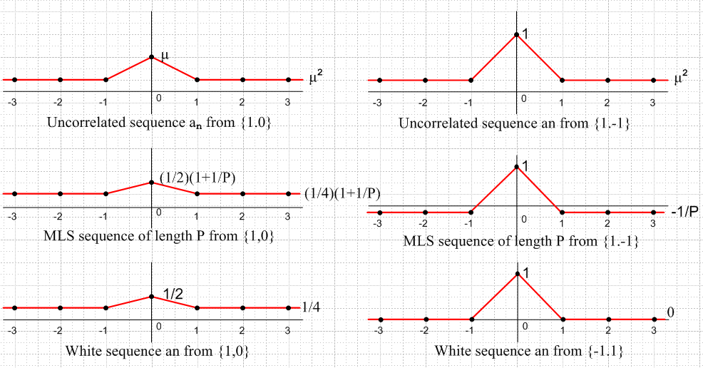

Fig 2.10

