Jim, PhL 1.14.11 1 AM

Here is part of Stakgold's book where he discusses the δ function theorem. He uses α where we were using symbol ε. I first quote one of his exercises quoted below to give you some motivation. This is exactly the case you concocted on the phone today around 11AM :

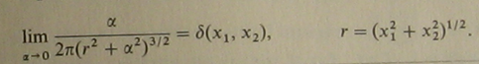

So then, here is the Theorem in n dimensions for an arbitrary function f(x1....xn)

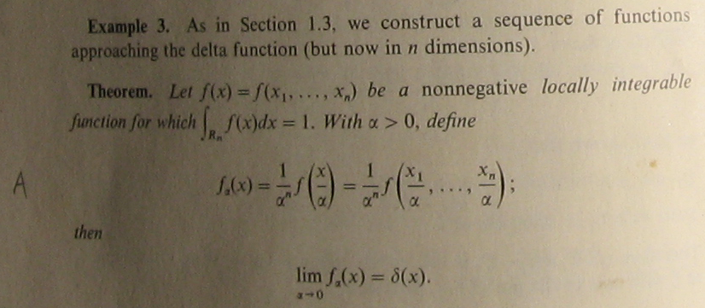

where δ(x) at the end means what I call δ(n)(x) . As he will bring up below, in the radial-only case the above becomes

gα(r) = α-n g(r/α)

limα→0 [α-n g(r/α)] = δ(n)(x)

and the normalization condition becomes

∫sphere dnV g(r) = 1 = (angle integral) * $^{\int_{0}^{∞}{}}$dr rn-1 g(r)

where the angle integral is 2π in 2D, 4π in 3D, and he calls it Sn(1) in nD.

Here is the essence of the proof:

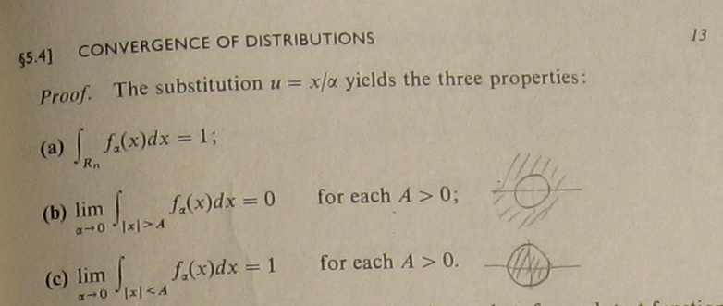

You just do what he says, u = x/α, and it is easy to show that each of the three items is true. This must be true for any finite A no matter how small you make A be, so limα→0 fα(x) = δ(n)(x) . Integral over Rn means over all dx1dx2 ...dxn where each variable is -∞ to ∞. He then adds a "technical section" having to do with the convergence of the upper tail end of his integral where he formally uses a "test" function. I don't think this part of the proof is necessary for you and me, but I include it anyway

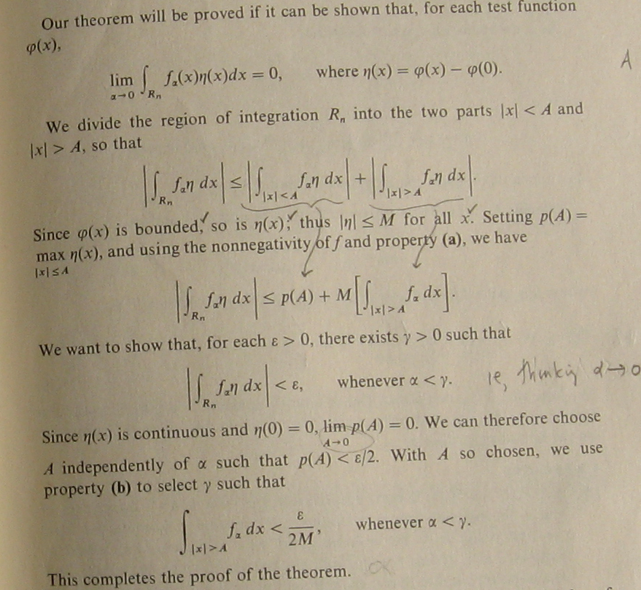

Now he goes on to specialize his delta theorem to the case that f(x1, x2....) = g(r) :

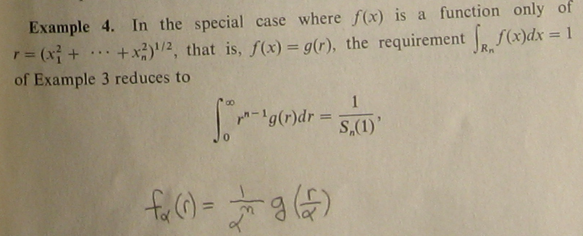

He then goes on with this g(r/α) situation on the next page of his book,

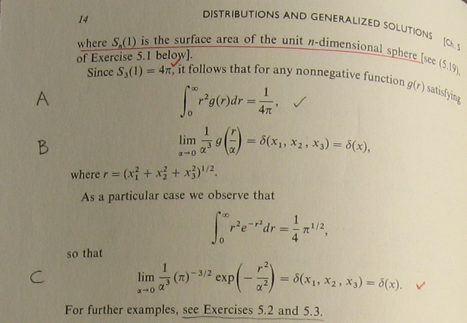

Now we are going to look at three of his "exercises". He puts lots of useful info into his exercises. The first one is this where he talks about the volume and surface area of a hypersphere in n dimensions. It is best to just accept the results I think. The volume integral is (5.17) and surface integral is (5.18).

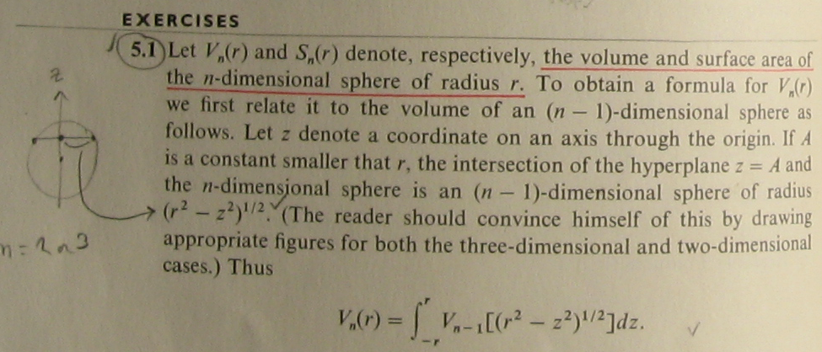

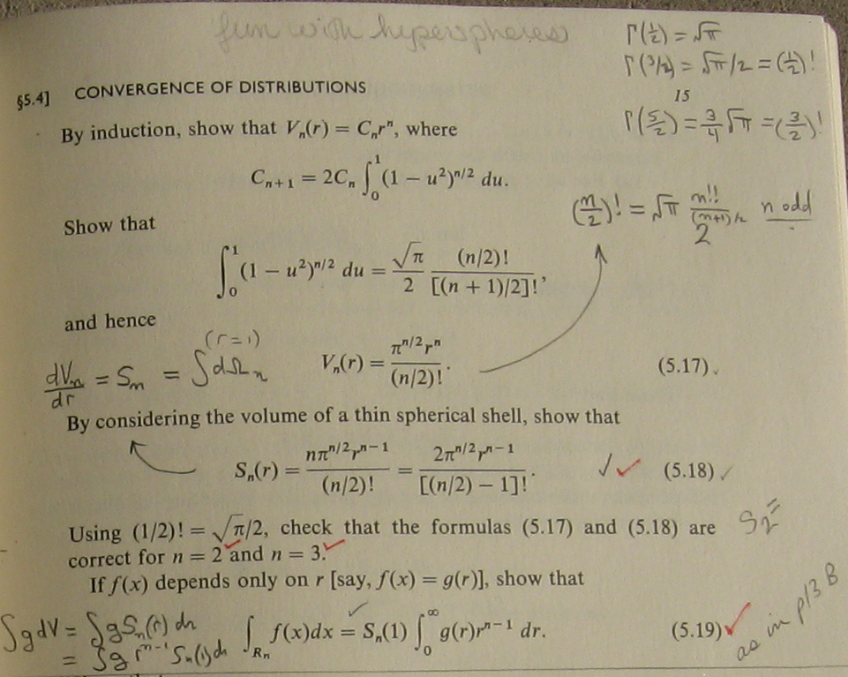

The case n = 1 is interesting and has a bit of a trick to it. The sphere of radius a is a line segment (-a,a) of length 2a, which 5.17 confirms. The "surface" area is S1(1) = 2 which 5.18 tells us, you get a "1 from each endpoint" of the segment. An much easier way to see this is as follows:

∫R1 f(x) dx = $^{\int_{-∞}^{∞}{}}$f(x) dx = 1 => $^{\int_{0}^{∞}{}}$ dr g(r) = 1/2 = 1/S1(1)

The trick for n = 1 is the "half a delta function" issue one often runs into, ( you only get half a loaf!)

limα↔0 [α-1 g(x/α)] = δ(x) on the domain x in (-∞,∞)
but
limα↔0 [α-1 g(r/α)] = (1/2) "δ(r)" on the domain r in (0,∞) (*)

if you define the "radial δ(r)" by $^{\int_{0}^{∞}{}}$dr "δ(r)"φ(r) = φ(0) for test function φ(r) . This is I think what people usually mean when they write δ(r) in a spherical coordinates context, so you get that extra factor of (1/2) shown in (*).

Here then is the next exercise which has two parts:

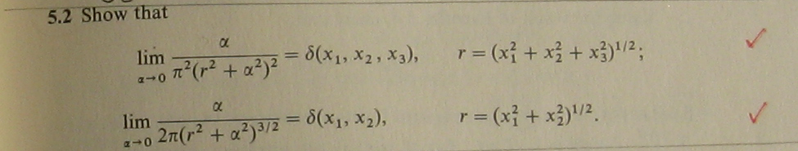

The second one above is the one you brought up today on the phone 1.14.11.
And then here is the next exercise:

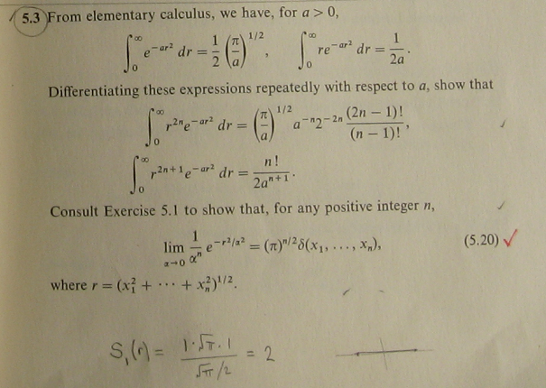

That's all folks!

