Associating integral equations with differential ones PhL 1.17.11

1. First of all, this concerns only Fredholm integral equations of this type ( in n dimensions, fixed "endpoints" for n=1 , fixed boundary region for n>1; the main point is the boundary not be dependent in any way on x )

f(x) = ∫dy k(x,y)g(y) f = Kg

This is a clearly a linear integral equation. I think we can allow a variable endpoint in the 1D case (Volterra equation) since we can replace that with a fixed endpoint and an adjusted kernel which vanishes on a triangular region.

We know that if k(x,y) is the Green's Function of some differential operator Lx , by which we mean

Lx k(x,y) = δ(x-y) ,

then we can hopefully apply Lx to both sides of our integral equation to get

Lxf(x) = ∫ dy [ Lx k(x,y) ] g(y) = ∫ dy δ(x-y) g(y) = g(x) g = Lf

If we can do this successfully, then we shall have made an association between our integral equation and a differential equation

f(x) = ∫dy k(x,y)g(y) and Lxf(x) = g(x)
(1) (2)
f = Kg Lf = g

Notice that we have said nothing about "boundary conditions". In equation (1), we are given f and we want to solve for g. In equation (2) we are given g and we want to solve for f. These are really different problems.

2. Now let's specialize our situation above as follows, where we set g(x) = λ f(x),

f(x) = λ ∫dy k(x,y)f(y) and Lxf(x) = λ f(x)
(1) (2)
f = λKf Lf = λf
Kf = (1/λ) f

Now instead of having two different problems, we have only one problem which is the eigenvalue problem. We can state this problem in either integral or differential form. Certainly in the differential form we are familiar with how boundary conditions create a Sturm Liouville problem with a spectrum on the real λ axis which is discrete for the regular situation, and continuous or mixed for the singular situation such as infinite endpoints.

3. Remember that this whole association idea is only valid for a special class of kernels k(x,y) which are Green's Functions. For the general kernel k(x,y), there probably exists no Lx such that Lx k(x,y) = δ(x-y), so there will be no differential equation associated with the integral equation as discussed above. This was something I did not realize even after reading Stakgold Chapter 3 on integral equations. I just assumed that every Fredholm eigenvalue problem had a differential form. But now I think there are lots of Fredholm eigenvalue problems that have no differential form and you probably have to just brute force solve them numerically. I don't think that being able to "invert" an integral equation using Sneddon methods such as a single or dual Abel transform is useful for solving an EV problem.

4. At present, I don't know how to tell whether or not a kernel is a Green's Function of some Lx, and I asked Richard Price if he knew. But here are a few things I think I know:

5. If n=1, if we restrict our search for Lx such that Lx has constant coefficients, if k(x,y) = g(x-y), if g(z) is an even function of z, and if g(z) has a Fourier Integral Transform, then no Lx exists of any order.

Here is a proof. First, if Lx has constant coefficients, Lx r(x-y) = δ(x-y) <= Lx r(x) = δ(x). If we transform this second equation into momentum space, we get [Σn=0∞ bn kn ] = (1/2π) ( 1/R(k) ). But since g(z) is even in z, it is easy to show that R(k) = F( |k| ). But |k| is not analytic at k = 0, so neither is R(k), and thus 1/R(k) cannot be matched by a power series in k about k = 0. An example of this case is the Love kernel which has g(z) = 1/(d2 + z2) and R(k) ~ exp(-d|k|). [ In the case of finite integration endpoints, we extend the kernel to (-∞,∞) in the natural way. ]

6. If n=1, if we restrict our search to Lx being second order and having continuous coefficient functions,

Lx = a(x)∂x2 + b(x)∂x + c(x)

then the following must be true for any Green's Function of such an operator

=> [∂xk(x,y)]|y+εy-ε = 1/a(y) = the jump in the first derivative

This says that k(x,y) must have a kink at x = y where the slope makes a sudden change, and this must be true for all y in our interval of interest. If we plot the function k(x,y) over the x,y plane, this kink must exist all along the diagonal. If we think of the string case, we can visualize this as a mountain ridge composed of triangles in our plot of k(x,y) which goes along the diagonal.
We also know that if Lx is to be self-adjoint, which allows it to have a complete set of eigenfunctions, then the candidate kernel must be symmetric k(x,y) = k(y,x).
Here is a plot of k(x,y) which is the Green's Function for the string

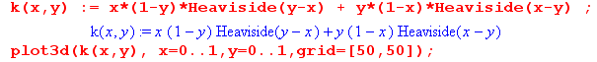

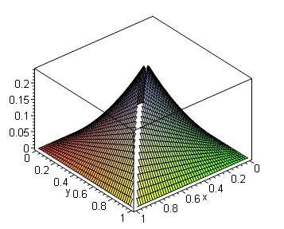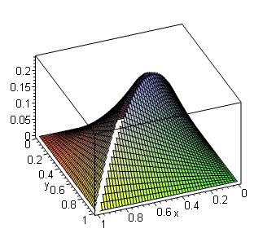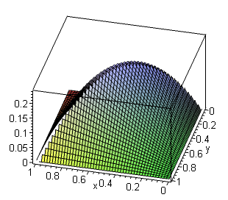

and one sees the mountain ridge along the diagonal, and the symmetry.
In contrast, here is a plot of the kernel of the Love integral equation (no mountain ridge)

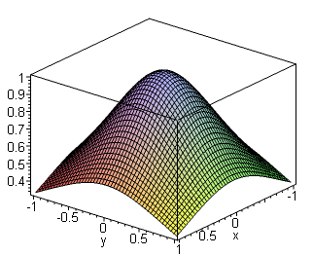

Therefore any k(x,y) which fails to have a diagonal mountain ridge can be ruled out (this mountain ridge could include both mountain and valley sections).
It seems pretty clear that in the space of k(x,y) kernels which might appear in integral equations, the vast majority will not have this shape.
This case covers a pretty broad class of Lx operators, including all those which generate the "special functions". It is possible that k(x,y) might have some Lx of some other form, but even if it does, probably Lx will be too complicated to work with.

Note added 1.18.11. I plotted the wrong thing for the Love kernel. That kernel has g(x) = 1/(d2+x2)
so the kernel is k(x,y) = g(x-y) = 1/(d2+(x-y)2). For d = 1 here is a plot of this thing

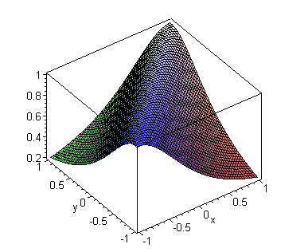
It has a "smooth" mountain ridge going down the diagonal, but smooth does not cut it, there has to be a discontinuity in slope as you cross the ridge by varying x with y fixed, but this baby is smooth going over the top at any angle. At any fixed y, [∂xk(x,y)]|x=y+εy-ε = 0, no jump, so cannot have Lx = a(x)∂x2 + b(x)∂x + c(x).

Here is an end-on view of the surface looking right down the diagonal:

