Sneddon Chap 2 notes: Supporting Math PhL 7.21.10

This is the huge background math chapter -- 36 pages jam-packed with equations. For the subject at hand, this stuff is the meat and potatoes, so at least some of it has to be assimilated. I will add notes here only when a section is needed for something later on in the book. These are "raw notes", there will be "meta notes" at some point. Thus, major sections of detail are just put "in line" as has been my past custom.

2.1 Integrals involving Bessel functions. 2
Question: What causes the sine and cosine J₀ integrals to be "discontinuous" at a=b? 2
1. Lipschitz's Integral 2
(a) power series method for deriving the Lipschitz Integral 2
(b) Watson's Bessel book gives this alternate derivation of the Lipschitz Integral 4
2. Weber's famous discontinuous sin/cos integrals. 4
3. A large family of discontinuous integrals 8
4. The addition of a 1/x factor to the Weber integrals. 11
Resuming our general Sneddon notes on page 28 12
Comment on Jacobi Polynomials, the Shifted Jacobi Polynomials, and the A&S G function 13
Hankel [29,30] 14
Sonine's first and second integrals 16
2.2 Infinite Series involving Bessel functions. [ 33] 17
2.3 Some Remarks on Integral Equations. [40] 18
(a) Srivastav's First Result ( x is upper endpoint) 18
(b) Srivastav's Second Result (x is lower endpoint) 21
(c) Special cases of Srivastav's two results 23
Niels Henrik Abel (5 August 1802 – 6 April 1829) 27
(d) The Laplace method with a general kernel [ 42 bot ] 29
(e) The Williams 1962a Method 33
2.4 Fractional Integration Operators. [ p 46 ] 35
(a) Repeated Integrals 35
Induction with F* 37
Induction with F* Revisited 38
(b) The Riemann-Liouville fractional integral (aka Euler transform of the 1st kind) 39
(c) The Weyl fractional integral (aka Euler transform of the 2nd kind) 41
(d) (PL) A general comment on "Transforms" and "Integral Equations" 43
(e) Erdelyi-Kober operators 45
(f) Some History. 50
2.5 Connection between the above EK operators to the Hankel operator 50
2.6 Jacobi Polynomials and Associated Legendre Functions 51
Appendix A: A theorem concerning differentiating a convolution Volterra integral. 52

2.1 Integrals involving Bessel functions.

[26] Sned states the series for J, then some interesting simple derivative facts which do appear in Schaum. One of my Smythian Laplace forms appears in 2.1.5.

[27] If you integrate these facts, you get the integrals shown top of page 27. Then 2.1.8 shows the integral of a general Jν-1 against a power xν+2n which we can then iteratively compute in terms of the basic ones just noted. One more integral is given 2.1.10, then we have our first integral representation in 2.1.11. At this point, we get a discussion of the very famous Weber discontinuous integrals

Question: What causes the sine and cosine J0 integrals to be "discontinuous" at a=b?

This kind of integral will be used to solve the charged disk problem. Sneddon claims you derive these by a "limiting process", but he does not explain. Here is a little web clip

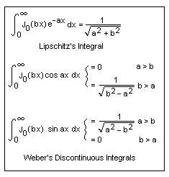

1. Lipschitz's Integral

The first integral does not seem so mysterious.

(a) power series method for deriving the Lipschitz Integral

I = $^{\int_{0}^{∞}{}}$dx J0(bx) e-ax

Jν(z) = Σs=0∞ (-1)s (z/2)ν+2s/[s! Γ(ν+1+s) ] = (z/2)ν Σs=0∞ (-1)s (z/2)2s/[s! Γ(ν+1+s) ]

J0(bx) = Σs=0∞ (-1)s (bx/2)2s/(s!)2 // as needed for the integral

This series by itself deserves some comment. First, for expansion around the regular singular point z = 0 the indicial equation tells you (see pdf) that the exponents are ±ν, and you see +ν above. So for ν ≠ integer, the other solution would be J-ν(z). When ν = integer, the difference of the exponents is an integer, so the second solution becomes the "log thing", etc etc. I found a nice Bessel pdf which goes through this stuff specifically for the Bessel equation (W&W and Bateman don't seem to mention exponents!).
Now let's insert the series into the Lipschitz's integral

I = Σs=0∞ (-1)s /(s!)2 *(b/2)2s $^{\int_{0}^{∞}{}}$dx x2s e-ax

This integral (done by parts) appears Schaum p 98 which says

$^{\int_{0}^{∞}{}}$dx x2s e-ax = Γ(2s+1)/a2s+1

so we arrive at

I = Σs=0∞ (-1)s /(s!)2 *(b/2)2s Γ(2s+1)/a2s+1

= Σs=0∞ (-1)s /(s!)2 * Γ(2s+1) 2-2s b2s a-2s-1

Meanwhile, if we go off and expand our known solution, we have

1/$\sqrt{a2+b2}$ = Σs=0∞ a-2s-1 b2s Γ(1/2)/ [s! Γ(1/2-s) ] // writing out (-1/2, s) binomial coeff

Comparison means we want to show that

(-1)s /(s!) * Γ(2s+1) 2-2s = Γ(1/2)/ Γ(1/2-s) (*)

My little "flip rule" is Γ(x)/Γ(x-n) = (-1)n Γ(n+1-x)/Γ(1-x) so set x = 1/2 and n = s to get

Γ(1/2)/Γ(1/2-s) = (-1)s Γ(s+1- 1/2)/Γ(1- 1/2) = (-1)s Γ(s+1/2)/Γ(1/2)

So now we have to show that

(-1)s /(s!) * Γ(2s+1) 2-2s = (-1)s Γ(s+1/2)/Γ(1/2)
or
Γ(2s+1) 2-2s = s! Γ(s+1/2)/Γ(1/2) (**)

Next, my little "duplication formula" says 22x-1 Γ(x)Γ(x+1/2) = $\sqrt{π}$ Γ(2x) so set x = s+1/2 to get

22(s+1/2)-1 Γ(s+1/2)Γ(s+1/2+1/2) = $\sqrt{π}$ Γ(2(s+1/2))
or
22s Γ(s+1/2)s! = $\sqrt{π}$ Γ(2s+1) = Γ(1/2)Γ(2s+1)
or
Γ(2s+1) 2-2s = Γ(s+1/2)s! / Γ(1/2)

But this is (**), QED.

(b) Watson's Bessel book gives this alternate derivation of the Lipschitz Integral

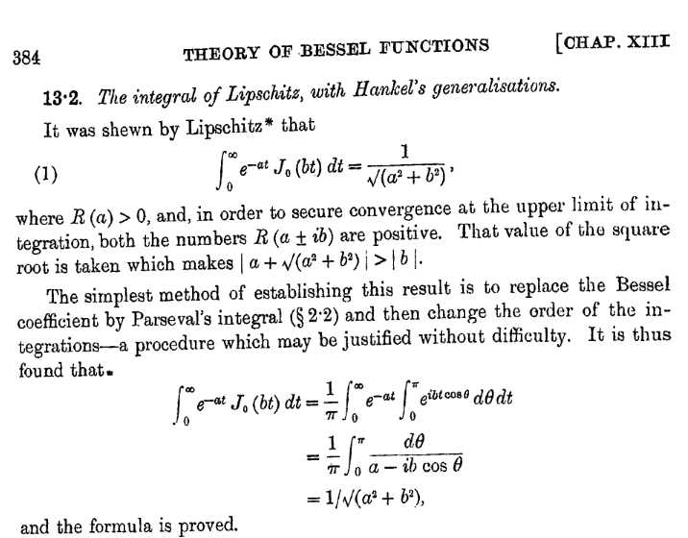

Notice that the second integral Watson uses is the one I studied in my Math binder section 5 which says

$^{\int_{0}^{∞}{}}$dx / (a ±bcosx) = π/$\sqrt{a2-b2}$

His integral representation for J appears in Bateman p 81 for general n, Watson assigns it to Parseval.

2. Weber's famous discontinuous sin/cos integrals.

Start with this

$^{\int_{0}^{∞}{}}$dx J0(bx) e-ax = 1/$\sqrt{a2+b2}$

Now replace a with z, a complex variable

$^{\int_{0}^{∞}{}}$dx J0(bx) e-zx = 1/$\sqrt{z2+b2}$ = 1/$\sqrt{(z+ib)(z-ib)}$

and here is our cut structure, where θ± > 0 :

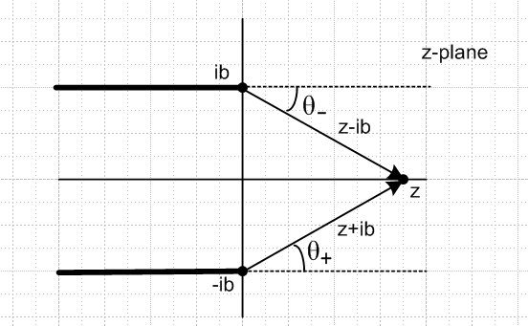

z-ib = |z-ib| eiθ+
z+ib = |z+ib| eiθ-

(z-ib)(z+ib) = |z-ib||z+ib| exp[ i (θ++θ-)]

We would like to move our point z to the imaginary axis in the z-plane. If we just move z to the left and up or down a little and end up with |z| < b, we get this picture

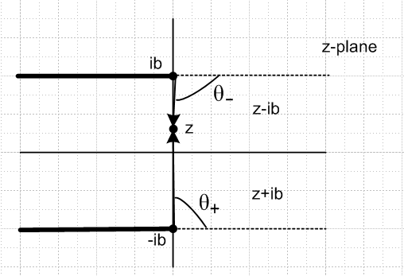

and we can see that our two angles add up to 0, so we have ( set z = ia, and |a| < b )

(z-ib)(z+ib) = |z-ib||z+ib| exp[ i (θ++θ-)] = |z-ib||z+ib|

= |ia-ib||ia+ib| = |a-b||a+b| = (b-a)(b+a) = b2-a2
so that

1/$\sqrt{z2+b2}$ = 1/$\sqrt{(z+ib)(z-ib)}$ = 1/$\sqrt{b2-a2}$

In this case we have shown that

$^{\int_{0}^{∞}{}}$dx J0(bx) e-iax = 1/$\sqrt{b2-a2}$ // which is 2.1.12

which tells us that, comparing real and imaginary parts

$^{\int_{0}^{∞}{}}$dx J0(bx) cos(ax) = 1/$\sqrt{b2-a2}$ |a| < b
$^{\int_{0}^{∞}{}}$dx J0(bx) sin(ax) = 0

On the other hand, if we wander to a point above z = +b, then both angles will be the same and will add up to π, and if we go down, angles add up to - π. Here is the picture in the up case

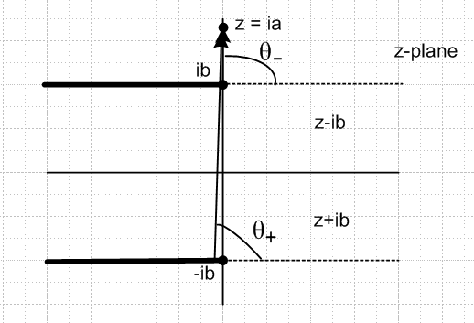

so combining these two cases, setting z = ±ia, we have , since |a| > b now,

(z-ib)(z+ib) = |z-ib||z+ib| exp[ i (θ++θ-)] = |z-ib||z+ib|e±iπ

= |ia-ib||ia+ib| e±iπ = |a-b||a+b| e±iπ = (a2-b2) e±iπ
so that

1/$\sqrt{z2+b2}$ = 1/$\sqrt{(z+ib)(z-ib)}$ = e∓iπ/2 /$\sqrt{a2-b2}$

In this case we have shown that

$^{\int_{0}^{∞}{}}$dx J0(bx) e∓iax = e∓iπ/2 /$\sqrt{a2-b2}$
or
$^{\int_{0}^{∞}{}}$dx J0(bx) e+iax = e-iπ/2 /$\sqrt{a2-b2}$ = i / $\sqrt{a2-b2}$

which tells us that, comparing real and imaginary parts

$^{\int_{0}^{∞}{}}$dx J0(bx) cos(ax) = 0 |a| > b
$^{\int_{0}^{∞}{}}$dx J0(bx) sin(ax) = 1/$\sqrt{a2-b2}$

If we repeat all the above for b → -b, we know that J0(bx) = J0(-bx) and then everything is the same. So we can summarize:

$^{\int_{0}^{∞}{}}$dx J0(bx) cos(ax) = 1/$\sqrt{b2-a2}$ |a| < |b|
$^{\int_{0}^{∞}{}}$dx J0(bx) sin(ax) = 0

$^{\int_{0}^{∞}{}}$dx J0(bx) cos(ax) = 0 |a| > |b|
$^{\int_{0}^{∞}{}}$dx J0(bx) sin(ax) = 1/$\sqrt{a2-b2}$

where a and b are real numbers. We are making no claims about these integrals when a and/or b become complex numbers!
Let's now reorder the above four integrals to show there are only two integrals,

$^{\int_{0}^{∞}{}}$dx J0(bx) cos(ax) = 1/$\sqrt{b2-a2}$ |a| < |b| // which are 2.1.13
= 0 |a| > |b|

$^{\int_{0}^{∞}{}}$dx J0(bx) sin(ax) = 0 |a| < |b| // which are 2.1.14
= 1/$\sqrt{a2-b2}$ |a| > |b|

Each of these integrals is "discontinuous" at the point |a| = |b| in a violent manner! As we approach from the variable side, the integral approaches ∞, then suddenly drops to 0 and stays there. Something like the charge density on a disk, in fact, as you approach the edge.
How do these discontinuous things arise? It is just a matter of phase. When you consider

$^{\int_{0}^{∞}{}}$dx J0(bx) e-zx = 1/$\sqrt{z2+b2}$

where each side is f(z), nothing dramatic happens as we let z move around in the z plane. For example, suppose you let z wander on a semicircle centered at z = +ib as in our first picture. It just happens that when z is on the bottom of this semicircle, the imaginary part of the integral goes to 0, and when z is on the top, the real part goes to 0. If you instead decide to wander up on a straight line path instead of a semicircle, we have to make a sudden jog about the branch point, and when we do that, an integral that was non-zero suddenly becomes 0. The complex integral shown above suddenly changes from real to imaginary as we do that jog. So perhaps this is the "limiting process" to which Sned refers.

3. A large family of discontinuous integrals

[After writing this section, I found that Sneddon quotes some of this stuff later on his page 28. ]

I am going to do some quotes from Watson's Bessel Treatise. First, he reviews the evaluation of the following "fairly complicated" integral, which has two J's, a power AND an exponential e-ct : [ p 400 ]

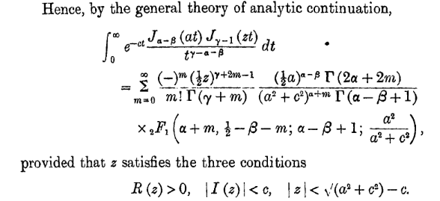

Here, z is a complex variable, but we are going to soon set z → b. The "discontinuous" nature of things is that you get two different answers depending on whether a > b or b > a. In each case, he sets things up and then takes c→ 0. Here are then the two different results. In each case you can see that the F function has an argument |z| < 1. Sadly, some horizontal lines came out poorly in the copying process. [ p 401 ]

For 0 < b < a : ( this appears also in Sneddon as 2.1.18b )

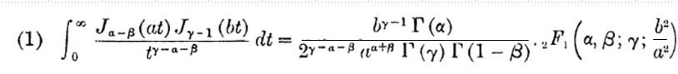

For 0 < a < b : ( this appears also in Sneddon as 2.1.18c )

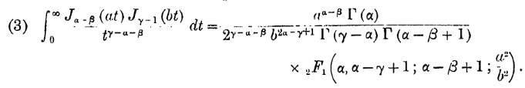
And here are some comments of Watson:

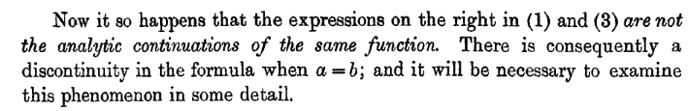

The case that a = b is yet another analytic function and Watson spends a lot of time figuring it out for the general case of all the other parameters.
Then on page 405, Watson provides a very nice list of special cases of the above equations (1) and (3). I shall quote his entire table from page 405 :

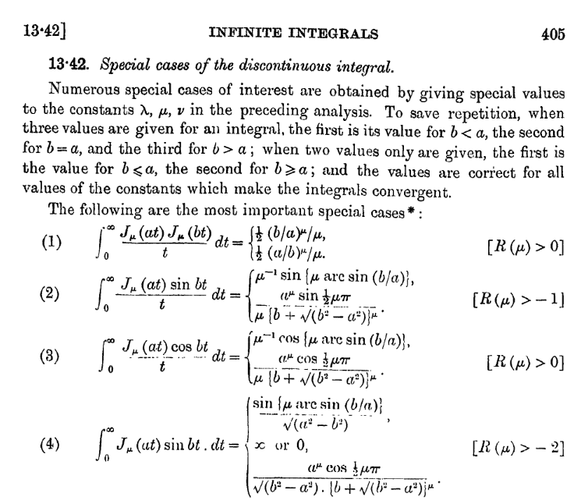
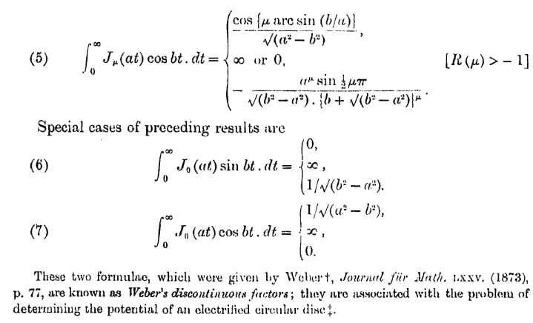
You might wonder where the sin and cos functions are coming from in these special cases. The answer is that they are part of the J1/2 and J-1/2 functions. According to Maple

J1/2(x) = $\sqrt{2/π}$ sin(x)/$\sqrt{x}$ J-1/2(x) = $\sqrt{2/π}$ cos(x)/$\sqrt{x}$

I presume you will find discontinuous integrals outside the Bessel World, but inside it is where our interest lies right now, doing azisym problems in cylindricals.

4. The addition of a 1/x factor to the Weber integrals.

We can write out Watson's (2) above for μ = 0 to get

$^{\int_{0}^{∞}{}}$dx J0(ax) sin(bx) 1/x = sin-1(b/a) b < a // which are 2.1.15
$^{\int_{0}^{∞}{}}$dx J0(ax) sin(bx) 1/x = (π/2) a < b

and these are the ones quoted by Sneddon on page 28. As you let b increase with b ≤ a, you get the sin-1 function, but then as you go to b > a, the result sticks where it was at b = a. These results are harder to derive from scratch, but no doubt can be traced to the exact same phase idea (Sneddon gives a method). The discontinuity here is more gentle, and in fact it is really a discontinuity of the slope, not the value.
Notice what happens if we differentiate these two results wrt the parameter b:

∂b$^{\int_{0}^{∞}{}}$dx J0(ax) sin(bx) 1/x = ∂b sin-1(b/a) b < a
∂b $^{\int_{0}^{∞}{}}$dx J0(ax) sin(bx) 1/x = ∂b (π/2) a < b
or
$^{\int_{0}^{∞}{}}$dx J0(ax) cos(bx) = 1/$\sqrt{1-(b/a)2}$* (1/a) = 1/$\sqrt{a2-b2}$ b < a
$^{\int_{0}^{∞}{}}$dx J0(ax) cos(bx) = 0 a < b

and this just duplicates what we found above (with a↔b). ( You cannot however just integrate the previous results to get these 1/x ones because you don't know the integration constant, but the results are consistent with each other. )
The corresponding integrals with cos(bx) in place of sin(bx) diverge at the x=0 endpoint, so we don't consider them.
What happens if we differentiate our original integrals these wrt a? We know that

∂zJ0(z) = ∂z[z-0J0(z)] = - z-0J1(z) = - J1(z) => ∂a J0(ax) = - x J1(z)

so this would add a factor of x to the integrand and they would then not converge. However, suppose we start with our 1/x results which were

$^{\int_{0}^{∞}{}}$dx J0(ax) sin(bx) 1/x = sin-1(b/a) b < a
$^{\int_{0}^{∞}{}}$dx J0(ax) sin(bx) 1/x = (π/2) a < b

Then apply ∂a to both sides and we get

$^{\int_{0}^{∞}{}}$dx J1(ax) sin(bx) = - ∂asin-1(b/a) b < a
$^{\int_{0}^{∞}{}}$dx J1(ax) sin(bx) = - ∂a (π/2) a < b

But
- ∂asin-1(b/a) = - 1/$\sqrt{1-(b/a)2}$ * ∂a(ba-1) = - 1/$\sqrt{1-(b/a)2}$ * b (-a-2) = 1/$\sqrt{a2-b2}$ (b/a)

Thus we conclude that

$^{\int_{0}^{∞}{}}$dx J1(ax) sin(bx) = (b/a) / $\sqrt{a2-b2}$ b < a // which are 2.1.16
$^{\int_{0}^{∞}{}}$dx J1(ax) sin(bx) = 0 a < b

Resuming our general Sneddon notes on page 28

[28] The Weber integrals topic continues, and we get the sine one with 1/k as 2.1.15, also discussed above. Then Sned talks about the general dual J discontinuous integral formula associated with the name Schafheitlin, Sonine and Weber which also commented on already above.

[29] Sned then takes a special case 2.1.19 of this big Schafheitlin monster which is a J J times a power. The evaluation of this integral is given in terms of Sned's "shifted Jacobi polynomial" . He does not call it this, and I learned about it in the following side trip notes:

Comment on Jacobi Polynomials, the Shifted Jacobi Polynomials, and the A&S G function

This comment relates to a function appearing in Sneddon page 29 equation 2.1.21. [ When I wrote this, I did not know Sned has a section later on for the Jacobi stuff.] Wiki makes these definitions and claims

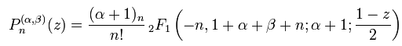

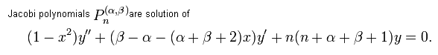
I have never had to use these polynomials for some reason. Wolfram again points out the connection to the rotation group as shown above, and says the "top" problem uses them, though Goldstein did not need them. Perhaps anything that uses all three Euler angles would be relevant.
My Erdelyi notes on orthogonals show that these Jacobi things are a huge chunk of all the "classical orthogonal polys", and various familiar polys are special cases, including the Legendres and the fats and the Gegenbauers. We are not talking general functions, we are talking polys here.

GR7 has this to say, no doubt the same as the above,

A&S don't give the F form, but they seem to have things normalized the same as GR7. Assuming this is the case, A&S relates these to another set of "Jacobi" polynomials which they call

Gn(p,q,x) ≡ n! Γ(n+p)/Γ(2n+p) * Pn(p-q,q-1)(2x-1)

As x ranges on [0,1], the argument 2x-1 ranges on [-1,1]. So G has the compressed range [0,1]. We can write

Pn(α,β)(x) = (-1)n Γ(n+1+β)/[ n! Γ(1+β) ] * F(n+α+β+1,-n; 1+β; (1+x)/2)

which we can now evaluate at the parameters shown

Pn(p-q,q-1)(x) = (-1)n Γ(n+1+q-1)/[ n! Γ(1+q-1) ] * F(n+(p-q)+q-1+1,-n; 1+q-1; (1+x)/2)

= (-1)n Γ(n+q)/[ n! Γ(q) ] * F(n+p,-n; q; (1+x)/2)

Then

Pn(p-q,q-1)(2x-1) = (-1)n Γ(n+q)/[ n! Γ(q) ] * F(n+p,-n; q; x)

Finally,

Gn(p,q,x) = n! Γ(n+p)/Γ(2n+p) * Pn(p-q,q-1)(2x-1)

= n! Γ(n+p)/Γ(2n+p) * (-1)n Γ(n+q)/[ n! Γ(q) ] * F(n+p,-n; q; x)

= Γ(n+p)/Γ(2n+p) * (-1)n Γ(n+q)/[ Γ(q) ] * F(n+p,-n; q; x)

= (-1)n Γ(n+p) Γ(n+q) /[Γ(2n+p) Γ(q) ] * F(n+p,-n; q; x)

= (-1)n Γ(n+p) Γ(n+q) /[Γ(2n+p) Γ(q) ] * Fn(p,q; x)

where this script function is what appears in Sneddon page 29. Let's then go the other way,

Gn(p,q,x) = (-1)n Γ(n+p) Γ(n+q) /[Γ(2n+p) Γ(q) ] * Fn(p,q; x)

Fn(p,q; x) = (-1)n Γ(2n+p) Γ(q) / [Γ(n+p) Γ(n+q)] * Gn(p,q,x)

= (-1)n Γ(2n+p) Γ(q) / [Γ(n+p) Γ(n+q)] * n! Γ(n+p)/Γ(2n+p) Pn(p-q,q-1)(2x-1)

= (-1)n Γ(2n+p) Γ(q) / [Γ(n+p) Γ(n+q)] * n! Γ(n+p)/Γ(2n+p) * Pn(p-q,q-1)(2x-1)

= (-1)n Γ(q) / Γ(n+q) * n! Pn(p-q,q-1)(2x-1)

You see on the web various mentions of "shifted Jacobi polynomials", and this is more or less what they mean. This phrase does not seem to define a standardized function, people differ in the constant out front. If I need to deal with these things, I can use the Gn(p,q,x) form given by A&S. Of course the F statement is a complete definition.

Hankel [29,30] The next section concerns the (symmetric) Hankel transform and the "modified Hankel transform" as defined by Erdelyi and Kober in 1949. I discuss this section in a separate 12 page doc called "Hankel and Modified Hankel Transforms, as per Sneddon".doc because there are various notational issues I had to get understood. I explain why each of the four notations is useful and why the {...} notation is in fact essential when functions (or factors of functions) have no name. Here are the four notations:

1 2 3 4
Fν = Cνf Fν(x) = Cν{f(s); x} Fν(x) = Cν f(x) Fν(x) = [Cνf] (x)
[Fν]x = [Cνf]x s = dummy variable

Suppose f(s) = s2. In this case, all but the notation 2 are clumsy at best. I tend to use notations 1 and 4 where possible to show basic matrix/vector algebra. Sneddon uses notations 2 and 3 randomly. Notation 3 is really just a sloppy version of notation 4. Quantum mechanics would say <x| Fν> = <x | Cν | f > and in particular [Cν]xy = <x | Cν | y >.

Here are some of the key ideas of this Hankel section:

The Regular (non-symmetric) Hankel Transform and idea of matrix versus script "operators" :

Fν(μ) = $^{\int_{0}^{∞}{}}$dx xJν(μx) f(x) f(x) = $^{\int_{0}^{∞}{}}$dμ μJν(μx) Fν(μ)
Fν(μ) = $^{\int_{0}^{∞}{}}$dx Cν(μ,x) f(x) f(x) = $^{\int_{0}^{∞}{}}$dμ Cν(x,μ) Fν(μ)

Cν(μ,x) = xJν(μx) Cν(x,μ) = μJν(μx)

Fν = Cνf f = CνF ν Cν = a matrix op

Cν2 = 1 Cν = Cν-1 Cν ≠ CνT
Cν2 = 1 Cν = Cν-1

Fν = Cνf f = CνF ν
Fν(μ) = Cν{f(s); μ} f(x) = Cν{Fν(s);x } s = "dummy variable"

Sned and I use various notations: Cν{f(s); μ} = [Cνf]μ = [Cνf](μ) = Cν f(μ) = <μ | Cν | f >
[Cν]αβ = <α | Cν | β >

Cν is an abstract operator in Hilbert space which acts on a vector to make another vector.
Cν is an ∞ x ∞ matrix of real numbers.

Product done in script operator notation:

AB { f(r); μ} ≡ A{ B{ f(r); s } ; μ}
(AB)f = A (Bf)

The Symmetric Regular Hankel Transform : (my doc uses K in place of H, Sned uses H )

Fν(μ) = $^{\int_{0}^{∞}{}}$dx (xμ)1/2Jν(μx)f(x) f(x) = $^{\int_{0}^{∞}{}}$dμ (xμ)1/2Jν(μx) Fν(μ)
Fν(μ) = $^{\int_{0}^{∞}{}}$dx Hν(μ,x) f(x) f(x) = $^{\int_{0}^{∞}{}}$dμ Hν(x,μ)Fν(μ)

Hν(μ,x) = (xμ)1/2Jν(μx) Hν(x,μ) = (xμ)1/2Jν(μx)

Fν = Hν f f = Hν Gν Hν = a matrix op

Hν2 = 1 Hν = Hν-1 and now also: Hν = HνT
Hν2 = 1 Hν = Hν-1

Fν = Hνf f = HνF ν
Fν(μ) = Hν{f(s); μ} f(x) = Hν{Fν(s);x } s = "dummy variable"

The Modified Hankel Transform: Sη,α f(μ): // can write Sη,α f(u) = [Sη,α f](u)

Fη,α(μ) = 2α μ-α $^{\int_{0}^{∞}{}}$dx x1-α J2η+α(μx) f(x) = Sη,α { f(r); μ } = Sη,α f(u)
f(x) = 2-α xα $^{\int_{0}^{∞}{}}$dμ μ1+α J2η+α(μx) Fη,α(μ) = Sη+α,-α { Fη,α(r); x } = Sη+α,-α Fη,α(x)

1 = Sη+α,-α Sη,α // for matrix ops
1 = Sη+α,-α Sη,α // for script ops

Sη,α { f(s); μ } = 2α μ-1/2-α H2η+α{ s1/2-α f(s); μ } // how S and H are related
or
H2η+α{ s1/2-α f(s); μ } = 2-α μ1/2+α Sη,α { f(s); μ }

Lest this seem vague, let's just write things out one more time

Sη,α { f(r); μ } = 2α μ-α $^{\int_{0}^{∞}{}}$dx x1-α J2η+α(μx) f(x)

= 2α μ-α $^{\int_{0}^{∞}{}}$dx x J2η+α(μx) [ f(x) x-α]

which shows that this modified thing is just a multiple of the non symmetric Hankel where we redefine the function we are transforming, and ν = 2η+α. Of course this then can be related to the symmetric Hankel as shown above. So the "modified Hankel" is nothing new, it is just a way to write the Hankel transform that "fits" with the needs to arise later.

He then gets into the fairly complicated:

Sonine's first and second integrals. This leads to a battery of fancy definite integrals on page 31. These have as integrands: one or two Bessel J (sometimes of unusual arguments), trigs, powers of t2±z2, and regular powers. Some integrals have fixed endpoints, others are Volterra-like.

[31] We are now at the bottom of this page, writing the Smythian form p 31 A for the potential. He has a typo here, he meant to have t1-2α as the factor used to redefine the coefficient. It is then not hard to show that you can rewrite the Smythian Form as shown in 2.1.35 [ see my doc op cit Section 6A ] , and the next two equations are also verified there. Basically this says you are representing the potential V as an integral representation with coefficient function ψn(t)e-zt in the integrand, and that integral representation is in fact just a (modified) Hankel transform with certain values for the parameters on Sη,α defined above.

[32] He then gives something related to a subject I skipped in the first chapter, and then he wraps up with two very fancy integrals. I will at least write them out one time, where I put things in an order that matches the indices, sort of:

Kν,α,β,γ(ρ,t;a) = $^{\int_{0}^{∞}{}}$ dy [ Kν(ay) / Iν(ay)] Iα(ρy) Iβ(ty) y1+γ

The other monster of interest is this:

K*ν,H,β,γ,δ(u,v) = $^{\int_{0}^{∞}{}}$ dy [(y K'ν(y) + HKν(y)) / (y I'ν(y) + HIν(y))] Iβ(uy) Iγ(vy) y1+δ

He talks about convergence and some relations where you apply ∂ρ or ∂u to these things. Right now I just cannot imagine in what context these monsters might appear.

Comment: As the problems get harder, and the integral equations messier, I can imagine how you might want to have more powerful notation to represent your integral operators. Perhaps you can manipulate just these operators rather than the integrals, and find a solution; then when you are done, you write it all out. That must be why he is jamming all this incredibly off-putting stuff into this support chapter, so he doesn't have to do it later when we are in the thick of solving some problem.

2.2 Infinite Series involving Bessel functions. [ 33]

We did integrals above, so we might as well do sums. He starts with a pretty general looking sum

Sν,α,β,γ(ρ,t;a) = (2/a2) Σn λnγ Jα(ρλn) Jβ(tλn) / Jν+12(aλn)

where the λn are such that Jν(aλn) = 0 so if βn are the usual zeros of Jν, then we have λn = βn/a = 1/L dimension. Some special cases are called s1 and s2 , and I see that Sneddon was an author on some of this detail work. We see s1 and s2 stated in terms of the above S object. He then defines a similar but different sum S* in 2.2.6 where now the μn are "radiation equation" solutions 2.2.7. He next seems to be converting the sum S to an integral 2.2.9 (2.2.10 for S*) which he can then evaluate in some cases as one of those also-horrible K integrals introduced at the end of the last section. This long 7 page section is just too detailed for me now, I have no motivation to slog through it, but I am happy to have data on such series. Probably GR7 has the same data. Sned however is showing how you derive some of these things. The Fourier-Bessel transform appears on page 37-38 with λn as zeros of Jν, and in fact some conditions are given for application of this transform (which is in my transforms.doc). I have notes later on the p 39 bottom Dini series stuff (Chap 5).

2.3 Some Remarks on Integral Equations. [40]

This is far more interesting to me right now, since I have battled integral equations in electrostatics for a while now. At the end of section (b) I summarize the two Srivastav results.

(a) Srivastav's First Result ( x is upper endpoint)

In 1963 Srivastav managed to handle a large class of integral equation forms all at once, and I think that may be all that Sned needs for this book. In the following, h(t) can be any monotonic increasing in [a,b] :

$^{\int_{a}^{x}{}}$dt f(t) / [h(x)-h(t)]α = g(x) interval for x,t is [a,b] interval for α is (0,1)
or
$^{\int_{a}^{u}{}}$dt f(t) / [h(u)-h(t)]α = g(u) // for use below!

This is an integral equation, we are given g(x) [ and h(t) ] and want to find f(t). Off hand I suppose you could expand the second factor using the binomial expansion, but that would give some horrible polynomial in h(x) being equal to g(x), not very useful. You could change variable from t to h(t). Let's see what he does. As usual, some a priori knowledge is used! We are told to "consider" the following integral

I(x) = $^{\int_{a}^{x}{}}$du h'(u)g(u) / [h(x)-h(u)]1-α

Plug in from above for g(u) and see what happens:

I(x) = $^{\int_{a}^{x}{}}$du h'(u){ $^{\int_{a}^{u}{}}$dt f(t) / [h(u)-h(t)]α } / [h(x)-h(u)]1-α

= $^{\int_{a}^{x}{}}$du$^{\int_{a}^{u}{}}$dt F(u,t,x,α) = ∫lower triangle du dt F(u,t,x,α)

where the "lower triangle" is the one in gray in these drawings, and where the integration shown above corresponds to the left drawing:

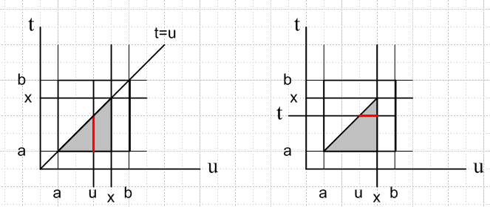

We can cover the same triangle by integrating as shown in the right drawing, which would be written this way

$^{\int_{a}^{x}{}}$dt$^{\int_{t}^{x}{}}$du F(u,t,x,α)

So using this fact, we then find that

I(x) = $^{\int_{a}^{x}{}}$du h'(u){ $^{\int_{a}^{u}{}}$dt f(t) / [h(u)-h(t)]α } / [h(x)-h(u)]1-α

= $^{\int_{a}^{x}{}}$du$^{\int_{a}^{u}{}}$dt h'(u) f(t) / { [h(u)-h(t)]α [h(x)-h(u)]1-α }

= $^{\int_{a}^{x}{}}$dt$^{\int_{t}^{x}{}}$du h'(u) f(t) / { [h(u)-h(t)]α [h(x)-h(u)]1-α }

= $^{\int_{a}^{x}{}}$dt f(t)$^{\int_{t}^{x}{}}$du h'(u) / { [h(u)-h(t)]α [h(x)-h(u)]1-α }

Consider now the inner integral which we will call J :

J ≡ $^{\int_{t}^{x}{}}$du h'(u) 1/{ [h(u)-h(t)]α [h(x)-h(u)]1-α} ≡ Q(t,x,α) x > t

Let y = h(u) and dy = h'(u)du so this becomes

J = $^{\int_{h(t)}^{h(x)}{}}$dy 1/{ [y-h(t)]α [h(x)-y]1-α} h(x) > h(t) since monotonic!

Let A = h(t) and B = h(x) so that B > A, and this integral is

J = $^{\int_{A}^{B}{}}$dy 1/{ [y-A]α [B-y]1-α}

Now change variables again so that z = y-A to get

J = $^{\int_{0}^{B-A}{}}$dz 1/{ [z]α [(B-A)-z]1-α} = $^{\int_{0}^{B-A}{}}$dz z-α [(B-A)-z]α-1

And change variables yet again so that w = z/(B-A) to get

J = $^{\int_{0}^{1}{}}$(B-A)dw [(B-A)w]-α [(B-A)-(B-A)w]α-1

= (B-A)1-α+α-1 $^{\int_{0}^{1}{}}$ dw w-α(1-w)α-1

= $^{\int_{0}^{1}{}}$ dw w-α(1-w)α-1 = B(1-α,α) if 1-α>0 and α>0 // Schaum page 103

= Γ(1-α)Γ(α) = π csc(πα) // PL gamma page

Notice that the conditions 1-α > 0 and α > 0 mean α > 0 and α < 1 so must have 0 < α < 1, one of our starting assumptions. Otherwise the beta integral diverges at one end or the other.

So the fascinating fact is that the integral J appears to be a function of x and t as well as α, but in fact is only a function of α due to the scaling of the factors, as shown above.

Therefore we have found that

I(x) = $^{\int_{a}^{x}{}}$dt f(t) { π csc(πα)} = π csc(πα) $^{\int_{a}^{x}{}}$dt f(t)

=> ∂x I(x) = π csc(πα) f(x)

so we have now "isolated" f(x) which is the thing we are trying to solve for! Recall that

I(x) = $^{\int_{a}^{x}{}}$du h'(u)g(u) / [h(x)-h(u)]1-α

so we have shown then that

f(x) = π-1sin(πα) ∂x { $^{\int_{a}^{x}{}}$du h'(u)g(u) / [h(x)-h(u)]1-α } // which is 2.3.2

and we have thus solved our original integral equation, which was this:

$^{\int_{a}^{x}{}}$dt f(t) / [h(x)-h(t)]α = g(x) interval for x,t is [a,b] interval for α is (0,1)

Remember this is valid for ANY monotonic increasing function h(x). A very nice result. I'm impressed.

(b) Srivastav's Second Result (x is lower endpoint)

Now thanks to cut and paste, I can redo the above, but for the second configuration of endpoints. Start now with this integral equation [ note in the bracket that the integration variable now comes first ]

$^{\int_{u}^{b}{}}$dt f(t) / [h(t)-h(x)]α = g(u) // which is 2.3.3

Consider

I(x) = $^{\int_{x}^{b}{}}$du h'(u)g(u) / [h(u)-h(x)]1-α

Plug in from above for g(u) and see what happens:

I(x) = $^{\int_{x}^{b}{}}$du h'(u){ $^{\int_{u}^{b}{}}$dt f(t) / [h(t)-h(u)]α } / [h(u)-h(x)]1-α

= $^{\int_{x}^{b}{}}$du$^{\int_{u}^{b}{}}$dt F(u,t,x,α) = ∫upper triangle du dt F(u,t,x,α)

This time the pictures look like this

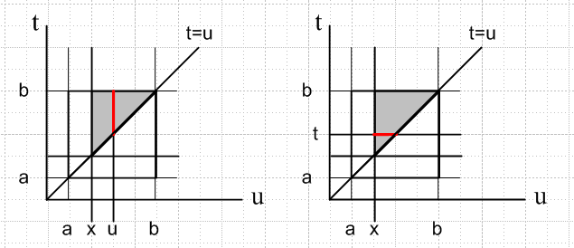

so we can write our integral this way

$^{\int_{x}^{b}{}}$dt$^{\int_{x}^{t}{}}$du F(u,t,x,α)

and we then have

I(x) =$^{\int_{x}^{b}{}}$dt f(t) $^{\int_{x}^{t}{}}$du h'(u) / { [h(t)-h(u)]α [h(u)-h(x)]1-α }

Consider now the inner integral, and let's just brute-force do what we did before, with apropos edits:

J ≡ $^{\int_{x}^{t}{}}$du h'(u) 1/{ [h(t)-h(u)]α [h(u)-h(x)]1-α} t > x

Let y = h(u) and dy = h'(u)du so this becomes

J = $^{\int_{h(x)}^{h(t)}{}}$dy 1/{ [-y+h(t)]α [-h(x)+y]1-α} h(t) > h(x) since monotonic!

Let A = h(x) and B = h(t) so that B > A, and this integral is

J = $^{\int_{A}^{B}{}}$dy 1/{ [-y+B]α [-A+y]1-α}

Now change variables again so that z = -y+B to get

J = $^{\int_{0}^{B-A}{}}$dz 1/{ [z]α [(B-A)-z]1-α} = $^{\int_{0}^{B-A}{}}$dz z-α [(B-A)-z]α-1

And change variables yet again so that w = z/(B-A) to get

J = $^{\int_{0}^{1}{}}$(B-A)dw [(B-A)w]-α [(B-A)- (B-A)w]α-1

= (B-A)1-α+α-1 $^{\int_{0}^{1}{}}$ dw w-α(1-w)α-1

= $^{\int_{0}^{1}{}}$ dw w-α(1-w)α-1 = B(1-α,α) if 1-α>0 and α>0 // Schaum page 103

= Γ(1-α)Γ(α) = π csc(πα) // PL gamma page

so this J comes out being the exact same as the last J. Therefore we have found that

I(x) = $^{\int_{x}^{b}{}}$dt f(t) { π csc(πα)} = π csc(πα) $^{\int_{x}^{b}{}}$dt f(t)

=> ∂x I(x) = – π csc(πα) f(x)

where the minus sign appears because now x is the lower endpoint, before it was the upper.

Recall that

I(x) = $^{\int_{x}^{b}{}}$du h'(u)g(u) / [h(x)-h(u)]1-α

so we have shown then that

f(x) = – π-1sin(πα) ∂x { $^{\int_{x}^{b}{}}$du h'(u)g(u) / [h(u)-h(x)]1-α } // which is 2.3.4

and we have thus solved our original integral equation, which was this (2.3.3)

$^{\int_{x}^{b}{}}$dt f(t) / [h(t)-h(x)]α = g(x) interval for x,t is [a,b] interval for α is (0,1)

Remember this is valid for ANY monotonic increasing function h(x). A very nice result. QED.

So here then is a summary of the two Srivastav results

S1: $^{\int_{a}^{x}{}}$dt f(t) / [h(x)-h(t)]α = g(x) interval for x,t is [a,b] interval for α is (0,1)
=> f(t) = π-1sin(πα) ∂t { $^{\int_{a}^{t}{}}$du h'(u)g(u) / [h(t)-h(u)]1-α } // which is 2.3.2

S2: $^{\int_{x}^{b}{}}$dt f(t) / [h(t)-h(x)]α = g(x) interval for x,t is [a,b] interval for α is (0,1)
=> f(t) = – π-1sin(πα) ∂t { $^{\int_{t}^{b}{}}$du h'(u)g(u) / [h(u)-h(t)]1-α } // which is 2.3.4

(c) Special cases of Srivastav's two results

A. Let h(u) = 1 - cos(u) on (0,π) // You can see that this meets the monotonic requirement

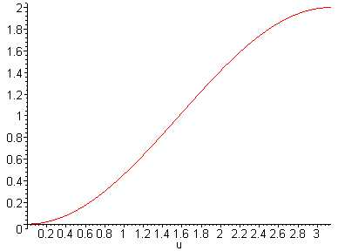

h(x)-h(t) = cos(t) - cos(x)
h'(u) = sin(u)

We can take our interval to (a,b) to be any subinterval of (0, π), and we get

S1: $^{\int_{a}^{x}{}}$dt f(t) / [cos(t) - cos(x)]α = g(x)
=> f(t) = π-1sin(πα) ∂t { $^{\int_{a}^{t}{}}$du sin(u)g(u) / [cos(u) - cos(t)]1-α }

S2: $^{\int_{x}^{b}{}}$dt f(t) / [cos(x) - cos(t)]α = g(x)
=> f(t) = – π-1sin(πα) ∂t { $^{\int_{t}^{b}{}}$du sin(u)g(u) / [cos(t) - cos(u)]1-α }

Now further specialize to α = 1/2 to get

S1: $^{\int_{a}^{x}{}}$dt f(t) / [cos(t) - cos(x)]1/2 = g(x)
=> f(t) = π-1 ∂t { $^{\int_{a}^{t}{}}$du sin(u)g(u) / [cos(u) - cos(t)]1/2 } // which are 2.3.5

S2: $^{\int_{x}^{b}{}}$dt f(t) / [cos(x) - cos(t)]1/2 = g(x)
=> f(t) = – π-1 ∂t { $^{\int_{t}^{b}{}}$du sin(u)g(u) / [cos(t) - cos(u)]1/2 } //which are 2.3.6

B. Let h(u) = u2 on the positive real axis [ claim is that this h(u) is the one Abel used! ]

h(x)-h(t) = x2 - t2
h'(u) = 2u

The interval can be any interval (a,b) on the positive real axis, say. Then

S1: $^{\int_{a}^{x}{}}$dt f(t) / [x2 - t2]α = g(x) interval for x,t is [a,b]
=> f(t) = (2/π)sin(πα) ∂t { $^{\int_{a}^{t}{}}$du u g(u) / [t2- u2]1-α } // which are 2.3.7

S2: $^{\int_{x}^{b}{}}$dt f(t) / [t2 - x2]α = g(x) interval for x,t is [a,b]
=> f(t) = – (2/π) sin(πα) ∂t { $^{\int_{t}^{b}{}}$du u g(u) / [u2- t2]1-α } // which are 2.3.8

Now further specialize to α = 1/2 to get

S1: $^{\int_{a}^{x}{}}$dt f(t) / [x2 - t2]1/2 = g(x) interval for x,t is [a,b]
=> f(t) = (2/π)∂t { $^{\int_{a}^{t}{}}$du u g(u) / [t2- u2]1/2 }

S2: $^{\int_{x}^{b}{}}$dt f(t) / [t2 - x2]1/2 = g(x) interval for x,t is [a,b]
=> f(t) = – (2/π) ∂t { $^{\int_{t}^{b}{}}$du u g(u) / [u2- t2]1/2 }

Historical Note. It is clear we can replace squared variables with unsquared ones in the above. This is how you get the "official" Abel integral equation and its solution, I quote from Polyanin's site: (ie, this is just S1 above) [ I derive this below ]

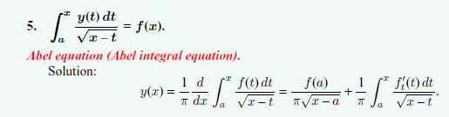

Polyanin also gives a "generalized Abel" as follows:

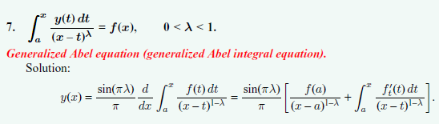

NOTE: See Appendix A concerning the rightmost forms shown above.

Again, this is just our previous S1 (α = λ) transcribed. Notice that these are all Fred 1 integral equations in which the function y(t) appears only inside the integral. We know there are Fred 2 equations related to this. Polyanin then has his Abel of the second kind and generalized Abel of the second kind.

I will derive the Abel equation right now from the general Srivastav solution, and then below in section (d) I will derive the generalized Abel using the Laplace Transform method!

Proof of Abel. The math to do the above change is tricky, so I will do it right here in line. There are many steps. Start with the S1 result:

S1: $^{\int_{a}^{x}{}}$dt f(t) / [x2 - t2]1/2 = g(x) interval for x,t is [a,b]
=> f(t) = (2/π)∂t { $^{\int_{a}^{t}{}}$du u g(u) / [t2- u2]1/2 }

Start with the first line only. Change variables to t' = t2 and dt' = 2tdt = 2$\sqrt{t'}$dt so dt = dt'/(2$\sqrt{t'}$). The first line then reads:

$^{\int_{a2}^{x2}{}}$dt'/(2$\sqrt{t'}$)f($\sqrt{t'}$) / [x2 -t']1/2 = g(x)

Now replace x2 by x everywhere, and replace a2 by α

$^{\int_{α}^{x}{}}$dt'/(2$\sqrt{t'}$)f($\sqrt{t'}$) / [x -t']1/2 = g($\sqrt{x}$)

and finally remove the dummy prime to get

$^{\int_{α}^{x}{}}$dt/(2$\sqrt{t}$)f($\sqrt{t}$) / [x -t]1/2 = g($\sqrt{x}$)

Now define a new functions y(t) ≡ f($\sqrt{t}$)/(2$\sqrt{t}$) and F(x) ≡ g($\sqrt{x}$) and we then have

$^{\int_{α}^{x}{}}$dt y(t)[x -t]1/2 = F(x)

Now we turn to the second line in the S1: above. Change variables to u' = u2 and du' = 2udu = 2$\sqrt{u'}$du so du = du'/(2$\sqrt{u'}$). The second line then reads:

f(t) = (2/π)∂t { $^{\int_{a2}^{t2}{}}$ du'/(2$\sqrt{u'}$) $\sqrt{u'}$ g($\sqrt{u'}$) / [t2- u']1/2 }

Now recall that dt = dt'/(2$\sqrt{t'}$) which means 1/dt = (2$\sqrt{t'}$)/dt' = (2t/dt') which means ∂t = 2t ∂t' which means ∂t = 2t ∂(t2). So write the above as

f(t) = (2/π) 2t ∂(t2) { $^{\int_{a2}^{t2}{}}$ du'/(2$\sqrt{u'}$) $\sqrt{u'}$ g($\sqrt{u'}$) / [t2- u']1/2 }

Now replace t by $\sqrt{t}$ everywhere to get

f($\sqrt{t}$) = (2/π) 2$\sqrt{t}$ ∂t { $^{\int_{a2}^{t}{}}$ du'/(2$\sqrt{u'}$) $\sqrt{u'}$ g($\sqrt{u'}$) / [t- u']1/2 }

Next, replace u' by u and a2 by α and cancel $\sqrt{u'}$ and move out the 1/2

f($\sqrt{t}$) = (2/π) $\sqrt{t}$ ∂t { $^{\int_{α}^{t}{}}$ du g($\sqrt{u}$) / [t- u]1/2 }

Multiply both sides by 1/(2$\sqrt{t}$) to get

f($\sqrt{t}$)/(2$\sqrt{t}$) = (2/π)(1/2) ∂t { $^{\int_{α}^{t}{}}$ du g($\sqrt{u}$) / [t- u]1/2 }

We then sub in from above to get

y(t) = (1/π) ∂t { $^{\int_{α}^{t}{}}$ du F(u) / [t- u]1/2 }

Now replace t with x

y(x) = (1/π) ∂x { $^{\int_{α}^{x}{}}$ du F(u) / [x- u]1/2 }

and then replace u with t

y(x) = (1/π) ∂x { $^{\int_{α}^{x}{}}$ dt F(t) / [x- t]1/2 }

Thus we have ended up with this transform: ( in very last step, rename F to be f)

$^{\int_{α}^{x}{}}$dt y(t)[x -t]1/2 = f(x)
y(x) = (1/π) ∂x { $^{\int_{α}^{x}{}}$ dt f(t) / [x- t]1/2 }

which we can compare with our quoted result above

Niels Henrik Abel (5 August 1802 – 6 April 1829) was a noted Norwegian mathematician^{[1]}

The Abel integral equation arose in Abel's solution of the generalized tautochrone problem (called Abel's Mechanical Problem). Imagine a frictionless bead sliding down a string having a 2D curved shape r(t). If arc length along the curve is s, then it has velocity ds/dt at any point. Suppose you want the time for the bead released at height y0 to reach the curve's lowest point to be some prescribed function T(y0). What curve r(t) will deliver this time function? As the wiki page shows, Abel had to solve this integral equation for the function ds/dy.

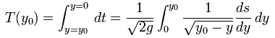

Once he obtained ds/dy, it is a standard calculus problem to deduce r(t). Abel's integral equation arises trivially from conservation of energy. The particular case T(y0) = T0 = constant, independent of y0, is the official tautochrone problem (same-time).
The above integral equation is Abel's Historical Equation. Notice it uses the upper Volterra endpoint y0, it has α = 1/2 for the power, and the variables inside the root are linear. Today, people I think allow that you might have either an upper or lower Volterra endpoint, and the variables inside the root might be squared instead of linear, and the power α might not be 1/2. In this latter case, some people call it the generalized Abel equation, but others (like Wolfram) just call it the Abel Transform. Here from Wolfram: (notice the interesting applications listed)
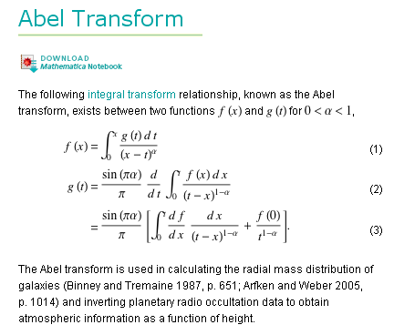
Wolfram goes on to show a different definition where now α = 1/2 and we have the lower Volterra endpoint and the variables are squared inside the root with compensating factor up top.

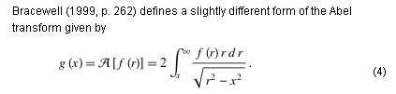
Wiki also points out that this integral equation is in fact a Laplace convolution equation (see below) so you can trivially solve it that way as well as by the general Srivastav method shown above. Abel died of TB (consumption) at age 27 -- in 1829, 8 years after Keats -- after a Christmas sled trip to visit his betrothed! He is also credited with inventing "group theory", perhaps hence non-Abelian gauge theory. Since Laplace transforms already existed (1785) it is not clear to me why this Abel equation is novel.

C. Let h(u) = u2 as before, but make these changes
(1) swap α with 1-α
(2) write f(t) = t2η+1F(t) * 2 / Γ(α)
(3) write g(x) = x2α+2η G(x)

[ This just puts things in a form Sned needs later. ] Then we get, copying from above and editing in our changes

S1: $^{\int_{a}^{x}{}}$dt t2η+1F(t) * 2 / Γ(α) [x2 - t2]α-1 = x2α+2η G(x)
=> t2η+1F(t) * 2 / Γ(α) = (2/π)sin(πα) ∂t { $^{\int_{a}^{t}{}}$du u u2α+2η G(u) / [t2- u2]α }

S2: $^{\int_{x}^{b}{}}$dt t2η+1F(t) * 2 / Γ(α) [t2 - x2] α-1 = x2α+2η G(x)
=> t2η+1F(t) * 2 / Γ(α) = – (2/π) sin(πα) ∂t { $^{\int_{t}^{b}{}}$du u u2α+2η G(u) / [u2- t2]α }

Now rearrange and then use Γ(α) Γ(1-α) = π/sin(πα) so that Γ(α) sin(πα)/π = 1/Γ(1-α) :

S1: 2 / Γ(α) * x-2α-2η $^{\int_{a}^{x}{}}$dt t2η+1F(t) [x2 - t2] α-1 = G(x)
=> F(t) = t-2η-1/Γ(1-α) * ∂t { $^{\int_{a}^{t}{}}$du u2α+2η+1 G(u) / [t2- u2]α } // which are 2.3.9 a=0

S2: 2 / Γ(α) * x-2α-2η $^{\int_{x}^{b}{}}$dt t2η+1F(t) [t2 - x2] α-1 = G(x)
=> F(t) = – t-2η-1/Γ(1-α) * ∂t { $^{\int_{t}^{b}{}}$du u2α+2η+1 G(u) / [u2- t2]α }

Now take S2 and replace η by -η-α and rewrite

S2: 2 / Γ(α) * x2η $^{\int_{x}^{b}{}}$dt t-2η-2α+1F(t) [t2 - x2] α-1 = G(x) // which are 2.3.10 b=∞
=> F(t) = – t2η+2α-1/Γ(1-α) * ∂t { $^{\int_{t}^{b}{}}$du u-2η+1 G(u) / [u2- t2]α }

(d) The Laplace method with a general kernel [ 42 bot ]

Here we look at the solution of a very particular form of an integral equation. And we are back to my favorite subject of diagonalization. Suppose we have, as in 2.3.12, (note Volterra sense)

G(u) = $^{\int_{0}^{u}{}}$ dτ K(u-τ)F(τ) // K and G are known, what is F ?

Apply $^{\int_{0}^{∞}{}}$du e-su to both sides to get , where I now use overbar for Laplace transform,

(s) = $^{\int_{0}^{∞}{}}$du e-su$^{\int_{0}^{u}{}}$ dτ K(u-τ)F(τ) = $^{\int_{0}^{∞}{}}$du$^{\int_{0}^{u}{}}$ dτ e-s K(u-τ)F(τ)

In u-τ space, this is an upper triangle integral, and we can rewrite it in this reordered form [ by the way, this is now item 2B.3 in my updated math misc doc "double sum and integral theorems.doc" ]

(s) = $^{\int_{0}^{∞}{}}$ dτ$^{\int_{τ}^{∞}{}}$du e-su K(u-τ)F(τ)

= $^{\int_{0}^{∞}{}}$ dτ e-sτ F(τ) $^{\int_{τ}^{∞}{}}$ du e-s(u-τ) K(u-τ) // now let w = u-τ

= $^{\int_{0}^{∞}{}}$ dτ e-sτ F(τ) $^{\int_{0}^{∞}{}}$ du e-sw K(w)

= (s) (s)

and there is your perfect diagonalization. The relevant group I suppose is T(1), but details are hazy right now regarding this endpoint. But you can see from the above that the Volterra endpoint is crucial to making it work. If we did it exactly as above, our solution to the integral equation would be

(s) = (s)/ (s)

F(t) = (2πi)-1 $^{\int_{c-i∞}^{c+i∞}{}}$ds est(s) = L-1{(s); t } = L-1{ (s)/ (s); t }

As a quick in-process example, suppose K(t) = t-α with α in (0,1). In this case

(s) = $^{\int_{0}^{∞}{}}$du e-su K(t) = $^{\int_{0}^{∞}{}}$du e-su t-α

For fun, we go look this up in ET I page 137 where we see

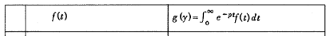
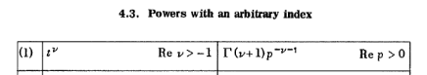

In our case, we have ν = -α and our condition is then that ν > -1 or -α > -1 or α < 1. We meet this condition, so all is well and we find that

(s) =$^{\int_{0}^{∞}{}}$du e-su t-α = Γ(1-α)/ s1-α α < 1

Now suppose over in s-space we define

(s) ≡ 1/(s) => (s) = (s) (s)

This would have a corresponding convolution equation which is this:

F(u) = $^{\int_{0}^{u}{}}$ dτ R(u-τ)G(τ)

So this looks like p 43A.
My question is: why does Sned add the factor of s which adds a derivative? Why not just use my result above? Well, consider in my example above

(s) = Γ(1-α)/ s1-α

(s) = 1/Γ(1-α) s1-α

We need to "come back" with our same ET I entry we used above in order to know R(t),

but now we have -ν-1 = 1-α so that ν = α-2 . To use this transform going back, we need ν > -1 which requires that α-2 > -1 which says α > 1. BUT this is out of our range! So we can't go back! That is the problem.
So let's see how we fix this problem. Instead of defining (s) as above, let's define instead

(s) = 1/[s (s)]

which will change the power by one unit. Then we have

(s) = (s)/ (s) and (s) = 1/[s (s)] => (s) = s (s) (s)

Now let the combination (s) (s) ≡ (s). Then we have

(s) = s (s)

and our Laplace rule tells us this means [ key fact: a derivative is appearing!! ]

F(t) = Q'(t) + Q(0)

But we know that (s) (s) ≡ (s) gives us a convolution equation Q(t) = $^{\int_{0}^{t}{}}$ dτ L(t-τ)G(τ) , and moreover, we have Q(0) = 0. Thus we find that

F(t) = ∂t $^{\int_{0}^{t}{}}$ dτ L(t-τ)G(τ) // which is Sned p 43 A

Now let's re-examine the problem we had. This time we have

(s) = 1/[s (s)] = [s (s)]-1 = [s Γ(1-α)/ s1-α]-1 = [sα Γ(1-α)]-1 = s-α/ Γ(1-α)

Now when we try to "come back" with this thing, we have -ν-1 = -α so ν = α-1 and our condition is that ν > -1 and that says α-1 > -1 or α > 0, which we meet! So now we CAN go back and we get

tν ↔ Γ(ν+1)s-ν-1

tα-1 ↔ Γ(α)s-α

tα-1 / Γ(α) ↔ s-α

tα-1 / [Γ(α) Γ(1-α)] ↔ s-α / Γ(1-α)

Therefore we find that [ recall that Γ(z+1)Γ(-z) = - π/sin(πz), and set z = -α ]

L(t) = tα-1 / [Γ(α) Γ(1-α)] = tα-1 sin(πα)/π

so in this example, our integral equation [ with K(t) = t-α with α in (0,1) ],

G(u) = $^{\int_{0}^{u}{}}$ dτ (u-τ)-αF(τ) // K and G are known, what is F ?

would have the solution

F(t) = ∂t $^{\int_{0}^{t}{}}$ dτ L(t-τ)G(τ) = - sin(πα)/π * ∂t $^{\int_{0}^{t}{}}$ dτ L(t-τ)G(τ)

= sin(πα)/π * ∂t $^{\int_{0}^{t}{}}$ dτ (t-τ)α-1G(τ)

OK, I get it. I will assume that when we move back to the squared coordinates, as in 2.3.11, we end up with the solution as shown in 2.3.17.
So, we have just derived the "generalized Abel transform" using the Laplace diagonalization method. We got this result:

G(u) = $^{\int_{0}^{u}{}}$ dτ (u-τ)-αF(τ) // K and G are known, what is F ?

F(t) = sin(πα)/π * ∂t $^{\int_{0}^{t}{}}$ dτ (t-τ)α-1G(τ)

Rewrite the above as

G(u) = $^{\int_{0}^{u}{}}$ dτ F(τ)/ (u-τ)α // K and G are known, what is F ?

F(t) = sin(πα)/π * ∂t $^{\int_{0}^{t}{}}$ dτ G(τ) / (t-τ)1-α

First change t to x in the second line, then replace τ with t everywhere, then u to x in the first line,
then rename F to be y, then rename G to be f, then change α to be λ

f(x) = $^{\int_{0}^{x}{}}$ dt y(t)/ (x-t)λ // K and G are known, what is F ?

y(x) = sin(πλ)/π * ∂x $^{\int_{0}^{x}{}}$ dt f(t) / (x-t)1-λ

which we can compare with our quote from above ( our Laplace definition gate us α = 0,

So, we have now derived the Generalized Abel transform using the Laplace diagonalization method. That method was not quite trivial due to the fact that we had to adjust with factor of s in order to have a reverse transform that existed!

Sneddon now does some special cases bottom p 43. The first is what I did above, K(t) = t-α with α in (0,1), and the integral equation and its solution replicates 2.3.7 which we already did. But we are now more general and can examine some brand new cases.
The first example is 2.3.18 which involves a kernel cos(k$\sqrt{x2-t2}$)/$\sqrt{x2-t2}$which I would say was pretty fancy, the solution is then 2.3.19. He then does the actual derivative (don't forget the endpoint contribution) and then I think does a parts integration which changes the sh back to ch, and that is why you need the extra condition. I did not do this detail, but it gives 2.3.20.

(e) The Williams 1962a Method

The integral equation we just treated above had this form

G(u) = $^{\int_{0}^{u}{}}$ dτ K(u-τ)F(τ)

where we have dependence through the Volterra endpoint as well as in the kernel. A more general integral equation is this one

G(u) = $^{\int_{0}^{a}{}}$ dτ K1(τ,u) F(τ)
or g(x) = $^{\int_{0}^{a}{}}$ dt f(t) K1(t,x)

This thing is more "complicated" because the fixed upper endpoint wrecks the Laplace diagonalization idea, and, moreover, the kernel is now an arbitrary function of two variables, not a function of a single difference variable, so Laplace is even more wrecked!
The answer is that, in general, you cannot analytically solve this equation for f(t). But you can recast it into the famous Second Kind Fredholm integral equation which is the one you can solve by the iterative Neumann / resolvent method, or a matrix method, etc etc. That recasting is the subject of this section. The recasting makes use of the exact Volterra integral equation solutions we developed up to this point. Let's see if we can at least state the "solution" algorithm. [ We start with the integral equation 2.3.21, and we end up with the Fred 2 integral equation 2.3.29 and things are a bit indirect! ]

This exotic piece of work is due to Williams 1962a, which was 4 years old with Sned published this book.
Here is an outline of how this all works:

(0) Our starting integral equation says g = K1f as shown 2.3.21. We are given g, we want to find f.

(1) First, we must find a kernel K0 which is a good approximation to our actual kernel K1. This will cause the difference function G = K1-K0 to be "small" as shown in 2.3.26.

(2) We then have to find another kernel K2 which meets two requirements: first, it has to satisfy 2.3.22 which involves K0 and three accessory functions hi(x); second, K2 must be a kernel that we somehow know ahead of time how to invert exactly. This means that given 2.3.23 or 24, we know how to write the solution f(t) as a function of g(t) for both endpoint cases. So before we even do much of anything, we have to do a search for five viable functions K0, K2 and the three hi(x).

(3) We next define a new kernel called L by 2.3.27 which says G = h1h3 ∫∫K2 K2L. By our assumption above about K2, we know how to invert this in each variable to get L = function of K2 and G and hi . So in theory then we have our new kernel L. Since G is "small" , L is also "small".

(4) We then mosh everything together and end up with a new Fred 2 integral equation 2.3.29 in which L is the kernel. The driving term g* comes from g by inverting 2.3.30 which again is K2. So we have to solve this Fred 2 as best we can for solution S(x). We do this by iteration since L is "small". The last step is to invert 2.3.28 go get f(t) from S(x) and we are done.

Later in Chapter 8 he does some exotic disk + other objects problems using this Williams method!

2.4 Fractional Integration Operators. [ p 46 ]

(a) Repeated Integrals

This is another obscure topic for sure. I have run into the subject of "fractional derivatives", but don't remember where that came up. I don't see that phrase in any of my math or physics notes. Well, yes, my transforms.doc mentions the "fractional calculus" because ET II has tables of forward and inverse transforms of this type, so I guess I will now learn a little about this for the first time ever, except I did read a little once on the web.

Start with

F1(x) = $^{\int_{0}^{x}{}}$dt f(t)

F2(x) = $^{\int_{0}^{x}{}}$dt F1(t) = $^{\int_{0}^{x}{}}$dt { $^{\int_{0}^{t}{}}$dt' f(t') }

The integration region is the lower-right triangle in t-t' (as x-y) space of the square (0,x)2, which can be rearranged in the usual manner (draw a quick scratch picture) so we have [ now my case 2A.1 in "double sum and integral theorems.doc" located in math/math misc ]

= $^{\int_{0}^{x}{}}$dt' $^{\int_{t'}^{x}{}}$dt f(t') = $^{\int_{0}^{x}{}}$dt' f(t') $^{\int_{t'}^{x}{}}$dt
= $^{\int_{0}^{x}{}}$dt' f(t') (x-t')

Next we have

F3(x) = $^{\int_{0}^{x}{}}$dt F2(t) = $^{\int_{0}^{x}{}}$dt {$^{\int_{0}^{t}{}}$dt' f(t') (t-t') } = $^{\int_{0}^{x}{}}$dt' f(t') $^{\int_{t'}^{x}{}}$dt (t-t')

=$^{\int_{0}^{x}{}}$dt' f(t') (1/2) (t-t')2|xt' = $^{\int_{0}^{x}{}}$dt' f(t') [(1/2) (x-t')2 - 0]

=(1/2!) $^{\int_{0}^{x}{}}$dt' f(t') (x-t')2

Next time we will have (1/3)( (x-t')2)|xt' = 1/3 (x-t')3 so we will get (1/3!) $^{\int_{0}^{x}{}}$dt' f(t') (x-t')3 , so the general rule seems clear:

Fn+1(x) = $^{\int_{0}^{x}{}}$dt Fn(t) = (1/n!) $^{\int_{0}^{x}{}}$dt' f(t') (x-t')n // which is p46A,B and 2.4.1

If we start with the other endpoint fixed we have

F1*(x) ≡ - $^{\int_{x}^{∞}{}}$dt f(t)

F2*(x) = - $^{\int_{x}^{∞}{}}$dt F1*(t) = - $^{\int_{x}^{∞}{}}$dt { - $^{\int_{t}^{∞}{}}$dt' f(t') } = (-1)2 $^{\int_{x}^{∞}{}}$dt$^{\int_{t}^{∞}{}}$dt' f(t')

The integration region is the upper-left triangle in t-t' (as x-y) space of the square (x,∞)2, which can be rearranged in the usual manner (draw a quick scratch picture) so we have [ result 2B.2 op cit ]

= (-1)2 $^{\int_{x}^{∞}{}}$dt' f(t') $^{\int_{x}^{t'}{}}$dt = (-1)2$^{\int_{x}^{∞}{}}$dt' f(t') (t'-x) = F2*(x) // fits formula

Next,

F3*(x) = - $^{\int_{x}^{∞}{}}$dt F2*(t) = - $^{\int_{x}^{∞}{}}$dt {$^{\int_{t}^{∞}{}}$dt' f(t') (t'-t)}

= - $^{\int_{x}^{∞}{}}$dt' f(t') $^{\int_{x}^{t'}{}}$dt (t'-t) = - $^{\int_{x}^{∞}{}}$dt' f(t') (1/2)(-1)(t'-t)2|t'x

= - $^{\int_{x}^{∞}{}}$dt' f(t') (1/2)(-1) [ 0 - (t'-x)2] = (-1)3 (1/2!) $^{\int_{x}^{∞}{}}$dt' f(t') (t'-x)2

= - (1/2!) $^{\int_{x}^{∞}{}}$dt' f(t') (t'-x)2

and I am off by a sign. I think his formula 2.4.2 is wrong, and the correct formula must be

Fn+1*(x) = (-1)n+1 (1/n!) $^{\int_{x}^{∞}{}}$dt' f(t') (t'-x)n

I will assume I am correct until I can find my error which is hiding from me, I am blocked from seeing it right now, so let it ride.

Try the induction and see what happens:

Induction with F*

Assume that this is true, as he states it.

Fn+1*(x) = (1/n!) $^{\int_{x}^{∞}{}}$dt' f(t') (t'-x)n
or
Fn+1*(t) = (1/n!) $^{\int_{t}^{∞}{}}$dt' f(t') (t'-t)n

Then want to show that this is true:

Fn+2*(x) = (1/(n+1)!) $^{\int_{x}^{∞}{}}$dt' f(t') (t'-x)n+1

We start using his iteration formula which is

Fn+2*(x) = – $^{\int_{x}^{∞}{}}$dt Fn+1*(t)

We then install our assumed Fn+1*(t),

= – $^{\int_{x}^{∞}{}}$dt {(1/n!) $^{\int_{t}^{∞}{}}$dt' f(t') (t'-t)n }

= – (1/n!) $^{\int_{x}^{∞}{}}$dt$^{\int_{t}^{∞}{}}$dt' [f(t') (t'-t)n]

We next reorder the integration pattern to get

= – (1/n!) $^{\int_{x}^{∞}{}}$dt'$^{\int_{x}^{t'}{}}$dt [f(t') (t'-t)n]

= – (1/n!) $^{\int_{x}^{∞}{}}$dt' f(t')$^{\int_{x}^{t'}{}}$dt (t'-t)n

= – (1/n!) $^{\int_{x}^{∞}{}}$dt' f(t')[ (1/(n+1))(-1) (t'-t)n+1]|t'x

= (-1)2 (1/(n+1)!) $^{\int_{x}^{∞}{}}$dt' f(t')[ (t'-t)n+1]|t'x

= (-1)2 (1/(n+1)!) $^{\int_{x}^{∞}{}}$dt' f(t')[ 0 - (t'-x)n+1 ]

= (-1)3(1/(n+1)!) $^{\int_{x}^{∞}{}}$dt' f(t') (t'-x)n+1

and this does NOT give his claimed result, it is off by a sign. Of course if I am erring, I am making the same mistake each time I do it because I am blinded to it. Oh well, time to move on, I will assume my result is correct. No errata noted on the web or in the book.

More on the sign problem with the F* stuff. It seems pretty clear that 46CLeft disagrees with 2.4.2 taken with n=0, so something is definitely wrong. Suppose we assume that both 46C equations have plus signs. Then what happens? I will redo the above induction with this assumption

Induction with F* Revisited

Assume that this is true, as he states it in 2.4.2

Fn+1*(x) = (1/n!) $^{\int_{x}^{∞}{}}$dt' f(t') (t'-x)n
or
Fn+1*(t) = (1/n!) $^{\int_{t}^{∞}{}}$dt' f(t') (t'-t)n

Then want to show that this is true:

Fn+2*(x) = (1/(n+1)!) $^{\int_{x}^{∞}{}}$dt' f(t') (t'-x)n+1

We start using his iteration formula which we now assume is this

Fn+2*(x) = + $^{\int_{x}^{∞}{}}$dt Fn+1*(t)

We then install our assumed Fn+1*(t),

= + $^{\int_{x}^{∞}{}}$dt {(1/n!) $^{\int_{t}^{∞}{}}$dt' f(t') (t'-t)n }

= + (1/n!) $^{\int_{x}^{∞}{}}$dt$^{\int_{t}^{∞}{}}$dt' [f(t') (t'-t)n]

Now consider op cit 2B.2 which says this (then I do a sequence of name changes)

2B.2 $^{\int_{x}^{∞}{}}$du$^{\int_{u}^{∞}{}}$dt F(u,t) = $^{\int_{x}^{∞}{}}$dt$^{\int_{x}^{t}{}}$du F(u,t) take t→t' :

2B.2 $^{\int_{x}^{∞}{}}$du$^{\int_{u}^{∞}{}}$dt' F(u,t') = $^{\int_{x}^{∞}{}}$dt'$^{\int_{x}^{t'}{}}$du F(u,t') take u → t:

2B.2 $^{\int_{x}^{∞}{}}$dt$^{\int_{t}^{∞}{}}$dt' F(t,t') = $^{\int_{x}^{∞}{}}$dt'$^{\int_{x}^{t'}{}}$dt F(t,t')

So we use this last result to reorder our integration to get

= (1/n!) $^{\int_{x}^{∞}{}}$dt'$^{\int_{x}^{t'}{}}$dt [f(t') (t'-t)n]

= (1/n!) $^{\int_{x}^{∞}{}}$dt' f(t')$^{\int_{x}^{t'}{}}$dt (t'-t)n

= (1/n!) $^{\int_{x}^{∞}{}}$dt' f(t')[ (1/(n+1))(-1) (t'-t)n+1]|t'x

= – (1/(n+1)!) $^{\int_{x}^{∞}{}}$dt' f(t')[ (t'-t)n+1]|t'x

= - (1/(n+1)!) $^{\int_{x}^{∞}{}}$dt' f(t')[ 0 - (t'-x)n+1 ]

= + (1/(n+1)!) $^{\int_{x}^{∞}{}}$dt' f(t') (t'-x)n+1

so we have shown then that

Fn+2*(x) = (1/(n+1)!) $^{\int_{x}^{∞}{}}$dt' f(t') (t'-x)n+1

and this is exactly what we want, so the induction proof is completed. So the fix is to get rid of those minus signs on line 46C! Then everything is just fine.

(b) The Riemann-Liouville fractional integral (aka Euler transform of the 1st kind)

OK, so we take our formula from above,

Fn+1(x) = (1/n!) $^{\int_{0}^{x}{}}$dt' f(t') (x-t')n

Fn(x) = (1/(n-1)!) $^{\int_{0}^{x}{}}$dt' f(t') (x-t')n-1

and we continue this off the integers to get

Fα(x) ≡ (1/Γ(α)) $^{\int_{0}^{x}{}}$dt' f(t') (x-t')α-1 = "Riemann Liouville fractional integral" = Rα{ f(t); x }

Sned then talks about how 6 or so other authors have variants of this thing, with varying fixed lower end points, and varying notation. Sned's notation is Fα(x) = Rα{ f(t); x } using his "general transform notation", where I guess R stands for Riemann.

Injected comment on inverting the above to find f(t). The equation above has the exact form of the Generalized Abel transform which we derived above using the Laplace method, here with α-1 = -λ.

What about the inverse of the Riemann transform? He does not explicitly state the result, but we can deduce it as follows. First, assume that we were to verify 2.4.9 which says this:

L { Rα{f(s); t} ;p } = p-α L {f(s); p } Re(α) > 0

where I have cleaned up his notation a bit, and where s and t are "dummy variables". It then seems pretty clear that

Rα{f(s); t} = L-1 { p-α L {f(s); p }; t }

In matrix notation I might write this as follows, where Λ is the diagonal matrix Λxy = x-α δxy ,

Rα = L-1 Λ L => Rα-1 = L-1 Λ-1 L

It would seem then that our inverse Riemann transform is this:

Rα-1{g(s); t} = L-1 { p+α L {g(s); p }; t }

so it is a known quantity. Of course there are always going to be "issues". This subject is mentioned in the Bateman ET II at the start of that section, but it is all in Russian!

What happens in the limit α → 0?

Rα{ f(t); x } = (1/Γ(α)) $^{\int_{0}^{x}{}}$dt' f(t') (x-t')α-1

This limit gives a 0 * ∞ situation. The ∞ comes from the upper end of this integration with 0-1 there. At the lower end we have x-1 there which is under control. There are two methods of getting the result we want:

(a) I think the trick is to first do a parts integration. Note that this is the standard thing you do to provide an analytic continuation of something to a place where your original form has convergence or limit problems. So,

$^{\int_{0}^{x}{}}$dt' f(t') (x-t')α-1 = $^{\int_{0}^{x}{}}$dt' f(t') ∂t' [ (-1/α) (x-t')α ]

= { f(t') [ (-1/α) (x-t')α ]}|x0 + (1/α) $^{\int_{0}^{x}{}}$dt' ∂t'f(t') (x-t')α

so we have

(1/Γ(α)) $^{\int_{0}^{x}{}}$dt' f(t') (x-t')α-1 = [ { f(t') [- (x-t')α ]}|x0 +$^{\int_{0}^{x}{}}$dt' ∂t'f(t') (x-t')α]/Γ(1+α)

= [ f(0) [ (x)α ] +$^{\int_{0}^{x}{}}$dt' ∂t'f(t') (x-t')α]/Γ(1+α)

= [ f(0) xα +$^{\int_{0}^{x}{}}$dt' ∂t'f(t') (x-t')α]/Γ(1+α)

Now take α → 0 and we get

= [ f(0) +$^{\int_{0}^{x}{}}$dt' ∂t'f(t') ] = f(0) + f(x) - f(0) = f(x)

Therefore we have shown that

limα→0 Rα{ f(t); x } = f(x) => R0 = 1 as shown in 2.4.11

(b) Here is an easier way. Go back to

Rα{ f(t); x } = (1/Γ(α)) $^{\int_{0}^{x}{}}$dt' f(t') (x-t')α-1

and we know everything comes from the upper endpoint, so we get

R0{ f(t); x } ≈ (1/Γ(α)) f(x) $^{\int_{0}^{x}{}}$ (x-t')α-1 = (1/Γ(α)) f(x) (-1/α) (x-t')α |x0

= (1/Γ(α)) f(x) (1/α) (x)α = 1/Γ(1+α) * f(x) xα = f(x)

Therefore R0 = 1 as shown in 2.4.11

(c) The Weyl fractional integral (aka Euler transform of the 2nd kind)

Similarly, we take the other form (my correction has been made now so 2.4.2 is correct)

Fn+1*(x) = (1/n!) $^{\int_{x}^{∞}{}}$dt' f(t') (t'-x)n

Fn*(x) = (1/(n-1)!) $^{\int_{x}^{∞}{}}$dt' f(t') (t'-x)n-1

Fn*(x) = (1/Γ(n) $^{\int_{x}^{∞}{}}$dt' f(t') (t'-x)n-1

Then we continue this RHS object off the positive integers to get the Weyl Fractional Integral.

Wα{ f(t); x } = (1/Γ(α) $^{\int_{x}^{∞}{}}$dt' f(t') (t'-x)α-1

and the only difference is the endpoints of the integral.
Now, tables of both these transforms appear in ET II, the "only table".
Sned shows how these transforms are connected to Fourier and Laplace transforms.

Again, he is not telling us the inversion formulas, but I think we can obtain them by the same method discussed above for the Riemann case.

What happens in the limit α → 0? I think the parts integration method will show W = 1 similarly to what happened above. This would be just a copy and edit proof, let's skip it.

Review of the Above. Sned defines two functions which have very fancy names: The Riemann-Liouville fractional integral, and the Weyl fractional integral. These names arise simply because both these functions are extensions of what you get doing multiple integrals of a function, the difference being which endpoint of the integral is the variable x. The thing is called "fractional integral" because we are extending the "integer integral" form from integers to arbitrary complex numbers which you can think of as real numbers which are then "fractions". But if you sweep away all these fancy names, we basically have two "transforms" which are just the special cases of the Srivastav results quoted above, and which in fact are nothing more than the "generalized Abel transforms". Here they are again:

Rα{ f(t); x } = (1/Γ(α)) $^{\int_{0}^{x}{}}$dt' f(t') (x-t')α-1
Wα{ f(t); x } = (1/Γ(α) $^{\int_{x}^{∞}{}}$dt' f(t') (t'-x)α-1

Once again, we recall from above

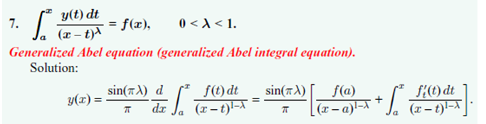

where it is the upper endpoint that is the variable. It is true that the Rα thing has that extra gamma function out front. Also, Polyanin did not list off the "other endpoint" Weyl case.
My point here is that, despite the high-falutin' development of these two transforms with all the fancy historical names, they are just the generalized Abel transforms we have already derived and studied. However, in all fairness, the generalized Abel is given for a restricted range of λ (or α), and we are soon going to learn how to extend the results for all λ (or α).

(d) (PL) A general comment on "Transforms" and "Integral Equations"

Consider for example a table of Laplace transforms.

f(s) = $^{\int_{0}^{∞}{}}$dt e-stF(t) F(t) = $^{\int_{c-i∞}^{c+i∞}{}}$ds e+tsf(s)

The left thing is called "the Laplace transform", and the right "the inverse Laplace transform". In this particular kind of transform, the inverse integral is admittedly a bit strange, but ignore that fact. You can regard either of these things as "an integral equation" and then the other thing is "the solution to that integral equation". It is true that not every function F(t) and not every function f(s) can be processed in this manner. Some functions f(s) "don't have" an inverse Laplace transform. Apart from this inconvenient fact, we have a "method of finding exact solutions to integral equations" : stare at your integral equation, try to convert it into a form which is a "transform" of some kind, then the "inverse transform" tells you the solution of your integral equation. The Fourier Transform is perhaps a better example since both directions have a real integration range, but that range does have to be (-∞,∞).
Now, how does Sned Chap 2 fit with this "comment" I am making?

(1) He opens the chapter by describing various J integrals, some of which are discontinuous ones. But these are just integrals, there are no "unknown functions" inside the integral. However, when we get to Chap 3 page 64, we see that, if we have some "integral equation" with an unknown function which "matches" an integral that we know, then in a sense that integral provides "a solution" of the integral equation. This seems like a stupid idea, but let's consider it for a moment.
Suppose you have in your arsenal this integral fact,

$^{\int_{a}^{b}{}}$ g(x,y) f(x) dx = h(y)

where all three functions are known. Then suppose someone hands you this "integral equation" to solve for s(x):

$^{\int_{a}^{b}{}}$ g(x,y) s(x) dx = h(y)

You could conclude at once that s(x) = f(x) was "a solution". We might write this in operator form as

Gs = h

In general, the solution of this equation is a particular solution plus any homo solution, so the most general solution might then be s(x) = f(x) + rhomo(x), and then s(x) is not the unique solution. But if G has an empty nullspace, then s(x) = f(x) is the unique solution.
So the point here is, that apart from this question of uniqueness, you can "solve" an integral equation if you know the right integral ahead of time. Consider this example:

$^{\int_{a}^{b}{}}$ g(x,y) f(x) dx = h(y)

$^{\int_{0}^{∞}{}}$ e-xy f(x) dx = h(y)

Suppose you have this last integral sitting in front of you. Somehow then asks you to solve this integral equation

$^{\int_{0}^{∞}{}}$ e-xy s(x) dx = h(y)

We conclude that s(x) = f(x) is "a solution". But our "integral sitting in front of us" is a Laplace transform, and we have a huge table of Laplace transforms at our disposal. So if we can find our "integral equation" as an entry in the table of Laplace transforms, then we can say we know "a solution" to that integral equation, and we don't have to even think about the $^{\int_{c-i∞}^{c+i∞}{}}$inverse transform integral. The nullspace in this case would be Gs = 0 or

$^{\int_{0}^{∞}{}}$ e-xy s(x) dx = 0

You suspect that there is no nullspace here. One argument is that the inverse transform is then an integral of 0 which forces s(x) = 0. If this is correct, then if we can find $^{\int_{0}^{∞}{}}$ e-xy s(x) dx = h(y) in our table of transforms, then we can solve this integral equation for s(x) just by inspection.
The same comment goes for other kernels. There seem to be many "standard kernels" like this one
e-xy which are associated with a table of transforms! So your game is to recast your integral equation into a form which has as kernel which has an associated transform table!
In passing, we note that our "know the integral ahead of time" method gets used on page 64 to solve the problem of the charged disk. Actually we have two integrals at once to "solve", each having the same unknown function A(ξ), with specific limited ranges (these are "dual integral equations"), but we have in our arsenal a matching pair of known integrals and they fit perfectly so our dual integral equations are thereby "solved by inspection", apart from the uniqueness question. But in this case we are talking Laplace and we know that things are unique.

(2) Sneddon then in section 2.3 starts talking directly about "integral equations". The ones here are integral equations of the Volterra form (with x as one or the other endpoint), which is different from the Laplace transform example above. But these cases do fall into this Volterra/kernel case

$^{\int_{0}^{y}{}}$ K(x-y) f(x) dx = h(y)

where now the "kernel" has the special form k(x,y) = K(x-y). For some K, this might be regarded as a "transform" and there might be a table somewhere. Sned has provided his own small table in Chap 2, but we don't have any names associated with these "transforms". In his final Williams section, Sned deals with our starting form above

$^{\int_{a}^{b}{}}$ g(x,y) f(x) dx = h(y)

and discusses an approximation idea for solving for f(x), if you cannot "find" this in some "table of transforms".

(3) We then come to section 2.4 with the fractional integrals. We can peek at ETII for example

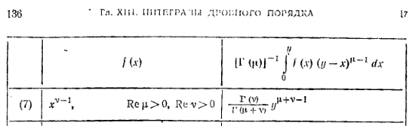

and we learn that , if someone hands you this integral equation with f(x) unknown,

$^{\int_{0}^{y}{}}$dx f(x) (y-x)μ-1 = Γ(μ) Γ(ν)/Γ(μ+ν) * yμ+ν-1

Then we can solve this integral equation (by staring at the table entry) and the solution is

f(x) = xν-1

Notice that this integral equation form really fits mold $^{\int_{0}^{y}{}}$ K(x-y) f(x) dx = h(y) above, and we were able to solve this mold using the Laplace method, so here we are doing an equivalent thing using fractional integral table instead of the Laplace table. Sned does not mention this fact.
End of long PL comment.

(e) Erdelyi-Kober operators

First, we recall the two transform pairs we already derived earlier (ie, generalized Abel fiddled with)

S1: 2 / Γ(α) * x-2α-2η $^{\int_{a}^{x}{}}$dt t2η+1F(t) [x2 - t2] α-1 = G1(x) ≡ Iη,α F(x)
=> F(t) = t-2η-1/Γ(1-α) * ∂t { $^{\int_{a}^{t}{}}$du u2α+2η+1 G(u) / [t2- u2]α } // which are 2.3.9 a=0

S2: 2 / Γ(α) * x2η $^{\int_{x}^{b}{}}$dt t-2η-2α+1F(t) [t2 - x2] α-1 = G2(x) ≡ Kη,αF(x)
=> F(t) = – t2η+2α-1/Γ(1-α) * ∂t { $^{\int_{t}^{b}{}}$du u-2η+1 G(u) / [u2- t2]α } // which are 2.3.10 b=∞

where we have a and b as set in the red comments. These are brought back onto the stage, and we think of each of these as a certain Stak style integral operator, you see the I and K names above. Sned shows that each of these can be connected to one of our fractional integral transforms. This entire section develops properties of these I and K integral operators. I just cannot be interested in these guys right now. He seems to be generalizing the above two transforms in some manner.

Ah, but now on 7.28.10 I need this Kober stuff because in Ch 4 he is going to use it to solve the Titchmarsh type dual integral equation pair! Here is a little comparison:

Iη,α F(x) = 2 / Γ(α) * x-2α-2η $^{\int_{0}^{x}{}}$dt t2η+1F(t) [x2 - t2] α-1
Rα{f(s); x} = (1/Γ(α)) $^{\int_{0}^{x}{}}$dt' f(t') (x-t')α-1

Kη,αF(x) = 2 / Γ(α) * x2η $^{\int_{x}^{∞}{}}$dt t-2η-2α+1F(t) [t2 - x2] α-1
Wα{ f(t); x } = (1/Γ(α) $^{\int_{x}^{∞}{}}$dt' f(t') (t'-x)α-1

You can see that the Kober things are generalizations of our two fractional guys where an arbitrary power has been thrown into the kernel. Note that we have already seen the I and K situations as a special case of the Srivastav general formula, this back on page 42. So we already know how to "invert" the I and K operators.

Let's now try to verify the following claim:

Iη,α F(x) = x-2α-2η Rα{ tη f(t1/2); x2}

Well, start with the definition of the R and do some edits.

Rα{f(s); x} = (1/Γ(α)) $^{\int_{0}^{x}{}}$dt' f(t') (x-t')α-1

Rα{ sη f(s1/2); x2} = (1/Γ(α)) $^{\int_{0}^{x2}{}}$dt' t'η f(t'1/2) (x-t'2)α-1

Now let t' = t2 so that dt' = 2tdt and we get

Rα{ sη f(s1/2); x2} = (1/Γ(α)) $^{\int_{0}^{x}{}}$dt 2t t2η f(t) (x2-t2)α-1

= (2/Γ(α)) $^{\int_{0}^{x}{}}$dt t2η+1 f(t) (x2-t2)α-1

= (2/Γ(α)) x-2α-2η $^{\int_{0}^{x}{}}$dt t2η+1 f(t) (x2-t2)α-1

= x+2α+2η (2/Γ(α)) x-2α-2η $^{\int_{0}^{x}{}}$dt t2η+1 f(t) (x2-t2)α-1

= x+2α+2η Iη,α f(x)

=> Iη,α f(x) = x-2α-2η Rα{ sη f(s1/2); x2} // which is 2.4.12 left

In particular this says

Iη,0 f(x) = x-2η R0{ sη f(s1/2); x2} = x-2η x2η f(x) = f(x)

so that

Iη,0 = 1 // which is 2.4.14 left

Next, let's now try to verify the other claim:

Kη,α F(x) = x2η Wα{ t-α-η f(t1/2); x2}

Well, start with the definition of the W and do some edits.

Wα{f(s); x} = (1/Γ(α)) $^{\int_{x}^{∞}{}}$dt' f(t') (t'-x)α-1

Wα{ s-α-η f(s1/2); x2} = (1/Γ(α)) $^{\int_{0}^{x2}{}}$dt' t'-α-η f(t'1/2) (t' - x2)α-1

Now let t' = t2 so that dt' = 2tdt and we get

Wα{ s-α-η f(s1/2); x2} = (2/Γ(α)) $^{\int_{0}^{x}{}}$dt t t-2α-2η f(t) (t2 - x2)α-1

= (2/Γ(α)) $^{\int_{0}^{x}{}}$dt t-2α-2η+1 f(t) (t2 - x2)α-1

= x-2η (2/Γ(α)) x2η $^{\int_{0}^{x}{}}$dt t-2α-2η+1 f(t) (t2 - x2)α-1

= x-2η Kη,α f(x)

so that

Kη,α f(x) = x2η Wα{ s-α-η f(s1/2); x2} // which is 2.4.13 left

In particular, this says that

Kη,0 f(x) = x2η W0{ s-η f(s1/2); x2} = x2η * x-2η f(x) = f(x)

=> Kη,0 = 1 // which is 2.4.14 right

Now go back to

Iη,α f(x) = x-2α-2η Rα{ tη f(t1/2); x2}

=> Iη+β,α f(x) = x-2α-2η-2β Rα{ tη+β f(t1/2); x2}

= x-2β x-2α-2η Rα{ tη tβf(t1/2); x2}

= x-2β x-2α-2η Rα{ tη [(t1/2)2β f(t1/2)]; x2}

= x-2β Iη,α [ x2β f(x) ] // which is 2.4.15

[49] The next relation of interest is fully derived on page 49 in my section C. The result is this, and then I recap the previous result

Iη,α Iη+α,β = Iη,α+β 2.4.17

Iη,α [ x2β f(x) ] = x2β Iη+β,α f(x) 2.4.15

He then goes on to get corresponding results for the K operator

Kη,α Kη+α,β = Kη,α+β 2.4.19

Kη,α [ x2β f(x) ] = x2β Kη-β,α f(x) 2.4.18

Now he talks about extending things to α < 0. Take 2.4.17 and want α + β = 0 so RHS = 1. Then have

Iη,α Iη+α,β = Iη,α+β
Iη,-β Iη-β,β = Iη,0 setting α = -β
Iη,α Iη+α,-α = Iη,0 setting β = -α

Take the second line above and set η = η + β to get

Iη+β,-β Iη,β = Iη+β,0

Finally replace β by α to get

Iη+α,-α Iη,α = Iη+α,0 = 1 which is 2.4.20
or
Iη+α,-α Iη,α f = f
or
Iη+α,-α g = f where g = Iη,α f which is 2.4.21

So think of this g as being "the solution" to Iη+α,-α g = f which has the second parameter negative.

He then gets similar results for K:

Kη+α,-α h = f where h = Kη,α f 2.4.22

Now I think the idea is that if α < 0, then both indices on all these forms have their usual positive values so you get to work as usual. It turns out that this in fact only works for -1 < α < 0 which includes the important value α = 1/2.

Now suppose we write out (as an integral) Iη+α,-α g = f as shown p 50 A, for -1 < α < 0. Since we know from our earlier work how to invert such an equation (see start of this section (e) above) , we can write that inversion as 2.4.23, and our derivative appears. He then introduces this differential operator

D f(x) = (1/2) ∂x(x-1 f(x))

for which I have no instant interpretation, right now it is just notation. Then our inversion first goes to p 50B where we use an I for the integral, and then the inversion goes to 2.4.25. Recall that g = Iη,α f so we are really writing down results for g, and g is what appears in Iη+α,-α g = f , so we are solving this equation! The solution is g = 2.4.25 !
In the same vein, we want to solve Kη+α,-α h = f for h, and we get 2.4.26 and then 2.4.27, again for α in this limited negative range.

If you want α to be more negative than -1, then we are not surprised to learn that keep doing parts integration until you get to your required range. This is the subject of page 51 for the I world. He integrates by parts n times and eventually we get 2.4.31 which we can compare to 2.4.25 and we see that our result there corresponds to a single parts integration. The idea of 2.4.31 is that you could have α = -n+ε and the RHS is well defined. Notice that we have Dn now appearing here.

He then on page 52 internally repeats the same stuff for the K world with result 2.4.33.

Discussion: The native object like Iη,α f(x) does not converge for α < 0. But he shows how you do analytic continuation by doing parts integration so that Iη,α f(x) becomes "well defined" for any negative value of α you want. So we can then in effect regard it as defined for all real α. Then if we go back to one or our earlier results

Iη,α Iη+α,-α = Iη,0 = 1

we can talk about applying Iη,α-1 to both sides to get

Iη,α-1 = Iη+α,-α // which is 2.4.34

This would not have any meaning had we not explained how to interpret Iη+α,-α for α > 0! So only after doing the above work are we "justified" in writing the above. There is a similar result for K. Finally, we get a rather astounding result 2.4.36 which shows that I and K are really "parts partners". This reminds me of the notion of a self-adjoint differential operator in Stak world where when you swing something from one side to the other, you get something slightly different.

(f) Some History. Basically all we have done here is to analytically continue the generalized Abel transforms to arbitrary real exponent. In addition to fancy names "Riemann-Liouville and Weyl fractional integral operators", we now have the same objects restated under the new names of the "Erdelyi-Kober operators". It is in these I and K forms that Sned will do all his work. The E-K things appeared in 1940 or so, whereas the other names refer to earlier history. Here is the Weyl reference I think, just noting he did this around 1917

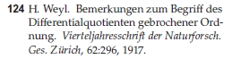

Riemann and Liouville were maybe in the 1850 time frame. I have a little PDF that reviews the history of "fractional calculus". Notice that Sned had no need to deal with "fractional derivatives". Abel as noted earlier was maybe 1825. Srivastav is 1963, very late in the game. So:

Laplace 1785 Laplace Transforms
Abel 1825 Abel integral equation (generalized or not)
Riemann-Liouville 1850 upper endpoint fractional integral transformation
Weber 1873 his discontinuous integrals
Weyl 1917 lower endpoint
Erdelyi-Kober 1940 renamed and combined with Hankel
Srivastav 1963 very general class of integral equation solutions

2.5 Connection between the above EK operators to the Hankel operator

[52] Now that I know about the I,K and S operators, I can at least quote with understanding the main results of this section. Here they are:

Iη+α,β Sη,α = Sη,α+β 13A 2.5.1

Kη,α Sη+α,β = Sη,α+β 14A 2.5.2 same RHS as previous

Sη+α,β Sη,α = Iη,α+β 15A 2.5.3

Sη,α Sη+α,β = Kη,α+β 16A 2.5.4 reversed LHS compared to previous

Sη+α,β Iη,α = Sη,α+β 17A 2.5.5

Sη,α Kη,α+β = Sη,α+β 18A 2.5.6 same RHS as previous

He then discusses a nice notation to make it completely clear which of several variables of a function is the variable you are talking about, see p 54 top, I like it. This then leads to result 2.5.8 which in turn leads to some statements about the huge K and K* monster integrals, 19A-22A. Done!

So, I have now been through everything in the page 274 Appendix A. I have at least derived some of these items, and I know I could derive all of them. Most of these things, like those shown above, just tell us what happens when we "concatenate" two integral operators. There is always just one variable floating around which we usually call x, and it appears as an endpoint of integrals (I and K only), in the integrand, and as part of an external factor function.

Iη,α F(x) = 2 / Γ(α) * x-2α-2η $^{\int_{0}^{x}{}}$dt t2η+1F(t) [x2 - t2] α-1
Kη,αF(x) = 2 / Γ(α) * x2η $^{\int_{x}^{∞}{}}$dt t-2η-2α+1F(t) [t2 - x2] α-1
Sη,α F(x) = 2α x-α $^{\int_{0}^{∞}{}}$dt t1-α J2η+α(xt) F(t)

All three of these can be directly related to the Hankel transform eventually. It seems that many transforms can be related to many other transforms!

2.6 Jacobi Polynomials and Associated Legendre Functions

He mentions his earlier definition of a shifted Jacobi, again not using that term, but here he finally hunkers down and talks about the official ones Pn(α,β)(x), the classical orthogonal polys. He does all the usual properties of these functions, and this includes some fancy integrals involving Pn(α,β)(x), 2.6.7 being a case in point where these things appear inside the integral and on the LHS. We can of course regard 2.6.5 and 2.6.6 as the classical orthogonality property, he writes this in a way I would write it.
Now recall that MF used this strange function,
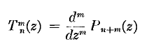 = tesseral polynomials

Pmm(z) = (1-z2)m/2T0m(z) = = sinmθ T0m(z) // one node at equator for z.

Well Sned starts using some T functions like this (he attributes his to Ferrar), but a little different. Specifically, he has

Tm+nm(x) = ei π m /2 Pn+mm(x)

and in some simple way the Pn(m,m)(z) are related to the above. So he is doing special cases of the Jacobis.
We now do a special case on fancy integral 2.6.7 noted above and out pops the infamous (to me) Mehler's integral representation of a Legendre polynomial, 2.6.21.
Now getting back to that orthogonality property, there must be a completeness property and an "expansion theorem" (meaning a transform) which appears in 2.6.25. So now we have a Jacobi Transform, I would call it, and he precedes to make a little table of transforms with some examples. They all look simple horrible!
He then, on page 59, writes down special cases of these special cases, and things are then not so bad. A whole densepack page of summations here involving Pn(z) and 1$\sqrt{cosx-cost}$ and Heaviside steps. These are "series involving Legendre polynomials". Sned is just packing in the database here for later access. Perhaps some or all of these results appear in GR7 or PBM. I have to say, some of these forms look a little familiar to me from my past attempted integral equation solution work (where I never could do anything).

[60] Sned now abruptly switches back to his "shifted Jacobi" thing. It too has orthogonality and expansion and all that stuff, but now we are on the (0,1) interval. This leads to more integrals of course.

And finally this exceedingly painful chapter comes to an end!

Comment: I notice an absence of the conical type Legendre functions. I think Sned will be working almost always in cylindrical coordinates in his entire book, which is why we have all the J stuff and not much P Q Legendre stuff.

Appendix A: A theorem concerning differentiating a convolution Volterra integral.

Suppose we have

g(x) = $^{\int_{a}^{x}{}}$dt k(x-t)f(t)

Define s(z) to be an integral of k(z), constant need not be known;

s(z) ≡ $^{\int_{}^{z}{}}$dz' k(z') + constant => k(z) = ∂zs(z)

Then we have

k(x-t) = ∂x s(x-t)

k(x-t) = – ∂t s(x-t)

Now let's assume momentarily that s(0) = finite. We now do the following parts integration:

g(x) = $^{\int_{a}^{x}{}}$dt k(x-t)f(t)

= – $^{\int_{a}^{x}{}}$dt [∂t s(x-t)] f(t)

= – [ s(x-t) f(t) ]|xa + $^{\int_{a}^{x}{}}$dt s(x-t) f '(t)

= – s(0) f(x) + s(x-a) f(a) + $^{\int_{a}^{x}{}}$dt s(x-t) f '(t)

Now we want to compute ∂xg(x) :

∂x g(x) = – s(0) f '(x) + f(a) ∂x s(x-a) + [ s(x-t) f '(t) ]|x + $^{\int_{a}^{x}{}}$dt [∂x s(x-t)] f '(t)

= – s(0) f '(x) + f(a) ∂x s(x-a) + [s(0) f '(x)] – $^{\int_{a}^{x}{}}$dt[ ∂t s(x-t)] f '(t)

= + f(a) ∂x s(x-a) – $^{\int_{a}^{x}{}}$dt[ ∂t s(x-t)] f '(t)

= + f(a) ∂x s(x-a) + $^{\int_{a}^{x}{}}$dt[ ∂x s(x-t)] f '(t)

= + f(a) k(x-a) + $^{\int_{a}^{x}{}}$dt k(x-t) f '(t)

Since the s(0) terms canceled out, we can relax our requiremement that s(0) = finite, perhaps treating it is a limit situation. So here is our theorem:

Theorem 1:

g(x) = $^{\int_{a}^{x}{}}$dt k(x-t)f(t) => ∂x g(x) = f(a) k(x-a) + $^{\int_{a}^{x}{}}$dt k(x-t)f '(t)

Now let's apply this to the following case:

k(x-t) = (x-t)λ-1

Then

g(x) = $^{\int_{a}^{x}{}}$dt (x-t)λ-1f(t) => ∂x g(x) = f(a) (x-a)λ-1 + $^{\int_{a}^{x}{}}$dt (x-t)λ-1f '(t)

This then verifies the rightmost quantity in the generalized and ungeneralized Abel transforms:

I guess Polyanin has f't(t) just in case f depends on some other variables. A strange notation!

Now we might as well repeat this derivation for the other Volterra endpoint. I will copy, paste, and then do lots of careful edits. Each line changes! Upper endpoint is b, the kernal has positive argument.

Suppose we have

g(x) = $^{\int_{x}^{b}{}}$dt k(t-x)f(t)

Define s(z) to be an integral of k(z), constant need not be known;

s(z) ≡ $^{\int_{}^{z}{}}$dz' k(z') + constant => k(z) = ∂zs(z)

Then we have

k(t-x) = ∂t s(t-x)

k(t-x) = - ∂x s(t-x)

Now let's assume momentarily that s(0) = finite. We now do the following parts integration:

g(x) = $^{\int_{x}^{b}{}}$dt k(t-x)f(t)

= + $^{\int_{x}^{b}{}}$dt [∂t s(t-x)] f(t)

= + [ s(t-x) f(t) ]|bx – $^{\int_{x}^{b}{}}$dt s(t-x) f '(t)

= – s(0) f(x) + s(b-x) f(b) – $^{\int_{x}^{b}{}}$dt s(t-x) f '(t)

Now we want to compute ∂xg(x) :

∂x g(x) = – s(0) f '(x) + f(b) ∂x s(b-x) + [ s(t-x) f '(t) ]|x – $^{\int_{x}^{b}{}}$dt [∂x s(t-x)] f '(t)

= – s(0) f '(x) + f(b) ∂x s(b-x) + [s(0) f '(x)] – $^{\int_{x}^{b}{}}$dt [∂x s(t-x)] f '(t)

= + f(b) ∂x s(b-x) – $^{\int_{x}^{b}{}}$dt [∂x s(t-x)] f '(t)

= – f(b) k(b-x) + $^{\int_{x}^{b}{}}$dt k(t-x) f '(t)

Since the s(0) terms cancelled out, we can relax our requiremement that s(0) = finite, perhaps treating it is a limit situation. So here is our theorem:

Theorem 1:

g(x) = $^{\int_{x}^{b}{}}$dt k(t-x)f(t) => ∂x g(x) = – f(b) k(b-x) + $^{\int_{x}^{b}{}}$dt k(t-x) f '(t)

Now let's apply this to the following case:

k(t-x) = (t-x)λ-1

Then

g(x) = $^{\int_{x}^{b}{}}$dt (t-x)λ-1f(t) => ∂x g(x) = – f(b) (b-x)λ-1 + $^{\int_{x}^{b}{}}$dt(t-x)λ-1 f '(t)

