Sneddon Chapter 3 Notes: the charged disk problem PhL 7.20.10

Sneddon's book came out in 1966, while green Jackson was 1962, which explains why green Jackson does not mention Sneddon as a reference (while red Jackson of many years later does).

3.1 Weber's Charged Disk Solution (1873) 1
Question: Who was H. Weber ? 2
The Weber Solution 3
3.2 Beltrami's Symmetric Potential Solution (1881) 4
3.3 Doing the Problem in Oblates ( Kelvin 1847/1872? ) 10
3.4 Copson's Solution to the Disk Dirichlet Problem (1947) 10
A. The Copson Solution 10
B. About Copson 14
C. Comments on the Copson method 14
D. Applications of the Copson Solution 15
3.5 Sneddon's Solutions of two Dual Integral Equation Pairs 15
A. Solution of the Beltrami Dual Integral Equations 16
B. Solution of a similar Dual Integration Pair 21
3.6 Methods based on integral representation of harmonic functions. 26

3.1 Weber's Charged Disk Solution (1873)

History Note: Laplace's equation was 1782,1785 regarding gravitational potential and mass density ρ. Maxwell's equations were 1861, one of which is Gauss's Law. Gauss's Law was formulated 1835 but published 1867. So in general, people were thinking about electrostatic potentials in the 1830-1870 time frame, and along came Weber below in 1873.
But George Green did his own Gauss's law and potential theory all back in 1828, he knew all about electrostatic potential theory -- he invented it! It was not until 1845 that Kelvin found this paper and published it for real in three parts 1850,52,54. " See Stak Ch 6 raw 1 for more on Green.
To summarize:

Laplace equation 1785
George Green 1825,1852 first math theory for electrostatic potential; done, pub
Gauss's law 1835,1867 re electrostatics; done, pub
Maxwell's Equations 1861
Weber's disk solution 1871

Something to remember perhaps is that at the time, there might only have been 1000 people in the entire world (10 per city, 100 cities) who could understand or who even cared about this stuff.

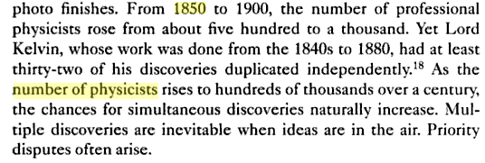

Question: Who was H. Weber ?

[12] H. Weber, ”¨ Uber die Besselschen Functionen und ihre Anwendung auf die Theorie der
elektrischen Str¨ome”. Journal f¨ur die reine und angewandte Mathematik, 75, pp.75-105,
(1873). -- this is the paper.

I have been trying to find Weber's name and the paper itself, have a start here

http://www.reference-global.com/doi/abs/10.1515/crll.1873.75.75

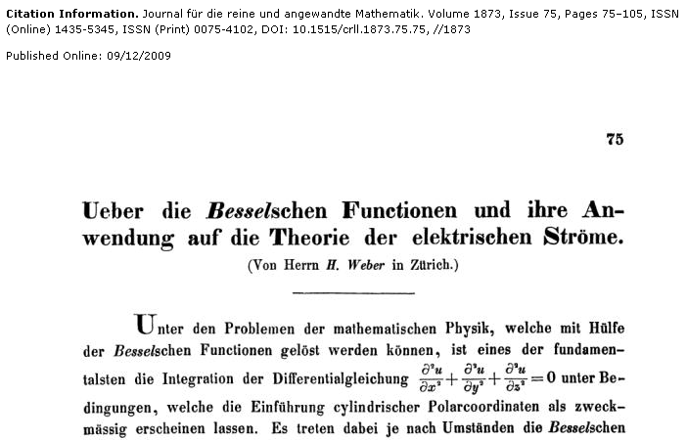

Wiki shows two contemporary German Heinrich Webers, but one was not good at math, and the other did math physics. It seems that our guy must be Heinrich Martin Weber. 1842 - 1913, but I am unable to correlate him with anything related to the disk problem: 1873, discontinuous, Bessel, disk. etc. Nothing shows up anywhere! The 1873 reference never says more than 'H. Weber". But HMW is associated with Weber functions and did "analysis". This total absence of correlation is truly amazing to me.
" "H. Weber" 1873 bessel" has 596 hits. " "H. Weber" 1873 Besselschen" has 98 hits.
The other Weber is Heinrich Friedrich Weber (1843–1912). Notice his life differs only 1 year at each end from the other Weber!
The function Yn(x) was introduced by Heinrich Weber (1842-1913)...
Watson's Bessel book scanner does not pick up Heinrich, but here is from his index:

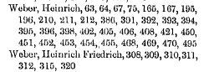

Pages 405-406 are where he talks Weber Schafheitlin, and you see him distinguishing "the other guy". So Watson is really confirming that it is in fact Heinrich Martin Weber, even though the web won't confirm this fact. He wrote the algebra book. He taught at Zurich for a while. He ended up in Strasbourg. He worked with Jacobi. He introduced the Y Bessel function, and here he has another paper on electrostatics in the same year 1873:

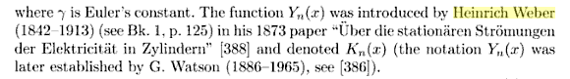

So that is who Weber is! Teacher of Hilbert, etc.

The Weber Solution

Weber's disk solution is based on having a beforehand-knowledge of certain integrals of the J0(bx) Bessel function against sine and cosine functions. Sneddon did these in his Chap 2, so all he does here is quote them. Since they are so all-important in this application, and since they are unusual in that they are "discontinuous", I am going to digress now to look at these integrals. [ See Sned Chapter 2 notes Appendix A, which has all the details. ]
So, we now back on page 63. We write out the BC's as usual, and use one of my azisym "atomic forms" as in 3.1.2 which is expo in z and J0 in ρ, and we arbitrarily write the coefficient as A(ξ)/ξ. Sneddon uses ξ where I use k as variable conjugate to z. The dual integral equations are then 3.1.3 where the first says V = 0 on the disk, and the second says σ = 0 outside the disk.
Then comes the magic. Simply by doing a side-by-side comparison of our sine discontinuous integrals discussed above, we "conclude" that A(ξ) = (2/π) sinξ. In our integrals, we see in other words that this A(ξ) must be a solution, and since the solution is unique, we have it. We then install this into our atomic form, and we have the potential as an atomic form dk integral, which is the same as Jackson page 92. Here we have radius of disk = 1, and V on disk = 1, just to keep things simple.
If you now apply ∂z to the potential, you cancel the 1/ξ factor and end up with the simple integral which evaluates to 1/ $\sqrt{a2-b2}$ and this then gives the famous σ distribution on the disk! This is his 3.1.5.
So here is a complete solution to the problem! We first obtained the dual integral equations, then we "solved" these integral equations by our prior knowledge of the "Weber" discontinuous integrals involved. This is for me a little better than pulling the solution out of a hat as Jackson did. Obviously, the method is quite "ad hoc". For more general dual integral equations, you would have to go off and hunt hard for the appropriate discontinuous integrals! [ But with the Polyanin Handbook of Integral Equations, 1998 and 2008, it might be easier than it was earlier. ]

3.2 Beltrami's Symmetric Potential Solution (1881)

Since this method is the basis for the general method, I went through it in full detail.

We restate the dual integral equations this time allowing for V = f(ρ) on the disk. Use 4πσ = -∂zV for σ on one side of disk, double it for total charge so that σ = -(1/2π) ∂zV. Use the same Smythian form for V as we used in the Weber solution, so that σ is then as shown 3.2.3, since ∂zV brings down a factor of -ξ which cancels the assumed 1/ξ.
So at this point, we have a statement of σ for the full range of ρ being (0,∞). It is 0 outside the disk, and it is some unknown σ(ρ) on the disk. This is similar to what Canon. does with the bowl, we introduce a function we don't know in some of the region, and here that is σ(ρ). Then, having a full region, we can use the orthogonality of the basis functions, which here means the Hankel transform, which in my transforms.doc appears as

f(ρ) = $^{\int_{0}^{∞}{}}$dk k Jν(kρ) Fν(k) // expansion (*)
Fν(k) = $^{\int_{0}^{∞}{}}$dρ ρ Jν(kρ) f(ρ) // projection
$^{\int_{0}^{∞}{}}$dρ ρ Jν(kρ) Jν(k'ρ) = δ(k-k')/k // orthogonality
$^{\int_{0}^{∞}{}}$dk k Jν(kρ) Jν(kρ') = δ(ρ-ρ')/ρ // completeness

So start with 3.2.3 which is this ( just diff the Smythian form, true for all ρ where σ = 0 for ρ>1)

σ(ρ) = $^{\int_{0}^{∞}{}}$dk k J0(kρ) [A(k)/(2πk)]

which matches our expansion (*) above, so we know that

[A(k)/(2πk)] = $^{\int_{0}^{∞}{}}$dρ ρ J0(kρ) σ(ρ)

A(k) = 2πk$^{\int_{0}^{∞}{}}$dρ ρ J0(kρ) σ(ρ) = 2πk$^{\int_{0}^{1}{}}$dρ ρ Jν(kρ) σ(ρ)

A(k) = 2πk$^{\int_{0}^{1}{}}$dρ ρ J0(kρ) σ(ρ) // which is 3.2.4

[ Note: this says that the Smythian form coefficient, A(k), which we don't know, is an integral of σ(ρ) which we also don't know. ]

where we have changed to (0,1) because we know σ = 0 for ρ>1. Now introduce a second helper function

Q(ρ) = 2π$^{\int_{ρ}^{1}{}}$dρ' ρ' σ(ρ') = total charge in annulus (ρ,1)

∂ρ Q(ρ) = - 2π ρ σ(ρ)

so we can write

A(k) = 2πk$^{\int_{0}^{1}{}}$dρ ρ J0(kρ) σ(ρ)

= - k$^{\int_{0}^{1}{}}$dρ ∂ρ [Q(ρ)] J0(kρ)

then do parts on this to get

= - k {[Q(ρ)] J0(kρ)} |10 + k $^{\int_{0}^{1}{}}$dρ Q(ρ) ∂ρ J0(kρ)

The parts evaluated at 1 vanishes since Q(1) = 0 for the thinned to nothing annulus. So

= + k Q(0) + k $^{\int_{0}^{1}{}}$dρ Q(ρ)[ ∂ρ J0(kρ)]

but Schaum page 137 shows that

∂ρ J0(kρ) = k ∂xJ0(x) = k [ (1/2) ( J-1(x)- J1(x) )] = - k J1(x) x = kρ

so we then continue

A(k) = + k Q(0) - k2$^{\int_{0}^{1}{}}$dρ Q(ρ)J1(kρ) // which is 3.2.6

[This says the Smythe coefficient A(k), which we don't know, is an integral of the annulus charge function, which we also don't know. ]

We are next supposed to imagine that some function F(s) exists such that 3.2.7 is true:

Q(ρ) = $^{\int_{ρ}^{1}{}}$dρ' ρ' F'(ρ') / $\sqrt{ρ'2- ρ2}$

I have no interpretation for this integral (eg, $\sqrt{ρ'2- ρ2}$ is not a distance I can identify), so let's regard this as an ansatz. [ However, it has a "kernel" which appeared heavily in Sned's Ch 2 on integral equations.]
[ Note that F(ρ) is the third helper function used in this development.] Assume some F'(s) exists so this thing integrates to Q(ρ). If we knew F'(s), we could then compute F(s) up to a constant in this way

F(ρ) = $^{\int_{0}^{ρ}{}}$dρ' F'(ρ')

where I have selected the integration constant so that F(0) = 0. We now adjust the "scale" of the function F so that

F(1) = $^{\int_{0}^{1}{}}$dρ' F'(ρ') = Q(0) = the total charge on the disk

The next step is to insert our ansatz into 3.2.6:

A(k) = k Q(0) - k2$^{\int_{0}^{1}{}}$dρ Q(ρ)J1(kρ)

= k F(1) - k2$^{\int_{0}^{1}{}}$dρ{$^{\int_{ρ}^{1}{}}$dρ' ρ' F'(ρ') / $\sqrt{ρ'2- ρ2}$}J1(kρ)

= k F(1) - k2$^{\int_{0}^{1}{}}$dρ{$^{\int_{ρ}^{1}{}}$dρ' ρ' F'(ρ') / $\sqrt{ρ'2- ρ2}$}J1(kρ)

Here we encounter a standard situation where we can write

$^{\int_{0}^{1}{}}$dρ$^{\int_{ρ}^{1}{}}$dρ' f(ρ,ρ') = $^{\int_{0}^{1}{}}$dρ'$^{\int_{0}^{ρ'}{}}$dρ f(ρ,ρ')

This rearrangement of the double sum is never obvious until you knuckle down and draw the picture showing the triangular integration region

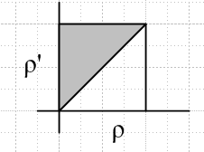
So doing this rearrangement (which of course assumes a certain convergence sense) we get

= k F(1) - k2$^{\int_{0}^{1}{}}$dρ'{$^{\int_{0}^{ρ'}{}}$dρ ρ' F'(ρ') / $\sqrt{ρ'2- ρ2}$}J1(kρ)

= k F(1) - k2$^{\int_{0}^{1}{}}$dρ' ρ' F'(ρ')$^{\int_{0}^{ρ'}{}}$dρ J1(kρ)/ $\sqrt{ρ'2- ρ2}$ // which is p 66A

I am able to adjust the so that

I = $^{\int_{0}^{ρ'}{}}$dρ J1(kρ)/ $\sqrt{ρ'2- ρ2}$ = $^{\int_{0}^{1}{}}$dt J1(kρ't)/$\sqrt{1-t2}$

Then we can apply GR7 p 674

so get, with x = t and y = kρ'

I = (π/2) [J1/2(kρ'/2)]2 = (π/2) [ $\sqrt{2/(πkρ'/2)}$ sin(kρ'/2)]2

= (π/2) 2/(πkρ'/2) * sin2(kρ'/2)

= (2/kρ') sin2(kρ'/2)

so we then have found that

A(k) = k F(1) - k2$^{\int_{0}^{1}{}}$dρ' ρ' F'(ρ')$^{\int_{0}^{ρ'}{}}$dρ J1(kρ)/ $\sqrt{ρ'2- ρ2}$

= k F(1) - k2$^{\int_{0}^{1}{}}$dρ' ρ' F'(ρ') I // define integral

= k F(1) - k2$^{\int_{0}^{1}{}}$dρ' ρ' F'(ρ') (2/kρ') sin2(kρ'/2) // install I

= k F(1) - k $^{\int_{0}^{1}{}}$dρ' F'(ρ') 2sin2(kρ'/2) // move constants

= k F(1) - k $^{\int_{0}^{1}{}}$dρ' F'(ρ') [1 - cos(kρ')] // trig formula half angle

= k F(1) - k $^{\int_{0}^{1}{}}$dρ' F'(ρ') + k$^{\int_{0}^{1}{}}$dρ' F'(ρ')cos(kρ') // two terms

= k F(1) - k { F(1)-F(0)} + k$^{\int_{0}^{1}{}}$dρ' F'(ρ')cos(kρ') // do first integral

= k$^{\int_{0}^{1}{}}$dρ' F'(ρ')cos(kρ') // final result agrees with 3.2.8

[ This says that the Smythe coefficient, which we don't know, is related to an integral of the helper function F'(ρ') which we also don't know. ]

Our next program instruction is to insert this A(k) into the potential integral equation (3.2.1) , the first of the dual set. This gives

f(ρ) = $^{\int_{0}^{∞}{}}$dk/k * J0(kρ) A(k) 0 < ρ < 1

= $^{\int_{0}^{∞}{}}$dk/k * J0(kρ) { k$^{\int_{0}^{1}{}}$dρ' F'(ρ')cos(kρ')}

= $^{\int_{0}^{∞}{}}$dk J0(kρ) $^{\int_{0}^{1}{}}$dρ' F'(ρ')cos(kρ')}

= $^{\int_{0}^{1}{}}$dρ' F'(ρ') $^{\int_{0}^{∞}{}}$dk J0(kρ)cos(kρ')

The required integral here is our famous Weber one where we say

$^{\int_{0}^{∞}{}}$dx J0(bx) cos(ax) = 1/$\sqrt{b2-a2}$ |a| < |b|
= 0 |a| > |b|

so I guess we want to set b = ρ and a = ρ' so that

$^{\int_{0}^{∞}{}}$dk J0(kρ)cos(kρ') = H(ρ-ρ') /$\sqrt{ρ2-ρ'2}$

Then we get

f(ρ) = $^{\int_{0}^{1}{}}$dρ' F'(ρ') H(ρ-ρ') /$\sqrt{ρ2-ρ'2}$

= $^{\int_{0}^{ρ}{}}$dρ' F'(ρ') /$\sqrt{ρ2-ρ'2}$ 0 < ρ < 1 // which agrees with 3.2.9

[ We just used one of our dual integral equations to eliminate A(k) in favor of f(ρ). This says that the prescribed potential f(ρ), which we DO know, is an integral of F'(ρ') which we don't know. But we know how to invert this particular integral equation! ]

At this point, we reach into the rabbit hat [ which I have now studied and derived ] page 41 2.3.7 which says, adjusted to our need here,

$^{\int_{0}^{ρ}{}}$dρ' F'(ρ') /$\sqrt{ρ2-ρ'2}$ = f(ρ) a = 0 α = 1/2 x = ρ b = 1 to match 2.3.7a

The solution of this "standard form" integral equation is 2.3.7 b:

F'(ρ') = 2 sin(π/2)/π * ∂ρ' $^{\int_{0}^{ρ'}{}}$ dρ ρ f(ρ) / $\sqrt{ρ'2-ρ2}$ 0 < t < 1

F'(ρ') = (2/π) ∂ρ' $^{\int_{0}^{ρ'}{}}$ dρ ρ f(ρ) / $\sqrt{ρ'2-ρ2}$ 0 < t < 1

The last step is that both sides are ∂ρ' so we must have

F(ρ') = (2/π) $^{\int_{0}^{ρ'}{}}$ dρ ρ f(ρ) / $\sqrt{ρ'2-ρ2}$ + constant

But constant = 0 so that F(ρ') = 0, and we get

F(ρ') = (2/π) $^{\int_{0}^{ρ'}{}}$ dρ ρ f(ρ) / $\sqrt{ρ'2-ρ2}$ which is 3.2.10

So we are done, and here is how our Beltrami solution plays out:

(a) compute F(ρ) from this last integral, since we are given f(ρ) as the potential on the disk,

F(ρ') = (2/π) $^{\int_{0}^{ρ'}{}}$ dρ ρ f(ρ) / $\sqrt{ρ'2-ρ2}$ // required integral #1

(b) diff to get F '(ρ')

(c) install this F '(ρ') into 3.2.8 to get A(k)

A(k) = k$^{\int_{0}^{1}{}}$dρ' F'(ρ') cos(kρ') // required integral #2

(d) install this into the Smythian form 3.2.1 to get the potential

V(ρ,z) = $^{\int_{0}^{∞}{}}$dk/k * A(k) e-kz J0(kρ)

(e) total disk charge density is given then by

σ(ρ) = -(1/2π) ∂zV = (1/2π) $^{\int_{0}^{∞}{}}$dk A(k) J0(kρ)

Let's now try this program for the case f(ρ) = 1 which is just the charged disk:

(a) F(ρ') = (2/π) $^{\int_{0}^{ρ'}{}}$ dρ ρ / $\sqrt{ρ'2-ρ2}$ = (2/π) ρ' // Maple integral

(b) F '(ρ') = (2/π)

(c) A(k) = (2/π) k$^{\int_{0}^{1}{}}$dρ' cos(kρ') = (2/π) k sin(k)/k = (2/π) sin(k)

(d) V(ρ,z) = $^{\int_{0}^{∞}{}}$dk/k * A(k) e-kz J0(kρ) = (2/π) $^{\int_{0}^{∞}{}}$dk/k * sin(k) e-kz J0(kρ) // sinc(k)

(e) σ(ρ) = (1/2π) $^{\int_{0}^{∞}{}}$dk (2/π) sin(k) J0(kρ) = π-2 $^{\int_{0}^{∞}{}}$dk J0(kρ) sin(k)

= (1/π2) 1/$\sqrt{1-ρ2}$ when 1 > ρ

and there you have it!

Comment: Beltrami has solved the Dirichlet problem for an arbitrary azisym potential on the disk V(ρ)! This is the first time I have seen this solution. His trick is to recast the problem so that a certain "standard solved integral equation" appears. I think this is a very clever little set of manipulations, well presented by Sneddon. We have to figure out how to get to a point where we have an integral equation where we KNOW the function on one side, and which we KNOW how to invert.

3.3 Doing the Problem in Oblates ( Kelvin 1847/1872? )

Sneddon gets right to the point and obtains, for the charged disk, the spheroidal solution 3.3.6 which then replicates our usual σ(ρ) on the disk. He then obtains a result for the Beltrami problem as well in terms of the oblate atoms as in 3.3.10 where the an are the Legendre expansion coefficients of the assumed f(ρ) = f(cosu) where sinu = η, and all that stuff. I have done all this elsewhere so am not paying too much attention. But I like the second last paragraph where Sneddon notes that this oblate solution is pretty useless if you are trying to do things in Cartesian coordinates.

3.4 Copson's Solution to the Disk Dirichlet Problem (1947)

A. The Copson Solution

Will be based on Beltrami inasmuch as we will shuffle things in such a way as to make integral equations appear which we know how to solve. Things start off exactly as I did things on my own;

3.4.1 prescribed Dirichlet potential on the disk , expanded on cos(nθ)

Sned is using the same θ basis functions cos[n(θ-θn)] method used by Smythe, rather than two expos or a sine and cosine term.

3.4.2 expand σ(ρ,θ) on these same cos[n(θ-θn)] basis functions

3.4.3 V = integral of q/R, just as I set things up once (see below)

3.4.4 writing out R in cylindricals, one point is on disk, the other off in space

The disk point is (r,θ,z=0) while the space point is (ρ,θ,z), so a dangerous notation for me. First, r is really a ρ type coordinate, not the usual "r". Secondly, he has two θ's now floating around. But OK.

3.4.5 insert 1 and 2 into 3 to get this messy looking integral which
just says V(on disk) = integral q/R), unknowns are the projections fn and σn

PL History Comment: This is exactly the starting point I took in an early attempt to find the Green's function not for the disk, but the iris. I just hunted that up now, it is " Iris Green's Function attempt using the Stak integral equation method.doc". So I was doing Green's rather than Dirichlet, and I had this:

V(r') = q/r1 + $^{\int_{a}^{∞}{}}$r dr$^{\int_{0}^{2π}{}}$dθ { Σn=0∞ σn(r) cos(nθ) } / $\sqrt{r2 + r'2 - 2rr' cos(θ-θ')}$ = 0

= q/r1 + Σn=0∞ $^{\int_{a}^{∞}{}}$r dr σn(r) { $^{\int_{0}^{2π}{}}$dθ cos(nθ) / $\sqrt{r2 + r'2 - 2rr' cos(θ-θ')}$ } = 0

If you put the point charge potential -q/r1 on the RHS, this is just a Dirichlet problem of course (hence the name "Green's By Dirichlet method"). I then attacked the θ integral and got (after a long time...) this result

In ≡ { $^{\int_{0}^{2π}{}}$dθ cos(nθ) / $\sqrt{r2 + r'2 - 2rr' cos(θ-θ')}$ } = cos(nθ') Fn(f)

= cos(nθ') (1/π) $\sqrt{r/r'}$ εn Qn-1/2[(r2 + r'2)/(2rr')]

You see the same σn (with all constants θn = 0 since assumed Green's at θ=0). My point is that I was faced with the same complicated trig integrand that the Copson method faces in 3.4.5. Early on I got a messy result for the θ integral, and later on was above to write it as a Qn-1/2 (...) function. The above equation then led to an integral equation for σn(r) roughly of this form, where the cn are known:

(q/b) (εn/2) cn(g) + $^{\int_{a}^{∞}{}}$dr σn(r) Fn(f) = 0 n = 0,1,2,3....

At this point I gave up, stuck with another integral equation I could not solve. I then went back and installed the known Smythe σ for the iris Green's problem, and even knowing the result, I was unable to verify it. I had to verify this relation to do that:

$^{\int_{d}^{∞}{}}$dh (h/$\sqrt{h2-d2}$) $^{\int_{0}^{2π}{}}$dθ * 1/ [ (1 + h2 - 2h cosθ) $\sqrt{h2 + ρ'2 - 2 ρ'h cos(θ-θ')}$]

= ( 2π / $\sqrt{d2 - 1}$) * 1/ $\sqrt{1 + ρ'2 - 2ρ' cosθ'}$ ]

But then eventually at the end of that doc, I was in fact able to do the verification using Qn-1/2 functions, but it was all quite "unsatisfying".
So I record the above personal "research" history to show that in fact I was in this canyon before, paddling along, but I was not really able to do much. The real question is this: what is the best thing to do when you encounter the double integral over the disk's surface that we encounter here. [ Note: as commented on directly below, by fully "doing" the θ integration to get the Q function, I was then not able to see things in the form of an integral equation I knew how to solve. An example of "going too far", or perhaps "going down the wrong path in the maze". ]

Resuming the Copson method, we next see

3.4.6 a special way to write the θ integral I note above!

What this says is that Copson has found an integral representation for Qn-1/2[(r2 + r'2)/(2rr')] which gets all the n dependence into a factors (rr')n and tn which is pretty amazing. This then is an integral representation of a toroidal or ring function, but I don't off hand see anything like it in Bateman. Maybe I can take a quick shot at it here:

Qn-1/2[(r2 + r'2)/(2rr')] = Qn-1/2[ {(r/r') + (r/r')-1 }/2]

Suppose you set r/r' = eμ (blindly) so we then have

= Qn-1/2[ { eμ + e-μ }/2] = Qn-1/2(chμ)

which is certainly encouraging. Suppose you think of r' as a constant and r as a variable, so r = r'eμ, then we seek an integral rep that looks like this

Qn-1/2(chμ) ~ $^{\int_{0}^{r'}{}}$dt t2n / [ $\sqrt{r'2-t2}$$\sqrt{r'2e2μ-t2}$] if r' < r meaning μ>1

But let t2 = y so 2tdt = dy so dt t2n = (1/2)t-1dy t2n = (1/2)dy t2n-1 = (1/2) dy yn-1/2. So we are then looking for something like this

Qn-1/2(chμ) ~ $\sqrt{r'}$!Syntax Error, Idy yn-1/2 / [ $\sqrt{r'2-y}$$\sqrt{r'2e2μ-y}$] if r' < r

= $\sqrt{r'}$!Syntax Error, Idy yn-1/2 [ (r'2-y)( r'2e2μ-y )]-1/2

= $^{\int_{0}^{a}{}}$dy yn-1/2 [ (a-y)( b-y )]-1/2 a = r'[ b = r'eμ = r

= $^{\int_{0}^{a}{}}$dy yn-1/2 / [ $\sqrt{y-a}$$\sqrt{y-b}$ ] = $^{\int_{0}^{a}{}}$dy yn-1/2 /$\sqrt{R}$ R = Ay2 + By + C

But this looks like a pretty basic integral that ought to be in GR7. But I don't see this integral with an arbitrary power of y. Searching in GR7 for cap Q, I don't see much, but this one keeps popping up.

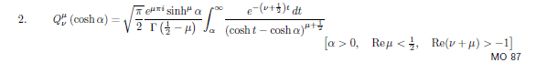
which says, for μ = 0,

Qν(chμ) ~ $^{\int_{μ}^{∞}{}}$dx e-(ν+1/2)x / $\sqrt{chx-chμ}$
Qn-1/2(chμ) ~ $^{\int_{μ}^{∞}{}}$dx e-nx / $\sqrt{chx-chμ}$

Maybe now let t = e-x and dt = -e-xdx so dxe-nx = -dtexe-nx = - dt e-(n-1)x = - dt tn-1. The endpoints then become: x = ∞ => t = 0, x=μ => t = e-μ so then we have

Qn-1/2(chμ) ~ $^{\int_{0}^{e-μ}{}}$ dt tn-1 / $\sqrt{chx-chμ}$

Next chx = (t + 1/t)/2 and chμ = [ (r/r') + (r/r')-1]/2 so

chx-chμ = (1/2) [(t + 1/t) - (r/r') + (r/r')-1 ] = (1/2t) [[(t2 + 1) - (r/r')t - (r/r')-1t ]

so it then says

Qn-1/2(chμ) ~ $^{\int_{0}^{e-μ}{}}$ dt tn-1/2 / $\sqrt{t2 - [(r/r')+(r'/r)]t + 1}$

$^{\int_{0}^{e-μ}{}}$ dt tn-1/2 /[$\sqrt{t-(r/r')}$$\sqrt{t-(r'/r)}$]
0 e-μ dt tn-1/2 /[t-(r/r') t-(r'/r) ]
$^{\int_{0}^{e-μ}{}}$ dy yn-1/2 /[$\sqrt{y-(r/r')}$$\sqrt{y-(r'/r)}$]

So I skip the details, I have found it! I can do this in more detail later!

So now let's resume Copson's path. We install the 3.4.6 replacement for the angular integral as shown p70 A. We then write it as two terms as in p 71A. Then no doubt studying the integration space (I would of course draw a picture) the t integration is moved to the left and we get 3.4.7. Bingo, the t integral is now in one of our standard forms (Abel) so it can be inverted and we get 3.4.9, where a new symbol Sn(ρ) stands in for the inner integral. But then this Sn(ρ) integral is also in our standard form and we can invert it as in 3.4.11. So we now have σn as an integral of Sn, and we have Sn as an integral of fn which are our prescribed Dirichlet coefficients. This is then all summarized in Copson's Theorem bottom of page 71. Then finally, of course, you can carry out the last stage of Stakgold's "integral equation method" program, which is you insert the now-known charge density σ into 3.4.3 and you have the potential everywhere. Very excellent, a complete solution of the disk Dirichlet problem, not done (at least this way) until 1947! It is all done using a simple partial wave analysis onto the cos(nφ) azimuthal functions, as I did above, more on this below.

B. About Copson

Copson Note (1901-1980): Born in Coventry , he married Whittaker's daughter Beatrice Mary in 1931 after taking a job with Whittaker at Edinburgh in Scotland (both cities on map below)

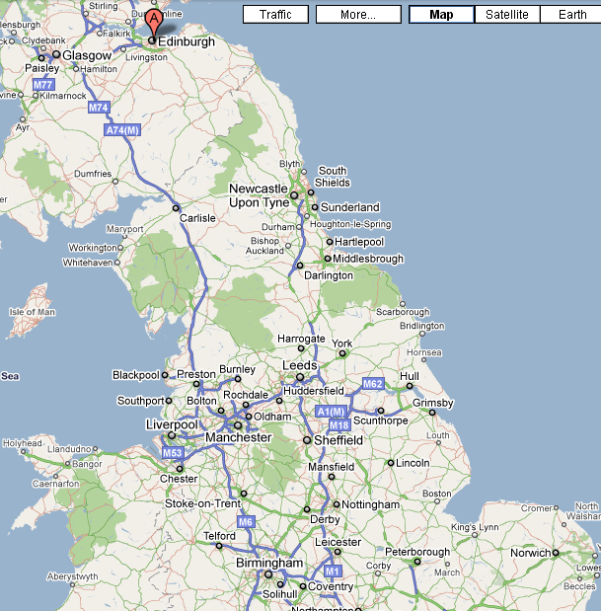

Copson was interested in classical analysis, including integral equations.

C. Comments on the Copson method

There is much to be learned in a general sense from this Copson approach.
First, recall in the Cartesian coordinates solution of the Green's function for a plane in " Finding Green's Functions by the Dirichlet Method.doc" (filed Stak), you start with a Smythian form as a double dkxdky integral of 1/R times the basis functions, and you can in fact do the dkx integral (pick one or the other). But as soon as you DO this integral, you have in a sense collapsed one of your integrals to a "special function" (in this case, K0), breaking the symmetry between kx and ky, and then you are faced with some difficult integral involving other factors and this special function (and possible factors that go with it). Often such integrals are hard or impossible to find, but in that case I found the required integral in ET II or I. The lesson here is that if you do an integral "too early in the game", you can make life a lot harder for yourself.
How does that apply to Copson. Well, although Sned did not point it out, I know that the angular integral can be done to get Qn-1/2{ [(r/ρ)+(ρ/r)]/2}. This is an example of "doing the integral too early" and forcing it to collapse down to a special function. Copson instead just replaces the θ angular integral with another integral which happens to have two factored denominator radicals which are just what we like to see for identifying integral equations we know how to solve, as shown in 3.4.6. In my case, I might collapse it down to a Qn-1/2, then elevate that back up to be the t integral he shows, just to prove that his t integral is the correct result.
Second, I suspect that the integral equation is being diagonalized on some group related to toroidal coordinates. This is leading to the factorization of the two denominator radicals that Copson obtains in his solution here.

D. Applications of the Copson Solution

(1) Disk with constant potential. Sned shows how we recover our previous results, we basically have in this case fn(ρ) = δn,0

(2) Earthed Disk in an External Field Parallel to the disk in the x direction. Think of this as a superposition problem. Assume that Ex = 1 so that V = -x = -ρcosθ from this external field. We want the charge σ to adjust itself on the disk to create V = +ρcosθ on the disk, so that when added to the potential of the external E field, the disk has V = 0 (earthed). So our problem is to apply Copson with this V, which simply means fn(ρ) = δn,1ρ. Turn the crank and out comes a simple answer for the charge σ = σ1. Sned did not mention it, but we really do have a partial wave expansion going on here in θ. The way this shows up in the solution is easy to see: in 3.4.10 fn generates only Sn and then Sn generates only σn. The PWA analysis is not obvious just looking at 3.4.3, but becomes obvious after we change the θ integral to the t integral, as in 3.4.5 with 3.4.6 installed. Even with my Qn-1/2 form I think this PWA is obvious. You can always diagonalize in θ (I think).
What about the problem of E field perp to an earthed disk? Well, from the Ez field alone we would have V = 0 in the disk plane if we set the zero correctly. The solution would then be σ = 0 on the disk. This is really a non-problem, no charge is induced since there are no tangential forces on the disk which can push the charges somewhere.

(3) Gallop's Problem of 1886. He wanted to set f(ρ) = f0 = J0(cρ) and other fn = 0 . We already know how to solve this from Beltrami. I think either that way or the Copson way, you end up with p 73D. For some reason unclear to me, Sned uses the Mehler integral to recast this result into the more complicated form 3.4.19.

(4) MacDonald's Problem of 1895. Now we have fn= Jn(cρ) for all n. Plug away and out comes 3.4.23, and the answer involves a single integral, just as does the Gallop problem. I guess you could either do this integral, or if not, call it a "MacDonald function".

3.5 Sneddon's Solutions of two Dual Integral Equation Pairs

A. Solution of the Beltrami Dual Integral Equations

Recall the Beltrami dual pair of interest p 65 3.2.1-2 which is for the Dirichlet disk problem with a radial potential. You might ask: in the Beltrami solution, did we ever actually solve these dual integral equations? Well, I would say yes. We had to compute F(x) from 3.2.10, differentiate it, plug F'(x) into 3.2.8 and then we had our A(ξ), so two integrals and a derivative needed to get A(ξ) from f(ρ). Here Sneddon feel's he has a more direct solution to this same pair of duals. Recall how we are able to find a valid magnetic field B that satisfies ∇xB = 0 if we write B in terms of a new function A with B = ∇xA. We can then play with A instead of B and not worry about satisfying the curl equation. Just so, here Sned expresses A(ξ) in terms of an integral of a new function φ(t) as in 3.5.1, and he claims that the second dual equation 3.2.2 is then "automatically satisfied" which means we are done with it and we go on to play with φ(t). Without much ado, Sned finds the result 3.5.9 which gives φ(t) as the derivative of an integral of f(ρ). Sned makes no mention, but φ(t) is exactly the F'(s) thing of Beltrami in 3.2.10. So whereas Beltrami shoves this into 3.2.8, Sned stuffs it into 3.5.1, and things are exactly the same. So at the point of my pencil line on page 75, I don't feel Sned has added anything new, but he seems to have arrived at the same result a little more directly. With Beltrami, we had to deal not only with F(s) as a helper function, but also with Q(ρ). In Sned's method our only helper function is φ(t).
Sned then goes on to write the solution A(ξ) in its double integral form first as p 75 B then as 3.5.10. He then verifies that this gives the canonical right answer when f(ρ) = 1.
On page 76 Sned claims that a certain Q is sometimes of interest and using his formula he gets a sum for Q if f(ρ) is a polynomial.
Question: Can I find this pair and its solution in the big fat Polyanin book of 2008? Page 33 has this:

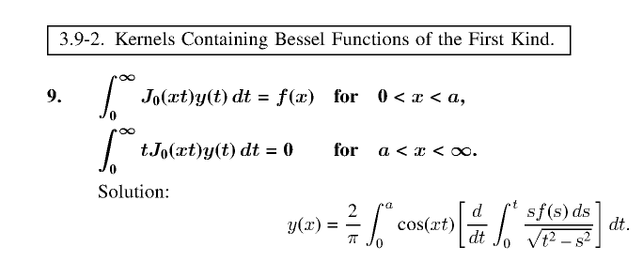

where we can think of y(t) = t-1A(t) of Sned 3.2.1-2 so think A(t) = t y(t). For a=1, this solution is exactly that of either the Beltrami or the Sned method! Hurray! Jackson's 1999 blue book does not mention Polyanin's 1998 book. I'm sure he knows about it now.
Nasim and Aggarwala (1984) may have a better solution to these duals. This I think is shown in Mandal's book (Google books). They seem to just use the Hankel and some integral representations.

Now I will do the details of Sned's φ development. The first four pencil checks done on scratch and we come to the claim under p 75A about the "automatic" thing. Looking at 3.2.2, our goal is that it be automatic that G(ρ) = 0 when ρ > 1, just as he says. Now 75A has the famous discontinuous J0 integral two times, the first time with a = 1, the second time with a = t. Thus, the first integral is 0 when ρ < 1. The second integral is 0 when ρ < t. We know from the φ' integral that t < 1, so ρ < t < 1, so this integral is also 0. So we have now proven that form 3.5.1 automatically satisfies 3.2.2 which is the second of our pair of interest. Now we look again at p 75 A in the case ρ < 1, and we can of course do both integrals to get 3.5.4 (if you don't see a calc here, I did it on scratch).
The next step of course is to jam our special φ form into the other dual equation 3.2.1 which is 3.5.5 which we do without regard to which of the two ranges we care about. It is all as before, except for the extra ξ-1 factor. So we get a new version of 75A with this extra factor, then we use 2.1.15 for the two integrals. But this is NOT what Sned wants to do, though you do get a result. Instead, he wants you to install 3.5.1 itself, not 3.5.2 which is post parts. When you do this, you get

F(ρ) = $^{\int_{0}^{∞}{}}$dξ ξ-1J0(ξρ) {ξ $^{\int_{0}^{1}{}}$dt φ(t)cos(ξt) }

= $^{\int_{0}^{1}{}}$dt φ(t) $^{\int_{0}^{∞}{}}$dξ J0(ξρ) cos(ξt)

where now our Jo cos integral appears which is evaluated in 2.1.13. Notice that t < 1 in the second integral. If ρ > 1, then ρ > t for all t, so we can evaluate the integral as 1/$\sqrt{ρ2-t2}$ and this gives result 3.5.7. If ρ < 1 then we break up the t integral like this:

= [ $^{\int_{0}^{ρ}{}}$dt φ(t) + $^{\int_{ρ}^{1}{}}$dt φ(t) ] $^{\int_{0}^{∞}{}}$dξ J0(ξρ) cos(ξt)

Now in the first integral we have t < ρ for all t so we evaluate the integral at ρ > t and get 1/$\sqrt{ρ2-t2}$again. The second integral has t > ρ with t < 1, so we have ρ < t < 1 hence ρ < 1 which means integral is 0. Thus we arrive at 3.5.6. Now for ρ < 1, we have shown that 3.2.1 appears this way

$^{\int_{0}^{ρ}{}}$dt φ(t) 1/$\sqrt{ρ2-t2}$ = f(ρ) which is 3.5.8

We can now apply our Chapter 2 result (I pasted then edited)

S1: $^{\int_{a}^{x}{}}$dt φ(t) / [ρ2 - t2]1/2 = f(ρ) interval for x,t is [0,b]
=> φ(t) = (2/π)∂t { $^{\int_{0}^{t}{}}$dρ ρ f(ρ) / $\sqrt{t2-ρ2}$} // which is 3.5.9

Then the solution of our duals is this

A(ξ)/ξ = (2/π)$^{\int_{0}^{1}{}}$dt cos(ξt) [∂t { $^{\int_{0}^{t}{}}$dρ ρ f(ρ) / $\sqrt{t2-ρ2}$}]

and this is the "famous" result which I just leave "as is", agrees with Sned and Polyanin.
Notice that part of this procedure was the useful definition of the functions G(ρ) and F(ρ) each of which is defined for all ρ, even though in 3.2.1 and 3.2.2 only one part of each integral appears in the set of dual integral equations. That is to say, we make these definitions:

F(ρ) ≡ $^{\int_{0}^{∞}{}}$dξ ξ-1J0(ξρ)A(ξ) 0 < ρ < ∞
G(ρ) ≡ $^{\int_{0}^{∞}{}}$dξ J0(ξρ)A(ξ) 0 < ρ < ∞

and the duals are

F(ρ) = f(ρ) ρ < 1
G(ρ) = 0 ρ > 1

Why the Hankel Transform cannot solve the dual equations.

Now let's try the Hankel method for solving these same duals. I paste my Hankel then edit, adjusting things for the F(ρ) definition above

F(ρ) = $^{\int_{0}^{∞}{}}$dξ ξ-1 J0(ξρ) [F0(ξ)ξ2] // expansion
[F0(ξ)ξ2] = ξ2 $^{\int_{0}^{∞}{}}$dρ ρ J0(ξρ) F(ρ) // projection

Now I let [F0(ξ)ξ2] = A(ξ) and I have

F(ρ) = $^{\int_{0}^{∞}{}}$dξ ξ-1 J0(ξρ) A(ξ) // expansion
A(ξ) = ξ2 $^{\int_{0}^{∞}{}}$dρ ρ J0(ξρ) F(ρ) // projection

The problem now is that I only know F(ρ) on part of its range, ρ < 1, so I cannot compute A(ξ) from the projection formula. Similarly, let's paste a new Hankel geared to the G(ρ) equation,

G(ρ) = $^{\int_{0}^{∞}{}}$dξ J0(ξρ) [G0(ξ)ξ] // expansion
[G0(ξ)ξ] = ξ $^{\int_{0}^{∞}{}}$dρ ρ J0(ξρ) G(ρ) // projection

Now I let [G0(ξ)ξ] = A(ξ) and I have

G(ρ) = $^{\int_{0}^{∞}{}}$dξ J0(ξρ) A(ξ) // expansion
A(ξ) = ξ $^{\int_{0}^{∞}{}}$dρ ρ J0(ξρ) G(ρ) // projection

Again, I cannot compute A(ξ) because I don't know G(ρ) on the entire range. But in this case, I do know that G(ρ) = 0 for ρ > 1, so I can replace the last line with

A(ξ) = ξ $^{\int_{0}^{1}{}}$dρ ρ J0(ξρ) G(ρ)

but still I have no solution for A.

The Nasim-Aggarwala Method (1984)

This taken from Mandal "Advances in Dual Integral Equations" Google book, p 17 (search on agg...)
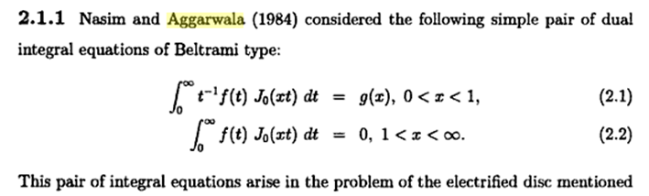

So these are the two equations we are studying, where f(t) = A(ξ), and where g(x) =f(ρ). Next they apply the Hankel to the second equation
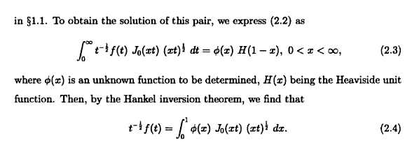
Here, their φ(x) is like my G(ρ). They use the Hankel, yes, and 2.4 is the result, but we don't know φ(x) in this range x < 1, so we cannot claim yet to know f(t). Continuing along,

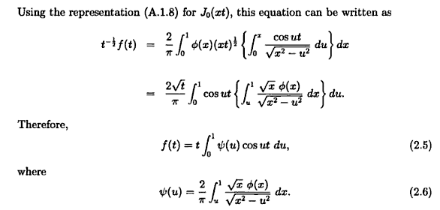

The integral representation of J0(xt) does not appear in Bateman or even Sneddon chapter 2. It is a representation where the argument is the product of two variables. We can start with GR7 page

Set a = bc to

$^{\int_{0}^{1}{}}$dx cos(bcx)/$\sqrt{1-x2}$ = (π/2)J0(bc)

Set x = y/b to get

$^{\int_{0}^{b}{}}$dy cos(cy)/$\sqrt{b2-y2}$ = (π/2)J0(bc)

J0(bc) = (2/π) $^{\int_{0}^{b}{}}$dy cos(cy)/$\sqrt{b2-y2}$

J0(xt) = (2/π) $^{\int_{0}^{x}{}}$du cos(tu)/$\sqrt{x2-u2}$ A.1.8 of Mandal

So this is nothing new, but it does "isolate" the factor t into the cosine factor, something that might be important. Mandal's next step is just a triangle integration reorder and he then has 2.5 with 2.6, I agree. But remember, we don't know φ(x) in this range. Let's keep going:

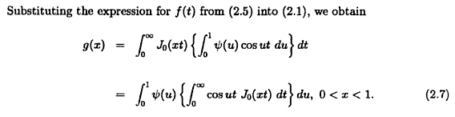
Nothing mysterious happened here. You now have our famous discontinuous integral and you break the u integration into 0,t and t,1 and install the integral results, and that finishes out the story:

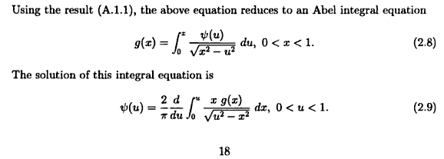

and then we are done because then 2.5 gives us f(t), the solution to our duals. I suspect this N&A derivation is considered the easiest one, dated 1984. This derivation does differ from Sned's p 74-5 method which is also fairly direct.

B. Solution of a similar Dual Integration Pair

This new pair is 3.5.15-16 and it differs from the previous pair only in that it has ξ where the previous had ξ-1 in the first equation. This time the helper function is called χ instead of φ, and when the dust settles, the solution is given as 3.5.19. He claims this dual pair relates to his "second basic problem", but I am not concerned with that connection right now.
Now let's find this pair in Polyanin: it is the very next entry.

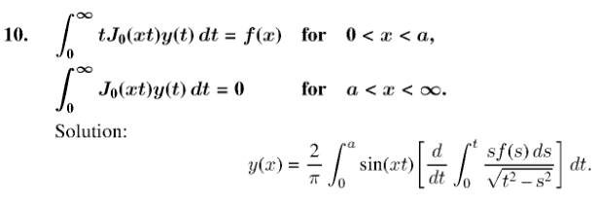

Here we identify y(t) = ψ(t) . If we compare Poly's result with Sned 3.5.19, they disagree!!! Poly has that d/dt sitting there, Sned has no d/dt! It seems unlikely that both results are correct. Sned derives his result right there, though I did not trace it. Hmm... Polyanin gives no reference at all for either of these results. A quick scratch effort did not show any immediate way to make both be correct, such as doing parts. And a web search did not turn up this pair of equations, nor is it in Bateman, so I leave this disagreement on hold for a while.

OK, let's now do the details of Sneddon's derivation. He first states the dual pair in 3.5.15,16. Then in 3.5.17 he puts in a sine instead of a cosine and χ instead of φ. He adds χ(0) = 0 which I am uncertain of. Why can you require this? Leave for the moment and move on. Now let's jam this sine thing into our same second dual equation (range on it is ρ > 1) and we will get

$^{\int_{0}^{∞}{}}$dξ J0(ξρ) [$^{\int_{0}^{1}{}}$dt χ(t) sin(ξt) ] = $^{\int_{0}^{1}{}}$dt χ(t) { $^{\int_{0}^{∞}{}}$dξ J0(ξρ) sin(ξt) }

This integral appears on page 28 which tells us it vanishes if ρ > t . But we have ρ > 1 > t, so ρ > t and so the integral is 0 and we therefore "automatically" satisfy the second dual with our assumed "form". Agreed. Now we go to the first of the dual pair and integrate by parts. So our first task is this

ψ(ξ) = $^{\int_{0}^{1}{}}$dt χ(t) sin(ξt) = – ξ-1 $^{\int_{0}^{1}{}}$dt χ(t) ∂tcos(ξt)

= – ξ-1 { χ(1)cos(ξ) - χ(0) - $^{\int_{0}^{1}{}}$dt χ'(t) cos(ξt)

I will keep the χ(0) for now. Insert this thing now into the first of the duals (valid ρ < 1) to get

$^{\int_{0}^{∞}{}}$dξ ξ J0(ξρ) ξ-1 { $^{\int_{0}^{1}{}}$dt χ'(t) cos(ξt) - χ(1)cos(ξ) + χ(0) }

= $^{\int_{0}^{∞}{}}$dξ J0(ξρ) { $^{\int_{0}^{1}{}}$dt χ'(t) cos(ξt) - χ(1)cos(ξ) + χ(0) }

= $^{\int_{0}^{1}{}}$dt χ'(t)$^{\int_{0}^{∞}{}}$dξ J0(ξρ) cos(ξt) - χ(1) $^{\int_{0}^{∞}{}}$dξ J0(ξρ) cos(1ξ) + χ(0) $^{\int_{0}^{∞}{}}$dξ J0(ξρ)cos(0ξ)

so now we have our discontinuous integral three times. Which ones vanish? Integral on page 27. We vanish if ρ < thing. In the second integral ρ < 1 so it vanishes. But not so in the third since ρ not < 0. So we keep the third integral which is

$^{\int_{0}^{∞}{}}$dξ J0(ξρ) = 1$\sqrt{ρ2-02}$ = 1/ρ

As for the first double integral, break into two parts so we have (always ρ < 1)

[ $^{\int_{0}^{ρ}{}}$dt χ'(t) + $^{\int_{ρ}^{1}{}}$dt χ'(t) ]$^{\int_{0}^{∞}{}}$dξ J0(ξρ) cos(ξt) = $^{\int_{0}^{ρ}{}}$dt χ'(t)/ $\sqrt{ρ2-t2}$
t < ρ t > ρ

The second integral vanishes and the first integral is then 1/$\sqrt{ρ2-t2}$ so get right side. I have then shown that, for ρ < 1,

$^{\int_{0}^{∞}{}}$dξ ξ J0(ξρ) ψ(ξ) = $^{\int_{0}^{ρ}{}}$dt χ'(t)/ $\sqrt{ρ2-t2}$ + χ(0)/ρ = f(ρ)

which I write as

[f(ρ) - χ(0)/ρ] = $^{\int_{0}^{ρ}{}}$dt χ'(t)/ $\sqrt{ρ2-t2}$

Compare this to 3.5.8 and we know the inversion is then 3.5.9, so

χ'(t) = (2/π) ∂t $^{\int_{0}^{t}{}}$dρ ρ [f(ρ) - χ(0)/ρ] / $\sqrt{t2-ρ2}$

= (2/π) ∂t $^{\int_{0}^{t}{}}$dρ ρ f(ρ)/ $\sqrt{t2-ρ2}$ - (2/π) χ(0) $^{\int_{0}^{t}{}}$dρ / $\sqrt{t2-ρ2}$

= (2/π) ∂t $^{\int_{0}^{t}{}}$dρ ρ f(ρ)/ $\sqrt{t2-ρ2}$ - (2/π) χ(0) (π/2)

= (2/π) ∂t $^{\int_{0}^{t}{}}$dρ ρ f(ρ)/ $\sqrt{t2-ρ2}$ - χ(0) = ∂t h(t) - χ(0)

which has the form

d/dt [ χ(t) - h(t)] = - χ(0)

Integrate both sides from 0 to t and get

[ χ(t) - h(t)] - [ χ(0) - h(0)] = - χ(0)t

But we can see that h(0) = 0 so this says

χ(t) = h(t) + χ(0) (1-t)

so I am stuck with this second term! Let's now install this into our ψ(ξ) result to get

ψ(ξ) = $^{\int_{0}^{1}{}}$dt sin(ξt) [h(t) + χ(0) (1-t)] = $^{\int_{0}^{1}{}}$dt sin(ξt) h(t) + χ(0) $^{\int_{0}^{1}{}}$dt sin(ξt) (1-t)

and so this last term messes things up. It is equal to

$^{\int_{0}^{1}{}}$dt sin(ξt) (1-t) = -sin(ξ)/ξ2 + 1/ξ

So now I finally have to face the question I avoided earlier: Why can we assume χ(0) = 0? Here are some words: " Let's make the ansatz that we can write ψ(ξ) as shown in 3.5.17 including χ(0) = 0. When we get done, we will see if this ansatz is born out as being valid. Well, our result is 3.5.18, and indeed, it has the property that χ(0) = 0. " OK, I guess I will buy into that argument for now.
Question: why in this development do we have χ'(t) in p 77C, while in the previous development we ended up with φ(t) in 3.5.6

How would the Nasim-Aggarwala derivation go with this dual pair?

We now have t1 in 2.1 instead of t-1, but 2.2 is the same, so the opening moves are exactly the same! So we should be able to get down to 2.4 with everything the same. Then let's install the same integral rep for J0 and continue through 2.6. Everything is the same because we have not even looked at 2.1 yet. Now if we install 2.6 into our new 2.1 (which now has t f(t) = t2 f(t)/t ) we get the first line of 2.7 but with an extra factor t2 in the t integral and I think this makes the dt integral diverge, and so this method is not going to fly! I dimly recall a Stak trick of doing parts somewhere, but let's not try to fish for that. Instead, how about finding the paper of N-A and seeing what they did! (This section is blanked from the Mandal book and I cannot find Mandal on line anywhere).
So first task is to find the reference.

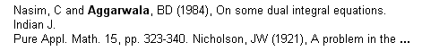

I have it, the pdf was first in the list. They start off with the previous pair of equations in 2.1, but regrettably they don't treat the second case! The only treatment of it I have so far is that of Sneddon.

I have just discovered errata for Polyanin's 1998 edition

http://eqworld.ipmnet.ru/En/info/errata.htm

but my thing is not in it! I think I found the 1998 edition in Russian, I can perhaps check on this particular dual pair in it and see what I see.

(1) There was no section 3-9.2 in the 1998 book. And that book was only 432 pages long, whereas the new one is 1143 as I well know.

Anthony M.J. Davis Emeritus

65. A translating disk in a Sampson flow; pressure driven flow through concentric holes in parallel walls, Quart. J. Mech. Appl. Math., 44(1991), 471-486.

Marriott no have. Fascinating, there is no source anywhere on this!

Here is from a 1987 Mandal paper I now have. In his opening section he has this

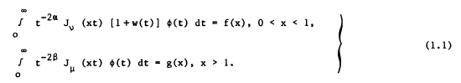

But then in later sections he treats special cases of this thing. Here is one such special case:

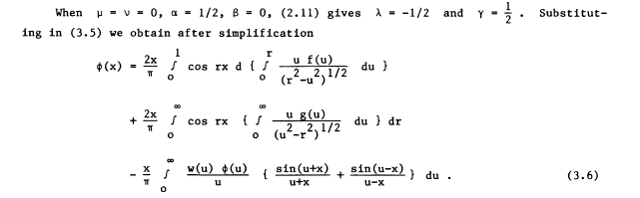

If I set w = g = 0, only the first term survives and we seem to get our usual answer, where I assume that d{ } = ∂r{..}dr. So this is the form with the cos and with the derivative. Now look at his next special case:
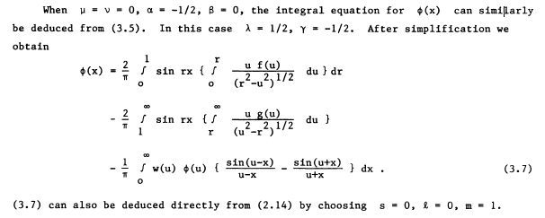

This is my case of interest! As before, I set g = w = 0 and only the first term survives. This is the sin thing, and as Sned says, there is no derivative. So this is first confirmation of Sned! More ammunition that Polyanin has a problem. I just fired off an email to these two authors, shall be interested to see what happens. My first ever email to Russia I think. Notice the missing "dr" above on second line. Even if you have driving functions in both equations, neither produces a d/dr according to 3.7 above. { Email was sent 7.25, as of today 8.16 I have gotten no response. I think it's a defunct website. }

3.6 Methods based on integral representation of harmonic functions.

Methods above means "methods of solving the charged disk problem".

(1) If we just write the potential in "Sneddon form" 3.6.1 (see Section 3.5 above) with origin at some point in space (no metal surfaces nearby, so no disk here), then it is true that V(ρ,z) is harmonic, being an azisym Laplace solution. Since there is no charge density in the z = 0 plane 3.6.2 is certainly true. Remember that the function φ(t) is an intermediate or "helper function" in the Sneddon solution. We continue on page 78 and A,B,C they are all scratch checked. Step C reminds me of the Weber form for the disk in Jackson, but I don't see a simple connection. Notice that we are suddenly causing "complex variables" to appear inside the integral. These arise simply because we wrote cos(ξt) in 3.6.2 in the usual exponential notation. Obviously, although complex numbers appear in p 78C, we know the imaginary part must come out being 0 since the potential is real. On page 78 Sned outlines just the start of charged disk development that he will return to later in the book, Section 7.5 where the Smythian Form is given by 3.6.3 with φ(t) being the helper function we used in the first pair dual analysis. This work was circa 1949 and involved an imposter Green!

(2) A second method starts with the mean value theorem looking statement 3.6.5 which he associates with "Whittaker's Solution of Laplace's equation". This is discussed in WW page 383 in my hard copy. WW show that the integral around a circle of any function f(z + ixcosθ + iysinθ, θ) is a Laplace equation solution.

F(x,y,z) = $^{\int_{0}^{2π}{}}$dθ G(z + ixcosθ + iysinθ, θ)

It is not clear to me how, from this, we arrive at 3.6.5. Perhaps it is some cylindrical coordinates analog of the Whittaker result above. Maybe a combination of the mean value theorem and this thing, so that you get V in both places.
OK, let it go. The point is that one can use this as the starting point for yet another charged disk solution, and he gives the whole thing on page 79.

