Sneddon Chap 4 notes: Dual Integral Equations PhL 7.26.10

4.1 Introduction. 1
4.2 Dual Integral Equations of the Titchmarsh Type [84] 2
4.2.1 Peter's Solution [ 1961] of Titchmarsh Type Duals [84] 3
4.2.2 Titchmarsh's Special Case Solution [ 1948 ] [86] 6
4.2.3 Noble's Special Case Solution [ 1958] [88] 7
Starting off. 7
Verify the Parameters. 9
Can I find this Noble case in Polyanin? 11
Case (a) β = 0 and 0 < α < 1 [89] 12
Case (b) α = 0 and 0 < β < 1 [90] 14
Comment on restrictions on the Modified Hankel. 15
4.2.4 The Gordon-Copson Solution of the Noble problem [ 1954, 1961] [91] 16
Case (a) : 0 < α-β [92] 18
Case (b) : 0 < β-α [92 bot] 19
4.3 Functions derived from solutions of Dual Integral Equations 19
4.4 Azisym Special cases 19
4.5 Dual Integral Equations with Trig Kernels [ p 98 ] 20
4.6 Dual Integral Equations with extra weight function 23
Noble 1963a: the approach here is get a Fred 2 integral equation for A(u). 24
4.6.2 System of Algebraic Equations. 24
4.6.3. Integral equation for χ1(x). 24
4.7 The General Problem 24
4.7.1 Reduction to the Solution of Two integral equations 26
4.7.2 The Multiplying Factor Method 28
4.7.3 The Integral Representation Method 29
4.7.4 Identification of the Operators 29
4.8 Approximate Solutions to Dual Integral Equations 29
4.9 Simultaneous Dual Integral Equations 30
Appendix A. Digression on K and I being triangular: 31

4.1 Introduction.

We get the idea of thinking of f(x) as two functions, one of interval left and one on the right. He then reviews some situations of the past which I skip for now.
Then on page 82 we are ready to start. We shall deal with two equations, each with a certain kernel K defining its operator L (word just hung at 100% cpu, I had to kill it and restart, perhaps a Google desktop problem which is now indexing my djvu files...) . Now in 4.1.7 he adds an extra w(x) weight function to the first equation, and we can just consider the weight as part of one of the kernels.
In 4.1.12 Sned defines f(x) and g(x) over the full range of x by setting these functions equal to the integral operators acting on the solution function A(u). Sned's quiet way of implying this is simply to have no restriction (such as x > 1) next to the equation. If you knew A(u), then you would know f and g over full range just from these definitions. We can think of f = (f1,f2) and g = (g1,g2) where we are thinking of the range sets (I1, I2). Then the functions prescribed are f1 and g2. There must exist what I call "the partner functions" f2 and g1. They must exist because, once you find A(u), you can compute them right from their definitions! He points out that sometimes you are more interested in learning the partner functions that you are in learning A(u). Here is an obvious example: In the charged disk problem, A(u) is the coefficient in a certain Smythian Form for the potential; f1 is the potential on the charged disk (= constant, this is in the z=0 plane); g2 is the charge density outside the charged disk also in the z = 0 plane (=0). What we are very interested in for this problem are these two items: f2 = the potential in the z=0 plane outside the disk, and g1 = the charge density on the disk!!! It is true that if we want to know the potential everywhere, then yes, we have to determine A(u) and then do the Smythian form integral.
This section then ends with a little recast job, but things are very confused. First we talked about L1 and L2 in 4.1.4-5 where the driving functions were λ and μ. But then we suddenly switched gears to having Lω and L as our two operators, as shown in 4.1.12 (these are the ones defined as f and g) . Now in 4.1.14 we are doing a hybrid of notations. We are talking the second equation of the pair 4.1.12, but the driving function is called μ, as it was for L2 in the opening section. So OK, suppose we can find a solution ONLY of the second equation of the dual pair 4.1.12, call that a(u), with μ as the driving function. This is what 4.1.14 says. This equation allows that μ may exist on (0,1), but we are only using its x>1 persona in 4.1.14. Now surely there is some dual solution A(u) so we can surely at least define α = A-a as in p 83A. Thus, A = a + α. What happens when we stuff this into both of 4.1.12? Well, we get ( I am using function names as Hilbert space vectors, so operators and vectors ) [ the idea here is that we assume we have found a, and we seek α so we can then know A = a+α ]

Lω(a+α) = λ => Lωα = λ - Lωa ≡ ν 4.1.14
L(a+α) = μ => Lα=0 4.1.15

So I agree with 4.1.14 and 15 and 16 and 17. Since we know μ and λ and L and ω, we could in theory do the computation of 17 which says ν = λ - LωL-1μH, and then we have simplified things in that now only one of our equations has a driving function. But part of the cost was we had to solve La = μ first so that we know a = L-1μ to use in our ν expression. But all OK. [ having now read up to the Copson section below, I have not seen this method yet used. ] [ I don't think it was ever used.]

4.2 Dual Integral Equations of the Titchmarsh Type [84]

The kernels here are Jμ and Jν, each with its own power function as a second factor, exponents are 2α and 2β, as shown in 4.2.1 and 4.2.2. Seems a reasonably broad class of kernels to ponder. Tit in 1948 only did the case μ = ν, but here we are being a little more general.
As our first step we write out the dual equations

$^{\int_{0}^{∞}{}}$du u-2α A(u) Jμ(xu) = F(x) x < 1
$^{\int_{0}^{∞}{}}$du u-2β A(u) Jν(xu) = G(x) x > 1

But Sned wants us to rescale things at this point and write

A(u) = uψ(u) f1(x) = 22α x-2α F(x) g2(x) = 22β x-2β G(x)

then our duals take this form

22α x-2α $^{\int_{0}^{∞}{}}$du u-2α+1 ψ(u) Jμ(xu) = f1(x) x < 1
22β x-2β $^{\int_{0}^{∞}{}}$du u-2β+1 ψ(u) Jν(xu) = g2(x) x > 1

and we recall our modified Hankel which was

2α μ-α $^{\int_{0}^{∞}{}}$dx x1-α J2η+α(μx) f(x) = Sη,α { f(r); μ }

Change int var to u, then change μ to x, then double α everywhere

2α x-α $^{\int_{0}^{∞}{}}$du u1-α J2η+α(xu) f(u) = Sη,α { f(r); x }

22α x-2α $^{\int_{0}^{∞}{}}$du u1-2α J2η+2α(xu) f(u) = Sη,2α { f(r); x }

Then select η so that 2η+2α = μ, so η = μ/2-α

22α x-2α $^{\int_{0}^{∞}{}}$du u1-2α Jμ(xu) ψ(u) = Sμ/2-α,2α { ψ(r); x }

Our first equation then reads the following, and then the second line is obvious

Sμ/2-α,2α { ψ(r); x } = f1(x) x < 1 4.2.4a
Sν/2-β,2β { ψ(r); x } = g2(x) x > 1 4.2.4b

Remember that we cannot simply "invert" at this point because we don't have full range for either equation for the mod Hankel. [ If we knew partner function f2 we could invert the first equation; or, if we know partner function g1, we could invert the second equation. ]

4.2.1 Peter's Solution [ 1961] of Titchmarsh Type Duals [84]

We start by simply defining λ as shown in 4.2.6 and writing two of our I,S,K rules top page 85, and I assume this has been done correctly. Notice that in each of these two rules, the S's on the LHS match those we just got above. Notice also that the S's on the RHS are the same! Right off the bat now I am going to jump to my matrix notation because it makes everything very much clearer!

We use a symbolic 2-component vector notation where the upper component is x in (0,1) and the lower is x in (1,∞). Here are some vectors we might use

F1 ≡ $\left(\begin{matrix}f1 \\ 0\end{matrix}\right)$ G2 ≡ $\left(\begin{matrix}0 \\ g2\end{matrix}\right)$ F = $\left(\begin{matrix}f1 \\ f2\end{matrix}\right)$ G = $\left(\begin{matrix}g1 \\ g2\end{matrix}\right)$ Ψ = $\left(\begin{matrix}ψ1 \\ ψ2\end{matrix}\right)$

Here then are the following fully solved duals

S1Ψ = F
S2 Ψ = G

where we know that each Si, being a mod Hank matrix, is invertible. Our prescribed duals are these

[S1 Ψ]1 = f1 or [S1ψ](x) = f1(x), x in I1
[S2 Ψ]2 = g2 or [S2ψ](x) = g2(x), x in I2

while the other two equations are

[S1 Ψ]2 = f2 or [S1ψ](x) = f2(x), x in I2
[S2 Ψ]1 = g1 or [S2ψ](x) = g1(x), x in I1

We want to find two matrices I and K such that IS1 = KS2 ≡ S so we have

IS1 Ψ = IF or S Ψ = I F
KS2 Ψ = KG S Ψ = KG

A key idea is that we require I to be lower triangular and K to be upper triangular. Assume that we can find candidates for such I and K. Then we have

S Ψ = IF = $\left(\begin{matrix}I11 & 0 \\ I21 & I22\end{matrix}\right)$$\left(\begin{matrix}f1 \\ f2\end{matrix}\right)$ = $\left(\begin{matrix}I11 f1 \\ *\end{matrix}\right)$ => [S Ψ]1 = I11 f1

S Ψ = KG = $\left(\begin{matrix}K11 & K12 \\ 0 & K22\end{matrix}\right)$$\left(\begin{matrix}g1 \\ g2\end{matrix}\right)$ = $\left(\begin{matrix}* \\ K22g2\end{matrix}\right)$ => [S Ψ]2 = K22 g2

When we talk about vector component [Q]1 , we are implying Q(x) where x lies in (0,1), etc. Thus, we can rewrite the last two objects on the right above as

[S Ψ]1 = I11 f1 => S ψ(x) = $^{\int_{0}^{1}{}}$du I11(x,u) f1(u) = $^{\int_{0}^{1}{}}$du I(x,u) f1(u), x in I1
[S Ψ]2 = K22 g2 => S ψ(x) = $^{\int_{1}^{∞}{}}$du K22(x,u) f1(u) = $^{\int_{1}^{∞}{}}$du K(x,u) f1(u), x in I2

In our notation, I11 refers to the matrix elements in the upper left part of matrix I, but obviously the values of these matrix elements are just I11(x,u) = I(x,u), so there is no need to maintain the 11 subscript.

We then have

S Ψ = $\left(\begin{matrix}I11 f1 \\ K22 g2\end{matrix}\right)$ ≡ $\left(\begin{matrix}h1 \\ h2\end{matrix}\right)$ = H

which we can invert to get our final solution

Ψ = S-1H // get Ψ ie ψ = S-1 ( h1 ∪ h2)
[S1 Ψ]2 = f2 // get the two partner functions
[S2 Ψ]1 = g1

Now, in the case that S1 and S2 are the two mod Hankel integral operators shown in 4.2.1 and 4.2.2, which is called by Sned the "Titchmarsh type" dual equations, it turns out that the triangular I and K matrices are those Erdelyi-Kober operators which themselves are basically the fractional integral transforms. The fact that we have IS1 = KS2 ≡ S is a property of these operators, as shown in p 85 A. Once this is established, the solution falls out.
If you try to take I = 1 and K = S1S2-1 as the candidate I and K, K in general is not triangular so things don't work out. That is, each Si is a "square matrix" so this product is square, not triangular.

Here then are the h components, in an older notation

H = $\left(\begin{matrix}h1 \\ h2\end{matrix}\right)$ = $\left(\begin{matrix}I11 22α x-2α F(x) \\ K22 22β x-2β G(x)\end{matrix}\right)$

He is able to do a little combining of the external factor with the I and K here to get this as

H = $\left(\begin{matrix}h1 \\ h2\end{matrix}\right)$ = $\left(\begin{matrix}22α x-2α I'11 F(x) \\ 22β x-2β K'22 G(x)\end{matrix}\right)$ or h = h1 ∪ h2 = ( h1(x), h2(x))

where I' and K' are a little simpler than I and K and appear in 4.2.8, so we can write our solution in this same notation as

A(u) = u S-1{ 22α s-2α I' F(s) ∪ 22β s-2β K'G(s); x }

= u S-1 [22α s-2α I' F(s) ] ∪ u S-1 [22β s-2β K' G(s) ]

All very doable. In each half of the union, we have to do one inner integral (such as I' F ), and then the outer integral S-1 on that. The outer integrals appear in Sned as 4.2.10 and then the inner integrals are 4.2.13,14. The section ends with the usual comment that if we have a range where things don't converge, we adjust using the parts trick as represented by some of Sned's Appendix A formulas.

Now Sned says that Peters himself (1961 paper) did not do the problem in this full generality, but did the following special case

α = -ω/2 β = 0

so his duals were these:

$^{\int_{0}^{∞}{}}$du uω A(u) Jμ(xu) = F(x) x < 1
$^{\int_{0}^{∞}{}}$du A(u) Jν(xu) = G(x) x > 1

so basically he was doing the problem of a power in the first equation only.

Just a bit more on notation. When I write

H = $\left(\begin{matrix}h1 \\ h2\end{matrix}\right)$ = a vector with two components called "upper and lower"

H(x) = $\left(\begin{matrix}h1(x) \\ h2(x)\end{matrix}\right)$ = the same vector, where we understand that x = 0,1 for the h1 and 1,∞ for h2

h(x) = h1(x) ∪ h2(x) = a piecewise function over all x made by combining the two pieces.

4.2.2 Titchmarsh's Special Case Solution [ 1948 ] [86]

He considered this special case

$^{\int_{0}^{∞}{}}$du u-2α A(u) Jν(xu) = F(x) x < 1
$^{\int_{0}^{∞}{}}$du A(u) Jν(xu) = G(x) x > 1

which is like the later Peters, but μ = ν here so this is a simpler case. So Sned just applies our general solution to this special case. The outer integrals are shown in 4.2.17 (the union of two terms) The two inner integrals for h1 and h2 are shown in 4.2.18.
Now we see a technical issue arise. We have this general form

h1 ~ Iη1,-α F h2 ~ Kη2,+α G

Therefore, if both F and G driver functions are present, you are going to have to deal with the "parts stuff" in one or the other of these hi integrals! If α < 0 and G = 0, then you are clean with h1 and you get the simple answer which is presented in 4.2.22 (ie, no parts action required). A special case occurs when F = 0 and α < 0 but α > -1, then you get 4.2.23 which has one derivative ∂t sitting in it. But for general α < 0, you have to do parts n times and the h2 integral is then 4.2.20 with that Dn thing, and 4.2.21 is the total answer for A(u), all when α < 0.
Similarly, if α > 0, you have to do parts with the h1 term as in 4.2.24 and the total answer is then given in 4.2.26.
Sned then looks at the special case 0 < α < 1. This brings in a single ∂t as shown top page 88. He then does parts to remove this thing which results in a shift in the J order and we get 4.2.27. He then looks at the two sub cases F = 0 and G = 0 and gives a result for each. One of these cases replicates a Busbridge 1938 solution (Beltrami was 1880's ).
So in this section all we did was apply our general Peters solution to this special case, and then we learned how to do parts to handle negative second indices on the I and K operators.

4.2.3 Noble's Special Case Solution [ 1958] [88]

Starting off. This is the full Peters case but limited to μ = ν. As in the Peters solution, we start off with

S1 Ψ = F
S2 Ψ = G

and then we want to find two matrices I and K such that IS1 = KS2 ≡ S so we have

IS1 Ψ = IF or S Ψ = I F
KS2 Ψ = KG S Ψ = KG

and now we focus just on this fact

IF = KG // which is p89 A

We then write

I [ F1 + F2 ] = K [ G1 + G2 ]

=> I F1 + I F2 = K G1 + K G2
=> K G1 – I F2 = I F1 - K G2 ≡ Φ = $\left(\begin{matrix}φ1 \\ φ2\end{matrix}\right)$ (*)

K $\left(\begin{matrix}g1 \\ 0\end{matrix}\right)$ – I $\left(\begin{matrix}0 \\ f2\end{matrix}\right)$ = I $\left(\begin{matrix}f1 \\ 0\end{matrix}\right)$ - K $\left(\begin{matrix}0 \\ g2\end{matrix}\right)$ = $\left(\begin{matrix}φ1 \\ φ2\end{matrix}\right)$

Now remember that the functions f1 and g2 are prescribed in their respective regions. Thus, we know how to compute Φ:

Φ = $\left(\begin{matrix}φ1 \\ φ2\end{matrix}\right)$ = I $\left(\begin{matrix}f1 \\ 0\end{matrix}\right)$ - K $\left(\begin{matrix}0 \\ g2\end{matrix}\right)$ = I F1 - K G2 = $\left(\begin{matrix}I11f1 \\ 0\end{matrix}\right)$ - $\left(\begin{matrix}0 \\ K22g2\end{matrix}\right)$ = $\left(\begin{matrix}I11f1 \\ - K22g2\end{matrix}\right)$

Knowing Φ, it turns out that we can compute "the partner functions" g1 and f2 using the other equation in (*) which is this

Φ = $\left(\begin{matrix}φ1 \\ φ2\end{matrix}\right)$ = K $\left(\begin{matrix}g1 \\ 0\end{matrix}\right)$ - I $\left(\begin{matrix}0 \\ f2\end{matrix}\right)$ = K G1 – I F2

and we now use the usual triangular sense of the K and I matrices to say

Φ = $\left(\begin{matrix}φ1 \\ φ2\end{matrix}\right)$ = $\left(\begin{matrix}K11 & * \\ 0 & *\end{matrix}\right)$ $\left(\begin{matrix}g1 \\ 0\end{matrix}\right)$ - $\left(\begin{matrix}* & 0 \\ * & I22\end{matrix}\right)$ $\left(\begin{matrix}0 \\ f2\end{matrix}\right)$ = $\left(\begin{matrix}K11g1 \\ 0\end{matrix}\right)$ - $\left(\begin{matrix}0 \\ I22f2\end{matrix}\right)$ = $\left(\begin{matrix}K11g1 \\ -I22f2\end{matrix}\right)$

which we can write -- just as we did in the Peters section --

φ(x) = K g1(x), x in I1 // which is 4.2.32
φ(x) = - I f2 (x), x in I2 / which is 4.2.34

where Sned uses the very strange notation Φ1(x) = φ(x) = φ1(x) ∪ φ2(x).

We can treat each of these two equations as a matrix equation within its respective subspace. We know that the triangular nature of each matrix is maintained if you go to the subspaces, so inverses exist. Then we can just write

g1(x) = K-1 φ(x), x in I1 // or φ1 = K11g1 => g1 = K11-1 φ1
f2(x) = I-1 φ(x), x in I2 // or φ2 = I 11g1 => f2 = I11-1 φ2

So this then gives us expressions for the previously unknown "partner functions" g1 and f2.

Looking back at these earlier statements

I F = S Ψ full range
KG = S Ψ full range

We can write our solution Ψ in either of two ways

Ψ = S-1 I F = S' I F = S" F // which is 4.2.35
Ψ = S-1 K G = S' K G = S''' G // which is 4.2.33

where we used 12A to invert S, then we used 17A for S' I = S" and 18A for S' K= S'''. (Below I will back and fill and show all parameter labels on all the operators. )

So let's review how you solve this problem using the Noble method:

• compute Φ from the prescribed functions. This costs you two integrals:

Φ ≡ $\left(\begin{matrix}φ1 \\ φ2\end{matrix}\right)$ ≡ I $\left(\begin{matrix}f1 \\ 0\end{matrix}\right)$ - K $\left(\begin{matrix}0 \\ g2\end{matrix}\right)$ = I F1 - K G2

• compute g1(x) according to the algorithm, which costs you one integral

g1(x) = K-1 φ(x), x in I1

• the solution is then this, which costs you one more integral.

Ψ = S''' G

So we have a total of four integrals (I think)

Verify the Parameters for the Noble Solution. So, we now have a "full" understanding of the development in terms of nice matrix notation. Sned does it just in equations which is fine. Now we want to go back and "fill in" the parameter values!

4.2.28 These are the duals, and we are just specializing the Peter form 4.2.4 which said

Sμ/2-α,2α { ψ(r); x } = f1(x) x < 1 4.2.4a
Sν/2-β,2β { ψ(r); x } = g2(x) x > 1 4.2.4b

Our only specialization is μ = ν. Thus we have

S1 = Sν/2-α,2α
S2 = Sν/2-β,2β

When it comes to S, we steal from p 85 A which was for the full Peters solution. First we note that

λ = ν - α + β // from 4.2.6 specialized to ν = μ

Then we know that

λ - ν + 2α = ν - α + β - ν + 2α = α+β

Thus we can read off our S from p 85A, either RHS:

S = Sν/2-α,α+β

Of course we also want to do our I and K, again from p 85 A. This time we need

λ - ν = ν - α + β -ν = β-α

λ - ν/2 - β = ν - α + β - ν/2 - β = ν/2 - α

Thus we read off from p 85 A that

I = Iν/2+α,β-α

K = Kν/2-α,α-β

Using our labels so far, I have thus confirmed p 88 C and D, 4.2.29, p 89A. The labels just recur in later equations until we get down to 4.2.33 where we have to do some work. Recall from above

Ψ = S-1 I F = S' I F = S" F // which is 4.2.35
Ψ = S-1 K G = S' K G = S''' G // which is 4.2.33

So first we need (and make use of 12A)

S' = S-1 = Sν/2-α,α+β-1 = Sη',α'-1 = Sη'+α',-α' = Sν/2+β,-α-β

where we used

η' = ν/2-α α' = α+β so η' + α' = ν/2-α + α+β = ν/2+β

hence the far right labeling. Next we have to compute

S' I = Sν/2+β,-α-β Iν/2+α,β-α (*)

and for this we use 17A which says

Sη'+α',β' Iη',α' = Sη',α'+β'

To match our form (*) we must have

η' = ν/2+α; α' = β-α ; η'+α' = ν/2+β; β' = -α-β

Is this viable? If we add the first two equations we get the third so OK! Then we have

α' + β' = β-α -α-β = -2α

S" = S' I = Sν/2+β,-α-β Iν/2+α,β-α = Sν/2+α,-2α // agrees with 4.2.35

Now let's do it the other way. We want

S''' = S' K = Sν/2+β,-α-β Kν/2-α,α-β (**)

and we now use 18A which says

Sη',α' Kη'+α',β' = Sη',α'+β'

To match our form (**) we must have

η'= ν/2+β α'= -α-β η'+α'= ν/2-α β' = α-β

As before, adding the first two equations gives the third, so we have a match. Then

Then we have

α' + β' = -α-β +α-β = -2β

S''' = S' K = Sν/2+β,-α-β Kν/2-α,α-β = Sν/2+β,-2β // agrees with 4.2.33

So here is a summary of all our results related to the Noble solution

S1 = Sν/2-α,2α
S2 = Sν/2-β,2β
S = Sν/2-α,α+β
I = Iν/2+α,β-α
K = Kν/2-α,α-β
S' = Sν/2+β,-α-β
S" = Sν/2+α,-2α
S''' = Sν/2+β,-2β

We are now 100% checked down to the pencil line on page 89.

Can I find this Noble case in Polyanin? Well, here it is (Peters with μ = ν ), but there is a serious limitation on the rang of α and β. For example, this works for α = 0 β = 1/2 or β = 0 α = -1/2.

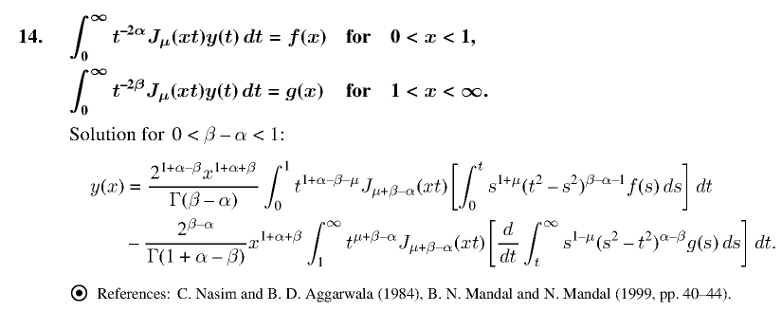

Polyanin just copied this particular ranged solution from the 1984 paper shown. I have this N&A paper and they do indeed show the above as:

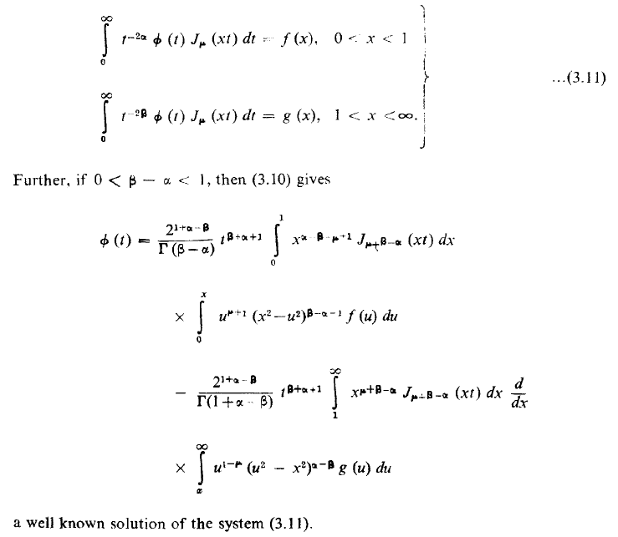

This simpler result requires a restriction on the quantity β-α as you see .

Now Sned continues the Noble solution section with two special cases:

Case (a) β = 0 and 0 < α < 1 [89]

We then have from the above list

S1 = Sν/2-α,2α
S2 = Sν/2,0
S = Sν/2-α,α
I = Iν/2+α,-α
K = Kν/2-α,α
S' = Sν/2,-α
S" = Sν/2+α,-2α
S''' = Sν/2,0

First task is to compute Φ

Φ = $\left(\begin{matrix}φ1 \\ φ2\end{matrix}\right)$ = I $\left(\begin{matrix}f1 \\ 0\end{matrix}\right)$ - K $\left(\begin{matrix}0 \\ g2\end{matrix}\right)$ = I F1 - K G2

which we can write as a single equation this way

Φ(x) = I f1(x) - K g2(x) = Iν/2+α,-α f1(x) - Kν/2-α,α g2(x)

We have to worry about I because -α is negative, so we end up with a derivative in that term. Using 2.4.25 Sned claims to get p 89B where you see this derivative. He then replaces the rescaled driver functions with their original forms F and G. We are still in the process of computing what I called Φ (and what he calls Φ1 for some reason). The integrals are written out in 4.2.37. He then writes my

Φ1 = K G1 p 90 B
G1 = K-1 Φ1 4.2.38

Our solution is then given by

Ψ = S''' G = Sν/2,0 G p 90 C

Now go back to the start of Section 4.2 above where we wrote

As our first step we write out the dual equations

$^{\int_{0}^{∞}{}}$du u-2α A(u) Jμ(xu) = F(x) x < 1
$^{\int_{0}^{∞}{}}$du u-2β A(u) Jν(xu) = G(x) x > 1

But Sned wants us to rescale things at this point and write

A(u) = uψ(u) f1(x) = 22α x-2α F(x) g2(x) = 22β x-2β G(x)

These ARE our equations of interest here, but we have μ = ν and β = 0. Notice that the rescaling definitions here agree with the top of page 90. So our whole Noble section has concerned these duals:

$^{\int_{0}^{∞}{}}$du u-2α A(u) Jν(xu) = F(x) x < 1
$^{\int_{0}^{∞}{}}$du u-2β A(u) Jν(xu) = G(x) x > 1

and our Case (a) then concerns these duals

$^{\int_{0}^{∞}{}}$du u-2α A(u) Jν(xu) = F(x) x < 1 0 < α < 1
$^{\int_{0}^{∞}{}}$du A(u) Jν(xu) = G(x) x > 1

So we set A(u) = uψ(u) and the answer is then 4.2.39. The result is quite complicated, here is what you have to do:

• compute Φ(x) as per 4.2.37 // two messy integrals

• compute g1 from Φ(x) as per 4.2.38 // integral, then a derivative

• compute A as per 4.2.39 // two integrals

Can I find this Case (a) in Polyanin? Well, he has something for when the second equation has no driver function: Sadly, Polyanin gives no reference -- a weak point in their Handbook I think. You have no way to go and check on one of their claimed results.

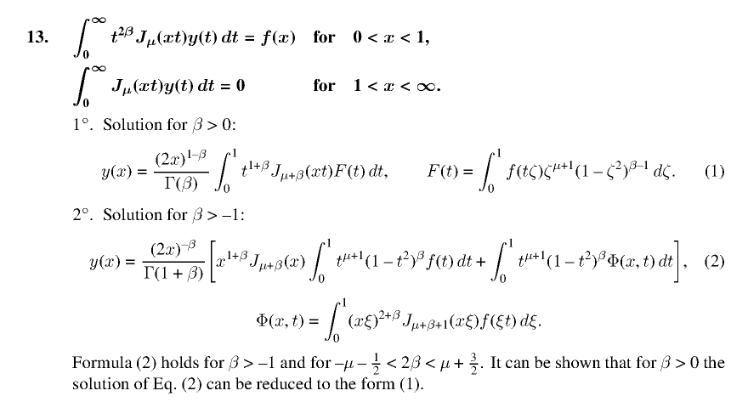

Polyanin really doesn't have all these fancy duals that Sneddon is methodically processing out!

Case (b) α = 0 and 0 < β < 1 [90]

This is a similar section with similar results. I have had enough Noble! The problem here is this one

$^{\int_{0}^{∞}{}}$du A(u) Jν(xu) = F(x) x < 1
$^{\int_{0}^{∞}{}}$du u-2β A(u) Jν(xu) = G(x) x > 1 0 < β < 1

Comment on restrictions on the Modified Hankel.

Something I now notice is that Sned, on page 30 where he talks mod Hank, does not talk about any restrictions on the two parameters η and α . Perhaps this is the problem one runs into with my simple method. Our only reference on mod Hankel is E&K 1940 which is Quart. J. Math. On Marriott I can at least see this paper sitting there

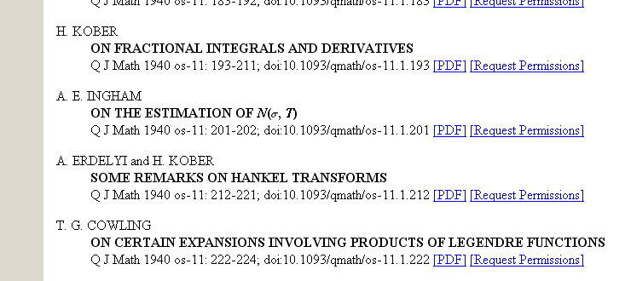

But of course it won't let me have the PDF. I wonder how this would go in person at Marriott? At least I have the title of the paper. But this google book,

Integral transforms of generalized functions and their applications
By R. S. Pathak

has some comments, but pretty heavy on the math. Things like existence proofs. At least he says this much:

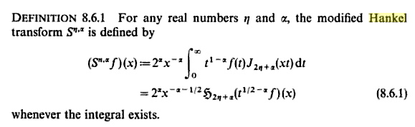

where the key phrase is "whenever the integral exists". I guess I would have to just "try" my method in some case to see if it works or not.

4.2.4 The Gordon-Copson Solution of the Noble problem [ 1954, 1961] [91]

Thankfully this is the last "solution" on Sneddon's agenda. Recall that our duals were these:

S1ψ = f1 valid on I1 S = I S1 = KS2 = IF = KG
S2ψ = g2 valid on I2

We can rewrite the above as full range results ( using my 2 component notation)

S1Ψ = F
S2Ψ = G

In the Noble solution we had these two alternative solutions

Ψ = S-1 I F = S' I F = S" F // which is 4.2.35
Ψ = S-1 K G = S' K G = S''' G // which is 4.2.33

Let's focus just on the following pieces of the above

Ψ = S' I F
Ψ = S' K G

where

S' = S-1 = Sν/2+β,-α-β

Gordon-Copson opens with this idea:

Ψ = S'Φ where Φ is unknown

So we know ahead of time that Φ = I F and Φ = K G are the right solutions, but since we don't know both parts of F or G, we cannot compute Φ from these equations directly. Our task, then, is to find some other way to compute Φ, and once we have Φ, we shall insert into the above Ψ = S'Φ and then we know Ψ and the problem is solved.

[ I suspect this is why Sned used Φ1 in the Nobel section, so he could use Φ here without confusion. ??]

So we are supposed to take the above Ψ and stuff it into our first dual S1Ψ = F to get

S1 S' Φ = F // which is 4.26 left

But then we go off and use 15A to compute

S1 S' = I' = Iν/2+β,α-β

which is a new I object for our ever-growing family. Thus we have

S1 S' Φ = I' Φ //which is 4.2.46 right

and here then is our full result

F = S1 S' Φ = I' Φ //which is 4.2.46 I' = Iν/2+β,α-β

[ Question: it seems that we could just say Φ = IF so F = I-1Φ and therefore I' = I-1. Let's see if this is correct. From p 52 we have that (In,a)-1 = In+a,-a. Here we start with I = Iν/2+α,β-α as in p 88C which equation I write as I S1 = KS2. Then set n = ν/2+α and a = β-α to get n+a = ν/2+β and -a = α-β, so this tells us that (Iν/2+α,β-α)-1 = Iν/2+β,α-β . And this agrees with I' shown above! ]

[ In general, a triangular matrix like I might not be invertible in the finite-N world if some diagonal element is 0. In the infinite dimensional world, I think this never happens. I is basically an Abel transform, and we know it has an inverse transform. ]

Similarly we get

G = S2 S' Φ = K' Φ //which is 4.2.47 K' = Kν/2-α,β-α

Now I need to make up my own stuff here to fill in some gaps. You see this is the I' case above. Write

I' Φ = F => Φ = I'-1F

Now expand the following way:

Φ = I'-1F = I'-1( F1 + F2) ≡ I'-1 F1 + I'-1 F2 ≡ Φ1 + Φ2 .

so we then have (recall that M triangular => M-1 triangular in same sense)

Φ1 + Φ2 = Φ = $\left(\begin{matrix}φ1 \\ φ2\end{matrix}\right)$

Φ1 = I'-1 F1 : $\left(\begin{matrix}φ11 \\ φ12\end{matrix}\right)$ = $\left(\begin{matrix}* & 0 \\ * & *\end{matrix}\right)$$\left(\begin{matrix}f1 \\ 0\end{matrix}\right)$ = $\left(\begin{matrix}c \\ d\end{matrix}\right)$

Φ2 = I'-1 F2 : $\left(\begin{matrix}φ21 \\ φ22\end{matrix}\right)$ = $\left(\begin{matrix}* & 0 \\ * & *\end{matrix}\right)$$\left(\begin{matrix}0 \\ f2\end{matrix}\right)$ = $\left(\begin{matrix}0 \\ a\end{matrix}\right)$

The above three lines tell us that

φ1 = φ11+ φ21 = "c" = [I'-1 F1]upper = [I'-1]upper f1 // this is p 92 A

What this means is that on the far left we have x in (0,1) and on the right, the matrix-vector sum is only over the range (0,1). You see this in 4.2.48 where he has a typo I have fixed. You can think of the kernel here as defined on (0,1) if you install the Heaviside.

Now let's write the other equations like this:

Φ1 + Φ2 = Φ = $\left(\begin{matrix}φ1 \\ φ2\end{matrix}\right)$

Φ1 = K'-1 G1 $\left(\begin{matrix}φ11 \\ φ21\end{matrix}\right)$ = $\left(\begin{matrix}* & * \\ 0 & *\end{matrix}\right)$$\left(\begin{matrix}g1 \\ 0\end{matrix}\right)$ = $\left(\begin{matrix}0 \\ a'\end{matrix}\right)$

Φ2 = K'-1 G2 $\left(\begin{matrix}φ21 \\ φ22\end{matrix}\right)$ = $\left(\begin{matrix}* & * \\ 0 & *\end{matrix}\right)$$\left(\begin{matrix}0 \\ g2\end{matrix}\right)$ = $\left(\begin{matrix}c' \\ d'\end{matrix}\right)$

The above three lines tell us that

φ2 = "d'" = [K'-1 G2]lower = [K'-1]lower g2 // this is p 92 B

what this means is that on the left we have x in (1,∞) and on the right, the matrix-vector sum is only over the range (1,∞). You see this in 4.2.49 where he has a typo I have fixed. You can think of the kernel here as defined on (0,1) if you install the Heaviside.
So we now have a way to compute both elements of Φ and we have

Φ = $\left(\begin{matrix}φ1 \\ φ2\end{matrix}\right)$

φ1 = [I'-1]upper f1 // 4.2.48 is a special case of this equation
φ2 = [K'-1]lower g2 // 4.2.49 is a special case of this equation

We now know Φ and we have

Ψ = S'Φ

$\left(\begin{matrix}ψ1 \\ ψ2\end{matrix}\right)$ = $\left(\begin{matrix}* & * \\ * & *\end{matrix}\right)$$\left(\begin{matrix}φ1 \\ φ2\end{matrix}\right)$ = $\left(\begin{matrix}* & * \\ * & *\end{matrix}\right)$$\left(\begin{matrix}φ1 \\ 0\end{matrix}\right)$ + $\left(\begin{matrix}* & * \\ * & *\end{matrix}\right)$$\left(\begin{matrix}0 \\ φ2\end{matrix}\right)$
= (0,1) integral + (1,∞) integral

where the first matrix/vector product involves only components in (0,1) and the second components in the range (1,∞). We know that A = uΨ so our complete solution is the two terms shown in 4.2.51.

Here are more detailed formulas for the magic I' and K' operators we have been using:

I' = Iν/2+β,α-β => I'-1 = Iν/2+α,β-α from 10A
K' = Kν/2-α,β-α => K'-1 = Kν/2+β,α-β from 11A

Case (a) : 0 < α-β [92]

In this case, operator I'-1 has a positive second index and so needs no further processing. On the other hand, the K'-1 has a negative second index which requires some parts integrations so we end up with derivatives for this operator. If we further assume that α-β > -1, then we know that only one parts integration will be required. Thus, the expression for φ1 (Sned's Φ1) will have a single derivative and φ2 (Sned's Φ2) will not, and this is what you see in 4.2.48 and 4.2.49. This extra condition means α-β < 1 so for the single derivative results, our conditions are really 0 < α-β < 1.

Case (b) : 0 < β-α [92 bot]

In this case, operator K'-1 has a positive second index and so needs no further processing. On the other hand, the I'-1 has a negative second index which requires some parts integrations so we end up with derivatives for this operator. If we further assume that β-α > -1, then we know that only one parts integration will be required. Thus, the expression for φ2 (Sned's Φ2) will have a single derivative and φ1 (Sned's Φ1) will not, and this is what you see in 4.2.53 and 4.2.52. This extra condition means β-α < 1 so for the single derivative results, our conditions are really 0 < β-α < 1.

4.3 Functions derived from solutions of Dual Integral Equations

I understand this section ahead of time. Sometimes you don't care about the dual solution, you care instead about the unknown "partner functions". Here he derives expressions for both partner functions in two cases (each with the proper restrictions), and here we work with the duals shown in 4.3.3 which is really the Titchmarsh special case of section (2) above. As usual, he shows all the details. I think I can let this section ride, since I know exactly what it is all about.

4.4 Azisym Special cases

If we go back to Chapter 3 on the Beltrami disk, our opening problem was this classic one,

$^{\int_{0}^{∞}{}}$dξ ξ-1A(ξ)J0(ξρ) = f(ρ) ρ < 1 f(ρ) = 1 for the charged disk
$^{\int_{0}^{∞}{}}$dξ A(ξ)J0(ξρ) = 0 ρ > 1

where J0 is forced by azisym on the Smythian form. So Sned wants us to do these a little more generally:

$^{\int_{0}^{∞}{}}$dξ ξ-1A(ξ)J0(ξρ) = φ1(ρ) ρ < 1
$^{\int_{0}^{∞}{}}$dξ A(ξ)J0(ξρ) = χ2(ρ) ρ > 1

and he now uses the same idea that φ(x) = [ φ1(x), φ2(x)] = [ F(x), G(x)] on the two regions I1 and I2. So all he really wants to do here is write all the results in the simplest form possible, using perhaps our Peters general formula, or the Noble one. Actually, we are within the Titchmarsh boundary for the rest of this section where only the first equation has a power. So we get

A(u) = 4.4.4 // double integrals of F and G
φ2= 4.4.5 // these are the partner functions
χ1 = 4.4.6

The latter two involve F** and G** which are the integrals of F and G shown in 4.4.7. He then ends this little section with 4.4.8 which gives an integral of χ1 in terms of F and G, so maybe this is "the total charge on the disk".
Sned then does (starting bottom of page 97) the similar case which has ξ+1

$^{\int_{0}^{∞}{}}$dξ ξ+1A(ξ)J0(ξρ) = φ1(ρ) ρ < 1
$^{\int_{0}^{∞}{}}$dξ A(ξ)J0(ξρ) = χ2(ρ) ρ > 1

and his answers here are

A(u) = 4.4.12 // double integrals of F and G
φ2= 4.4.13 // these are the partner functions
χ1 = 4.4.14
integral of χ1 = 4.4.16 where X appearing here is an F function as shown in 4.4.17.

Whereas the first problem aligned with the electrostatics of a disk with prescribed potential on the disk and prescribed σ outside the disk (the two functions φ1 and χ2), this second problem he claims arises in the study of "stress near penny-shaped cracks in infinite elastic bodies".

4.5 Dual Integral Equations with Trig Kernels [ p 98 ]

(a) cosine case with ξ-1

We now replace Jμ(xρ) in kernels with cos(xρ) and we consider the duals 4.5.3 and 4.5.4

$^{\int_{0}^{∞}{}}$dξ ξ-1A(ξ)cos(ξρ) = φ1(ρ) = F(x) ρ < 1
$^{\int_{0}^{∞}{}}$dξ A(ξ) cos(ξρ) = χ2(ρ) = 0 ρ > 1

It seems to me if you set α = 1/2 and ν = -1/2, this should in fact just be a special case of our earlier work, but he says that something goes wrong, but he does not say what. I have looked pretty carefully at the Busbridge solution 4.2.27 and I don't see any problem with these values of α and ν.
In any event, he is going to proceed with a new idea called the Sneddon method. He is going to make use of a set of discontinuous integrals. For J1 we have p 99B which has one of the integrals being 0, but more importantly we have p 99 C&D which gives 0 in the sense of our second dual above. The reason for this may be traced to our Watson lists of special cases of the general JJ discontinuous formula,

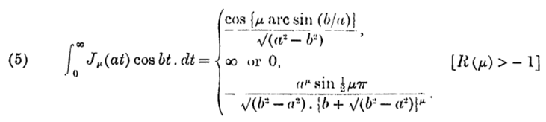

Here you see that for b > a=1, the second integral will vanish when μ = even integer! This then suggests the series form shown in 4.5.6 where the summation part will yield 0 when inserted into the second dual. The first term will give

$^{\int_{0}^{∞}{}}$dξ ξ J1(ξ) cos(ξρ)

but this looks divergent to me since J → ξ-1/2 . Later he will claim a0 = 0, so I wonder why he added this term in the first place in 4.5.6 ? So forget that first term. If we jam this form into first dual we get 4.5.7 which gives F(x) as a series in the Jacobi polys (these are those script F ones, I guess the shifted ones) as in 4.5.7. Since these polys have orthog, he can invert to get his Smythian coefficients aq as in 4.5.8 and 4.5.9. He then notes that your F(x) must be such that a0 = 0. (This could be related to the Stak stuff on the Neumann external problem where I recall similar stuff. But I already need a0 = 0 from above!) He then goes on to get a simple formula for the partner of F which is φ2 as in 4.5.12,. and the other partner χ1 as shown p 101 A.
So let's summarize: the solution of the trig duals 4.5.3,4 is given by A(u) = the series in 4.5.6 where the coefficients aq are given by 4.5.8. Sned uses Du = ∂u . So we have a single infinite series where each coefficient is a single integral of F(x) but you have to do q fancy derivatives which is a little messy. The φ2 partner function is very simple as in 4.5.12, while the other is a little more complicated.

He then turns to some special cases of the driving function F(x)

• F(x) = polynomial

• F(x) = polynomial with only even powers. Here we get a closed form finite series for each aq , and the partner functions come out being finite polynomials in certain square root containing functions.

• F(x) = cos(nπx). In this situation, we get aq = 2J2q(nπ) and a0 = J0(nπ) and

A(u) = u J1(u)J0(nπ) + rest

so here is a case where a0 ≠ 0! Then that second dual integral is going to involve

I ≡ $^{\int_{0}^{∞}{}}$dξ ξ J1(ξ) cos(ξρ)

so I guess this does NOT diverge somehow! Alpha cannot do it. Let's try it this way

I = (1/2) $^{\int_{0}^{∞}{}}$dξ ξ J1(ξ)[ eiξρ + e-iξρ] = (1/2) $^{\int_{0}^{∞}{}}$dξ ξ J1(ξ) eiξρ + cc = (1/2) J + cc

We go look this integral up in GR and find

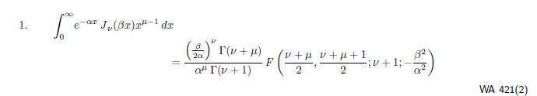

so we set μ = 2 and ν = 1 and α = -iρ and β = 1 and we get

J = (1/2α) α-2 Γ(3)/Γ(2) F(3/2, 2; 2; -1/α2) α = -iρ

= (1/2) α-3 2 F(3/2, 2; 2; -1/α2)

= α-3 F(3/2, 2; 2; -1/α2)

= (-iρ)3 F(3/2, 2; 2; 1/ρ2)

For ρ > 1, the F is well defined, and the integral J is imaginary! Therefore

I = (1/2)J + cc = 0 when ρ > 1

When ρ < 1, I don't know what happens. But in our duals, we only care about I2 where ρ > 1! So very good. This is not an integral I could find anywhere!

$^{\int_{0}^{∞}{}}$dξ ξ J1(ξ) cos(ξρ) = 0 for ρ > 1

Nor does Sned even mention this critical fact.

(b) sine case with ξ-1

Next, we have a quick shot at our same problem with cos → sin as in 4.5.22. In this case we know that

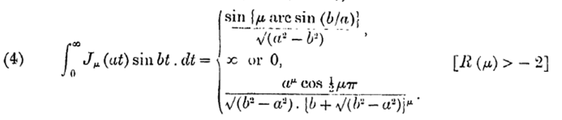

so this will be 0 for ρ > 1 (in our case) as long as μ = 1,3,5...., and this gives rise to the series form 4.5.23 where now we have only odd terms. So this series satisfies the second dual at once. He then just quotes the result for the coefficients aq which are similar to the cos case (but he does not tells us the integral analogous to p 99C).

• Special case: F(x) = Σn=1∞ bn sin(nπx), A(u) = double sum in 4.5.26.

(c) cosine case with ξ+1 ( p 103 bottom)

This is a crack problem situation and the solution to the duals is pretty simple. He shows the solution, and we get as that solution 4.5.28 where g(t) is given by 4.5.31. The partner functions are also given and each is another integral of g(t), and he wraps up with something for the integral of the χ1 partner.

Then on page 105 Sned gives another derivation of this exact same solution using a 1963a method of Tranter. I suspect then that the derivation given above is Sned's own, and he is then using Tranter just as verification, the way I do things as well. The Tranter solution is 4.5.33.

4.6 Dual Integral Equations with extra weight function

This is the Titchmarsh situation where an extra factor [ 1 + k(u) ] is added to the first dual, and where k(u) is some known arbitrary function. Since k(u) is unspecified, and since the situation is now much more complicated than in the Titchmarsh case, Sned is just going for a Fred 2 integral equation which could be numerically solved. He starts with Ψ = S H and where H = (h1,h2) which need to be found. The solution for h2 is 4.6.6, and it is for h1 that he obtains the inhomo Fred 2 equation 4.6.11 with kernel given by 4.6.10. The inhomo driving term in this Fred 2 is H(x) as developed in 4.6.9. Since the kernel integral better converge, we get now some restrictions on k(u) as shown top page 108. Once you solve the Fred 2 for h1, you have 4.6.12 as your final solution.

Case (a) -1 < α < 0.
Subcase ν = 0 and α = -1/2

Case (b) 0 < α < 1
Subcase ν = 0 and α = 1/2

All the time Sned makes contact with the work done by others in the 1955-1963 time frame.

Noble 1963a: the approach here is get a Fred 2 integral equation for A(u). He is always using those Kober operators. The result is 4.6.33 with L in 4.6.32 and driving term given in various ways.

Subcase ν = 0 and α = 1/2 p 112
Subcase ν = 0 and α = -1/2 p 112 lower down

Finally, on page 113, he considers what happens if you put the weight function now called [1 + n(u)] in the second equation instead of the first. He quotes all results, method is similar he says.

4.6.2 System of Algebraic Equations. [ p 113] This is a Tranter 1954 method which provides an alternative to solving a Fred 2 equation. I am going to skip this, perhaps it is similar to doing a Neumann solution to that integral equation. Sned says Tranter stimulated lots of activity with his early papers.

4.6.3. Integral equation for χ1(x). Logical approach if this partner is what you are after, and he does this with G = 0. I skip the details, and he treats the usual two cases
Case (a) 0 < α < 1
Case (b) -1 < α < 0.

4.7 The General Problem

Retrospective Preliminary Comment: In the paragraphs below, Sned sets us up with certain operators M1 and M2(c). These operators are then used in all the following subsections. Only in the first section does he make use of M2(1) which is a special partial triangular matrix which is then a tool for obtaining the replacement of the dual integral equations with a sequential solution of two regular integral equations. Everywhere else he uses just M2(∞). He shows how this all ties in with the Peters method, so for me there is really nothing new here except for this first section on the sequential integral equations.

This section is much more subtle than Sned makes it seem, but I think my matrix notation brings out this subtlety. So I will use my own matrix notation here to replace Sned's equations. He uses g(x) to refer to the integral over its full range, I call this vector G. We start with our duals in solved form where we know A so we know everything

L1A = F F = (f1, f2) = (F, ?) in Sned notation
L2A = G G = (g1, g2) = (h, G) in Sned notation
4.7.2 A = (A1,A2)

The duals we are given to start with are these:

[L1A]1 = f1
[L2A]2 = g2

where [L1A]1 means the "upper components" of the vector L1A, just as f1 means upper of F. Now 4.7.3 says

L1L2-1 = M1M2(∞) 4.7.3

Now we assume that L1 and L2 are "fully populated matrices" meaning that we do not have any Volterra endpoints in the duals (although as a special case I suppose we could). So the two Li matrices are "square". But what are the "shapes" of M1 and M2 ? Let m1 be the kernel of M1.

m1(x,y) = m1(x,y) H(y>0)H(y<x) = lower triangular 4.7.4

m2(x,y,c) = m2(x,y,c) H(y>x)H(y<c) = partial upper triangular 4.7.5

which looks like this on the left

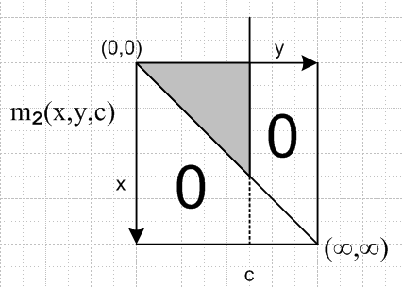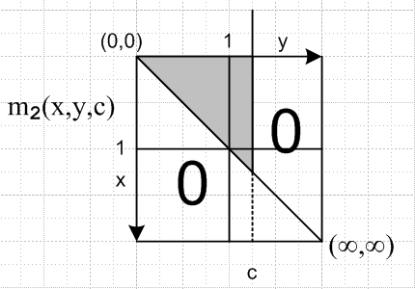

As a schematic notation, I might put x = 1 and y = 1 halfway along each direction, remembering that each axis is really all the reals. This gives us what you see on the right.

Sned is going to use c = 1 and c = ∞ in what follows, so we can draw those two matrices: m2(x,y,∞)

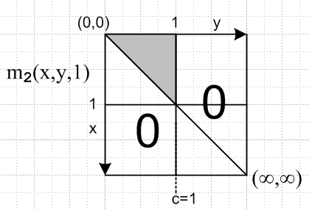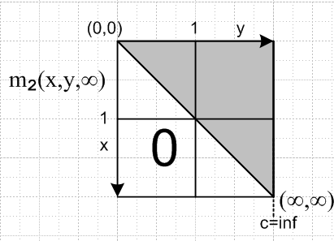

The upper left portion of both these last two matrices are the same!

We can represent our three M matrices this way

M1 = $\left(\begin{matrix}* & 0 \\ * & *\end{matrix}\right)$ M2(1) = $\left(\begin{matrix}* & 0 \\ 0 & 0\end{matrix}\right)$ M2(∞) = $\left(\begin{matrix}* & * \\ 0 & *\end{matrix}\right)$

M1 M2(1) = $\left(\begin{matrix}a & 0 \\ b & c\end{matrix}\right)$$\left(\begin{matrix}d & 0 \\ 0 & 0\end{matrix}\right)$ = $\left(\begin{matrix}ad & 0 \\ bd & 0\end{matrix}\right)$

M1 M2(∞) = $\left(\begin{matrix}a & 0 \\ b & c\end{matrix}\right)$$\left(\begin{matrix}d & e \\ 0 & f\end{matrix}\right)$ = $\left(\begin{matrix}ad & ae \\ bd & be+cf\end{matrix}\right)$

Notice these facts:

[M1 M2(∞)]11 = [M1 M2(1)]11 = ad // this fact is used
[M1 M2(∞)]21 = [M1 M2(1)]21 = bd // this fact never used

Then here are some of his next equations, all fine:

M1-1L1 = M2(∞)L2 4.7.6
L1-1M1 = L2-1M2(∞)-1 4.7.7

4.7.1 Reduction to the Solution of Two integral equations

First, reader be aware of how my notation compares to Sned's:

G = (g1, g2) = (h, G)Sned

F = (f1, f2) = (F, - )Sned

So, we start off

L2A = G => A = L2-1G // which is p 119 A

L1A = F => L1 L2-1G = F
=> [L1 L2-1G]1 = f1 // which is 4.7.9

For p 120 A I need this:

f1 = [L1 L2-1G]1 = [M1M2(∞)G]1 = [M1M2(∞)]11 g1 + [M1M2(∞)]12 g2

= [M1M2(∞)]11 g1 + G* G* = [M1M2(∞)]12 g2

But from above, we know that [M1 M2(∞)]11 = [M1 M2(1)]11 so we can say

f1 = [L1 L2-1G]1 = [M1 M2(1)]11 g1 + G* // which is p 120 A

[M1 M2(1)]11 g1 = f1 - G* //which is 4.7.11

We can regard this last result as the 11 portion of the following matrix equation,

M1 M2(1) G = $\left(\begin{matrix}ad & 0 \\ bd & 0\end{matrix}\right)$$\left(\begin{matrix}g1 \\ g2\end{matrix}\right)$ = $\left(\begin{matrix}adg1 \\ bdg1\end{matrix}\right)$ = $\left(\begin{matrix}[M1 M2(1)]11g1 \\ [M1 M2(1)]21g1\end{matrix}\right)$ = $\left(\begin{matrix}f1 - G* \\ [M1 M2(1)]21g1\end{matrix}\right)$= $\left(\begin{matrix}f1 - G* \\ *\end{matrix}\right)$

Apply M1-1 to both sides to get

M2(1) G = M1-1$\left(\begin{matrix}f1 - G* \\ *\end{matrix}\right)$ = $\left(\begin{matrix}* & 0 \\ * & *\end{matrix}\right)$$\left(\begin{matrix}f1 - G* \\ *\end{matrix}\right)$ = $\left(\begin{matrix}[M1-1]11(f1 - G*) \\ *\end{matrix}\right)$

=> h* ≡ [M2(1) G]1 = [M1-1]11(f1 - G*) // which is 4.7.12

But consider
[M2(1) G]1 = [M2(1)]11g1 + [M2(1)]12g2 M2(1) = $\left(\begin{matrix}* & 0 \\ 0 & 0\end{matrix}\right)$

= [M2(1)]11g1

So 4.7.12 says

h* ≡ [M2(1)]11g1 = [M1-1]11(f1 - G*) // [M1]11 h* = f1 - G*

Within the "1 subspace" the matrix [M2(1)]11 is upper triangular and can be inverted to give a similar shaped matrix. (With the full space, M2(1) is NOT invertible, by the way, given the matrix form above!)
So we then get

[M2(1)-1]11 h* = g1 // which is 4.7.13

So we end up now with this set of equations:

A = L2-1G // solution of integral equation G = L2A

g1 = [M2(1)-1]11 h* // solution of integral equation h* ≡ [M2(1)]11g1

h* = [M1-1]11(f1 - G*) // solution of integral equation [M1]11 h* = f1 - G*

G* = [M1M2(∞)]12 g2 // something you just compute

In words: We assumed up front that L1L2-1 = M1M2(∞) so we assume that we know all about M1 and M2 as defined in 4.7.4 and 5. This is "the big assumption". Finding the Mi and verifying that L1L2-1 = M1M2(∞) might take some work! Then since g2 is prescribed (he called it G) we know G*. Then since f1 is prescribed as well, we know h*. But then we know g1 which we did not know at the start! But then we know all of G, so we compute A, and we are done! If you only want to know partner g1, then you skip the last step and don't bother computing A. In this case, my comments show how the problem has been reduced to "solving two integral equations", which then explains the title of this section. Remember that if we know some matrix M, finding M-1 means solving an integral equation.

How does the Peters Solution fit with the method outlined just above?
This question is fully answered below; we can connect the M1 and M2 with the I and K guys.

4.7.2 The Multiplying Factor Method

This is the method that I best understand, it is just the Peters method. Start with

L1A = F F = (f1, f2) column vector // L1 ~ S1 of Peters
L2A = G G = (g1, g2) column vector // L2 ~ S2 of Peters

Assume the operators M1 and M2(∞) of the previous section where we had

M1-1L1 = M2(∞)L2 ≡ L3 4.7.15 // M1-1 ~ I of Peters, M2(∞) ~ K of Peters

and we note in passing that L3-1 = L2-1 M2(∞)-1 = L1-1 M1 which is p 121 E .

So apply M1-1 to the first equation of the pair above and M2(∞) to the second equation

M1-1 L1A = M1-1F ≡ F' ( his Γ1) p 120 A
M2(∞)L2A = M2(∞)G ≡ G' ( his Γ2) p 121 C

so we end up with these two full-matrix equations

L3A = F' = (f1', f2')
L3A = G' = (g1', g2')

We can write out the upper and lower components of each of these equations

[L3A]1 = f1' // ≡ γ1
[L3A]2 = f2'

[L3A]1 = g1'
[L3A]2 = g2' // ≡ γ2

Meanwhile, we have "shape information" on our two M operators, to wit, both are triangular

M1 = $\left(\begin{matrix}* & 0 \\ * & *\end{matrix}\right)$ M1-1 = $\left(\begin{matrix}* & 0 \\ * & *\end{matrix}\right)$ ( like I) M2(∞) = $\left(\begin{matrix}* & * \\ 0 & *\end{matrix}\right)$ (like K)

Therefore we have

F' = M1-1F = $\left(\begin{matrix}* & 0 \\ * & *\end{matrix}\right)$$\left(\begin{matrix}f1 \\ f2\end{matrix}\right)$ = $\left(\begin{matrix}[M1-1]11 f1 \\ *\end{matrix}\right)$ => f1' = [M1-1]11 f1 4.7.14L // = γ1
G' = M2 G = $\left(\begin{matrix}* & * \\ 0 & *\end{matrix}\right)$$\left(\begin{matrix}g1 \\ g2\end{matrix}\right)$ = $\left(\begin{matrix}* \\ [M2]22 g2\end{matrix}\right)$ => g2' = [M2]22 g2 4.7.14R // = γ2

So given the two prescribed functions f1 and g2, we know the two functions f1' and g2' so we can regard them as "prescribed" as well. So consider these two component equations from above

[L3A]1 = f1' = [M1-1]11 f1 ≡ h1 // = γ1
[L3A]2 = g2' = [M2]22 g2 ≡ h2 // = γ2

so we have H = (h1,h2) which Sned calls γ

L3A = H p 121 D => A = L3-1H = the solution to the problem 4.7.16

A few comments are in order:

(1) I claim that, by not making use of the triangularity of the matrices, Sned cannot support his claim 4.7.16 without resorting to writing out all the details of the integrals that represent M1 and M2, so he keeps sweeping this painful detail under the rug, which becomes very non-painful in the matrix view.

(2) He fails to mention that this is exactly the Peters method that we painfully learned earlier.

4.7.3 The Integral Representation Method

In the previous section we has A = L3-1H and we had two ways to write L3-1 in terms of our known operators. He now gives h = (h1, h2) the new name g. The point is that we are now supposed to regard the equation A = L3-1H as an "integral representation" of A, such that we replace the unknowns A1 and A2 by the unknowns I call h1 and h2. If we can find these two unknowns, then we know A. But we found these two unknowns in the last section, namely

h1 = [M1-1]11 f1
h2 = [M2]22 g2

We are warned that one of our two forms of L3-1 may "not exist" and the other might. So somehow this "method" seems pretty much the same as our multiplier method above. I suspect he means by the term "integral representation" a single integral. I guess if all operators exist, something like L3-1 = L2-1 M2(∞)-1 can be regarded as such a single integral. It certainly was in the Peters situation where this equation read S-1 = S2-1K and we could use Sned's Appendix A to get S-1 as a single integral operator.

4.7.4 Identification of the Operators

OK, here finally he shows how the Peters solution fits into the general methods just reviewed. He "identifies" the operators M1 and M2, and N1 and N2 which make them up. So at least Sned gives us closure on this connection. See my comment (2) above.

4.8 Approximate Solutions to Dual Integral Equations

This is the kind of material that the true practitioner just study, while the passing dabbler can just browse. Two methods are discussed here.

(1) This is attributed to King (1936). We noted earlier that if you have a weight function as in 4.8.1, it is likely that you will never find a closed form solution to your duals and approximation is required. Basically the solution outlined here is perturbation theory in terms of the weight function ε inside the kernel which is assumed to be "small". With ε = 0, the solution is A(0) which we assume we know exactly! ( so it pays, as I think Polyanin said, to try to template yourself around a known problem). Then you make a perturbations series as in (4.8.5). Had Schiff done this, he would show a smallness parameter λ more explicitly. You then end up with an iterative method as shown p 124 C. At each level of the perturbation theory, you have a dual integral equation problem where the second equation driver function is 0. This can be formally solved as shown in 4.8.6 so that each level A(r+1) of the solution can be computed from the previous level A(r) as an integral involving ε and known operators. The reader is told to go read King's paper for example.

(2) This variational method is that of Noble 1958b and is quite elaborate, I did not read it through. You start off with a dual pair like 4.8.8,9 where we allow some single-variable factors as part of the kernel. But this is a very narrow case because we have L1 = L2 ! Also, he is going to assume that L1-1 = L1. This is what allows him to somehow replace the duals with a single integral equation. The variational part comes in on page 126 where he defines J(e) as a functional of the function e and sets δJ = 0 and all that stuff. I skip all the rest, this is a very specialized method for a very specialized case. I suppose Sned felt it was an interesting and different method (being variational) so he threw it in.

4.9 Simultaneous Dual Integral Equations

What Sned means by this title is shown in 4.9.1. The first "dual equation" is actually a system of n equations (with label i), and each equation involves some Jμi Bessel function and has some prescribed driving function pi(x). In each equation, n different unknown functions Ψi appear, weighted by some coefficients cij . The second "dual equation" is also a system of n equations, where each equation is for a specific Ψi unknown with its Jμi Bessel function, and the driving function is 0. In other words, the second equation set is much simpler than the first set. I could come up with some hyper matrix notation for all this stuff if I were serious about it.
So don't confuse this with some kind of n-fold set of equations where you have n intervals which generalize (0,1) and (1,∞). Here we still have only those two intervals, and they are still I1 and I2.
Why you would care about such a problem is unclear, but Sned throws it in to flesh out his chapter on duals. It is another "different" problem so it warranted a home in his monograph. Erdogan and Bahar 1964 are the people who did this one. Sned produces 4 page of details. In 4.9.2 he seems to expand each Ψi in certain Bessel's with a set of coefficients Ajm which he then wants to solve for. He produces a horrible set of equations from which you are supposed to find these Aik as shown in 4.9.5. The index sum goes to infinity, so it is some kind of infinite matrix equation for Aik which no doubt is just a reflection of the integral equation nature of things. At this point Sned thankfully ceases and desists, mentioning several groups who have attacked such a matrix equation in various contexts.
He then starts over with a slightly different problem. Here, in place of Jμi(xy) we have sin(xy) or cos(xy) so things would seem a bit simpler. This is shown in 4.9.6. This time, he assumes a solution for as shown in 4.9.7a for Ψi which is a sum of Bessel functions, motivated of course by our knowledge of the Weber discontinuous trig integrals, which he requotes. The coefficients are Aij. We end up with 4.9.13 which is again an infinite matrix equation for the Aij , albeit a much simpler one than we got in our first example.
I don't know if this system case is mentioned in Polyanin.

And so, finally, ends this very long and difficult Chapter 4.

Appendix A. Digression on K and I being triangular:

Let's look at our three "matrices" called S, I and K a little more closely, and we are not so interested in the parameters (which I will suppress) as in the "matrix sense".

First here is S:

S f(u) = $^{\int_{0}^{∞}{}}$dt [ 2α u-α t1-α J2η+α(ut)] f(t)

Because the integral runs the full range, we can think of S as a "normal matrix" and we have the form

S f(u) = $^{\int_{0}^{∞}{}}$dt S(u,t) f(t)

[S f]u = Σt=0∞ Sutft

If we think of our matrix index values as all real numbers in 0,∞, then we have a pretty clear matrix interpretation here, and it seems that the matrix Sut is "fully populated", which means for any value of u and t, Sut is some non-zero number (barring random 0's here and there, perhaps).

Now consider the K operator which has this form (the lower end point is u, not 0 ! )

K f(u) = $^{\int_{u}^{∞}{}}$dt { 2 / Γ(α) * u2η t-2η-2α+1 [t2 - u2] α-1 } f(t)

= $^{\int_{u}^{∞}{}}$dt k(u,t) f(t) = $^{\int_{0}^{∞}{}}$dt [k(u,t)H(t-u) ] f(t)

so our matrix has this form, which we shall see soon is upper-right triangular

Kut = k(u,t)H(t-u)

Finally, consider the nature of operator I (the upper end point is u, not ∞ ! )

I f(u) = $^{\int_{0}^{u}{}}$dt i(u,t) f(t) = $^{\int_{0}^{∞}{}}$dt [ i(u,t) H(u-t)]f(t)

which says that

Iut = i(u,t)H(u-t)

Now we want a graphic interpretation of these matrices K and I. Here it is;

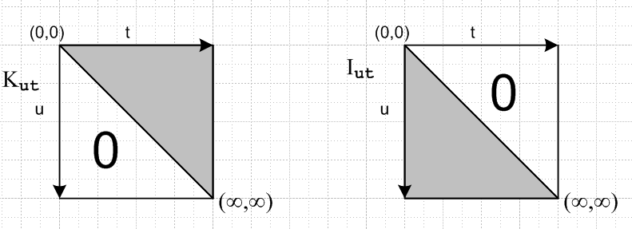

We want our x = (0,1) portion of vector components to be the first components, and this means we want our matrices to have (0,0) as the upper left corner. So K is upper-right triangular, and I is lower-left triangular. Since we never care about matrices which are triangular in "the other direction", only one of the modifying words is needed. For example, K is an upper triangular matrix, or right triangular matrix.

What about K-1 and I-1 : What do we know about the inverse matrices I-1 and K-1 in terms of "shape"? Well, according to the usual rule I-1 = cof(IT) /det(I), the result is not obvious to me. Luckily, I have "been here before" and in my matrix binder, section 7, Theorem M30, we learn that "the inverse of a triangular matrix is a triangular matrix of the same sense". I quote there the proof and it is very non-obvious indeed! Note the a triangular matrix of either type is generally non-zero on the exact diagonal. For an infinite dimensional matrix, that is a bit of a hazy issue.
Thus K-1 has the same shape and K, and I-1 has the same shape as I.
It is also true that the product of two triangular matrices is a triangular matrix of the same shape.

