Coulomb Wave Functions PhL 12.15.08

Summary of this document 1
1. Relation to the Coulomb-potential radial Schrodinger equation. 4
2. Frobenius Solution to get indices 5
3. The F_{L} Solution 5
4. Show that the CWF equation reduces to the Confluent HG equation: 6
5. Computing the large-ρ limit of F_{L} : determining the value of C_{L}. 8
6. The G_{L} Solution. 11
7. Bateman to the rescue? 13
Reference: J. Math. Phys. 40, 6145 (1999); DOI:10.1063/1.533083 14
8. Goldberger Watson to the rescue? 14
Whitaker Functions 14
Goldberger Watson Comments 16

Milton Abramowitz did this Coulomb WF A&S Chapter 14 himself, page 538.

Summary of this document

1. First we show that the A&S Coulomb Wave Function equation (CWFE) in variable ρ and function w(ρ) is equivalent to the radial Schrodinger equation (RSE) for a V(r) ~ 1/r "Coulomb" central potential, in variable r and function χ(r), where the true SE radial function is Rl(r) = χl(r)/r. The connection is that χ(r) = w(ρ) with no multiplying functional factors, where ρ = kr with k being the momentum of the colliding (or orbiting) particle of reduced mass μ. Whereas the RSE has a χ'(r) term, the CWFE has no w'(ρ) term. The dimensionless parameter η appearing in the A&S ODE is the same as n in Schiff, namely, η = n = (μ/2) ZZ'e2/k.

2. Next, we note that the CWFE has a regular singularity at ρ=0. We attempt a Frobenius series solution at this point ρ=0 and compute the indices to be r = -L and L+1 ( L = l, both used below). AS claim that the CWFE has an irregular singularity at ρ = ∞ and is therefore not a Fuchsian ODE. We do not carry through the Frobenius method for recursion relations for reasons soon to be seen.
We know on general grounds that an ODE with a regular singularity at ρ=0 will have two independent solutions of the form w1= ρL+1*Mclaurin and w2 = w1(ρ)ln(ρ) + ρ-L *Maclaurin' where w1 converges around ρ=0 and the w2 does not. This is the general notion for me of 1st and 2nd kind solutions. Both solutions are formally "regular" but AS refer to w2 as "the irregular" solution just to distinguish the two solutions.

3. We then examine the first CWFE solution which is written w1 ~ FL = CL ρL+1 ΦL(ρ) with Φ being the Mclaurin series and CL a special normalizing constant. Instead of solving for Φ directly, we digress as follows.

4. We prove that the CWFE is convertible to the Confluent Hyper Geometric Equation (CHGE). As above, the CWFE involves w(ρ) while the CHGE involves y(x). We find that the connection is then given by w(ρ) = xl+1e-x/2 y(x) where x = 2iρ, a = L+1-iη and c = 2L+2. Note that in this case, there are multiplying functional factors. We use Maple to compute the required second derivative
w" = ∂ρ2 [xl+1e-x/2 y(x) ] as part of this proof. If we take y(x) = M(a,c,x) [AS] = Φ(a,c,x) [ Bateman ], and knowing this is a Mclaurin series in x, we identify FL = CL ρL+1 ΦL(ρ) = CL ρL+1 e-x/2 Φ(a,c,x), where we now have two different functions with the name Φ. We can conclude that ΦL(ρ) is the Mclaurin series for the product of functions e-x/2 Φ(a,c,x), where again x=2iρ. For the record, then

w1(ρ) ~ FL(ρ) = CL ρL+1 ΦL(ρ) = CL ρL+1 e-iρ Φ(L+1-iη, 2L+2,2iρ) ρ = kr

where we see this Φ is evaluated at a purely imaginary argument. Since we know all about Φ from Bateman, we are happy to have this connection between FL and Φ. By the way, since the CHGE has all real constants, w1*(ρ) is also a solution,

w1*(ρ) ~ FL*(ρ) = CL ρL+1 ΦL*(ρ) = CL ρL+1 e+iρ Φ(L+1+iη, 2L+2,-2iρ) ρ = kr

and this solution has e+ikr dependence and appears in Schiff page 142 equation 21.18.

5. We then want to know the large-ρ behavior of FL(ρ). We know from Bateman that the way you do this is by using the relation Φ ~ Ψ + Ψ ' (shorthand for a long equation), and then insert the asymptotic forms for Ψ and Ψ '. When we do this lengthy calculation, we find that if we set the real normalizing constant CL(η) to a certain value, the limit is extremely simple:

FL(ρ) → sinθL = sin [ρ-ηln(2ρ) - Lπ/2 + σL ] where σL = arg Γ(L+1+iη)

This limit is of course of interest in the Coulomb scattering problem. Each partial wave L has a different phase which comes from - Lπ/2 + σL where this latter symbol is called the "Coulomb Phase Shift".

6. We then study the second solution called GL. We expect to see it as w2 = FL ln(ρ) + ρ-L Mclaurin, but this is not GL. Instead GL is defined very strangely as:

GL(ρ) = 2η/Co2(η) [ FL ln(ρ) + {ln(2) + qL(η)/ pL(η)} FL ] + ρ-L DL(η) Mclaurin

where we have added in a certain multiple of FL. The reason for the obscure "constant" functions of η is not given and seems totally mysterious as this point. The Mclaurin series is called ψ(ρ) with some recursion relation for its coefficients. With this definition, we have no idea how we might compute the large-ρ limit, but A&S claim that, amazingly, it is this:

GL(ρ) → cosθL = cos [ρ-ηln(2ρ) - Lπ/2 + σL ] where σL = arg Γ(L+1+iη)

7. Bateman produces a similar complicated function like GL in his section on "the logarithmic case" on page 261. Bateman is discussing that the "second kind" solution is peculiar because the argument c in Φ(a,c,x) is a positive integer, a fact related (I think) to the fact that ρ=0 is a regular singular point. You see this same ln(x) factor in Bateman's result and you see the correct Mclaurin series, and thoughtfully Bateman outlines how this complex formula can be derived. So the AS GL is Bateman's second solution plus an admixture of FL.

8. At this point we are still mystified by this complicated GL functional form that is required to obtain the simple asymptotic behavior GL(ρ) → cosθL, but then Goldberger and Watson come to the rescue. This rescue first requires us to accept yet another conversion of the ODE to a form called Whittaker's equation (WE). If y(a,c,x) is a solution of the CHGE, then the corresponding solution of the WE is given by f(x) = e-x/2 xl+1 y(a,c=2l+2,x). Recall that we had w(ρ) = xl+1e-x/2 y(x) where w(ρ) was for CWFE and y(x) was for CHGE. So we now have f(x) = e-x/2 xl+1 y(a,c,x) = w(ρ). So we see that the Whittaker functions f(x) are basically the same as the Coulomb Wave function functions w(ρ) apart from the change of argument x = 2iρ, so the Whittaker functions are good to deal with. On the other hand, our information store is mostly Bateman on the Φ and Ψ functions, so we want to relate the Whitakers to these. Instead of writing Whittaker functions as f(a,c,x), the notation fκ,μ(x) is used, where c = 1 + 2μ and a = 1/2 - κ + μ. In our case, this means we have μ = l+1/2 and κ = iη . So we then have:

Mκ,μ(z) = e-z/2zμ+1/2 Φ(1/2 + μ-κ; 1+2μ; z) = z1 AS 13.1.32
Wκ,μ(z) = e-z/2zμ+1/2 Ψ(1/2 + μ-κ; 1+2μ; z) = z5 AS 13.1.33

as our first and second kind Whittaker functions, so we know all about these functions! GW then define the following two functions ( Y* ≠ complex conjugate of Y, but will be so in the large x limit! )

Y = phase * eπη/2 Wk,μ(x)
Y* = phase' * eπη/2 W-k,μ(-x)

Then, using our known properties of Ψ to get the large-x limits of these things , we find that

Y → i e-iθ
Y* → - i e+iθ = complex conjugate of Y

Then, using the same FL we had in A&S, we can relate this to Φ(a,c,x) and thus to Mκ,μ(x). But, we know that Bateman gives us Φ ~ Ψ + Ψ ' (same shorthand as above), which means M ~ W + W' and we find this very simple result

FL = (Y+Y*)/2 → sinθ

where the equality is not an asymptotic limit, but an exact fact. We then DEFINE GL to be this

GL = (Y–Y*)/2i → cosθ so Y = FL + iGL and Y* = FL - iGL

where again the equality is not an asymptotic limit, but an exact fact. We now have an exact expression for GL in terms of our familiar Ψ functions. In our case with c = integer, each Ψ function include both a Φ(a,c,x) ln(x) term and a series term as in Bateman page 261. This then leads to the huge messy form of GL as given in A&S. The point is that we define GL as shown above so it has the limit cosθ, and then it comes out being the big mess shown in A&S when we just evaluate it as per Bateman. Then as shown above we find that FL + iGL = Y ~ Wk,μ(x) ~ Ψ and are not surprised to find a simple integral representation for FL + iGL as in AS.
The GW versions of F and G have an extra factor of $\sqrt{2/π}$ and -$\sqrt{2/π}$ which I have removed in the above discussion. Their method of analysis comes from a paper of Yost, Wheeler and Bright in 1936, so the Whittaker functions must have been in use by that time. Original Whittaker and Watson was 1909 (?).
So here is what we have learned. The FL function is normalized so that it → sinθ in the large r limit appropriate for scattering. The "second solution" GL is then carefully selected so it → cosθ in this same limit.

1. Relation to the Coulomb-potential radial Schrodinger equation.

The ODE is the radial SE using a Coulomb Potential 1/r. It is not the equation for Rl(r) but rather for χl(r) = r Rl(r) . This ODE appears on page 117 of Schiff as 19.2. There is no first derivative, sort of a rarity. We might as well write it out:

χ" + [k2 - U(r) - l(l+1)/r2] χ = 0 U(r) = 2μ/2 V(r) V(r) = ZZ'e2/r k2 = 2μE2

where for proton-proton scattering you would put Z = Z' = +1, and l = 0,1,2,3... Milton writes this as

w" + [1 - 2η/ρ - l(l+1)/ρ2] w = 0

so we have to do some more scaling to get into his form where k2 = 1. Try ρ = kr = dimensionless, and w(ρ) = χ(r) so that [ and r = ρ/k and 1/r = k/ρ ]

∂ρ w(ρ) = ∂rχ(r) dr/dρ = 1/k ∂rχ(r) or w' = χ'/k w" = χ"/k2

so the second equation then becomes

χ"/k2 + [1 - 2η/ρ - l(l+1)/ρ2] χ = 0
χ" + [k2 - 2ηk2/ρ - l(l+1)k2/ρ2] χ = 0
χ" + [k2 - 2ηk/r - l(l+1)1/r2] χ = 0

which we compare to our starting point of

χ" + [k2 - (2μ/2) ZZ'e2/r - l(l+1)/r2] χ = 0

This comparison then shows that we need

2ηk = (2μ/2) ZZ'e2 => η = (μ/2) ZZ'e2/k

Now recall from Schiff's collision chapter that we used

n = (μZZ'e2/2)/k // dimensionless, real, not an integer

so we then just have η = n. When we find a solution w(ρ), we say

χ(r) = w(kr) Rl(r) = χl(r) / r = wl(kr)/r

and n just appears in the result.

So, now that we know the connection to the SE and the Coulomb Problem, what are the solutions?

2. Frobenius Solution to get indices

If we try Frobenius like so

w = ρa Σk=0akρk w" + [1 - 2η/ρ - l(l+1)/ρ2] w = 0

we get this result

Σk=0 ak { (k+a)(k+a-1) ρk+a-2 + ρk+a - 2η ρk+a-1 - l(l+1) ρk+a-2 } = 0
Σk=0 ak ρk+a-2{ (k+a)(k+a-1) + ρ2 - 2η ρ - l(l+1) } = 0

Question: what is the coefficient in this sum for the power ρa-2 ? Only two terms in {..} are present for this power, and if we want this coefficient to be zero, we have to set

(a)(a-1) = l(l+1) => a = l+1 or a = -l

These are the "indices" as AS say in the first paragraph.

3. The FL Solution

Notice that ρ = 0 is a "regular singular point" since at worst a double pole in the w factor. According to my general ODE notes, at such a point there should be two solutions of the following form:

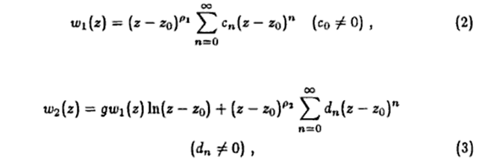

where in our case we will have ρ1 = l+1 and ρ2= -l and zo = 0. We see from AS that

w1(ρ) = ρl+1 Φl(ρ)

where Φ is a series like that shown above. We have to juggle things a bit however by changing the summation variable

Φl(ρ) = Σn=0anρn = Σk=l+1 ak-l-1 ρk-l-1

then he defines

Alk = ak-l-1

so in any event, we have our first "regular" solution which AS write this way

FL = CL ρL+1 ΦL(ρ)

The next thing they do is select a specific value for CL, but no reason is given! But I think I can now trace this down. First, our main connection between the coulomb wave function and the confluent is this:

FL(ρ) = CL ρL+1 e-iρ M(L+1-iη, 2L+2; 2iρ) ρ = kr

You have to wonder where that factor e-iρ is coming from. Suppose we define x = 2iρ, then we would have on the right above (ignoring constant factors)

xL+1 e-x/2 M(L+1-iη, 2L+2; x)

4. Show that the CWF equation reduces to the Confluent HG equation:

So maybe I should do the equation conversion myself! ( 2 hour penalty!) The CWF equation is this:

w" + [1 - 2η/ρ - l(l+1)/ρ2] w = 0

The CHG equation is this

xy" + (c-x)y' -ay = 0

We can try in the CWF equation this form

w(ρ) = xl+1 e-x/2 y(x) x = 2iρ

We need the second derivative of this thing, so make Maple compute it. But be careful:

∂ρ = dx/dρ ∂x = (2i) ∂x

∂ρ2 = (2i)2 ∂x2 = -4 ∂x2

w(ρ)" = - 4 ∂x2 [xl+1 e-x/2 y(x)]

Our CWF equation then becomes this:

w" + [1 - 2η/ρ - l(l+1)/ρ2] w = 0

- 4 ∂x2 [xl+1 e-x/2 y(x)] + [1 - 2η/ρ - l(l+1)/ρ2] xl+1 e-x/2 y = 0

But replace 1/ρ = 2i/x so the above is then

- 4∂x2 [xl+1 e-x/2 y(x)] + [1 - 4iη/x +4 l(l+1)/x2] xl+1 e-x/2 y = 0

- ∂x2 [xl+1 e-x/2 y(x)] + [1/4 - iη/x + l(l+1)/x2] xl+1e-x/2 y = 0

We want to claim that somehow this mess reduces to this form:

xy" + (c-x)y' -ay = 0

Now for Maple, I define things as follows:

f = ∂x2 [xl+1 e-x/2 y(x)];
g = [1/4 - iη/x + l(l+1)/x2] xl+1e-x/2y(x)

Then our equation above says

-f + g = 0

But then I scale things like this

f1 = f/ (xl+1 e-x/2)
g1 = g/ (xl+1 e-x/2)

and our equation is then

-f1+g1= 0

Here is the entire Maple calculation based on this:

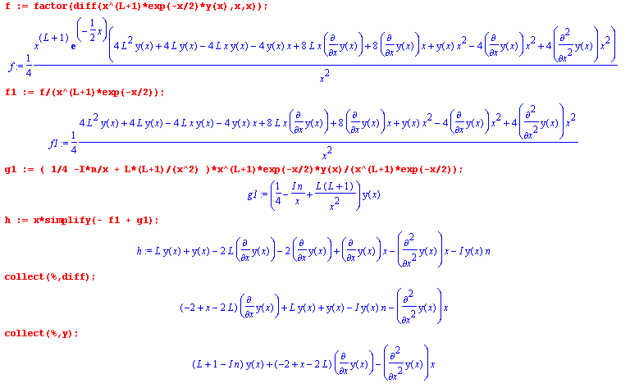
The last line is then our final equation which is then:

(L+1-iη)y + (x-2L-2)y' - xy" = 0

xy" + (2L+2 - x) y' - (L+1-iη)y = 0

xy" + (c-x)y' -ay = 0

We conclude that

a = L+1-iη c = 2L+2

So our solution to the original CWF equation will be this:

xl+1 e-x/2 M(L+1-iη; 2L+2; x)

But then we replace x = 2iρ and we have

ρL+1 e-iρ M(L+1-iη; 2L+2; 2iρ)

where I throw out a constant factor. If we multiply this by a "normalizing constant" CL we get exactly the function A&S show for FL on page 538.

5. Computing the large-ρ limit of FL : determining the value of CL.

FL is defined as follows on p 538 (with CL(η) as stated in 14.1.7)

FL = CL(η) ρL+1 e-iρ M(L+1-iη; 2L+2; 2iρ) a = L+1-iη b = 2L+2 b-a = L+1+iη

What is the large-ρ limit of this thing? This is in Bateman but let's use AS p 508 top instead (for the limit of the confluent function M). Note that we are just using the usual Bateman idea that Φ = AΨ + BΨ' to get this limit! We take the upper sign in 13.5.1 because our arg(z) = π/2 which is in the first range.

M(L+1-iη; 2L+2; 2iρ) / Γ(2L+2) → e+iπ(L+1-iη) /Γ(L+1+iη) (2i)iη-L-1 (ρ)iη-L-1

+ e2iρ /Γ(L+1-iη) (2i)-L-1-iη (ρ) -L-1-iη
so we get

FL/ Γ(2L+2) → CL(η) ρL+1 e-iρ { 1/ Γ(L+1+iη) * e+iπ(L+1-iη) (2i)-L-1+iη (ρ) -L-1+iη

+ 1/ Γ(L+1-iη) * (2i) -L-1-iη (ρ) -L-1-iη e2iρ }

= CL(η) { e+iπ(L+1-iη)/ Γ(L+1+iη) * (2i)-L-1+iη (ρ) +iη e-iρ

+ 1/ Γ(L+1-iη) * (2i) -L-1-iη (ρ)-iη eiρ }

This needs some processing at this point. Write

iα = (eiπ/2)α = eiπα/2 => (i)-L-1+iη = eiπ(-L-1+iη)/2 = e-iπ(L+1-iη)/2
(i)-L-1-iη = eiπ(-L-1-iη)/2 = e-iπ(L+1+iη)/2

Then have

FL/ Γ(2L+2) = CL(η) { e+iπ(L+1-iη)/ Γ(L+1+iη) * (2)-L-1+iη (ρ) +iη e-iρ e-iπ(L+1-iη)/2

+ 1/ Γ(L+1-iη) * (2) -L-1-iη (ρ)-iη eiρ e-iπ(L+1+iη)/2}

= CL(η) { 1/ Γ(L+1+iη) * (2)-L-1+iη (ρ) +iη e-iρ e+iπ(L+1-iη)/2

+ 1/ Γ(L+1-iη) * (2) -L-1-iη (ρ)-iη eiρ e-iπ(L+1+iη)/2}

= 2 CL(η) Re { 1/ Γ(L+1+iη) * (2)-L-1+iη (ρ) +iη e-iρ e+iπ(L+1-iη)/2 }

where in the second last line we have A + A* inside the {..}, hence 2 Re(A). Now we have to identify the precise phase inside

2iη = eiηln(2) ρiη = eiηln(ρ) e+iπ(-iη/2) = eπη/2

so we have

= 2 CL(η) Re { 1/ Γ(L+1+iη) * (2)-L-1 eiηln(2) eiηln(ρ) e-iρ e+iπ(L+1)/2 eπη/2 }

= 2 CL(η) Re { 1/ Γ(L+1+iη) * (2)-L-1 eiηln(2)+ iηln(ρ) -iρ+iπ(L+1)/2 eπη/2 }

= 2 CL(η) Re { [ 1/ Γ(L+1+iη) * (2)-L-1 eπη/2 ] [eiηln(2ρ) -iρ+iπ(L+1)/2 ] }

where we have now isolated the phasor factor. Now one more step: write

Γ(L+1+iη) = | Γ(L+1+iη) | eiσ σ = arg { Γ(L+1+iη)} then have

= CL(η) Re { [ 1/ |Γ(L+1+iη)| * (2)-L eπη/2 ] [eiηln(2ρ) -iρ+iπ(L+1)/2-iσ ] }

where we move the σ to the phase, and cancel factors of 2. But now the first [..] is real, so have

= CL(η) [ 1/ |Γ(L+1+iη)| * (2)-L eπη/2 ] cos[ ηln(2ρ) -ρ + π(L+1)/2 – σ )]

Now we see that if CL is defined as in 14.1.7

CL = 2L e-πη/2 |Γ(L+1+iη)|/ Γ(2L+2)

We then find that

FL = Γ(2L+2) * {2L e-πη/2 |Γ(L+1+iη)|/ Γ(2L+2)} * [ 1/ |Γ(L+1+iη)| * (2)-L eπη/2 ] * cos[...]

= cos[φ] where φ = ηln(2ρ) -ρ + π(L+1)/2 – σ = - θ + π/2

Now use the fact that cos(π/2 - θ) = sin(θ) and we get our final answer

FL = sin(θ) θ = ρ - ηln(2ρ) - Lπ/2 + σ σ = arg Γ(L+1+iη)

and THIS is exactly the reason for setting CL as shown ! Then the limit has unity coefficient and is just a sine! And of course in scattering theory it is this large ρ = kr limit that we really care about.
Is my result consistent with 14.5.1 of AS? Let's look at this in more detail. His expressions g and f (not to be confused with mine above! ) are series in 1/ρ so I want to keep only the first term. The leading term in the f series is f0 = 1. The leading term in the g series is g1 = b0 ~ 1/ρ. So the real first term of the large ρ limit from 14.5.1 is just this:

FL = sinθL = sin [ρ-ηln(2ρ) - Lπ/2 + σL ] where σL = arg Γ(L+1+iη)

and luckily this is exactly my result.

6. The GL Solution.

Recall that when you have a regular singular point at ρ=0, there are two regular solutions that I quoted above from my cribbed web ODE notes.

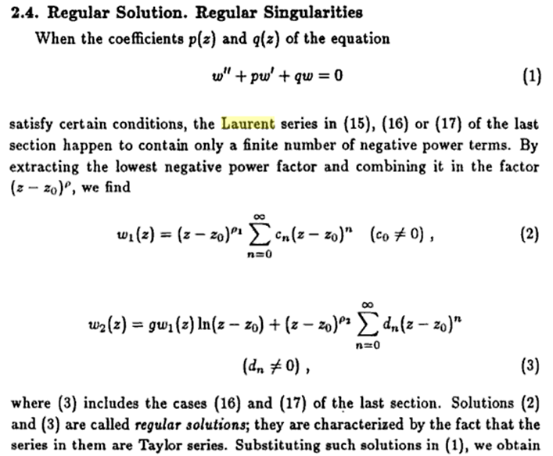

So we expect our second regular solution to have this form:

w2,L = k { FL ln(ρ) + ρ-L Σn=0 cn ρn }

If we shift the summation index to k = -L + n, the series can be written

Σn=0 cn ρn = Σn=-L ck+L ρk+L ≡ Σn=-L akL ρk+L = ψ of 14.1.17

So then we have

w2,L = k { FL ln(ρ) + K ρ-L ψ }

where we add constant K which just redefines the series coefficients. We can always add some FL to this thing and still have a second independent solution, so do this

GL = w2,L + k [ ln(2) + q/p ] FL = k FL [ ln(2ρ) + q/p] + k Kρ-L ψ

We now want to set these values for the constants

k = 2η/Co2(η) // our same CL thing, see 14.1.8 for this particular one

kK = D => second term = Dρ-L ψ ≡ θL

Then we have

GL = { 2η/Co2(η)} FL [ ln(2ρ) + q/p] + θL

and where q and p and D are certain given expressions. So we have justified 14.1.14 from first principles on a general ODE. This is in fact the second "regular solution" but they like to call it "the irregular Coulomb Wave Function" to distinguish if from FL which is the "regular Coulomb Wave Function" .
Now the next question of course is why do they select all these strange "constants"? It must involve some limit. Notice that the series ψ is not just some arbitrary series, it is a special series that solves the ODE!! We know that in the large ρ limit, we have FL→ sin(θL). so the big question is finding the limit of the series ψ! In other words, we have

GL → { 2η/Co2(η)} sin(θL) [ ln(2ρ) + q/p] + lim[θL]

More theory is needed here so that we could justify the integral representations shown on page 539, and then these could be used to find the limit of GL. In the end, I have no doubt whatsoever that all the tricky functions are chosen for exactly one reason: to get this limiting result

GL → cos(θL) as shown in 14.5.2

which then is a nice match for

FL → sin(θL)

In fact, looking at the integral representations, we might say HL = FL + iGL and the limit we must have that HL → cos + i sin = 1 ! It would probably not be too hard to show this from 14.3.1, but how do you derive 14.3.1 ?? We know from our ODE1 theory that the wronskian for the CWF equation should be a constant, and we see that this comes out 1 in 14.2.4. Getting this to be 1 might explain some of the complicated factors which appear in the definition of GL.
Is this going to be in Whittaker and Watson which I ordered yesterday? Here is their index:"

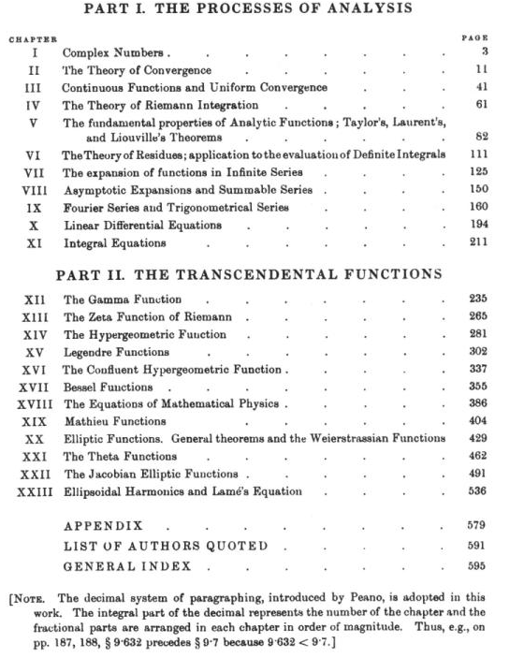

Probably it is NOT there, so I would need another Bateman like source on this subject.
These functions are used in nuclear collision analysis, and AS give one Bloch source for same, but they give no nice information source!

7. Bateman to the rescue?

Recall we have

FL = CL(η) ρL+1 e-iρ M(L+1-iη; 2L+2; 2iρ) a = L+1-iη c= 2L+2

Let's look again at page 260 where he discusses the special case where c = 2,3,4.... which is exactly our situation!! In this case, he directly states the second solution on page 261 as (13), and Bateman explains how you derive this result from an earlier integral representation. So I could probably make Bateman and A&S agree on this log solution thing. But that does not give me an explanation of the amazingly simple integral representation shown on page 539 as 14.3.1.
I just found this interesting paper abstract;

"The motivation for the present paper lies in the fact that the literature concerning the Coulomb wave functions F_{L}(ɛ,ρ) and G_{L}(ɛ,ρ) is a jungle in which it may be hard to find a safe way when one needs general formulas for the Coulomb wave functions with complex values of the variable ρ and the parameters L and ɛ. For the Coulomb wave functions and certain linear combinations of these functions we discuss the connection with the Whittaker function, the Coulomb phase shift, Wronskians, reflection formulas (L-->-L-1), integral representations, series expansions, circuital relations (ρ-->ρe^{+/-iπ}) and asymptotic formulas on a Riemann surface for the variable ρ. The parameters L and ɛ are allowed to assume complex values."

Reference: J. Math. Phys. 40, 6145 (1999); DOI:10.1063/1.533083

So there would be a place to look. A web scan shows that CWF is a very obscure topic, this function does not have a classical history behind it.

8. Goldberger Watson to the rescue?

Whitaker Functions

Once again, from AS we had:

FL = CL(η) ρL+1 e-iρ M(L+1-iη; 2L+2; 2iρ)

Look on Bateman page 248 to see how the Whittaker function is defined:

M(a;c;z) = z-c/2 ez/2 Mκ.μ(z) a = 1/2 - κ + μ c = 1 + 2μ

μ = (c-1)/2 κ = 1/2 + μ - a = 1/2 + c/2 - 1/2 - a
= c/2 - a

This is confirmed in AS 13.1.32 which I will now derive from the above

M(1/2 - κ + μ; 1 + 2μ;z) = z-(μ+1/2) ez/2 Mκ,μ(z)

In our application we have

a = L+1-iη c = 2L+2 μ = L +1/2 κ = L+1 - (L+1-iη ) = iη

so we have this connection

M(L+1-iη; 2L+2;z) = z-L-1 ez/2 Mκ.μ(z)

M(L+1-iη; 2L+2;2iρ) = (2iρ)-L-1 eiρ Mκ.μ(2iρ)

Then we can make this connection:

FL = CL(η) ρL+1 e-iρ { (2iρ)-L-1 eiρ Mκ,μ(2iρ) } = CL(η) { (2i)-L-1Mκ,μ(2iρ) }

= CL(η) 2-L-1 e-iπ(L+1)/2 Miη,L+1/2 (2iρ)

so I think the Whittaker of imaginary argument is our baby, just a constant out in front, and this function has more information! But Bateman only has a few integral representations! GW (181) does sort of confirm that FL ~ Miη,L+1/2 (2iρ) where z = 2iρ . In (183) you see that GW have normalized their F and G functions slightly differently from AS.

Now look at Goldberger Watson page 260 where we see just this value of μ. GW have switched the roles of symbols κ and k which adds some confusion. I will translate:

(174) κ = i η // GW way k = iξ

(172C) η = Mre1e2/k Mr = μ = reduced mass e1 = Ze e2= Z'e
// so GW must be setting = 1
Now, what are two independent solutions?

M(1/2 - κ + μ; 1 + 2μ;z) = z-(μ+1/2) ez/2 Mκ,μ(z)

a = 1/2 - κ + μ c = 1 + 2μ c-a = 1/2 +κ + μ

Consider this thing:

M(1/2 + κ + μ; 1 + 2μ;-z) = (-z)-(μ+1/2) e-z/2 M-κ,μ(-z)

If we think of M(1/2 - κ + μ; 1 + 2μ;z) = M(a,c,z) = y1 of Bateman page 252, then we would
say that

y1 = M(1/2 - κ + μ; 1 + 2μ;z)

y3 = ez M(1/2 +κ + μ; 1 + 2μ;- z)

Now for non-integral c, these two solutions are the same by Kummer's transform page 253. But in our case, c = 2L+2 = 2,4,6.... and so is a positive integer and we are in exactly the case discussed page 260. But all we learn there is that y2 does not exist. I suspect Kummer's is still true somehow, we we then have

Mκ,μ(z) = z+(μ+1/2) e-z/2 M(1/2 - κ + μ; 1 + 2μ;z) = z+(μ+1/2) e-z/2 y1

M-κ,μ(-z) = (-z)+(μ+1/2) e+z/2 M(1/2 + κ + μ; 1 + 2μ;-z) = (-z)+(μ+1/2) e+z/2 e-z y3

= (-z)+(μ+1/2) e-z/2 y3 = (-z)+(μ+1/2) e-z/2 y1

so if Kummer is still true, these are NOT lin indeps. Ah, but GW are using W, not M!

Now from AS 13.1.33 we have

Mκ,μ(z) = e-z/2zμ+1/2 Φ(1/2 + μ-κ; 1+2μ; z) = z1 AS 13.1.32
Wκ,μ(z) = e-z/2zμ+1/2 Ψ(1/2 + μ-κ; 1+2μ; z) = z5 AS 13.1.33

and this agrees with Bateman p 264. Bateman refers to these solutions as z1and z5 as you see. Bateman lists off other solutions, but does not say which pairs are linearly independent, and the two solutions that GW are dealing with are z6 and z8 which are W's. If these were M's, they would be about the same due to Kummer's which is Bateman page 264 (7).
But really Wκ,μ(z) and W-κ,μ(-z) are like Ψ(1/2 + μ-κ; 1+2μ; z) and ez Ψ(1/2 + μ+κ; 1+2μ; -z) which are in fact y5 and y7 on Bateman page 258, and these are linearly independent, and we even get the Wronskian of these two functions as K57 ≠ 0 QED.

Conclusion: I am now happy with GW's claim in their (175) as a general solution! Then (176a) of GW is really Bateman p 259 (7).

Goldberger Watson Comments // starting on page 260

Equation (171) is the confluent HG equation which has no first derivative term. He recasts it into Whitaker's standard form (173) using μ and κ constants instead of a,b where there is a change in functional form as noted in Bateman page 248. The solution to (171) are the Φ and Ψ of Bateman, but the solutions to (173) are the Whittaker functions Mκ,μ(z) and Wκ,μ(z) which "correspond" to Φ and Ψ .
Equation (176a) is what Bateman p 259 (7) looks like if you put it in terms of the M and W functions. Equation (176b) then must has our friend Φ = M in the square bracket as the usual confluent HG power series.
We know that we can write asymptotic forms for Φ, in fact I just did that above in this document. This was based on the known large-z forms of Ψ. GW write down these two limits in terms of W in equations (177).
Next, they define two new functions called Yl(z) and Yl*(z) where * does not mean CC. These Y's are just constants times the two W's of interest. The phase in (179) is the same as the phase σL I used in my computation above. We then get limits for Y and Y* as in (180) and we notice that both Y and Y* are unimodular functions in this limit, ie, they are just phases. So in the asymptotic limit (only), they are in fact CC of each other! Write them in this way

Y → i e-iθ Y* → -i e+iθ

Now we back up a step and replace the W's in (176a) with Y and Y* and we get then the very simple result (181). So fine, we then have this result:

Fl = what must be $\sqrt{2/π}$ FL(AS) = 1/2 $\sqrt{2/π}$[ Y + Y*]

Thus we would find that

FL(AS) = 1/2 [Y + Y*] = 1/2 [i e-iθ -i e+iθ] =

= 1/2 [i (C-iS) - i(C+iS)] = 1/2 [ 2S] = S = sin(θ)

The equality here would apply in general, but only in the limit are Y and Y* cc's.
Now (182) says

Gl = what must be - $\sqrt{2/π}$ GL(AS). = $\sqrt{2/π}$/(2i) *[ Y* - Y]

Thus, we would find that

GL(AS) = 1/(2i) [ Y-Y*] = 1/(2i) [i e-iθ +i e+iθ] = 1/2[e-iθ +e+iθ] = 1/2*2C

= cos(θ).

in agreement with everything I have done above.
Now comes our little bonus. we can write:

FL(AS) = 1/2 [Y + Y*]
GL(AS) = 1/(2i) [ Y-Y*]

Y + Y* = 2 FL(AS)
Y – Y* = 2i GL(AS)

Add and subtract these last two lines to get

Y = FL(AS)+ i GL(AS)
Y* = FL(AS) - i GL(AS)

Thus, the integral representation in AS 14.3.1 is no longer a mystery. It is just an integral representation for Y ~ W ~ Ψ so this thing is just a version of Bateman page 255 (2) where the integration variable t has been scaled z tBateman = tAS . Then 14.3.2 is just that for a different Ψ, no problemo.

Comment: notice that the large-r limits of the solutions FL(AS) and GL(AS) are just sine and cosine functions of arguments which involve both kr and ln(kr), which is the slightly strange part, and the phase dependence on L is two fold. One is the -πL/2 term you see in there, and the other is that σL which is arg( Γ(L+1 +iη)) which is a function of both L and energy η = n.

It is not clear yet exactly how you set up the Coulomb scattering problem, but you can see that these functions are going to be very relevant! So I think GW have made a contribution to my picture here, and of course W&W will also when that book arrives from Amazon.
GW quote their stuff from a paper by Yost, Wheeler and Bright in 1936. Remember that AS started in 1964, many years later, so you would think they would have cleaned things up a little better than this. From the GW presentation, we see that GL is just ~ (Y-Y*) which is the difference between two scaled Ψ functions, but in AS we see GL instead as some horrendous monster with 5 auxiliary functions! This is just the way it is when you write it in the official manner that you are supposed to write the second solution of an ODE. Again, AS have unimpressive references, 3 are to themselves.

Magnus and Oberhettinger, by the way, wrote their own German special functions books perhaps a little before the Bateman project which they were both principles in. You see references MO in GR for example. Most of GR's Whittaker references are from MO, some are from WH which is Whittaker and Watson, a few from Bateman which is their EH I. I wonder if MO continued to think of their own books as the main act, and Bateman as just some project they were paid to work on for a while.

Here is a nice list of Special Function book references:

http://www.ericweisstein.com/encyclopedias/books/SpecialFunctions.html

