How Olver Obtains a large ν form for P and Q PhL 2.13.11

1. Bateman. If you try to find this large ν limit using Bateman's suggested (44), the thing is invalid near z = 1 so it is not useful to me. Here is how that goes:

Recall the general form of

F(a,b,c,z) = 1 + ab/c z/1!+ a(a+1)b(b+1)/[c(c+1)] z2/2! + ...

If we can find a form in which ν only appears in the c parameter, then that form IS a large ν asymptotic expansion. For Q, the only such form is (44) !! Bateman mentions this on page 62 in the large ν paragraph. But here is the convergence region for (44):

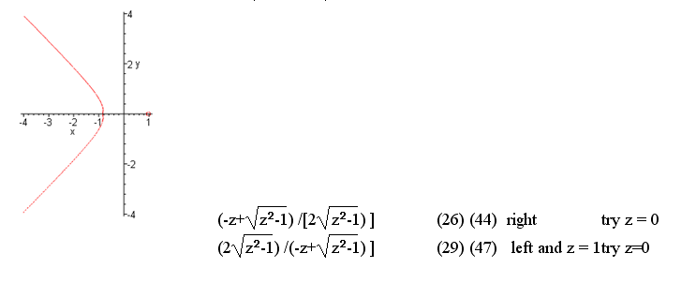

Notice the very strange contour around the point z = 1!!! We can get more detail on that by plotting the function shown above f := (-z+sqrt(z^2-1))/(2*sqrt(z^2-1)); for a few ranges of z>1

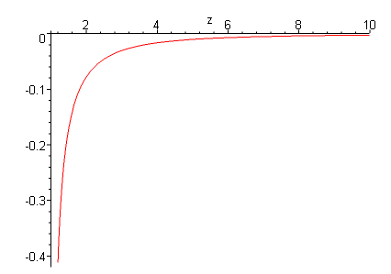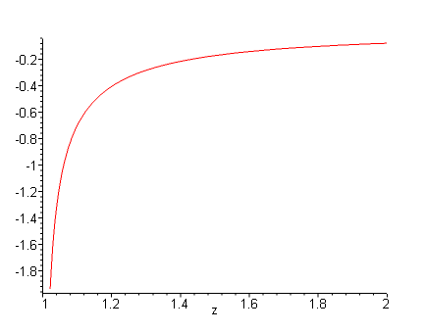

We can see from the right plot that we hit f = -1 and some value like z = 1.1.

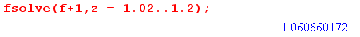

[ If you manually solve you find z = 3/$\sqrt{8}$ = the number above.]

Therefore, our form (44) does not converge below z = 1.06, so our large ν expansion will be no good as we get close to z=1, horrors!!! And (47) does not have ν isolated into the c position. Therefore, we have no forms at all that give us what we want!!

2. How Olvers does it

We start on his page 463 (djvu 477) which is in Chapter 12. Warning: every chapter has its own equation (1.01), so when you hunt back, be sure you stay in Chapter 12!

He defines u = n+1/2 where n is what appears in the Legendre equation.

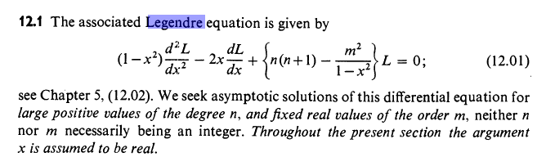

In 12.04 he seems to define ζ this way

ζ 1/2 = cosh-1x where x is the usual x, for the case x ≥ 1

He converts the Legendre equation to some other form. Olver is following a more general approach he started with generic f(x) and g(x) appearing in a certain ODE form which Legendre fits, see page 438 (d 452) The new ODE is this

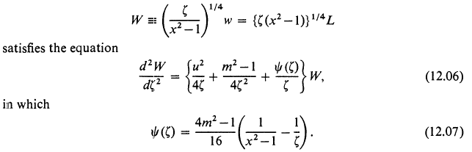

where note that the top line is not two separate equations! So W is a rescaled version of the normal Legendre solution L. He turns his crank and ends up finally with this for Q

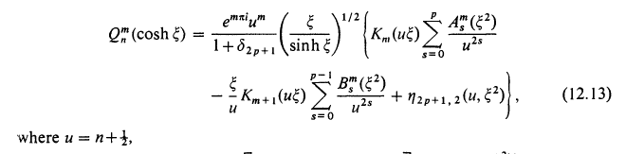

where we are in the large n limit! But this is not very useful unless we know what those A and B coefficients are. Also, δ and η are certain quantities for which he presents upper bounds only. His corresponding P formula is this

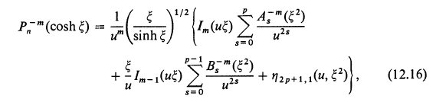

In his general theory on page d 454 he has

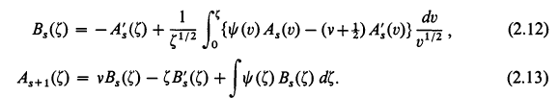

where prime means derivative. You start with A0(ζ) = 1 (constant). Then the first equation gives you B0 as a pretty simple integral. You put that into the second equation to get A1, and iterate in that manner. You can see that only the ψ function appears here, so this is a general class of coefficients, and it shows up in his adjusted ODE solution. For the Legendre case he rewrites them as

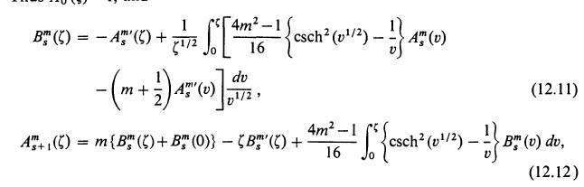

where again prime means derivative and you start with A0(ζ) = 1 . Amazingly he does not state B0 so we have to compute it like this

B0m(ζ) = 1/$\sqrt{ζ}$ $^{\int_{0}^{ζ}{}}$ dv/$\sqrt{v}$[ (4m2-1)/16 * { csch2$\sqrt{v}$ - 1/v}

= (4m2-1)/16 * 1/$\sqrt{ζ}$ $^{\int_{0}^{ζ}{}}$ dv/$\sqrt{v}${ csch2$\sqrt{v}$ - 1/v}

It must be that the B series is less important in the limit. Yes, both B series are down by 1/u = 1/n = 1/ν for large values. So this then is where the AS results come from! I have verified that AS quoted them exactly right!

