Legendre Functions Evaluated at z = +1 and -1 PhL 3.23.10

I have done this wrong so many times, I will now produce a whole separate doc addressing the question, and I will do Maple verification along the way.

See Bateman on this exact subject p 163-164! I missed this.

What does form (14) look like for on-the-cut P functions? 1
What does form (15) look like for on-the-cut P functions? 2
Case P(+1) 2
(a) μ ≠ integer and μ ≠ imaginary 2
(b) μ = 0 2
(c) μ = 1,2,3.... 2
(d) μ = -1,-2,-3 2
(e) final summary for P(1): all results valid for any ν 3
Case P(-1) 3
(a) μ ≠ integer and μ ≠ imaginary 3
A. THE FORM 15 METHOD 3
B. THE FORM 14 METHOD 4
(b) μ = 0 5
THE FORM 15 METHOD 5
THE FORM 14 METHOD 5
(c) μ = -1,-2,-3 ... 6
THE FORM 15 METHOD 6
(d) μ = 1,2,3... 6
(e) μ and ν both integers 6
Summary of conclusions for P(-1): 9
What does form (32) look like for on-the-cut Q functions? 10
Case Q(+1) 10
(a) μ ≠ integer and μ ≠ imaginary 10
Off the cut Q function: 11
Corrections for on-the-cut Q. 11
Case Q(-1) 12
SUMMARY OF ALL RESULTS 12
Appendix A: Clarification of the value of F(-ν,ν+1; 1-μ; ζ=1). 14
Appendix B. Poles and Zeros of the ratio f(ν,μ) 14
Scraps (ignore, but keep) 16

What does form (14) look like for on-the-cut P functions?

Here is my conversion rule

P: P(z) = e±iπa A(z-1)α F + e±iπb B(z-1)β F'
P(x) = cosπ(α+a+μ/2) A |z-1|α F + cosπ(β+b+μ/2) B |z-1|β F '

So for (14) we have only the A term with a = 0 and α = -μ/2, so then the cos = 1 and all we do is flip, so nothing interesting happens here.

What does form (15) look like for on-the-cut P functions?

Same rule as above, but now we have two terms with a = 0, α = -μ/2 and b = -μ, β = +μ/2. Then

cosπ(α+a+μ/2) = cosπ(0) = 1

cosπ(β+b+μ/2) = cosπ(μ/2-μ+μ/2) = cosπ(0) = 1

Therefore in (15) we the two flip-arounds AND the signed phase goes away!

Case P(+1)

(a) μ ≠ integer and μ ≠ imaginary

Use form (14) which has one term and it's F = 1. For general μ, this blows up if Re(μ) > 0. For Re(μ) < 0, get 0. Result:

Re(μ) < 0: Pνμ(1) = 0
Re(μ) > 0: Pνμ(1) = ∞

(b) μ = 0

Use form (14) which says Pν0(1) = 1. I think it can be argued that Pν0(z) is therefore finite near z = 1 for any ν, which means that all derivatives of Pν0(z) at z = 1 will be finite, used in (c) below. Result:

μ = 0 Pνμ(1) = 1

(c) μ = 1,2,3....

Use page 148 (4) and argument above that derivatives are finite. Conclusion is then this, since we have a finite derivative times a quantity that is 0.

μ = 1,2,3.... Pνμ(1) = 0

(d) μ = -1,-2,-3

Here we go back to (14) where F = 1 and (z-1) factor gives 0, so conclude that

μ = -1,-2,-3.... Pνμ(1) = 0

(e) final summary for P(1): all results valid for any ν

• μ ≠ integer and μ ≠ imaginary:
Re(μ) < 0: Pνμ(1) = 0 // Maple samples verified
Re(μ) > 0: Pνμ(1) = ∞

• μ = integer:
Pνμ(1) = δ0μ

I have ignored the case of imaginary μ in which case our form (14) will have that fast rotating phasor factor (z-1)-μ/2 = exp[- i (α/2) ln(z-1)] which I don't really know what to do with (α = Im(μ)).

Case P(-1)

(a) μ ≠ integer and μ ≠ imaginary

A. THE FORM 15 METHOD

Use form (15) which has F = 1 in both terms. If Re(μ) > 0, the first term is 0, while the second term factor (z+1)-μ/2 blows up and the only rescue is ν = integer. So we conclude that:

Re(μ) > 0 ν ≠ integer Pνμ(-1) = ∞ // Maple confirmed with samples
Re(μ) > 0 ν = integer Pνμ(-1) = 0 // Maple confirmed with samples

Now if Re(μ) < 0, the second term is 0, but now the first term factor (z+1)μ/2 blows up. The only rescue here is if we can make one of the gammas have a pole. The condition is this for the first gamma.

Γ(1+ν-μ) has pole when ν = μ-1, μ-2, .... = μ-J J = 1,2,3

We know from ν-symmetry that the second gamma has a pole if

-ν-1 = μ-J ν = -μ-1+J = -μ, -μ+1 = -μ + I I = 0,1,2...

The black dots then show points where we will get Pνμ(-1) = 0 when Re(μ) < 0

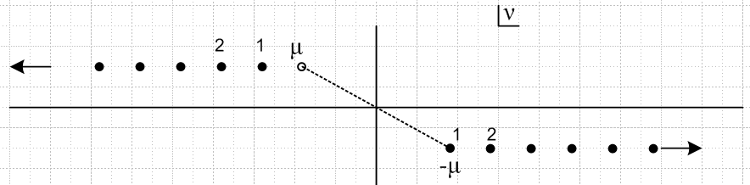

left string: ν = μ-J right string: ν = -μ + I

[ The upper left string is really the ν → -ν-1 symmetry string. For example, upper left point 1 is the symmetry value for the lower right point 1. We do not want to include P functions twice in a spectral situation, so we arbitrarily keep only the right side string. ]

Maple seems to have a counterexample:

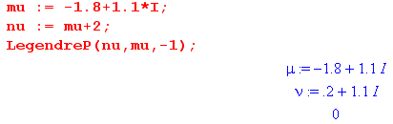

but as usual, this is some "alternate definition" gizmo. We can see the true value by using -1+ε. I have now verified that upper string above, going both ways. With the μ shown above, I replace the +2 with the values -1,-2,-3 and always get 0 which appears as 10-19 on both real and imaginary parts. Then I use values +0,+1,+2,+3 and it blows up 10+18 say. So this is how you force Maple to tell the truth at -1. I have also had Maple verify the lower string including the point ν = -μ which gives 0. So, at least Maple is agreeing.

So then here is our first conclusion about P(-1):

Re(μ) > 0 and μ ≠ integer ν ≠ integer Pνμ(-1) = ∞
Re(μ) > 0 and μ ≠ integer ν = integer Pνμ(-1) = 0 rescue

Re(μ) < 0 and μ ≠ integer and ![ν = μ-J or ν = -μ+I] Pνμ(-1) = ∞
Re(μ) < 0 and μ ≠ integer and [ν = μ-J or ν = -μ+I] Pνμ(-1) = 0 rescue

B. THE FORM 14 METHOD

Let's go back to form (14) for a moment and try to use it for z = -1. We then have F(-ν,ν+1,1-μ,ζ =1). We then look at GR page 1040 which talks about convergence of this F thing. It all depends on this quantity

α+β-γ = -ν + ν + 1 - 1+μ = μ.

If 0 ≤ Re(μ) < 1, we diverge at ζ = 1.
If Re(μ) < 0, we converge at ζ = 1.
If Re(μ) ≥ 1, we diverge at ζ = 1.

which we can summarize this way

Re(μ) ≥ 0 F diverge at ζ = 1 but rescue if ν = integer "first line"
Re(μ) < 0 F converge at ζ = 1 "second line"

Now let's combine our first line result with the other factors in form (14) and we conclude

Re(μ) ≥ 0 F diverge at ζ = 1 but rescue if ν = integer
(z+1)μ/2 → 0 so get 0 * ∞ if no rescue, get 0 if rescue (*)

Our conclusion for line (*) is unclear by the (14) method, since 0*∞ with no rescue, but Method (15) tells us that the ∞ wins out. If there is a rescue, then have 0*0 = 0 which agrees with Method (15).

Next we have from our second line above:

Re(μ) < 0 F converge at ζ = 1
(z+1)μ/2 → ∞ so would seem to have divergence with no rescue chance

But maybe the rescue conditions cause F to converge to 0, then we have 0*∞ and unclear. In fact, for this range of μ, we know from Appendix X below that

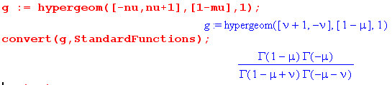 Re(μ) < 0 only!

The denominator gammas here are the same as appear in (15) first term, so you see that rescue will be obtained here by the same rescue as shown in the (15) result which I quote from method (15) above.

Re(μ) < 0 and μ ≠ integer and ![ν = μ-J or ν = -μ+I] Pνμ(-1) = ∞
Re(μ) < 0 and μ ≠ integer and [ν = μ-J or ν = -μ+I] Pνμ(-1) = 0 rescue

If no rescue, then (z+1)μ/2 → ∞ and we get the first line above. So, this 4-gamma thing confirms our Method (15) results. In general, the Method (15) gives more definite results for Re(μ) > 0.

(b) μ = 0

THE FORM 15 METHOD

Now form (15) is no good since has Γ(μ) factors. If you try to take the limit μ→0 you get ∞ * 0 so not clear what is happening. I tried some Maple l'Hopital on this without success. I am struggling on this case which is Pν(-1)!

Numerical fiddling with Maple suggests the following: If you pick ν ≠ integer, as you let z → -1 there sees to be no stable limit. The value gets larger and larger as you approach, but in what seems a log sort of way, so not dramatic. As if there were a ln(z+1) factor floating around always. On the other hand, if you set ν = integer of either sign, you always get either +1 or -1 as your result.

THE FORM 14 METHOD

Let's go back to form (14) for a moment and try to use it for z = -1. Recall our conclusions from above:

Re(μ) ≥ 0 F diverge but rescue if ν = integer agrees with above
Re(μ) < 0 F converge

which for μ = 0 becomes just this:

μ = 0 F diverge but rescue if ν = integer

In this situation, there are no other factors in (14), so the conclusion seems quite clear, AND it agrees with my Maple numerical fiddling.

Since P(-1) blows up if not rescued, the slope at -1 must also be going to ∞, and then recur to say the slope of THAT goes to infinity, and I think I can conclude loosely that all derivatives are going to diverge if there is no rescue. But this does not help much in the derivative formulas because we just have 0*∞ .

(c) μ = -1,-2,-3 ...

THE FORM 15 METHOD

If ν ≠ integer, then we have to worry about the first F being invalid. We also have (z+1)μ/2 diverging in that first term. The Γ(-μ) factor is OK. To rescue this first term, we need a zero from the gamma pair. But if μ = integer as we have assumed, and ν ≠ integer, then no rescue is possible. So I think we are safe to say that the first term blows up. As for the second term, the F function is finite and = 1. But now Γ(μ) blows up and you are supposed to take the μ limit before any z limit, so the 1+z power → 0 is not allowed to help you here. The sin ≠ 0 since we assumed ν ≠ integer. So I think the second term blows up as well! The terms blow up in different ways and they will not cancel. My conclusion here is pretty simple

Pνμ(-1) = ∞ when ν ≠ integer μ = -1,-2,-3...

(d) μ = 1,2,3...

While we're here, we can do the μ = 1,2,3.. case in the same way. It just reverses the roles of the two terms in (15). Now the first blows from Γ(-μ) with no rescue, and the second blows from (z+1)-μ/2 . So I conclude as well that

Pνμ(-1) = ∞ when ν ≠ integer μ = 1,2,3....

In fact, if μ = 0, both terms blow up so we can just include that now in our case here. Conclusion:

Pνμ(-1) = ∞ when ν ≠ integer μ = any integer

Does Maple support these claims? Yes, I did some samples. As before with μ = 0 blow up is slow.

(e) μ and ν both integers

Now finally we want the special case μ and ν are both integers. If we start with (15) as usual, we can ignore the entire second term due to sinπν. So first consider μ = 1,2,3... We have F = 1 but Γ(-μ) is blowing up. So our only hope is a zero in those two gammas. The zero situation with the gammas is this:

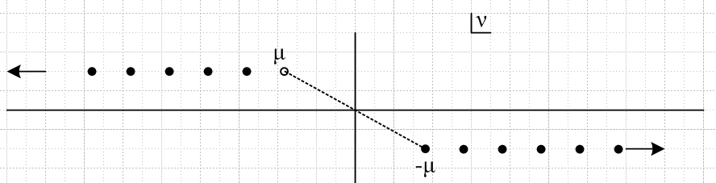

left string: ν = μ-J right string: ν = -μ + I

But we now want μ = 1,2,3 so have to redraw this picture accordingly (shown for μ= 4)

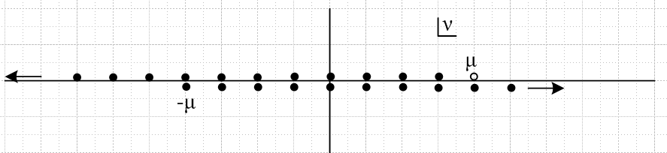

This says that the "two gammas" are causing a double-zero for all integer ν from ν =-μ to ν = μ-1. It only takes one zero to cancel the Γ(-μ) pole in the first term of (15). The second zero then kills off P(z) for any z including z = -1 ! So we then have this partial conclusion:

μ = 1,2,3.... ν = integer (-μ,μ-1) Pνμ(-1) = 0 = Pνμ(z)

As an example, this says that P-22(z) = P-12(z) = P02(z) = P12(z) ≡ 0. If you pick some random z, Maple will confirm this fact:

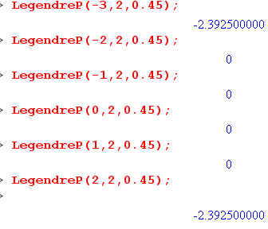

Now for ν = μ and above, we have only a single zero, so our first term could be finite. But (1+z)μ/2 → 0 and we get 0 in that case too, but only for z = -1, not all z. So we can summarize our results this way:

μ = 1,2,3.... ν = integer (-μ,μ-1) Pνμ(-1) = 0 = Pνμ(z)
μ = 1,2,3.... ν = any integer Pνμ(-1) = 0

If we take into account the ν symmetry of the P function, and we are interested in spectrum, then we eliminate the negative ν values, and we also eliminate identically 0 functions since they cannot be eigenfunctions! So

μ = 1,2,3.... ν = μ, μ+1 .... Pνμ(-1) = 0 // spectrally speaking

I think Maple supports this claim, but sometimes with .99999 it does not state a result.

Now what about μ = -1, -2, -3 with ν = integer? We consider (14). We have F(-ν,1+ν,1-μ,1) which is finite. In fact, this can be written as

F(-ν,1+ν,1-μ,ζ = 1) = Γ(1-μ)Γ(-μ) / [ Γ(1-μ+ν)Γ(-μ-ν)] // valid Re(μ) < 0 recall App A

So (14) now reads in our current case

Pνμ(-1) = (z+1)μ/2 (-2)-μ/2 Γ(-μ) / [ Γ(1-μ+ν)Γ(-μ-ν)]

The Γ(-μ) is fine. The (z+1)μ/2 → ∞. So our only rescue is the two denom gammas. We go back again to our starting picture,

And we now assume μ = negative integer and redraw (I have selected μ = -1).

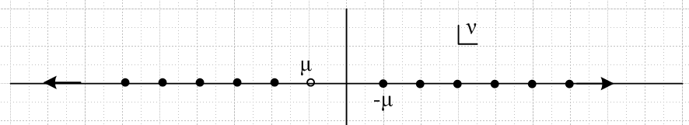

Rescue occurs at all integers ν except ν = (μ,-μ-1). No rescue when ν in this range. Another way to state the range of no rescue is -|μ| ≤ ν < |μ|, so ν is "too small" for μ. So our conclusion is this:

μ = -1, -2, -3 and ν = integer and [ -|μ| ≤ ν < |μ| ] Pνμ(-1) = ∞
μ = -1, -2, -3 and ν = integer and ![ -|μ| ≤ ν < |μ| ] Pνμ(-1) = 0

Notice this fact:

![ -|μ| ≤ ν < |μ| ] is the same as [ ν < -|μ| OR ν ≥ |μ| ] as picture shows

In terms of spectrum, we as usual throw out the ν < 0 possibilities and we are left with ν ≥ |μ|. We have then shown that:

μ = 1,2,3.... ν = μ, μ+1 .... Pνμ(-1) = 0 // spectrally speaking
μ = -1, -2, -3 ν = |μ|, |μ|+1, ... Pνμ(-1) = 0 // spectrally speaking
μ = 0 ν = 0,1,2.... Pνμ(-1) = (-1)ν

In terms of spectrum, we can group all three of these cases above as follows:

μ = integer ν = |μ|, |μ|+1, ... Pνμ(-1) = 0 except Pν0(-1) = (-1)ν

Now, we know that when μ = integer. Now I want to wedge in one more fact here. First, here are the zeros and poles of f(ν,μ) from our appendix below

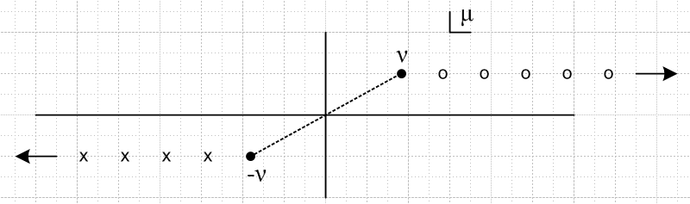

Suppose we take ν = some integer in the positive set 0,1,2.. (perhaps ν = 2). In our spectrum we don't care about negative ν stuff, so we ignore the poles on the left. We have zeros to the right of ν, but we know that such μ values cannot be in the combined ν,μ spectrum since ν ≥ |μ| as shown above. Therefore, for our spectral range of interest, f(ν,μ) is finite and non-zero, and therefore so is f(ν,-μ) = 1/f(ν,μ). Therefore, according to Bateman p 140 (7), the functions Pνμ(z) and Pν-μ(z) are multiples of each other where the multiple is a finite non-vanishing number. Thus, we can take either one as our "independent function". One tradition is to take the positive value and write it as Pν|μ|(z). So here is our spectrum of eigenfunctions:

μ = integer ν = |μ|, |μ|+1, ... Pν|μ|(z)

I am gratified to find the information on the above line confirmed in Stakgold page 395 A and above!!! When Stak builds his spherical harmonics, he uses only Pν|μ|(z) as shown p 395 C' . Jackson does this a little differently on page 65.

Here is an earlier Maple test I will leave here for now. Let's set μ = -1. It is very hard to make Maple "tell the truth" and do complex general evaluation. Here are a set of results:

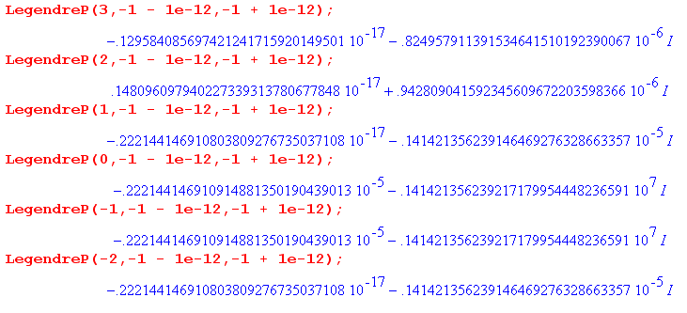
I have to provide tiny ε to force it to compute long hand and not use "alternate definitions". You see that when ν = -1 and ν = 0 we are blowing up as predicted (in the imaginary part, it turns out). I think it should below up in the real part because everything is real here, μ and ν, so that is a mystery. I can directly enter the form (14) and get my claims.
Let's try μ = -2. We expect blow up when ν = 1,0,-1,-2 . This gives a better set of results:

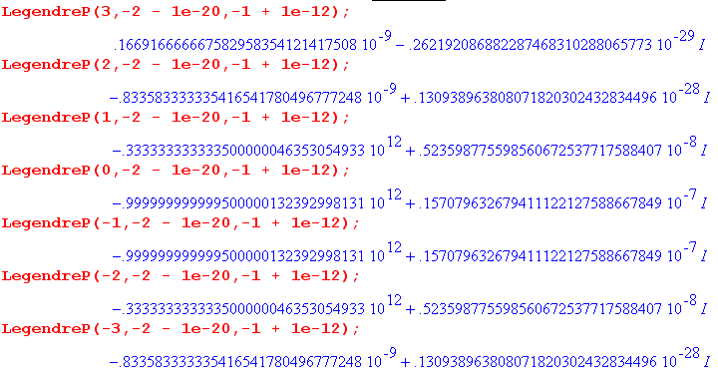

I think I have done this correctly.

Summary of conclusions for P(-1):

Re(μ) > 0 and μ ≠ integer ν ≠ integer Pνμ(-1) = ∞
Re(μ) > 0 and μ ≠ integer ν = integer Pνμ(-1) = 0 rescue

Re(μ) < 0 and μ ≠ integer and ![ν = μ-J or ν = -μ+I] Pνμ(-1) = ∞
Re(μ) < 0 and μ ≠ integer and [ν = μ-J or ν = -μ+I] Pνμ(-1) = 0 rescue

μ = 1,2,3.... ν ≠ integer Pνμ(-1) = ∞
μ = 1,2,3.... ν = integer Pνμ(-1) = 0 rescue

μ = -1,-2,-3.... ν ≠ integer Pνμ(-1) = ∞
μ = -1, -2, -3 and ν = integer and [ -|μ| ≤ ν < |μ| ] Pνμ(-1) = ∞
μ = -1, -2, -3 and ν = integer and ![ -|μ| ≤ ν < |μ| ] Pνμ(-1) = 0 rescue

μ = 0 and ν ≠ integer Pν0(-1) = ∞
μ = 0 and ν = integer Pν0(-1) = (-1)ν rescue

μ = integer and ν ≠ integer Pν0(-1) = ∞ summary

Comment on SL problem: Suppose we know that μ = 1,2,3... In this case, the ν spectrum is ALL integers, but of course we only take ν = 0,1,2... to avoid redundancy. If, however, we have μ = -1,-2,-3... then our ν spectrum is missing ν = 0,1,2...|μ|-1 . So the spectrum is really ν = |μ| up to +∞ . In these comments we are only considering the P(-1) situation and we need to look at the other end as well. More on this later.

Comment on rescues above. Here is way to classify the "rescues" above into two general bins (the "spectrum" results take both ± into consideration)

first, a reminder of P(+1) finite cases:
ν = anything:
Re(μ) < 0 and μ ≠ integer
μ = integer Pνμ(1) = δ0μ

now the P(-1) finite cases:
ν = integer:
Re(μ) > 0 and μ ≠ integer
μ = 1,2,3....
μ = -1, -2, -3 and ν = integer and ![ -|μ| ≤ ν < |μ| ]
μ = 0
spectrum: μ = integer and ν = |μ|, |μ|+1, ... can use either Pνμ(z) or Pν|μ|(z)
Pνμ(z) ≡ 0: μ = 1,2,3.... ν = integer (-μ,μ-1)

ν = special values shown here:
Re(μ) < 0 and μ ≠ integer and [ν = μ-J or ν = -μ+I]
spectrum: ν = -μ+I and use Pνμ(z)

We now shift our attention from the P function to the Q function.

What does form (32) look like for on-the-cut Q functions?

Here is my conversion rule

Q: e-iπμ Q (z) = e±iπa A(z-1)α F + e±iπb B(z-1)β F'
Q(x) = cosπ(α+a-μ/2) A |z-1|α F + cosπ(β+b-μ/2) B |z-1|β F '

So for (32) we have first term with a = 0 and α = μ/2, and second term with b = 0 and β = -μ/2. The first cos is then 1, the second cos is cosπμ. So, we get flip on both factors as usual, and a new cosπμ factor on the second term. This is verified page 144 (10).

Case Q(+1)

(a) μ ≠ integer and μ ≠ imaginary

Assume off the cut Q for now, will consider at the end. Use form (32) which has two terms both with F = 1. If Re(μ)>0, the first term is 0, but the second term blows up and there is no rescue. If Re(μ) < 0, the second term is 0, but the first term blows up. Here there is a rescue possibility if f(ν,μ) has a zero. We know from Appendix B below such zeros occur in two situations:

[ν ≠ -J' and ν ≠ -J'/2] and μ = ν + J f(ν,μ) = 0
[ν = -J' or ν = -J'/2 ] and μ = -ν + I f(ν,μ) = 0

So here is our situation so far J = 1,2,3 ... I = 0,1,2,3...

Re(μ)>0 Qνμ(1) = ∞ // Maple checked

Re(μ)<0
[ν ≠ -J' and ν ≠ -J'/2] and μ = ν + J Qνμ(1) = 0 rescue ν = μ-J (*)
[ν = -J' or ν = -J'/2 ] and μ = -ν + I Qνμ(1) = 0 rescue ν = -μ+I (**)
otherwise Qνμ(1) = ∞

However, in the (**) case since ν < 0, we have μ = -ν+I = positive, which violates Re(μ)<0. Thus the (**) rescues cannot really happen, so we remove them from the list and resummarize:

Re(μ)>0 Qνμ(1) = ∞ // Maple checked

Re(μ)<0
[ν ≠ -J' and ν ≠ -J'/2] and μ = ν + J Qνμ(1) = 0 rescue ν = μ-J (*)
otherwise Qνμ(1) = ∞

Basically this says that if ν is a negative integer or negative half integer, rescue is not possible. The only possible rescue case is (*) and this requires Re(μ) < 0 and in this case you see that ν = μ-J is a string of points starting at negative ν=-|μ|-1 and going off to the left! In this case, if μ = 0,-1,-2... then all those rescue points for ν would be negative integers and are therefore disallowed! Similarly, if μ = 1/2,-1/2,-3/2 we get the rescue ν being negative half integers so these μ are also ruled out. μ = 1/2 is also ruled out since it is positive. Therefore we have an extra piece of information:

[μ = -J' or μ = -J'/2 ] => Qνμ(1) = ∞

For a (*) check in Maple, I set ν = -4.6 and get rescues at the right places like μ = -3.6, -2.6, not -4.6. Here is an example of a rescue:

We are done, there are no other cases! Positive integer μ or half integer μ are ruled out by Re(μ) > 0. So here is another way to state our results:

Off the cut Q function:
μ = integer or half integer Qνμ(1) = ∞
Re(μ) > 0 Qνμ(1) = ∞
Re(μ) < 0 and μ ≠ integer or half integer Qνμ(1) = 0 for ν = μ-J only
Re(μ) < 0 and μ ≠ integer or half integer Qνμ(1) = ∞ for ν ≠ μ-J

For a SL problem with μ = integer on interval (-1,1), the first line rules out Q at once.

Comment: We have seen above how our only possibility for a Q rescue occurs when f(ν,μ) has a zero. But looking at p 140 (4), we see that in this case (note μ ≠ integer) Q = P * constant, so really our rescue case can be thought of as a P function! Page 144 (13) shows that this comment also applies to on-the-cut Q functions.

Corrections for on-the-cut Q. Recall from above we said: " Use form (32) which has two terms both with F = 1. If Re(μ)>0, the first term is 0, but the second term blows up and there is no rescue." However, for on the cut Q we have cos(πμ) on the second term, so we could get a rescue with μ = half integer. But only positive half integers work since we must have Re(μ) > 0.

Thus, we have to adjust our claim above to be this:

On the cut Q function:
μ = integer, or negative half integer Qνμ(1) = ∞
Re(μ) > 0 and μ ≠ half integer Qνμ(1) = ∞
Re(μ) > 0 and μ = half integer Qνμ(1) = 0
Re(μ) < 0 and μ ≠ integer or half integer Qνμ(1) = 0 for ν = μ-J only

Case Q(-1)

From Bateman p 140 (12), we find that for off-the-cut Q functions, the results at z = -1 are exactly the same as at z = +1. The only difference is a phase which plays no role when things are 0 or ∞. Therefore, from a SL perspective, that last two cases above offer a possibility where a Q function is finite at both ends of (-1,1)

For on-the-cut Q functions, we have the messier result p 144 (15).

(a) μ = integer and ν = integer. In this case, the P term goes away and Q(-1) is same as Q(1) for the on-the-cut Q function as shown above. Same if μ and ν are both half-integers.

I could tabulate all the other results. The main interest would be to consider Q(1) = 0 cases and see what happens for Q(-1).

(b) Assume μ = positive half integer so Q(+1) = 0. If ν ≠ half integer, then P term is present and for Re(μ)>0 it blows sky high. But if ν = half integer, then μ+ν = integer and only the Q term remains. So I think this would be a case where Q = 0 at both ends!

μ = positive half integer AND ν = half integer Qνμ(-1) = 0

(c) Assume Re(μ) < 0 and μ ≠ integer or half integer and ν = μ-J. Since Re(μ) < 0, there is no contribution from the P term. But the Q terms is also 0, so this is another case of interest

Re(μ) < 0 and μ ≠ integer or half integer Qνμ(-1) = 0 for ν = μ-J only

SUMMARY OF ALL RESULTS

P(1): need either Re(μ) < 0 or μ = integer to P(1) = 0; ν = don't care

• μ ≠ integer and μ ≠ imaginary:
Re(μ) < 0: Pνμ(1) = 0
Re(μ) > 0: Pνμ(1) = ∞

• μ = integer:
Pνμ(1) = δ0μ

P(-1): In all cases where P(-1) = 0, ν must assume certain discrete values.

Re(μ) > 0 and μ ≠ integer ν ≠ integer Pνμ(-1) = ∞
Re(μ) > 0 and μ ≠ integer ν = integer Pνμ(-1) = 0 rescue

Re(μ) < 0 and μ ≠ integer and ![ν = μ-J or ν = -μ+I] Pνμ(-1) = ∞
Re(μ) < 0 and μ ≠ integer and [ν = μ-J or ν = -μ+I] Pνμ(-1) = 0 rescue

μ = 1,2,3.... ν ≠ integer Pνμ(-1) = ∞
μ = 1,2,3.... ν = integer Pνμ(-1) = 0 rescue

μ = -1,-2,-3.... ν ≠ integer Pνμ(-1) = ∞
μ = -1, -2, -3 and ν = integer and [ -|μ| ≤ ν < |μ| ] Pνμ(-1) = ∞
μ = -1, -2, -3 and ν = integer and ![ -|μ| ≤ ν < |μ| ] Pνμ(-1) = 0 rescue

μ = 0 and ν ≠ integer Pν0(-1) = ∞
μ = 0 and ν = integer Pν0(-1) = (-1)ν rescue

μ = integer and ν ≠ integer Pν0(-1) = ∞ summary

Alternate presentation of P results where we should only cases where either P(±1) is finite (the "rescues"). On lines in the P(-1) section where we state the spectrum, we take into account the P(+1) conditions.

the P(+1) finite cases: Pνμ(1) = 0 in these cases [ with exception P00(1) =1] , else Pνμ(1)= ∞
ν = anything:
Re(μ) < 0 and μ ≠ integer
μ = integer Pνμ(1) = δ0μ

the P(-1) finite cases: Pνμ(-1) = 0 in these cases, else Pνμ(-1)= ∞
ν = integer:
Re(μ) > 0 and μ ≠ integer
μ = 1,2,3.... // in this case, Pνμ(z) ≡ 0 for -μ ≤ ν < μ
μ = -1, -2, -3 and ν = integer and ![ -|μ| ≤ ν < |μ| ] // ie, ! [ μ ≤ ν < -μ ]
μ = 0
spectrum: μ = integer and ν = |μ|, |μ|+1, ... can use either Pνμ(z) or Pν|μ|(z)
Pνμ(z) ≡ 0: μ = 1,2,3.... ν = integer (-μ,μ-1) as noted 5 lines above

ν = special integrally-spaced values shown here:
Re(μ) < 0 and μ ≠ integer and [ν = μ-J or ν = -μ+I]
spectrum: ν = -μ, -μ+1,... and use Pνμ(z)

the Q results:

Q(1): in all cases with Q(1)=0, really Q = constant x P

Re(μ)>0 Qνμ(1) = ∞ // Maple checked

Re(μ)<0
[ν ≠ -J' and ν ≠ -J'/2] and μ = ν + J Qνμ(1) = 0 rescue ν = μ-J (*)
otherwise Qνμ(1) = ∞ J,J' = 1,2,3...

Q(-1):

for off the cut Q, same as Q(1); otherwise similar, see notes above.

Alternate presentation of Q results where we should only cases where either Q(±1) is finite (the "rescues"):

the Q(±1) finite cases:
Re(μ) < 0 and μ ≠ integer or half integer Qνμ(±1) = 0 for ν = μ-J only
but in this situation, Q ~ P and our spectrum here replicates the ν-reflected P spectrum I think.

General Comments:

(1) The only SL solution cases involve P functions, and we have the two spectral situations shown above.

(2) When μ = 1,2,3.... and ν = integer, we get just the first term in (15) [ (14) does not apply], and this first term in (15) vanishes identically when the "two denom gammas" have poles. This is the only situation for P or Q functions where the functions vanish identically. We have from above,

Pνμ(z) ≡ 0: μ = 1,2,3.... ν = integer (-μ,μ-1) ie -μ ≤ ν < μ " ν is too small for μ"

Obviously we cannot include vanishing functions (and corresponding EV's) in any kind of spectrum.

Appendix A: Clarification of the value of F(-ν,ν+1; 1-μ; ζ=1).

Maple makes this general statement without any conditions:

Re(μ) < 0 !!!

However, GR on page 1042 seem to attach some conditions to this claim, and they have various other forms as well. So we have

α = -ν
β = ν+1 α+β = 1
γ = 1-μ

The condition they give for the above claim is that

Re(1-μ) > 1 => Re(-μ) > 0 => Re(μ) < 0.

The other forms in GR involve inequalities mixing μ and ν and so don't see too useful.

Appendix B. Poles and Zeros of the ratio f(ν,μ)

I keep doing this over and over, so let's write it down. We have

f(ν,μ) ≡ Γ(1+ν+μ)/Γ(1+ν-μ)

The numerator has poles when ν+μ = -1,-2,-3.... or μ = -ν - J'
The denominator has poles when ν-μ = -1,-2,-3... or μ = ν + J J',J = 1,2,3...

Therefore, if we look in the μ plane, we find that
f(ν,μ) has zeros when μ = ν + J, and has poles when μ = -ν - J' .

Here is a picture drawn for Re(ν) > 0:

In general the poles don't cancel the zeros, but they do in two special cases. The first is the case where ν = -1,-2,-3....

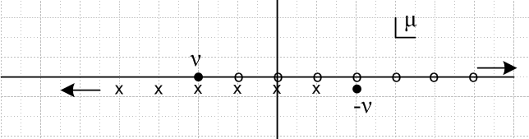

So iff ν = a negative integer, then we can cancellations from μ = ν+1 up to and including -ν-1. A cancellation just means that f takes a finite value, as it does everywhere else in the μ plane. So we could draw the above picture like so
ν = -1, -2, -3....

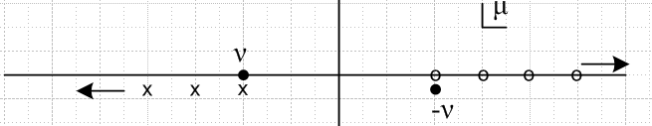

and this is similar to the case that ν = 0,1,2,3 which looks like this:

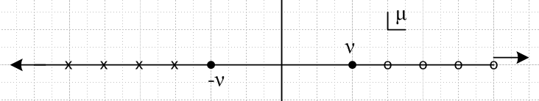

We can summarize these results concerning the zeros of f(ν,μ): J = 1,2,3... I = 0,1,2...

ν ≠ -J' and μ = ν + J f(ν,μ) = 0
ν = -J' and μ = -ν + I f(ν,μ) = 0

ν ≠ -J' and μ = -ν - J f(ν,μ) = ∞
ν = -J' and μ = ν - I f(ν,μ) = ∞

otherwise: f(ν,μ) = finite

You can see that the second pair of lines comes from negating μ. I verified the above claims with some Maple samples using this code:

restart;
Digits := 20;
f := GAMMA(1+nu+mu)/GAMMA(1+nu-mu);
nu := -2.3;
mu := -nu - 0 + 1e-18;
f;

There is a second special case where ν is a negative half-integer. Here is the picture with ν = -3/2

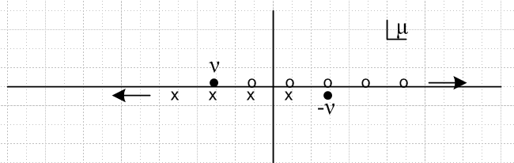

Here we get cancellations from for μ = ν+1 up to and including -ν-1, so residual zeros start at μ = -ν and go to the right. This is the same range as in the case of ν = negative integer. However, in the integer case if ν = -1, we have one cancellation and residual zeros then start at μ = -ν. In the half integer case, if ν = -1/2, there are no cancellations at all and zeros start at μ = ν+1 = 1/2 = -ν. Luckily, this is the same zero starting point as the integer case. Similarly, poles start at ν and go off to the left in both cases.

Here are the special case results for half integers:

ν = -J'/2 and μ = -ν + I f(ν,μ) = 0

ν = -J'/2 and μ = ν - I f(ν,μ) = ∞

So we can now present our total results:

[ν ≠ -J' and ν ≠ -J'/2] and μ = ν + J f(ν,μ) = 0
[ν = -J' or ν = -J'/2 ] and μ = -ν + I f(ν,μ) = 0

[ν ≠ -J' and ν ≠ -J'/2] and μ = -ν - J f(ν,μ) = ∞
[ν = -J' or ν = -J'/2 ] and μ = ν - I f(ν,μ) = ∞

otherwise: f(ν,μ) = finite

Scraps (ignore, but keep)

*******************************************************************************

These are scraps from leg prop doc where I tried doing this before:

Scrap Appendix G. Functions evaluated at z = 1.

Function Q:

(a) Let's start with Q (32) for μ ≠ integer so both F functions are non-singular and both F = 1 for z=1,

Qνμ(1) = f(ν,μ) (z-1)μ/2 2-μ/2 Γ(-μ)/2 + (z-1)-μ/2 2 μ/2 Γ(μ)/2

But even in this nice case, one or the other (z-1)α factors diverges (so one term diverges and the other term is 0) , so if Re(μ) > 0 or Re(μ) < 0 we get Qνμ(1) = ∞ for general values of μ and ν.
For values that make f(ν,μ) = 0, you find that Qνμ(1) = 0 for Re(μ) < 0, and Qνμ(1) = ∞ for Re(μ) > 0 We know this happens when ν-μ = -1,-2... . (just do it!) (μ = ν + J, J = 1,2,3..., see next appendix)
For μ = 0, we have Qνμ(1) = Γ(-0)/2 + Γ(0)/2 = Γ(0) = ∞, so this joins the Re(μ) > 0 case.

None of these results for Q seems very useful. The general result is that Qνμ(1) = ∞ except for these two cases, both of which require Re(ν) < -1 and Re(μ) < 0 .

(1) Re(μ) <0 AND ν ≠ negative integer AND μ = ν + J , J = 1,2,3... => Qνμ(1) = 0
This case requires Re(ν) < -1 to get any hits on the last condition!

(2) Re(μ) <0 AND ν = negative integer AND μ = -ν +J, J = 0,1,2.. => Qνμ(1) = 0

There is one other nasty case I have skipped, which is when μ is imaginary. Suppose we write μ = iα. Then we have

(z-1)μ/2 = exp[ i (α/2) ln(z-1)]

so as z → 1, this phasor runs around infinitely fast maintaining its unit length. The phasor in the second term in Q rotates the other direction. Probably Q has some well defined and finite limit in this case, but I don't feel like doing it. The case μ = 0 I have done above.

(b) Summary for Q:

Qνμ(1) = ∞ except Qνμ(1) = 0 in these two cases, both of which require Re(ν) < -1 and Re(μ) < 0:
ν ≠ negative integer AND μ = ν + J, J = 1,2,3..
ν = negative integer AND μ = -ν +J, J = 0,1,2..

Function P:

Let's start with P (14) where F = 1 in this limit as long as μ ≠ 1,2,3..... It then says

Pνμ(z) = 2μ/2 (z-1)-μ/2 / Γ(1-μ) * 1 (*)

If Re(μ) < 0, we both avoid the pole problem in the F function and in the external gamma. Also, the factor (z-1)-μ/2 → 0 so we conclude that

Pνμ(1) = 0 Re(μ) < 0.

Exactly at the value μ = 0 we get Pνμ(z) = 20/2 (z-1)-0/2 / Γ(1-0) * 1 = 1*1/1 = 1. So:

Pνμ(1) = 1 μ = 0

For Re(μ) > 0, but μ ≠ 1,2,3 we still have the above form (*). The factor (z-1)-μ/2 then diverges and the other factors are finite, so we conclude that

Pνμ(1) = ∞ Re(μ) > 0 but μ ≠ 1,2,3

In the case that μ = 1,2,3...., we know that

f(ν,μ) Pν-μ(z) = Pνμ(z) f(ν,μ) ≡ [ Γ(ν+μ+1)/ Γ(ν-μ+1) ]

=> Pνμ(z) = f(ν,-μ) Pν-μ(z)

Therefore, for Re(μ) > 0 we can say

Pνμ(1) = f(ν,-μ) Pν-μ(z) = f(ν,-μ) 0 = 0 // valid μ = positive integer

So we have this strange set of results: (valid for general ν )

Pνμ(1) = 1 μ = 0
Pνμ(1) = 0 Re(μ) < 0.
Pνμ(1) = ∞ Re(μ) > 0 but μ ≠ 1,2,3
Pνμ(1) = 0 μ = 1,2,3....

If we are only dealing with μ = integer, then we can say

Pνμ(1) = δμ0 // valid for general ν, μ = integers.

These are the off-cut functions. For on-cut the results are exactly the same for this reason: the two kinds of P's are the same when μ = 0, and otherwise each term is 0 in the on-cut definition.

Again, I have ignored the case of imaginary μ in which case our form (14) will have that fast rotating phasor factor (z-1)μ/2 = exp[- i (α/2) ln(z-1)] which I don't really know what to do with.

Scrap Appendix I. Functions evaluated at z = -1.

Function P:

We can now use off-the-cut formula p 140 (10) to consider Pνμ(-1). Except for the two special cases noted in (b) above (Appendix G), the Q term will have Qνμ(1) = ∞ and this can only be killed off by ν+μ = integer. So our pre-condition for Pνμ(-1) to be finite is that ν+μ = integer. But even if this is true, the first term will have Pνμ(1) = ∞ if Re(μ) > 0 but μ ≠ 1,2,3 . If we ignore the special cases in (b), perhaps by just assuming that Re(ν) ≥ -1, then we arrive at these conclusions:

Pνμ(-1) = finite if ν+μ = integer except when ( Re(μ) > 0 but μ ≠ 1,2,3 )

So, there are several cases of interest:

Pνμ(-1) = 0 Re(μ) < 0 and ν+μ = integer
Pνμ(-1) = 0 μ = 1,2,3 and ν+μ = integer
Pνμ(-1) = ∞ Re(μ) > 0 but μ ≠ 1,2,3

If we have one of the special cases in (b), then we can make an alternative to the second condition that ν+μ = 0. This alternative would be μ+ν = J for the second exception in (b), but this is just a subset of saying ν+μ = integer, so this situation is really covered already. But the first exception in (b) still survives and we can write it down and add it to the above list this way:

Pνμ(-1) = 0 Re(μ) < 0 and ν-μ = -J, J = 1,2,3... // requires Re(ν) < -1.

So let's try to summarize again:

Pνμ(-1) = 0 Re(μ) < 0 and [ ν+μ = integer or ν-μ = -J, J = 1,2,3.. ]
Pνμ(-1) = 0 μ = 1,2,3 and ν+μ = integer
Pνμ(-1) = ∞ Re(μ) > 0 but μ ≠ 1,2,3

If μ = 0, then Qνμ(1) = ∞ with no special (b) cases, and we require that ν+μ = integer, or ν = integer to kill off this Q term. In this case, we find from (10) that Pνμ(-1) = (-1)ν Pνμ(1) = (-1)ν . So let's add this to the list which is now this:

Pνμ(-1) = 0 Re(μ) < 0 and [ ν+μ = integer or ν-μ = -J, J = 1,2,3.. ]
Pνμ(-1) = 0 μ = 1,2,3 and ν+μ = integer
Pνμ(-1) = ∞ Re(μ) > 0 but μ ≠ 1,2,3
Pνμ(-1) = ∞ μ = 0, ν ≠ integer
Pνμ(-1) = (-1)ν μ = 0, ν = integer

As before, I ignore the fast rotating phasor case where μ = imaginary. The above results are valid for both on the cut and off the cut P and Q functions.

Function Q:

The formula here is Bateman p 140 (12) which says Qνμ(-1) is just a multiple of Qνμ(1), so we will have the same conclusion as above:

Qνμ(-1) = ∞ except Qνμ(-1) = 0 in these two cases, both of which require Re(ν) < -1 and Re(μ) < 0:
ν ≠ negative integer AND μ = ν + J, J = 1,2,3..
ν = negative integer AND μ = -ν +J, J = 0,1,2..

Value of P(-1)

Assume general complex μ for the moment. Use form (15) which has F = 1 in both terms. If Re(μ) > 0, the second term factor (z+1)-μ/2 blows up and the only rescue is ν = integer. The first term is zero. So we conclude that:

Re(μ) > 0 ν ≠ integer Pνμ(-1) = ∞ // Maple confirmed with samples
Re(μ) > 0 ν = integer Pνμ(-1) = 0 // Maple confirmed with samples

Now if Re(μ) < 0, the second term is 0, but now the first term factor (z+1)μ/2 blows up. The only rescue here is if we can make one of the gammas have a pole. The condition is this for the first gamma.

Γ(1+ν-μ) has pole when ν = μ-1, μ-2, .... = μ-J J = 1,2,3

We know from symmetry that the second gamma has a pole if

-ν-1 = μ-J ν = -μ-1+J = -μ, -μ+1 = -μ + I I = 0,1,2...

The black dots then show points where we will get Pνμ(-1) = 0 when Re(μ) < 0

Maple seems to have a counterexample:

but as usual, this is some "alternate definition" gizmo. We can see the true value by using -1+ε. I have now verified that upper string above, going both ways. With the μ shown above, I replace the +2 with the values -1,-2,-3 and always get 0 which appears as 10-19 on both real and imaginary parts. Then I use values +0,+1,+2,+3 and it blows up 10+18 say. So this is how you force Maple to tell the truth at -1. I have also had Maple verify the lower string including the point ν = -μ which gives 0. So, at least Maple is agreeing.

In this example, we have Re(μ) < 0 so the second term in (15) gives 0. Neither gamma of the first term has a pole,

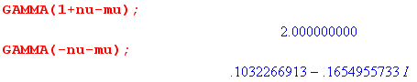

But clearly (z+1)μ/2 = 0-1.8 = ∞, but Maple says P is 0.

