Legendre Functions of various Forms and Maple PhL 2.15.10

My notes on this subject are dispersed in various documents. Here I want to attempt to produce a clear and unified presentation of this subject.

Part I: The Cut Structure of Various Functions of Interest 1
1. f₁(z,μ) = [(z+1)/(z-1)]^{μ/2} 1
2. f₂(z,μ) = [(1+z)/(1-z)]^{μ/2} 2
3. f₃(z,μ) = (z+1)^{μ/2}(z-1)^{μ/2} 2
4. f₄(z,μ) = (1+z)^{μ/2}(1-z)^{μ/2} 3
5. F(a,b,c,z) 3
6. Three functions: (z-1)^{α}_{0L} = (z-1)^{α} , (z-1)^{α}_{0R}, and (1-z)^{α}_{0R} = (1-z)^{α} . 4
Part I: The Associated Legendre Functions 6
1. The Classical Legendre Functions. 6
(a) Cut Structure. 6
(b) More on Maple. 7
(c) Other authors. 8
2. The Maple Cut-To-Right (CTR) Legendre Functions. 8
3. The Bateman on-the-cut (on) Legendre functions 9

Part I: The Cut Structure of Various Functions of Interest

1. f1(z,μ) = [(z+1)/(z-1)]μ/2

Consider the function f(z) = [(z+1)/(z-1)]μ/2. For the usual Method A angle specification for z in the z-plane (-π,π), we can write this as

[(z+1)/(z-1)]μ/2 = |(z+1)/(z-1)|μ/2 exp[ i(μ/2)( arg(z+1) - arg(z-1) ]

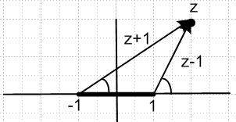

If z = +2, both angles are 0 and f(z) = |(z+1)/(z-1)|μ/2.
If z = -2+iε, both angles are +π and f(z) = |(z+1)/(z-1)|μ/2
If z = -2-iε, both angles are -π and f(z) = |(z+1)/(z-1)|μ/2

Therefore, f(z) is real and uncut to the right of z = +1, and to the left of z = -1. Therefore the cut must be as drawn above.

The cut structure for g(z) = [(z-1)/(z+1)]μ/2 looks exactly the same, just do the above steps with 1↔-1

You could write f(z) = (z+1)μ/2 (z-1)-μ/2 and you could think of this function has having two cuts, one from each factor.

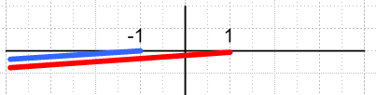

As we showed above, however, if you draw both cuts going exactly to the left, the two cuts exactly cancel to the left of -1. This is a better picture to use if you are later going to talk about (z-1) → (1-z) because then this causes the cut to z = +1 to go to the right.

The function f(z) appears in the basic P definition Bateman p 124 (14) which has one term with F
arg (1-z)/2. The corresponding Q definition p 130 (32) has g(z) in the first term and f(z) in the second term. Therefore, these factors contribute the above left picture cut to the overall cut structure of P and Q.

2. f2(z,μ) = [(1+z)/(1-z)]μ/2

Consider the function F(z) = [(1+z)/(1-z)]μ/2. For the usual Method A angle specification for z in the z-plane (-π,π), we can write this as

[(1+z)/(1-z)]μ/2 = |(1+z)/(1-z)|μ/2 exp[ i(μ/2)( arg(1+z) - arg(1-z) ]

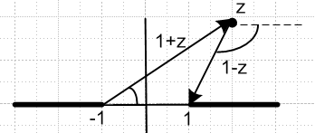

If z = +2±iε, the angles are 0 and ∓π so phase is e±i(μ/2)π so we have a cut on the right.
If z = - 2±iε, the angles are ±π and 0 so phase is e±i(μ/2)π so we have a cut on the left.
If z = +0.6±iε, the angles are 0 and 0 and phase is e0 .

Therefore, f(z) is real and uncut in (-1,1).

The cut structure for G(z) = [(1-z)/(1+z)]μ/2 looks exactly the same, just do the above steps with 1↔-1

You could write f(z) = (1+z)μ/2 (1-z)-μ/2 and you could think of this function has having two cuts. The first factor has the left cut above, the second factor has the right cut.

3. f3(z,μ) = (z+1)μ/2(z-1)μ/2

Consider the function r(z) = (z2- 1)μ/2 = (z+1)μ/2(z-1)μ/2. For the usual Method A angle specification for z in the z-plane (-π,π), we can write this as

[(z+1)(z-1)]μ/2 = |(z+1)(z-1)|μ/2 exp[ i(μ/2)( arg(z+1) + arg(z-1) ]

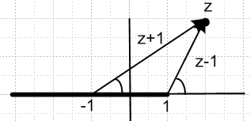

If z = +2±iε, the angles are 0 and 0 so phase is e0 so there is not cut for z > 1
If z = - 2±iε, the angles are ±π and ±π so phase is e±i(μ/2)2π so we have a cut on the left.
If z = +0.6±iε, the angles are 0 and ±π and phase is e±i(μ/2)π so we have a cut also in the middle.

You could write f(z) = (z+1)μ/2 (z-1)μ/2 and you could think of this function has having two cuts, one from each factor.

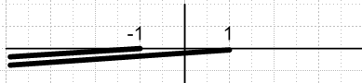

In this case the cuts do NOT cancel, so you get the unified cut shown above.

4. f4(z,μ) = (1+z)μ/2(1-z)μ/2

Consider the function s(z) = (1-z2)μ/2 = (1+z)μ/2(1-z)μ/2. For the usual Method A angle specification for z in the z-plane (-π,π), we can write this as

[(1+z)(1-z)]μ/2 = |(1+z)(1-z)|μ/2 exp[ i(μ/2)( arg(1-z) + arg(1+z) ]

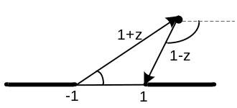

If z = +2±iε, the angles are 0 and ∓π so phase is e∓i(μ/2)π so there is a cut on the right
If z = - 2±iε, the angles are ±π and 0 so phase is e±i(μ/2)π so we have a cut on the left.
If z = +0.6±iε, the angles are 0 and 0 and phase is e0 so no cut in the middle.

You could write f(z) = (1-z)μ/2 (1+z)μ/2 and you could think of this function has having two cuts, one from each factor. The first factor has a cut to the right, the second a cut to the left.

5. F(a,b,c,z)

The function F(z,b,c,z) we know converges for |z| < 1. For some reason, Bateman never mentions the cut structure of this function in z, but W&W do on page 18-2: Here it is on the left:

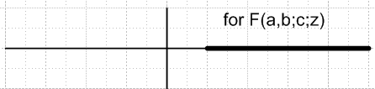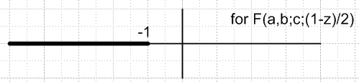

If follows that the function F(a,b,c, (1-z)/2 ) has a cut for (1-z)/2 ≥ 1 which is 1-z ≥ 2 or z ≤ -1, and this is shown on the right above. [ This is a fact I did not know until just now! ] I think you can show this from the integral representation Bateman p 114 (1). The factor (1-tz)-α has a branch point at z = 1/t and over the integration t ranges in (0,1) so you get a superposition of branch points for z = (1,+∞) and somehow this superposition becomes the cut. Notice the Method C angle idea |arg(1-z)| < π.

The two Bateman expressions mentioned above both have F functions of this form, and so have this cut. However, Bateman p 134 (41) for Q has the cut for 1/z2 ≥ 1 which means

6. Three functions: (z-1)α0L = (z-1)α , (z-1)α0R, and (1-z)α0R = (1-z)α .

This subject is treated in Complex/ " Study of (1-z)α and related functions.doc ".

(1) In that document, the first function we discuss is the "standard" function (z-1)α0L written usually as just (z-1)α . This function is cut to the Left from z = +1, and 0 indicates the Principal Sheet. It is real and positive on the uncut real axis to the right of z = 1.

(2) We also discuss a second function we call an "alternate function" (z-1)α0R which has the cut taken instead to the right. The cut moves left to right by swinging down and CCW. This exposes the +1 sheet of the function (z-1)α0L for Im(z) < 0. As a result, the functions (z-1)α0L and (z-1)α0R agree when Im(z) >0, but differ by a phase when Im(z)<0. The relation can be summarized as

(z-1)α0R = (z-1)α0L Im(z) ≥ 0 (*)
(z-1)α0R = (z-1)α0L e+i2πα Im(z) ≤ 0

We write this symbolically setting α = 1 and setting (z-1)α0L = (z-1)α as

(z-1)0R = (z-1) Im(z) ≥ 0
(z-1)0R = (z-1) e+i2π Im(z) ≤ 0

The function (z-1)α0R can be regarded as a certain analytic continuation of (z-1)α0L from its principal sheet 0, to a sheet whose upper half is the original principal sheet 0 of (z-1)α0L, and whose lower sheet is sheet +1 of the function (z-1)α0L. We have thus done "half a wind". This interpretation is useful when one thinks about the Q1(iζ) function, as explained in the referenced doc.

Here is a picture of the two function's z-planes with indications of how angles are measured for each:

(z-1)α0L = (z-1)α (z-1)α0R
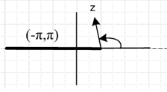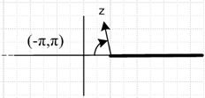
angles (-π,π) with 0 on cut extension angles (-π,π) with 0 on cut extension

In both cases the functions are real and positive for z located on the uncut real axis, and this is how the Principal Sheet (Sheet = 0) of each functin is defined. If you enter (z-1)α in Maple, what you get is the standard function (z-1)α0L. If you want to have Maple compute with (z-1)α0R, you have to define this function as shown above in (*) , both lines.

The document also discusses a third function g(z) = (1-z)α0R which is also cut to the Right. This function is regarded as g(z) = f(-z) where f(z) = (1+z)α0L = (z+1)α0L = (z- [-1])α0L . This last function is just our "standard form" (z-1)α0L where we have moved the branch point from 1 to -1. This picture shows how this all works: [ note that g(z) = f(-z) reflects everything including cuts and branch points through z=0 ]

f(z) = (1+z)α0L evaluated at z = -z g(z) = (1-z)α0R
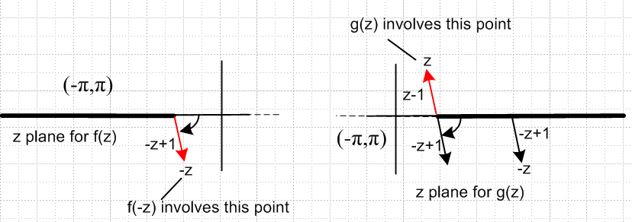

The drawing on the left us just for "support"; the z-plane for g(z) = (1-z)α0R is shown on the right. As claimed, the cut is taken to the Right from the branch point located at z = +1. A key fact is that the angle for g(z) is now measured (-π,π) with the zero taken on the cut itself, not the cut extension as with our previous two functions (z-1)α0L and (z-1)α0R shown above. The function (1-z)α0R we regard as "the standard function" of this type, and we would normally just write it as (1-z)α . If you enter (1-z)α in Maple, what you get is this standard function (1-z)α0R .

We show in the document that the second and third functions mentioned above are related like this:

(z-1)αOL = e±iαπ (1-z)αOR Im(z) 0

We can drop the subscripts if we accept that the functions shown are the "standard functions",

(z-1)α = e±iαπ (1-z)α Im(z) 0

As in the previous case, we can symbolically represent this as

(z-1) = e±iπ (1-z) Im(z) 0

These symbolic relations apply both in power expressions as well as log functions like ln(z-1). Here is some Maple code verifying the above claim where we have f(z) = (z-1)α and g(z) = (1-z)α. [ this g is the same as g above, but f is different. Think of f and g as local to this Maple exercise. ] We use α = .23 .

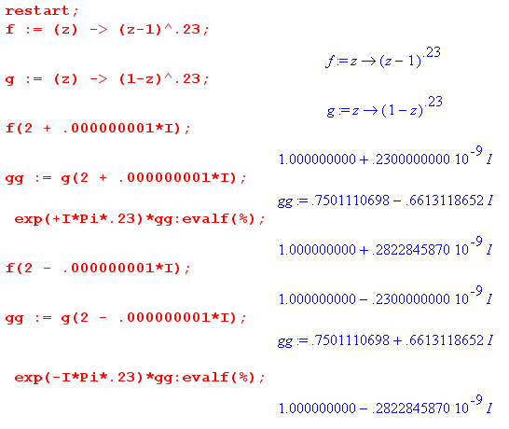

Part I: The Associated Legendre Functions

1. The Classical Legendre Functions.

These are the Bateman off-the-cut functions always written with "z" as an argument in Bateman. Bateman also uses a script P and Q to denote these functions, but I don't do that, I use the argument (z vs x) to tell. These are the functions that MOST of Bateman's formulas apply to, such as the huge table p 124-139.

(a) Cut Structure.

It is convenient to use Bateman p 124 (14) and p 130 (32) as definitions of the P and Q functions, since all three F functions involved have argument ξ = (1-z)/2 . This provides a disk of convergence around the point z = 1 with radius 2 units. Here in schematic form are these two definitions:

P = f1(z,μ) F(ξ) (14)

e-iπμ Q = f1(z,-μ)F(ξ) + f1(z,μ)F(ξ) (32)

The f1 function has a cut structure than can be drawn in two useful ways, as found in Section 1 above;

If we use the way on the left, then the overall cut structure for P and Q appears as follows, which we draw in two slightly different ways:

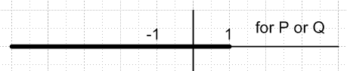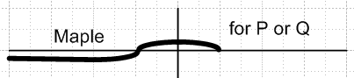

The drawing on the right is just meant to show what Maple does if you give it a real z argument that lies on one of the cuts. I quote:

"Rather than take this approach, Maple defines the default Legendre functions to be continuous onto the cuts, from above for the cut (, -1) and from below for the cut (-1, 1). "

However, if we use the right-side f1 cut structure shown above (red-blue), we can re-express the cuts of P and Q in this fashion, where we deform the cuts just to maintain the Maple evaluation method for real arguments (left figure below).

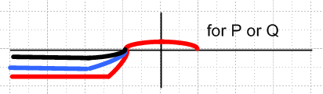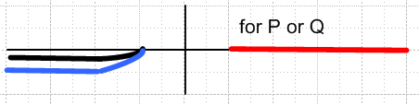

In the next section, we shall define some different P and Q functions which have (z-1) replaced by (1-z) only in the outside factors shown above. This causes (z-1)-μ/2 to be replaced by (1-z)-μ/2. In the language of Section 6 above, we are replacing (z-1)-μ/2OL by (1-z)-μ/20R where α = -μ/2. The cut going to the left of the first function is reflected through z=0 and appears going to the right in the second function. This is the red cut above and in the right figure above we show it going to the right. The new functions defined this way are then uncut in the region (-1,1).

(b) More on Maple.

The on line Help at http://www.maplesoft.com/supp ort/help/AddOns/view.aspx?path=Legendre
is a little clearer than my Maple V help, but they do agree, so Maple has not changed its ways regarding these functions since Maple V (we are now 2010 at Maple 13, new editions like Xilinx or Microsoft! ) Here from the on-line Help:

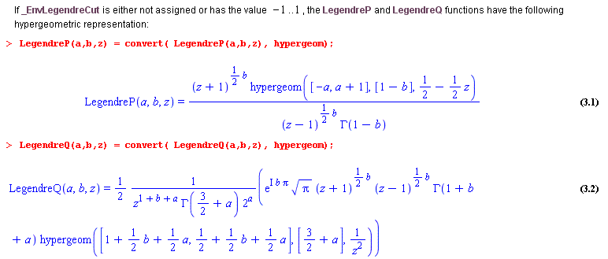

The P function shown above is our P function shown above, Bateman (14). However, the Q function shown is not the Bateman (32) we used, but the Bateman form (41) which has F argument 1/z2. This (41) is convenient for large z values and has only a single term.

When you don't adjust the Maple environment variable _EnvLegendreCut and leave it be the default default, Maple is thinking exactly of the Bateman classical functions.

(c) Other authors.

A&S p 332 and GR p 998 both agree exactly with Bateman. A&S use "z" to denote these Classical functions, and use "x" to denote the on-the-cut functions, just as Bateman does, with the same connections. I will mention this subject below. GR had a notation typo fixed in GR7.

As for Smythe and MF we have, for the classical functions,

Qνμ(z)Smythe = Qνμ(z)Bateman

Qνμ(z)MF = e-iμπ Qνμ(z)Bateman

W&W talk about various forms and mention Hobson, Barnes, Ferrer and others. I think this was before things were more or less standardized, so I won't use this source unless I have to.

2. The Maple Cut-To-Right (CTR) Legendre Functions.

(a) My conclusion is that these are "ill-defined" at least for the Q function. See separate document "Maple CTR Legendre.doc". I tried defining these functions in various different ways, including the way they claim in their Help, but none of my trial definitions gives the same result that you get setting the cut to the right with _EnvLegendreCut := 1..infinity . Their QCTR function delivers near-real values on the cut
(-1,1), and complex values other places. When z is close to the cut, say .36± iε, my methods give the correct real part, but the wrong imaginary part.

(b) A web search on < maple _EnvLegendreCut> delivers only 39 hits, same for similar searches. So this is not really something anybody has worked with much. No one else has found value in it.

(c) Early on, I thought these functions might be the "analytic continuations" like my famous Q1(iζ) function, but that is not the case. My continued Q1,0R blows up one way and blows down the other way on the imaginary axis, but here is what Q1,CTR does: (it is symmetric, blowing up both ways).

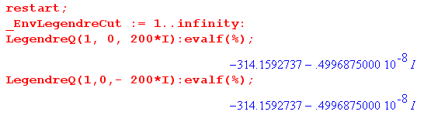

If I want to use Q1,0R type functions, I will have to construct them myself.

(d) I think it would be very good to NEVER USE these CTR Maple functions. I feel they don't really mean anything at all.

3. The Bateman on-the-cut (on) Legendre functions

These are defined in Bateman page 143, and he has properties for these functions as well. Other authors follow suit. The convention is to use "z" as an argument of the classical Legendre functions, and use "x" for the on-cut functions. Note that the OTC functions have no meaning for z off the real interval (-1,1). Maple tried to do this with their CTR functions, but see above. Here is how you might implement this function in Maple:

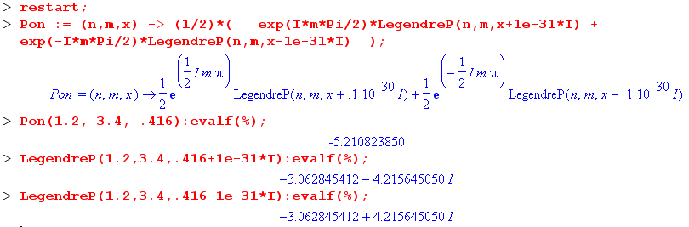

Since we have Digits := 10 by default, the actual value of the imaginary part has no effect on the results (even before the two terms are added), but the sign clearly does, and that is all we want.

On the cut Q functions could be implemented in similar fashion, using Bateman p 143 (2).

I discuss these functions more in "legendre on cut.doc", including how the various "rules" are different for these functions versus the classical P(z) type functions.

