Zeros and Poles of Legendre Functions in n,m space and Q (43) PhL 2.19.10

This is just a little detail I would like to get out of the way, so I can use it later when I need it. I have never tried to be systematic about this.
The pole/zero structure in the n,m plane depends on what range of z you are interested in, because that determines which Bateman expression you look at. See "Convergence for Bateman forms.doc" in Legendre folder to see the various convergence regions.
Somehow this n,m spectral stuff got mixed in with my Q (43) analysis. Leave for the moment.

Preliminary #1. 1
Preliminary #2 1
The Q(z) function using (43): the n,m spectrum 2
The Q(z) function using (43): the z-plane cut structure 3
The Q(z) function using (43): replacing z = iζ where ζ is real. 4
Suppose we to replace the ± sign between our two terms in qnew with a – sign 6

Preliminary #1. This function appears frequently ( note that f(n,-m) = 1/f(n,m) )

f(n,m) = Γ(1+n+m)/ Γ(1+n-m) poles when n+m = -1,-2,... n = -m - posint
zeros when n-m = -1,-2... n = m - posint

f(n,-m) = Γ(1+n-m)/ Γ(1+n+m) poles when n-m = -1,-2,... n = m - posint
zeros when n+m = -1,-2... n = - m - posint

The spectra are shown below. At the dots, poles and zeros cancel giving a finite result. This happens at both the integral and half-integral mesh points in the triangle of dots, which extends downward forever.
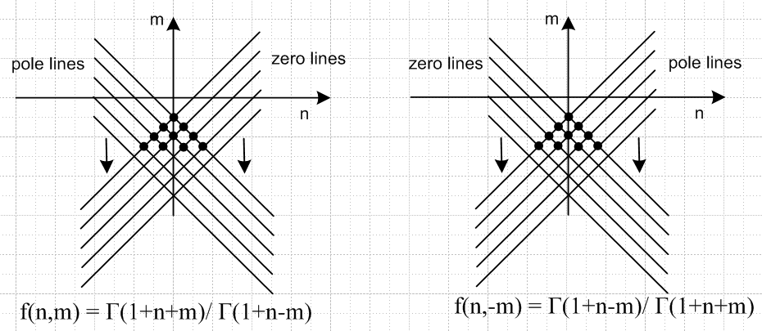

Preliminary #2. Another pair of functions which appear a lot are these:

g1(n,m) = Γ(1/2+n/2+m/2) / Γ(1+n/2-m/2)

poles when n/2+m/2 = -1/2,-3/2, -5/2 = - posoddint/2 n+m = - posoddint m = -n - posoddint poles
zeros when n/2-m/2 = -1, -2, -3... = - posint n-m = - posint m = n +2* posint zeros

g2(n,m) = Γ(1+n/2+m/2) / Γ(1/2+n/2-m/2)

poles when n/2+m/2 = -1, -2, -3... = - posint n+m = - 2*posint m = -n -2* posint
zeros when n/2-m/2 = -1/2,-3/2, -5/2 = - posoddint/2 n-m = - posoddint m = n + posoddint

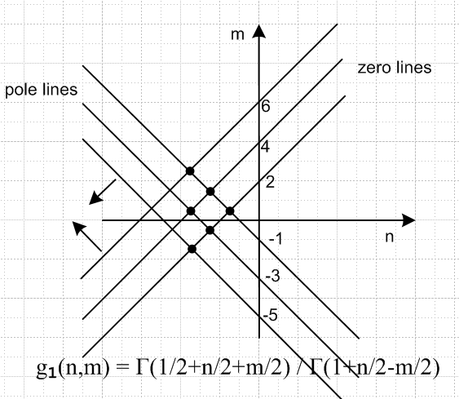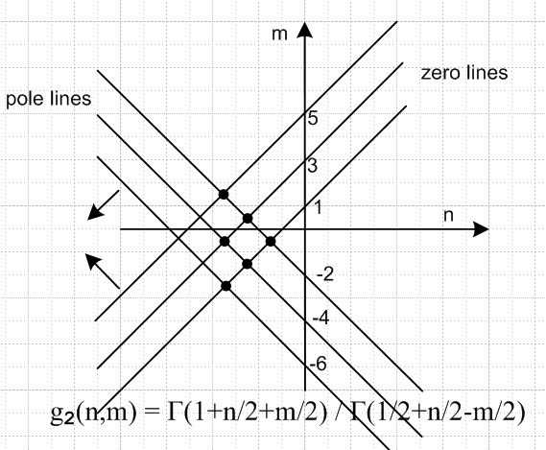

The g2 spectrum is obtained by raising the n axis one unit. As before, we have lines of zeros and lines of poles and dots where the two cancel which are only on half-integral points for these functions.

The Q(z) function using (43): the n,m spectrum

A very clean choice here is form (43) with arg = z2/(z2-1) which gives a clean convergence region including the entire imaginary axis, no question about it:

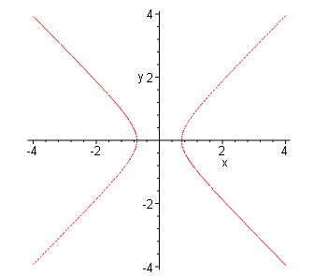

Luckily, this form has fixed F "c" arguments, so we can use this form to study n,m space for Qnm(iζ).
Here it is:

e-iπmQnm(z) = $\sqrt{π}$2m-1 g1(n,m) e∓iπ(n+1/2) (z2-1)n/2 F(a,b,c; z2/(z2-1)) (*)
+ $\sqrt{π}$2m g2(n,m) e∓iπ(n-1/2) z (z2-1)n/2-1/2 F(a',b',c'; z2/(z2-1))

where we (now) understand that (z2-1)α must be written out as two factors!!

We have the n,m space spectrum for each of these gi factors, so we can tell where either term either has a zero or a pole. If n has some weird real positive value [ perhaps it makes Pn(ξ1) = 0 ] , we draw a vertical line on the right at this off-mesh value and we find that, if we also have integer m, we will never hit a pole or a zero of either g1 or g2, so we get a finite contribution from all integers m for a given n. ( Of course we might accidentally have a problem but I think that will take care of itself. )

The Q(z) function using (43): the z-plane cut structure

(a) As z runs ∞ to 1+ε, the argument in the F function runs 1+ε to ∞. That is the right side red curve below in this plot of the arg versus z.

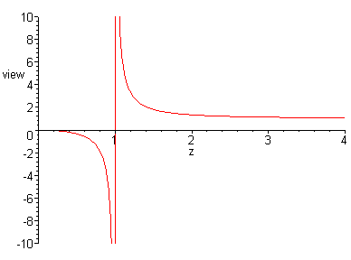

Therefore, the F function part of the functions has a cut (+1,+∞) and (-∞,-1).

(b) If we examine the situation in the (-1,1) region, we can use the Bateman page 123 "symbolic" rule (which I have now derived)

(z2-1) = e±iπ (1-z2)

to say that

e∓iπ(n+1/2)(z2-1)n/2 = e∓iπ(n+1/2) e±iπn/2 (1-z2)n/2 = e∓iπn/2 (∓i) (1-z2)n/2

e∓iπ(n-1/2)z (z2-1)n/2-1/2 = e∓iπ(n-1/2)z e±iπ(n/2-1/2) (1-z2)n/2-1/2 = e∓iπn/2 (1-z2)n/2-1/2

and then we have:

e-iπmQnm(z) = $\sqrt{π}$2m-1 g1(n,m) (∓i) e∓iπn/2 (1-z2)n/2 F(a,b,c; z2/(z2-1))
+ $\sqrt{π}$2m g2(n,m) z e∓iπn/2 (1-z2)n/2-1/2 F(a',b',c'; z2/(z2-1))

so there does seem to be a cut on the (-1,1) region due to these different phase factors. So our function seems then to have a cut along the entire real axis.

(c) Aside: Suppose we now shift from complex variable z to complex variable ζ with connection z = +iζ ? The above then becomes

e-iπmQnm(iζ) = $\sqrt{π}$2m-1 g1(n,m) (∓i) e∓iπn/2 (1+ζ2)n/2 F(a,b,c; ζ2/(ζ2+1))
+ $\sqrt{π}$2m g2(n,m) ζ (+i) e∓iπn/2 (1+ζ2)n/2-1/2 F(a',b',c'; ζ2/(ζ2+1))

Just leave this result here, and continue on using (*) above:

The Q(z) function using (43): replacing z = iζ where ζ is real.

(a) What happens to (z2-1)n/2 when we set z = iζ ?

There no longer any doubt about this. We have (ζ is a real variable, not a complex variable)

(z2-1)α ≡ (z+1)α(z-1)α = |z2-1|α exp(iα(θ+φ)] = |z2-1|α e±iπα

To explain this conclusion, consider these pictures

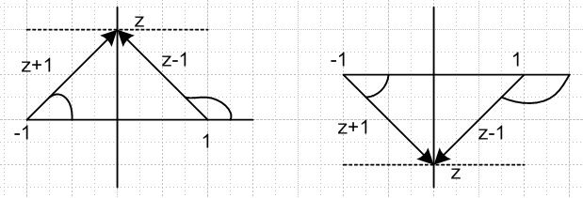

For z in the upper half plane, both angles are positive and add to π. But for z in the lower half, the angles are both positive and add to -π . QED. Therefore

Rule: when z = ±iζ we have (z2-1)α = (ζ2+1)α e±iπα = (ζ2+1)α (±i)2α

[ Aside: if you don't write (z2-1)α as two factors, you get (z2-1)α = (ζ2+1)α e+iπα which is the wrong answer!!! ]

This function (z2-1)α we know is cut near the origin, so we expect it to have a discontinuous value above and below the origin.

(b) Converting (*) above to its ζ form

Now for the main act: Setting z = iζ the above becomes

e-iπm Qnm(iζ) = $\sqrt{π}$2m-1 g1(n,m) e∓iπ(n+1/2) (±i)n (ζ2+1)n/2 F(a,b,c; ζ2/(ζ2+1))
+ $\sqrt{π}$2m g2(n,m) e∓iπ(n-1/2) (iζ) (±i)n-1 (ζ2+1)n/2-1/2 F(a',b',c'; ζ2/(ζ2+1))

= $\sqrt{π}$2m-1 g1(n,m) e∓iπ(n+1/2) (±i)n (ζ2+1)n/2 F(a,b,c; ζ2/(ζ2+1))
∓ $\sqrt{π}$2m g2(n,m) e∓iπ(n-1/2) (±iζ) (±i)n-1 (ζ2+1)n/2-1/2 F(a',b',c'; ζ2/(ζ2+1))

= $\sqrt{π}$2m-1 g1(n,m) e∓iπ(n+1/2) (±i)n (ζ2+1)n/2 F(a,b,c; ζ2/(ζ2+1))
∓ $\sqrt{π}$2m g2(n,m) e∓iπ(n-1/2) (ζ) (±i)n (ζ2+1)n/2-1/2 F(a',b',c'; ζ2/(ζ2+1))

= $\sqrt{π}$2m-1 g1(n,m) (∓i)(2n+1) (±i)n (ζ2+1)n/2 F(a,b,c; ζ2/(ζ2+1))
∓ $\sqrt{π}$2m g2(n,m) (∓i)(2n-1)) (ζ) (±i)n (ζ2+1)n/2-1/2 F(a',b',c'; ζ2/(ζ2+1))

= $\sqrt{π}$2m-1 g1(n,m) (∓i)(n+1) (ζ2+1)n/2 F(a,b,c; ζ2/(ζ2+1))
∓ $\sqrt{π}$2m g2(n,m) (∓i)(n-1))(ζ) (ζ2+1)n/2-1/2 F(a',b',c'; ζ2/(ζ2+1))

= $\sqrt{π}$2m-1 g1(n,m) (∓i)(n+1) (ζ2+1)n/2 F(a,b,c; ζ2/(ζ2+1))
∓ $\sqrt{π}$2m g2(n,m) (∓i)(n+1) (∓i)(-2) (ζ) (ζ2+1)n/2-1/2 F(a',b',c'; ζ2/(ζ2+1))

= $\sqrt{π}$2m-1 g1(n,m) (∓i)(n+1) (ζ2+1)n/2 F(a,b,c; ζ2/(ζ2+1))
± $\sqrt{π}$2m g2(n,m) (∓i)(n+1) (ζ) (ζ2+1)n/2-1/2 F(a',b',c'; ζ2/(ζ2+1))

= (∓i)(n+1) { $\sqrt{π}$2m-1 g1(n,m) (ζ2+1)n/2 F(a,b,c; ζ2/(ζ2+1))

± $\sqrt{π}$2m g2(n,m) ζ (ζ2+1)n/2-1/2 F(a',b',c'; ζ2/(ζ2+1))

The {...} is a finite real function of a real variable ζ. But due to the outside factor, the total function is discontinuous above and below the origin, as we expect. That is, we know e-iπm Qnm(iζ) is cut at the origin in z space, a discontinuity above and below z = 0.

But now multiply both sides by (±i)n+1 and we end up with this:

(-i)2m (±i)n+1 Qnm(iζ) = { $\sqrt{π}$2m-1 g1(n,m) (ζ2+1)n/2 F(a,b,c; ζ2/(ζ2+1))
± $\sqrt{π}$2m g2(n,m) ζ (ζ2+1)n/2-1/2 F(a',b',c'; ζ2/(ζ2+1)) }

If we call the object in {..} f(ζ), we see that

f(ζ) = A + (+ζ) B ζ > 0
f(-ζ) = A - (-ζ) B ζ > 0

Therefore f(ζ) = f(-ζ) and f is symmetric.

Aside: The large ζ behavior for ζ → ± ∞ appears to be ζn with a contribution from both terms, but we know this is wrong because we know Qnm(z) → |z|-n-1. The rescue must come from the F function. If we assume ζ is very large, we can write arg = 1-ζ-2 . We might call ξ-2 = Z → 0 so arg = 1-Z. Then we could use the Kummer HGF connection formulas to find how our F behaves near Z = 0. This would no doubt reveal a behavior F → ζ-2n-1 and then we get our desired large ζ form. But if this F behavior were true, then we would expect F → 0 and that is not the case. Bateman says:

F(a,b,c,1) = Γ(c) Γ(c-a-b) /[ Γ(c-a)Γ(c-b) ]

I tried the first F function and did not get 0. So I guess it must be an effect where both terms are involved and you only get ζ-n-1 when you add the two terms for large ζ. We KNOW it has to work out, so need to waste time on this.

Let's now define:

qnm(ζ)new ≡ (-i)2m (±i)n+1 Qnm(iζ) RHS1

= { $\sqrt{π}$2m-1 g1(n,m) (ζ2+1)n/2 F(a,b,c; ζ2/(ζ2+1)) RHS2
± $\sqrt{π}$2m g2(n,m) ζ (ζ2+1)n/2-1/2 F(a',b',c'; ζ2/(ζ2+1)) }

(c) Realization that we have simply replicated the symmetric q found by other means.

The above result is identical to my famous q function found by different means

qnm(ζ) ≡ (-i)2m (±i)n+1 Qnm(iζ)

(d) What happens if you replace the ± sign with a – sign inside {...}

Suppose we to replace the ± sign between our two terms in qnew with a – sign.

We would then get:

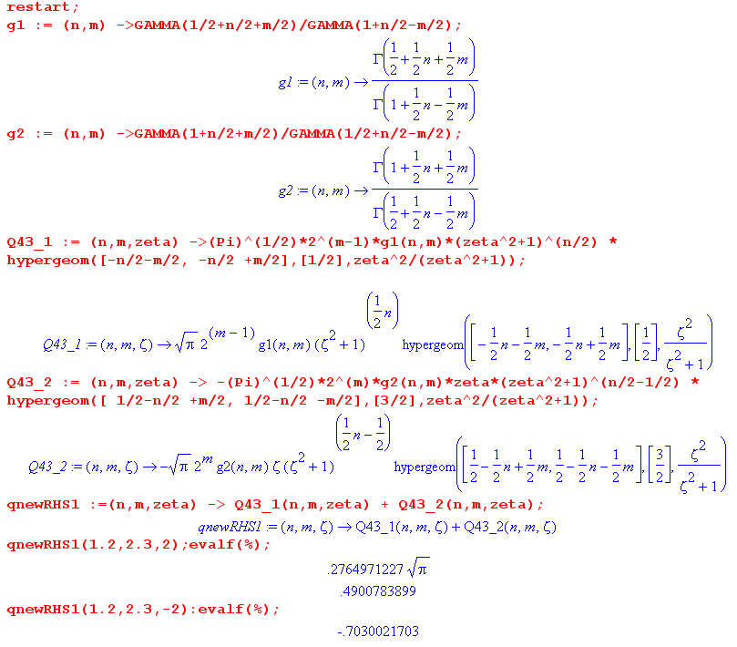

If we do this sign change, we get an asymmetric function, as the numbers show above. Now let's look at a particular case when we do this:

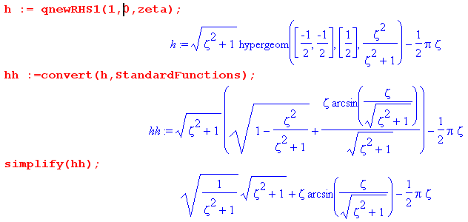
If I finish this off by hand, I get

qnewRHS(1,0,ζ) = 1 + ζ [ sin-1() - π/2] = 1 + ζ [ tan-1(ζ) - π/2] = 1 - ζ cot-1(ζ)

and this is pretty much Q1(jζ) = ζ cot-1(ζ) – 1 ! Going the other way

qnm(ζ) ≡ (-i)2m (±i)n+1 Qnm(iζ) = (±i)1+1 Qnm(iζ) = - Q1(iξ)

so it agrees.

Somehow I may have stumbled onto a general Q formula for "going through the cut"! But how did that happen? I am glad I found this thing, but am totally mystified how it came about.

