Legendre Functions on the Cut PhL 1.5.10

Motivation. Bateman has a huge chapter on Legendre functions which are defined with both cuts pulled off to the left. Then on page 143 they talk about separate versions of these functions being defined "on the cut", meaning on the (-1,1) interval. I know how they define these functions (their "prescription"), but I don't know how to modify the other 3,000 properties of Legendre functions they talk about. This needs sharpening. These on-the-cut functions are sometimes called "modified" Legendre functions.

We know that our ODE has regular singular points at +1 and -1 and ∞ and our P and Q solutions have branch points at these locations. From "MF ODE" doc we know that

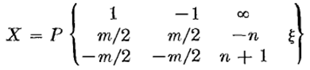

so the exponents at z = 1 and -1 are ± μ/2 as we see so often in our Bateman reading.

Since cuts are always hard for me to think about, I have to build up with simple examples. I have this all in some other document, but I will just start over here. [ "contours and cuts.doc" in ODEs]

Warmup Example 1. f = $\sqrt{z}$ 1
Warmup Example 2. f(z) = z^{1/3} (1-z)^{1/2} 3
The P function on the cut (Bateman) 4
The Q function on the cut (Bateman) 5
1. Let's apply the prescription of p 144 to the form p 130 (32) for the Q function. 6
2. Does Q(x) solve the Legendre equation? 6
3. Are the many "relations" which were proven for Q(z) and P(z) still valid for Q(x) and P(x) ? 7
(3a) Table Relations. 7
Summary of these results: 8
(3b) Page 140 relations. 9
(3c) The Wronskian. 9
(3d) Integer Cases. 9
4. Why does the grouping [ e^{-iμπ} Q_{ν}^{μ} (z) ] always appear together? 10
5. What causes the (1-z) to turn around inside the log of the Q functions? 11
6. How could you make a table of the integral P and Q functions? 11
7. Pause to gather up all results so far: 13
8. Comparison of Bateman/me to Morse Feshbach 14
9. Comparison of Bateman/me to Smythe 17
My conclusions comparing Smythe and Bateman/me and MF 20
Appendix A: Selections for MF regarding Legendre functions. 20

Warmup Example 1. f = $\sqrt{z}$

(a) We normally draw the cut like this:
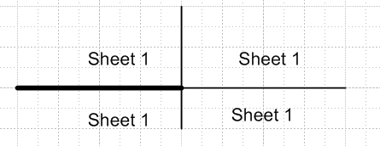

This function has two sheets at are accessed by f = $\sqrt{R}$ eiθ/2 as θ runs over a range of 4π. We could take this range to be (-2π, 2π). On the positive real access we set θ = 0 so f = $\sqrt{R}$= real. Then (-π,π) gives us access to all of Sheet 1 (white). To get to Sheet 2 we need the two ranges (π,2π) and (-2π,π) sort of unioned together, but none of Sheet 2 is shown in the above picture. Over on the cut upper side of Sheet 1 we have f = $\sqrt{R}$eiπ/2 = i$\sqrt{R}$, and on the lower side we have -i$\sqrt{R}$. One way to define Sheet 1 is to say that Re(f) = $\sqrt{R}$cos(θ/2) is positive everywhere on this sheet, and it is negative everywhere on Sheet 2.

(b) We can now talk about rotating the branch cut counter clockwise.

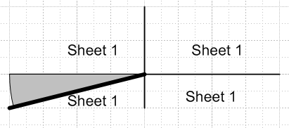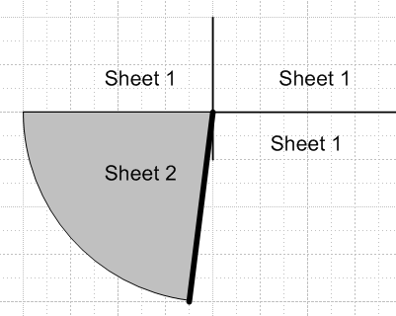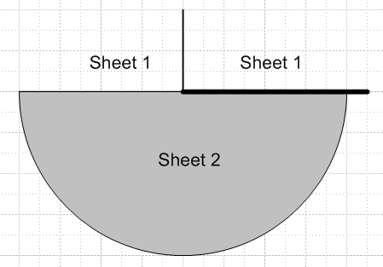

As we do this, we expose more and more of Sheet 2, shown gray. Eventually we have the cut going to the right. We are not changing the function, we are just exposing different parts of its sheets. So, for example, at a point z = 4+iε, we have f = 2 in all four pictures as ε→0. And at z = -4+iε, we have f = i 2. However, if we compare our first picture far above to our last picture on the right, the function has different values in the lower half plane, because in the first picture this lower half plane is Sheet 1, but in the last picture it is Sheet 2. For example, in the first picture at z = -4-iε we have f = -i 2. In the last picture, however, we have instead f = +i2 because we get to this point starting just above the cut and going below it.
Now someone might come along and attempt to define a function "f(z) on the cut",

f(z)on the cut = (1/2) [ e-iπ/2f(z=-R+iε) + e+iπ/2 f(z=-R–iε) ]

= (1/2) [ e-iπ/2 i $\sqrt{R}$ + e+iπ/2 (-i $\sqrt{R}$)]

= (1/2) [$\sqrt{R}$ + $\sqrt{R}$)] = $\sqrt{R}$

We would get the same result if we thought about this function:

g(z) = f(-z) with branch cut drawn to the right in the z plane

This function is then real for z on the negative real axis. This is NOT the same function we started with, which was f(z). So the "f(z) on the cut" function is not simply f(-|z|+iε). After all, the latter is imaginary, whereas "f(z) on the cut" is real. In fact, we have

f(z)on the cut = f(-z) = $\sqrt{-z}$

and his is real when z is on the negative real axis.

Warmup Example 2. f(z) = z1/3 (1-z)1/2

Now things are much more complicated, and this is the example I discuss in contours and cuts. I will quote, with some editing:

Here is a useful picture:

m = 0,1,2 n = 0,1

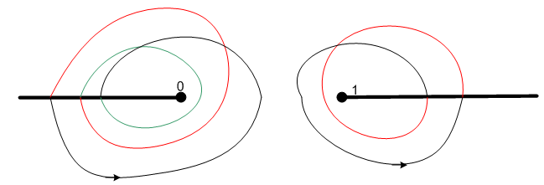

For the branch point on the left which arises from z1/3, there are three sheets encountered as you rotate around the point z=0 many times. If we had f(t) = z1/3, we would have just the left branch cut, and we would say that f(z) had 3 sheets. Similarly, if we just had f(z) = (1-z)1/2, we would only have the branch cut on the right, and the function f(z) would have 2 sheets.
We can think of 3 winding numbers possible on the left, and 2 on the right. Call these m and n. Then the phase accrued by moving away from the black-black sheet is this

phase = 2π( m/3 - n/2)

m n ( m/3 - n/2) Sheet name:
0 0 0 black-black
1 0 1/3 red-black
2 0 2/3 green-black
0 1 -1/2 black-red
1 1 1/3 - 1/2 = -1/6 red-red
2 1 2/3 - 1/2 = +1/6 green-red

There are 6 sheets for f(z) = z1/3 (1-z)1/2 because there are six different phases, and they are equally spaced around the circle:

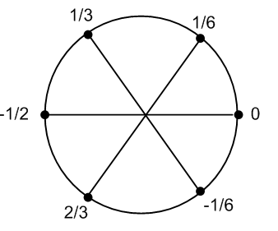
End quote. Now let's re-examine the picture above

The colors are carefully drawn to match the branch cuts as drawn. But we really want the cut at z=1 to go off to the left. Imagine swinging that cut clockwise down, and as we do so, we adjust the colors on the two windings so they change at the cut. Well, it was not that hard to just rotate the right side of the picture, so here is something closer to what we want

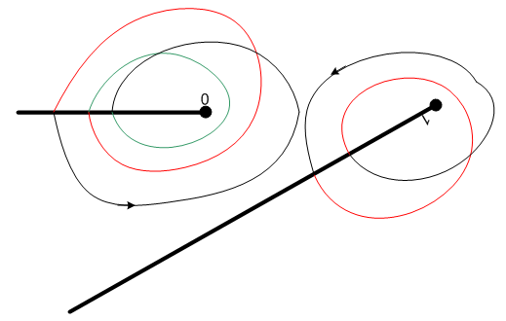

So when you have multiple branch points in a function, you really need to label sheets with a set of winding numbers like the m.n considered here. It is very hard to draw a good picture (a parking garage somehow) showing the 6 sheets.

Hopefully these warmup examples are enough. In our general case below of course we have an infinite number of winding numbers possible at each branch point.

The P function on the cut (Bateman)

Let's start with Pνμ(z) as given in Bateman p 122 [ P (14)] top where we have, from a cut point of view,

Pνμ(z)start = [(z+1)/(z-1)]μ/2

where the F function converges in a disk of radius 2 about the point z = 1. So we can't really "get to" the cut below -1 with this form, so we shall restrict our interest to the portion of the cut that runs (-1,1). But still we can draw the cuts everywhere:
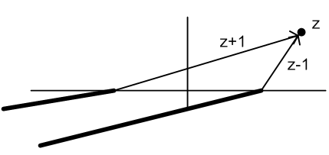

The reason we draw the cuts to the left is to have things be real on the positive real axis far off to the right, the usual "real analytic" thing I think.
Recall from Warmup Example 1 how we arranged to have things be real on the negative axis. We defined f(z)on_the_cut by replacing z with -z. Here we can do that same thing just with the cut on the right by replacing z-1 with 1-z. Then we get

Pνμ(z)on_the_cut = [(z+1)/(1-z)]μ/2 // can also write as [(1+z)/(1-z)]μ/2

Now notice that (the first phase is negative since (1-z) is in the denominator )

Pνμ(x+iε)start = [(z+1)/(z-1)]μ/2 e-iπμ/2
Pνμ(x–iε)start = [(z+1)/(z-1)]μ/2 e+iπμ/2

We can do this same thing "the long way" by using the rule Bateman gives on page 143:

Pνμ(z)on_the_cut = (1/2) [ e+iπμ/2 Pνμ(x+iε)start + e-iπμ/2 Pνμ(x-iε)start ]

which is not simply the average of Pνμ(z)start above and below the cut!
So basically, we get to our "on the cut" version simply by changing z-1 → 1-z in our factor. We do NOT make any changes in the F function of course, since it has no cut. We are just dealing with the cuts here.
When we do as described above, we have

Pνμ(z)start = p 122 (3) = 1/Γ(1-μ) [ (z+1)/(z-1)]μ/2 F[ -ν, ν+1; 1-μ; (1-z)/2 ]

Pνμ(z)on the cut = p 143 (6) = 1/Γ(1-μ) [ (1+z)/(1-z)]μ/2 F[ -ν, ν+1; 1-μ; (1-z)/2 ]

Note added 2.22.10. You can think of P (22) as "working everywhere" if you think of F as a function, not a series. In this sense F(a,b,c,z) has a cut (1,∞), so F (a,b,c,(1-z)/2) has a cut (-∞,-1). So one should keep this cut in mind, it is not JUST the outside powers that make cuts. More elsewhere.

The Q function on the cut (Bateman)

1. Let's apply the prescription of p 144 to the form p 130 (32) for the Q function.
We do this because this form has the same (1-z)/2 argument of F as the P form we used, which seems nice somehow. The symbolic form of (32) is this:

e-iμπQνμ(z) = (z-1)μ/2 + (z-1)-μ/2

Note added 1.26.10. In this symbolic form, we ignore constants of μ and ν, we ignore the F function, and we ignore factors of the form zα or (1+z)α. The reason is that none of these factors is expressed differently if you are to the right of the branch point at z = 1, or if you are to the left of it in the range
(-1,1) (above or below the cut). Thus, all these factors will be the same for on cut and off cut functions. We might choose to write z+1 and 1+z for on cut functions, but obviously there is no issue here. We never "wind" around the point z = -1 or z = 0.

Therefore we can say

e-iμπQνμ(x+iε) = e+iπμ/2|z-1|μ/2 + e-iπμ/2|z-1|μ/2
e-iμπQνμ(x-iε) = e-iπμ/2|z-1|μ/2 + e+iπμ/2|z-1|μ/2

The prescription then says

e-iμπQνμ(x) ≡ (1/2) [e-iπμ/2 Qνμ(x+iε) + e+iπμ/2 Qνμ(x-iε) ]

= (1/2) e-iπμ/2 [Qνμ(x+iε)]
+ (1/2) e+iπμ/2 [Qνμ(x-iε)]

= (1/2) e-iπμ/2 [e+iπμ/2|z-1|μ/2 + e-iπμ/2|z-1|μ/2]
+ (1/2) e+iπμ/2 [e-iπμ/2|z-1|μ/2 + e+iπμ/2|z-1|μ/2]

= (1/2) [|z-1|μ/2 + e-iπμ|z-1|μ/2]
+ (1/2) [|z-1|μ/2 + e+iπμ|z-1|μ/2]

= |z-1|μ/2 + cos(πμ) |z-1|μ/2

and this agrees with the symbolic form of p 144 (10). Notice that this resulting form is real on the cut (-1,1) for real parameters and real argument! Surely this must be a major motivation for choosing this definition for the on-the-cut Q function. The on-the-cut P function has this same property.

2. Does Q(x) solve the Legendre equation?
Consider limε→0 (x+iε). Let's say this takes you to a point on Sheet 1 of the ODE sheet structure, call it x+. At this point, certainly Qνμ(x+) is a solution of the ODE. If we, as an ant, crawl around the branch point at z = 1, and go to point x-, and from there up to the real axis, then we are at a point on Sheet 2. More precisely, if the starting sheet was m,n = 0.0, then x+ is on this sheet 0.0 and x- is on the sheet 0.1 because we wind CW one around z = 1 (making my own CW convention just locally here). Since Qνμ(z) is a solution of the ODE for z any point on any sheet m.n (OK, stay away from the singular points), then certainly Qνμ(x-) is also a solution of the ODE.
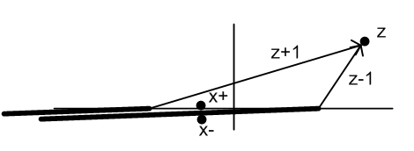

Therefore, the function which is defined to be " Q on the cut" is the sum of two ODE solutions, and must therefore itself be a solution at the point z = x. Question answered!

3. Are the many "relations" which were proven for Q(z) and P(z) still valid for Q(x) and P(x) ?
This question needs a systematic answer. Start on page 122 where we have various numbered "facts" about P(z) and Q(z) functions. Items (3) and (5) are two entries of the table of "joining relations" to follow. Items (7) and (8) come from parameter shifting forms of the F function. Then on page 123 we have an introduction to the tables, and I skip the Wronskian for the moment.

(3a) Table Relations.

So basically, our question is this: are the many entries in "the tables" valid for the P(x) and Q(x) functions? Or do they need to be modified? A certain table entry has this symbolic form, where I show only (z-1) factors [ see note on symbolic form above ]

P = A(z-1)α F + B(z-1)β F'

There might only be one term. The exponents are usually 0, μ/2 or -μ/2, but other values do appear. Let's now consider the above sample relation at our special points. (the relation is valid at all points z)

P(x+) = A(z-1)+α F + B(z-1)+β F'
P(x-) = A(z-1)-α F + B(z-1)-β F'

where we have

(z-1)+ = |z-1| e+iπ => (z-1)+α = |z-1|α e+iπα
(z-1)- = |z-1| e-iπ => (z-1)-α = |z-1|α e-iπα

Rewrite the above then as (later we can set |z-1| = (1-x) )

P(x+) = A e+iπα|z-1|α F + Be+iπβ |z-1|β F'
P(x-) = A e-iπα |z-1|α F + Be-iπβ |z-1|β F'

Now apply the phases to each equation according to our prescription

e+iπμ/2 P(x+) = A e+iπμ/2 [e+iπα|z-1|α ]F + B e+iπμ/2[e+iπβ |z-1|β ]F'
e-iπμ/2P(x-) = A e-iπμ/2[ e-iπα |z-1|α ] F + B e-iπμ/2[e-iπβ |z-1|β ]F'

where I have put [..] around places where we use the "rules" that Bateman states. Now let's add and divide by 2.

P(x) = { e+iπμ/2 e+iπα + e-iπμ/2 e-iπα }/2 * A |z-1|α F
+ { e+iπμ/2 e+iπβ + e-iπμ/2 e-iπβ }/2 * B |z-1|β F '

= { e+iπ(α+μ/2) + e-iπ(α+μ/2) }/2 * A |z-1|α F
+ { e+iπ(β+μ/2) + e-iπ(β+μ/2) }/2 * B |z-1|β F '

= cosπ(α+μ/2) * A |z-1|α F + cosπ(β+μ/2) * B |z-1|β F '

So this is the new relation, and it is not the same, we have the extra cosine factors!!! So the exact relation for the P(x) functions depends on the values of α and β. I will do some examples in a moment. Bateman could have been clearer about this!
What about the Q functions? The table entries for those have this form:

e-iπμ Q(z) = A(z-1)α F + B(z-1)β F

and following similar steps we quickly get

e-iπμ Q (x+) = A e+iπα|z-1|α F + Be+iπβ |z-1|β F'
e-iπμ Q (x-) = A e-iπα |z-1|α F + Be-iπβ |z-1|β F'

Now apply the reverse phases to those applied for the P function:

e-iπμ/2e-iπμ Q (x+) = A e-iπμ/2e+iπα|z-1|α F + B e-iπμ/2e+iπβ |z-1|β F'
e+iπμ/2e-iπμ Q (x-) = A e+iπμ/2e-iπα |z-1|α F + B e+iπμ/2e-iπβ |z-1|β F'

Then add and divide by 2 to get

Q(x) = { e-iπμ/2 e+iπα + e+iπμ/2 e-iπα }/2 * A |z-1|α F
+ { e-iπμ/2 e+iπβ + e+iπμ/2 e-iπβ }/2 * B |z-1|β F '

which is the same as our previous result for P but with μ → -μ. So here is our final result:

Q(x) = cosπ(α - μ/2) * A |z-1|α F + cos(β - μ/2) * B |z-1|β F '

Summary of these results:

P: P(z) = A(z-1)α F + B(z-1)β F'
P(x) = cosπ(α+μ/2) A |z-1|α F + cosπ(β+μ/2) B |z-1|β F '

Q: e-iπμ Q (z) = A(z-1)α F + B(z-1)β F'
Q(x) = cosπ(α-μ/2) A |z-1|α F + cosπ(β-μ/2) B |z-1|β F '

Let's now do a P example. Select entry (14) from the table. We see that α = -μ/2 and B = 0.

P(x) = cosπ(0) A |z-1|α F = A |z-1|α F // agrees with 143 (6)

Let's now do a Q example. Select entry (32) from the table. We see that α = μ/2 and β = -μ/2:

Q(x) = cosπ(0) A |z-1|α F + cosπ(μ) B |z-1|β F ' // agrees with 144 (10)

There are entries in the table that require special attention in two ways. First, look at (17). The second term has a ± factor that we would have to throw into our machinery, causing a change in what happened above. We would use the + sign for our x+iε value, and the - sign for our x-iε. Second, look at (23). This one has a factor zσ so we have to work that into our analysis if we care about the (-1,0) part of the interval.

(3b) Redo Table Relations allowing for more general form:

So basically, our question is this: are the many entries in "the tables" valid for the P(x) and Q(x) functions? Or do they need to be modified? A certain table entry has this symbolic form, where I show only (z-1) factors [ see note on symbolic form above ] and possible ± type phase factors

P = e±iπaA(z-1)α F + e±iπbB(z-1)β F'

There might only be one term. The α,β exponents are usually 0, μ/2 or -μ/2, but other values do appear. Let's now consider the above sample relation at our special points. (the relation is valid at all points z)

P(x+) = e+iπaA(z-1)+α F + e+iπbB(z-1)+β F'
P(x-) = e-iπaA(z-1)-α F + e-iπbB(z-1)-β F'

where we have

(z-1)+ = |z-1| e+iπ => (z-1)+α = |z-1|α e+iπα
(z-1)- = |z-1| e-iπ => (z-1)-α = |z-1|α e-iπα

Rewrite the above then as (later we can set |z-1| = (1-x) )

P(x+) = e+iπaA e+iπα|z-1|α F + e+iπbBe+iπβ |z-1|β F'
P(x-) = e-iπaA e-iπα |z-1|α F + e-iπbBe-iπβ |z-1|β F'

Now apply the phases to each equation according to our prescription

e+iπμ/2 P(x+) = e+iπaA e+iπμ/2 [e+iπα|z-1|α ] F + e+iπb B e+iπμ/2[e+iπβ |z-1|β ]F'
e-iπμ/2 P(x-) = e-iπaA e-iπμ/2 [e-iπα |z-1|α] F + e-iπb B e-iπμ/2[e-iπβ |z-1|β ]F'

where I have put [..] around places where we use the "rules" that Bateman states. Now let's add and divide by 2.

P(x) = { e+iπa e+iπμ/2 e+iπα + e-iπa e-iπμ/2 e-iπα }/2 * A |z-1|α F
+ { e+iπb e+iπμ/2 e+iπβ + e-iπb e-iπμ/2 e-iπβ }/2 * B |z-1|β F '

= { e+iπ(α+μ/2+a) + e-iπ(α+μ/2+a) }/2 * A |z-1|α F
+ { e+iπ(β+μ/2+b) + e-iπ(β+μ/2+b) }/2 * B |z-1|β F '

= cosπ(α+μ/2+a) * A |z-1|α F + cosπ(β+μ/2+b) * B |z-1|β F '

So this is the new relation, and it is not the same, we have the extra cosine factors!!! So the exact relation for the P(x) functions depends on the values of α and β and a and b. I will do some examples in a moment. Bateman could have been clearer about this!
What about the Q functions? The table entries for those have this form:

e-iπμ Q(z) = e+iπa A(z-1)α F + e+iπb B(z-1)β F

and following similar steps we quickly get

e-iπμ Q (x+) = A e+iπ(α+a)|z-1|α F + Be+iπ(β+b) |z-1|β F'
e-iπμ Q (x-) = A e-iπ(α+a) |z-1|α F + Be-iπ(β+b) |z-1|β F'

Now apply the reverse phases to those applied for the P function:

e-iπμ/2e-iπμ Q (x+) = A e-iπμ/2 e+iπ(α+a)|z-1|α F + B e-iπμ/2e+iπ(β+b) |z-1|β F'
e+iπμ/2e-iπμ Q (x-) = A e+iπμ/2 e-iπ(α+a) |z-1|α F + B e+iπμ/2 e-iπ(β+b) |z-1|β F'

Then add and divide by 2 to get

Q(x) = { e-iπμ/2 e+iπ(α+a)+ e+iπμ/2 e-iπ(α+a) }/2 * A |z-1|α F
+ { e-iπμ/2 e+iπ(β+b) + e+iπμ/2 e-iπ(β+b) }/2 * B |z-1|β F '

which is the same as our previous result for P but with μ → -μ. So here is our final result:

Q(x) = cosπ(α + a - μ/2) * A |z-1|α F + cos(β + b - μ/2) * B |z-1|β F '

Summary of these results:

P: P(z) = e+iπa A(z-1)α F + e+iπb B(z-1)β F'
P(x) = cosπ(α+a+μ/2) A |z-1|α F + cosπ(β+b+μ/2) B |z-1|β F '

Q: e-iπμ Q (z) = e+iπa A(z-1)α F + e+iπb B(z-1)β F'
Q(x) = cosπ(α+a-μ/2) A |z-1|α F + cosπ(β+b-μ/2) B |z-1|β F '

Let's now do a P example. Select entry (14) from the table. We see that α = -μ/2 and B = 0 and a=b=0:

P(x) = cosπ(0) A |z-1|α F = A |z-1|α F // agrees with 143 (6)

Let's now do a Q example. Select entry (32) from the table. We see that α = μ/2 and β = -μ/2:

Q(x) = cosπ(0) A |z-1|α F + cosπ(μ) B |z-1|β F ' // agrees with 144 (10)

There are entries in the table that require special attention in two ways. First, look at (17). The second term has a ± factor that we would have to throw into our machinery, causing a change in what happened above. We would use the + sign for our x+iε value, and the - sign for our x-iε. Second, look at (23). This one has a factor zσ so we have to work that into our analysis if we care about the (-1,0) part of the interval.

(3b) Page 140 relations. These are based on the tables, so I think we have to consider each one as a separate problem! Luckily Bateman has done most these for us on page 144 (all involve arg = x). The one exception on page 144 is the equation showing that P is the discontinuity of Q, and the 2008 errata found a sign error on the RHS. Probably (9) is OK since not mentioned in the errata. But there might be errata which I am missing. [ I looked into this and see that there is a source of errata at jstor that I cannot access, though I could walk to the library. I asked Jim if he could get me a password, doubt anything will come of that. ]

(3c) The Wronskian. He gives this result on page 146, very close to the z result on page 123. The only difference is that the phase is missing and (1-z2) is now (1-x2).

(3d) Integer Cases.

[ P ] The various constants which appear in the "definition" of Pνμ(z) come, no doubt, from the historical integral μ situation where, given our P(z) definition, it is true that

Pνm (z) = (z2-1)m/2∂mPν(z) m = 1,2,3....

Let's think of the above line as a case of our more general form [ we can think of Pν like F because Pν has μ=0, the prescription phases are both 1, and there is no cut for Pν, so Pν(z) = Pν(x) ],

P = A(z-1)α F + B(z-1)β F'

where AF is ∂mPν(z) and α = m/2 and B = 0. We then know our on-the-cut form of this relation will be:

P(x) = cosπ(α+m/2) * A |z-1|α F = cos(πm) A |z-1|α F = (-1)m A |z-1|α F

Therefore, we have that

Pνm (x) = (-1)m (1-x2)m/2∂mPν(x) m = 1,2,3....

Once we define Pνm (z), the (-1)m in the above equation is forced, it is not an optional phase. The presence of this (-1)m factor is called the Condon-Shortley Phase. You could define P(z) differently to get rid of this phase, but I don't think anyone would do that.

Side Question: Does Qν(z) have a cut? These functions all have ln[ (z+1)/(z-1)] which does in fact have a branch point at z = 1. The generic "form" here is ln(z-1). When we set (z-1)+ = |z-1| e+iπ, for example, we get form = ln|z-1| + iπ. then disc ln(z-1) = 2πi. I have been ignoring this kind of cut in the above discussion! You cannot use (32) to express Qν since Γ(μ) blows up in both terms. In fact, none of the Qν "relations" exists showing a disk around z = +1. So at least we don't have any contradictions. That is to say, we don't have a relation saying Qν has a power branch point when we know it has a log one.

[ Q ] The various constants which appear in the "definition" of Qνμ(z) come, no doubt, from the historical integral μ situation where, given our Q(z) definition, it is true that

Qνm (z) = (z2-1)m/2∂mQν(z) m = 1,2,3....

which is identical to the P equation. We have just shown that Qν(z) has a cut from z=1 so we have to be more careful now. Let's construct our on-the-cut version of things here:

Qνm (z+iε) = (z +1)m/2 |z -1|m/2 eimπ/2∂m Qν(z+iε)
Qνm (z-iε) = (z +1)m/2 |z -1|m/2 e-imπ/2∂m Qν(z-iε)

Apply the proper prescription phases:

e-imπ/2Qνm (z+iε) = (z +1)m/2 |z -1|m/2 e-imπ/2eimπ/2 ∂mQν(z+iε)
e+imπ/2Qνm (z-iε) = (z +1)m/2 |z -1|m/2 e+imπ/2e-imπ/2∂mQν(z-iε)

e-imπ/2Qνm (z+iε) = (z +1)m/2 |z -1|m/2 ∂mQν(z+iε)
e+imπ/2Qνm (z-iε) = (z +1)m/2 |z -1|m/2 ∂mQν(z-iε)

The prescription p 143 (applied twice) then says

eimπ Qνm (x) = (z +1)m/2 |z -1|m/2 ∂mQν(x)

(-1)m Qνm (x) = (1+x)m/2 (1-x)m/2 ∂mQν(x)

(-1)m Qνm (x) = (1-x2)m/2 ∂mQν(x)

Qνm (x) = (-1)m (1-x2)m/2 ∂mQν(x)

so in the end, we get an equation identical to the P equation.

4. Why does the grouping [ e-iμπ Qνμ (z) ] always appear together?

You see this factor sort of "thrown in" in the fundamental definition p 122 (5) of Q. We have also seen how we sort of "throw it out" when we deal with Q "on the cut", according to the prescription. Here is a possible explanation. Consider our results above:

Pνm (z) = (z2-1)m/2∂mPν(z) m = 1,2,3....
Qνm (z) = (z2-1)m/2∂mQν(z) m = 1,2,3....

Had we not included the eiπμ factor in definition p 122 (5) of Q, then the second equation above would have an extra factor of (-1)m sitting in it, and then the second equation would not look like the first one. I will bet that is the historical reason!
Then once you put eiπμ into the definition of Q to make the above Rodriguez things work right, in order for the on-the-cut Q function to work out right, you have to remove this phase in the prescription.

5. What causes the (1-z) to turn around inside the log of the Q functions?

Consider first some Smythe data,

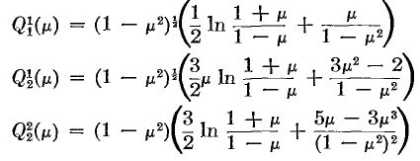

where things are already "turned around" so he is using on-the-cut functions. Let's just try this with Q0 and see what happens. We start with

Q0(z) = (1/2) log[ (z+1)/(z-1)]

Now we swing z around on the top so we have

Q0(z+iε) = (1/2) log[ (z+1)/{|z-1|e+iπ})]
Q0(z-iε) = (1/2) log[ (z+1)/{|z-1|e-iπ})]

and apply the prescription which in this case is just add and divide by 2. In doing this sum, the +iπ cancels the -iπ and you get

Q0(x) = (1/2) log[ (z+1)/{|z-1|}] = (1/2) log[ (1+x)/(1-x)]

and THAT is how the (1-z) gets turned around inside a log. Once the turn around has happened, the log function is real on the (-1,1) cut region, so the statement made earlier that Qνμ(x) is real on the cut is born out in this example.

6. How could you make a table of the integral P and Q functions? Start with these formulas:

Pnm (z) = (z2-1)m/2∂m Pn(z) m = 1,2,3....
Qnm (z) = (z2-1)m/2∂mQn(z) m = 1,2,3....

Then all you need is a formula for Pn(z) and Qn(z). But Bateman page 152 shows that

Pn(z) = (2nn!)-1∂n (z2-1)n // Rodriguez

The Qn functions are not so easy. The general form is this:

Qn(z) = (1/2) Pn(z) log[ (z+1)/(z-1)] - Wn-1(z)

where W is a polynomial of degree n-1 in z. An expression on page 153 is given for this polynomial, but it is something you have to compute from a sum involving shifted Pn functions. Using Rodriquez I think I could cause Maple to generate all these functions.

What about integer m < 0 values?

From Bateman p 140 we know that (μ must be an integer or there is another term)

Pνm(z) Γ(ν-m+1) = Pν-m(z) Γ(ν+m+1) m = any integer

For the Q functions, the answer is given in page 140 (2)

eiμπ Qν-μ(z) Γ(ν+μ+1) = e-iμπ Qνμ(z) Γ(ν-μ+1)

This is true for any μ, not just integer μ.

What about on-the-cut integer m < 0 values?

Bateman doesn't give us these, so let's use the prescription and compute them:

Pνm(z+iε) Γ(ν-m+1) = Pν-m(z+iε) Γ(ν+m+1)
Pνm(z-iε) Γ(ν-m+1) = Pν-m(z-iε) Γ(ν+m+1)

Apply proper phases on the left

e+imπ/2Pνm(z+iε) Γ(ν-m+1) = e+imπ/2Pν-m(z+iε) Γ(ν+m+1)
e-imπ/2Pνm(z-iε) Γ(ν-m+1) = e-imπ/2Pν-m(z-iε) Γ(ν+m+1)

e+imπ/2Pνm(z+iε) Γ(ν-m+1) = e+imπe-imπ/2Pν-m(z+iε) Γ(ν+m+1)
e-imπ/2Pνm(z-iε) Γ(ν-m+1) = e-imπe+imπ/2Pν-m(z-iε) Γ(ν+m+1)

e+imπ/2Pνm(z+iε) Γ(ν-m+1) = (-1)m e-imπ/2Pν-m(z+iε) Γ(ν+m+1)
e-imπ/2Pνm(z-iε) Γ(ν-m+1) = (-1)m e+imπ/2Pν-m(z-iε) Γ(ν+m+1)

and now do the prescription to get

Pνm(x) Γ(ν-m+1) = (-1)m Pν-m(x) Γ(ν+m+1)

Jackson on page 65 agrees. Let's try the Q functions now

eiμπ Qν-μ(z+iε) Γ(ν+μ+1) = e-iμπ Qνμ(z+iε) Γ(ν-μ+1)
eiμπ Qν-μ(z-iε) Γ(ν+μ+1) = e-iμπ Qνμ(z-iε) Γ(ν-μ+1)

Apply the phases: (carefully!)

e+iμπ/2 eiμπ Qν-μ(z+iε) Γ(ν+μ+1) = e+iμπ/2 e-iμπ Qνμ(z+iε) Γ(ν-μ+1)
e-iμπ/2 eiμπ Qν-μ(z-iε) Γ(ν+μ+1) = e-iμπ/2 e-iμπ Qνμ(z-iε) Γ(ν-μ+1)

eiμπ e+iμπ/2 Qν-μ(z+iε) Γ(ν+μ+1) = e+iμπ/2 e+iμπ/2e-iμπ e-iμπ/2Qνμ(z+iε) Γ(ν-μ+1)
eiμπ e-iμπ/2 Qν-μ(z-iε) Γ(ν+μ+1) = e-iμπ/2 e-iμπ/2e-iμπ e+iμπ/2Qνμ(z-iε) Γ(ν-μ+1)

eiμπ e+iμπ/2 Qν-μ(z+iε) Γ(ν+μ+1) = e+iμπ e-iμπ e-iμπ/2Qνμ(z+iε) Γ(ν-μ+1)
eiμπ e-iμπ/2 Qν-μ(z-iε) Γ(ν+μ+1) = e-iμπ e-iμπ e+iμπ/2Qνμ(z-iε) Γ(ν-μ+1)

At this point, we have to assume μ = integer = m so both equations show the same factor at the start of the RHS:

eiμπ e+iμπ/2 Qν-μ(z+iε) Γ(ν+μ+1) = (-1)m e-iμπ e-iμπ/2Qνμ(z+iε) Γ(ν-μ+1)
eiμπ e-iμπ/2 Qν-μ(z-iε) Γ(ν+μ+1) = (-1)m e-iμπ e+iμπ/2Qνμ(z-iε) Γ(ν-μ+1)

Now we can apply the prescription on both sides to get

Qν-μ(x) Γ(ν+μ+1) = (-1)m Qνμ(x) Γ(ν-μ+1)

by which we really mean

Qν-m(x) Γ(ν+m+1) = (-1)m Qνm(x) Γ(ν-m+1)

So we can now summarize our results: (m = any integer)

Pν-m(z) Γ(ν+m+1) = Pνm(z) Γ(ν-m+1) // general
Qν-m(z) Γ(ν+m+1) = Qνm(z) Γ(ν-m+1)

Pν-m(x) Γ(ν+m+1) = (-1)m Pνm(x) Γ(ν-m+1) // on the cut
Qν-m(x) Γ(ν+m+1) = (-1)m Qνm(x) Γ(ν-m+1)

7. Pause to gather up all results so far:

Here is the "base form" for each function, z = general, x = on-the-cut version

Pνμ(z) = 1/Γ(1-μ) [(z+1)/(z-1)]μ/2 F[ -ν, ν+1; 1-μ; (1-z)/2 ]
Pνμ(x) = 1/Γ(1-μ) [ (1+x)/(1-x)]μ/2 F[ -ν, ν+1; 1-μ; (1-x)/2 ]

Qνμ(z) = (1/2) Γ(1 + ν + μ) Γ(-μ) /Γ(1+ν-μ) * (z-1)μ/2 (z+1)-μ/2F[ -ν, 1+ν; 1+μ; (z-1)/2 ]
+ (1/2) Γ(μ) (z-1)-μ/2(z+1)μ/2 F[ -ν, 1+ν; 1–μ; (z-1)/2 ]

Qνμ(x) = (1/2)Γ(1 + ν + μ) Γ(-μ) /Γ(1+ν-μ) * (1-x)μ/2 (1+x)-μ/2 F[ -ν, 1+ν; 1+μ; (1-x)/2 ]
+ cos(πμ) (1/2) Γ(μ) (1-x)-μ/2 (1+x)μ/2 F[ -ν, 1+ν; 1-μ; (1-x)/2 ]

The on-the-cut versions of P and Q are real for z in (-1,1) if the parameters are real.

Here is a general method to modify most of the joining relations, shown here in "symbolic form"

P: P(z) = A(z-1)α F + B(z-1)β F'
P(x) = cosπ(α+μ/2) A(1-x)α F + cosπ(β+μ/2) B (1-x)β F '

Q: e-iπμ Q (z) = A(z-1)α F + B(z-1)β F'
Q(x) = cosπ(α-μ/2) A (1-x)α F + cosπ(β-μ/2) B(1-x)β F '

The Wronskian for regular P and Q is page 123 (13).

The Wronskian for on-the-cut P and Q is page 146 (25).

When μ = m, an integer, we have these results:

Pνm (z) = (z2-1)m/2∂mPν(z) m = 1,2,3....
Pνm (x) = (-1)m (1-x2)m/2∂mPν(x) m = 1,2,3.... // "CS phase"

Qνm (z) = (z2-1)m/2∂mQν(z) m = 1,2,3....
Qνm (x) = (-1)m (1-x2)m/2 ∂mQν(x) m = 1,2,3... // "CS phase"

Pn(z) = (2nn!)-1∂n (z2-1)n n = 1,2,3... // Rodriguez
Pn(x) = (2nn!)-1∂n (x2-1)n n = 1,2,3.. // Rodriguez (same)

Qn(z) = (1/2) Pn(z) log[ (z+1)/(z-1)] - Wn-1(z) // p 153
Qn(x) = (1/2) Pn(x) log[ (1+x)/(1-x)] - Wn-1(x) // p 153

Pν-m(z) Γ(ν+m+1) = Pνm(z) Γ(ν-m+1) // any integer m
Pν-m(x) Γ(ν+m+1) = (-1)m Pνm(x) Γ(ν-m+1) // any integer m

Qν-m(z) Γ(ν+m+1) = Qνm(z) Γ(ν-m+1) // any integer m
Qν-m(x) Γ(ν+m+1) = (-1)m Qνm(x) Γ(ν-m+1) // any integer m

8. Comparison of Bateman/me to Morse Feshbach

First I throw a bunch of MF clips into Appendix A below, then fetch up things in some reasonable order:

1. The following Rodriguez agrees with mine above, could be either regular or on the cut.
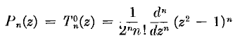
2. Below agrees with NEITHER my regular or cut versions! The exponent is really ½ m, just hard to see. This looks like on-the-cut but without the Condon-Shortley phase!
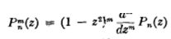
Pνm (x) = (-1)m (1-x2)m/2∂mPν(x) // my Bateman result on cut

3. I think this may be the key result below, which I rewrite

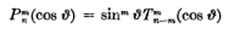

Pnm(x) = (1-x2)m/2 Tn-mm(x)
Pn(x) = Tn0(x)

Set n = n'+m in the above first line to get

Pn'+mm(x) = (1-x2)m/2 Tn'm(x)

Pn+mm(x) = (1-x2)m/2 Tnm(x)

Tnm(x) = (1-x2)-m/2 Pn+mm(x)

and then my last line agrees with the MF statement below
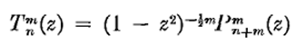

Now, using his formula above, MF would say that

P11(x) = (1-x2)1/2 T01(x) = (1-x2)1/2 * 1 = (1-x2)1/2

Now according to Bateman, this should be

Pνm (x) = (-1)m (1-x2)m/2∂mPν(x)

P11(x) = (-1) (1-x2)1/2

so yes, MF do use a different phase from Condon-Shortley!
And they use "on the cut" functions I would say.

4. This is a puzzling one for me:

Let me first set β = μ and then α = ν-β to get

(1-z2)-μ/2 Pνμ(z) = (z-1)-μ /Γ(1-μ) * F(-ν, ν+1; 1-μ; (1-z)/2)

This is very confusing because they have both the 1-z and z-1 forms appearing together! Lets take a stab and write (z-1)-μ = (1-z)-μ e-iμπ where I go above rather than below. Then we have

(1-z2)-μ/2 Pνμ(z) = (1-z)-μ e-iμπ /Γ(1-μ) * F(-ν, ν+1; 1-μ; (1-z)/2)

(1-z)-μ/2(1+z)-μ/2 Pνμ(z) = (1-z)-μ e-iμπ /Γ(1-μ) * F(-ν, ν+1; 1-μ; (1-z)/2)

Pνμ(z) = (1-z)μ/2 (1-z)-μ (1+z)μ/2e-iμπ /Γ(1-μ) * F(-ν, ν+1; 1-μ; (1-z)/2)

Pνμ(z) = e-iμπ * (1-z)-μ/2 (1+z)μ/2 /Γ(1-μ) * F(-ν, ν+1; 1-μ; (1-z)/2)

Pνμ(x) = e-iμπ * (1-x)-μ/2 (1+x)μ/2 /Γ(1-μ) * F(-ν, ν+1; 1-μ; (1-x)/2)

=> Pνμ(x)MF = e-iμπ Pνμ(x)Bateman

So there is that same sign factor I found in the example above. The sign in the phase is not clear, I just picked one. For integer μ of course get just (-1)m as in the example above.

5. How about this baby:

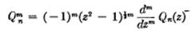
which I can compare to my results

Qνm (z) = (z2-1)m/2∂mQν(z) m = 1,2,3....
Qνm (x) = (-1)m (1-x2)m/2 ∂mQν(x) m = 1,2,3...

So this agrees with neither of my/Bateman results. I suspect they are NOT using the on-the-cut version of the Q functions as evidenced by some of their examples below, where you always see z first in the log. So I would say again that we have

Qνμ(z)MF = e-iμπ Qνμ(z)Bateman
Qνm(z)MF = (-1)m Qνm(z)Bateman

so we have that same "extra" phase factor here. There is a certain logic here, however, in that the MF version is simpler in that it does not carry around all that e-iμπ baggage that you see in Bateman.

6. My conclusions comparing MF and Bateman:

Pνμ(x)MF = e-iμπ Pνμ(x)Bateman where Bateman is the on-the-cut version

Qνμ(z)MF = e-iμπ Qνμ(z)Bateman where Bateman is the regular version

I think this then resolves the massive confusion one has when reading MF on this subject.

9. Comparison of Bateman/me to Smythe

His page 148 shows up these formulas,

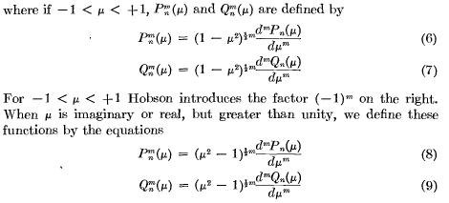
I should compare the first two to my on-the-cut versions

Pνm (x) = (-1)m (1-x2)m/2∂mPν(x) m = 1,2,3.... // "CS phase"
Qνm (x) = (-1)m (1-x2)m/2 ∂mQν(x) m = 1,2,3...

So Smythe also uses the non-CS phase, and even comments on it being in "Hobson". Then in the last two equations above, Smythe is talking about "general" z = μ, and I compare to Bateman

Pνm (z) = (z2-1)m/2∂mPν(z) m = 1,2,3....
Qνm (z) = (z2-1)m/2∂mQν(z) m = 1,2,3....

So, Smythe agrees with Bateman for the general functions, and disagrees by (-1)m otherwise on the cut. (If I assume from the top, I could decide what this phase is for general μ, but let's not do that. )
So when Smythe writes "examples" for P and Q, how do you know which he is using? Well, just looking at these things, I would say they are ALL on the cut versions since 1 comes first:

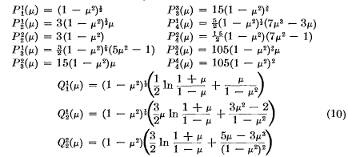

We can now compare the three authors for on-the-cut P11 :

P11 = (1-x2)1/2 Smythe
P11 = (1-x2)1/2 MF
P11 = - (1-x2)1/2 Bateman (Condon-Shortley phase)

For Q functions, Smythe would agree with MF, except MF uses regular and Smythe on-the-cut. As I think I mentioned elsewhere, Smythe never uses F and has the HG series written out only one time for something, as you find by searching his index.
Let's do one Bateman calculation to compare with the above.

Q1(z) = (1/2) z ln([(z+1)/(z-1)] - 1 regular

Qνm (z) = (z2-1)m/2∂mQν(z) m = 1,2,3....

Q11 (z) = (z2-1)1/2∂1Q1(z) m = 1,2,3....

∂1Q1(z) = z (1/2) [ 1/(z+1) - 1/(z-1)] + (1/2) ln([(z+1)/(z-1)]

= (1/2) [ -z/(z2-1)] + (1/2) ln([(z+1)/(z-1)]

= - z/(z2-1) + (1/2) ln([(z+1)/(z-1)]

=> Q11 (z) = (z2-1)1/2 [- z/(z2-1) + (1/2) ln([(z+1)/(z-1)]

= (z2-1)1/2[(1/2) ln([(z+1)/(z-1)] - z/(z2-1) // Bateman general

Let's compare this first to MF who does general but with the other phase:

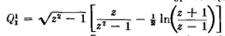

So Bateman and MF agree except for a sign, as I expected.
Now how would I convert my Bateman result above to on-the-cut? Write it out:

Q11 (z+iε) = |z2-1|1/2 eiπ/2 [ - z/(z2-1) + (1/2) ln([(z+1)/{|z-1|eiπ} ]
Q11 (z-iε) = |z2-1|1/2 e-iπ/2 [ - z/(z2-1) + (1/2) ln([(z+1)/{|z-1|e-iπ} ]

As usual, add the prescription phases

e-iπ/2Q11 (z+iε) = |z2-1|1/2 e-iπ/2 eiπ/2 [ - z/(z2-1) + (1/2) ln([(z+1)/{|z-1|eiπ} ]
e+iπ/2Q11 (z-iε) = |z2-1|1/2 e+iπ/2 e-iπ/2 [ - z/(z2-1) + (1/2) ln([(z+1)/{|z-1|e-iπ} ]

e-iπ/2Q11 (z+iε) = |z2-1|1/2 [ - z/(z2-1) + (1/2) ln([(z+1)/{|z-1|eiπ} ]
e+iπ/2Q11 (z-iε) = |z2-1|1/2 [ - z/(z2-1) + (1/2) ln([(z+1)/{|z-1|e-iπ} ]

In the difference the iπ will cancel so prescription then says

Q11(x) = e-iπ1 |z2-1|1/2 [ - z/(z2-1) + (1/2) ln([(z+1)/{|z-1|} ]

= (-1) (1-x2)|1/2 [ x/(1-x2) + (1/2) ln([(1+x)/(1-x)| ] // Bateman on the cut

Smythe above has

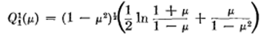

so as expected, we differ only by an overall sign.

Here are some other Smythe facts just to get them included here.

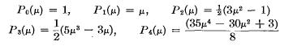
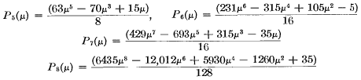

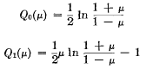
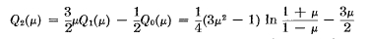
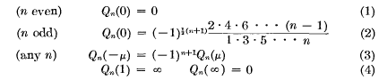

My conclusions comparing Smythe and Bateman/me and MF

Pνμ(x)Smythe = e-iμπ Pνμ(x)Bateman = Pνμ(x)MF where Bateman is the on-the-cut version

Qνμ(x)Smythe = e-iμπ Qνμ(x)Bateman where Bateman is on-the-cut version
Qνμ(z)Smythe = Qνμ(z)Bateman where Bateman is regular

Qνμ(z)MF = e-iμπ Qνμ(z)Bateman where Bateman is the regular version

and here I have just copied down a line from the MF to Bateman comparison.

Appendix A: Selections for MF regarding Legendre functions.
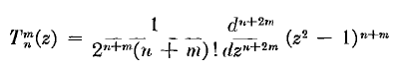

The following Rodriguez agrees with mine above, could be either regular or on the cut.
