Some Questions about Legendre Functions PhL 12.21.09

Some of the work here is presented in better form in these later docs:
See "Legendre Functions Evaluated at z = +1 and -1.doc" summary section.
See "Legendre SL Problem and Spherical Harmonics.doc"

When I started this document, I was very confused about these questions. I had just read about the S-L problem (ODE) and wanted to apply the S-L completeness idea to the associated Legendre equation, but I did not know how to do this for that ODE, nor did I know how to extend the idea to completeness in a multi-variable sense for solutions of a PDE. This document then stretched out to 35 pages of pretty raw notes, as new topics kept coming up. I eventually got all the answers, and I will now write a META version of this document to highlight what was learned and to filter out the massive amount of noise. I will also try to write a cleaner answer to the first question.

Question #1: In Spherical Coordinates, what causes l to be quantized? 1
Smythe? 1
Morse & Feshbach and their T functions? 3
PL: Quantization of l 4
What about the Q functions? 5
Question #2: In what sense are the Spherical Harmonics "complete" ? 6
Stakgold's answer: 6
Morse and Feshbach's answer 8
Courant and Hilbert's answer. 9
PL proof of the Courant and Hilbert "Linkage Theorem of Completeness" 13
Orthogonality and Completeness of the P_{n}^{m}(z) functions. 15
Summary of Results on the Associated Legendre Polynomials P_{n}^{m}(z) 19
Some comments about completeness on the sphere. 21
What happens if you have only a partial sphere? 21
Question #3: Eigenfunctions of Associated Legendre for m = 1/3. 21
Comments on the orange slice Dirichlet problem. 28
Question #4: How does all this apply to oblate spheroidal coordinates? 30
Question #5: How does all this apply to ellipsoidal coordinates? 32
Closing Comments: 33
Question #5: How does all this apply to Cartesian coordinates? 34

Question #1: In Spherical Coordinates, what causes l to be quantized?

Smythe?

1. Let's start with spherical harmonics. When we separate Laplace in sphericals, what happens? Smythe, for example, talks about this on page 129.

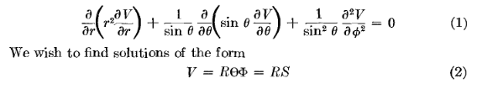
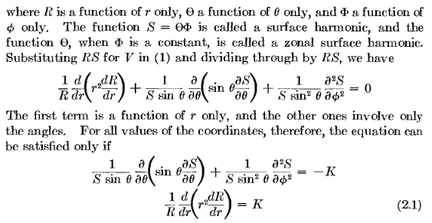

So far so good. When there is no azimuthal dependence, things are constant for all points on a colatitude θ. Things vary only with θ and this will end up being Pν(cosθ) and for some historic reason, these are called zonal harmonics. I wish I knew why. A quick can suggests the following: think of the earth with its "zones"

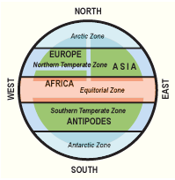
The idea of a zone is that things are constant in a zone since the earth rotates any point on a latitude gets the same solar treatment. So Pν(cosθ) is a function only of the "zone" in this sense. I am sure that is it! Now continue Smythe:

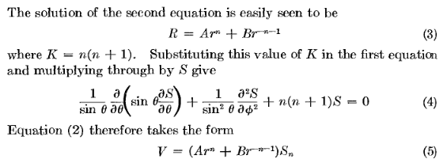

This is fine, but there is no claim that n cannot be a general complex number. Well, at this point Smythe peters out, he just uses n as if it were an integer with no comments.

Morse & Feshbach and their T functions?

2. Let's try someone else. How about MF. Volume 2 page 1264, we join the discussion in progress:

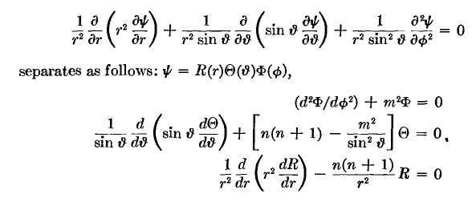
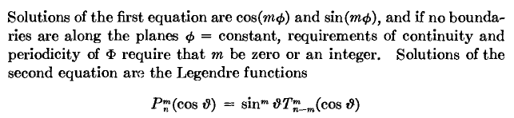

I agree that m = integer in this case. And he is using that goofy T function mentioned back in Section 5.2. We continue:

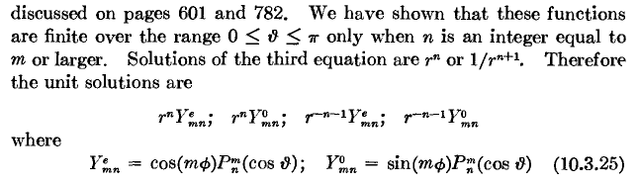

so at least MF say something about why n is integral. So I will have to go look back at the earlier discussion of the T functions, willing to do that. But first let's finish out here:

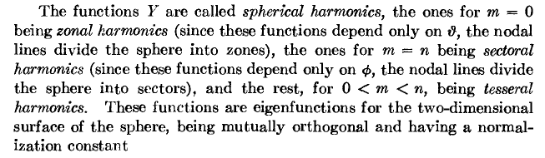

I added some MF notes on this T function in my original Section 5.2 MF notes. I still have not found where "we have shown that...".

PL: Quantization of l

But maybe I can just do it now. I would just look at the F connection which is this:

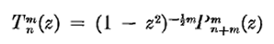

Suppose the upper index is an integer β = m, what does the F formula tell us? If m is a positive integer, you will not get poles from c = 1+β. If z = 0, argument is 0, so no convergence issue there. But if z = -1, argument is 1 and we do have a divergence problem. In this case, we can get truncation of the series if either a or b is 0,-1,-2.. integer. So there are two choices for truncation

α + 2m + 1 = negative integer = -N α = -N-1 - 2m = -1-2m, -2-2m, -3-2m....

α = positive integer α = 0,1,2,3....

So this tells us that the lower index has to be an integer due to convergence problems at -1 (never at +1). So to summarize regarding Tαβ : if the upper index β is a positive integer (m), then if the lower index is NOT 0,1,2..., the function Tαβ diverges at z = -1. So lower index gets quantized.
We can restate this in terms of P. If the upper index is a positive integer (m), then in order to get finiteness at z = -1, we must have n be 0,1,2.... If n+m = l, then we need l = m, m+1... . So this is the famous result. If you look at Pνμ(z), if μ = m ≥ 0, then you must have ν = m, m+1,m+2 to get convergence at z = -1.
I have not proven conclusively that the series diverges right at the point -1. We could do our analytic continuation trick and show this conclusively. For example, Bateman p 124 (15) shows Pνμ(z) in terms of (1+z)/2 which is clean at z = -1, but you can see that one or the other of the two terms blows up, depending on the sign of Re(μ). This clinches the deal.

Conclusion: If you look for a separated solution of Laplace that is valid on the entire sphere (all φ, for example), then φ causes m to be quantized. You get the associated Legendre equation for the θ function, and it then has to be Pνm(z) and Qνm(z) . We have just shown that Pνm(z) blows up unless ν = m,m+1... .

[ I now realize that there is more to say here. Namely, the set of functions Pnm(z) n = m, m+1, m+2... form a complete set of eigenfunctions on the interval (-1,1). This is a Sturm-Liouville problem because the endpoints are "singular" in the Stakgold BV problem sense. In such a problem, you require that the EF's not blow up anywhere in your closed interval, and that causes n to be quantized. So you will have the usual orthogonality and completeness theorems for these Pnm(z), though I don't think I have seen the completeness stated anywhere. I learned this info by reading Courant & Hilbert, see below notes. ]

What about the Q functions?

Side Question: But how do you know that the Qνm(z) function might not be OK for ν NOT an integer? I think it always blows up at both endpoints. If you look at the most basic F representation Bateman 122, you see an F series that diverges everywhere outside the unit circle. Of course you can continue into the interior, but there are always divergence problems at the z = -1 and 1 points, though again I don't have a proof of this. But here are some Q functions with integers on ν, just as some examples,

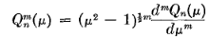

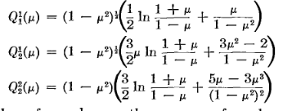

You see that log in there with problems at both endpoints and it never seems to go away. μ = z for Smythe. Actually, the leading power might clear the log, but then the second terms blow up.
OK I have to say "uncle" now. I don't have a proof of why the Q functions could not be finite for μ = m and ν = non integer or integer.
One more try. Look at Bateman p 130 (32) where the F series diverges at z = -1. We can save the day by having ν = integer (positive or negative !) to get the F series to truncate. Really need ν positive so the c argument doesn't pole on us. But, there are two terms and for any value of μ = m, one or the other has a negative power and things really do blow up at z= -1. So the conclusion here is this: whether or not ν = integer, Qνm(z) blows up at z = -1 . I think a similar argument based on (33) shows that this same Q also blows up at z = +1 ! I think these conclusions are the same for general complex values of μ. I think you don't ever want to use a Qνμ(z) function if z = +1 or z = -1 are going to be involved. You use Q for some exterior problem where you want no divergence at z = ∞.
So if you want to expand a continuous (let's say) function f(θ,φ) on the full sphere, you cannot have Q functions floating around since they blow up at both poles and are not continuous there, so any coefficient on them would violate your requirement. Similarly for the P functions if ν ≠ integer. So you are left then with the Ylm . Quantization of l comes from the requirement that your harmonics be continuous functions suitable for expanding continuous functions!

Question #2: In what sense are the Spherical Harmonics "complete" ?

Introduction: One gets the impression that the Y's form a complete set of orthogonal functions for expanding any "reasonable" (perhaps continuous) function f(θ,φ) on the sphere. After all, given any f, you can compute the flm and then reconstruct f, in the exact sense of a single variable Fourier-like transform (Mellin, Sine, Series, etc etc ). But all these "transforms" come from the ODE world, not the PDE world, as far as I know. Perhaps this is related to "Fourier transforms on groups"? At least the issue here is a "multi-variable" Fourier transform.
Since Stakgold spent so much time on the 1D ODE subject, you would think he would have something to say about the PDE completeness issue. In the ODE world, we set up a BV problem on a well-defined interval, we use a self-adjoint L operator, we have homo BC's, and we usually end up with a set of eigenfunctions which are "complete". The final proof usually requires us to look at the corresponding integral equation and show that the kernel there is Hilbert-Schmidt.
In the Laplace PDE, for example, we know that we try solving it by the method of separation, and we know that this gives us candidate solutions of the form rn,-n-1Pnm(cosθ) eimφ where the m and n are the separation constants (and where I ignore the other r power for now, think interior). The three product functions are "cross linked" by the separation constants. It is true that eimφ form a complete set for φ expansion, but things then become "unclear" as you move to θ. How does the cross-linking fit in? This does not seem to be a situation where we just have an independent complete set in each variable. [ Exactly this issue is treated by CH below. ]

Stakgold's answer:

So let's go scan Stakgold's PDE work and try to find the answer to this question. Maybe I knew it and have just forgotten it ( sound familiar?).
Let's start with Chap 5 meta meta. Well, this chapter is mostly about N dimensional distribution theory. It lists off the fundy solutions for various PDE's, and the talks about classification of PDE's. But nothing here on "completeness".
So next we move to Chap 6 meta meta. This is the potential theory chapter, the last one I have read. Here we start with 2D Laplace, the circle Dirichlet. Then we get into surface layers, and the special integral equations of potential theory. The subject then switches to Green's Functions. I note in this quick pass the following claims:

Theorem 5: The integral operator G implied by g is completely continuous.
Theorem 6: For n = 2 and n=3, G is a H-S operator.

This sounds relevant, but let's keep scanning. We get the general solution of Dirichlet in terms of the Green's Function integrated against charge density, and the Green's normal derivative integrated against some preset surface potential f(ξ). Then suddenly and unexpectedly, before we learn "methods of computing Green's Functions", we run smack into a section on the eigenfunction problem, which I here just compare to the Green's function problem.

– ∇2φλn(x) = λφλn(x) φλn = 0 on σ λn = eigenvalues
– ∇2g(x|ξ) = δ(x-ξ) g = 0 on σ

This sounds extremely relevant to my question. We then have this claim of a connection between these two problems:

g(x|ξ) = Σn φλn(x)λn(ξ) / λn

As in the 1D world of ODE's, we now learn that the EV's are real, and that EF's are orthogonal. This is the point in the book where the "long dormant" Hilbert Space machinery "powers up again". I now directly quote a block of meta meta notes:

Integral Equation Form. Stak next shows that we can convert our PDE eigenvalue problem into an integral equation EV problem by just thinking of the EV equation – ∇2φλn(x) = λφλn(x) as a general Poisson equation with q(x) = λφλn(x) and using our previously found solution to Poisson ( with f = 0 on σ) which was

u(x) = ∫R dξ g(x|ξ) q(ξ) – ∫σ dSξ f(ξ) ∂ξn g(x|ξ) = ∫R dξ g(x|ξ) q(ξ)
so
φλn(x) = ∫R dξ g(x|ξ) [λφλn(x)] = λ ∫R dξ g(x|ξ) φλn(x)
or
∫R dξ g(x|ξ) φλn(x) = μ φλn(x) μ = 1/λ
or
Gφλn = μ φλn Fred 2 homo (see Vol I page 195)

I think this is the very first time in this two volume series that Stak has written down a multi-dimensional Fredholm integral equation. Remember that all of volume I was 1D. Well, this is not quite true. In our boundary layer work where we were using the "integral equation method" to find potentials, we did encounter multi-dimensional integral equations of various Fred kinds. It happens that those equations involved integrals over σ, whereas here we have fuller integrals over R.

So now we are right on track. Here is the N-dimensional version of the Volume 1 ODE work. There is the integral equation, and its kernel is exactly the Green's Function!
At this point, the notes wander off into "Green's Functions for Unbounded Regions", and then we are off into "methods of computing Green's Functions". Two computational methods are the full and partial eigenfunction method. We are constantly peppered with Examples and Exercises in our main flow. Then we are off into physical applications. Nothing more about completeness!

So, Stakgold took us very close to the subject of interest, but then veered away. Let's now look directly in the text near the above sections for more information. The two theorems noted above are on p 133-135. The theorems are proved, but nothing is said about completeness or spectrum or any of that stuff.
Now the direct quote above is from page 138. Near page bottom he does say that "in Chapter 3 we showed that an integral operator which is CC or HS has eigenfunctions which "can be chosen" to form a complete orthonormal set over R. " So this is it, buried in a comment.
Let's look back at Chapter 3 and see if he treated more than 1D stuff there, I thought not. I just paged through all of Chapter 3. Everything is explicitly 1D, there is no generalization whatsoever in this chapter to more than one variable. The same is true for Chapter 5.

Grok: So I think there is a reason for my confusion here! Stakgold, "my man", has skipped this subject because he had so much other stuff to present. I see his problem. I have paged through the rest of Vol II and I see nothing on my subject. So all I get from Stak is the suggestive little quote above.

SO: I need to find another source on this subject! Even though he had two volumes and even though he spent a huge 1D effort, Stak has let me down.

Morse and Feshbach's answer

WW? This entire book seems to deal only with 1D stuff. Special functions, ODE's.

MF? OK, I am hoping the MF tome has something on this! Their Chapter 6 is Eigenfunctions and their Use. There is a section on "completeness", so I will now take a look. Spectral theory yes, but it might all be 1D only. Page 738 has the completeness discussion. But the gist of this discussion is that projections onto EF's get smaller and smaller and your series converges and in this sense the EF set is complete. It is all 1D. Then (scanning on the word "completeness") we get to page 754 and we see this:

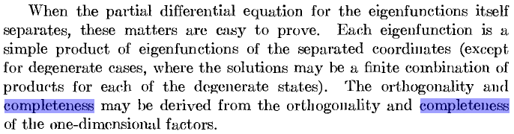

This is the idea I think is wobbly and which I mentioned above in my intro. [ But C&H firm it up below.]
MF's next discussion is bottom of page 776 where they at least admit that completeness is a subject of interest. On page 777 they repeat their previous "proof of completeness" in a fairly abstract manner. The define a partial sum of projections on basis vectors, and they define Jn as the "tail" of the sequence, and then they show that as n→∞, the tail vanishes and we achieve "completeness". For some reason they have positive only eigenvalues, I think I could figure that out (maybe number of negatives is finite). Again, at least MF are facing up to this question. They make no mention of H-S or complete continuity or integral equation or anything like that. Well, Chap 8 is on integral equations, but nothing on completeness.

OK, I need another source! Let's try some of our other downloaded books. I own no books on PDE's other than Stak.

Courant and Hilbert's answer.

Is this the real Hilbert?

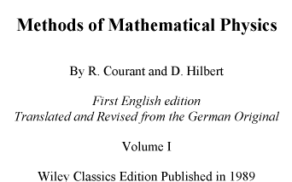

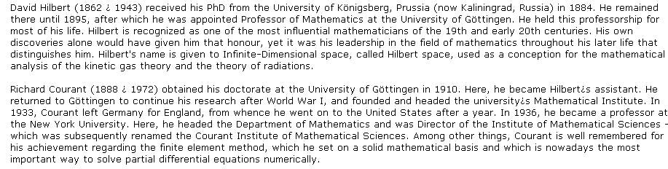

Yes, it is the actual Hilbert Space Hilbert! Certainly these guys ought to know what they are talking about.
They do discuss completeness on page 51, where Nf means (f,f). Their discussion is similar to MF, and in fact to the abstract Stak discussion of Chap 2. You are trying to approximate a function "in the mean" by a series. Bessel's inequality says series ≤ f in effect, but then if functions are complete, series = f. This sort of begs the question I think. You have to show your functions form a basis. So OK, the subject is on the CH radar, let's look for more in the books.
Around page 425 they again discuss completeness in the variational framework, where again the positive definiteness of the operator comes in. I am scanning the index in one window for "completeness" and they looking at the text in a second instance of the viewer. I see that the completeness of the spherical harmonics is explicitly discussed on page 512!!! OK, here we go. They open with this:

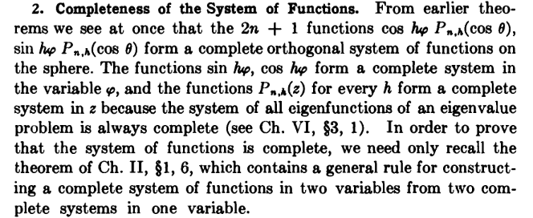

So at last, I have found good data on my question! We are back to the "separation" method here. Of course h is m. Notice the dramatic statement that the EF's of every EV problem are "complete". I would not have made that claim. I would have thought the operator would need to be self-adjoint, or the corresponding kernel H-S, or something a little more restrictive. So let's go back to Chap 6 3.1 and review what they say there before continuing! ( This has turned out to be a good question I am asking). It is page 424 where I think I just was. Then I will return to p 512. Page 424 talks about EF's and EV's from the variational point of view, and in this context completeness is proven. (Bessel's gives an equality). So maybe this is an alternative to the "integral equation" method of proving completeness. Now back to p 512 and the above paragraph. Let's now assume that we are separately complete in φ and z as discussed in the above quote. We now have to deal with the linkage of separation constants in the product function which is the spherical harmonic. The φ and θ worlds are cross coupled by m (his h). He refers to Chap PP section 1.6 which is on page 56, so there I now go! Here is what I like to see:

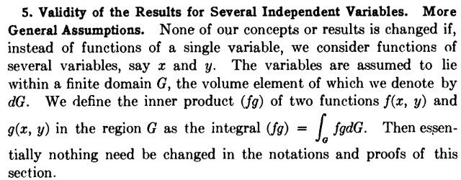
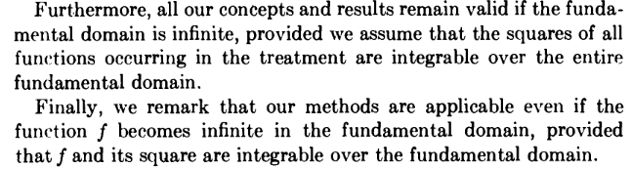

For CH, a "fundamental domain" is just a reasonable region in N-space, Stak would call it R. CH talk a lot about this term earlier. This is just what I have been looking for!
They go on, on p 56, just to state the "product" idea of sets of complete functions which I recall from Stak. So nothing fancy here. Let's return now to our earlier quote

So if we think of the products Pn,m(z) cos(mφ), they are sort of saying we can ignore the linking m label on the P function! So this is like a product of independent functions fn(z) gm(φ) spanning a 2D space.
Aha, let's go back to page 56 where they make exactly this point!!! I quote:

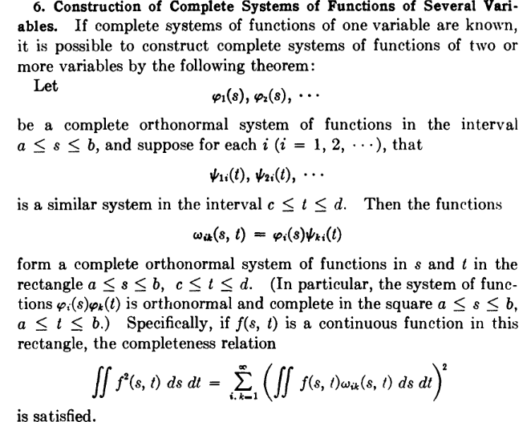

Some clarification is needed here. You need to think of the first list as being the φi. Then for EACH value of i, suppose you have a completely different set of complete functions ψji, j = 1,2,3..., This is the cross linkage issue! His parenthetic remark is OK if you use (a,b) in both directions, that is the theorem I am familiar with from Stak, but here we are doing something new! So now he is going to prove this theorem!

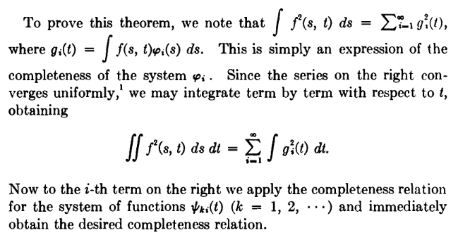

PL proof of the Courant and Hilbert "Linkage Theorem of Completeness"

I am not following the proof, so I will write it in full detail in my own words, the only way.

(1) First, I want to prove the first claim above. Consider first this projection: [ I am going to change the name from f to g:

gi(t) = $^{\int_{a}^{b}{}}$ds g(s,t) φi(s).

Here we think of t as a fixed parameter, so g(s,t) = g(t)(s) basically. For any t, we get a set of projections. I have no problem with that. The projections are different for different t. Now it is the Bessel equality

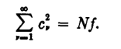

which we translate in this case to say

Σi=1∞ [gi(t)]2 = Ng = (g,g) = $^{\int_{a}^{b}{}}$ds [g(t)(s)] 2

All this says is that if we pick any t we want, we have a "complete expansion" on the s variable. This is also a sort of Parseval equality I would call it. So this proves the first claim he makes.

(2) Second: start with our result from (1) above,

$^{\int_{a}^{b}{}}$ds [g(s,t)] 2 = Σi=1∞ [gi(t)]2

Integrate both sides over the t range (c,d)

$^{\int_{c}^{d}{}}$dt [$^{\int_{a}^{b}{}}$ds [g(s,t)] 2 ] = $^{\int_{c}^{d}{}}$dt Σi=1∞ [gi(t)]2

Now assume for the moment we can do the order interchange. We then have

$^{\int_{c}^{d}{}}$dt$^{\int_{a}^{b}{}}$ds [g(s,t)] 2 = Σi=1∞ ( $^{\int_{c}^{d}{}}$dt [gi(t)]2 )

(3) Suppose we now expand gi(t) on its basis functions ψji(t) for j = 1,2,3.. [ expansion, projection ]

gi(t) = Σj=1∞ gji ψji(t) gji = $^{\int_{c}^{d}{}}$dt gi(t) ψji(t)

Notice that for each i on the LHS, we are expanding in a different set of basis functions. What does our Bessel / Parseval equality say regarding the above expansion and projection?

$^{\int_{c}^{d}{}}$dt [gi(t)] 2 = Σj=1∞ [gji]2

because we have assume the ψji(t) is complete! Now insert this into the last equation in part (2):

$^{\int_{c}^{d}{}}$dt [$^{\int_{a}^{b}{}}$ds [g(s,t)] 2 ] = Σi=1∞ ( $^{\int_{c}^{d}{}}$dt [gi(t)]2 )

= Σi=1∞ Σj=1∞ [gji]2

which we can think of in this manner

∫∫dt ds [g(s,t)] 2 = Σi,j=1∞ [gji]2

and this is really it. It says we get the Bessel's equality in the 2D sense, where the gji are the 2D projections. It is this Bessel equality that implies completeness! The projection is this

gji = $^{\int_{c}^{d}{}}$dt gi(t) ψji(t) = $^{\int_{c}^{d}{}}$dt [$^{\int_{a}^{b}{}}$ds g(s,t) φi(s)] ψji(t)

= ∫∫dt ds g(s,t) [φi(s) ψji(t)]

and thus we get the claimed result.

(4) Comments: I have now highlighted in red the second index of ψji . If you delete this index, you get the "usual" rectangle completeness result. You see that this index just "goes along for the ride". It sits there and does nothing at all! So the fact that you have a different set of ψ eigenfunctions for each φi makes no difference in our proof of 2D completeness. This is the critical result I was looking for, it explains the "linkage" problem for the separation constants, just as he says above in the quote. This same proof would work if the index "i" was several separation constants, which result we might have in curvilinear coordinates other than spherical.

(5) Now what about that order interchange business and the assumption of uniform convergence? Well, CH have a whole footnote on this, so not exactly trivial, and involves Dini's Theorem which lives on the web. Here is that footnote,

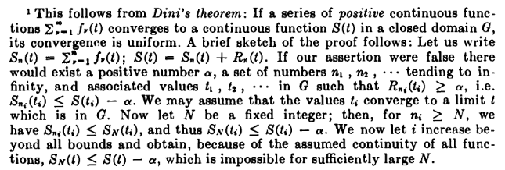

OK, I will let this ride.

Main point: When you have separation constant linkage in a product solution, as long as you know which index (or sep constant) is your EV index, and which are "fixed" linkage indices, you can apply the above theorem. For the spherical harmonics, we have rn Pnm(z) cos(mφ) let us say. We start with the m index which gets quantized in the usual way to be integer. We then make the claim that n is also an integer of appropriate range so that Pnm(z) is finite everywhere on its interval (-1,1). We think of this as a Sturm Liouville problem on that interval with singular endpoints, and -- for fixed m -- we get a set of eigenvalues n which will be n = m,m+1,m+2..... ∞ . Even though this is an S-L singular problem, we know according to CH that, for any m, the set of EF's is a complete set on z. We apply our cross linkage theorem above and conclude that Pnm(z) cos(mφ) [ + sine ] is a complete set on the (θ,φ) space. Adjust slightly if you want to put eimφ in place of the cosine. This general idea should generalize to any "harmonic functions" in some other curvilinear coordinates.

Orthogonality and Completeness of the Pnm(z) functions.

Exercise: So, based on the above, write down the orthogonality and completeness for the associated Legendre polynomials which are the eigenfunctions of the SL problem with the Legendre ODE and the interval (-1,1), no explicit BC's. The equation is this:

L = (1-z2) D2 - 2z D + [ n(n+1) - m2/(1-z2)] Lu = 0 Bateman p 121

L' = D2 - 2z/(1-z2) D + [ n(n+1)/ (1-z2) - m2/(1-z2)2] = D2 + pD + q L'u = 0

Notice that p has a pole at +1 and -1, and that q has a pole and a double pole at these two locations. There is also a regular singularity at z=∞. Think of m as a fixed parameter. Orthogonality appears Bateman 171

$^{\int_{-1}^{1}{}}$dz Pnm(z)Pkm(z) = δn,k (n+1/2)-1 (n+m)! / (n-m)! n = m,m+1, m+2 ...... ∞

= δn,k Knm

Completeness must then be this,

Σn=m∞ Cnm Pnm(z)Pnm(z') = δ(z-z')

To verify this, apply the dz' integral to both sides,

$^{\int_{-1}^{1}{}}$dz' Σn=m∞ Cnm Pnm(z)Pnm(z') = $^{\int_{-1}^{1}{}}$dz δ(z-z')

Σn=m∞ Pnm(z) $^{\int_{-1}^{1}{}}$dz' Pnm(z') = 1

At this point, look up this fact from my MF notes, where T0m(z) has no z dependence

Pmm(z) = (1-z2)m/2T0m(z) T0m(z) = 2m/$\sqrt{π}$Γ(m+1/2) //also from MF

It is hard to find a statement of this value. Most books really want you do think in terms of the Gegenbauer polynomials, and we know that:

$^{\int_{-1}^{1}{}}$dz Pnm(z)Pkm(z) = δn,k (n+1/2)-1 (n+m)! / (n-m)! n = m,m+1, m+2 ...... ∞

= δn,k Knm

Completeness probably has this general form which I will take as a trial form:

Σn=m∞ Cnm Pnm(z)Pnm(z') = δ(z-z')fm(z)

To verify this, apply ∫dz' PNm(z') to both sides, where N ≥ m :

$^{\int_{-1}^{1}{}}$dz' PNm(z') Σn=m∞ Cnm Pnm(z)Pnm(z') = $^{\int_{-1}^{1}{}}$dz' PNm(z')δ(z-z') fm(z)

Σn=m∞ Cnm Pnm(z) $^{\int_{-1}^{1}{}}$dz' PNm(z')Pnm(z') = fm(z) PNm(z)

Σn=m∞ Cnm Pnm(z) δN,n KNm = fm(z) PNm(z)

CNm PNm(z) KNm = fm(z) PNm(z)

CNm KNm = fm(z)

This is satisfied if we set CNm = 1/ KNm and fm(z) = 1, So completeness must be this:

Σn=m∞ (1/ Knm) Pnm(z)Pnm(z') = δ(z-z') Knm = (n+1/2)-1 (n+m)! / (n-m)!

Suppose we write this in terms of the MF T functions

(1-z2)m/2 Tn-mm(z) = Pnm(z)

then our claimed orthogonality is this: ( set k = n-m so that n = k+m )

Σn=m∞ (1/ Knm) (1-z2)m/2 Tn-mm(z) (1-z'2)m/2 Tn-mm(z') = δ(z-z')

Σk=0∞ (1/ Kk+mm) (1-z2)m/2 Tkm(z) (1-z'2)m/2 Tkm(z') = δ(z-z')

This certainly looks strange,

Different tack : is my claim compatible with completeness of spherical harmonics? Jackson is the only place I see completeness stated, page 65

Σn=0∞Σm=-nn Ynm*(θ',φ') Ynm(θ,φ) = δ(φ-φ')δ(z-z') 3.56 Jackson

Ynm(θ,φ) = [ {(2n+1)/4π} (n-m)!/(n+m)! ]1/2 Pnm(z) eimφ 3.53 Jackson

Insert the bottom into the top and you get

Σn=0∞Σm=-nn [ {(2n+1)/4π} (n-m)!/(n+m)! ] Pnm(z') e-imφ' Pnm(z) eimφ = δ(φ-φ')δ(z-z')

Σn=0∞Σm=-nn [ {(2n+1)/4π} (n-m)!/(n+m)! ] Pnm(z') Pnm(z) eim(φ-φ') = δ(φ-φ')δ(z-z')

Σn=0∞Σm=-nn [ {(n+1/2)/2π} (n-m)!/(n+m)! ] Pnm(z') Pnm(z) eim(φ-φ') = δ(φ-φ')δ(z-z')

Knm = (n+1/2)-1 (n+m)! / (n-m)! [ {(n+1/2)/2π} (n-m)!/(n+m)! ] = (1/2π)(1/Knm)

Σn=0∞Σm=-nn (1/Knm) Pnm(z') Pnm(z) eim(φ-φ') = 2π δ(φ-φ')δ(z-z')

I think we have to reorder the sum. The first step is to fold the negative m part over:

Sneg ≡ Σm=-n-1 (1/Knm) Pnm(z') Pnm(z) eim(φ-φ')

= Σm=1n (1/Kn-m) Pn-m(z') Pn-m(z) e-im(φ-φ')

Now use Jackson 3.51 which says

Pn-m(z) = (-1)m(n-m)!/(n+m)! Pnm(z)

Kn-m = (n+1/2)-1 (n-m)! / (n+m)! from above

Sneg =
Σm=1n [ (n+1/2)(n+m)!/ (n-m)! ] [ (-1)m(n-m)!/(n+m)! Pnm(z')] [ (-1)m(n-m)!/(n+m)! Pnm(z)] e-im(φ-φ')

= Σm=1n [ (n+1/2) (n-m)!/ /(n+m)! ] Pnm(z') Pnm(z) e-im(φ-φ')

= Σm=1n (1/Knm) Pnm(z') Pnm(z) e-im(φ-φ')

So now here is the result with the negative m values flipped to the positive side:

2π δ(φ-φ')δ(z-z') = Σn=0∞Σm=0n (1/Knm) Pnm(z') Pnm(z) eim(φ-φ')

+ Σn=0∞ Σm=1n (1/Knm) Pnm(z') Pnm(z) e-im(φ-φ')

The m=0 term in the first sum is this:

Σn=0∞ (1/Kn0) Pn0(z') Pn0(z) = Σn=0∞ (n+1/2)Pn(z')Pn(z)

which we shall return to in a moment. The two remaining sums are then this:

Σn=1∞Σm=1n (1/Knm) Pnm(z') Pnm(z) (2) cos[ m(φ-φ')]

Now finally we can interchange order to get

= Σm=1∞ Σn=m∞(1/Knm) Pnm(z') Pnm(z) (2) cos[ m(φ-φ')]

= Σm=1∞ (2) cos[ m(φ-φ')] Σn=m∞(1/Knm) Pnm(z') Pnm(z)

Now I apply my claimed rule from above

Σn=m∞(1/Knm) Pnm(z') Pnm(z) = δ(z'-z)

so that those remaining two sums add to this

= Σm=1∞ (2) cos[ m(φ-φ')] δ(z'-z)

Then our total answer to this point is this:

2π δ(φ-φ')δ(z-z') =?= Σn=0∞ (n+1/2)Pn(z')Pn(z) + Σm=1∞ (2) cos[ m(φ-φ')] δ(z'-z)

Now where can I find the completeness of the Legendre polynomials? Jackson does not have it. Nor does Stak V I. Nor does Schiff. Nor does Messiah. Nor does Schaum. I had to find some obscure doc on the web to get a statement, which is this:

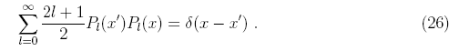

So my result above is then this

2π δ(φ-φ')δ(z-z') =?= δ(z'-z) + Σm=1n (2) cos[ m(φ-φ')] δ(z'-z)

= { 1 + 2 Σm=1∞ cos[ m(φ-φ')] } δ(z'-z)

Now look at the bracketed object

1 + 2 Σm=1∞ cos[ m(φ-φ')] = 1 + Σm=1∞ [ eim(φ-φ') + e-im(φ-φ') ]

= 1 + Σm=1∞ eim(φ-φ') + Σm=-1-∞ eim(φ-φ')

= Σm=-∞∞ eim(φ-φ') = 2π δ(φ-φ')

and FINALLY we are done. What an amazing mess. But how else would you really prove completeness of the spherical harmonics with proper constant factors etc?

Summary of Results on the Associated Legendre Polynomials Pnm(z)

1. The ODE for associated Legendre functions is this: (take your choice)

L = (1-z2) D2 - 2z D + [ n(n+1) - m2/(1-z2)] Lu = 0 Bateman p 121

L' = D2 - 2z/(1-z2) D + [ n(n+1)/ (1-z2) - m2/(1-z2)2] = D2 + pD + q L'u = 0

Notice that p has a pole at +1 and -1, and that q has a pole and a double pole at these two locations. There is also a regular singularity at z=∞. Think of m as a fixed non-negative integer.

2. For m a fixed integer, the eigenfunctions of this S-L system are the Pnm(z) with n = m,m+1....∞.

3. The orthogonality of these eigenfunctions is given by

$^{\int_{-1}^{1}{}}$dz Pnm(z)Pkm(z) = δn,k (n+1/2)-1 (n+m)! / (n-m)! n,k = m, m+1, m+2 ...... ∞

= δn,k Knm Knm = Knm = (n+1/2)-1 (n+m)! / (n-m)!

You can think of Pnm(z) = 0 for n < m if you want. Kn0 = (n+1/2)-1

4. The completeness of these eigenfunctions is given by:

Σn=m∞(1/Knm) Pnm(z') Pnm(z) = δ(z'-z)

4A. The above two items can be written in standard form for normalized φnm(z):

Σn=m∞ φnm(z') φnm(z) = δ(z'-z) φnm(z) = Pnm(z) / $\sqrt{Knm}$ // complete

$^{\int_{-1}^{1}{}}$dz φnm(z)φkm(z) = δn,k n,k = m, m+1, m+2 ...... ∞ // orthonormal

Think about QM bra-ket notation here and everything is perfect.

5. In the special case that m = 0 we get the following orthogonality from (3) and completeness from (4)

$^{\int_{-1}^{1}{}}$dz Pn(z)Pk(z) = δn,k (n+1/2)-1 n,k = 0,1... ∞

Σn=0∞(n+1/2) Pn(z') Pn(z) = δ(z'-z)

6. The above results are compatible with Jackson's following statements about spherical harmonics,

Ynm(θ,φ) ≡ [ {(2n+1)/4π} (n-m)!/(n+m)! ]1/2 Pnm(z) eimφ definition 3.53 Jackson

Σn=0∞Σm=-nn Ynm*(θ',φ') Ynm(θ,φ) = δ(φ-φ')δ(z-z') completeness 3.56 Jackson

∫dΩ Ynm*(θ,φ) Yn'm'(θ,φ) = δn,n'δm,m' orthogonality 3.55 Jackson

Pn-m(z) = (-1)m(n-m)!/(n+m)! Pnm(z) m reflection 3.51 Jackson

but it takes a bit of effort to verify this compatibility, as shown out in detail above.

Some comments about completeness on the sphere.

We have seen that the set of functions hnm(θ,φ) = Pnm(z) e-imφ (for usual range of n and m) forms a complete set for expanding an arbitrary reasonable function f(θ,φ) on the sphere. But we also know that the set of functions knm(θ,φ) = Pn(z) e-imφ would also be a complete set for the same purpose, and this set is not "cross linked".
What is the difference between these two sets of 2D basis functions?

(a) Either one allows you to project and recover (expand) a reasonable f(θ,φ) on the sphere. Let's call the projections Hnm for the first basis, and Knm for the second basis.

(b) However, if you are looking for solutions to the Laplace equation, then you must use the first set. For example, inside a Dirichlet sphere specified at some arbitrary f(θ,φ) you will find that

V(r,θ,φ) = Σnm rn Hnm hnm(θ,φ)

V(1,θ,φ) = Σnm Hnm hnm(θ,φ) = f(θ,φ)

The projections Knm are useless for solving this problem. The reason is that when we do separation of the Laplace equation, we get the cross-linked general solution terms rn Pnm(z) e-imφ = rn hnm(θ,φ) where the n is cross linked as shown. Each term of this form solves Laplace, so any lincomb also solves Laplace. The function rn knm(θ,φ) does NOT solve Laplace, that's why I say it is "useless" for this purpose.

What happens if you have only a partial sphere?

If you have a partial azimuth problem, you no longer get m = integer. If V = 0 on the "sides of the orange slice", you would get sin kφ type azimuth functions and you might get m = M α/π or something like that, where M is an integer, so m is quantized but not to integers. In this case, recall the P function from Bateman page 122 is this (for general complex n and m)

Pnm(z) = 1/Γ(1-m) [ (z+1)/(z-1)]m/2 F[ -n, n+1; 1-m; (z-1)/2 ]

This form is useful when m ≠ integer, because then the gamma and the F function don't blow up. If n is an integer, the F function at least truncates and is then OK at z = ± 1. But, for any general value of m, the leading factor blows up at one end or the other, there is no avoiding it. So if we think of that situation as an SL problem, then what do we conclude? There are no eigenfunctions that are finite everywhere? So I think I can rephrase this into another question. [ The above does show that for z = +1, P blows up when m is positive. If n is an integer, it shows blow up at z = -1 if m is negative. But if n is not an integer, the series does not truncate, and we get no conclusion from the above at z = -1. See below later. ]

Question #3: Eigenfunctions of Associated Legendre for m = 1/3.

If m = 1/3 (just some non-integer), what are the eigenvalues and eigenfunctions of the associated Legendre equation, which we treat as a S-L problem? Interval is (-1,1) as usual. The only possible solutions must have this form:

A Pνm(z) + B Qνm(z) ν = TBD

Ie, when we do our separation with cross linkage, we get the associated Legendre ODE. I now see that I never got confirmation anywhere on my presumed orange slice solution in Stak Chap 6, so it is now suspect! [ But that was an EV problem, not a Laplace problem, I think it is still OK. ] My argument for integer n does not hold up. It would be good if I could find someone attacking the orange slice problem! Maybe Smythe? I have looked hard. Smythe does note that you need n ≠ integer for cone problems, and I did one of these in Stak Chapter 6. But I am not concerned now with a cone but with an orange slice with V = 0 on the two faces, so that I get quantized real non-integer m. I don't see the orange slice in Smythe.
The question here is precisely: what happens to n? If it were a "partial orange slice" bounded by θ1 and θ2 having V = 0, then we are back to a cone situation and we have non-integer EV n values. Taking the orange slice as a limit of this situation sounds very painful.
Do MF do this orange slice problem? If so, it would be in Section 10.3 which is dp 271. The sphericals stuff is dp 283. I just don't see it in this chapter! Quick Kelvin finds nothing.
Does the web have anything on this? (explorer restart)

Laplace "orange slice" Legendre 7 hits, nada
Laplace "spherical wedge" Legendre 29 hits, nada
Laplace "spherical slice" Legendre 18 hits, nada
Laplace "spherical section " Legendre 18 hits, nada
How about books specialized to electrostatics?

So, I am in my rowboat all alone on this subject. Maybe the partial slice approach is the only way. You could then get ν = certain zeros as functions of the two angles θ1 and θ2. Well, suppose you want zero at the two ends θ = 0 and θ = π, meaning z = -1 and +1. Going back to the above

Pnm(z) = 1/Γ(1-m) [ (z+1)/(z-1)]m/2 F[ -n, n+1; 1-m; (z-1)/2 ]

If n = integer, for any given m we get a zero at one end and a divergence at the other end! So this is not going to work S-L wise. Let's try that kind of search

"sturm-liouville" "associated Legendre"

I did find a paper that talks about the two endpoints in terms of LC and LP with some refinements. Here is some data from that paper:

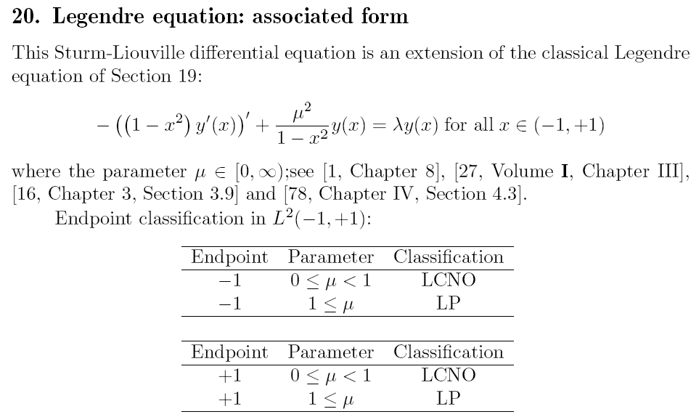

LCNO means limit circle, non-oscillatory. Notice that the weight function appearing in the above EV equation is s(x) = 1, so finite s-norm just means square and integrate near endpoint.
This same paper www.math.niu.edu/SL2/papers/birk0.pdf says that for regular Legendre (μ=0) you get LCNO at both ends, which agrees with Stakgold.

The above data seems to indicate that with μ = 1/3, you are still LC at both ends.

How do you know you can find a solution that is finite s-norm at both ends ? Well, remember, finite-s norm does NOT mean the function does not blow up at an endpoint. Explicitly what it means is shown page 295: the full integral (a,b) of the squared solution must be finite. If you have ln(1-z) for example, you have something blowing up at z = 1, but the integral of this squared is finite (Maple) at the endpoint, so it would be a finite s norm solution.

Let's reconsider what we already know about the P and Q solutions for general ν when m = 1/3. Start with the P function, written for general complex n and m:

Pnm(z) = 1/Γ(1-m) [ (z+1)/(z-1)]m/2 F[ -n, n+1; 1-m; (z-1)/2 ]

Let's study the point z = +1 . F = 1 there for any n, and m ≠ positive integer. We then find that

Pnm(z) = 1/Γ(1-m) [ (2)/(z-1)]m/2 near z = 1

If Re(m) > 0, this blows up for sure at z = 1, regardless of the nature of n. But I think if Re(m) < 1, this blow up will be square integrable, for what it's worth (ie, finite s norm).

Conclusion: If m = 1/3, the function Pnm(z) blows up at z=1 for any complex n, but is square integrable there.

OK, now what about the Q function at z = +1 ? Let's use the two term result p 131 Bateman which is this:

Qνμ(z) = Γ(1 + ν + μ) Γ(-μ) (z-1)μ/2 (z+1)-μ/2/[2Γ(1+ν-μ)] F[ -ν, 1+ν; 1+μ; (z-1)/2 ]

+ (1/2) Γ(μ) (z-1)-μ/2 (z+1) μ/2 F[ -ν, 1+ν; 1-μ; (z-1)/2 ]

Now, go near z = +1 again, and we get

Qνμ(z) = Γ(1 + ν + μ) Γ(-μ) (z-1)μ/2 (2)-μ/2/[2Γ(1+ν-μ)] + (1/2) Γ(μ) (z-1)-μ/2 (2) μ/2

If m = 1/3 = μ, the second term blows up at z = 1. And for μ = -1/3, the first term does! [However, if we select ν so that 1+ν-μ = -1,-2... then the first Q term above goes away and the second one would be OK for μ < 0 at z = +1. For any μ < 0, the P function is OK at z = +1 as well. ]

Conclusions so far:

(1) both functions Pνμ(z) and Qνμ(z) blow up at z = +1 if Re(μ) ≥ 0 non integer, for any value of ν.

(2) both P and Q are nevertheless finite-s-norm provided Re(μ) < 1. (s(x) = 1)

(3) The Wronskian of P and Q is shown Bateman p 123 bottom. For general μ and ν, this is not zero. For certain values of ν, it will vanish, however, and then for those values P and Q are not independent.

(4) So, for μ = 1/3 and ν = general value, there is NO solution of the associated Legendre equation (including P and Q) which is finite at z = +1.

(5) Therefore we don't even have to think about the point z = -1, since we already have "a problem".

(6) For the Sturm-Liouville problem where you look for functions that are finite on the interval, we find that when μ = 1/3, there are NO solutions!!! But I think there might still be finite s-norm solutions at least at the respective endpoints and maybe over the entire range (-1,1).

(7) For our orange slice type problem, we seem to need μ = M(α/π) which is a set of spaced values that go out forever, so we won't just have Re(μ) < 1. [ I keep neglecting the negative μ values! ]

But still, the above "data" says for Re(μ) > 1, there is still a LP solution. What is it? How about a linear combination of our two problem solutions? I will use the "on the cut" forms:

Pνμ(z) = 1/Γ(1-μ) (1+z) μ/2(1-z)-μ/2 F[ -ν, ν+1; 1- μ; (z-1)/2 ]

Qνμ(z) = Γ(1 + ν + μ) Γ(-μ) (1-z)μ/2 (1+z)-μ/2/[2Γ(1+ν-μ)] F[ -ν, 1+ν; 1+μ; (1-z)/2 ]

+ (1/2) Γ(μ) cos(πμ) (1-z)-μ/2 (1+z)μ/2 F[ -ν, 1+ν; 1-μ; (1-z)/2 ]

Near z = 1 and consider Re(μ) > 0 and keep only singular part:

Pνμ(z) = 1/Γ(1-μ) (2) μ/2(1-z)-μ/2

Qνμ(z) = + (1/2) cos(πμ) Γ(μ) (2)μ/2 (1-z)-μ/2

So you could lincom these two solutions to get one that really was finite at z = +1 . You could do this for μ = 30.33, for example. So this agrees I think with the idea that this problem is LP at z = +1 when Re(μ) > 1, as quoted above from the PDF. There is only one solution! It is both finite and finite s norm. Also, the lincomb that does the trick works for any ν . I constructed this in Maple for some random ν and μ values and we do indeed get the lincom to be finite at z = +1.

It seems to me highly unlikely that the exact same linear combination would be finite at z = -1, and Maple seems to agree. The same lincomb that works at z = +1 blows up at z = -1.

Conclusion: for general ν, there is no solution at all with μ = 1/3 that is finite on (-1,1). So the (1D ODE associated Legendre) Sturm-Liouville problem has no eigenfunctions at all! For Re(μ) > 1, there are no finite s-norm solutions either. So you might expect someone to point out this fact in some Sturm discussion. [ But what about μ < 0 ? ]

I have now spent several hours scanning the web for clarification. It seems that most people use the SL term for the regular self-adjoint L problem and don't talk much about the singular case. I could find no discussion of the EF's of the associated Legendre ODE when μ ≠ integer. I am glazing over, I could scan for another 1,000 hours and not find anything, bad method.

Idea: Is it possible that the T functions are somehow better for this purpose (maybe that is why MF use them).

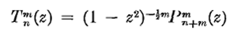

But looking at the above, if anything, for given Re(m) > 0, the T functions are even more singular at the endpoints. [ On the other hand, for m < 0, they are less singular...]

Question: why don't we have the same problem for m = 3 as for general Re(m) > 0?

Answer: first of all, the expression above for P is not valid since c = 1-m. So the discussion as presented above simply does not apply. Bateman p 148 talks about integral m values for μ. The first thing we do is use p 140 (7) and this gives p 148 (1) as a reasonable form for P. Here you see that at z = +1, we have no blowup in P. And if ν = correct integers, then also no blow up at z = -1.

Question: Consider the orange slice with the walls at V = 0. Clearly the entire hinge axis of the slice must have V = 0 then, because the walls come in on the axis. But in the separable form, what can possibly cause a 0 on the entire z axis line segment as you approach it from inside the orange slice perhaps half way between the walls? The Φ(φ) function won't do it for you. The radial function is different at each point along the segment, so it won't do it. Only the Θ(z) function can possibly do it. We have rν Pνμ(z) Φμ(φ). Are there any values of whatsoever that cause P to vanish at z = 1 and at a=-1???

Pνμ(z) = 1/Γ(1-μ) (1+z) μ/2(1-z)-μ/2 F[ -ν, ν+1; 1- μ; (z-1)/2 ]

Any negative μ would give a zero at z = +1. [ Finally it dawns on me... ]

Plan A: Let's start all over again and thing about negative values of μ instead of μ = 1/3 as I did above. Perhaps we can get a more useful conclusion.

Here are our on-the-cut P and Q functions

Pνμ(z) = 1/Γ(1-μ) (1+z) μ/2(1-z)-μ/2 F[ -ν, ν+1; 1- μ; (z-1)/2 ]

Qνμ(z) = Γ(1 + ν + μ) Γ(-μ) (1-z)μ/2 (1+z)-μ/2/[2Γ(1+ν-μ)] F[ -ν, 1+ν; 1+μ; (1-z)/2 ]

+ (1/2) Γ(μ) cos(πμ) (1-z)-μ/2 (1+z)μ/2 F[ -ν, 1+ν; 1-μ; (1-z)/2 ]

If we go near z = +1 we get

Pνμ(z) = 1/Γ(1-μ) (2) μ/2(1-z)-μ/2

Qνμ(z) = Γ(1 + ν + μ) Γ(-μ) (1-z)μ/2 (2)-μ/2/[2Γ(1+ν-μ)]

+ (1/2) Γ(μ) cos(πμ) (1-z)-μ/2 (2)μ/2

For general μ (and ν) the Q function looks pretty bad at z = +1 regardless of the sign of μ. Remember that the μ values will come from the azimuth equation so are not really controllable, so cannot count on cos(πμ) to kill off the second term, for example. So I think we have to rule out the Q function entirely!
[ Except if Γ(1+ν-μ) has a pole, the first Q term goes away and the second Q term is OK at z = +1 for negative μ. ]

The P function looks like a possibility if Re(μ) < 0, however, at z = +1, and this for general ν.

So maybe we have some thin chance of it also being OK at z = -1 at least for some ν ! To this end we can look at Bateman (15) on page 125 where the F = 1 now at z = -1. Here is what I see:

Pνμ(z) = Γ(-μ) (z+1)μ/2 (z-1)-μ/2/ [ Γ(1+ν-μ)Γ(-ν-μ)] F(-ν, 1+ν; 1+μ, [1+z]/2)

- (1/π) sin(νπ) Γ(μ)(z-1)1/2(z+1)-1/2 e(-1)(±1)iμπ F(-ν, 1+ν; 1-μ, [1+z]/2)

and near z = -1 this becomes:

Pνμ(z) = Γ(-μ) (z+1)μ/2 (-2)-μ/2/ [ Γ(1+ν-μ)Γ(-ν-μ)]

- (1/π) sin(νπ) Γ(μ)(-2)μ/2(z+1)-μ/2 e(-1)(±1)iμπ

If μ < 0, the second term is OK, but not the first term. Maybe we could fix the first term by carefully selecting a value of ν which makes one of the Γ functions in the denominator have a pole, sort of killing off the term. Hmmm. This situation does not appear in the Bateman special values section p 148, but I think some author talked about it.
So I will roll my own here. Want -ν-μ = -N meaning ν+μ = N, N = 1,2,3... meaning

ν = -μ + N N = 1,2,3... μ = some negative real value

So for such values of ν (which are not integers!) we really do kill off the first term. We could also select these values using the other gamma function

1+ν-μ = -N N = 1,2,3.... => ν = μ - N-1

So there appear to be two "strings" of ν values that make P vanish at z = -1. [ For the second string, the Q functions are OK at z = +1, but I suspect not at -1. ]

[ Look again at these two strings. They make poles of Γ(1+ν-μ)Γ(-ν-μ) . But these are just related by ν replaced with -ν-1, but we know that Pνμ= P-ν-1 so we can consider only one of these strings and ignore the other, it does not give new functions. ]

Conclusion: for any generic negative value of μ (make it non integral), if we select ν +μ = 1,2,3.... ) or the other string) then our function Pνμ(z) vanishes both at z = 1 and z = -1, which is just what we need for our orange slice problem. So the general form of our solution for the orange slice will be this:

sin(μα) = 0 => μα = Jπ μ = Jπ/α α = slice angle (0,α)
but only take negative values, so have

μi = -iπ/α i = 0,1,2,3.4....

Then our orange slice solution will be (pick string with ν marching to the right)

let νj = - μi +j j = 1,2,3

ψ(r,z,φ) = Σμi Σνj Aμi,νj rνj Pνjμi(z) sin(μiφ)

We could then tune the coefficients to get some desired f(θ,φ) on the outer orange slice skin. Assume that is at r = 1, then we have

Σμi Σνj Aμi,νj Pνjμi(z) sin(μiφ) = f(z,φ)

We would have to restrict to f(z,φ) which vanish at z = ±1. So then we would have our outer surface Dirichlet problem!
What problem did I think I solved for an orange slice in Stakgold? [ EV problem, not Laplace! ]

Question: In the Stak treatment of the full sphere Vol II p 144, how is it that we get Bessel functions instead of our usual rl powers, as solutions of the radial equation???

I would have thought there is only one "radial equation" for Laplace in sphericals, and rl and the solutions. Oops. Answer is simple. The Laplace equation is not the same as the eigenvalue equation which is really the Helmholtz or wave equation with time replaced by k (ω). If you take those Bessel functions and set λ = 0, you get the Laplace equation and the powers. So keep in mind which problem you are solving!

Comments on the orange slice Dirichlet problem.

(1) I have never seen this problem solved anywhere.

(2) If we take just the negative quantized m values allowed by the azimuthal problem, we find that there are some values of ν such that Pνm(z) = 0 at both ends of the (-1,1) interval. This is what we need for the orange slice problem. These are ν = |m|, |m| + 1, |m| + 2, same as for the full sphere integer m problem.

(3) The general orange slice Laplace cross-linked solution will then have this form

μi = -iπ/α i = 0,1,2,3.... (0,α) is the orange slice azimuthal range

let νij = |μi| +j j = 0,1,2,3..

ψ(r,z,φ) = Σij=0∞ Aμi,νij rνij Pνijμi(z) sin(μiφ)

(4) Recall those T functions again.

Set m = μ and n+m = ν. Then n = ν-μ and we would say

Tν-μμ(z) = (1 - z2)-μ/2 Pνμ(z) = (1 - z2)-μ/2 P-ν-1μ(z) = T-ν-1-μμ(z)

I thought this might make the lower T index be integers. One of my strings is ν-μ = -j-1, so we get negative integers, which the T people ( and C people) don't like much. So I guess the P function form really does work better here, not the T function.

(5) Now, what about the question: does the associated Legendre ODE with separation constants μ and ν have eigenfunctions? Pause for a moment,

Aside: If you look at "the Legendre equation" in Schaum, you can think of it as an eigenvalue problem where we have already found the eigenvalues to be λ = n(n+1) with n = integer. This equation is singular at both ends of the interval (-1,1) in the BV problem sense (limit circle). You must call the solutions Pn(z) the eigenfunctions of this eigenvalue problem. However, these eigenfunctions do not vanish at both ends of an interval which is perhaps the "usual" way we think of eigenfunctions. So this is an exception to our normal sense of "eigenfunctions" which vanish at both ends of an interval. The Regular BV problem allows for an unmixed BC at each end, but when we deal with multiple dimensions, we always mean that u(σ) = 0 on an entire bounding surface. If we rescaled the P functions, we might come up with an unmixed BC at z = 1 I suppose. But it would never be u(1) = 0 there!

Now back to our question. We know for μ = integer, that there are eigenfunctions called Pνμ(z) and we must have ν = certain integers as the eigenvalues. We did that "last time", and we just pointed out in the paragraph above that these "eigenfunctions" don't vanish at the interval endpoints. Now today, we have learned that for μ = negative non-integer real value, we can find a certain string of (non-integer) values of ν cause a different set of eigenfunctions of the same Pνμ(z) form. However, this set of eigenfunctions happens to vanish at both ends of the (-1,1) interval, as required for the orange slice problem which gives rise to this situation.

(6) So think of the orange slice Laplace problem with some f(θ,φ) specified on the outer skin and V = 0 on the sides of the slice. We know that the Laplace solution inside the slice must have the cross-linked form rν,-ν-1 Pνμ(z) sin(μφ). This is the triple separated form. For each of the three functions, we have an eigenfunction problem of S-L form, in fact (each L is self-adjoint). You see the usual EF's for φ which quantize μ to equally spaced negative real μ values. For each of these μ values, we have an eigenvalue problem in the z variable which results in a string of possible ν values, and in fact these cause Pνμ(±1) = 0. Finally, the R equation is forced by the cross link to have these same eigenvalues ν in the form ν(ν+1), and these cause the rν,-ν-1 form. So to summarize, the φ situation quantizes μ, then the z situation quantizes ν, and we are then done. Then we do lincomb with coefficients to match some orange skin surface preset. I similar sequence of cross link chain resolution happens for the full sphere, but the values for μ and ν are different!

Maple Test. Let's see if my claim that we vanish at both ends is really true.

Pνμ(z) μ = -1/3 ν = +1/3 + j = 1/3, 4/3, 7/3, 10/3... P7/3ν(z)

Yes, it really is true. Here are some plots: [ the ν = 1/3 has a bug, see meta.]

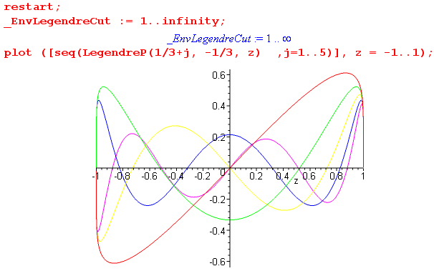

I have plotted 5 different ν values for μ = - 1/3, and each curve vanishes at both ends, as my theory says it should. If you put in μ = +1/3, no fiddling with ν makes the above vanishing happen!!

Question #4: How does all this apply to oblate spheroidal coordinates?

The cross linked separated solutions terms have this form (from Smythe + me):

[ A Pnm(iζ) + B Pnm(iζ) ] Pnm(ξ) Φm(φ) r, θ, φ type ordering

Compared to spherical coordinates, here we see a double linkage instead of a single linkage between the left two functions, that is one big difference in the nature of the solution terms!
So we can do the cross link "trace" as before. For a full spheroid (perhaps Dirichlet problem on entire spheroid) we get m = integer quantization. Then at once for the θ type coordinate ξ we require n = integer in appropriate range on the middle P function, and also, it has to be a P! This linkage works out exactly a in sphericals. If you are running the full range of ξ (as in my full spheroid surface example), then the middle function has to be a P, and the lower index has to be an appropriate integer to m, just as in sphericals, so that the function is finite at both ξ endpoints. [ If you don't run a full range of ξ, then if V = 0 on the two conical surfaces, you will get some quantized values of n that related to the zeros of P at the one or two bounding cone angles. In this case, perhaps the Q functions can also appear in the ξ world, though I have not shown them above. ]
So assuming this full ξ range case, we know that the Φm(φ) are "complete" in φ, and we know that for each m, the functions Pnm(ξ) form a complete set in ξ, as n runs it range n = m, m+1..... (its "string" of values). So the combined functions Pnm(ξ) Φm(φ) form a complete set for any function f(ξ,φ) on the spheroid (using the MF linkage completeness theorem) ! Hurray! Again, just as in sphericals.
At this point, there is no freedom left on the indices. Smythe points out these limits of the two functions in the square bracket. I think he really means "large ζ" limits

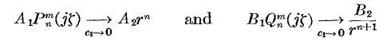

Can I verify these results somehow? On the left all we can do is take large positive imaginary argument. Consider Bateman p 126 (23) which is 1/z2 expansion stuff. The first term vanishes for our n,m values because Γ(-ν-μ) has a pole (gamma has a pole at 0,-1,-2 says Schaum). The other term becomes this

Pνμ(iζ) = 2ν/$\sqrt{π}$* Γ(1/2+ν) (iζ)ν+μ (iζ)-μ/ Γ(1+ν-μ) F[-ν/2-μ/2, 1/2-ν/2-μ/2; 1/2-ν; 1/(iζ)2]

and for very large ζ this becomes

Pνμ(iζ) = 2ν/$\sqrt{π}$ Γ(1/2+ν) / Γ(1+ν-μ) (iζ)ν = (2i)ν/$\sqrt{π}$ Γ(1/2+ν) / Γ(1+ν-μ) ζν

or, where we set ζ = r/c1 as Smythe says, with c1 the focal distance for the oblate system.,

Pnm(iζ) = (2i)n/$\sqrt{π}$ Γ(1/2+n) / Γ(1+n-m) ζ n
= (2i)n/$\sqrt{π}$ Γ(1/2+n) / Γ(1+n-m) (r/c1) n

and this is thus producing the require rn term in the radial world. We can do a similar thing for Q, Bateman p 134, there is now only one term:

e-iμπ Qνμ(iζ) =

2-ν-1$\sqrt{π}$ Γ(1+ν+μ) (iζ)-1-ν-μ (iζ)μ / Γ(ν+3/2) F[1+ν/2+μ/2, 1/2+ν/2+μ/2; ν+3/2; 1/(iζ)2]

= 2-ν-1$\sqrt{π}$ (iζ)-ν-1 / Γ(ν+3/2)

= (2i) -ν-1$\sqrt{π}$/ Γ(ν+3/2) ζ-ν-1

e-imπ Qnm(iζ) = (2i) -n-1$\sqrt{π}$/ Γ(n+3/2) (r/c1)-n-1

Qnm(iζ) = (-1)m (2i) -n-1$\sqrt{π}$/ Γ(n+3/2) (r/c1)-n-1

and this is exactly what we expect.
Main point: the role of the P and Q functions in the first factor is like the role of rn and r-n-1 in sphericals. If you are doing an interior problem, you will pick the P only, and for exterior only the Q.
Notice that the large argument behavior does not depend so much on the fact that we are going off in the imaginary axis direction. We could go off in any direction and get a similar result for P and Q using our large z formula where F→ 1.

Comments: Let's look back at the confusion I was having a week ago on this subject. I kept wanting to understand the ODE system where the "range" was (0,+i∞). It is just the associated Legendre equation where z is in this range. I was wondering what the "eigenfunctions" were of this ODE in this range. I thought that this EF problem might somehow be setting values at least for n.
So here is how I now think this works out. Yes, we have an ODE system on (0,+i∞) as the interval. The 0 endpoint is regular (in the BV problem sense of Stakgold) because the p and q functions are smooth at that point, and the i∞ end is singular. As such, it is either LC or LP. I think it is LP because only the Q function will have finite s norm at i∞. The P function will not. As usual for this ODE, s(z) = 1 is the weight function, and λ = ν(ν+1) is the eigenvalue. As appropriate for a problem with a singular endpoint, we find that the spectrum of eigenvalues for ν is continuous. I think it is the entire real axis ν > -1/2 because this range makes finite s norm. This is true for any value of m which has the relationship to n noted above, and which we used in finding the large arg behavior of P. [ The conclusion might hold for any value of m as well. ] So for any m, I think we have this continuous spectrum for ν from this ODE. There is no quantization of ν to get values to be finite. If you look at the small z expansions of P and Q, neither blows up at z = 0, so no quantization from that endpoint either.
So that ODE exists, but does not determine anything in this problem. The m and n values are determined completely from the "angular world".
We could consider an orange slice spheroidal problem and then we would I think have m = string of equally spaced negative values, then n = string just as we found above in the spherical case, and so the solution form is exactly the same idea as in the spherical case, and your only concern is exterior or interior. If you have an annular spheroid, then both P and Q can get involved and you specify a f(angles) on both surfaces!
So finally I think I am happy with this scenario! I imagine the prolate spheroidal situation is similar.
One extra note. We are talking the Laplace Dirichlet situation here. If we wanted to think about eigenfunctions inside a 3D metal spheroid, or orange slice, that is a different problem and we then have another eigenvalue constant. We can just think of that as the k12 Helmholtz constant that MF carry around all the time. In the spherical case, this extra constant converted the simple powers like rn into spherical jn(β(n+1/2)k r) Bessel functions. The m and n quantization here is the usual integer situation, and the new element is that, for each integer n, we have to find a set of zeros of jn , and these are indexed by the letter k, and this makes all the jn = 0 on the surface.
Now in the spheroidal eigenfunction inside all-metal V = 0 problem, if we add this extra element like k12 or λn,k = β(n+1/2)k, the functions P and Q are going to be replaced by some more complicated functions and we are going to have k12 get quantized by the requirement that these analogs of jn have zeros on the spheroidal surface. I don't know what these functions are in the oblate case, but I would expect them to be more complicated than P and Q, just as the jn are more complicated that rn. Perhaps Smythe talks about this somewhere in his book, or perhaps MF do. These eigenfunctions could then be used to create a formal Green's Function for the spheroidal shell or orange slice etc etc using the bilinear summation series.

Question #5: How does all this apply to ellipsoidal coordinates?

Looking back at my ellipsoidal doc #2, I am reminded of this piece of info

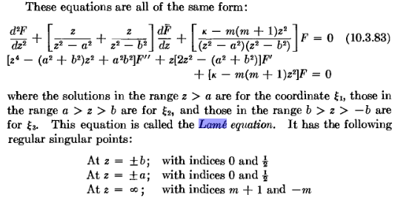
OK, this equation really does have all 5 regular singular points! We can compare this to WW page 197 where they had 5 points at a1......a4 at the 5th at ∞, so our ellipsoidal equation is a special case of the "generalized Lame". The indices are given for each point, and I note the difference is 1/2 for four of the points, as WW commented. The z=∞ indices are as shown, functions of m. The two separation constants are called κ and m. The equation is the same equation for all three variables, just different ranges as we know, all shown in the clip above.
So what can I say about the problem in the three intervals: (a,∞), (b,a), (-b,b) or (0,b) as the case may be. Is this even a SL operator? Maybe I should look now at that last WW chapter in their last edition. I am now browsing this chapter, exactly on topic. Lame is dated 1839. But I see this is going to be quite complicated, so this is not the right place to take notes.
I took some notes and found WW to be completely irrelevant, not to mention opaque.
I then read some of my ellipsoidal META notes (doc #3) and that led me to write another doc called " Finding Solutions to the Lame Equation.doc" where I guess I understood for the first time how the separation constants get double-quantized in that world. It is all understood now, and here is my concluding comment from that doc:

Closing Comments:

I looked first at spherical, then at spheroidal coordinates, pondering the question of the cross-linkage of the separation constants and how they got quantized. In these two cases, quantization started with the azimuthal world, usually an index called m taking equally spaced values. For each such m, we found that the second separation constant ν on Pνm had also to be quantized. This happens a little differently in different cases. For a full sphere or spheroid, ν is the simple string ν = m, m+1, m+2... as this causes P to be finite at z = -1 and +1. For an orange slice of a sphere, ν = a similar string but is not integers. For a spherical section with one or two conical surfaces having V = 0, ν = a string that causes the P function to have zeroes on the conical surface(s).
When we turn to ellipsoidals, there is no azimuth to start quantization with, but as we have seen, it turns out that there is still an integral quantum number m = 0,1,2,3... just as in the azimuthal systems. In ellipsoidals, however, the second separation constant κ takes extremely strange values, not just an equally spaced string of values as in the other two cases and the ν coordinate. The mechanism which causes the double quantization in ellipsoidals is still that the solution functions be finite on their intervals, or shall we say, the solution functions exist on their intervals. In the ellipsoidal case, the three separated ODE's are all the same, so we need a solution valid on the entire interval (0,∞) and this requires truncation, and that requires double quantization.
Finally, I have to say there is really no mystery about these Lame solutions and the four species and the second kind partners. It is all completely straightforward, and there is no need to bring in the Weierstrass P function or Neville's method and all that stuff that WW get into.
Just a reminder about the exterior potential of a metal ellipsoid held at constant V. We find the solution with the lowest level functions E00 = 1 for ξ2 and ξ3, and the F00 second partner for ξ1. This partner happens to be a Jacobi type elliptic integral function sn-1 of F(z,k) thing. Both MF and Kelvin and I am sure Byerly do this solution, and compress to get the elliptical plate as well. It is not rocket science, I have to keep saying that over and over.

Question #6: How does all this apply to Cartesian coordinates?

I sort of forget about these fellas. What happens here if you separate Laplace?

-(∂x2 + ∂y2 + ∂z2 ) XYZ = kh2 XYZ

Here I throw in a Helmholtz just for fun, so we can think eigenfunctions as well as Laplace solutions.

(YZ∂x2X + ZX∂y2Y + XY∂z2Z) = -kh2 XYZ

∂x2X/ X + ∂y2Y/Y + ∂z2Z/Z = -kh2

Let's set two of the separation constants to kx2 and ky2 so we have

∂x2X/ X = -kx2 ∂y2Y/Y = -ky2 ∂z2Z/Z = -kh2 + kx2+ ky2

The X solutions are X(x) = exp(±ikxx) where we can stay hazy about the nature of kx. The X equation has no finite singular points so series solutions (ie, these functions) converge in entire complex x plane. We then have

solution term = exp(±ikxx) exp(±ikyy) exp(±ikzz) = Ekx(x) Eky(y)Ekz(z)

where kz2 ≡ kh2 – kx2– ky2
This situation is a in a sense more like the ellipsoidals than the sphericals or spheroidals, because there is no azimuth. Without having a specific problem, all we can say is that for Laplace, there are two separation constants which I have called kx and ky (and kh = 0 in this case), and kz is a function of these two. Here is a comparison of the causality cross linkage structure for three coordinate systems based on the simplest basic problems ( sphere, ellipsoid, box with one face free)

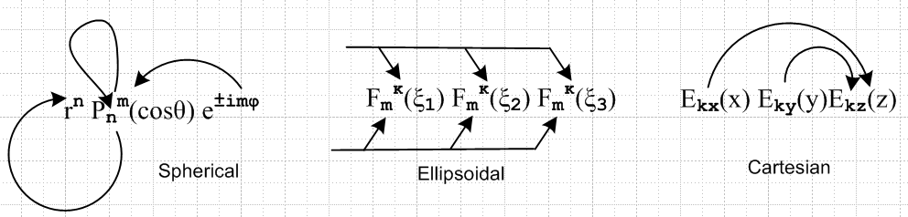

In our simple spherical problem, quantization begins with the azimuth m, causes integer n, and that is then forced onto the rn third function. For Cartesian box, we get two of these independent starting integers nx and ny (see below), and these then force the quantum number for the z direction. In ellipsoidals, we don't "start" with any of the three coordinates, the m,κ quantized values sort of come from the outside.

Cartesian Laplace and Eigenfunction Sample Problems

For Cartesians, the analog of the full sphere or spheroid or ellipsoid would I suppose be "the box". The simplest box would have V = 0 on the x and y surfaces, so kx a = nxπ and then the solution term has this form

solution term = sin(nxπx) sin(nyπy) exp(±ikzz) kz2 ≡ kh2 – (nxπ/a)2– (nyπ/b)2

If we then also put V = 0 on the 0 wall in the z direction, our general solution is then

u(x,y,z) = Σnx,ny A±nx,ny sin(nxπx) sin(nyπy) sh([ikz]z) [ikz]= (nxπ/a)2 + (nyπ/b)2 - kh2

Again, for Laplace kh = 0. If we prescribe some f(x,y) on the free surface, then we have

u(x,y,c) = Σnx,ny Anx,ny sh([ikz](nx, ny)c) sin(nxπx) sin(nyπy) = f(x,y)

Did Stak do this Dirichlet problem? Yes, he does the 2D case on page 108 Exercise 6.13. In our case here we would just have a double Fourier sine series transform situation, where I ignore constants

fnx',ny' = ∫∫dxdy f(x,y) sin(nx'πx) sin(ny'πy) = ∫∫dx dy u(x,y,c) sin(nx'πx) sin(ny'πy)

= Σnx,ny Anx,ny sh([ikz](nx, ny)c) ∫∫dx dy sin(nxπx) sin(nyπy) sin(nx'πx) sin(ny'πy)

= Σnx,ny Anx,ny sh([ikz](nx, ny)c) [ ∫dx sin(nxπx) sin(nx'πx) ] [∫ dy sin(nyπy) sin(ny'πy)]

= Σnx,ny Anx,ny sh([ikz](nx, ny)c) δnx,nx' δny,ny' Knx,ny

= Anx',n'y sh([ikz](nx', ny')c) Knx,ny

Then our general solution to the Dirichlet problem would be

u(x,y,c) = Σnx,ny { fnx,ny/ [sh([ikz](nx, ny)c) Knx,ny] } sin(nxπx) sin(nyπy)

The eigenfunction problem is a little easier, we require that

sh([ikz]c) = 0 => kzc = (nzπ) => [kh2 – (nxπ/a)2– (nyπ/b)]2 = (nzπ/c)2

=> kh2 = (nxπ/a)2+ (nyπ/b)2+ (nzπ/c)2 ≡ knx,ny,nz2 // the eigenvalues

In this case, having kh present allows the third solution to be sine like as well as the other two. The eigenfunctions of the box then have three quantum numbers and we might say

φnx,ny,nz(x,y,z) = sin(nxπx) sin(nyπy) sin(nzπz) ∇2φnx,ny,nz = knx,ny,nz2 φnx,ny,nz

