The Weierstrass p-function symbol PhL 11.17.10

• We start with the WW comment on this p function stuff

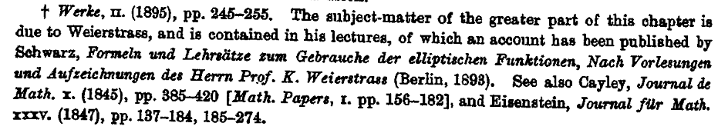

So this guy Schwarz "wrote up" Weierstrass's lectures and in this 1885 book the symbol appears. I was able to find the above reference as a scanned google book here (Formulas and Theorems on the use of the elliptic functions, adapted from Lectures and Notes of Herr K. Weierstrass)

http://books.google.com/books?id=wj4LAAAAYAAJ&printsec=frontcover&dq=formeln+und+lehrsatze&source=bl&ots=um7yQEIJZO&sig=L8wH5CXito1CKYgJ_yTDIpFW9hw&hl=en&ei=lzHkTN3FFYuisQP12IFn&sa=X&oi=book_result&ct=result&resnum=4&ved=0CCoQ6AEwAw#v=onepage&q&f=false

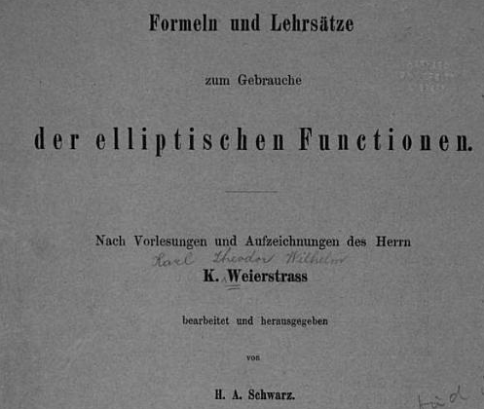

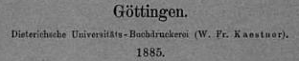

in which we see the p function defined as follows:
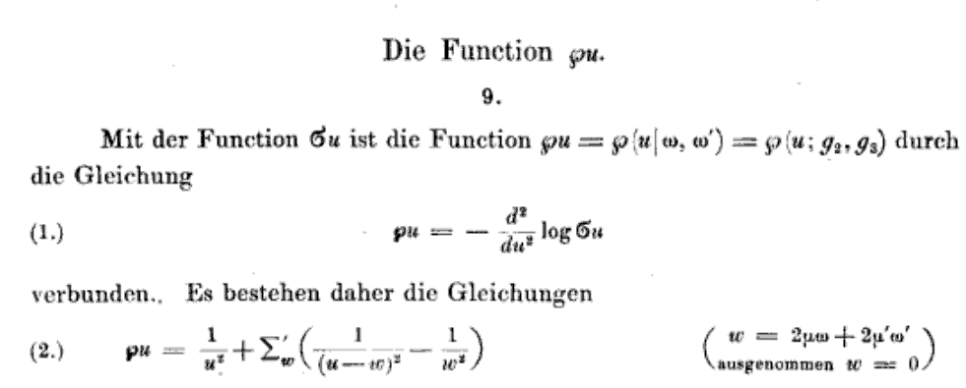
and there is "that p thing" Other functions like the σ function have elaborate script names as well.

• In WW this letter appears this way, and it appears somewhat bolded.
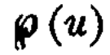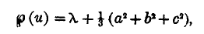

• And now, a paragraph concerning German fonts used for printing.

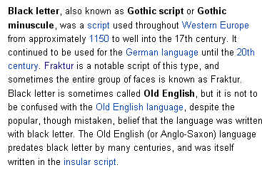

• In W&W, the Weierstrass elliptic function is written with a very strange looking "p" . I think this is a sort of script version of the lower case German black letter p (in its origin)

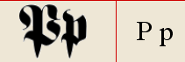 http://www.beerstein.net/articles/alpha.htm

• Amazingly, wiki has an entry on this subject
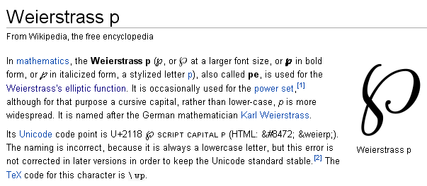
• One person says http://www.mai.liu.se/~halun/complex/elliptic/

"This is Weierstrass's ``P function. According to tradition, the P should always be written with the fanciest font available! "

• The unicode standard has included this character as code 2118, (this from a PDF I saved)

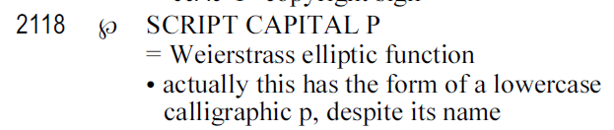

That quoted author found something in Lucida Sans Unicode code 2118 which appears in my font viewer, Letters like this don't appear in the "insert symbol" dialog unless you type in something like 2118 unicode, then from then on it shows you ALL the glyphs. They call this a "script capital p" to wit: ℘ ℘ where the second is bolded.

Bateman uses this ℘(z) on page 328. If I don't bold it, it looks too light, but if I do, it is ℘(z) which looks darker than Bateman, but is very close to how it appears in W&W:

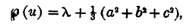
℘(z) = λ + (1/3)(a2+ b2+ c2) // close enough!

• A&S just use a capital script P instead: P(u)

• GR7 uses a non-bolded form
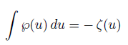
• I cannot think of any other function where you are required to use something other than a regular letter or a Greek letter.

• I do wonder where this character was first used. Probably in his lectures, Weierstrass used such a symbol in his work in the blackboard (his slate board). Probably it was Schwarz who first printed the symbol?

• W&W's Cayley 1847 reference exists in collected math papers which I am now bringing in. This is the earliest item in the WW reference list I quote above. But it's in French and I don't see the p function appearing in it in any form. So forget it!

