Appendix F for FT PhL 7.20.13

This was the original version of Appendix F, it got replaced by the v2 file.

Appendix F: The Power Density of an Infinite Pulse Train having a Repeated Sequence 1
(a) The Spectral Power Density for a Single Pulse Train with a Repeated Sequence 1
(b) Calculation for an Ensemble of such Pulse Trains subject to Certain Conditions. 4
(c) Limit as P → ∞ of the Ensemble Result 8

Appendix F: The Power Density of an Infinite Pulse Train having a Repeated Sequence

(a) The Spectral Power Density for a Single Pulse Train with a Repeated Sequence

The problem here is to write P(ω) for an infinite pulse train whose coefficients are periodic with period P. The result is stated below in (F.12). Then in the ensemble special case that <aman> is independent of the index values m and n, a result for <P(ω)> is given in (F.22). The limit P→∞ of that equation is taken with the result shown in (F.28).

We start with our expression (34.14) for the spectral power density of an infinite sequence,

P(ω) = T1 Ppulse(ω) (1/T) $\sum_{n = -∞}^{∞}{}$ $\sum_{m = -∞}^{∞}{}$ ym* yn eiω(m-n)T$_{1}$ (34.14)

where T is the duration of the infinite sequence (to which we return soon). Suppose the sequence ym is composed of subsequences of length P that repeat. Then

ym+IP = ym for any integer I (F.1)
We can reorganize the double sum in (34.14) into a quadruple sum by defining :

n = IP + n'
m = JP + m' .

Then the double sum above becomes,

$\sum_{n = -∞}^{∞}{}$ $\sum_{m = -∞}^{∞}{}$ ym* yn eiω(m-n)T$_{1}$

= $\sum_{I = -∞}^{∞}{}$ $\sum_{J = -∞}^{∞}{}$ $\sum_{n' = 0}^{P-1}{}$ $\sum_{m' = 0}^{P-1}{}$ (yJP + m')* (yIP +n') eiωP(I-J)T$_{1}$ eiω(m'-n')T$_{1}$

= $\sum_{I = -∞}^{∞}{}$ $\sum_{J = -∞}^{∞}{}$ $\sum_{n' = 0}^{P-1}{}$ $\sum_{m' = 0}^{P-1}{}$ (ym')* (yn') eiωP(I-J)T$_{1}$ eiω(m'-n')T$_{1}$ , (F.2)

where in the last line we have used the periodicity of the yn. The following illustration shows how, in this reorganization, we first sum over a square grid patch with n' and m', and then we sum over an array of those patches with I and J.

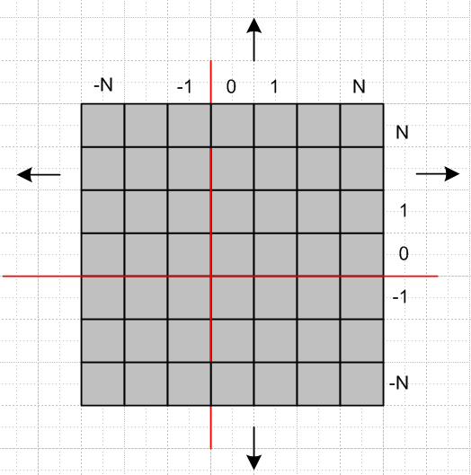

In order to regulate things, we shall assume that the I and J sums range from -N to N rather than from -∞ to ∞. This means we are assuming that the sequence is (2N+1) repeated periods in length and not infinite. Then of course we can say

T = (2N+1)PT1 .

As usual, we keep N finite as long as possible, and then take N→ ∞ in the end.

We now rewrite (F.2) by removing the primes from summation indices and reordering the factors

$\sum_{n = -∞}^{∞}{}$ $\sum_{m = -∞}^{∞}{}$ ym* yn eiω(m-n)T$_{1}$ →

= [ $\sum_{I = -N}^{N}{}$ $\sum_{J = -N}^{N}{}$ eiωP(I-J)T$_{1}$ ] [ $\sum_{n = 0}^{P-1}{}$ $\sum_{m = 0}^{P-1}{}$ ym* yn eiω(m-n)T$_{1}$ ] . (F.3)

The expression is now completely factored into two separate factors (thanks to the periodicity of yn).

The second factor we recognize as

[ $\sum_{n = 0}^{P-1}{}$ $\sum_{m = 0}^{P-1}{}$ ym* yn eiω(m-n)T$_{1}$ ] = | $\sum_{n = 0}^{P-1}{}$ yn e-iωnT$_{1}$ | 2 = | Y"(z) |2 (F.4)

where z = eikωT$_{1}$ and X"(z) is the Z transform of our subsequence of length P.

The first factor can be processed using various results of Appendix A. We write

[ $\sum_{I = -N}^{N}{}$ $\sum_{J = -N}^{N}{}$ eiωP(I-J)T$_{1}$ ] = | $\sum_{I = -N}^{N}{}$ eiωPIT$_{1}$ | 2 . (F.5)

Then apply (A.30)

$\sum_{n = -N}^{N}{}$ eink = 2π δ5(k,N) = 2π { $\frac{sin[(N+1/2)k]}{2π sin(k/2)}$ } (A.30)

with k = ωPT1 to get

[ $\sum_{I = -N}^{N}{}$ $\sum_{J = -N}^{N}{}$ eiωP(I-J)T$_{1}$ ] = | 2π δ5(ωPT1,N) | 2 = [ 2π δ5(ωPT1,N) ] 2 . (F.6)

Then from (A.20),

δ6(k,N) ≡ $\frac{1}{2π}$ $\frac{[2πδ5(k,N)]2}{(2N+1)}$ = $\frac{1}{2N+1}$ $\frac{sin2[(N+1/2)k]}{2π sin2(k/2)}$ . (A.20)

we can write the first factor of (F.3) as

[ $\sum_{I = -N}^{N}{}$ $\sum_{J = -N}^{N}{}$ eiωP(I-J)T$_{1}$ ] = (2N+1) 2π δ6(ωPT1,N) . (F.7)

At this point we have

P(ω) = T1 Ppulse(ω) $\frac{1}{T}$ [ $\sum_{I = -N}^{N}{}$ $\sum_{J = -N}^{N}{}$ eiωP(I-J)T$_{1}$ ] [ $\sum_{n = 0}^{P-1}{}$ $\sum_{m = 0}^{P-1}{}$ ym* yn eiω(m-n)T$_{1}$ ]

= T1 Ppulse(ω) $\frac{1}{(2N+1)PT1}$ [(2N+1) 2π δ6(ωPT1,N) ] [ | Y"(z) |2 ]

= Ppulse(ω) $\frac{1}{P}$ [2π δ6(ωPT1,N) ] [ | Y"(z) |2 ] . (F.8)

Now finally we take N→∞ using (A.21)

limN→∞ δ6(k,N) = $\sum_{m = -∞}^{∞}{}$δ(k-2πm) (A.21)

with this result

P(ω) = Ppulse(ω) $\frac{1}{P}$ $\sum_{m = -∞}^{∞}{}$2π δ(ωPT1-2πm) | Y"(z) |2 . (F.9)

Recalling that ω1 = 2π/T1, we write

δ(ωPT1-2πm) = (PT1)-1 δ(ω - 2πm/(PT1)) = (PT1)-1 δ(ω - ω1m/P) , (F.10)

so our expression for P(ω) becomes

P(ω) = Ppulse(ω) $\frac{1}{P2}$$\frac{2π}{T1}$ $\sum_{m = -∞}^{∞}{}$δ(ω - ω1m/P) | Y"(z) |2
or
P(ω) = Ppulse(ω) $\frac{1}{P2}$ ω1 $\sum_{m = -∞}^{∞}{}$ | Y"(z) |2 δ(ω - ω1m/P)
Y"(z) = $\sum_{n = 0}^{P-1}{}$ yn e-iωnT$_{1}$
| Y"(z) |2 = [ $\sum_{n = 0}^{P-1}{}$ $\sum_{m = 0}^{P-1}{}$ ym* yn eiω(m-n)T$_{1}$ ] . (F.11)

Using a normalized Z transform Q"(z) ≡ Y"(z)/P we can write this as

P(ω) = Ppulse(ω) ω1 $\sum_{m = -∞}^{∞}{}$ | Q"(z) |2 δ(ω - ω1m/P)
Q"(z) = $\frac{1}{P}$ $\sum_{n = 0}^{P-1}{}$ yn e-iωnT$_{1}$
| Q"(z) |2 = $\frac{1}{P2}$ $\sum_{n = 0}^{P-1}{}$ $\sum_{m = 0}^{P-1}{}$ ym* yn eiω(m-n)T$_{1}$ . (F.12)

The result is seen to be eminently finite and of course is entirely discrete, as befits the spectrum of any periodic function.

(b) Calculation for an Ensemble of such Pulse Trains subject to Certain Conditions.

Suppose now instead of a particular subsequence of length P, we have an ensemble of such subsequences (all of length P), which, when installed, yield an ensemble of infinite-length pulse trains. In each pulse train of this ensemble, there is a sequence of length P that is repeated an infinite number of times.

Then we apply the ensemble average <..> to (F.12) to get

<P(ω)> = Ppulse(ω) ω1 $\sum_{m = -∞}^{∞}{}$ δ(ω - ω1m/P) $\frac{1}{P2}$ $\sum_{n = 0}^{P-1}{}$ $\sum_{m = 0}^{P-1}{}$ <ym* yn> eiω(m-n)T$_{1}$ (F.13)

At this point, suppose it happens that

<ym* yn> = α for m ≠ n

<ym* yn> = β for m = n (F.14)

where α and β are independent of the indices shown. Notice in the (F.13) sum that max(n-m) = P-1, so we don't have to worry about these indices differing by an integral multiple of P. We have now restricted our interest now to the sequence a0,a1, ...aP-1.

Comment: Equ. (F.14) would be true if the random variables Ym and Yn were uncorrelated, but saying that α and β are independent of the indices covers a larger class of possibilities, including some in which α and β are in fact correlated. In other words, saying that α and β as shown above don't depend on the indices m and n does not imply that <ym* yn> = <ym*>< yn> which is the definition of being uncorrelated.

Then we can write

$\sum_{n = 0}^{P-1}{}$ $\sum_{m = 0}^{P-1}{}$ <ym* yn> eiω(m-n)T$_{1}$ = α $\sum_{n = 0}^{P-1}{}$ $\sum_{m≠n}^{}{}$ eiω(m-n)T$_{1}$ + β $\sum_{n = 0}^{P-1}{}$ 1
= α $\sum_{n = 0}^{P-1}{}$ $\sum_{m≠n}^{}{}$ eiω(m-n)T$_{1}$ + βP . (F.15)

To evaluate the double sum, we write it as

$\sum_{n = 0}^{P-1}{}$ $\sum_{m≠n}^{}{}$ eiω(m-n)T$_{1}$ = $\sum_{n = 0}^{P-1}{}$ $\sum_{m = 0}^{P-1}{}$ eiω(m-n)T$_{1}$ – $\sum_{n = 0}^{P-1}{}$$\sum_{m=n}^{}{}$ eiω(m-n)T$_{1}$
= | $\sum_{n = 0}^{P-1}{}$ e-iωnT$_{1}$ |2 – $\sum_{n = 0}^{P-1}{}$1 = | $\sum_{n = 0}^{P-1}{}$ e-iωnT$_{1}$ |2 – P . (F.16)

Now let ωT1 = k and consider

$\sum_{n = 0}^{P-1}{}$ e-ink = $\sum_{n = 0}^{P-1}{}$ (e-ik)n = $\sum_{n = 0}^{P-1}{}$xn = 1 + x + ... + xP-1 = $\frac{1-xP}{1-x}$

= $\frac{1-e-ikP}{1-e-ik}$ . (F.17)

With a Maple assist,

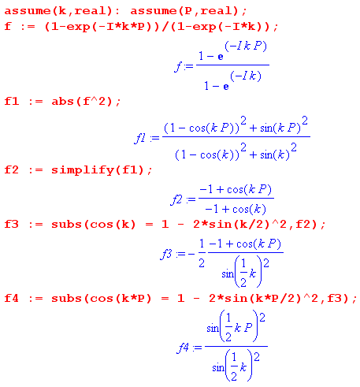
we see that

| $\sum_{n = 0}^{P-1}{}$ e-ink |2 = | $\frac{1-e-ikP}{1-e-ik}$ |2 = $\frac{sin2(kP/2)}{sin2(k/2)}$ . (F.18)

But from (A.20)

δ6(k,N) ≡ $\frac{1}{2π}$ $\frac{[2πδ5(k,N)]2}{(2N+1)}$ = $\frac{1}{2N+1}$ $\frac{sin2[(N+1/2)k]}{2π sin2(k/2)}$ . (A.20)

setting P = 2N+1 we recognize $\frac{sin2(kP/2)}{sin2(k/2)}$ as one of our multiple delta function models, so then

| $\sum_{n = 0}^{P-1}{}$ e-ink |2 = | $\frac{1-e-ikP}{1-e-ik}$ |2 = $\frac{sin2(kP/2)}{sin2(k/2)}$ = 2π P δ6(k, $\frac{P-1}{2}$) . (F.19)

Setting k = ωT1 and applying (F.19) to (F.16) we get

$\sum_{n = 0}^{P-1}{}$ $\sum_{m≠n}^{}{}$ eiω(m-n)T$_{1}$ = | $\sum_{n = 0}^{P-1}{}$ e-iωnT$_{1}$ |2 – P = 2π P δ6(ωT1, $\frac{P-1}{2}$) - P

= P [2π δ6(ωT1, $\frac{P-1}{2}$) - 1]. (F.20)

We now go back to (F.13)

<P(ω)> = Ppulse(ω) ω1 $\sum_{m = -∞}^{∞}{}$δ(ω - ω1m/P) $\frac{1}{P2}$ $\sum_{n = 0}^{P-1}{}$ $\sum_{m = 0}^{P-1}{}$ <ym* yn> eiω(m-n)T$_{1}$ (F.13)

and install (F.15) to get
= Ppulse(ω) ω1 $\sum_{m = -∞}^{∞}{}$δ(ω - ω1m/P) $\frac{1}{P2}$ [α { $\sum_{n = 0}^{P-1}{}$ $\sum_{m≠n}^{}{}$ eiω(m-n)T$_{1}$ } + βP ] . (F.21)

Then we use (F.20) for {...} to get

= Ppulse(ω) ω1 $\sum_{m = -∞}^{∞}{}$δ(ω - ω1m/P) $\frac{1}{P2}$ [α { P [2π δ6(ωT1, $\frac{P-1}{2}$) - 1] } + βP ]
= Ppulse(ω) ω1 $\sum_{m = -∞}^{∞}{}$δ(ω - ω1m/P) $\frac{1}{P}$ [α { [2π δ6(ωT1, $\frac{P-1}{2}$) - 1] } + β ]
or
<P(ω)> = Ppulse(ω) ω1 $\sum_{m = -∞}^{∞}{}$δ(ω - ω1m/P) $\frac{1}{P}$ [(β-α) + α 2π δ6(ωT1, $\frac{P-1}{2}$) ] (F.22a)
where
δ6(k,N) ≡ $\frac{1}{2N+1}$ $\frac{sin2[(N+1/2)k]}{2π sin2(k/2)}$ => 2π δ6(ωT1, $\frac{P-1}{2}$) = $\frac{1}{P}$ $\frac{sin2(PωT1/2)}{sin2(ωT1/2)}$ .

Evaluating at the delta function hit values ω = ω1m/P we find

2π δ6 = $\frac{1}{P}$$\frac{sin2(mπ)}{sin2(mπ/P)}$ = for N = any integer .

To get alternate forms for (F.22a), we first express each term as a separate sum,

<P(ω)> = Ppulse(ω) ω1 $\frac{1}{P}$ [(β-α)$\sum_{m = -∞}^{∞}{}$δ(ω - ω1m/P) + α$\sum_{m = -∞}^{∞}{}$δ(ω - ω1m/P) 2πδ6(ωT1, $\frac{P-1}{2}$) ]

Since only those m which are multiples of P contribute to the second sum in (F.22a), we may rewrite that second sum as follows,

<P(ω)> = Ppulse(ω) ω1 $\frac{1}{P}$ [(β-α)$\sum_{m = -∞}^{∞}{}$δ(ω - ω1m/P) + α $\sum_{N = -∞}^{∞}{}$δ(ω - ω1N) P ] // m = NP
= Ppulse(ω) ω1 [(β-α) $\frac{1}{P}$$\sum_{m = -∞}^{∞}{}$δ(ω - ω1m/P) + α $\sum_{m = -∞}^{∞}{}$δ(ω - ω1m) ] (F.22b)
= Ppulse(ω) ω1 $\sum_{m = -∞}^{∞}{}$[ (β-α) $\frac{1}{P}$δ(ω - ω1m/P) + α δ(ω - ω1m) ] (F.22c)
= Ppulse(ω) ω1 [ (β-α) $\frac{1}{P}$$\sum_{m ≠ 0}^{}{}$δ(ω - ω1m/P) + α $\sum_{m ≠ 0}^{}{}$δ(ω - ω1m) + { (β-α) /P + α } δ(ω) ]
(F.22d)
If xpulse(t) is real, then by (7.4) Ppulse(ω) is an even function of ω, and we can then reflect the negative part of the sum to the positive side to get,

= Ppulse(ω) ω1 [ (β-α) $\frac{2}{P}$$\sum_{m = 1}^{∞}{}$δ(ω - ω1m/P) + 2α $\sum_{m = 1}^{∞}{}$δ(ω - ω1m) + { (β-α) /P + α } δ(ω) ]
(F.22e)
In all forms of (F.22) we have: α = <ym* yn> for m≠n β = <yn* yn> .

These slightly different forms of <P(ω)> are useful for different purposes. All results are valid for any finite integer P. Since each sequence in the ensemble is periodic with the same period P, the ensemble average spectrum is entirely discrete. The m≠0 sums include positive and negative integers.

Here is a graphical representation of (F.22d) drawn for some arbitrary Ppulse(ω) and P = 4. Each

<P(ω)> = Ppulse(ω) ω1 [ (β-α) $\frac{1}{P}$$\sum_{m ≠ 0}^{}{}$δ(ω - ω1m/P) + α $\sum_{m ≠ 0}^{}{}$δ(ω - ω1m) + { (β-α) /P + α } δ(ω) ]
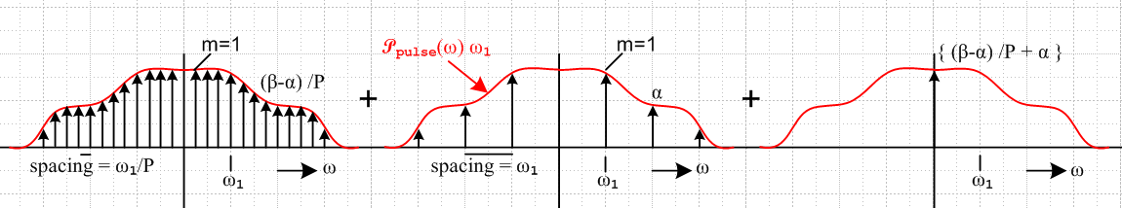
Fig F.1

Each vertical arrow represents a spectral δ line. The height of the arrow is the value of the red envelope curve times the quantity shown. The red curve Ppulse(ω) ω1 will in general have an infinite extent, an example being Ppulse(ω) ω1 = sinc2(ωT1/2) = sinc2(πω/ω1) for a box shaped pulse as in (9.2). Once a particular Ppulse(ω) is specified, it might quench some of the spectral lines. For the box example, lines are quenched when ω = Nω1 for N = ±1,±2 .... In this case, all the lines of the central image go away and the corresponding lines in the left image also vanish, this being every Pth line in that image:

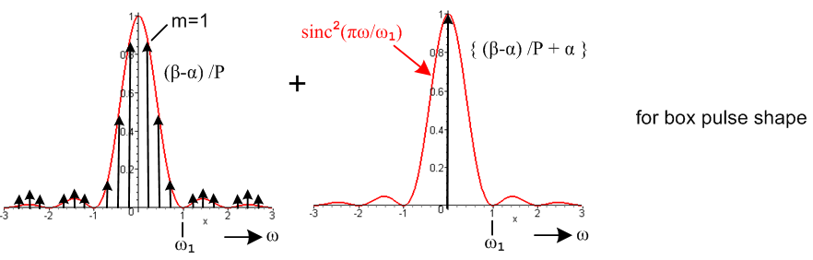

(c) Limit as P → ∞ of the Ensemble Result

We would now like to take the limit of the above as P→∞. To do this right, we would really have to undo the N→∞ limit, we can compute this limit as follows. Write (F.22b) as

<P(ω)> = Ppulse(ω) [(β-α) { $\frac{ω1}{P}$$\sum_{m = -∞}^{∞}{}$δ(ω - ω1m/P) } + ω1 α $\sum_{m = -∞}^{∞}{}$δ(ω - ω1m) ] (F.23)
Then define

fP(ω) ≡ $\frac{ω1}{P}$$\sum_{m = -∞}^{∞}{}$δ(ω - ω1m/P) . (F.24)
As P→∞, the spacing of the δ lines becomes closer and closer, while the amplitude $\frac{ω1}{P}$ of each δ line becomes less and less. Perhaps we can argue that in the limit this becomes some continuous function.

In line with the distribution theory approach to symbolic functions noted in Appendix A, suppose we integrate this function from some a to a+ε for small ε, where a is an arbitrary real number,

$^{\int_{a}^{a+ε}{}}$ fP(ω) dω = $\frac{ω1}{P}$$\sum_{m = -∞}^{∞}{}$$^{\int_{a}^{a+ε}{}}$ δ(ω - ω1m/P)
= $\frac{ω1}{P}$ $\sum_{m = -∞}^{∞}{}$ Θ(a ≤ω1m/P ≤ a+ε) (F.25)

where we use the notation of Appendix A (e) for the Θ function which takes value 1 if the inequality argument is valid. If P is a large integer, how many non-zero terms does this Σm have? The inequality argument reads

Pa/ω1 ≤ m ≤ Pa/ω1 + Pε/ω1 .

Since P is large, we round each term in this equation to the nearest integer, making little error. We select a very small ε first, and then we make sure P is large enough so Pε/ω1 is still a reasonably large integer when rounded. Then we have

$^{\int_{a}^{a+ε}{}}$ fP(ω) dω = $\frac{ω1}{P}$$\sum_{m =Pa/ω1}^{Pa/ω1 + Pε/ω1}{}$ Θ(a ≤ω1m/P ≤ a+ε) = $\frac{ω1}{P}$ $\sum_{m =Pa/ω1}^{Pa/ω1 + Pε/ω1}{}$ 1
= $\frac{ω1}{P}$ ( Pε/ω1) = ε . (F.26)

Since we then have (for very large P) that $^{\int_{a}^{a+ε}{}}$ fP(ω) dω = ε for any real a and for ε as small as we like, and since the integral over range ε is proportional to ε, the function fP(ω) is equivalent to the constant function 1. Thus we have shown that,

limP→∞ fP(ω) = limP→∞ [ $\frac{ω1}{P}$$\sum_{m = -∞}^{∞}{}$δ(ω - ω1m/P)] = 1. (F.27)

We then obtain this P→∞ limit of (F.23),

<P(ω)> = Ppulse(ω) [(β-α) + ω1 α $\sum_{m = -∞}^{∞}{}$δ(ω - ω1m) ] (F.28)
= Ppulse(ω) [(β-α) + (1/T1) α $\sum_{m = -∞}^{∞}{}$2π δ(ω - ω1m) ] // ω1 = 2π/T1
= Ppulse(ω) [(β-α) + α $\sum_{m = -∞}^{∞}{}$2π δ(ωT1 - 2πm) ] .

This agrees with our result obtained earlier for a random ensemble of infinite sequences for which <aman> does not depend on the values of m and n,

<P(ω)> = Ppulse(ω) { (β-α) + α$\sum_{m = -∞}^{∞}{}$2π δ(ωT1- 2πm) } (35.11)

