This is the Title PhL 3.26.05

Note that page numbering is turned on in this template.

35. Statistical Pulse Trains 2
(a) What is a Statistical Pulse Train? 2
(b) The region of support for y_{m}y_{m+s} for a finite pulse train 3
(c) The Spectral Power Density for a specific pulse train 5
(d) The mean Spectral Power Density for an Ensemble of pulse trains 6
(e) Adding Stationarity to the Ensemble Situation 6
(f) Adding Independence along with Stationarity to the Ensemble Situation 9
(g) Comparison between the two kinds of averages <..> and <...>₁ 11
(h) Miscellaneous topics 13
The Two Pathways for computing P(ω) 13
The equivalence of P(ω) and <P(ω)> for infinite pulse trains 14
Facts about Infinite Uncorrelated Statistical Pulse Trains 15
Specialization for symbols in the set {A,B} 16
(i) Statistical Uncorrelated Pulse Trains: Summary and Example 18
(j) A numerical example of a Statistical Pulse Train 18
(k) A paradox and its resolution 22
(l) What role has the Autocorrelation Function played in our development? 24

35. Statistical Pulse Trains

(a) What is a Statistical Pulse Train?

Suppose we use a logic analyzer or digital scope to capture a 1 GHz PAM signal (zeros and ones) for 1 μsec so a sequence of K = 1,000 symbols ym are stored. We could compute the average value for this sequence and we might find <ym>1 = 0.55. Here <...>1 refers to a horizontal average over a single pulse train amplitude sequence. By its definition, this average cannot depend on the index m, we are just computing an average of the ym values in the sequence,

<ym>1 = (1/K) Σm=1K ym .

Now it might be that during this 1 μsec, there was something unusual about the data being sent, so that this measurement of <ym>1 = 0.55 is not really representative over a longer term. One alternative would be to capture a much longer sequence. Rather than do this, our approach will be to capture very many 1 μsec pulse trains and form an ensemble of these representative pulse trains. Perhaps we do this for a whole minute, so the ensemble then has a huge number (call it I) of pulse trains. We then write down these amplitude sequences in a vertical list on a very long piece of paper, one sequence below the next. We then number the positions in the sequences 1 to N and we then define <ym> as the vertical average through this ensemble of the sequences in position m. This vertical average is written

<ym> = (1/I) Σi=1I ym(i)

and in theory this could be different for different columns m. For example, consider this ensemble of sequences which has K = 6 and I = 3:

1 2 3 4 5 6
a b c d e f sequence #1
a' b' c' d' e' f' sequence #2
a" b" c" d" d" f" sequence #3 Ensemble Fig 35.1

We would have

<ym>1 = (a+b+c+d+e+f)/6. // horizontal average for the first sequence
<y3> = (c + c' + c")/3 // vertical average for column 3

Our pulse train sequence has a random variable Ym associated with each pulse train position, m = 1,2...K, and the vertical average <ym> is the expected value of Ym over the ensemble, normally written <ym> = E(Ym). The experiment associated with Ym is the generation of a pulse train by some Apparatus, the experiment is run many times, and the outcomes for random variable Ym are the values of the symbols located in position m of these pulse trains. See Appendix G for the meaning of "random variable".
The ensemble is characterized by various statistical properties, such as E(Ym) or E(YnYmYk), each being a vertical average down through the ensemble. Our statistical pulse train is an idealized pulse train whose amplitudes form a statistical sequence whose statistics ( like E(Ym) and E(YnYmYk) ) exactly match those of the ensemble. It is not any particular member of the ensemble, since any member might deviate somehow. And it is certainly not the average of the pulse trains in the ensemble, since this average pulse train would have amplitudes ym = <ym> which has nothing to do with anything ( and also would have illegal symbols, e.g., ym = 1/2). If K were very large, a pulse train of the ensemble might come close to being a statistical pulse train.
Common usage refers to our statistical pulse train as a random pulse train whose sequence of amplitudes is a random sequence. The problem with this terminology is that the word "random" suggests for example that <ym> = the mean value of Ym in the ensemble = 1/2. That is to say, the word random suggests a flat distribution where p(1) = 1/2 and p(0) = 1/2. But if p(1) = 1/3 and p(0) = 2/3, our ensemble would still be associated with a statistical pulse train, Any value of p ≡ p(1) would describe a statistical pulse train, along with the other statistical properties. This same subtle implication of the word random appears in Appendix G on "random variables" and basic probability theory.
In what follows, we shall only be concerned with the first and second order statistics of the statistical pulse train, which are <ym> = E(Ym) and <ymyn> = E(YmYn).

How many member pulse trains must the ensemble contain? Could it have only two pulse trains? The answer is that the ensemble could be small, but then the statistical properties of the random variables as discovered by the ensemble would have a large amount of error. For example, for column n there is some normalized distribution pYn(yn) associated with the random variable Yn. Suppose yn took values from {1,2,3,4,5,6}, and suppose pYn(yn) were a flat distribution. Here might be the different views of pYn(yn) as obtained from ensembles with I = 2, 50 and 1000 pulse trains :

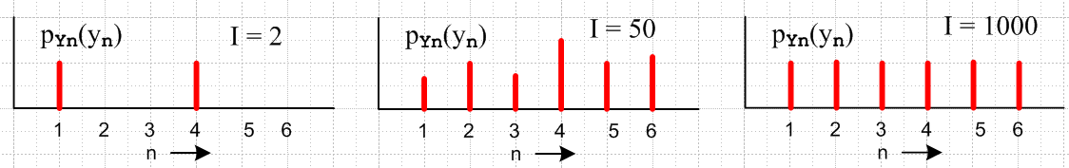

Since E(Yn) = Σn yn pYn(yn), the error propagates into this and all other expectation values associated with the statistical pulse train. For any required degree of accuracy δ of the statistical quantities, we can find some value Id such that for I > Iδ the ensemble will realize that accuracy. In theory, we just imagine that I = ∞, and then everything is perfect.

(b) The region of support for ymym+s for a finite pulse train

The product of amplitudes ymym+s appears many times below. For a finite pulse train it is useful to see where the product vanishes and where it does not vanish in terms of m and s. In the previous section we discussed a finite pulse train having yn with n = 1 to K, but now we instead have yn with n = -N to N so our finite pulses train now have (2N+1) amplitudes yn. We imagine the finite pulse train embedded in an infinite pulse train that has all zeros to the left of -N and to the right of +N. In this case we may write for this infinite pulse train,

ymym+s = ymym+s θ(m ≤ N)θ(m ≥-N) θ(m+s ≤ N)θ(m+s ≥ -N)

= ymym+s θ(m ≤ N)θ(m ≥-N) θ(s ≤ N-m)θ(s ≥ -N-m)

where we use an inequality-style Heaviside step function θ. The product of the four θ functions and thus the quantity ymym+s vanishes outside the gray parallelogram in this drawing of the (m,s) plane,

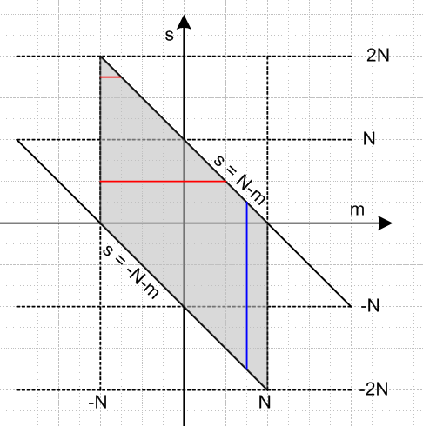 Fig 35.2

Thus, assuming m is in range -N to N, we may write

ymym+s = (35.1)

Below we shall be interested in the following quantity (the autocorrelation sequence),
rs = < ymym+s>1 = $\frac{1}{2N+1}$$\sum_{m= -∞}^{∞}{}$ ymym+s // a horizontal average (35.2)
= $\frac{1}{2N+1}$$\sum_{m= -∞}^{∞}{}$ ymym+s θ(m ≤ N)θ(m ≥-N) θ(s ≤ N-m)θ(s ≥ -N-m)
= $\frac{1}{2N+1}$$\sum_{m= -∞}^{∞}{}$ ymym+s θ(m ≤ N)θ(m ≥-N) θ(m ≤ N-s)θ(m ≥ -N-s)

= $\frac{1}{2N+1}$$\sum_{m = max(-N,-N-s)}^{min(N,N-s)}{}$ ymym+s . (35.3)

The range of m appearing in this sum is represented by a red line in the figure for two positive values of s. For s > 2N there is no range left so rs = 0, and the same when s < -2N. Thus, we may regard

rs = rs θ(s≤2N)θ(s≥-2N) . (35.4)

Another quantity of interest, R"(z) = Z Transform of rs, therefore has this restricted sum range for a finite pulse train,

R"(z) = $\sum_{s = -∞}^{∞}{}$ rs z-s = $\sum_{s = -2N}^{2N}{}$ rs z-s . (35.5)

Notice that <ymym+s>1 = rs does not depend on m due to its "horizontal" average definition shown in (35.2). The non-dependence of <ymym+s>1 on m has nothing to do with "stationarity" as will be discussed below. That is, <ymym+s>1 is for a particular pulse train, it is not an ensemble average.

(c) The Spectral Power Density for a specific pulse train

There are many ways to write the power density expression for a pulse train, see (32.18) and (34.14a). For an infinite pulse train we may write (reader should perhaps ponder each form),

P(ω) = Ppulse(ω)$\sum_{s = -∞}^{∞}{}$<ymym+s>1 z-s = Ppulse(ω)$\sum_{s = -∞}^{∞}{}$ rs z-s
= Ppulse(ω) R"(z) = Ppulse(ω) $\frac{T1}{T}$ | Y"(z) |2 rs = $\frac{T1}{T}$$\sum_{m= -∞}^{∞}{}$ ymym+s
= Ppulse(ω) $\frac{T1}{T}$ ($\sum_{m = -∞}^{∞}{}$ym z-m )* ($\sum_{n = -∞}^{∞}{}$yn z-n )
= Ppulse(ω) $\frac{T1}{T}$ ($\sum_{m = -∞}^{∞}{}$ $\sum_{n = -∞}^{∞}{}$ ym yn zm-n ) // z = eiωT$_{1}$ so (z-m)* = zm
= Ppulse(ω) $\frac{T1}{T}$ ($\sum_{m = -∞}^{∞}{}$ $\sum_{s = -∞}^{∞}{}$ ym ym+s z-s ) P(ω) INFINITE (35.6)

Recall that T is the duration of the infinite pulse train, written as T = 2πδ(0) in (33.22). This T always cancels away, so we are not concerned about its infinite nature. It is a limit (2N+1)T1 as N→∞.

For a finite pulse train we find, using (35.3) and (35.5) and Fig 35.2,

P(ω) = Ppulse(ω) $\sum_{s = -2N}^{2N}{}$<ymym+s>1 z-s = Ppulse(ω) $\sum_{s = -2N}^{2N}{}$ rs z-s
= Ppulse(ω) R"(z) = Ppulse(ω) $\frac{1}{2N+1}$| Y"(z) |2 rs = $\frac{1}{2N+1}$$\sum_{m = max(-N,-N-s)}^{min(N,N-s)}{}$ ymym+s
= Ppulse(ω) $\frac{1}{2N+1}$ ($\sum_{m = -N}^{N}{}$ym z-m )* ($\sum_{n = -N}^{N}{}$yn z-n )
= Ppulse(ω) $\frac{1}{2N+1}$ ($\sum_{m = -N}^{N}{}$ $\sum_{n = -N}^{N}{}$ ym yn zm-n )
= Ppulse(ω) $\frac{1}{2N+1}$ ($\sum_{m = -N}^{N}{}$ $\sum_{s = -N-m}^{N-m}{}$ ym ym+s z-s ) P(ω) FINITE (35.7)

In the last expression, the sum on s is represented by the blue line in Fig 35.2. In all these expressions, one can regard ymym+s and ym yn as being stripped of their Heaviside θ functions as in (35.3). That is to say, there are no places in any of the above expressions where ymym+s = 0 because it is out of range. Later when we add stationarity, we will replace ym ym+s by f(s) which is never 0 in an out-of-range sense.

(d) The mean Spectral Power Density for an Ensemble of pulse trains

We now apply our ensemble average <....> to the previous equation groups to get for the infinite case,

<P(ω)> = Ppulse(ω)$\sum_{s = -∞}^{∞}{}$<<ymym+s>1> z-s = Ppulse(ω)$\sum_{s = -∞}^{∞}{}$ <rs> z-s
= Ppulse(ω) <R"(z)> = Ppulse(ω) $\frac{T1}{T}$< | Y"(z) |2> <rs> = $\frac{T1}{T}$$\sum_{m= -∞}^{∞}{}$ <ymym+s>
= Ppulse(ω) $\frac{T1}{T}$ < ($\sum_{m = -∞}^{∞}{}$ym z-m )* ($\sum_{n = -∞}^{∞}{}$yn z-n ) >
= Ppulse(ω) $\frac{T1}{T}$ ($\sum_{m = -∞}^{∞}{}$ $\sum_{n = -∞}^{∞}{}$ <ym yn> zm-n )
= Ppulse(ω) $\frac{T1}{T}$ ($\sum_{m = -∞}^{∞}{}$ $\sum_{s = -∞}^{∞}{}$ <ym ym+s> z-s ) <P(ω)> INFINITE (35.8)

and for an ensemble of finite pulse trains,

<P(ω)> = Ppulse(ω) $\sum_{s = -2N}^{2N}{}$<<ymym+s>1>z-s = Ppulse(ω) $\sum_{s = -2N}^{2N}{}$ <rs> z-s
= Ppulse(ω) <R"(z) > = Ppulse(ω) $\frac{1}{2N+1}$ <| Y"(z) |2>, <rs> = $\frac{1}{2N+1}$$\sum_{m = max(-N,-N-s)}^{min(N,N-s)}{}$ <ymym+s>
= Ppulse(ω) $\frac{1}{2N+1}$ < ($\sum_{m = -N}^{N}{}$ym z-m )* ($\sum_{n = -N}^{N}{}$yn z-n ) >
= Ppulse(ω) $\frac{1}{2N+1}$ ($\sum_{m = -N}^{N}{}$ $\sum_{n = -N}^{N}{}$ <ym yn> zm-n )
= Ppulse(ω) $\frac{1}{2N+1}$ ($\sum_{m = -N}^{N}{}$ $\sum_{s = -N-m}^{N-m}{}$ <ym ym+s> z-s ) <P(ω)> FINITE (35.9)

(e) Adding Stationarity to the Ensemble Situation

The stationarity assumption is that the Apparatus generating the pulse trains of the ensemble is a "stationary stochastic process" which means (at least) that

<ym> does not depend on m // where <ym> does not vanish
<ymym+s> does not depend on m // where <ymym+s> does not vanish (35.10)

Recall that for a finite pulse train, <ym> vanishes outside the range (-N,N) while <ymym+s> vanishes outside the gray region in Fig 35.2. For an infinite pulse train these objects don't vanish anywhere.

From Appendix G we know that

cov(X,Y) = E(XY) - μxμy (G.24b)
=> cov (Ym ,Ym+s) = <ymym+s> - <ym><ym+s> = <ymym+s> - <ym>2 // stationarity of <ym>

Assuming <ym> and <ymym+s> are stationary is the same as assuming <ym> and cov (Ym ,Ym+s) are stationary. If we make no stationarity requirement on other statistical measures (like <ym3>), this limited sense of stationarity is usually called wide-sense stationarity (WSS).

This stationarity assumption applies to both finite and infinite pulse trains. It is an assumption about the process which generates pulse trains regardless of their length.

It is helpful to define μ ≡ <ym> and <ymym+s> = f(s) and rewrite the stationarity assumption in this manner for a finite pulse train, where the second equation invokes Fig 35.2's gray region,

<ym> =

<ymym+s> = // m in (-N,N) (35.11)

For an infinite pulse train, the upper lines apply and then <ym> = μ and <ymym+s> = f(s) everywhere.

With this stationarity assumption, we can write

<rs> = $\frac{T1}{T}$$\sum_{m = -∞}^{∞}{}$ <ymym+s> = $\frac{T1}{T}$f(s)$\sum_{m = -∞}^{∞}{}$[1] = f(s) // infinite pulse train

<rs> = $\frac{1}{2N+1}$$\sum_{m = max(-N,-N-s)}^{min(N,N-s)}{}$ <ymym+s> = $\frac{1}{2N+1}$f(s)$\sum_{m = max(-N,-N-s)}^{min(N,N-s)}{}$ [1] =
= $\frac{1}{2N+1}$f(s) (2N+1 - |s|) // see red lines in Fig 35.2

= $\frac{2N+1 - |s|}{2N+1}$f(s) // finite pulse train

To summarize :

<rs> = f(s) // infinite pulse train
<rs> = $\frac{2N+1 - |s|}{2N+1}$f(s) // finite pulse train (35.12)

Here then are the infinite pulse train expressions assuming stationarity :

<P(ω)> = Ppulse(ω)$\sum_{s = -∞}^{∞}{}$<<ymym+s>1> z-s = Ppulse(ω)$\sum_{s = -∞}^{∞}{}$ <rs> z-s
= Ppulse(ω) <R"(z)> = Ppulse(ω) $\frac{T1}{T}$< | Y"(z) |2> <rs> = f(s)
= Ppulse(ω) $\frac{T1}{T}$ < ($\sum_{m = -∞}^{∞}{}$ym z-m )* ($\sum_{n = -∞}^{∞}{}$yn z-n ) >
= Ppulse(ω) $\frac{T1}{T}$ ($\sum_{m = -∞}^{∞}{}$ $\sum_{n = -∞}^{∞}{}$ <ym yn> zm-n )
= Ppulse(ω) $\sum_{s = -∞}^{∞}{}$ f(s) z-s <P(ω)> INFINITE (stat) (35.13)

In the last line we used

$\frac{T1}{T}$ ($\sum_{m = -∞}^{∞}{}$ $\sum_{s = -∞}^{∞}{}$ <ym ym+s> z-s ) = $\frac{T1}{T}$ ( $\sum_{s = -∞}^{∞}{}$ f(s) z-s ) $\sum_{m = -∞}^{∞}{}$[1] = $\sum_{s = -∞}^{∞}{}$ f(s) z-s

and then the last line just replicates the first line given that <rs> = f(s).
And here are the finite pulse train <P(ω)> expressions assuming stationarity :

<P(ω)> = Ppulse(ω) $\sum_{s = -2N}^{2N}{}$<<ymym+s>1>z-s = Ppulse(ω) $\sum_{s = -2N}^{2N}{}$ <rs> z-s
= Ppulse(ω) <R"(z) > = Ppulse(ω) $\frac{1}{2N+1}$ <| Y"(z) |2> <rs> = $\frac{2N+1 - |s|}{2N+1}$f(s)
= Ppulse(ω) $\frac{1}{2N+1}$ < ($\sum_{m = -N}^{N}{}$ym z-m )* ($\sum_{n = -N}^{N}{}$yn z-n ) >
= Ppulse(ω) $\frac{1}{2N+1}$ ($\sum_{m = -N}^{N}{}$ $\sum_{n = -N}^{N}{}$ <ym yn> zm-n )
= Ppulse(ω) $\sum_{s = -2N}^{2N}{}$ f(s) z-s $\frac{2N+1 - |s|}{2N+1}$ <P(ω)> FINITE (stat) (35.14)

In the last line we did this manipulation on the last line of (35.9) (see the gray region in Fig 35.2)

$\frac{1}{2N+1}$$\sum_{m = -N}^{N}{}$ $\sum_{s = -N-m}^{N-m}{}$ <ym ym+s> z-s = $\frac{1}{2N+1}$$\sum_{s = -2N}^{2N}{}$ $\sum_{m = max(-N,-N-s)}^{min(N,N-s)}{}$ f(s) z-s

= $\frac{1}{2N+1}$ $\sum_{s = -2N}^{2N}{}$f(s) z-s$\sum_{m = max(-N,-N-s)}^{min(N,N-s)}{}$ [1] = $\frac{1}{2N+1}$ $\sum_{s = -2N}^{2N}{}$ f(s) z-s ( 2N+1 - |s| )

One again, we see that the final expression in (35.14) replicates the first one with <rs> as shown.

(f) Adding Independence along with Stationarity to the Ensemble Situation

As shown in Appendix G, if Yn and Ym are independent random variables, then for s ≠ 0,

f(s) = <ym ym+s> = E(YnYm+s) = E(Yn)E(Ym+s) = <ym><ym+s> = <ym><ym> = <ym>2 // stationarity
or
f(s) = μ2 μ = <ym>

But for s = 0, the result is different. We write

f(0) = <ymym> = <ym2> = σ2 + μ2 where σ2 ≡ <ym2>- <ym>2 = <ym2>- μ2 (G.30)

To summarize:

f(s) = . // stationarity and independence assumed (35.15)

For the last time (!), we consider the various <P(ω)> expressions now with stationarity and independence assumed. Rather than write all the expressions, we focus just on the first equation (same as the last) of the group (35.13) for the infinite case,

<P(ω)> = Ppulse(ω)$\sum_{s = -∞}^{∞}{}$ <rs> z-s = Ppulse(ω)$\sum_{s = -∞}^{∞}{}$ f(s) z-s
= Ppulse(ω) [ f(0) + $\sum_{s ≠ 0}^{}{}$ f(s) z-s ]
= Ppulse(ω) [(σ2 + μ2) + μ2$\sum_{s ≠ 0}^{}{}$ z-s ]
= Ppulse(ω) [σ2 + μ2$\sum_{s = -∞}^{∞}{}$ z-s ] // now use (13.2) with z = eiωT$_{1}$ to get :
= Ppulse(ω) [σ2 + μ2$\sum_{m = -∞}^{∞}{}$2πδ(ωT1 - 2πm) ] . <P(ω)> INFINITE (stat+indep) (35.16)

We shall return to this classic result below. Meanwhile, we have from the first equation (same as the last) of the group (35.14) for the finite case,

<P(ω)> = Ppulse(ω)$\sum_{s = -2N}^{2N}{}$ f(s) z-s $\frac{2N+1 - |s|}{2N+1}$
= Ppulse(ω)[ f(0) + $\sum_{s ≠ 0}^{}{}$ f(s) z-s $\frac{2N+1 - |s|}{2N+1}$ ]
= Ppulse(ω)[ (σ2 + μ2) + μ2 $\sum_{s ≠ 0}^{}{}$z-s $\frac{2N+1 - |s|}{2N+1}$ ]
= Ppulse(ω)[ σ2 + μ2 $\sum_{s = -2N}^{2N}{}$z-s $\frac{2N+1 - |s|}{2N+1}$ ] // see App. D and comments below

= Ppulse(ω)[ σ2 + μ2 $\frac{1}{2N+1}$ $\frac{sin2[(N+1/2)ωT1]}{sin2(ωT1/2)}$ ] // now use (A.20) to get:

= Ppulse(ω)[ σ2 + μ2 2π δ6(ωT1,N) ] . <P(ω)> FINITE (stat+indep) (35.17)

The evaluation of the Σs in the third last line is non-trivial and is carried out in Appendix D. The last line expresses the second last line in the language of Appendix A where δ6 is the delta function model shown in (A.20). From (A.21) we know that

limN→∞ δ6(k,N) = $\sum_{m = -∞}^{∞}{}$δ(k-2πm) (A.21)

so the last line of (35.17) becomes in the limit N→∞,

<P(ω)> = Ppulse(ω)[ σ2 + μ2 2π$\sum_{m = -∞}^{∞}{}$δ(k-2πm) ]

which (as expected) agrees with the last line of (35.16) for the infinite case.

Evaluation of the Σs in (3.17) is not really necessary since we can compute <P(ω)> using a different equation from the group (35.13), namely

<P(ω)> = Ppulse(ω) $\frac{1}{2N+1}$ ($\sum_{m = -N}^{N}{}$ $\sum_{n = -N}^{N}{}$ <ym yn> zm-n ) . (35.18)

Sometimes double sums (or double integrals) are easier to evaluate than a single-sum representation of the same function. The double sum in (35.18) may be evaluated as follows, using (35.15),

$\sum_{n = -N}^{N}{}$ $\sum_{m = -N}^{N}{}$ <ym yn> zn-m = $\sum_{n = -N}^{N}{}$ [ $\sum_{m = n}^{}{}$f(0) zn-m + $\sum_{m ≠ n}^{}{}$ f(n-m) zn-m ]
= $\sum_{n = -N}^{N}{}$ [(σ2 + μ2) + μ2 $\sum_{m ≠ n}^{}{}$ zn-m + ] // in first term $\sum_{m = n}^{}{}$ zn-m = 1
= $\sum_{n = -N}^{N}{}$ [ σ2 + μ2 $\sum_{m = -N}^{N}{}$ zn-m + ]
= (2N+1) σ2 + μ2 ($\sum_{n = -N}^{N}{}$zn)( $\sum_{m = -N}^{N}{}$zm)*

= (2N+1) σ2 + μ2 [ 2π δ5(ωT1,N) ]2 // from (13.3) used twice with k = ωT1

= (2N+1) σ2 + μ2 [ (2N+1) 2π δ6(ωT1,N) ] // from (A.20) (35.19)

and therefore

<P(ω)> = Ppulse(ω) $\frac{1}{2N+1}$ { (2N+1) σ2 + μ2 [ (2N+1) 2π δ6(ωT1,N) ] }

= Ppulse(ω)[ σ2 + μ2 2π δ6(ωT1,N)]

which agrees with the last line of (35.17), and we bypassed doing the Appendix D sum.

(g) Comparison between the two kinds of averages <..> and <...>1

We now want to compare the two averages appearing in the above equations :

<ym>1 cannot depend on m from its definition as a horizontal average over a sequence.
<ym> might depend on m, but does not with the stationarity assumption

<ymym+s>1 = rs cannot depend on m from its definition (32.17), but generally depends on s
<ymym+s> may depend on m as well as s, but with stationarity depends only on s

<ymym+s>1 is not associated with any random variables
<ymym+s> is associated with random variables Ym and Ym+s as outlined in section (a) above

If Ym and Ym+s are independent random variables, then <ymym+s> = <ym>< ym+s> (see App G).
In contrast, the statement <ymym+s>1 = <ym>1< ym+s>1 = <ym>1< ym>1 = < ym>12 might be true, but has no connection to any random variables upon whose independence this factoring could be postulated.
(35.20)

In order to make a connection between these two kinds of averages, we have to make some assumptions.

For an ensemble of pulse trains of very long length (large N), we assume that each ensemble member is a "statistical pulse train" in that it very closely has the statistics of the ensemble as a whole. This does not mean that the ensemble pulse trains are the same.
One implication of this assumption is that all member pulse trains (i = 1,2.. I) then have the same autocorrelation function and we may then write

rs(i) = <ymym+s>1(i) = (1/N) Σm=1N ym(i) ym+s(i) = the same for all i = 1 to I.

≡ rs ≡ <ymym+s>1 . (35.21)

Consider then,

Σm=1N <ymym+s> = N <ymym+s> . // stationarity

On the left side of this equation we insert the definition of <ymym+s>,

<ymym+s> = (1/I) Σi=1I ym(i) ym+s(i) , (35.22)

with this result

Σm=1N (1/I) Σi=1I ym(i) ym+s(i) = N <ymym+s> .

Now reorder the sums to get,

(N/I) Σi=1I [(1/N) Σm=1N ym(i)ym+s(i)] = N <ymym+s>

(N/I) Σi=1I <ymym+s>1(i) = N <ymym+s>

(1/I) Σi=1I <ymym+s>1 = <ymym+s> // use (35.21) and cancel the N's

<ymym+s>1 [ (1/I) Σi=1I 1 ] = <ymym+s>

<ymym+s>1 = <ymym+s> . // horizontal average equals vertical average

As a special case, we can set s = 0 to get

<ym2>1 = < ym2> .

In similar fashion, our very large N assumption implies that all pulse trains in the ensemble have the same horizontal mean, so

<ym>1(i) ≡ <ym>1 . (35.23)

Repeating the above steps now for <ym >,

Σm=1N <ym > = N <ym> // stationarity

Σm=1N [ (1/I) Σi=1I ym(i)] = N <ym>

(N/I) Σi=1I (1/N) Σm=1N [ym(i)] = N <ym>

(N/I) Σi=1I <ym>1(i) = N <ym>

(1/I) Σi=1I <ym>1 = <ym> // use (35.23) and cancel the N's

<ym>1 = <ym> .

Thus, assuming stationarity and very large N, we have found that

<ymym+s>1 = <ymym+s>
<ymym>1 = <ymym>
<ym>1 = <ym> . // all three lines only for very large N (35.24)

These relations are equalities for N = ∞, are approximately valid for large N, and are invalid for small N.

If we add to our assumptions so far that Ym and Ym+s are independent, not only may we write

E(YmYm+s) = E(Ym)E(Ym+s) ⇔ <ymym+s> = <ym>< ym+s> // independent, s≠ 0

but we may also write, using stationarity and independence

<ymym+s> = <ym>< ym> = <ym>2 s ≠ 0

which by (35.24) then justifies the claim sometimes made that,

<ymym+s>1 = <ym>1< ym>1 = <ym>12 s≠0 //stationary + independent + N→∞ (35.25)

(h) Miscellaneous topics

The Two Pathways for computing P(ω)

From (35.6) and (35.8) we have obtained these two general "formulas" for the spectral power density of a an infinite pulse train, prior to assuming stationarity or independence. We first write these as

P(ω) = Ppulse(ω) ($\sum_{s = -∞}^{∞}{}$rs z-s ) first line of (35.6) "autocorrelation"

P(ω) = Ppulse(ω) $\frac{T1}{T}$($\sum_{m = -∞}^{∞}{}$ym z-m )* ($\sum_{n = -∞}^{∞}{}$yn z-n ) (35.26)
= Ppulse(ω) $\frac{T1}{T}$ ($\sum_{m = -∞}^{∞}{}$ $\sum_{n = -∞}^{∞}{}$ ym yn zm-n ) third line of (35.6) "double sum"

The corresponding equations for finite pulse trains are,

P(ω) = Ppulse(ω) ($\sum_{s = -2N}^{2N}{}$rs z-s ) first line of (35.7) "autocorrelation"

P(ω) = Ppulse(ω) $\frac{T1}{T}$($\sum_{m = -N}^{N}{}$ym z-m )* ($\sum_{n = -N}^{N}{}$yn z-n ) (35.26)'
= Ppulse(ω) $\frac{T1}{T}$ ($\sum_{m = -N}^{N}{}$ $\sum_{n = -N}^{N}{}$ ym yn zm-n ) third line of (35.7) "double sum"

In either case we have two distinct pathways for the computation of P(ω). We might call these pathways the autocorrelation approach which uses rs, and the double-sum approach which directly uses the yn data without the intermediary of rs. We saw earlier that the double-sum approach provided an easier pathway for the finite pulse train case, leading to the last line of (35.17) using the steps shown in (35.19), but in general the autocorrelation approach is the one most commonly used.

The autocorrelation approach will be used in Section 37 for the AMI line code, in Section 38 for the Change/Hold Line code, and in Appendix F for infinite pulse trains with repeated subsequences such as the Maximum Length Sequence output by a shift register generator.

The equivalence of P(ω) and <P(ω)> for infinite pulse trains

We now rewrite (35.26), this time using an ensemble average on the lower equation,

P(ω) = Ppulse(ω) ($\sum_{s = -∞}^{∞}{}$<ymym+s>1 z-s ) one pulse train (35.6)
<P(ω)> = Ppulse(ω) $\frac{T1}{T}$ ($\sum_{s = -∞}^{∞}{}$ $\sum_{m = -∞}^{∞}{}$ <ym ym+s> z-s ) ensemble of pulse trains (35.8)
When stationarity is assumed for the process creating the pulse trains, in the second line above we may slide <ym ym+s> z-s to the left through the Σm sum, which sum becomes Σm[1] = T/T1 and we then have this pair of formulas

P(ω) = Ppulse(ω) $\sum_{s = -∞}^{∞}{}$<ymym+s>1 z-s = Ppulse(ω) ($\sum_{s = -∞}^{∞}{}$rs z-s) one pulse train (35.7)
<P(ω)> = Ppulse(ω) $\sum_{s = -∞}^{∞}{}$ <ym ym+s> z-s . ensemble of pulse trains (35.8)
(35.27)

Our point is merely that, according to (35.24) which states <ymym+s>1 = <ymym+s>, the two right hand side expressions are the same for infinite pulse trains, and there is no distinction between <P(ω)> for the ensemble and P(ω) for any member of the ensemble. There is also no distinction between rs and <rs> since every pulse train in the ensemble has the same autocorrelation function as in (35.21).

Facts about Infinite Uncorrelated Statistical Pulse Trains

Here we use the word "uncorrelated" as a sort of euphemism for what is really a stationary and independent statistical pulse train as described above. It is true that independent does imply uncorrelated as shown in Appendix G (c). Since the converse is not true, our term is somewhat inaccurate.

In the special case of stationarity and independence, we found that from (35.12),

rs = <rs> = f(s) = <ym> = μ, <ym2> = σ2 + μ2 (35.12)
where
rs = limN→∞ [$\frac{1}{(2N+1)}$$\sum_{n = -N}^{N}{}$ yn yn+s ] . (32.16)

A plot of rs is usually presented in this traditional manner,

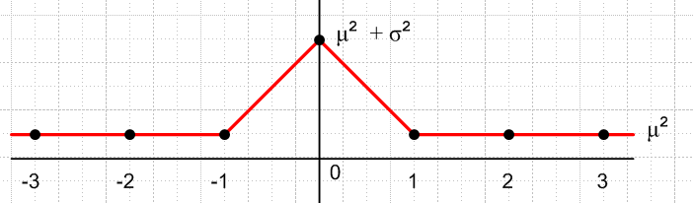 Fig 35.3

and the corresponding ensemble average power spectrum was shown in the last line of (35.16)

<P(ω)> = Ppulse(ω) [ σ2 + μ2$\sum_{m = -∞}^{∞}{}$2πδ(ωT1 - 2πm) ] . (35.16)

The spectrum has a continuous piece σ2 Ppulse(ω) proportional to the variance σ2 of the yn over the ensemble, and a discrete set of lines proportional to the square of the mean μ = <ym> of the ensemble. According to the comments above and (35.24), we can think of <P(ω)> = P(ω) of any member of the ensemble, μ = <ym> = <ym>1 as the mean for that member, and similarly σ2 = <ym2> - μ2 = σ2 = <ym2>1 - μ2 as the variance for that member of the ensemble. With this reinterpretation of μ2 and σ2 as properties of a single pulse train, we then have for any member of the ensemble,

P(ω) = Ppulse(ω) [ σ2 + μ2$\sum_{m = -∞}^{∞}{}$2πδ(ωT1 - 2πm) ] . (35.28)
Since
2πδ(ωT1 - 2πm) = (2π/T1) δ (ω - 2πm/T1) = ω1 δ(ω - mω1) = δ( $\frac{ω}{ω1}$- m) (35.29)

we can write these alternate forms for (35.28) :

P(ω) = Ppulse(ω) [σ2 + ω1 μ2 $\sum_{m = -∞}^{∞}{}$ δ(ω - mω1) ] (35.28a)
P(ω) = σ2 Ppulse(ω) + ω1 μ2 $\sum_{m = -∞}^{∞}{}$ Ppulse(mω1)δ(ω - mω1) (35.28b)
P(ω) = Ppulse(ω) [σ2 + μ2$\sum_{m = -∞}^{∞}{}$ δ( $\frac{ω}{ω1}$- m) ] (35.28c)
P(ω) = σ2 Ppulse(ω) + μ2 $\sum_{m = -∞}^{∞}{}$ Ppulse(mω1) δ( $\frac{ω}{ω1}$- m) (35.28d)

Verification of (35.28) // "trust but verify"

To find external verification for (35.28), we write the expression in terms of f where ω = 2πf,

Ppulse(ω) = $\frac{|Xpulse(ω)|2}{2πT1}$ = $\frac{|Xpulse(f)|2}{2πT1}$ // (34.4) and text after (1.4)

P(f) = 2πP(ω) // (34.4) last item

2π δ(ωT1-2πm) = 2π δ(2πfT1-2πm) = (1/T1) δ( f - m/T1) .

Then (35.28) becomes

$\frac{1}{2π}$P(f) = $\frac{|Xpulse(f)|2}{2πT1}$( σ2 + $\frac{μ2}{T1}$$\sum_{m = -∞}^{∞}{}$ δ( f - m/T1) )
or
P(f) = $\frac{|Xpulse(f)|2}{T1}$ ( σ2 + $\frac{μ2}{T1}$$\sum_{m = -∞}^{∞}{}$ δ( f - m/T1) ) . (35.28e)

This may be compared to result (A.17) in Appendix A of Xiong which we quote,

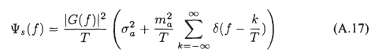 QED

Specialization for symbols in the set {A,B}

As a simple example, suppose the set of symbols that our yi can take is just {A,B}. Then the pmf distribution associated with random variable Yn (see Appendix G) is quite simple :

pYn(x) = p if x = A
pYn(x) = 1-p if x = B . (35.30)

We can then compute

μ = <ym> = [p]A + [1-p]B . (35.31)

For n ≠ m we then have

<ymyn> = <ym>2 = μ2 = { pA + (1-p)B }2

= [pp] AA + [p(1-p)] AB + [(1-p)p]BA + [(1-p)(1-p)]BB (35.32)

and for n = m,

<ym2> = [p]AA + [(1-p)] BB . (35.33)

In the square brackets [..] we indicate the probability of some case occurring, and this is multiplied by the value that the quantity in question takes in that case. Notice how the long expression for <ymyn> makes complete sense if one enumerates all possibilities. The variance may be computed as

σ2 = <yn2> - μ2 = [p]AA + [(1-p)] BB - { pA + (1-p)B }2

= [p(1-p)] (A-B)2 (35.34)

where Maple helps out,

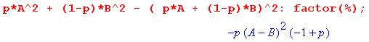 .

With the reinterpretations of μ2 and σ2 noted above (now applying to a single pulse train), we then have for our infinite statistical pulse train with independent amplitudes in the set {A,B}

P(ω) = Ppulse(ω) [σ2 + μ2 $\sum_{m = -∞}^{∞}{}$2πδ(ωT1 - 2πm)] (35.28)
= Ppulse(ω) [ p(1-p)(A-B)2 + (pA + (1-p)B)2 $\sum_{m = -∞}^{∞}{}$2πδ(ωT1 - 2πm)] . (35.35)

For the interesting case that p = 1/2 this becomes

P(ω) = Ppulse(ω) [ $\frac{1}{4}$ (A-B)2 + $\frac{1}{4}$ (A+B)2 $\sum_{m = -∞}^{∞}{}$2πδ(ωT1 - 2πm)] (35.36)

For the classic unipolar case A = 1 and B = 0, both coefficients are 1/4. For bipolar with A = 1 and B = -1 the coefficients are 1 and 0. Since the mean is then μ= 0, the discrete spectrum goes away. Since for both amplitudes |ym | = 1, we are not surprised to find σ2 = 1.

(i) Statistical Uncorrelated Pulse Trains: Summary and Example

Here then is a brief summary of the above results:

Spectral Power Density of an Uncorrelated Statistical Pulse Train (35.37)

x(t) = $\sum_{n = -∞}^{∞}{}$ yn xpulse(t - nT1) // or $\sum_{n = -N}^{N}{}$ for a finite pulse train
P(ω) = Ppulse(ω) [ σ2 + μ2 $\sum_{m = -∞}^{∞}{}$2πδ(ωT1 - 2πm)] // infinite (35.28)
P(ω) = Ppulse(ω) [ σ2 + μ2 2π δ6(ωT1,N) ] // finite (35.17)

If symbols are restricted to {A,B} then :
σ2 = p(1-p) (A-B)2 and for p = 1/2 σ2 = $\frac{1}{4}$ (A-B)2 (35.34)
μ = pA + (1-p)B and for p = 1/2 μ2 = $\frac{1}{4}$ (A+B)2 (35.31)

Example: Suppose A = 1 and B = 0 so that σ2 = p(1-p) and μ2 = p2. If we go on to assume p = 1, then every pulse has amplitude 1 and we have a simple pulse train. In this case σ2 = 0 and μ2 = 1 so
P(ω) ≡ Ppulse(ω)$\sum_{m = -∞}^{∞}{}$ 2πδ(ωT1 - 2πm) joules
which agrees with our infinite simple pulse train result (33.25). As we reduce p below p = 1, the line spectra are scaled down by μ2 = p2 < 1, and a continuous spectrum starts to appear with σ2 = p(1-p). The randomness (variance σ2) of the amplitude magnitudes creates a continuous component in the spectral power density. As p reaches p = 1/2, we get σ2 = 1/4 and μ2 = 1/4 to give this classic result
P(ω) = Ppulse(ω) [(1/4) + (1/4) $\sum_{m = -∞}^{∞}{}$2π δ(ωT1- 2πm) ] p = 1/2 (35.38)
Finally, when p reaches p = 0, then every pulse has B = 0, x(t) ≡ 0, σ2 = 0, μ2 = 0, and so P(ω) = 0. There is nothing left.

(j) A numerical example of a Statistical Pulse Train

Recall from box (34.4) that for a finite pulse train,

P(ω) = $\frac{|X(ω)|2}{2πT}$ = $\frac{|X(ω)|2}{2π(2N+1)T1}$ Ppulse(ω) = $\frac{|Xpulse(ω)|2}{2πT1}$. (35.39)

Therefore we can write the last line of (35.17) as,

$\frac{<|X(ω)|2>}{(2N+1)}$ = |Xpulse(ω)|2 [(1/4) + (1/4) 2π δ6(ωT1,N) ] . (35.40)

We shall use for xpulse(t) a square pulse of height A=1 and width τ = T1 = 1 so that, from (9.2),

| Xpulse (ω) | = sinc(ω/2) . (35.41)

Since our pulse train will be fairly short (N = 20 pulses) and since we shall only average a small number of pulse trains (M = 10), we know our result will not exactly match (35.40). Still, we hope to see in our result some kind of continuous background spectrum which approximates the curve (1/4)|Xpulse(ω)|2 = (1/4) sinc2(ω/2), and we expect to see delta-function-like peaks which, since 2πδ6(0,N) = (2N+1), have a peak value of about (1/4)41 = 10.25. Since this will be added to the continuous background, the central peak should have a height of 10.25 + .25 = 10.5. However, for our small ensemble, we won't have exactly p = 1/2, so the delta peak won't be exactly 10.5 units high.

We know that δ6 has identical peaks spaced by 2π, but we expect the non-central peaks to be suppressed by the sinc2(ω/2) zeros which occur at ω = m(2π).

Here is a self-documented Maple program which generates <|X(ω)|2>. The program also generates the quantity <X(ω)> upon which we shall comment in section (k) below.

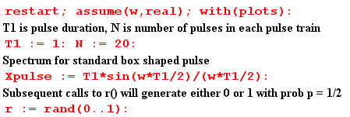
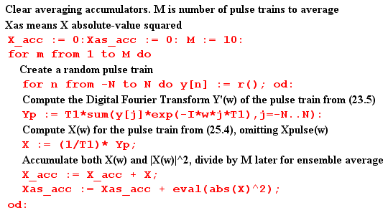
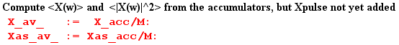

At this point, before Xpulse(ω) is added to the result, we plot <|X(ω)|2>. As expected, we see the peaks of δ6 spaced by 2π and having height around 10 units,

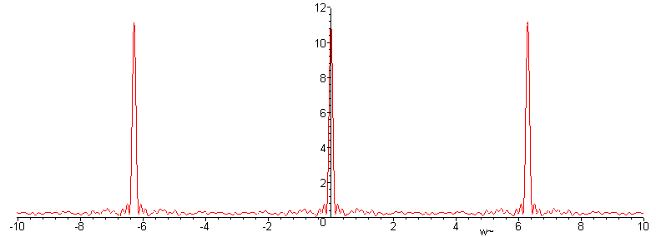
Fig 35.4
We now insert copies of Xpulse(ω) as appropriate,

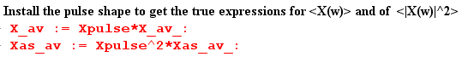

and then we can plot $\frac{<|X(ω)|2>}{(2N+1)}$ for ω in the same range (-10,10)

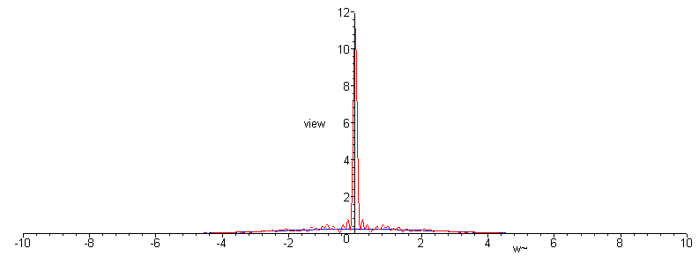
Fig 35.5

We see that the zeros of the sinc function have killed off the adjacent peaks.

Next, we restrict the plot height to be 0.8 units to view the detail, chopping off the central δ6 peak,

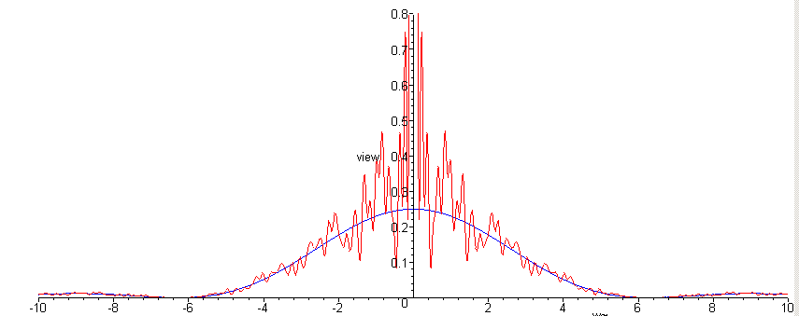
Fig 35.6

The spectrum $\frac{<|X(ω)|2>}{(2N+1)}$ is seen to have a continuous component which very well approximates one quarter of the sinc2 curve, as we hoped it would. This tracking also occurs away from the central peak. Here is a blow-up of the above plot for ω in the range (5, 30)

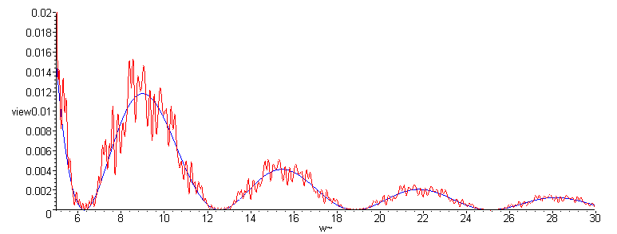
Fig 35.7

It might be noted that Maple does this work analytically, so that Xas-av is a function of ω having a large number of trigonometric terms. For the reader's interest, we show Xas-av(ω) for a typical program run :

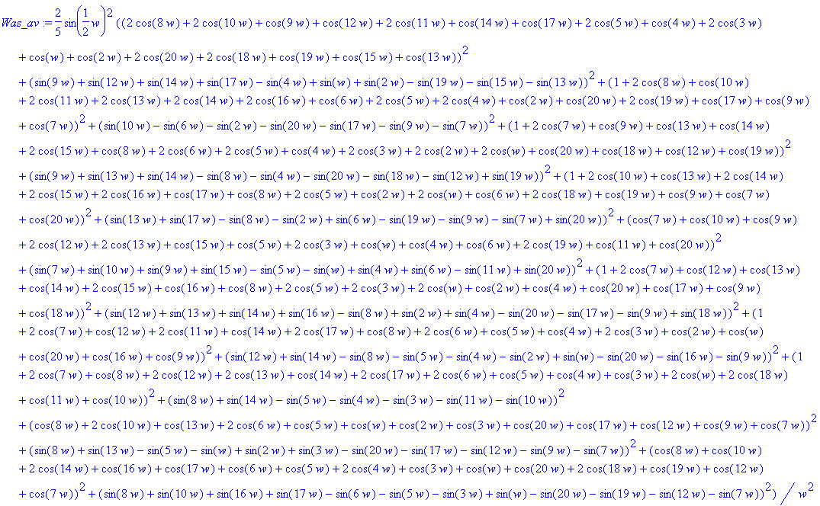

In more serious work with larger numbers, one would of course do this in a more numeric fashion, but we are able to confirm the basic results even with this small experiment.

(k) A paradox and its resolution

Now while here, we can back up and apply our statistical average directly to the spectrum in (34.6) using (34.7). The result is

<X(ω)> = Xpulse(ω) $\sum_{n = -∞}^{∞}{}$<yn> e-inωT$_{1}$ . (34.6,7) (35.42)

From (35.31) we have

<yn> = [p] A + [1-p] B = p if A=1, B=0 . (35.43)

In this case, we can extract p from the above sum, which then collapses to form the usual (13.2) delta function sum. The result is then the same as the regular pulse train result (14.4) with an overall factor of p out front, namely,

<X(ω)> = p $\sum_{m = -∞}^{∞}{}$Xpulse(mω1) 2π δ( ωT1 - 2πm) . (35.44)

This says that our average spectrum is 100% discrete, there is no continuous part! If p = 1/2, the average spectrum is just 1/2 times our discrete unit amplitude pulse train spectrum (14.4). How can this be true, if we just showed in (35.28) that the average spectral density <|X(ω)|2> has a continuous spectral component?

The answer lies in the fact that <ab> ≠ <a><b>, where < > is our averaging operation. Thus

<|X(ω)|2> ≠ <X(ω)><X(ω)*> . (35.45)

In particular we have from the second last line of (35.9) and (35.42),

$\sum_{m = -N}^{N}{}$ $\sum_{n = -N}^{N}{}$ <ym yn> zm-n ≠ ($\sum_{n = -N}^{N}{}$<yn> z-n ) ($\sum_{m = -N}^{N}{}$<ym> zm ) . (35.46)

These double sums would be equal if <ym yn> = <yn><ym> for all m and n, but this is not true when n = m. The left sum in that case sees <ym2> = σ2+μ2 while the right side sees <ym>2 = μ2.

In general we do not expect the average of a product to be the product of the averages,

( $\frac{1}{N}$Σi=1N AiBi) ≠ ( $\frac{1}{N}$Σi=1N Ai) ( $\frac{1}{N}$Σi=1N Bi) .

In the numerical example presented in the previous section we computed <X(ω)> for a small ensemble of pulse trains. Here are plots of the real and imaginary part of <X(ω)>,

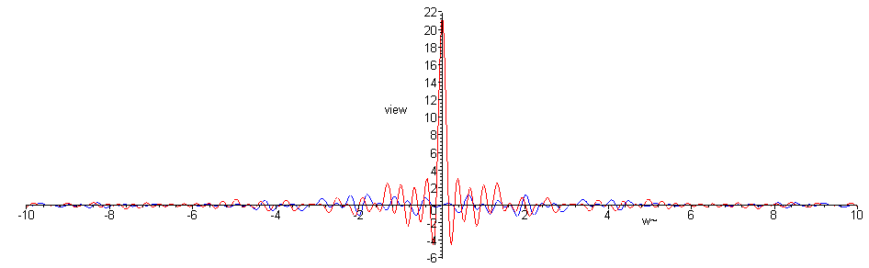
Fig 35.8

We can see that, apart from the noise of our low statistics, there is only the central peak and no continuous spectrum component. A blow-up of the central region follows,

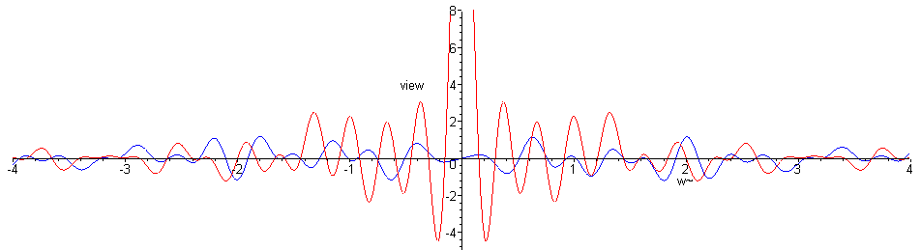
Fig 35.9

(l) What role has the Autocorrelation Function played in our development?

In Section 32 the autocorrelation function was first introduced as rx(t) for x(t), and was computed for the simple case of a box pulse. Treating the definition of rx(t) as a convolution equation, the Wiener-Khintchine relation Rx(ω) = |X(ω)|2 was trivially derived, where Rx(ω) is the Fourier Integral Transform of rx(t). It was then shown that the spectral energy density of a pulse train is E(ω) = (1/2π) Rx(ω) due to this relation. It was then shown that rx(0) = E, the total energy in the pulse train. We then commented on the origin of the name, showing that the auto-correlation function is the cross-correlation function of a function with itself. Finally, we developed the Z Transform version of the Wiener-Khintchine Relation R"(z) = (T1/T) | Y"(z) |2 where R"(z) is the Z Transform of the autocorrelation sequence rs.

Section 33 (simple pulse trains) made no mention of autocorrelation.

In Section 34 (general pulse trains) it was noted again that P = rx(0)/T since P = E/T, and that P(ω) = Rx(ω)/ (2πT) since Rx(ω) = |X(ω)|2. At the end of section (b) both E(ω) and P(ω) are stated in terms of R"(z) . In particular, (34.14a) says P(ω) = Ppulse(ω) R"(z) where R"(z) = Σs rsz-s, and this expression for P(ω) appears throughout the current Section 35.

Comments:

(1) In the Two Pathways discussion above, we showed that the autocorrelation pathway is only one of two approaches one might take to obtain P(ω). Thus, it is always possible to compute P(ω) without ever using or even knowing about the autocorrelation sequence rs. For example, in (35.17) the autocorrelation approach leads to a nearly intractable sum evaluation (Appendix D), whereas the double-sum approach leads to an easier discovery of P(ω), as shown directly in (35.19).

(2) In some textbooks, one gets the impression that the autocorrelation function is somehow indispensable for the development of the P(ω) equations. It is not, but it is convenient for many applications. We will use the autocorrelation approach several times in the remaining Sections.

