36. Application to some Standard Non-Correlated Pulse Train Types (Line Codes) 1
(a) Unipolar NRZ line code 1
(b) Bipolar NRZ line code 4
(c) Unipolar RZ line code 6
(d) Bipolar RZ line code 9
(e) Manchester line code 11
(f) Noise, ISI and Eye Patterns 13

36. Application to some Standard Non-Correlated Pulse Train Types (Line Codes)

Here we apply our boxed results (35.37) to statistical pulse trains of various types. When a pulse train is in fact a voltage on a pair of wires (transmission line, such as a telephone "line"), the way in which signals are encoded in the pulse train is called a line code. One could consider a random speed Morse code signal going down a wire as a line code, but the term usually refers to a sequence of equally spaced amplitude modulated pulses, meaning a pulse train. Often line codes get modulated onto an RF carrier, in which case the line code is thought of as the baseband signal prior to modulation. For this reason, line codes are often discussed in the "baseband chapter" of any digital communications text.
The line code names are a little strange due to their history. Here are the pulse shapes used for RZ and NRZ lines codes. In either case a 1 is (is coded as) a pulse and a 0 is no pulse.

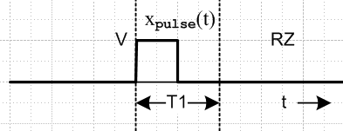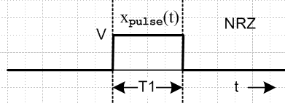
Fig 36.1

On the left, since the signal returns to zero inside the pulse period, it is called a "return to zero" code RZ.
Since this does not happen on the right, that is a "non return to zero" code, NRZ.

(a) Unipolar NRZ line code

Pulse Shape. The pulse is a box of amplitude V and width τ = T1,

Fig 36.2

From (9.2) we know that

Xpulse(ω) = (VT1) sinc(ωT1/2) = (VT1) sinc(π $\frac{ω}{ω1}$) ω1 = 2π/T1

Ppulse(ω) = $\frac{|Xpulse(ω)|2}{2πT1}$ = (VT1)2 sinc2(π $\frac{ω}{ω1}$)/(2πT1) = (V2/ω1) sinc2(π $\frac{ω}{ω1}$) (36.1)

Coding: NRZ is a normal binary signal, high for period T1 to indicate a 1, and low for T1 to indicate a 0. Sometimes this is called unipolar NRZ since the signal never goes negative.

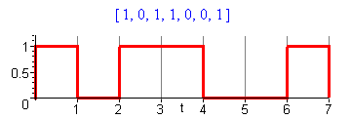 Fig 36.3

Coefficients σ2 and μ2 : From summary box (35.37),

A = 1 and B = 0 => σ2 = p(1-p) μ2 = p2 μ = p

Spectrum: The average spectral power density for the NRZ line code is :

P(ω) = σ2 Ppulse(ω) + μ2 $\sum_{m = -∞}^{∞}{}$ Ppulse(mω1) δ( $\frac{ω}{ω1}$- m) (35.28d)
P(ω) = (V2/ω1) [ p(1-p) sinc2(π $\frac{ω}{ω1}$) + p2 $\sum_{m = -∞}^{∞}{}$ sinc2(π $\frac{ω}{ω1}$) δ( $\frac{ω}{ω1}$- m)
P(ω) = (V2/ω1) [ p(1-p) sinc2(π $\frac{ω}{ω1}$) + p2 δ( $\frac{ω}{ω1}$) ] // any p (36.2)
P(ω) = (V2/ω1) [ $\frac{1}{4}$ sinc2(π $\frac{ω}{ω1}$) + $\frac{1}{4}$ δ( $\frac{ω}{ω1}$) ] // for p = 1/2 (36.3)

The sinc function killed off all but the m = 0 line ( the "DC line").

In order to express this (and later) results in the frequency domain, we use these relations

P(ω) = P(f)/2π // (34.4) bottom line
1/ω1 = T1/2π
$\frac{ω}{ω1}$ = $\frac{f}{f1}$ ≡ x for plots // f1 = 1/T1 (36.4)

to obtain

P(f) = V2T1 [ p(1-p) sinc2(π $\frac{f}{f1}$) + p2 δ( $\frac{f}{f1}$) ] // any p (36.2)'
P(f) = V2T1 [ $\frac{1}{4}$ sinc2(π $\frac{f}{f1}$) + $\frac{1}{4}$ δ( $\frac{f}{f1}$) ] // for p = 1/2 (36.3)'

This last line can be written

P(f) = V2 [ $\frac{1}{4}$ T1 sinc2(πfT1) + $\frac{1}{4}$ δ(f) ] // for p = 1/2 (36.3)"

which then agrees with Xiong (2.25).

Plot: Ignoring the overall factor (V2/ω1) we make this plot of P(ω) given by (36.2):
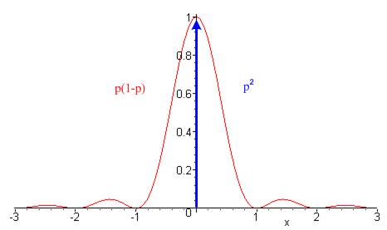 Fig 36.4

The red curve should be scaled by the red factor shown on the left, and the blue delta line should be scaled by the blue factor on the right.

Power Partition: The total power in the continuous part of the spectrum is: ( dω = ω1dx )

AC power = $^{\int_{-∞}^{∞}{}}$ ω1dx P(xω1> = p(1-p) V2 $^{\int_{-∞}^{∞}{}}$ dx sinc2(πx) = p(1-p) V2 .

The total power in the DC line at ω = 0 is

DC power = $^{\int_{-∞}^{∞}{}}$ ω1dx P(xω1) = V2$^{\int_{-∞}^{∞}{}}$ dx p2 δ(x) = p2V2

Thus we find that

total power = p2 V2 + p(1-p) V2 = pV2
DC AC
If p = 1/2, then

total power = (1/4) V2 + (1/4) V2 = (1/2)V2 (36.5)
DC AC

so half the power is in the DC line and half in the AC signal. The DC term is certainly reasonable since we know that with p = 1/2, the average voltage is (V/2).
If one wanted to reduce wasted power, it would be good to give this signal a DC offset of -V/2 and then there would be no DC line. This is in fact the next example if one takes V → V/2.

(b) Bipolar NRZ line code

Pulse Shape. The pulse shape is the same as for Unipolar NRZ

Fig 36.2

Ppulse(ω) = (V2/ω1) sinc2(π $\frac{ω}{ω1}$) same as for unipolar NRZ (36.1)

Coding: 1 is coded as a positive box with amplitude V, and a 0 as a negative box having amplitude -V.

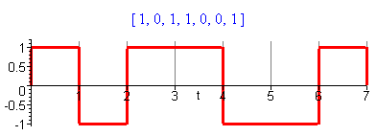 Fig 36.5

Coefficients σ2 and μ2 : From summary box (35.37),

A = 1 and B = -1 => σ2 = 4p(1-p) μ2 = (1-2p)2 μ = 2p-1

Spectrum: The average spectral power density for the bipolar NRZ line code is :

P(ω) = σ2 Ppulse(ω) + μ2 $\sum_{m = -∞}^{∞}{}$ Ppulse(mω1) δ( $\frac{ω}{ω1}$- m) (35.28d)
P(ω) = (V2/ω1) [4p(1-p) sinc2(π $\frac{ω}{ω1}$) + (1-2p)2$\sum_{m = -∞}^{∞}{}$ sinc2(π $\frac{ω}{ω1}$) δ( $\frac{ω}{ω1}$- m)
P(ω) = (V2/ω1) [4p(1-p) sinc2(π $\frac{ω}{ω1}$) + (1-2p)2 δ( $\frac{ω}{ω1}$) ] // any p (36.6)
P(ω) = (V2/ω1) [ sinc2(π $\frac{ω}{ω1}$) ] { = Ppulse(ω) } // for p = 1/2 (36.7)

which become, using (36.4),

P(f) = (V2T1) [4p(1-p) sinc2(π $\frac{f}{f1}$) + (1-2p)2 δ( $\frac{f}{f1}$) ] // any p (36.6)'
P(f) = (V2T1) [ sinc2(π $\frac{f}{f1}$) ] { = Ppulse(f) } // for p = 1/2 (36.7)'

This last result agrees with Xiong (2.20). The spectrum is all continuous when p = 1/2 since then the DC portion is killed off. A discrete spectrum cannot exist if the waveform amplitudes have zero mean, μ = 0.
Notice that for p = 1/2, bipolar NRZ has P(ω) = Ppulse(ω), so the statistical pulse train spectrum is the same as that of the underlying pulse.

Plot: Ignoring the overall factor (V2/ω1) we make this plot of <P(xω1)> given by (36.6)

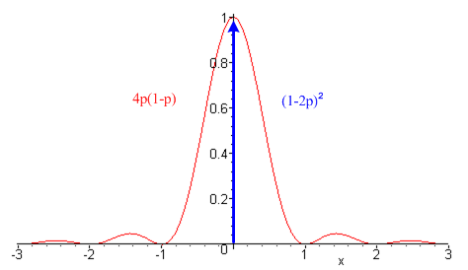 Fig 36.6

which is the same as the spectrum for unipolar NRZ except for the two scaling factors.

Power Partition: We can again compute the DC and AC power.

AC power = unipolar NRZ with p(1-p) → 4p(1-p), so AC = 4p(1-p) V2

DC power = unipolar NRZ with p2 → (2p-1)2, so DC = (2p-1)2 V2

total power = (2p-1)2V2 + 4p(1-p)V2 = V2 , independent of p. (36.8)
DC AC

The total power is independent of p because a pulse has the same AC power if it goes up or down. For p = 1/2 we get

total power = 0 + V2 = V2 // p = 1/2
DC AC

and now no power is wasted pushing DC through a line. If we take V→V/2 to have a comparable peak-to-peak amplitude, we find

AC power = (V/2)2

which is the same as the AC power in (36.5); it is not affected by a DC offset of -V/2.

(c) Unipolar RZ line code

Pulse Shape. Here the basic pulse is a box that fills only half the time interval T1.

Fig 36.7

According to (12.1) applied to the above pulse.

x(t) ↔ X(ω)
x(t - T1/2) ↔ X(ω) e-iωT$_{1}$/2 . (12.1)

where X(ω) is for a pulse of total width T1/2 centered at t = 0. The spectrum of this centered pulse is given by (9.2) with τ = T1/2 as X(ω) = (VT1/2) sinc(ωT1/4). Thus, the above pulse has this spectrum

Xpulse(ω) = e-iωT$_{1}$/2 (VT1/2) sinc(ωT1/4) = e-iωT$_{1}$/2 (VT1/2) sinc( $\frac{π}{2}$ $\frac{ω}{ω1}$)

and then

Ppulse(ω) = $\frac{|Xpulse(ω)|2}{2πT1}$ = $\frac{(VT1/2)2}{2πT1}$ sinc2( $\frac{π}{2}$ $\frac{ω}{ω1}$) = (V2/4ω1) sinc2( $\frac{π}{2}$ $\frac{ω}{ω1}$) . (36.9)

Coding: 1 is coded as the presence of the pulse, 0 is coded as the absence of a pulse.

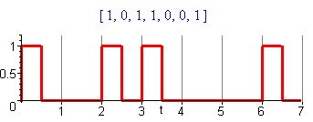 Fig 36.8

Coefficients σ2 and μ2 : From summary box (35.37), coefficients are the same as for NRZ,

A = 1 and B = 0 => σ2 = p(1-p) μ2 = p2 μ = p

Spectrum: The average spectral power density for the unipolar RZ line code is :

P(ω) = σ2 Ppulse(ω) + μ2 $\sum_{m = -∞}^{∞}{}$ Ppulse(mω1) δ( $\frac{ω}{ω1}$- m) (35.28d)
P(ω) = (V2/4ω1) [ p(1-p) sinc2( $\frac{π}{2}$ $\frac{ω}{ω1}$) + p2$\sum_{m = -∞}^{∞}{}$ sinc2( $\frac{π}{2}$ $\frac{ω}{ω1}$) δ( $\frac{ω}{ω1}$- m)
P(ω) = (V2/4ω1) [ p(1-p) sinc2( $\frac{π}{2}$ $\frac{ω}{ω1}$) + p2$\sum_{m = odd}^{}{}$ sinc2( $\frac{π}{2}$m) δ( $\frac{ω}{ω1}$- m) + p2 δ( $\frac{ω}{ω1}$) ] (36.10)
P(ω) = (V2/4ω1) [ $\frac{1}{4}$ sinc2( $\frac{π}{2}$ $\frac{ω}{ω1}$) + $\frac{1}{4}$$\sum_{m = odd}^{}{}$ sinc2( $\frac{π}{2}$m) δ( $\frac{ω}{ω1}$- m) + $\frac{1}{4}$ δ( $\frac{ω}{ω1}$) ] (36.11)

where the last line is for p = 1/2. Then using (36.4) we write the f domain versions,

P(f) = (V2T1/4) [ p(1-p) sinc2( $\frac{π}{2}$ $\frac{f}{f1}$) + p2$\sum_{m = odd}^{}{}$ sinc2( $\frac{π}{2}$m) δ( $\frac{f}{f1}$- m) + p2 δ( $\frac{f}{f1}$) ] (36.10)'
P(f) = (V2T1/4) [ $\frac{1}{4}$ sinc2( $\frac{π}{2}$ $\frac{f}{f1}$) + $\frac{1}{4}$$\sum_{m = odd}^{}{}$ sinc2( $\frac{π}{2}$m) δ( $\frac{f}{f1}$- m) + $\frac{1}{4}$ δ( $\frac{f}{f1}$) ] (36.11)'
In all these expressions one can replace sinc2( $\frac{π}{2}$m) by its odd-integer value $\frac{4}{π2}$$\frac{1}{m2}$ since
sinc2( $\frac{π}{2}$ m) = $\frac{4}{π2}$$\frac{1}{m2}$

Result (36.11)' agrees with Xiong (2.31) in which Rb ≡ 1/T = our 1/T1, but he has not separated out the three terms m = 0, m = even ≠ 0 and m = odd.

Plot: Ignoring now the overall factor (V2/4ω1) we get this power spectrum P(ω) from (36.10),

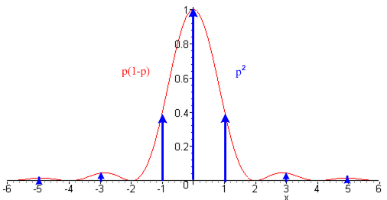 Fig 36.9

We now have three pieces: a continuous part, the DC line, and a set of lines at odd m. The main peak is twice as wide as the NRZ peak since the underlying pulse is half as wide.

Power Partition: Once again, we can compute the total power for each of these three pieces.

odd lines power = $^{\int_{-∞}^{∞}{}}$ ω1dx P(xω1) = ω1 (V/2)2 (1/ω1) p2$^{\int_{-∞}^{∞}{}}$ dx sinc2( $\frac{π}{2}$x) 2$\sum_{m = 1 3 5...}^{∞}{}$ δ(x - m)
= (V/2)2 2p2 $\sum_{m = 1 3 5...}^{∞}{}$sinc2( $\frac{π}{2}$m) = (V/2)2 2p2$\sum_{m = 1 3 5...}^{∞}{}$ $\frac{π}{2}$$\frac{π}{2}$ = (V/2)2 2p2 (2/π)2 $\sum_{m = 1 3 5...}^{∞}{}$ $\frac{1}{m2}$
= (V/2)2 2p2 (2/π)2 (π2/8) = p2(V/2)2

where the sum Σodd(1/m2) = π2/8 is from Gradshteyn and Ryzhik 0.234.2. Then

DC power = $^{\int_{-∞}^{∞}{}}$ ω1dx P(xω1) = (V/2)2p2 $^{\int_{-∞}^{∞}{}}$ dx sinc2( $\frac{π}{2}$x) δ(x) = p2 (V/2)2

which is the same as the odd lines power. Finally,

continuum power = $^{\int_{-∞}^{∞}{}}$ ω1dx P(xω1) = (V/2)2 p(1-p) $^{\int_{-∞}^{∞}{}}$ dx sinc2( $\frac{π}{2}$x) = 2p(1-p) (V/2)2

So the power partitioning is

total power = p2(V/2)2 + p2 (V/2)2 + 2p(1-p) (V/2)2
DC other lines continuum
= p2(V/2)2 + p(2-p) (V/2)2 = 2p(V/2)2 = (p/2)V2 . (36.12)
DC AC

This is half of the total power of unipolar NRZ (36.4), which seems reasonable since the pulses here have half the duration.

(d) Bipolar RZ line code

Pulse Shape. The pulse shape is the same as for Unipolar RZ

Fig 36.7

Ppulse(ω) = (V2/4ω1) sinc2( $\frac{π}{2}$ $\frac{ω}{ω1}$) . (36.9)

Coding: 1 is coded as a positive pulse with amplitude V, and a 0 as a negative pulse having amplitude -V.

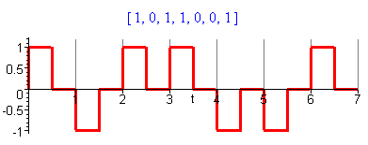 Fig 36.10

Coefficients σ2 and μ2 : From summary box (35.37), and the same as for bipolar NRZ

A = 1 and B = -1 => σ2 = 4p(1-p) μ2 = (1-2p)2 μ = 2p-1

Spectrum: The average spectral power density for the bipolar RZ line code is :

P(ω) = σ2 Ppulse(ω) + μ2 $\sum_{m = -∞}^{∞}{}$ Ppulse(mω1) δ( $\frac{ω}{ω1}$- m) (35.28d)
P(ω) = (V2/4ω1) [4p(1-p) sinc2( $\frac{π}{2}$ $\frac{ω}{ω1}$) + (1-2p)2$\sum_{m = -∞}^{∞}{}$ sinc2( $\frac{π}{2}$ $\frac{ω}{ω1}$) δ( $\frac{ω}{ω1}$- m)
P(ω) = (V2/4ω1) [4p(1-p) sinc2( $\frac{π}{2}$ $\frac{ω}{ω1}$) + (1-2p)2$\sum_{m = odd}^{}{}$ sinc2( $\frac{π}{2}$ m )δ( $\frac{ω}{ω1}$- m) + (1-2p)2 δ( $\frac{ω}{ω1}$)] (36.13)
P(ω) = (V2/4ω1) sinc2( $\frac{π}{2}$ $\frac{ω}{ω1}$) { = Ppulse(ω) } // p = 1/2 (36.14)

which become, using (36.4),

P(f) = (V2T1/4) [4p(1-p) sinc2( $\frac{π}{2}$ $\frac{f}{f1}$) + (1-2p)2$\sum_{m = odd}^{}{}$ sinc2( $\frac{π}{2}$ m )δ( $\frac{f}{f1}$- m) + (1-2p)2 δ( $\frac{f}{f1}$) ] (36.13)'
P(f) = (V2T1/4) sinc2( $\frac{π}{2}$ $\frac{f}{f1}$) { = Ppulse(f) } // p = 1/2 (36.14)'

This last result agrees with Xiong (2.30). As noted earlier, sinc2( $\frac{π}{2}$m) = $\frac{4}{π2}$$\frac{1}{m2}$ for odd m.

Plot: Ignoring now the overall factor (V2/4ω1) we get this power spectrum from (36.13),

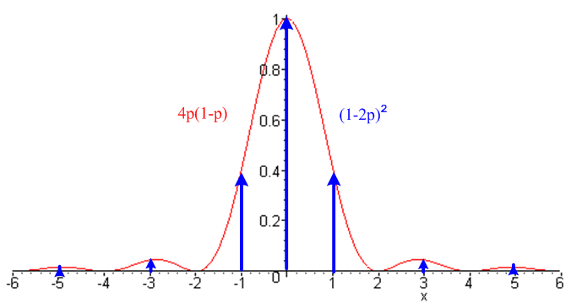 Fig 36.11

Power Partition: Once again, we can compute the total power for each of three pieces. These are the same as for the unipolar RZ if we make the replacements p(1-p) → 4p(1-p) and p2→ (1-2p)2, so

odd lines power = (1-2p)2 (V/2)2

DC power = (1-2p)2 (V/2)2

continuum power = 8p(1-p) (V/2)2

So the power partitioning is

total power = (1-2p)2 (V/2)2 + (1-2p)2 (V/2)2 + 8p(1-p) (V/2)2
DC odd lines continuum

= (1-2p)2 (V/2)2 + [1-4p(p-1)] (V/2)2 = 2 (V/2)2 = V2/2 (36.15)
DC AC

As expected, this is half the total power of bipolar NRZ since the pulses have half the duration. For p = 1/2 all the power is in the continuum.

(e) Manchester line code

This line code was developed at the University of Manchester probably in the World War II era. At that time Tom Kilburn, Alan Turing and others were building the world's first stored-program computer.

Pulse Shape: The pulse shape here is the biphase (biphasic, diphase) pulse,

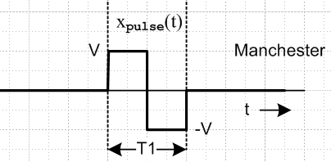 Fig 36.12

We already computed Xpulse(ω) for this pulse in (19.2), so we now set τ = T1/2 and A/2 = V to get

Xpulse(ω) = (4iV/ω) sin2(ωT1/4) = (4iV/ω) sin(ωT1/4) [sin(ωT1/4) / (ωT1/4 )] (ωT1/4 )

= (iVT1) sin(ωT1/4) sinc(ωT1/4)

Ppulse(ω) = $\frac{|Xpulse(ω)|2}{2πT1}$ = (V2/ω1) sin2( $\frac{π}{2}$ $\frac{ω}{ω1}$) sinc2( $\frac{π}{2}$ $\frac{ω}{ω1}$) . (36.16)

This spectral pulse density is 4 sin2( $\frac{π}{2}$ $\frac{ω}{ω1}$)times that of the RZ pulse shown in (36.9). This extra factor kills off the spectrum at ω = 0.

Coding: 1 is coded as the above pulse, 0 is coded as the negative of the pulse (but some sources use the opposite polarity),

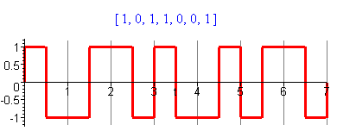 Fig 36.13

Coefficients σ2 and μ2 : From summary box (35.37), and the same as for bipolar NRZ

A = 1 and B = -1 => σ2 = 4p(1-p) μ2 = (1-2p)2 μ = 2p-1

Comment: Notice that the mean value of the waveform in Fig 36.13 is 0 regardless of p, whereas the mean value μ of the amplitudes yn is given by μ = 2p-1.

Spectrum: The average spectral power density for the Manchester code is :

P(ω) = σ2 Ppulse(ω) + μ2 $\sum_{m = -∞}^{∞}{}$ Ppulse(mω1) δ( $\frac{ω}{ω1}$- m) (35.28d)
P(ω) = (V2/ω1) [4p(1-p) sin2( $\frac{π}{2}$ $\frac{ω}{ω1}$) sinc2( $\frac{π}{2}$ $\frac{ω}{ω1}$) + (1-2p)2$\sum_{m = -∞}^{∞}{}$ sin2( $\frac{π}{2}$ $\frac{ω}{ω1}$) sinc2( $\frac{π}{2}$ $\frac{ω}{ω1}$) δ( $\frac{ω}{ω1}$- m)]
P(ω) = (V2/ω1) [4p(1-p) sin2( $\frac{π}{2}$ $\frac{ω}{ω1}$) sinc2( $\frac{π}{2}$ $\frac{ω}{ω1}$) + (1-2p)2$\sum_{m = odd}^{}{}$ sinc2( $\frac{π}{2}$ m )δ( $\frac{ω}{ω1}$- m) ] (36.17)
P(ω) = (V2/ω1) sinc2( $\frac{π}{2}$ $\frac{ω}{ω1}$) { = Ppulse(ω) } // p = 1/2 (36.18)

which become, using (36.4),

P(f) = (V2T1) [4p(1-p) sin2( $\frac{π}{2}$ $\frac{f}{f1}$) sinc2( $\frac{π}{2}$ $\frac{f}{f1}$) + (1-2p)2$\sum_{m = odd}^{}{}$ sinc2( $\frac{π}{2}$ m ) δ($\frac{f}{f1}$- m) ] (36.17)'
P(f) = (V2T1) sin2( $\frac{π}{2}$ $\frac{f}{f1}$) sinc2( $\frac{π}{2}$ $\frac{f}{f1}$)] // p = 1/2 (36.18)'

As noted earlier, sinc2( $\frac{π}{2}$m) = $\frac{4}{π2}$$\frac{1}{m2}$ for odd m. The last result agrees with Xiong (2.38). He refers to this Manchester code as Bi-Φ-L.

Plot: Ignoring the leading factor (V2/ω1) the spectrum for (36.17) has this plot,
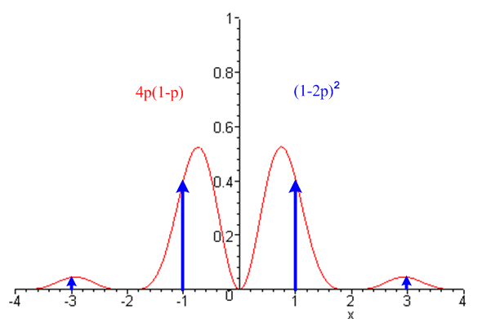 Fig 36.14
Power Partition:
lines power = $^{\int_{-∞}^{∞}{}}$ ω1dx<P(xω1)> = V2 (2p-1)2$^{\int_{-∞}^{∞}{}}$ dx sin2( $\frac{π}{2}$x) sinc2( $\frac{π}{2}$x)$\sum_{m = ±odd}^{}{}$ δ(x - m)
= V2 (2p-1)2$\sum_{m = ±odd}^{}{}$ sin2( $\frac{π}{2}$m) sinc2( $\frac{π}{2}$m) = V2 (2p-1)2$\sum_{m = ±odd}^{}{}$ sin4( $\frac{π}{2}$m) ( $\frac{π}{2}$m)-2
= V2 (2p-1)2(2/π)2$\sum_{m = ±odd}^{}{}$ 1 /m2 = V2 (2p-1)2(2/π)2 2$\sum_{m = 1 3 5...}^{∞}{}$ 1 /m2

= V2 (2p-1)2(2/π)2 2 (π2/8) = (2p-1)2 V2

continuum power = $^{\int_{-∞}^{∞}{}}$ ω1dx<P(xω1)> = V2 4p(1-p) $^{\int_{-∞}^{∞}{}}$ dx sin2( $\frac{π}{2}$x) sinc2( $\frac{π}{2}$x) = V2 4p(1-p)

since the integral is just 1. Therefore,

total power = 0 + (2p-1)2 V2 + 4p(1-p) V2 = V2 (36.19)
DC lines continuum AC

In the case p = 1/2, the lines power vanishes leaving only continuum power = V2.

Since the power is kept away from DC, Manchester coding is useful for AC-coupled transmission lines, such as lines incorporating transformers. The down side compared to NRZ is that the first spectral hump goes out to ω = 2ω1, which reflects the fact that the minimum pulse width is T1/2 whereas in NRZ it is T1. So a transmission line must then have twice the bandwidth for Manchester relative to NRZ.

(f) Noise, ISI and Eye Patterns

In general, if some spectral components are filtered away in a transmission line (or in some general signal pathway), the corresponding pulse (by inverse Fourier Transform) has curved corners, meaning the pulse gets rounded and spread out. This effect along with noise can result in inter-symbol interference (ISI). The superposition of such pulses on an oscilloscope (triggered on a recovered T1 clock) for a random pulse train is called an eye pattern. This pattern must have a central clear area to allow the two (or more for some line codes) pulse levels to be distinguished by a receiving circuit. Here is a marginal eye pattern for NRZ on the left, and a better one for AMI on the right (see Section 37).

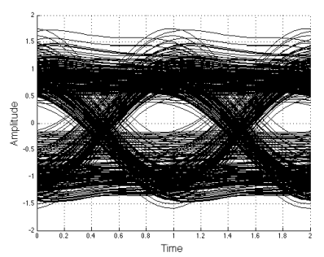 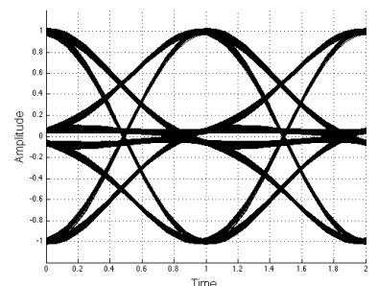 Fig 36.15

