35. Statistical Pulse Trains

What is a Statistical Pulse Train?

Suppose we intercept a 1 GHz digital signal (zeros and ones) for 1 μsec and thus grab a sequence of N = 1,000 amplitude symbols ym (perhaps using a logic analyzer or digital scope). We could compute the average value for this sequence and we might find <ym>1 = 0.55. Here <...>1 refers to a "horizontal" average over a single pulse train amplitude sequence. By its definition, this average cannot depend on the index m, we are just doing an average of the ym values in the sequence,

<ym>1 = (1/N) Σm=1N ym .

Now it might be that during this 1 μsec, there was something unusual about the data being sent, so that this measurement of <ym>1 = 0.55 is not really representative over a longer term. One alternative would be to capture a much longer sequence. Rather than do this, our approach will be to grab very many 1 μsec pulse trains and form an ensemble of these representative pulse trains. Perhaps we do this for a week, so the ensemble then has a huge number of pulse trains. We then write down these amplitude sequences in a vertical list on a very tall piece of paper, one sequence below the next. We then number the positions in the sequences 1 to N and we then define <ym> as the vertical average through this ensemble of the sequences in position m. This vertical average is written

<ym> = (1/I) Σi=1I ym(i)

and in theory this could be different for different columns m. For example, consider this ensemble of seqeunces which has N = 6 and I = 3:

1 2 3 4 5 6
a b c d e f sequence #1
a' b' c' d' e' f' sequence #2
a" b" c" d" d" f" sequence #3

We would have

<ym>1 = (a+b+c+d+e+f)/6. // for the first sequence
<y3> = (c + c' + c")/3 // for column 3

Our pulse train sequence has a random variable Ym associated with each horizontal pulse train position, m = 1,2...N, and the "vertical" average <ym> is the expected value of Ym over the ensemble, normally written <ym> = E(Ym). The experiment associated with Ym is the generation of a pulse train by some Apparatus, the experiment is run many times, and the outcomes for random variable Ym are the values of the symbols located in position m of these pulse trains. See Appendix G for the meaning of "random variable".
The ensemble is characterized by various statistical properties, such as E(Ym) or E(YnYmYk), each being a vertical average down through the ensemble. Our statistical pulse train is an idealized pulse train whose amplitudes form a statistical sequence whose statistics ( like E(Ym) and E(YnYmYk) ) exactly match those of the ensemble. It is not any particular member of the ensemble, since any member might deviate somehow. And it is certainly not the average of the pulse trains in the ensemble, since this average pulse train would have amplitudes ym = <ym> which has nothing to do with anything ( and also would have illegal symbols, eg, ym = 1/2). If N were very large, a pulse train of the ensemble might come close to being a statistical pulse train.
More normal parlance would refer to our statistical pulse train as a random pulse train whose sequence of amplitudes is a random sequence. The problem with this terminology is that the word "random" suggests for example that <ym> = the mean value of Ym in the ensemble = 1/2. That is to say, the word random suggests a flat distribution where p(1) = 1/2 and p(0) = 1/2. But if p(1) = 1/3 and p(0) = 2/3, our ensemble would still be associated with a statistical pulse train, Any value of p ≡ p(1) would describe a statistical pulse train, along with the other statistical properties. This same subtle implication of the word random appears in Appendix G on "random variables" and basic probability theory.
In what follows, we shall only be concerned with the first and second order statistics of the statistical pulse train, which are <ym> = E(Ym) and <ymyn> = E(YmYn).

(a) Spectral power density for a Statistical Pulse Train

With the above introduction, we imagine now a large ensemble of I pulse trains in which a particular pulse train is labeled by index i. This pulse train has coefficients yn(i) . We are interested in the ensemble averages of E(ω) and P(ω) and P. We indicate the ensemble average of some quantity Q by <Q>. By averaging equations (34.13) through (34.15) we obtain

<E(ω)> = T1 Ppulse(ω) $\sum_{n = -∞}^{∞}{}$ $\sum_{m = -∞}^{∞}{}$ <ym* yn> eiω(m-n)T$_{1}$ (35.1)
<P(ω)> = T1 Ppulse(ω) (1/T) $\sum_{n = -∞}^{∞}{}$ $\sum_{m = -∞}^{∞}{}$ <ym* yn> eiω(m-n)T$_{1}$ (35.2)

<P> = $^{\int_{-∞}^{∞}{}}$dω <P(ω)> (35.3)

where

<ym* yn> = (1/I) $\sum_{i = 1}^{I}{}$ ym(i)* yn(i) . (35.4)

Up to this point we have been general, allowing the ym(i) to be complex coefficients, but from now on we consider them to be real, so we can delete the asterisks in the above equations.

In general one can consider statistical pulse trains whose amplitudes are randomly ("statistically!") selected in some manner from a discrete set of possible amplitudes {A,B,C....}, or perhaps even from a continuous set. Here we limit our interest to the discrete set {A,B}, but the methods outlined below can be generalized for signals having more than two encoded amplitudes.

A very simple case to consider is this, where A and B are real,

ym = A probability p p(A)
ym = B probability 1-p p(B) . (35.5)

Remember that index m labels pulse location m in the pulse train. If probabilities of a pulse value at locations m and at n are independent (so they are uncorrelated), then we can write the averaged coefficients as follows, first for two different locations m ≠ n, then for the same location m = n :

n ≠ m α ≡ <ymyn> = [pp] AA + [p(1-p)] AB + [(1-p)p]BA + [(1-p)(1-p)]BB

n = m β ≡ <ym2> = [p]AA + [(1-p)] BB . (35.6)

In the square brackets [..] we indicate the probability of some case occurring, and this is multiplied by the value that the quantity in question takes in that case. The reader must now stop reading and stare at the above equations until they make complete sense. Notice that the second line is quite distinct from the first line. In the double summation in (35.2), there are both diagonal terms where m = n, and off-diagonal terms where m≠n. These groupings must be treated separately according to (35.6). We have defined new symbols α and β to emphasize that, for the situations shown, there is no dependence on the n and m indices for these quantities. In a later sections, we shall encounter situations where the above equations do not apply because there is correlation between positions m and n.

Comment: The non-dependence of <ym> and <ym2> on m can be justified loosely by saying that nothing distinguishes one pulse train position from another. This issue is addressed in Appendix G (g), see for example (G.46), (G.47) and (G.50). We find for example that <ym> is position-independent for a suitable ensemble regardless of the nature of the correlation between the random variables for the pulse train.

Inserting (35.6) into (35.2) gives a fundamental result [ with T as in (34.4) ]

<P(ω)> = T1 Ppulse(ω) (1/T) { α$\sum_{n = -∞}^{∞}{}$ $\sum_{m ≠ n}^{}{}$ [ eiω(m-n)T$_{1}$] + β$\sum_{n = -∞}^{∞}{}$ $\sum_{m = n}^{}{}$ [1] } . (35.7)

Appendix D shows how α and β may be written in terms of the mean μ and variance σ2 of the values of the amplitudes ym(i) for the pulses at position m in the pulse train ensemble. There we show that

<ym> = μ = [p]A + [1-p]B

n ≠ m α ≡ <ymyn> = <ym>2 = μ2 = { [p]A + [1-p]B }2 = [pp] AA + [p(1-p)] 2AB + [(1-p)(1-)]BB

n = m β ≡ <ym2> = [p]AA + [(1-p)] BB = σ2 + μ2 = σ2 + α (D.16)

σ2 = [ p(1-p)] (A-B)2 . (D.18)

The key relations of interest are these,

α = μ2
β = μ2 + σ2 = α + σ2
σ2 = (β-α) . (D.17)

Thus we can write (35.7) as
<P(ω)> = T1 Ppulse(ω) (1/T) { μ2$\sum_{n = -∞}^{∞}{}$ $\sum_{m ≠ n}^{}{}$ [ eiω(m-n)T$_{1}$] + (μ2 + σ2)$\sum_{n = -∞}^{∞}{}$ $\sum_{m = n}^{}{}$ [1] }
(35.7a)
In general we shall continue to use the parameters α and β, occasionally referring to μ and σ.

(b) Infinite Statistical Pulse Train with Non-Correlated Coefficients

Recall now equation (35.7),

<P(ω)> = T1 Ppulse(ω) (1/T) { α$\sum_{n = -∞}^{∞}{}$ $\sum_{m ≠ n}^{}{}$ [ eiω(m-n)T$_{1}$] + β$\sum_{n = -∞}^{∞}{}$ $\sum_{m = n}^{}{}$ [1] } . (35.7)

To evaluate the first double sum, we write it as

$\sum_{n = -∞}^{∞}{}$ $\sum_{m ≠ n}^{}{}$ [ eiω(m-n)T$_{1}$] = $\sum_{n = -∞}^{∞}{}$ { $\sum_{m = -∞}^{∞}{}$ [ eiω(m-n)T$_{1}$] – 1 }

= ( $\sum_{n = -∞}^{∞}{}$ e+iωnT$_{1}$ ) ($\sum_{m = -∞}^{∞}{}$e-iωmT$_{1}$ ) – $\sum_{n = -∞}^{∞}{}$1 = | $\sum_{n = -∞}^{∞}{}$ e+iωnT$_{1}$ |2 - $\sum_{n = -∞}^{∞}{}$1 . (35.8)

Note that each sum is real, according to (13.2), so we can replace | |2 by { }2.
We now quote two results from Appendix A,

$\sum_{n = -∞}^{∞}{}$ 1 = [ 2π δ(0)] (A.36)
{$\sum_{n = -∞}^{∞}{}$ einωT$_{1}$}2 = [ 2πδ(0) ] { $\sum_{m = -∞}^{∞}{}$2π δ(ωT1- 2πm) } , (A.39)

so the first double sum in (35.7) becomes

$\sum_{n = -∞}^{∞}{}$ $\sum_{m ≠ n}^{}{}$ [ eiω(m-n)T$_{1}$] = [ 2πδ(0) ] { $\sum_{m = -∞}^{∞}{}$2π δ(ωT1- 2πm) - 1} . (35.9)

From (A.36) the second double sum in (35.7) is just [ Σm=n 1 for fixed n has just one term which is 1 ]

$\sum_{n = -∞}^{∞}{}$ $\sum_{m = n}^{}{}$ [1] = $\sum_{n = -∞}^{∞}{}$ [1] = [ 2π δ(0)] , (35.10)

and therefore we may write (35.7) as

<P(ω)> = T1 Ppulse(ω) (1/T) { α [ 2πδ(0) ] [ $\sum_{m = -∞}^{∞}{}$2π δ(ωT1- 2πm) - 1] + β [ 2π δ(0)] }
= Ppulse(ω) (T1 [ 2πδ(0) ]/T) { α [ $\sum_{m = -∞}^{∞}{}$2π δ(ωT1- 2πm) - 1] + β }
or
<P(ω)> = Ppulse(ω) { (β-α) + α$\sum_{m = -∞}^{∞}{}$2π δ(ωT1- 2πm) } (35.11)

where we used T = [2πδ(0)]T1 from (33.22). This is a famous result which will be applied below.
In Appendix D (D.17) we show that (β-α) = σ2 and α = μ2 where μ and σ2 are the mean and variance of the pulse train amplitudes ym(i) which occur at position m in the pulse train. Thus (35.11) may be written,
<P(ω)> = Ppulse(ω) { σ2 + μ2$\sum_{m = -∞}^{∞}{}$2π δ(ωT1-2πm) } . (35.11a)

In this form we see that the continuous part of the spectrum arises from the variance σ2 in the ensemble values of the pulse train amplitudes ym(i), while the discrete part of the spectrum is present only if the pulse amplitudes have a non-vanishing mean μ .

Verification

To find external verification for (35.11), we write things in terms of f where ω = 2πf,

Ppulse(ω) = $\frac{|Xpulse(ω)|2}{2πT1}$ = $\frac{|Xpulse(f)|2}{2πT1}$ // (34.4) and text after (1.4)

P(f) = 2πP(ω) // (34.4) last item

2π δ(ωT1-2πm) = 2π δ(2πfT1-2πm) = (1/T1) δ( f - m/T1) .

Then (35.11a) becomes

$\frac{1}{2π}$<P(f)> = $\frac{|Xpulse(f)|2}{2πT1}${ σ2 + $\frac{μ2}{T1}$$\sum_{m = -∞}^{∞}{}$ δ( f - m/T1) }
or
<P(f)> = $\frac{|Xpulse(f)|2}{T1}${ σ2 + $\frac{μ2}{T1}$$\sum_{m = -∞}^{∞}{}$ δ( f - m/T1) } (35.11b)

This may be compared to result (A.17) in Appendix A of Xiong which we quote,

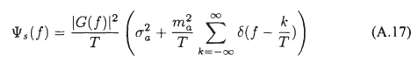

(c) Finite Statistical Pulse Train with Non-Correlated Coefficients

Recall again equation (35.7) but assume now a finite pulse train so the sums are different

<P(ω)> = T1 Ppulse(ω) (1/T) { α$\sum_{n = -N}^{N}{}$ $\sum_{m ≠ n}^{}{}$ [ eiω(m-n)T$_{1}$] + β$\sum_{n = -N}^{N}{}$ $\sum_{m = n}^{}{}$ [1] } . (35.12)

To evaluate the first double sum, we write it as

$\sum_{n = -N}^{N}{}$ $\sum_{m ≠ n}^{}{}$ [ eiω(m-n)T$_{1}$] = $\sum_{n = -N}^{N}{}$ { $\sum_{m = -N}^{N}{}$ [ eiω(m-n)T$_{1}$] – 1 }
= ( $\sum_{n = -N}^{N}{}$ e+iωnT$_{1}$ ) ($\sum_{m = -N}^{N}{}$e-iωmT$_{1}$ ) – $\sum_{n = -N}^{N}{}$1 = |$\sum_{n = -N}^{N}{}$ e+iωnT$_{1}$ |2 - (2N+1) . (35.13)

where | |2 = { }2 since (13.3) says each sum is real. From Appendix A we have

$\sum_{n = -N}^{N}{}$ eink = 2π { $\frac{sin[(N+1/2)k]}{2π sin(k/2)}$ } = 2πδ5(k,N) , (A.30)

so using (35.13) the first double sum in (35.12) becomes

$\sum_{n = -N}^{N}{}$ $\sum_{m ≠ n}^{}{}$ [ eiω(m-n)T$_{1}$] = [2πδ5(ωT1,N)]2 - (2N+1) . (35.14)

The second double sum in (35.12) is just

$\sum_{n = -N}^{N}{}$ $\sum_{m = n}^{}{}$ [1] = $\sum_{n = -N}^{N}{}$ [1] = (2N+1) (35.15)

and therefore we may write (35.12) as

<P(ω)> = T1 Ppulse(ω) (1/T) { α { [2πδ5(ωT1,N)]2 - (2N+1)} + β(2N+1) }

= Ppulse(ω) ((2N+1) T1/T) { α { $\frac{[2πδ5(ωT1,N)]2}{(2N+1)}$ - 1)} + β }

= Ppulse(ω) { (β-α) + α $\frac{[2πδ5(ωT1,N)]2}{(2N+1)}$ }

where this time we used T = (2N+1)T1 from (33.22). The factor multiplying α can be replaced using (A.20),

δ6(k,N) ≡ $\frac{1}{2π}$ $\frac{[2πδ5(ωT1,N)]2}{(2N+1)}$ = $\frac{1}{2N+1}$ $\frac{sin2[(N+1/2)k]}{2π sin2(k/2)}$ (A.20)

to give

<P(ω)> = Ppulse(ω) { (β-α) + α 2π δ6(ωT1,N) } (35.16)

which is the finite pulse train version of (35.11). In the limit N → ∞ we know from (A.21)

limN→∞ δ6(k,N) = $\sum_{m = -∞}^{∞}{}$δ(k-2πm) (A.21)

so that (35.16) becomes
<P(ω)> = Ppulse(ω) { (β-α) + α$\sum_{m = -∞}^{∞}{}$2π δ(ωT1-2πm) }
which reproduces (35.11).

(d) Statistical Non-Correlated Pulse Trains: Summary and Examples

Here then is a brief summary of the above results:

Spectral Power Density of a Non-Correlated Statistical Pulse Train (35.17)

x(t) = $\sum_{n = -∞}^{∞}{}$ yn xpulse(t - nT1) // or $\sum_{n = -N}^{N}{}$ for a finite pulse train
<P(ω)> = Ppulse(ω) [ (β-α) + α $\sum_{m = -∞}^{∞}{}$2π δ(ωT1- 2πm) ] // infinite (35.11)

<P(ω)> = Ppulse(ω) [ (β-α) + α 2π δ6(ωT1,N) ] // finite (35.16)

α = [pp] AA + [p(1-p)] AB + [(1-p)p]BA + [(1-p)(1-p)]BB // = <ymyn> when n≠m
(35.6)
β = [p]AA + [(1-p)] BB // = <ymyn> when n=m

A pulse has probably p of having amplitude A, and probability 1-p of having amplitude B.

A=1 and B=0 => α = p2 β = p (β - α) = p(1-p)

One can express α and β in terms of the statistical mean μ and variance σ2 :

μ = [p]A + [1-p]B α = μ2
σ2 = [ p(1-p)] (A-B)2 β = μ2+σ2 (β-α) = σ2 (D.16)

Example 1: Assuming A = 1 and B = 0, setting p = 1 in the above box gives α = 1 and (β-α) = 0. In this limit, our statistical average pulse train spectrum becomes the same as that for the simple pulse train of (33.25)

P(ω) ≡ Ppulse(ω)$\sum_{m = -∞}^{∞}{}$ 2πδ(ωT1 - 2πm) joules
P(ω) ≡ Ppulse(ω) 2π δ6(ωT1,N) joules (33.25)

This is because with p = 1 every pulse in the pulse train has the same amplitude A=1, which is how a simple pulse train is defined. As we reduce p below p = 1, the line spectra are scaled down by α = p2 < 1, and a continuous spectrum starts to appear with (β - α) = p(1-p). The randomness (variance σ2) of the ensemble creates a continuous component in the spectral power density P(ω) as per (35.11a) .

Example 2: Let p=0 with A=1 and B=0. Then every pulse has B = 0, x(t) ≡ 0, α = β = 0, and both terms in P(ω) vanish so there is zero spectral energy density.

Example 3: Let p=1/2 with A=1 and B=0, so α = p2 = 1/4 and β = p = 1/2. This pulse train then has an equal probably of 1's and 0's. We find from box (35.17) that

<P(ω)> = Ppulse(ω) [(1/4) + (1/4) $\sum_{m = -∞}^{∞}{}$2π δ(ωT1- 2πm) ] infinite (35.18)
<P(ω)> = Ppulse(ω) [(1/4) + (1/4) 2π δ6(ωT1,N) ] finite (35.19)

In (35.18) the discrete spectrum has been reduced to 1/4 of its full strength, and a continuous spectrum exists with coefficient 1/4 as shown.

(e) A numerical example of a Statistical Pulse Train

Recall from box (34.4) that for a finite pulse train,

P(ω) = $\frac{|X(ω)|2}{2πT}$ Ppulse(ω) = $\frac{|Xpulse(ω)|2}{2πT1}$ T = (2N+1)T1. (35.20)

Therefore we can write our p = 1/2 Example 3 result (35.19) as

$\frac{<|X(ω)|2>}{(2N+1)}$ = |Xpulse(ω)|2 [(1/4) + (1/4) 2π δ6(ωT1,N) ] . (35.21)

We shall use for xpulse(t) a square pulse of height A=1 and width τ = T1 = 1 so that, from (9.2),

|Xpulse (ω) | = sinc(ω/2) . (35.22)

Since our pulse train will be fairly short (N = 20 pulses) and since we shall only average a small number of pulse trains (M = 10), we know our result will not exactly match (35.21). Still, we hope to see in our result some kind of continuous background spectrum which approximates the curve (1/4)|Xpulse(ω)|2 = (1/4) sinc2(ω/2), and we expect to see delta-function-like peaks which, since 2πδ6(0,N) = (2N+1), have a peak value of about (1/4)41 = 10.25. Since this will be added to the continuous background, the peak should have a height of 10.25 + .25 = 10.5. However, for our small ensemble, we won't have exactly p = 1/2, so the delta peak won't be exactly 10.5 units high.

We know that δ6 has identical peaks spaced by 2π, but we expect the non-central peaks to be suppressed by the sinc2(ω/2) zeros which occur at ω = n(2π).

Here is the self-documented Maple program which generates <|X(ω)|2> . The program also generates the quantity <X(ω)> upon which we shall comment in Section 36 below.

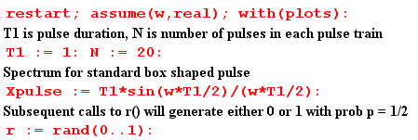
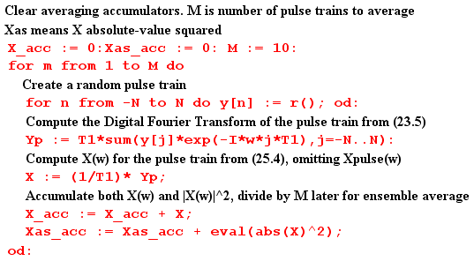
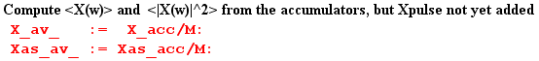

At this point, before Xpulse(ω) is added to the result, we plot <|X(ω)|2>. As expected, we see the peaks of δ6 spaced by 2π and having height around 10 units,

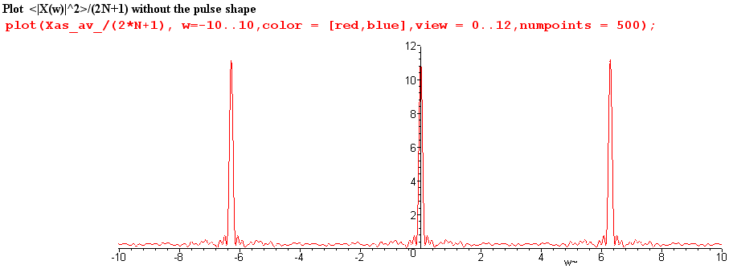
Fig 35.1

We now insert copies of Xpulse(ω) as appropriate,

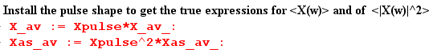

and then we can plot $\frac{<|X(ω)|2>}{(2N+1)}$ for ω in the same range (-10,10)

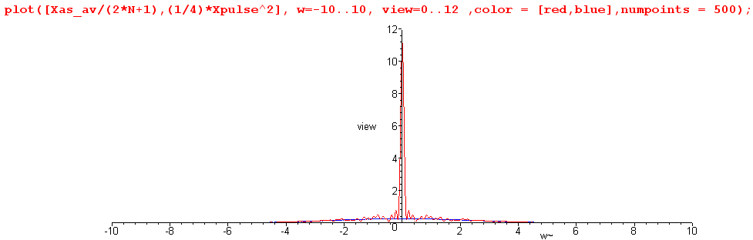
Fig 35.2

We see that the zeros of the sinc function have killed off the adjacent peaks.

Next, we restrict the plot height to be 0.8 units to view the detail, chopping off the δ6 peak,

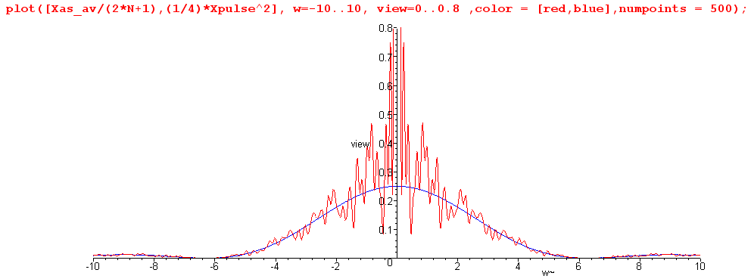
Fig 35.3

The spectrum $\frac{<|X(ω)|2>}{(2N+1)}$ is seen to have a continuous component which very well approximates one quarter of the sinc2 curve, as we hoped it would. This tracking also occurs away from the central peak. Here is a blow-up of the above plot for ω in the range (5, 30)

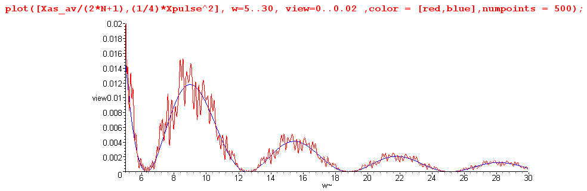
Fig 35.4

It might be noted that Maple does this work analytically, so that Was-av is a function of ω having a large number of trigonometric terms. For the reader's interest, we show Was-av(ω) for a typical program run :

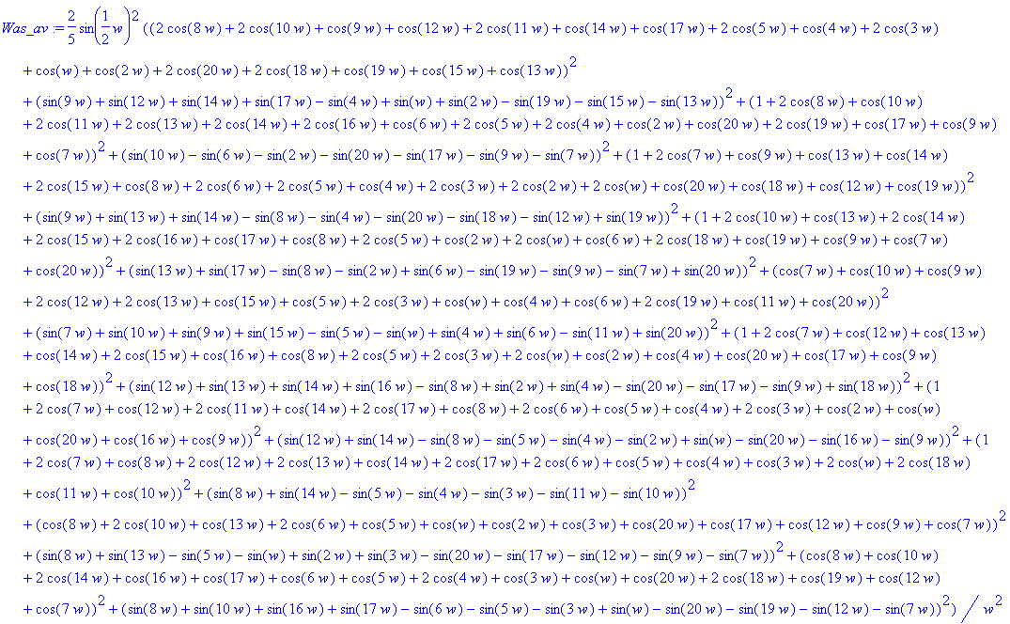

In more serious work with larger numbers, one would of course do this in a more numeric fashion, but we are able to confirm the basic results even with this small experiment.

(f) What role has the Autocorrelation Function played in our development?

In Section 32 the autocorrelation function was first introduced as rx(t) for x(t), and was computed for the simple case of a box pulse. Treating the definition of rx(t) as a convolution equation, the Wiener-Khintchine Relation Rx(ω) = |X(ω)|2 was trivially derived. It was then shown that the spectral energy density of a pulse train is E(ω) = (1/2π) Rx(ω) due to this relation. Finally, it was shown that rx(0) = E, the total energy in the pulse train. We then commented on the origin of the name, showing that the auto-correlation function is the cross-correlation function of a function with itself when that function is real.

In Section 34 it was noted again that P = rx(0)/T since P = E/T, and that P(ω) = Rx(ω)/ (2πT) since Rx(ω) = |X(ω)|2.

Sections 33 and 35 made no reference at all to the autocorrelation function.

This leads us to make several comments:

(1) The autocorrelation function played no role whatsoever in our development of key equations such as

<P(ω)> = Ppulse(ω) [ (β-α) + α $\sum_{m = -∞}^{∞}{}$2π δ(ωT1- 2πm) ] // infinite (35.11)

(2) In some textbooks, one gets the impression that the autocorrelation function is somehow crucial for the development of such equations. It is not.

(3) Nevertheless, since P(ω) = Rx(ω)/ (2πT), one can start with a description of x(i)(t) of pulse train i in a statistical ensemble, compute from it rx(i)(t) and from that Rx(i)(ω) . One could then do a statistical average to obtain <P(ω)> = (2πT)-1(1/I) Σi=1I Rx(i)(ω). So it is possible to take a pathway to deriving equations like (35.11) which does pass through the land of the autocorrelation function.

(4) Our main reason for even bringing it up is that autocorrelation is closely related to what we are doing, and in other applications such as those involving noise (and pseudo-noise PN) it becomes more significant. In such applications, the definition of rx(t) might include a normalizing factor so it is then autocorrelation per unit time, or per pulse (per chip in the PN world).

(5) In (34.14a) we noted that P(ω) = Ppulse(ω) R"(z) where R"(z) is the Z transform of the autocorrelation sequence rs defined in (32.17). Then in Appendix F (e) we compute R"(z) for a sequence which respects certain simple conditions met by a Maximum Length Sequence (MLS). The resulting P(ω) is not easily computed in any other manner, so in this case the pathway through the autocorrelation route is extremely valuable.

(g) A paradox and its resolution

Now while here, we can back up and apply our statistical average directly to the spectrum in (34.6) using (34.7). The result is

<X(ω)> = Xpulse(ω) $\sum_{n = -∞}^{∞}{}$<yn> e-inωT$_{1}$ . (34.6,7)

We could then argue that

<yn> = [p] A + [1-p] B = p if A=1, B=0 . (35.23)

In this case, we can extract p from the above sum, which then collapses to form the usual (13.2) delta function sum. The result is then the same as the regular pulse train result (14.4) with an overall factor of p out front, namely,
<X(ω)> = p $\sum_{m = -∞}^{∞}{}$Xpulse(mω1) 2π δ( ωT1 - 2πm) . (35.24)

This says that our average spectrum is 100% discrete, there is no continuous part! If p = 1/2, the average spectrum is just 1/2 times our discrete unit amplitude pulse train spectrum (14.4). How can this be true, if we just showed in (35.11) that the average spectral density <|X(ω)|2> has a continuous spectral component?

The answer lies in the fact that <ab> ≠ <a><b>, where < > is our averaging operation. Thus

<|X(ω)|2> ≠ <X(ω)><X(ω)*> . (35.25)

There is no reason in the world why the average of a product should be the product of the averages,

( $\frac{1}{N}$Σi=1N AiBi) ≠ ( $\frac{1}{N}$Σi=1N Ai) ( $\frac{1}{N}$Σi=1N Bi) .

In the numerical example presented in Section 35 (f), we computed <X(ω)> for a small ensemble of pulse trains. Here are plots of the real and imaginary part of <X(ω)>,

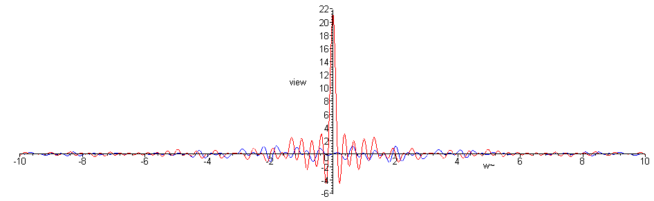
Fig 35.5

We can see that, apart from the noise of our low statistics, there is only the central peak and no continuous spectrum component. A blow-up of the central region follows,

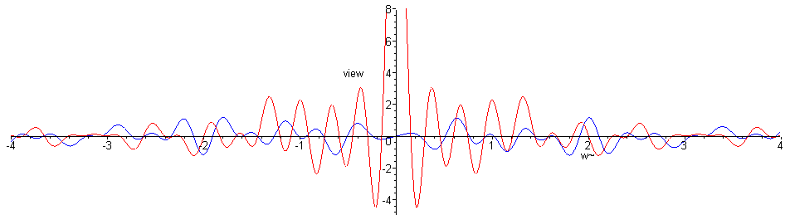
Fig 35.6

