Finding Support for Spectral Decimation Section PhL 3.17.13

www.analog.com/static/imported-files/tutorials/MT-017.pdf

This paper draws this picture,

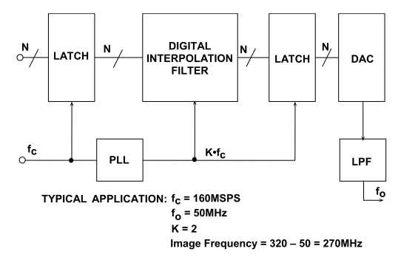

which suggested to me two things:

(1) there is no decimation here.
(2) my brick wall filter in this context is called an "interpolation filter".

http://www.scribd.com/doc/20203269/Interpolation-filters-for-oversampled-audio-DACs

This paper is cannot be downloaded without paying, but you can see it. Early comment:

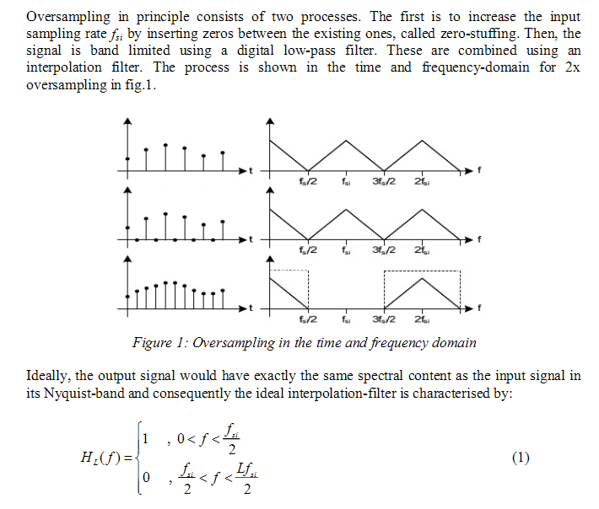

He refers to decimation as "zero-stuffing" but he does not say why one might do this. Also, it seems wrong that the two signals shown have the same spectrum, I think this might be wrong.
What I find is that decimation broadens the sinc function which has good and bad news. The good news is that you have less sinx/x distortion on the central peak, but the bad news is that you have added a lot of closer in image spectra! That is what decimation does, and I want to find someone who agrees with me.
Another figure is this one:

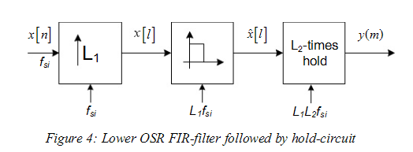

What do these notations mean? Here it is again

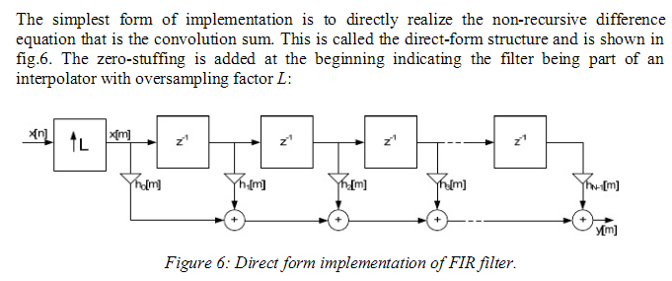

I think the leftmost box does both decimation and Low pass filter. As for filter implementation,
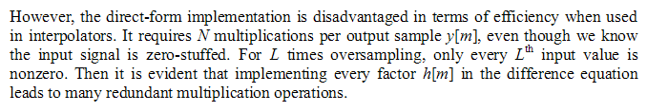

He shows how you can do this with a polyphase idea to reduce hardware, seems reasonable. It is a good paper, but I need another source.

www.hit.bme.hu/~papay/edu/Conv/pdf/Jonas.pdf

This guy also uses an up arrow

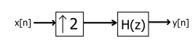

He doesn't say if the box does zero-stuffing or not.

http://books.google.com/books?id=Kvo7cjmaEpkC&pg=PA391&lpg=PA391&dq=decimation+oversampling+DAC&source=bl&ots=77M7ekBiLK&sig=9YGbS-d2F29NKcbIrhzZcLDD3HE&hl=en&sa=X&ei=zytGUceiEuj7ygG_s4DABA&ved=0CGAQ6AEwCA#v=onepage&q=decimation%20oversampling%20DAC&f=false

This one has an interesting idea of doing a filter in stages,

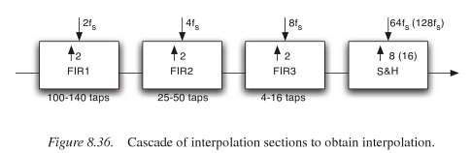

Each stage runs 2x faster than the one before. Fast clock uses more power, but filters have fewer taps so less power. I like it. What is the rule of "sample and hold" here?

http://www.dspguru.com/dsp/faqs/multirate/decimation

Loosely speaking, "decimation" is the process of reducing the sampling rate. In practice, this usually implies lowpass-filtering a signal, then throwing away some of its samples.

The most immediate reason to decimate is simply to reduce the sampling rate at the output of one system so a system operating at a lower sampling rate can input the signal. But a much more common motivation for decimation is to reduce the cost of

So I am using decimation incorrectly! I am really doing zero-stuffing.

