Comments on Bennet and Davey PhL 5.11.13

1. Comments on Bennet and Davey 1
2. My original source notes from long ago 2
3. Smith "Digital Transmission Systems" 2
4. Library bike trip 13
5. Xiong book stuff 16

1. Comments on Bennet and Davey

The Bennet and Davey theory is based on two different pulse shapes g1 and g2, whereas my theory is based on one pulse shape xpulse(t), so very hard to compare results!

I thought this book was the basis of my spectral theory doc, but now that I have the book, it seems to have much less than I thought. Chapter 19 concerns the "statistics of digital signals", and I will try to do some translation between B&D and my stuff.

1. They always use df instead of dω and f in place of ω.

2. My signal x(t) for them is called s(t,T) where -T < t < T so 2T is the length of their finite pulse train.

3. My signal X(ω) form them is S(f,T). Since they use df, their Fourier Transform on page 316 is symmetric.

4. They use ws(f,T) ≡ | S(f,T) |2 / T. Roughly this is my P(ω) = |X(ω)|2 / 2πT except my T is half of their T. So ws is the spectral power density of signal s(t).

4. On page 317 they show my kind of random signal with A and B amplitudes selected at random. Their pulse width is Ts. They in fact use two different pulse shapes g1 and g2 so these would correspond to my two amplitudes of the same xpulse . So roughly g1(t) = Axpulse(t) and g2(t) = Bxpulse(t). But this would only be a special case of the B&D analysis.

5. Their pulse train is written on p 317 as s(t,T) = Σn=-NN sn(t) where sn is gi(t-nTs). They then assume that g1 has p and g2 has 1-p in 19.8.

6. They next define in (19-9),

v(t,T) = Σn [ p g1(t-nTs) + (1-p) g2(t-nTs) ] = Σn [ pA + (1-p)B]xpulse(t-nT1) for me.

I am very unclear what this means. For me this is a simple pulse train with y = pA + (1-p)B which seems not very interesting. It is I guess the average of all pulse trains, and they are going to somehow subtract out this average from something. So OK, they define u = s - v, so u is the pulse train with this average pulse train subtracted out. I am very confused.

7. They define an in 19-12 in a very strange manner, it is not an amplitude. This is all pretty useless to me! How can I connect it to anything?

u = s - v

un(t) = an [g1(t-nTs) - g2(t-nTs) ] = an [ A - B ] xpulse(t-nT1)

Ouch, I had no idea this would be so bad! Eventually he gets to this: (translate to me)

ws(f) = 2fsp(1-p)(A-B)2|Xpulse(f)|2 + fs2[ p A + (1-p) B ]2 Xpulse(0)2 δ(f)

+ 2fs2 Σm=1∞ | pA + (1-p)B |2 |Xpulse(mfs)|2δ(f-mfs) STOP!!!

2. My original source notes from long ago

STOP. It just occurs to me that most of my "stuff" came from some other book. Maybe the AMI thing only came from B&D! Ouch. Let's go hunt around in my old notes. I find this in contents_refs.doc in my scrambler section (quoted paragraphs from my 1990 notes)

5. D.R.Smith, Digital Transmission Systems, VNR, 1985. [Alva Young ]

"Chapter 5 of this book is on baseband transmission. It discusses NRZ, NRZI, AMI, CMI, RZ, and other line codes. It mentions the connection between spectral energy and the autocorrelation function, and then quotes without proof the spectral energy density of several line codes. This served as motivation for my Spectral Chapter 6. It has a small amount on (digital) equalization, and Section 5.10 is entitled "data scrambling techniques". This section quotes a few of the results proved in the Scrambler notes. "

6. Bennett and Davey, Data Transmission, MH, (1965). [ BTS Library ]

"This frequently-referenced book is very well written and must be a classic of the field. Chapter 19 is on the statistics of digital signals, which provided hints for Spectral Chapter 6. "

So it is the SMITH book that I was using, argggggg! I will look now for it on line. This is now in 3rd edition at $140 Amazon. A lot of it seems present in Google books.

http://books.google.com/books?id=4IASeihofskC&printsec=frontcover#v=onepage&q&f=false

I find a download for third edition but I don't believe it, site is

http://www.pdfebookes.com/digital-transmission-systems-PDF4-776203/

Yup, you need some kind of password from http://www.linkbax.com which is probably a virus site. Yup, its one of those ad survey sites which never ends. Cannot find a good download, so let's try Google books again.

3. Smith "Digital Transmission Systems"

This Smith book had some results, but nothing complete, Xiong found later is better, see below.

I will try to quite relevant pieces from the Smith book on Google books.
Chapter on baseband transmission begins on page 258. The TOC is blocked, but I can get that from Amazon,

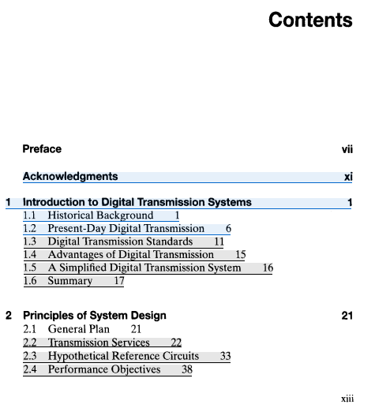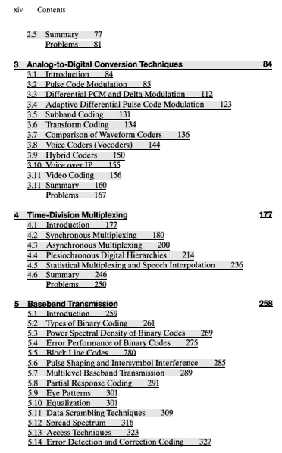
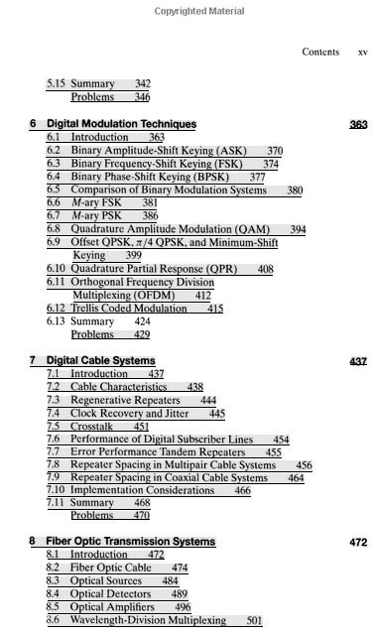
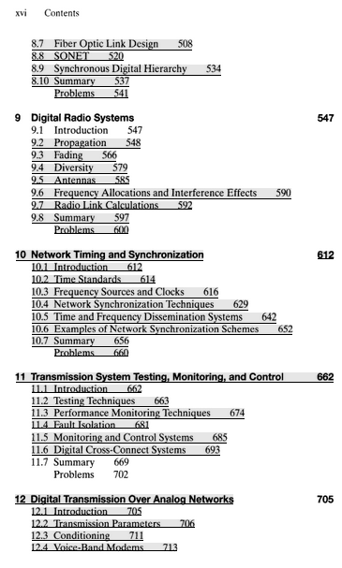
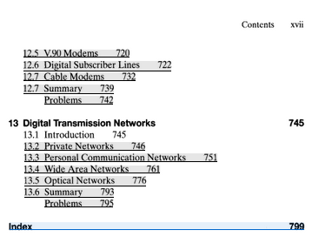

For my purposes, only Chapter 5 on Baseband is relevant. This is pp 258-346. So how much of these 80 pages can be seen in Google books? It is perforated with missing pages, but here are a few things I can extract, [ a few snippets available from Google Books version of the Smith book: ]

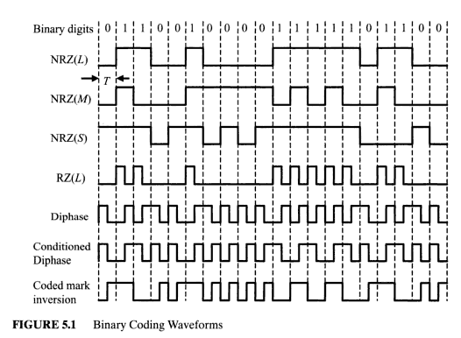

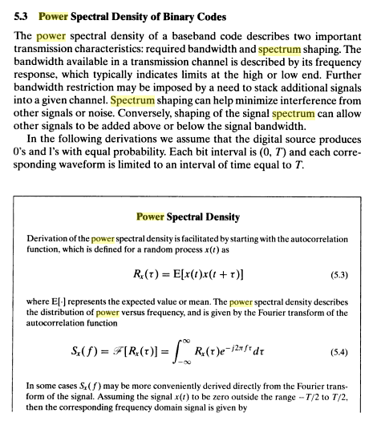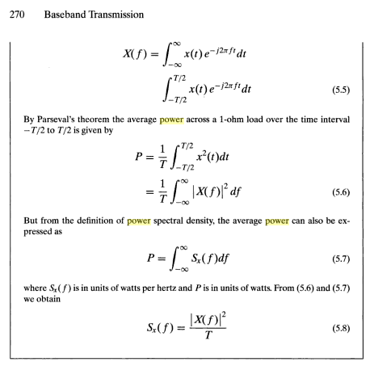
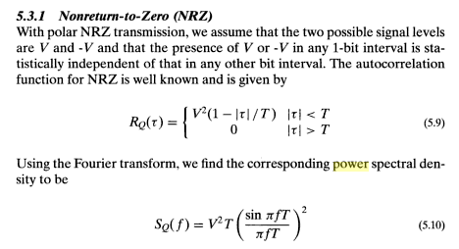// agrees with Xiong
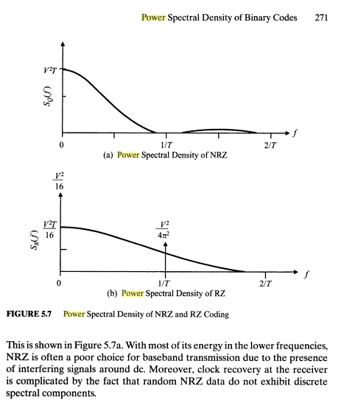

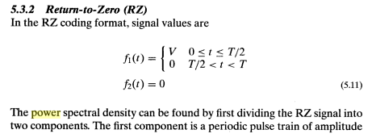

but p 272,273 are missing, continuing:

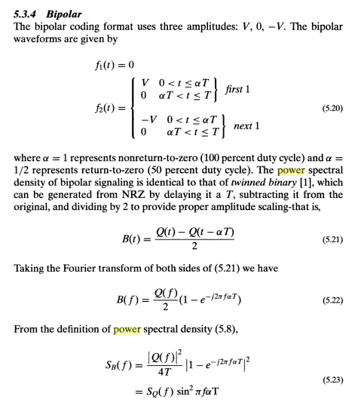
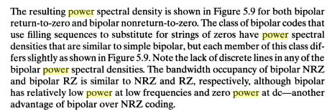

That's about all there is!

Marriott Smith: the three editions are 1985, 1993 and 2004.

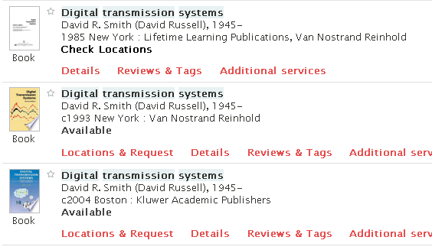

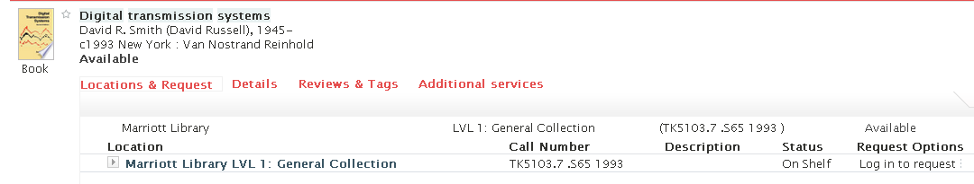

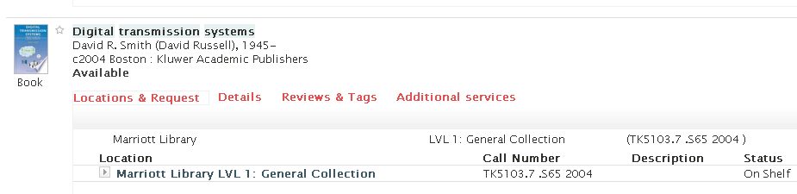

SO they claim that the two newest editions are "on the shelf" !
But where is Smith getting his results FROM? Answer not clear, the chapter does have a page of pretty narrow topic references. So I am not immediately led to another book.

4. Library bike trip to look up Smith, liked Xiong better.

SMITH STUFF

After taking these photos, I was able to download the Xiong book (minus a few pages).

Library Bike Trip. I took my camera to Marriott and found lots of good books. The 2004 Smith book was there, and that is the first set of photos. Here are my results from that book: [ Smith ]

NRZ:

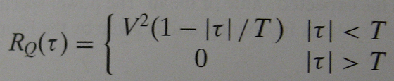
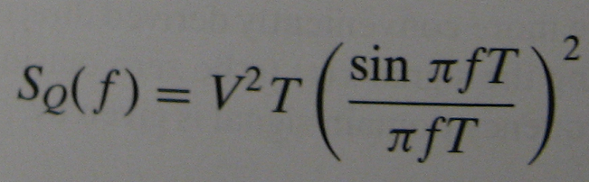

RZ:

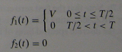
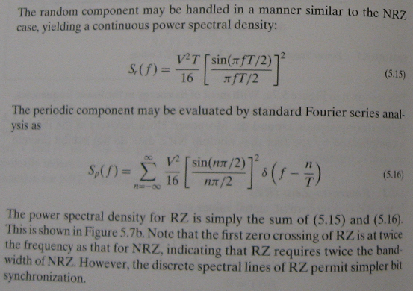 // sum agrees with Xiong

Bipolar: (with α = 1 this is my AMI I think) (yes sometimes this IS called Bipolar)

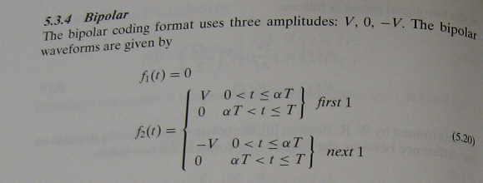

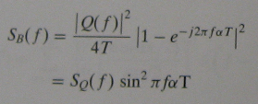

Diphase: (in the graph below he suggests this is Manchester) .

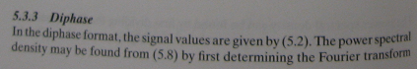

but I don't have (5.2). The spectrum is this:

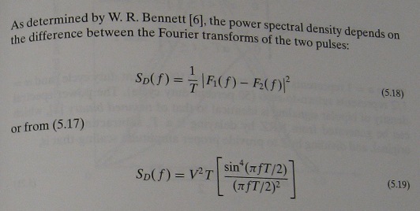

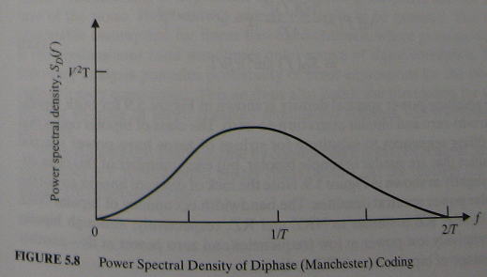

I then switched to another book which I think was Xiong, Digital Modulation Techniques.

5. Xiong book stuff

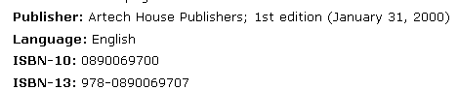

I was able to download this from 4shared and confirm the page numbers of my photos. Page 28 of the download is blank, but I have a photo.

Here are results from that source (these are on page 28)

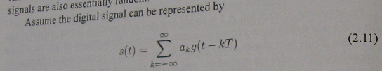

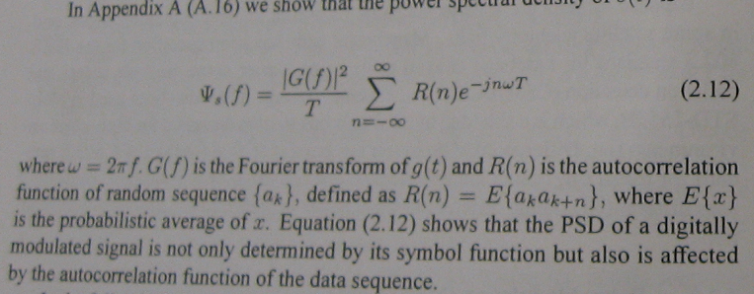

The rest I take from the download,

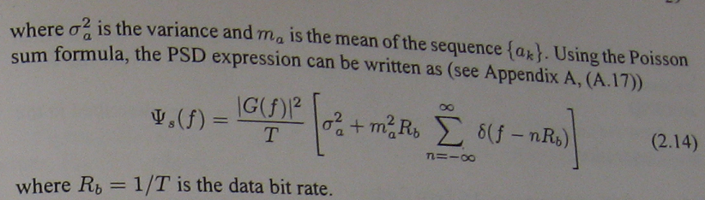

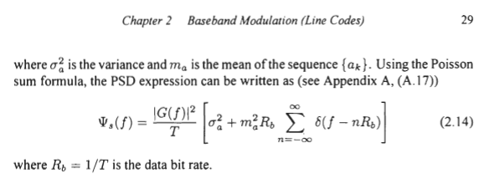

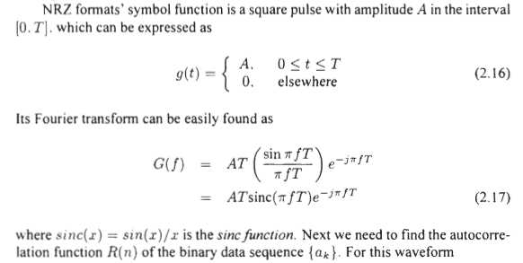
etc etc and then

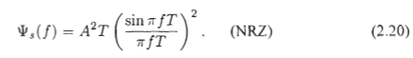

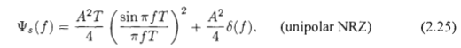

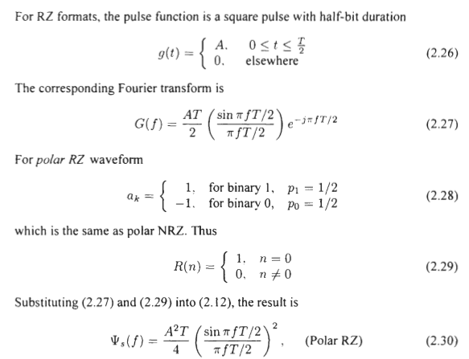

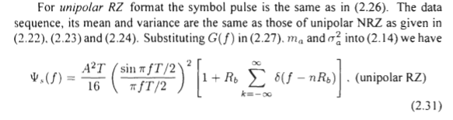

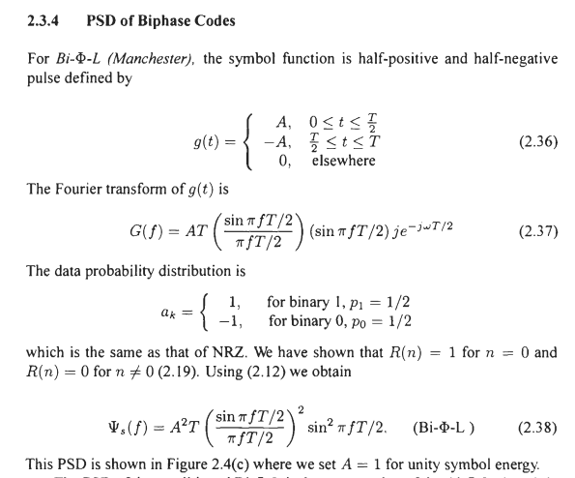

I then copied some pages from the Xiong appendix. There he comes up with this general formula, '

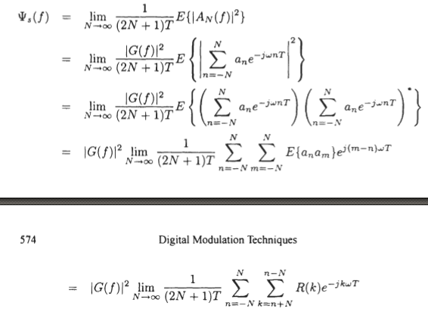

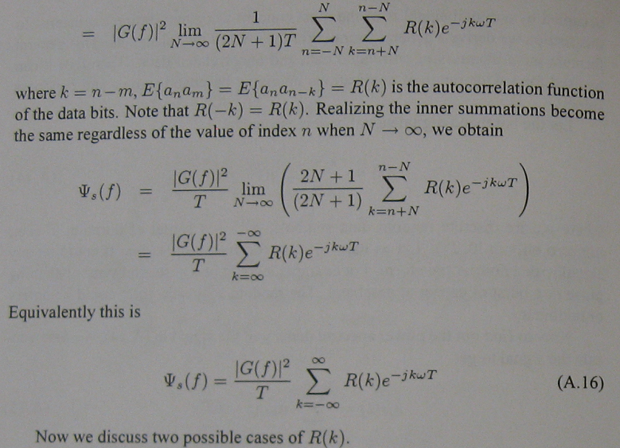

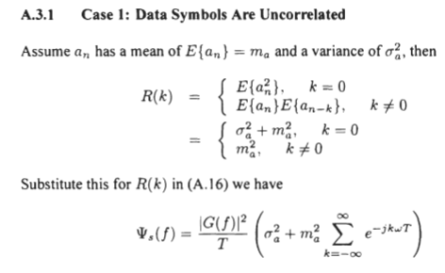

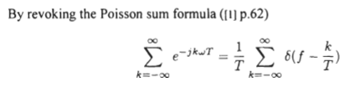

I don't think I gave this formula a name did I?

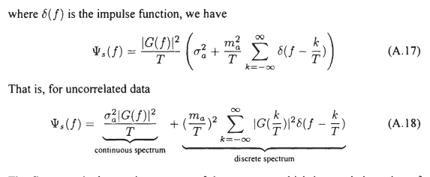

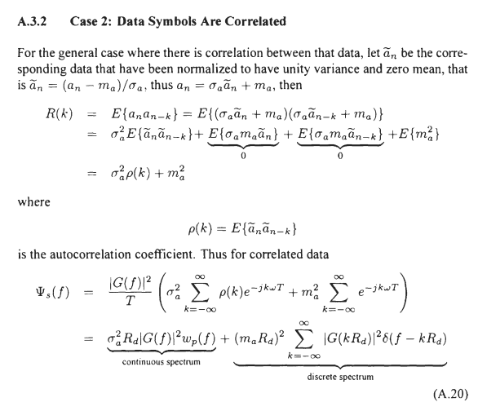

Notice that all authors use "power spectral density" PSD and not "spectral power density".

And THAT is the end of my slide show. I looked in a very new Proakis edition and an older one but could find nothing really on this subject. All in all, this was a good bike library trip.

