I decided to buy this book since only $4 total delivered to my house. 3.21.13

It is in the BTS library which is no good for me, and not in SLC according to WorldCat , not at SLC libe, not at Marriott, nothing handy. Could not find online. I can get it from this CA seller for $4 including ship and tax, so I did it just now. I may want to check other results. This AMI stuff is not easy to find.

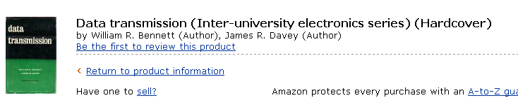

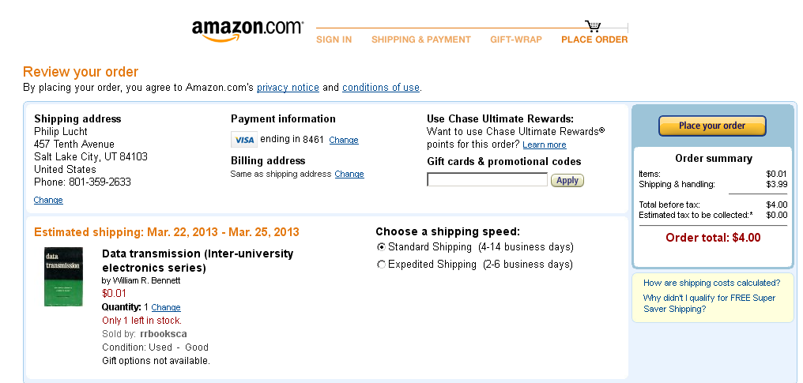

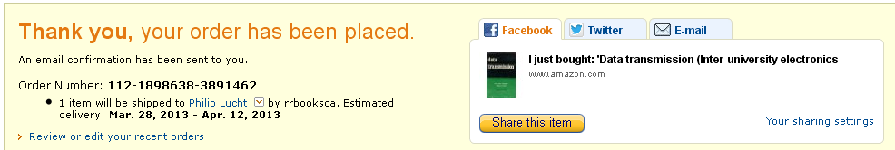

Order placed on 3/21. It is now 3/30 and no delivery, but this is in their range. Order has no tracking so I just have to wait. I thought it was just coming from CA.

