New Section 35 PhL 3.26.05

35. Statistical Amplitude Modulated Pulse Trains Part II

(a) Infinite Pulse train with Random Coefficients

Recall now equation (34.18) which we give a new number,

<P(ω)> = T1 Ppulse(ω) (1/T) { α$\sum_{n = -∞}^{∞}{}$ $\sum_{m ≠ n}^{}{}$ [ eiω(m-n)T$_{1}$] + β$\sum_{n = -∞}^{∞}{}$ $\sum_{m = n}^{}{}$ [1] } (35.1)

To evaluate the first double sum, we write it as

$\sum_{n = -∞}^{∞}{}$ $\sum_{m ≠ n}^{}{}$ [ eiω(m-n)T$_{1}$] = $\sum_{n = -∞}^{∞}{}$ { $\sum_{m = -∞}^{∞}{}$ [ eiω(m-n)T$_{1}$] – 1 }

= ( $\sum_{n = -∞}^{∞}{}$ e+iωnT$_{1}$ ) ($\sum_{m = -∞}^{∞}{}$e-iωmT$_{1}$ ) – $\sum_{n = -∞}^{∞}{}$1 = | $\sum_{n = -∞}^{∞}{}$ e+iωnT$_{1}$ |2 - $\sum_{n = -∞}^{∞}{}$1

We now quote two results from Appendix A

$\sum_{n = -∞}^{∞}{}$ 1 = [ 2π δ(0)] (A.32)
{$\sum_{n = -∞}^{∞}{}$ einωT$_{1}$}2 = [ 2πδ(0) ] { $\sum_{m = -∞}^{∞}{}$2π δ(ωT1- 2πm) } (A.35)

so the first double sum in (35.4) becomes

$\sum_{n = -∞}^{∞}{}$ $\sum_{m ≠ n}^{}{}$ [ eiω(m-n)T$_{1}$] = [ 2πδ(0) ] { $\sum_{m = -∞}^{∞}{}$2π δ(ωT1- 2πm) - 1} (35.5)

The second double sum in (35.4) is just

$\sum_{n = -∞}^{∞}{}$ $\sum_{m = n}^{}{}$ [1] = $\sum_{n = -∞}^{∞}{}$ [1] = [ 2π δ(0)] (35.6)

and therefore we may write (35.1) as

<P(ω)> = T1 Ppulse(ω) (1/T) { α [ 2πδ(0) ] [ $\sum_{m = -∞}^{∞}{}$2π δ(ωT1- 2πm) - 1] + β [ 2π δ(0)] }
= Ppulse(ω) (T1 [ 2πδ(0) ]/T) { α [ $\sum_{m = -∞}^{∞}{}$2π δ(ωT1- 2πm) - 1] + β }
or
<P(ω)> = Ppulse(ω) { (β-α) + α$\sum_{m = -∞}^{∞}{}$2π δ(ωT1- 2πm) } (35.7)

where we used T = [2πδ(0)]T1 from (33.22).

(b) Finite Pulse train with Random Coefficients

Recall again equation (34.18) but assume now a finite pulse train so the sums are different

<P(ω)> = T1 Ppulse(ω) (1/T) { α$\sum_{n = -N}^{N}{}$ $\sum_{m ≠ n}^{}{}$ [ eiω(m-n)T$_{1}$] + β$\sum_{n = -N}^{N}{}$ $\sum_{m = n}^{}{}$ [1] } (35.8)

To evaluate the first double sum, we write it as

$\sum_{n = -N}^{N}{}$ $\sum_{m ≠ n}^{}{}$ [ eiω(m-n)T$_{1}$] = $\sum_{n = -N}^{N}{}$ { $\sum_{m = -N}^{N}{}$ [ eiω(m-n)T$_{1}$] – 1 }
= ( $\sum_{n = -N}^{N}{}$ e+iωnT$_{1}$ ) ($\sum_{m = -N}^{N}{}$e-iωmT$_{1}$ ) – $\sum_{n = -N}^{N}{}$1 = |$\sum_{n = -N}^{N}{}$ e+iωnT$_{1}$ |2 - (2N+1) (35.9)

From Appendix A we have

$\sum_{n = -N}^{N}{}$ eink = 2π { $\frac{sin[(N+1/2)k]}{2π sin(k/2)}$ } = 2πδ5(k,N) (A.**)

so the first double sum in (35.9) becomes

$\sum_{n = -N}^{N}{}$ $\sum_{m ≠ n}^{}{}$ [ eiω(m-n)T$_{1}$] = [2πδ5(ωT1,N)]2 - (2N+1) . (35.10)

The second double sum in (35.9) is just

$\sum_{n = -N}^{N}{}$ $\sum_{m = n}^{}{}$ [1] = $\sum_{n = -N}^{N}{}$ [1] = (2N+1) (35.11)

and therefore we may write (35.8) as

<P(ω)> = T1 Ppulse(ω) (1/T) { α { [2πδ5(ωT1,N)]2 - (2N+1)} + β(2N+1) }

= Ppulse(ω) ((2N+1) T1/T) { α { $\frac{[2πδ5(ωT1,N)]2}{(2N+1)}$ - 1)} + β }

= Ppulse(ω) { (β-α) + α $\frac{[2πδ5(ωT1,N)]2}{(2N+1)}$ }

where this time we used T = (2N+1)T1 from (33.22). The factor multiplying α can be replaced using (A.20),

δ6(k,N) ≡ $\frac{1}{2π}$ $\frac{[2πδ5(ωT1,N)]2}{(2N+1)}$ = $\frac{1}{2N+1}$ $\frac{sin2[(N+1/2)k]}{2π sin2(k/2)}$ (A.20)

to give

<P(ω)> = Ppulse(ω) { (β-α) + α 2π δ6(ωT1,N) } (35.12)

which is the finite pulse train version of (35.7). In the limit N → ∞ we know from (A.21)

limN→∞ δ6(k,N) = $\sum_{m = -∞}^{∞}{}$δ(k-2πm) (A.21)

so that (35.13) becomes
<P(ω)> = Ppulse(ω) { (β-α) + α$\sum_{m = -∞}^{∞}{}$2π δ(ωT1-2πm) }
which reproduces (35.7).

(c) Statistical Pulse Trains Summary and Examples

Here then is a brief summary of the above results:

Spectral Energy Density of a Random Pulse Train (35.13)

x(t) = $\sum_{n = -∞}^{∞}{}$ yn xpulse(t - nT1) // or $\sum_{n = -N}^{N}{}$ for a finite pulse train
<P(ω)> = Ppulse(ω) [ (β-α) + α $\sum_{m = -∞}^{∞}{}$2π δ(ωT1- 2πm) ] // infinite (35.7)

<P(ω)> = Ppulse(ω) [ (β-α) + α 2π δ6(ωT1,N) ] // finite (35.12)

α = [pp] AA + [p(1-p)] AB + [(1-p)p]BA + [(1-p)(1-p)]BB // = <aman> when n≠m
(34.17)
β = [p]AA + [(1-p)] BB // = <aman> when n=m

A pulse has probably p of having amplitude A, and probability 1-p of having amplitude B.

A=1 and B=0 => α = p2 β = p (β - α) = p(1-p)

Example 1: If we set p = 1 in the above box, we get α = 1 and (β-α) = 0. In this limit, our statistical average pulse train spectrum becomes the same as that for the simple pulse train of (33.25)

P(ω) ≡ Ppulse(ω)$\sum_{m = -∞}^{∞}{}$ 2πδ(ωT1 - 2πm) joules
P(ω) ≡ Ppulse(ω) 2π δ6(ωT1,N) joules (33.25)

This is because when p = 1 every pulse in the pulse train has the same amplitude A, which is how a simple pulse train is defined. As we reduce p below p = 1, the line spectra are scaled down by α = p2 < 1, and a continuous spectrum starts to appear with (β - α) = p(1-p). The randomness of the ensemble creates a continuous component in the spectral power density P(ω) .

Example 2: Let p=0 with A=1 and B=0. Then every pulse has B = 0, x(t) ≡ 0, α = β = 0, and both terms in P(ω) vanish so there is zero spectral energy density.

Example 3: Let p=1/2 with A=1 and B=0, so α = p2 = 1/4 and β = p = 1/2. This pulse train then has an equal probably of 1's and 0's. We find from box (35.13) that

<P(ω)> = Ppulse(ω) [(1/4) + (1/4) $\sum_{m = -∞}^{∞}{}$2π δ(ωT1- 2πm) ] infinite (35.14)
<P(ω)> = Ppulse(ω) [(1/4) + (1/4) 2π δ6(ωT1,N) ] finite (35.15)

In (35.15) the discrete spectrum has been reduced to 1/4 of its full strength, and a continuous spectrum exists with coefficient 1/4 as shown.

(e) A detailed numerical statistical pulse train example

Recall from box (33.36) that for a finite pulse train,

P(ω) = $\frac{|X(ω)|2}{2πT}$ Ppulse(ω) = $\frac{|Xpulse(ω)|2}{2πT1}$ T = (2N+1)T1. (35.16)

Therefore we can write our p = 1/2 Example 3 result (35.15) as

$\frac{<|X(ω)|2>}{(2N+1)}$ = |Xpulse(ω)|2 [(1/4) + (1/4) 2π δ6(ωT1,N) ] . (35.17)

We shall use for xpulse(t) a square pulse of height 1 and τ = T1 = 1 so that, from (9.2),

|Xpulse (ω) | = sinc(ω/2) .

Since our pulse train will be fairly short (N = 20 pulses) and since we shall only average a small number of pulse trains (M = 10), we know our result will not exactly match (35.17). Still, we hope to see in our result some kind of continuous background spectrum which approximates the curve (1/4)|Xpulse(ω)|2 = (1/4) sinc2(ω/2), and we expect to see a delta-function-like peak which, since 2πδ6(0,N) = (2N+1), has a peak value of about (1/4)41 = 10.25. Since this will be added to the continuous background, the peak should have a height of 10.25 + .25 = 10.5. However, for our small ensemble, we won't have exactly p = 1/2, so the delta peak won't be exactly 10.5 units high.

We know that δ6 has identical peaks spaced by 2π, but we expect the non-central peaks to be suppressed by the sinc2(ω/2) zeros which occur at ω = n(2π).

First, here the self-documented Maple program which generates <|X(ω)|2> . The program also generates the quantity <X(ω)> upon which we shall comment in Section 36 below.

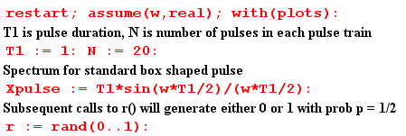
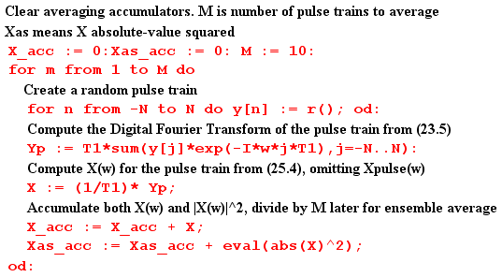
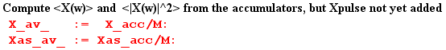

At this point, before Xpulse(ω) is added to the result, we plot <|X(ω)|2>. As expected, we see the peaks of δ6 spaced by 2π and having height around 10 units,

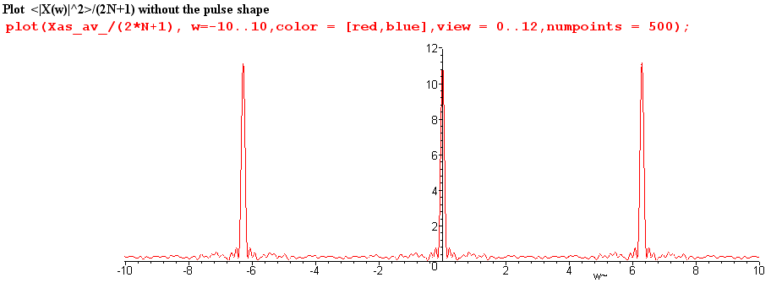

We now insert copies of Xpulse(ω) as appropriate,

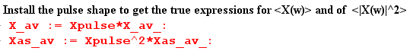

and then we can plot $\frac{<|X(ω)|2>}{(2N+1)}$ for ω in the same range (-10,10)

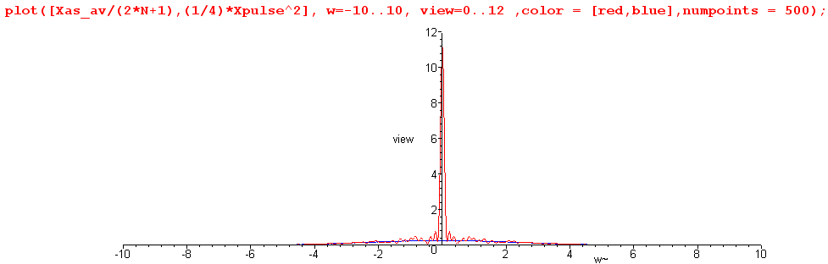

We see that the zeros of the sinc function have killed off the adjacent peaks.

Next, we restrict the plot height to be 0.8 units to view the detail, chopping off the δ6 peak,

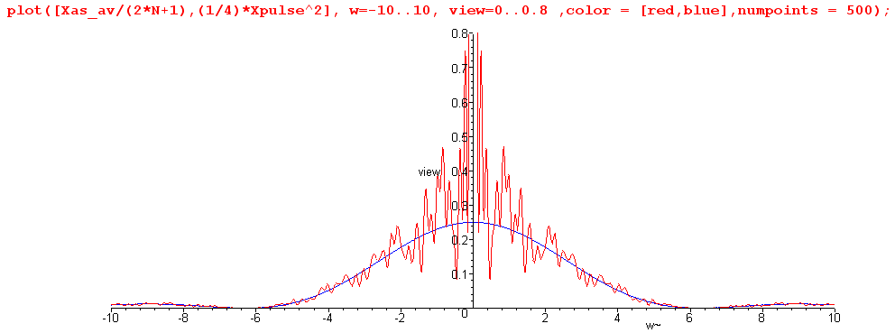

The spectrum $\frac{<|X(ω)|2>}{(2N+1)}$ is seen to have a continuous component which very well approximates one quarter of the sinc2 curve, as we hoped it would. This tracking also occurs away from the central peak. Here is a blow-up of the above plot for ω in the range (5,30)

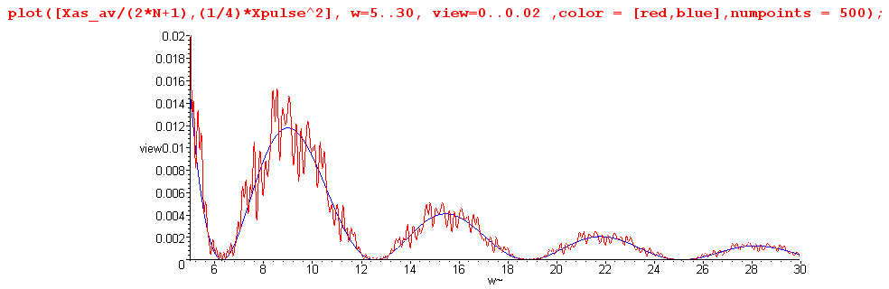

It might be noted that Maple does this work analytically, so that Was-av is a function of ω having a huge number of trigonometric terms. For the reader's interest, we show Was-av(ω) for a typical program run :

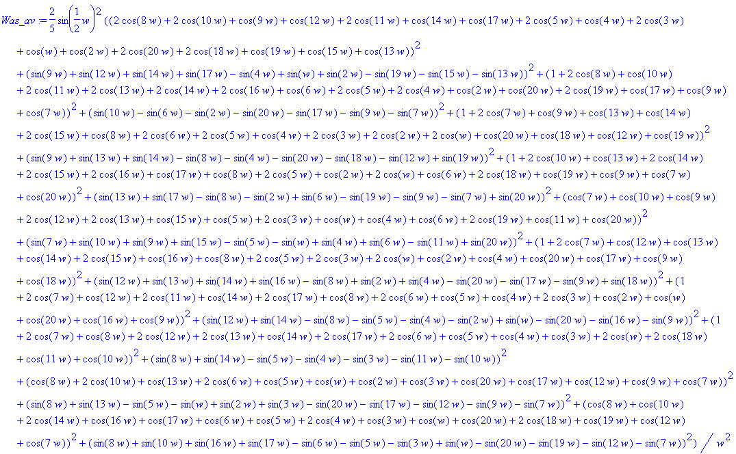

In more serious work with larger numbers, one would of course do this in a more numeric fashion, but we are able to confirm the basic results even with this small experiment.

