old sections 33,34,35 PhL 3.26.13

33. Autocorrelation and Spectral Energy Density for a Simple Pulse Train

(a) Infinite Simple Pulse Train

This is the first section in which we use the δ(0) notation of Appendix A which may make the reader feel a bit uncomfortable. In subsection (b) we shall repeat everything for a finite pulse train and then take the limit N→∞ to obtain the same results without using δ(0).

From summary box (14.12) we know the spectrum of an infinite pulse train formed from pulses xpulse(t) separated by time T1 [ in the second line, note that δ( ωT1 - 2πm) = (1/T1) δ(ω - mω1) ]

x(t) = $\sum_{n = -∞}^{∞}{}$ xpulse(t - nT1) (14.1)
X(ω) = $\sum_{m = -∞}^{∞}{}$ Xpulse(mω1) 2π δ(ωT1 - 2πm) (14.4)

We have been careful to write this in its original developed form without any scaling of the delta function, heeding the warning below equation (A.30) in Appendix A. The spectrum of the pulse is being sensed at discrete frequencies to generate the Fourier Series coefficients cm = (1/T1)Xpulse(mω1).

Our next task is to compute | X(ω) |2 :

| X(ω) |2 = {$\sum_{m = -∞}^{∞}{}$ Xpulse(mω1) 2πδ(ωT1 - 2πm)} {$\sum_{n = -∞}^{∞}{}$ Xpulse(nω1)* 2πδ(ωT1 - 2πn)}
= $\sum_{m = -∞}^{∞}{}$ $\sum_{n = -∞}^{∞}{}$ Xpulse(mω1) Xpulse(nω1)* 2πδ(ωT1 - 2πm) 2πδ(ωT1 - 2πn) .

Looking at the product of the two delta functions, there can be no contribution to the double sum unless m = n, so we continue

= $\sum_{m = -∞}^{∞}{}$ | Xpulse(mω1) |2 2πδ(ωT1 - 2πm) 2πδ(ωT1 - 2πm) .

Since both delta functions have the same argument, the effect of one delta is to set the argument of the other to 0, so we continue

= $\sum_{m = -∞}^{∞}{}$ | Xpulse(mω1) |2 2πδ(0) 2πδ(ωT1 - 2πm)
so that
| X(ω) |2 = [2πδ(0)] $\sum_{m = -∞}^{∞}{}$ | Xpulse(mω1) |22πδ(ωT1 - 2πm) .

As defined in (32.6) we then get this result for the spectral energy density of a pulse train,

E(ω) = $\frac{|X(ω)|2}{2π}$ = [2πδ(0)] $\sum_{m = -∞}^{∞}{}$|Xpulse(mω1)|2 δ(ωT1 - 2πm) . (33.1)

Since an infinite pulse train x(t) has infinite total energy, we are not surprised to find that the spectral energy density is also infinite due to the δ(0).
Appendix A shows that [2πδ(0)] = (2N+1) if we "undo the limit", allowing us to write the previous equation as (we will do this again below in section (b) )

$\frac{E(ω)}{(2N+1)}$ = $\sum_{m = -∞}^{∞}{}$|Xpulse(mω1)|2 δ(ωT1 - 2πm) (33.2)

The quantity on the left is the spectral energy density of an average pulse in the pulse train and is a sensible quantity even in the limit N→∞. If we divide this by the duration of a pulse T1, we obtain the spectral power density of an average pulse in the pulse train. But this is just the average spectral power density of the pulse train taken as a whole, which we shall give the name P(ω). Thus the spectral power density of a pulse train is given by

P(ω) ≡ $\frac{E(ω)}{(2N+1)T1}$ = $\frac{|X(ω)|2}{2π(2N+1)T1}$ = $\frac{1}{T1}$ $\sum_{m = -∞}^{∞}{}$|Xpulse(mω1)|2 δ(ωT1 - 2πm) (33.3)

The underlying pulse has spectral energy density |Xpulse(mω1)|2/2π and duration T1, so we could also define

Ppulse(ω) ≡ $\frac{Epulse(ω)}{T1}$ = $\frac{|Xpulse(ω)|2}{2πT1}$ = spectral power density of the underlying pulse (33.4)

We end up then with this expression for the spectral power density of an infinite pulse train :

P(ω) = $\sum_{m = -∞}^{∞}{}$ Ppulse(mω1) 2πδ(ωT1 - 2πm) (33.5)

where the delta function is dimensionless because its argument is dimensionless. An equivalent form of the above is, using ω1 = T1/2π,

P(ω) = $\frac{1}{T1}$ $\sum_{m = -∞}^{∞}{}$ Ppulse(mω1) 2πδ(ω-mω1) = ω1$\sum_{m = -∞}^{∞}{}$ Ppulse(mω1) δ(ω-mω1) (33.6)

The power spectrum is entirely discrete, being a series of δ lines separated by ω1 = 2π/T1 whose amplitudes are controlled by the envelope function ω1Ppulse(ω).

(b) Finite Simple Pulse Train

Recall these equations from the end of Section 14,

x(t) = $\sum_{n = -N}^{N}{}$ xpulse(t - nT1) (14.1)

X(ω) = Xpulse(ω) 2π δ5(ωT1,N) (14.4)

where δ5 is a certain delta function model described in Appendix A. We then have

| X(ω) |2 = | Xpulse (ω) |2 [2π δ5(ωT1,N)]2 . (33.7)

Recalling the definition of the δ6 delta function model from Appendix A,

δ6(k,N) ≡ $\frac{1}{2π}$ $\frac{[2πδ5(ωT1,N)]2}{(2N+1)}$ (A.20)

we obtain

$\frac{1}{2π}$ $\frac{|X(ω)|2}{(2N+1)}$ = | Xpulse (ω) |2 δ6(ωT1,N)

to which we add common factors on both sides to get

$\frac{1}{2π}$$\frac{1}{T1}$$\frac{|X(ω)|2}{(2N+1)}$ = $\frac{E(ω)}{(2N+1)T1}$ = $\frac{1}{T1}$| Xpulse (ω) |2 $\frac{1}{2π}$ 2π δ6(ωT1,N)

Using the definitions of (33.3) for P(ω) and (33.4) for Ppulse(ω), this becomes

P(ω) = Ppulse(ω) 2π δ6(ωT1,N) (33.8)

which is a purely continuous spectrum which has strong peaks separated by 2π when N is large.

For N→∞, we use result (A.21)

limN→∞ δ6(ωT1,N) = $\sum_{m = -∞}^{∞}{}$δ(ωT1-2πm) (A.21)

to obtain from (33.8)

P(ω) = Ppulse(ω) 2π δ6(ωT1,N) = Ppulse(ω) 2π $\sum_{m = -∞}^{∞}{}$δ(ωT1-2πm)
= $\sum_{m = -∞}^{∞}{}$ Ppulse(ω) 2π δ(ωT1-2πm) = $\sum_{m = -∞}^{∞}{}$ Ppulse(mω1) 2π δ(ωT1-2πm)

which replicates (33.5) obtained for the infinite pulse train. This derivation avoids the unpleasant δ(0) object, but requires Appendix A information about the δ5 and δ6 delta function models. It is somewhat of a tradeoff.

Example: We run a 1 GHz pulse train into an HP Spectrum Analyzer and we assume that it takes 1 msec to compute each frequency bin. For a given bin, we have a finite pulse train of N = 106 pulses. In (33.6) the width of one of the delta peaks in δ6(k,N) is Δk ≈ π/N (Appendix A) so Δ(ωT1) = π/N and Δω = ω1/N. If a spectral line falls in some bin, it will have the following line width

∆ω = ω1/ N or ∆f = f1/N .

In our example, the line width ∆f would be 109/106 = 1 kHz. This is just an application of the uncertainty principle which says ∆t ∆f ≈ 1. Here, ∆t is the time of measurement (the 1 msec), and ∆f is the line width (the 1 KHz). The frequency is uncertain by amount ∆f, so the line has width Δf.

(c) Autocorrelation and Average Power for a Simple Pulse Train

We can compute the autocorrelation function for pulse train x(t) directly in the time domain using definition (32.1), and we shall do this later with the addition of statistics. Here instead we inverse Fourier transform both sides of (33.1),

E(ω) = $\frac{|X(ω)|2}{2π}$ = [2πδ(0)] $\sum_{m = -∞}^{∞}{}$|Xpulse(mω1)|2 δ(ωT1 - 2πm). (33.1)

Using (1.2) apply $^{\int_{-∞}^{∞}{}}$dω e+iωt to both sides to get

$^{\int_{-∞}^{∞}{}}$dω e+iωt $\frac{|X(ω)|2}{2π}$ = [2πδ(0)]$^{\int_{-∞}^{∞}{}}$dω e+iωt$\sum_{m = -∞}^{∞}{}$|Xpulse(mω1)|2 δ(ωT1 - 2πm)

From (32.8) we know that |X(ω)|2 = Rx(ω), so from (1.2) the left side is just rx(t). On the right side the delta function pins the phasor ω to a specific value and the result is

$\frac{rx(t)}{2πδ(0)}$= (1/T1) $\sum_{m = -∞}^{∞}{}$|Xpulse(mω1)|2 eimω$_{1}$t (33.9)

Undoing the limit,

$\frac{rx(t)}{(2N+1)}$= (1/T1) $\sum_{m = -∞}^{∞}{}$|Xpulse(mω1)|2 eimω$_{1}$t (33.10)

In this undone limit, we define the duration of the pulse train to be

T ≡ (2N+1)T1 (33.11)

Dividing both sides of (33.10) by T1 then gives

$\frac{rx(t)}{T}$= (1/T1)2 $\sum_{m = -∞}^{∞}{}$|Xpulse(mω1)|2 eimω$_{1}$t (33.12)

But we know that (1/T1) Xpulse(mω1) = c(mω1) = cm, the complex Fourier coefficient of (14.13). So we can rewrite the above result one more time to get a simple result for the autocorrelation function of x(t),

$\frac{rx(t)}{T}$= $\sum_{m = -∞}^{∞}{}$|cm|2 eimω$_{1}$t (33.13)

Finally, we can set t=0 to get,

$\frac{rx(0)}{T}$= $\sum_{m = -∞}^{∞}{}$|cm| 2 (33.14)

Recall from (32.10) that rx(0) is the total energy in the pulse train, so rx(0)/T is the average power carried by the pulse train (delivered to a 1Ω load). We can then write

<p> = $\frac{1}{T}$$^{\int_{-∞}^{∞}{}}$dt p(t) = average power = $\sum_{m = -∞}^{∞}{}$|cm| 2 .

Some texts add (1/T) in their definition of rx(t), but we have chosen not to do that.

So, the average power in a pulse train is the sum of the squared magnitudes of the complex Fourier Series coefficients. We know that c-m = cm* when x(t) is real, so we can reflect the negative sum over to the positive side and gain a factor of 2. We also know that 2cm = am - ibm from (15.4), so this gives us several other ways to write the above sum

<p> = |c0|2 + 2 $\sum_{m = 1}^{∞}{}$|cm|2
= (1/4) |a0|2 + (1/2) $\sum_{m = 1}^{∞}{}${ |am|2 +|bm|2 } (33.15)

The magnitude-squares of the Fourier Series coefficients give a power decomposition of a pulse train x(t).

34. Statistical Amplitude Modulated Pulse Trains Part I

Earlier we used w(t) for a pulse train, here it is called x(t), so W(ω) ≡ X(ω).

(a) Infinite pulse trains

Suppose we have, in place of the infinite pulse train of (33.1) with all coefficients unity, a new pulse train where the coefficients are completely general numbers, presumably real. Later we might want to have each coefficient be either a 1 or a 0. For now, we stay general, so here is our amplitude modulated pulse train,

x(t) = $\sum_{n = -∞}^{∞}{}$ an xpulse(t - nT1) . (34.1)

Dimensions: Think of xpulse(t) and x(t) as volts, so the an are dimensionless.

Now, lets imagine that we have a "statistical ensemble" of such pulse trains. Each such pulse train gets a label i. Then we can say,

x(i)(t) = $\sum_{n = -∞}^{∞}{}$ an(i)xpulse(t - nT1) . (34.2)

We now define the operation < > to indicate the average of some quantity over a large statistical ensemble of systems. Assume there are ' I ' systems in the ensemble. We then have,

<rx(t)> = (1/I) $\sum_{i = 1}^{I}{}$$^{\int_{-∞}^{∞}{}}$ dt' x(i)(t') x(i)(t' + t) . (34.3)

If we now insert (34.2) twice into (33.3),

<rx(t)> = (1/I) $\sum_{i = 1}^{I}{}$$^{\int_{-∞}^{∞}{}}$ dt' { $\sum_{m = -∞}^{∞}{}$ am(i) xpulse(t' - mT1)}{ $\sum_{n = -∞}^{∞}{}$ an(i) xpulse(t' + t - nT1)}

=$\sum_{m = -∞}^{∞}{}$ $\sum_{n = -∞}^{∞}{}$ { (1/I) $\sum_{i = 1}^{I}{}$ am(i) an(i) } $^{\int_{-∞}^{∞}{}}$ dt' xpulse(t' - mT1) xpulse(t' + t - nT1)

Following our statistical ensemble averaging rule, we define

<aman> ≡ (1/I) $\sum_{i = 1}^{I}{}$ am(i)an(i) (34.4)

so that

<rx(t)> = $\sum_{m = -∞}^{∞}{}$ $\sum_{n = -∞}^{∞}{}$ <aman> $^{\int_{-∞}^{∞}{}}$ dt' xpulse(t' - mT1) xpulse(t' + t - nT1) (34.5)

Now replace integration variable t' by t" = t' - mT1 to evalaute the integral appearing above,

$^{\int_{-∞}^{∞}{}}$ dt" xpulse(t") xpulse(t" + { t + (m-n)T1 }) = rpulse[t + (m-n)T1] (34.6)

and we end up with

<rx(t)> = $\sum_{m = -∞}^{∞}{}$ $\sum_{n = -∞}^{∞}{}$<aman> rpulse[t + (m-n)T1)] (34.7)

This expresses the autocorrelation function of the pulse train as a sum, with statistically averaged coefficients, over the autocorrelation function of the pulse used to build the pulse train.

We wish to Fourier transform (34.7) to the ω domain using (1.1), so apply $^{\int_{-∞}^{∞}{}}$dt e-iωt to both sides,

$^{\int_{-∞}^{∞}{}}$dt e-iωt <rx(t)> = $\sum_{m = -∞}^{∞}{}$ $\sum_{n = -∞}^{∞}{}$<aman> $^{\int_{-∞}^{∞}{}}$dt e-iωt rpulse[t + (m-n)T1)]

On the left move the integration inside the statistical sum implied by <...> to get <Rx(ω)> . On the right, replace integration variable t by t' = t + (m-n)T1 so that e-iωt = e-iωt' eiω(m-n)T$_{1}$ . The result is

<Rx(ω)> = Rpulse(ω) $\sum_{m = -∞}^{∞}{}$ $\sum_{n = -∞}^{∞}{}$ <aman> eiω(m-n)T$_{1}$ (34.8)

We now use the relation (32.8) to replace each R(ω) with it's corresponding spectral density. Thus,

<|X(ω)|2> = |Xpulse(ω)|2 $\sum_{m = -∞}^{∞}{}$ $\sum_{n = -∞}^{∞}{}$ <aman> eiω(m-n)T$_{1}$ (34.9)

Divide both sides by 2π and use (33.1) and (33.4) to write this as

< E(ω) > = Epulse(ω) $\sum_{m = -∞}^{∞}{}$ $\sum_{n = -∞}^{∞}{}$ <aman> eiω(m-n)T$_{1}$ (34.10)

This result describes the spectral energy density of a statistical pulse train in terms of the spectral energy density of the pulse we select to build the train, and in terms of the statistically averaged coefficients. The integral $^{\int_{-∞}^{∞}{}}$dω Epulse(ω) is the (finite) total energy in one of the pulses from which the pulse train is constructed, while $^{\int_{-∞}^{∞}{}}$dω < E(ω)> is the total energy in the average pulse train of a statistical ensemble of pulse trains. If N = ∞, then this integral is infinite.

If we now make some statistical assumptions about the coefficients, we will arrive at the spectrum of a statistical pulse train. This is exactly what we want to know.

We already see from (34.9) a principle fact. The spectral density of the pulse acts as an "envelope" function, regardless of what happens with the double summation business. More on this below.

(b) Finite pulse trains

Everything in the previous section is the same except we replace infinite sums by finite ones. Here are a few of the results :

x(t) = $\sum_{n = -N}^{N}{}$ an xpulse(t - nT1) . (34.11)

<rx(t)> = $\sum_{m = -N}^{N}{}$ $\sum_{n = -N}^{N}{}$<aman> rpulse[t + (m-n)T1)] (34.12)

<|X(ω)|2 > = |Xpulse(ω)|2 $\sum_{m = -N}^{N}{}$ $\sum_{n = -N}^{N}{}$ <aman> eiω(m-n)T$_{1}$ (34.13)

< E(ω) > = Epulse(ω) $\sum_{m = -N}^{N}{}$ $\sum_{n = -N}^{N}{}$ <aman> eiω(m-n)T$_{1}$ (34.14)

35. Statistical Amplitude Modulated Pulse Trains Part II

(a) Statistics

By our definition (34.4) above, we have this average over our statistical ensemble of pulse trains:

<aman> ≡ (1/I) $\sum_{i = 1}^{I}{}$ am(i)an(i) . (35.1)
A very simple case to consider is this:

am = A probability p
am = B probability 1-p (35.2)

Remember that index m labels pulse location m in the pulse train. If probabilities of a pulse value at locations m and at n are uncorrelated (they are independent of each other), then we can write the averaged coefficients as follows, first for two different locations m ≠ n, then for the same location m = n :

n ≠ m <aman> = [pp] AA + [p(1-p)] AB + [(1-p)p]BA + [(1-p)(1-p)]BB ≡ α

n = m <am2> = [p]AA + [(1-p)] BB ≡ β (35.3)

In the square brackets [..] we indicate the probability of some case occurring, and this is multiplied by the value that the quantity in question takes in that case. The reader must now stop reading and stare at the above equations until they make complete sense. Notice that the second line is quite distinct from the first line. In the double summation in (34.9), there are both "diagonal" terms where m = n, and off diagonal terms where m≠n. These groupings must be treated separately according to the above. We have defined new symbols α and β to emphasize that, for the situations shown, there is no longer any dependence on the n and m indices for these quantities. In a later section, we shall encounter a situation where the above equations do not apply because there is correlation between positions m and n (the AMI line code).

Comment on expectation values, correlation and covariance

In the language of statistics, one can imagine a "random variable" Am associated with location m in our pulse train, and this variable can take certain values am (perhaps 0 and 1). We imagine a statistical ensemble of pulse trains indexed by i, and at location m the ith pulse train has value am(i) of Am.

If all pulse trains in our ensemble of pulse trains count the same in our average (they do), then one can write <aman> in (35.1) as

E(AmAn) = (1/I) $\sum_{i = 1}^{I}{}$ am(i)an(i) in the sense of E(XY) = (1/I) $\sum_{i = 1}^{I}{}$x(i)y(i)

where E(q) means the expectation value of quantity q. This particular expectation value has a special name: it is called the correlation of X and Y. So in fact we have

<aman> = E(AmAn) = (1/I) $\sum_{i = 1}^{I}{}$ am(i)an(i) ≡ corr(AmAn) // correlation of Am and An

If corr(AmAn) is a significant positive or negative number, then the random variables Am and An are strongly correlated in some way. This means that the probabilities of values of am(i) and an(i) are related in some way. One might wonder how there could be a correlation between locations m and n in a pulse train. We shall see this happen below in the discussion of the AMI lines code.

If Am and An are independent random variables, we expect corr(AmAn) ≈ 0.

Two other expectation values of interest are these, the mean and the covariance :

E(Am) = (1/I) $\sum_{i = 1}^{I}{}$am(i) = <am> // mean of Am
E( [Am-<am>][ [An-<an>]) = (1/I) $\sum_{i = 1}^{I}{}$[ am(i) - <am>] [an(i)- <an>]
= cov(AmAn) // covariance of Am and An

If it happens that <am> = 0 for a certain pulse train, then covariance and correlation are the same.

(b) Infinite Pulse train with Random Coefficients

Using the above forms for the coefficient averages, (34.9) becomes

<|X(ω)|2> = |Xpulse(ω)|2 { α$\sum_{n = -∞}^{∞}{}$ $\sum_{m ≠ n}^{}{}$ [ eiω(m-n)T$_{1}$] + β$\sum_{n = -∞}^{∞}{}$ $\sum_{m = n}^{}{}$ [1] } (35.4)

To evaluate the first double sum, we write it as

$\sum_{n = -∞}^{∞}{}$ $\sum_{m ≠ n}^{}{}$ [ eiω(m-n)T$_{1}$] = $\sum_{n = -∞}^{∞}{}$ { $\sum_{m = -∞}^{∞}{}$ [ eiω(m-n)T$_{1}$] – 1 }

= ( $\sum_{n = -∞}^{∞}{}$ e+iωnT$_{1}$ ) ($\sum_{m = -∞}^{∞}{}$e-iωmT$_{1}$ ) – $\sum_{n = -∞}^{∞}{}$1 = | $\sum_{n = -∞}^{∞}{}$ e+iωnT$_{1}$ |2 - $\sum_{n = -∞}^{∞}{}$1

We now quote two results from Appendix A

$\sum_{n = -∞}^{∞}{}$ 1 = [ 2π δ(0)] (A.32)
{$\sum_{n = -∞}^{∞}{}$ einωT$_{1}$}2 = [ 2πδ(0) ] { $\sum_{m = -∞}^{∞}{}$2π δ(ωT1- 2πm) } (A.35)

so the first double sum in (35.4) becomes

$\sum_{n = -∞}^{∞}{}$ $\sum_{m ≠ n}^{}{}$ [ eiω(m-n)T$_{1}$] = [ 2πδ(0) ] { $\sum_{m = -∞}^{∞}{}$2π δ(ωT1- 2πm) - 1} (35.5)

The second double sum in (35.4) is just

$\sum_{n = -∞}^{∞}{}$ $\sum_{m = n}^{}{}$ [1] = $\sum_{n = -∞}^{∞}{}$ [1] = [ 2π δ(0)] (35.6)

and therefore we may write (35.4) as

<|X(ω)|2> = |Xpulse(ω)|2{ α [ 2πδ(0) ] { $\sum_{m = -∞}^{∞}{}$2π δ(ωT1- 2πm) - 1} + β [ 2π δ(0)] }
= [ 2πδ(0) ] |Xpulse(ω)|2 { α$\sum_{m = -∞}^{∞}{}$2π δ(ωT1- 2πm) - 1} + β}
so

$\frac{<|X(ω)|2>}{2πδ(0)}$= |Xpulse(ω)|2 [(β-α) + α$\sum_{m = -∞}^{∞}{}$2π δ(ωT1- 2πm) ] (35.7)

Next, we undo the limit replacing 2πδ(0) = (2N+1) on the left. At the same time we divide both sides by 2πT1. To get

$\frac{<|X(ω)|2>}{2π(2N+1)T1}$ = $\frac{|Xpulse(ω)|2}{2πT1}$ [(β-α) + α$\sum_{m = -∞}^{∞}{}$2π δ(ωT1- 2πm) ]

Then using (33.3) and (33.4) this becomes

<P(ω)> = Ppulse(ω) [(β-α) + α$\sum_{m = -∞}^{∞}{}$2π δ(ωT1- 2πm) ] (35.8)

Here Ppulse(ω) is the spectral power density of xpulse(t), and its integral over dω is finite. The left side is <P(ω)> which is the statistically averaged spectral power density of the pulse train, and its integral over dω is also finite.

(c) Finite Pulse train with Random Coefficients

We repeat the previous section for a finite random pulse train. Using the above forms for the coefficient averages, (34.13) becomes

<|X(ω)|2> = |Xpulse(ω)|2 { α$\sum_{n = -N}^{N}{}$ $\sum_{m ≠ n}^{}{}$ [ eiω(m-n)T$_{1}$] + β$\sum_{n = -N}^{N}{}$ $\sum_{m = n}^{}{}$ [1] } (35.9)

To evaluate the first double sum, we write it as

$\sum_{n = -N}^{N}{}$ $\sum_{m ≠ n}^{}{}$ [ eiω(m-n)T$_{1}$] = $\sum_{n = -N}^{N}{}$ { $\sum_{m = -N}^{N}{}$ [ eiω(m-n)T$_{1}$] – 1 }
= ( $\sum_{n = -N}^{N}{}$ e+iωnT$_{1}$ ) ($\sum_{m = -N}^{N}{}$e-iωmT$_{1}$ ) – $\sum_{n = -N}^{N}{}$1 = |$\sum_{n = -N}^{N}{}$ e+iωnT$_{1}$ |2 - (2N+1)

From Appendix A we have

$\sum_{n = -N}^{N}{}$ eink = 2π { $\frac{sin[(N+1/2)k]}{2π sin(k/2)}$ } = 2πδ5(k,N)

so the first double sum in (35.9) becomes

$\sum_{n = -N}^{N}{}$ $\sum_{m ≠ n}^{}{}$ [ eiω(m-n)T$_{1}$] = [2πδ5(ωT1,N)]2 - (2N+1) . (35.10)

The second double sum in (35.9) is just

$\sum_{n = -N}^{N}{}$ $\sum_{m = n}^{}{}$ [1] = $\sum_{n = -N}^{N}{}$ [1] = (2N+1)

and therefore we may write (35.9) as

<|X(ω)|2> = |Xpulse(ω)|2{ α [ [2πδ5(ωT1,N)]2 - (2N+1) ] + β (2N+1) }

= (2N+1) |Xpulse(ω)|2{ α [$\frac{[2πδ5(ωT1,N)]2}{(2N+1)}$- 1] + β (2N+1) }

so
$\frac{<|X(ω)|2>}{(2N+1)}$= |Xpulse(ω)|2 {(β-α) + α $\frac{[2πδ5(ωT1,N)]2}{(2N+1)}$} (35.11)

The factor multiplying α can be replaced using (A.20),

δ6(k,N) ≡ $\frac{1}{2π}$ $\frac{[2πδ5(ωT1,N)]2}{(2N+1)}$ = $\frac{1}{2N+1}$ $\frac{sin2[(N+1/2)k]}{2π sin2(k/2)}$ (A.20)

to give

$\frac{<|X(ω)|2>}{(2N+1)}$= |Xpulse(ω)|2 { (β-α) + α 2π δ6(ωT1,N) } (35.12)

Divide both sides by 2πT1 and use (33.3) and (33.4) to get

<P(ω)> = Ppulse(ω) [ (β-α) + α 2π δ6(ωT1,N) ] (35.13)

which is the finite pulse train version of (35.8). In the limit N → ∞ we know from (A.21)

limN→∞ δ6(k,N) = $\sum_{m = -∞}^{∞}{}$δ(k-2πm) (A.21)

so that (35.13) becomes
<P(ω)> = Ppulse(ω) [ (β-α) + α$\sum_{m = -∞}^{∞}{}$2π δ(k-2πm) ]
which reproduces (35.8).

(d) Statistical Pulse Trains Summary and Examples

Spectral Energy Density of a Random Pulse Train (35.14)

x(t) = $\sum_{n = -∞}^{∞}{}$ an xpulse(t - nT1) (34.1) or $\sum_{n = -N}^{N}{}$ an xpulse(t - nT1) (34.11)

P(ω) = $\frac{|X(ω)|2}{2π(2N+1)T1}$ = spectral power density for a pulse train, total power is ∫dω P(ω)

<P(ω)> = average spectral power density for an ensemble of pulse trains

Ppulse(ω) = $\frac{|Xpulse(ω)|2}{2πT1}$ = spectral power density for the underlying pulse

Spectral energy density per pulse for a statistical pulse train ( average of ensemble):
<P(ω)> = Ppulse(ω) [(β-α) + α $\sum_{m = -∞}^{∞}{}$2π δ(ωT1- 2πm) ] // infinite (35.8)
<P(ω)> = Ppulse(ω) [ (β-α) + α 2π δ6(ωT1,N) ] // finite (35.13)

If P(f)df = P(ω)dω = P(ω) 2πdf , then <P(f)> = 2πP(ω), in any of the lines above.

Alternate form for the above equations:

$\frac{<|X(ω)|2>}{2πδ(0)}$= |Xpulse(ω)|2 [(β-α) + α$\sum_{m = -∞}^{∞}{}$2π δ(ωT1- 2πm) ] // infinite (35.7)
$\frac{<|X(ω)|2>}{(2N+1)}$= |Xpulse(ω)|2 [ (β-α) + α 2π δ6(ωT1,N) ] // finite (35.12)

α = [pp] AA + [p(1-p)] AB + [(1-p)p]BA + [(1-p)(1-p)]BB // = <aman> when n≠m
(35.3)
β = [p]AA + [(1-p)] BB // = <aman> when n=m

A pulse has probably p of having amplitude A, and probability 1-p of having amplitude B.

A=1 and B=0 => α = p2 β = p (β - α) = p(1-p)

This is a fascinating result for <P(ω)> for an infinite pulse train. There are two weighted terms: the first term has weight (β - α), the second term has weight α. The first term is just (β-α) times the spectrum of the pulse used to build the pulse train -- it is a continuous function of ω. The second term is the same discrete spectrum we found in (33.3) for the simple pulse train. It's delta functions pick off specific values of |Xpulse(ω)|2 at the lines.

Here are a few examples using A = 1 and B = 0.

Example 1: Let p=1 with A=1 and B=0. This is just the simple pulse train analyzed in Section 33 (a) for which we found that

P(ω) = $\sum_{m = -∞}^{∞}{}$ Ppulse(mω1) 2πδ(ωT1 - 2πm) (33.5)

Since p = 1, we find α = p2 = 1 and β = p = 1, so (β-α) = 0 and our (35.8) reduces to the above.

Example 2: Let p=0 with A=1 and B=0. Then every pulse has B = 0, x(t) ≡ 0, α = β = 0, and both terms in (38.5) vanish so there is zero spectral energy density.

Example 3: Let p=1/2 with A=1 and B=0, so α = p2 = 1/4 and β = p = 1/2, This pulse train then has an equal probably of 1's and 0's. We find from (38.5) and (35.13) that

<P(ω)> = Ppulse(ω) [(1/4) + (1/4) $\sum_{m = -∞}^{∞}{}$2π δ(ωT1- 2πm) ] infinite (35.15)

<P(ω)> = Ppulse(ω) [(1/4) + (1/4) 2π δ6(ωT1,N) ] finite (35.16)

In (35.15) the discrete spectrum has been reduced to 1/4 of its full strength, and a continuous spectrum exists with coefficient 1/4 as shown.

(e) A detailed numerical statistical pulse train example

In this example, we shall average a small ensemble of pulse trains with p = 1/2 in an attempt to verify the result (35.16) stated above, which we rewrite as

$\frac{<|X(ω)|2>}{(2N+1)}$ = |Xpulse(ω)|2 [(1/4) + (1/4) 2π δ6(ωT1,N) ] . (35.17)

We shall use the standard square pulse of height 1 and τ = T1 = 1 so that, from (9.2),

|X(ω)pulse| = sinc(ω/2) .

Since our pulse train will be fairly short (N = 20 pulses) and since we shall only average a small number of pulse trains (M = 10), we know our result will not exactly match (35.17). Still, we hope to see in our result some kind of continuous background spectrum which approximates the curve (1/4)|Xpulse(ω)|2 = (1/4) sinc2(ω/2), and we expect to see a delta-function-like peak which, since 2πδ6(0,N) = (2N+1), has a peak value of about (1/4)41 = 10.25. Since this will be added to the continuous background, the peak should have a height of 10.25 + .25 = 10.5. However, for our small ensemble, we won't have exactly p = 1/2, so the delta peak won't be exactly 10.5 units high.

We know that δ6 has identical peaks spaced by 2π, but we expect the non-central peaks to be suppressed by the sinc2(ω/2) zeros which occur at ω = n(2π).

First, here the self-documented Maple program which generates <|X(ω)|2> . The program also generates the quantity <X(ω)> upon which we shall comment in Section 36 below.

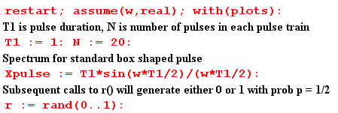
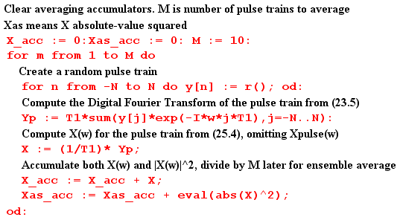
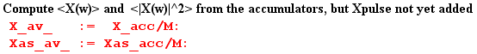

At this point, before Xpulse(ω) is added to the result, we plot <|X(ω)|2>. As expected, we see the peaks of δ6 spaced by 2π and having height around 10 units,

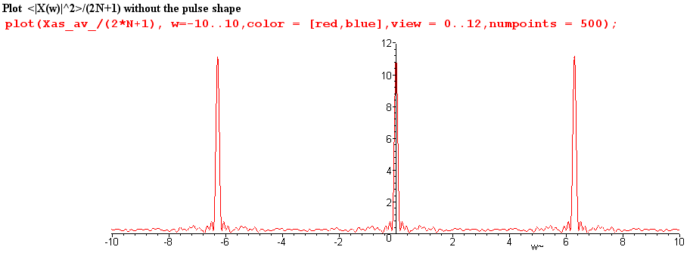

We now insert copies of Xpulse(ω) as appropriate,

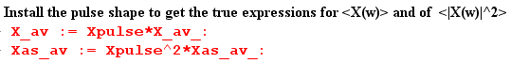

and then we can plot $\frac{<|X(ω)|2>}{(2N+1)}$ for ω in the same range (-10,10)

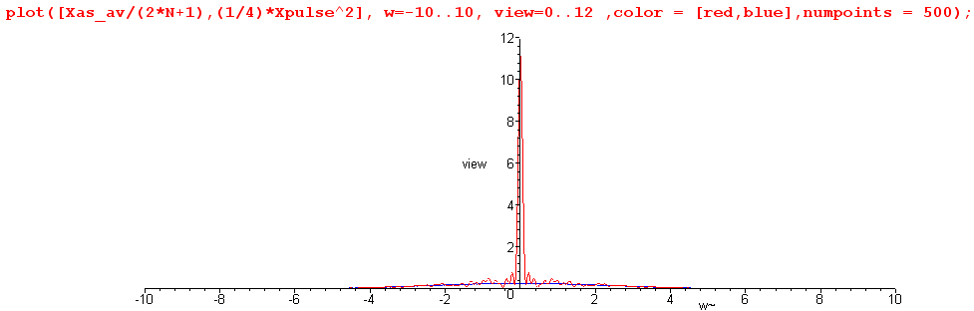

We see that the zeros of the sinc function have killed off the adjacent peaks.

Next, we restrict the plot height to be 0.8 units to view the detail, chopping off the δ6 peak,

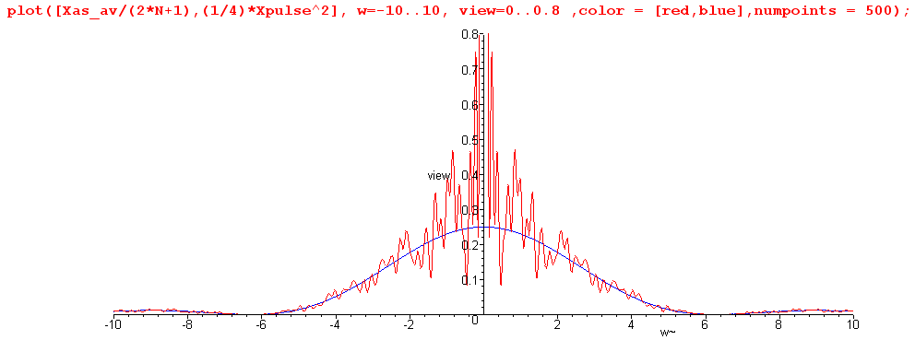

The spectrum $\frac{<|X(ω)|2>}{(2N+1)}$ is seen to have a continuous component which very well approximates one quarter of the sinc2 curve, as we hoped it would. This tracking also occurs away from the central peak. Here is a blow-up of the above plot for ω in the range (5,30)

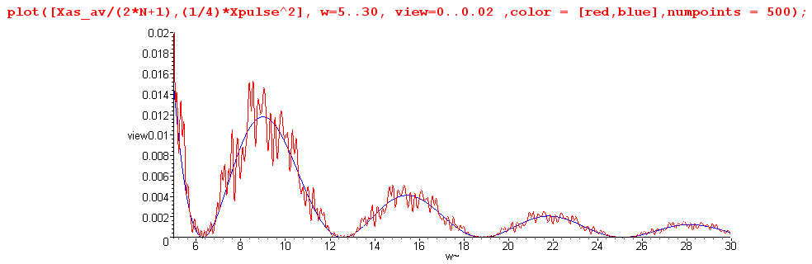

It might be noted that Maple does this work analytically, so that Was-av is a function of ω having a huge number of trigonometric terms. For the reader's interest, we show Was-av(ω) for a typical program run :

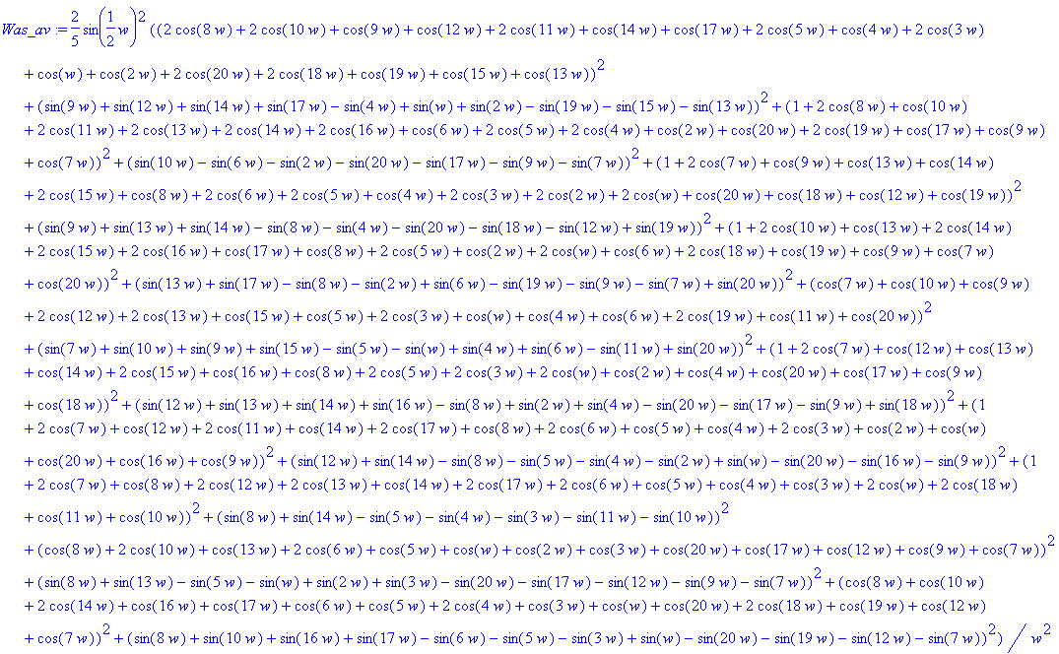

In more serious work with larger numbers, one would of course do this in a more numeric fashion, but we are able to confirm the basic results even with this small experiment.

section 26 starting part
____________________________
In this Chapter we introduced some new definitions, such as the autocorrelation function, and the Wiener-Khintchine relation. We used these in our derivation of the statistical average of the spectral density of a pulse train.

The whole thing was somewhat of a deception, and here we want to make sure the reader has not missed this point. Our main purpose for introducing autocorrelation and Wiener-Khintchine was to get these well-known terms into our dialog, since they appear in texts.

In reality, there is nothing at all new in this Chapter, and we certainly did not need to use the words autocorrelation or Wiener-Khintchine to get our main results.

As shown in (32.7), autocorrelation is just a standard convolution of x(t) with x(-t), and Wiener-Khintchine is just the convolution theorem (3.6) applied to this convolution equation, with (7.2) and (7.1) thrown in. In effect, we could have just defined R(ω) to be |X(ω)|2, given it the new name "autocorrelation", and then forgotten about it.

Here for example is a simple derivation of (34.10):

Start off with the pulse train "i" with statistical coefficients an(i), as in (34.2),

x(i)(t) = $\sum_{n = -∞}^{∞}{}$ an(i) xpulse(t - nT1) (36.1)

Fourier transform both sides in the usual manner, picking up the usual time-shift phase,

X(i)(ω) = Xpulse(ω) $\sum_{n = -∞}^{∞}{}$ an(i) e-inωT$_{1}$ (36.2)

Magnitude-square this thing to get

|X(i)(ω)|2 = |Xpulse(ω)|2 $\sum_{m = -∞}^{∞}{}$ $\sum_{n = -∞}^{∞}{}$ am(i)an(i) eiω(m-n)T$_{1}$ (36.3)

Finally, divide by 2π, use definition (33.1) for E, and average over ensemble index i to get

< E(ω) > = Epulse(ω) $\sum_{m = -∞}^{∞}{}$ $\sum_{n = -∞}^{∞}{}$ <aman> eiω(m-n)T$_{1}$

which is (34.10).

The derivation of (35.8) would then proceed as outlined in Section 35 with no mention of the autocorrelation function.

