This is the Title PhL 3.26.05

Note that page numbering is turned on in this template.

Chapter 6: Statistical Pulse Trains

32. The Autocorrelation Function

This is a very simple idea which is often made to seem complicated. Start with a reasonable function x(t). Define the autocorrelation function of x(t) as follows:

rx(t) ≡ $^{\int_{-∞}^{∞}{}}$ dt' x(t') x(t' + t) (32.1)

The integrand is the function evaluated at time t' times the same function evaluated at later time t'+t. Some texts might define the above with an extra overall "normalizing" constant factor; we leave it as shown.

A simple reflection property follows from the above definition (use t" = t' + t ):

rx(-t) = rx(t) (32.2)

Thus, in (32.1) we could put either +t or -t in the last parentheses.

Although we have not yet mentioned statistics and randomness, one could easily imagine the following situation. Suppose x(t') is some sort of random function ("noise") that takes values in the range -1 to 1. It seems likely that for a value of the separation t that is larger than some small value, you might get rx(t) = 0. The vague argument would be that there is no "correlation" between x(t') and x(t'+t), so the product of these two functions ought to be pretty random, and a sum of random numbers in the range -1 to 1 ought to be zero. Even in this case, we can see that the result is not zero if t = 0, since we are then summing a positive quantity. In fact, rx(0) is the area under x(t)2.

(a) Autocorrelation function for a Square Pulse.

Before going any further, let us compute the autocorrelation function for some simple case we are familiar with. A good candidate is x(t) = a square pulse of width τ and amplitude A. As in (9.1),

xpulse(t) = A [ θ(t + τ/2) - θ(t - τ/2) ] . (9.1)

One can easily do the above integral (32.1) to get the answer, but it is very obvious what the answer is. We are multiplying a box times a box shifted by t. Where they overlap, the integrand is A2. The boxes only overlap if the absolute value of shift t is less than the width τ of the pulse. If this is so, the size of the overlap is τ-|t|. If |t| is larger than τ, there is no overlap, so the integral is 0. Thus,

rpulse(t) = A2(τ-|t|) θ(τ-|t|) = (A2τ) [ 1 - |t|/τ ] θ(τ-|t|) (32.3)

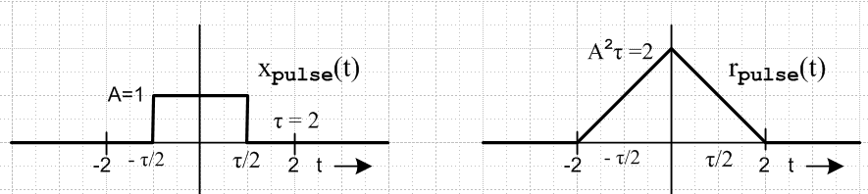

(b) Energy in a finite signal x(t)

The total energy in a finite duration signal x(t) can be computed in either the t-domain or the ω-domain using Parseval's formula (10.5), to which we add 1/R to each side.

E = $^{\int_{-∞}^{∞}{}}$dt |x(t)|2/R = $^{\int_{-∞}^{∞}{}}$dω $\frac{|X(ω)|2}{2πR}$ (32.4)

If we think of x(t) as the voltage across a resistor R, then dt x2(t)/R is the energy delivered to the resistor in time dt, and the integral on the left is the total energy in signal x(t). The dimensions on the right are, looking at (1.1),

dω $\frac{|X(ω)|2}{2πR}$ = sec-1 (volt-sec)2/ohms = (volt2/ohms)sec = watts-sec = joules = energy (32.5)

Setting R = 1Ω, we can write this as

E = $^{\int_{-∞}^{∞}{}}$dt p(t) = $^{\int_{-∞}^{∞}{}}$dω E(ω) (32.6)

p(t) ≡ |x(t)|2 = energy density in the t-domain (joule/sec = watt)
p(t)dt = energy in dt (joules)

E(ω) ≡ |X(ω)|2/2π = energy density in the ω-domain (joule-sec)
E(ω)dω = energy in dω (joules)

We shall refer to E(ω) as the spectral energy density of signal x(t) whose Fourier Transform is X(ω). The isolated single pulse xpulse(t) has a corresponding Epulse(ω) .

(c) The Spectral Density Connection: Wiener-Khintchine

Changing to t" = -t', we can trivially rewrite the definition (32.1) as follows:

rx(t) = $^{\int_{-∞}^{∞}{}}$dt"x(t - t") x(-t") . // energy units (32.7)

This has the standard convolution equation form (3.1) where we select

b(t) = x(t) ↔ B(ω) = X(ω)
c(t) = x(-t) ↔ C(ω) = X(−ω) = X(ω)* // from (7.1) and (7.2)

Thus, the diagonalized frequency domain form (3.6) is

Rx(ω) = |X(ω)|2 (32.8)

Dividing by 2π we find that

E(ω) = (1/2π) Rx(ω) (32.9)

This is the key result. It says that the Fourier integral transform of the autocorrelation function of x(t) is 2π times the spectral energy density of x(t). This seemingly simple result gets the elaborate label of a Wiener-Khintchine Relation, see Bennett and Davey, Data Transmission, p 334.

Note also from (32.1) that rx(t) evaluated at t = 0 gives the total energy in signal x(t),

rx(0) = $^{\int_{-∞}^{∞}{}}$dt x2(t) ≡ E = total energy in signal x(t) (32.10)

For us, the significance of (32.9) is that we can "inject statistics" into a computation of the autocorrelation function, and then we will know the power spectrum of our statistical signal from (32.9). All we have to do is Fourier transform the autocorrelation function rx(t). Examples will follow.

(d) Verification of Wiener-Khintchine for a Square Pulse.

In (32.3) we have the autocorrelation function for a square pulse. One can insert this into the Fourier transform (1.1) to compute Rx(ω).

Rx(ω) = $^{\int_{-τ}^{τ}{}}$ dt (A2τ) [ 1 - | t | / τ ] e-iωt = 2(A2τ) $^{\int_{0}^{τ}{}}$dt (1-t/τ) cos(ωt)

= 2(A2τ) (1-cos(ωτ))/(ω2τ) = 4(A2τ) sin2(ωτ/2)/(ω2τ) = (A2τ2) sin2(ωτ/2)/(ωτ/2)2

= (Aτ)2 [ sinc(ωτ/2) ]2 (32.11)

and this is recognized from (9.2) to be |X(ω)|2 for the square pulse, in agreement with (32.8) .

(e) Cross-correlation, convolution, and autocorrelation

Note: a* means complex conjugation, b ∗ c means convolution, b ⋆ c means cross-correlation

The cross-correlation of two functions b and c is defined this way

(b⋆c)(t) = $^{\int_{-∞}^{∞}{}}$ dt' b*(t')c(t+t') = (c⋆b)*(-t) (32.12)

where the right equality is easy to show setting t+t' = t". So in general, b⋆c ≠ c⋆b .

In Section 7 we noted that a function is Hermitian if f*(-t) = f(t).

Fact: If b and c are both Hermitian, then b⋆c = c⋆b. (32.13)

Proof: b⋆c = $^{\int_{-∞}^{∞}{}}$ dt' b*(t')c(t+t') = $^{\int_{-∞}^{∞}{}}$ dt' b(-t')c*(-t-t') = $^{\int_{-∞}^{∞}{}}$ dt' b(t"+t)c*(t") = c⋆b

If b and c are both real and both even, then again, b⋆c = c⋆b .

The convolution of two functions b and c we saw from the (3.1) and (3.2) was this

(b∗c)(t) = $^{\int_{-∞}^{∞}{}}$ dt' b(t')c(t-t') = (c∗b)(t)

In order to relate these two operations, we need to show more detail in the notation. Thus, using t" = -t',

[b(t)⋆c(t)](t) = $^{\int_{-∞}^{∞}{}}$ dt' b*(t')c(t+t') = $^{\int_{-∞}^{∞}{}}$ dt" b*(-t")c(t-t") = [b*(-t) ∗ c(t)](t)

Then if b(t) is a Hermitian function so b*(-t) = b(t), then we have shown that :

Fact: If b is Hermitian, then b⋆c = c∗b. (32.14)

If b = c = real, then we have from (32.1) and (32.2),

rb(t) = $^{\int_{-∞}^{∞}{}}$ dt' b(t')b(t'+t) = $^{\int_{-∞}^{∞}{}}$ dt' b(t')b(t'-t)

so we have just proven this fact :

Fact: If b is real, then rb = b⋆b = b∗b (32.15)

Thus, for a real function b, the autocorrelation function is the cross-correlation function of b with itself.
This then gives some motivation for the name associated with rb. It is also the convolution of b with itself.

33. Energy and Power of a Pulse Train

In subsections (a) through (d) we deal only with simple pulse trains. Along the way, certain facts are developed which apply to general as well as simple pulse trains. In subsection (e) we gather together these general facts, and then show how quantities of interest can be related to the autocorrelation function.

(a) Infinite Simple Pulse Train

This is the first section in which we use the δ(0) notation of Appendix A which may make the reader feel a bit uncomfortable. In subsection (b) we shall repeat everything for a finite pulse train and then take the limit N→∞ to obtain the same results without using δ(0). In both sections we shall include the Z transform in passing, but our main work is in the ω variable, not the z variable.

From Section 14 (a) we know the spectrum of an infinite pulse train formed from pulses xpulse(t) separated by time T1 ,

x(t) = $\sum_{n = -∞}^{∞}{}$ xpulse(t - nT1) (14.1)
X(ω) = Xpulse(ω) $\sum_{m = -∞}^{∞}{}$ 2π δ(ωT1 - 2πm) (14.4)

We can obtain the same expressions from box (25.4) which summarizes amplitude modulated pulse trains by setting all amplitudes to yn = 1 and changing w,W to x,X:

x(t) = $\sum_{n = -∞}^{∞}{}$ yn xpulse(t -tn) = $\sum_{n = -∞}^{∞}{}$ xpulse(t -tn) (33.1)

X(ω) = (1/T1)Xpulse(ω) X'(ω) = Xpulse(ω) X"(z) (33.2)

X"(z) = X'(ω)/T1 = $\sum_{n = -∞}^{∞}{}$yn e-iωnT$_{1}$ = $\sum_{n = -∞}^{∞}{}$ e-iωnT$_{1}$ . (33.3)

X'(ω) is the Digital Fourier Transform of x(t), and X"(z) is the Z Transform, where z = eiωT$_{1}$
In the last line we then use (13.2)

$\sum_{n = -∞}^{∞}{}$e±ink = $\sum_{m = -∞}^{∞}{}$2πδ(k - 2πm) -∞ < k < ∞ (13.2)

so that (33.3) becomes

X"(z) = X'(ω)/T1 = $\sum_{n = -∞}^{∞}{}$ e-iωnT$_{1}$ = $\sum_{m = -∞}^{∞}{}$2πδ(ωT1 - 2πm) (33.4)

and then (33.2) says

X(ω) = (1/T1)Xpulse(ω) X'(ω) = Xpulse(ω) $\sum_{m = -∞}^{∞}{}$2πδ(ωT1 - 2πm) (33.5)

in agreement with (14.4) quoted just above (33.1).

To find the frequency domain power spectrum of a signal x(t), our first task is to compute | X(ω) |2. From (33.2) we get

|X(ω)|2 = |Xpulse(ω)|2 (1/T1)2 |X'(ω)|2 = |Xpulse(ω)|2 | X"(z) |2 z = eiωT$_{1}$ (33.6)

We therefore must deal with the following object, using (33.4),

| X"(z) |2 = (1/T1)2 |X'(ω)|2 = [ $\sum_{m = -∞}^{∞}{}$2πδ(ωT1 - 2πm) ] 2 , (33.7)

and we are now faced with the issue of squaring delta functions. Formally these objects don't exist in the realm of distribution theory, but as discussed in Appendix A, we can deal with them in an ad hoc way which proves to be useful.

[ $\sum_{m = -∞}^{∞}{}$2πδ(ωT1 - 2πm) ] 2 = $\sum_{m = -∞}^{∞}{}$2πδ(ωT1 - 2πm) $\sum_{n = -∞}^{∞}{}$2πδ(ωT1 - 2πn)

= $\sum_{m = -∞}^{∞}{}$ $\sum_{n = -∞}^{∞}{}$2πδ(ωT1 - 2πm) 2πδ(ωT1 - 2πn)

Looking at the product of the two delta functions, there can be no contribution to the double sum unless m = n, so we continue
= $\sum_{m = -∞}^{∞}{}$ 2πδ(ωT1 - 2πm) 2πδ(0) = [2πδ(0)] $\sum_{m = -∞}^{∞}{}$ 2πδ(ωT1 - 2πm)
so that
[ $\sum_{m = -∞}^{∞}{}$2πδ(ωT1 - 2πm) ] 2 = [2πδ(0)] $\sum_{m = -∞}^{∞}{}$ 2πδ(ωT1 - 2πm) . (33.8)

The object δ(0) is formally undefined, but in Appendix A we ascribe the meaning that 2πδ(0) = 2N+1 in the limit that N→ ∞ and we can always "undo the limit" when necessary. We shall firm up this idea in section (b) directly below. So we have shown then that

| X"(z) |2 = (1/T1)2 |X'(ω)|2 = [2πδ(0)] $\sum_{m = -∞}^{∞}{}$ 2πδ(ωT1 - 2πm) (33.9)
or
$\frac{|X"(z)|2}{[2πδ(0)]}$ = (1/T1)2$\frac{|X'(ω)|2}{[2πδ(0)]}$ = $\sum_{m = -∞}^{∞}{}$ 2πδ(ωT1 - 2πm) (33.10)

Then from (33.6)

$\frac{|X(ω)|2}{[2πδ(0)]}$ = |Xpulse(ω)|2 $\frac{|X"(z)|2}{[2πδ(0)]}$ = |Xpulse(ω)|2 (1/T1)2$\frac{|X'(ω)|2}{[2πδ(0)]}$

= |Xpulse(ω)|2 $\sum_{m = -∞}^{∞}{}$ 2πδ(ωT1 - 2πm) (33.11)

We shall now repeat the above set of steps for a finite pulse train.

(b) Finite Simple Pulse Train

Our finite pulse train always has pulses ranging from n = -N to N instead of from n = -∞ to ∞. We start off exactly as in the previous section but with limited sums

x(t) = $\sum_{n = -N}^{N}{}$ yn xpulse(t -tn) = $\sum_{n = -N}^{N}{}$ xpulse(t -tn) (33.12)

X(ω) = (1/T1)Xpulse(ω) X'(ω) = Xpulse(ω) X"(z) (33.13)

X"(z) = X'(ω)/T1 = $\sum_{n = -N}^{N}{}$yn e-iωnT$_{1}$ = $\sum_{n = -N}^{N}{}$ e-iωnT$_{1}$ (33.14)

In the last line we then use (13.3)

$\sum_{n = -N}^{N}{}$ eink = 2π { $\frac{sin[(N+1/2)k]}{2π sin(k/2)}$ } ≡ 2π δ5(k,N) -∞ < k < ∞ (13.3)

where δ5 is a periodic delta function model discussed in Appendix A (b). Equation (33.14) becomes

X"(z) = X'(ω)/T1 = $\sum_{n = -N}^{N}{}$ e-iωnT$_{1}$ = 2π δ5(ωT1,N) (33.15)

and then equation (33.13) says

X(ω) = Xpulse(ω) 2π δ5(ωT1,N) . (33.16)

This δ5 is periodic with period 2π and has identical peaks separated by 2π. For finite N, these are peaks of finite width and height. Squaring, we find

| X(ω) |2 = | Xpulse (ω) |2 [2π δ5(ωT1,N)]2 . (33.17)

Recalling the definition of the δ6 delta function model from Appendix A,

2π δ6(k,N) ≡ $\frac{[2πδ5(k,N)]2}{(2N+1)}$ (A.20)

we obtain

$\frac{|X(ω)|2}{(2N+1)}$ = | Xpulse (ω) |2 2π δ6(ωT1,N) (33.18)

and this is the finite pulse train result. We can then take the limit N→∞ and make use of

limN→∞ δ6(ωT1,N) = $\sum_{m = -∞}^{∞}{}$δ(ωT1-2πm) (A.21)

to find that

limN→∞ [$\frac{|X(ω)|2}{(2N+1)}$] = | Xpulse (ω) |2 $\sum_{m = -∞}^{∞}{}$δ(ωT1-2πm) (33.19)

and this replicates (33.11) with the promised connection 2πδ(0) = limN→∞ (2N+1).

It is useful now to provide some side-by-side comparisons of results

X"(z) = X'(ω)/T1 = $\sum_{n = -∞}^{∞}{}$ e-iωnT$_{1}$ = $\sum_{m = -∞}^{∞}{}$2πδ(ωT1 - 2πm) infinite (33.4)
X"(z) = X'(ω)/T1 = $\sum_{n = -N}^{N}{}$ e-iωnT$_{1}$ = 2π δ5(ωT1,N) finite (33.15)

X(ω) = Xpulse(ω) $\sum_{m = -∞}^{∞}{}$2πδ(ωT1 - 2πm) infinite (33.5)
X(ω) = Xpulse(ω) 2π δ5(ωT1,N) . finite (33.16)

$\frac{|X(ω)|2}{[2πδ(0)]}$ = |Xpulse(ω)|2 $\sum_{m = -∞}^{∞}{}$ 2πδ(ωT1 - 2πm) infinite (33.11)
$\frac{|X(ω)|2}{(2N+1)}$ = | Xpulse (ω) |2 2π δ6(ωT1,N) finite (33.18)

One can interpret $\frac{|X(ω)|2}{[2πδ(0)]}$ as the value of |X(ω)|2 per pulse in an infinite pulse train.

(c) Spectral Energy/Power Density of a Simple Pulse Train

In this section, everything is in the frequency domain, nothing is in the time domain.

Recall from (32.6) that

E(ω) ≡ |X(ω)|2/2π = energy density in the ω-domain (joule-sec) (32.6)
E(ω)dω = energy in dω (joules)

where E(ω) is the spectral energy density of signal x(t) whose Fourier Transform is X(ω).
If we divide E(ω) by 2N+1 or 2πδ(0) we obtain the pulse train's average spectral energy density per pulse, which is the same as the energy density of an average pulse in the pulse train. Using our two expressions above for infinite and finite pulse trains, we then find

$\frac{E(ω)}{[2πδ(0)]}$ = $\frac{|X(ω)|2}{2π[2πδ(0)]}$ = $\frac{1}{2π}$|Xpulse(ω)|2 $\sum_{m = -∞}^{∞}{}$ 2πδ(ωT1 - 2πm)
$\frac{E(ω)}{(2N+1)}$ = $\frac{|X(ω)|2}{2π(2N+1)}$ = $\frac{1}{2π}$ | Xpulse (ω) |2 2π δ6(ωT1,N) (33.20)

If we divide the energy of the average pulse by T1, we obtain power of an average pulse, and this is the same as the average power of the pulse train. Thus,

P(ω) ≡ $\frac{E(ω)}{T1[2πδ(0)]}$ = $\frac{|X(ω)|2}{2πT1[2πδ(0)]}$ = $\frac{1}{2π}$|Xpulse(ω)|2 (1/T1)$\sum_{m = -∞}^{∞}{}$ 2πδ(ωT1 - 2πm)
P(ω) ≡ $\frac{E(ω)}{T1[2N+1]}$ = $\frac{|X(ω)|2}{2πT1[2N+1]}$ = $\frac{1}{2π}$|Xpulse(ω)|2 (1/T1) 2π δ6(ωT1,N) (33.21)

If is perhaps helpful to define

T ≡ (33.22)

Then the above maybe be restated

P(ω) ≡ $\frac{E(ω)}{T}$ = $\frac{|X(ω)|2}{2πT}$ = $\frac{1}{2π}$|Xpulse(ω)|2 (1/T1)$\sum_{m = -∞}^{∞}{}$ 2πδ(ωT1 - 2πm)
P(ω) ≡ $\frac{E(ω)}{T}$ = $\frac{|X(ω)|2}{2πT}$ = $\frac{1}{2π}$|Xpulse(ω)|2 (1/T1) 2π δ6(ωT1,N) (33.23)

Meanwhile, our xpulse(t) which lasts only for duration T1 itself has an energy and a power

Ppulse(ω) ≡ $\frac{Epulse(ω)}{T1}$ = $\frac{|Xpulse(ω)|2}{2πT1}$ (33.24)

We can then write (***) in the following compact form

P(ω) ≡ Ppulse(ω)$\sum_{m = -∞}^{∞}{}$ 2πδ(ωT1 - 2πm) joules
P(ω) ≡ Ppulse(ω) 2π δ6(ωT1,N) joules (33.25)

Notice that δ(ωT1 - 2πm) and δ6(ωT1,N) are both dimensionless, so the dimensions in each equation trivially match. A power density P(ω) has dimensions of energy = joules, so that P(ω)dω then has the dimensions of joules/sec = watts, and this is the pulse train power contained in interval dω of the spectrum.

For the infinite pulse train, we are always allowed to write

2π δ(ωT1 - 2πm) = (2π/T1) δ(ω - m(2π/T1)) = ω1 δ(ω - mω1) ω1 ≡ 2π/T1

to get
P(ω) ≡ Ppulse(ω) ω1$\sum_{m = -∞}^{∞}{}$ δ(ω - mω1) infinite (33.26)

which shows more explicitly that the power lines occur at the harmonics ω = mω1 . Recall now these two earlier facts

c(ω) ≡ (1/T1)Xpulse(ω) (14.14)

cm ≡ c(mω1) = (1/T1)Xpulse(mω1) (14.10)

For the infinite pulse train we can then write

P(ω) ≡ Ppulse(ω) ω1$\sum_{m = -∞}^{∞}{}$ δ(ω - mω1) = $\frac{|Xpulse(ω)|2}{2πT1}$ $\frac{2π}{T1}$ $\sum_{m = -∞}^{∞}{}$ δ(ω - mω1)

= $\frac{|Xpulse(ω)|2}{T12}$$\sum_{m = -∞}^{∞}{}$ δ(ω - mω1) = |c(ω)|2 $\sum_{m = -∞}^{∞}{}$ δ(ω - mω1) = $\sum_{m = -∞}^{∞}{}$ |c(mω1)|2 δ(ω - mω1)
so that
P(ω) = $\sum_{m = -∞}^{∞}{}$ |cm|2 δ(ω - mω1). (33.27)

Recall from box (15.12) that Dim(cm) = Dim[x(t)] = volts (say), so |cm|2 = watts into a 1Ω resistor, and since δ(ω - mω1) has dimensions sec, |cm|2 δ(ω - mω1) then has dimensions watt-sec = joules, as befits any P(ω) object.
If we assume x(t) is a real pulse train, then X(ω) is Hermitian X(-ω) = [ X(ω)]* by (7.1), which means

c-m= (1/T1)Xpulse(-mω) = (1/T1)[Xpulse(mω)]* = cm*
so
|c-m|2 = |cm|2 x(t) real (33.28)

and then we can fold the negative part of the sum in (**) to get

P(ω) = $\sum_{m = -∞}^{∞}{}$ |cm|2 δ(ω - mω1) = |c0|2 δ(ω) + 2$\sum_{m =1}^{∞}{}$|cm|2 δ(ω - mω1) (33.29)

and then finally, recalling from our Fourier Series box (15.2) that cm = [ am - ibm ]/2 and b0= 0 we get

P(ω) = a02 δ(ω) + (1/2) $\sum_{m =1}^{∞}{}$(am2+bm2) δ(ω - mω1) (33.30)

(d) Average Power P for a Simple Pulse Train

We seek an expression for the average power P in a general pulse train. This is of course a time domain quantity, not a frequency domain quantity.

P = [ total energy in pulse train / time duration of pulse train ] = average pulse train power

= (1/T)$^{\int_{-∞}^{∞}{}}$dt |x(t)|2 = $^{\int_{-∞}^{∞}{}}$dω $\frac{|X(ω)|2}{2πT}$ // from (32.4) with R = 1Ω
so
P = $^{\int_{-∞}^{∞}{}}$dω P(ω) . // from (33.23) (33.31)

This is certainly reasonable since P(ω) is the average spectral power density of the pulse train.

For the special case of a simple pulse train, we found above that

P(ω) = $\sum_{m = -∞}^{∞}{}$ |cm|2 δ(ω - mω1) = a02 δ(ω) + (1/2) $\sum_{m =1}^{∞}{}$(am2+bm2) δ(ω - mω1)

Therefore the power in a simple pulse train is given by

P = $\sum_{m = -∞}^{∞}{}$ |cm|2 = a02 + (1/2) $\sum_{m =1}^{∞}{}$(am2+bm2) (33.32)

(e) General Pulse Train results and connection with the Autocorrelation Function

Certain results of the previous section apply to general pulse trains and we gather them here:

E(ω) ≡ |X(ω)|2/2π = energy density in the ω-domain (joule-sec) (32.6)

T ≡ (33.22)

P(ω) ≡ $\frac{E(ω)}{T}$ = $\frac{|X(ω)|2}{2πT}$ (33.23)

Ppulse(ω) ≡ $\frac{Epulse(ω)}{T1}$ = $\frac{|Xpulse(ω)|2}{2πT1}$ (33.24)

P = $^{\int_{-∞}^{∞}{}}$dω P(ω) . (33.31)

We now bring the autocorrelation function into the discussion. Let x(t) be an arbitrary but real pulse train, and recall that

rx(t) ≡ $^{\int_{-∞}^{∞}{}}$ dt' x(t') x(t' + t) (32.1)

Then, using T from (33.22),

rx(0) ≡ $^{\int_{-∞}^{∞}{}}$ dt' x(t')2 = P T = E = total energy in the pulse train (33.33)

so the average pulse train power maybe written in terms of the autocorrelation function evaluated at t = 0,

P = rx(0)/T . (33.34)

We diagonalized (32.1) treated as a convolution equation to obtain

|X(ω)|2 = Rx(ω)

which we called the Wiener-Khintchine Relation. Here Rx(ω) is the Fourier Integral Transform of the autocorrelation function rx(t) of x(t). Then from (33.23) that P(ω) = $\frac{|X(ω)|2}{2πT}$we get

P(ω) = Rx(ω)/ (2πT) (33.35)

In this way, both P and P(ω) can be expressed in terms of the autocorrelation function. Thus, one approach to finding P and P(ω) for a pulse train is to try and determine rx(t).
Here then is a box summarizing all the general pulse train results:

Energy and Power Properties of a General Pulse Train (33.36)

E(ω) ≡ |X(ω)|2/2π = energy density in the ω-domain (joule-sec) (32.6)

T ≡ (33.22)

P(ω) ≡ $\frac{E(ω)}{T}$ = $\frac{|X(ω)|2}{2πT}$ = Rx(ω)/ (2πT) joules (33.23) and (33.35)

Ppulse(ω) ≡ $\frac{Epulse(ω)}{T1}$ = $\frac{|Xpulse(ω)|2}{2πT1}$ (33.24)

P = $^{\int_{-∞}^{∞}{}}$dω P(ω) = rx(0)/T watts (33.31) and (33.34)

If P(f)df = P(ω)dω = P(ω) 2πdf , then P(f) = 2πP(ω).

34. Statistical Amplitude Modulated Pulse Trains Part I

(a) Spectral Energy/Power Density for a General Pulse Train

In the previous Section we dealt with simple pulse trains. Here we consider the more general amplitude modulated pulse train. In all equations, one can replace $\sum_{n = -∞}^{∞}{}$ by $\sum_{n = -N}^{N}{}$to adapt the equation to a finite pulse train instead of an infinite one.

x(t) = $\sum_{n = -∞}^{∞}{}$ yn xpulse(t -tn) (34.1)

X(ω) = (1/T1)Xpulse(ω) X'(ω) = Xpulse(ω) X"(z) (34.2)

X"(z) = X'(ω)/T1 = $\sum_{n = -∞}^{∞}{}$yn e-iωnT$_{1}$. (34.3)

To find the frequency-domain power spectrum of a signal x(t), our first task is to compute | X(ω) |2. From (34.2) we get

|X(ω)|2 = |Xpulse(ω)|2 (1/T1)2 |X'(ω)|2 = |Xpulse(ω)|2 | X"(z) |2 z = eiωT$_{1}$ (34.4)

We therefore must deal with the following object, using (33.4),

| X"(z) |2 = (1/T1)2 |X'(ω)|2 = | $\sum_{n = -∞}^{∞}{}$yn e-iωnT$_{1}$ | 2

= $\sum_{n = -∞}^{∞}{}$yn e-iωnT$_{1}$ $\sum_{m = -∞}^{∞}{}$ym* e+iωmT$_{1}$ = $\sum_{n = -∞}^{∞}{}$ $\sum_{m = -∞}^{∞}{}$ ym* yn eiω(m-n)T$_{1}$ (34.5)
so that
| X(ω) |2 = | Xpulse(ω) |2 $\sum_{n = -∞}^{∞}{}$ $\sum_{m = -∞}^{∞}{}$ ym* yn eiω(m-n)T$_{1}$ (34.6)

From box (33.36) we then have

E(ω) ≡ |X(ω)|2/2π = (1/2π) | Xpulse(ω) |2 $\sum_{n = -∞}^{∞}{}$ $\sum_{m = -∞}^{∞}{}$ ym* yn eiω(m-n)T$_{1}$ (34.7)
P(ω) ≡ $\frac{E(ω)}{T}$ = (1/2πT) | Xpulse(ω) |2$\sum_{n = -∞}^{∞}{}$ $\sum_{m = -∞}^{∞}{}$ ym* yn eiω(m-n)T$_{1}$ (34.8)

which we can write as

E(ω) = T1 Ppulse(ω) $\sum_{n = -∞}^{∞}{}$ $\sum_{m = -∞}^{∞}{}$ ym* yn eiω(m-n)T$_{1}$ (34.9)
P(ω) = T1 Ppulse(ω) (1/T) $\sum_{n = -∞}^{∞}{}$ $\sum_{m = -∞}^{∞}{}$ ym* yn eiω(m-n)T$_{1}$ (34.10)

P = $^{\int_{-∞}^{∞}{}}$dω P(ω) . (33.31) (34.11)

Not knowing details of the yn there is not much else we can do in these expressions.

(b) Spectral Energy/Power Density for a Statistical Pulse Train

We imagine now a large ensemble of I pulse trains in which a particular pulse train is labeled by index i. This pulse train has coefficients yn(i) . We are interested in the ensemble averages of E(ω) and P(ω) and P. We indicate the ensemble average of some quantity Q as <Q>. By averaging the last three equations above we obtain

<E(ω)> = T1 Ppulse(ω) $\sum_{n = -∞}^{∞}{}$ $\sum_{m = -∞}^{∞}{}$ <ym* yn> eiω(m-n)T$_{1}$ (34.12)
<P(ω)> = T1 Ppulse(ω) (1/T) $\sum_{n = -∞}^{∞}{}$ $\sum_{m = -∞}^{∞}{}$ <ym* yn> eiω(m-n)T$_{1}$ (34.13)

<P> = $^{\int_{-∞}^{∞}{}}$dω <P(ω)> . (34.14)

where

<ym* yn> = (1/I) < ym(i)* yn(i)> (34.15)

Up to this point we have tried to be general, allowing the ym(i) to be complex coefficients, but from now on we consider them to be real, so we can delete the asterisks in the above equations.

A very simple case to consider is this, where A and B are real,

ym = A probability p
ym = B probability 1-p (34.16)

Remember that index m labels pulse location m in the pulse train. If probabilities of a pulse value at locations m and at n are uncorrelated (they are independent of each other), then we can write the averaged coefficients as follows, first for two different locations m ≠ n, then for the same location m = n :

n ≠ m α ≡ <ymyn> = [pp] AA + [p(1-p)] AB + [(1-p)p]BA + [(1-p)(1-p)]BB

n = m β ≡ <ym2> = [p]AA + [(1-p)] BB (34.17)

In the square brackets [..] we indicate the probability of some case occurring, and this is multiplied by the value that the quantity in question takes in that case. The reader must now stop reading and stare at the above equations until they make complete sense. Notice that the second line is quite distinct from the first line. In the double summation in (34.13), there are both "diagonal" terms where m = n, and off diagonal terms where m≠n. These groupings must be treated separately according to the above. We have defined new symbols α and β to emphasize that, for the situations shown, there is no longer any dependence on the n and m indices for these quantities. In a later section, we shall encounter a situation where the above equations do not apply because there is correlation between positions m and n (the AMI line code).

Inserting (34.17) into (34.13) gives

<P(ω)> = T1 Ppulse(ω) (1/T) { α$\sum_{n = -∞}^{∞}{}$ $\sum_{m ≠ n}^{}{}$ [ eiω(m-n)T$_{1}$] + β$\sum_{n = -∞}^{∞}{}$ $\sum_{m = n}^{}{}$ [1] } (34.18)

In Section 35 we shall evaluate this important result for infinite and finite pulse trains, but we pause momentarily for a digression.

(c) Digression on expectation values, correlation and covariance

In the language of statistics, one can imagine a "random variable" Ym associated with location m in our pulse train, and this variable can take certain values ym (perhaps 0 and 1). We imagine a statistical ensemble of pulse trains indexed by i, and at location m the ith pulse train has value ym(i) of Ym.

If all pulse trains in our ensemble of pulse trains count the same in our average (they do), then one can write <ymyn> in (35.1) as

E(YmYn) = (1/I) $\sum_{i = 1}^{I}{}$ ym(i)yn(i) in the sense of E(XY) = (1/I) $\sum_{i = 1}^{I}{}$x(i)y(i)

where E(q) means the expectation value of quantity q. This particular expectation value has a special name: it is called the correlation of X and Y. So in fact we have

<ymyn> = E(YmYn) = (1/I) $\sum_{i = 1}^{I}{}$ ym(i)yn(i) ≡ corr(YmYn) // correlation of Ym and Yn

If corr(YmYn) is a significant positive or negative number, then the random variables Ym and Yn are strongly correlated in some way. This means that the probabilities of values of ym(i) and yn(i) are related in some way. One might wonder how there could be a correlation between locations m and n in a pulse train. We shall see this happen below in the discussion of the AMI lines code.

If Ym and Yn are independent random variables, we expect corr(YmYn) ≈ 0.

Two other expectation values of interest are these, the mean and the covariance :

E(Ym) = (1/I) $\sum_{i = 1}^{I}{}$ym(i) = <ym> // mean of Ym
E( [Ym - <ym>][ [Yn - <yn>]) = (1/I) $\sum_{i = 1}^{I}{}$[ ym(i) - <ym>] [yn(i)- <yn>]
= cov(YmYn) // covariance of Ym and Yn

If it happens that <ym> = 0 for a certain pulse train, then covariance and correlation are the same.

35. Statistical Amplitude Modulated Pulse Trains Part II

(a) Infinite Pulse train with Random Coefficients

Recall now equation (34.18) which we give a new number,

<P(ω)> = T1 Ppulse(ω) (1/T) { α$\sum_{n = -∞}^{∞}{}$ $\sum_{m ≠ n}^{}{}$ [ eiω(m-n)T$_{1}$] + β$\sum_{n = -∞}^{∞}{}$ $\sum_{m = n}^{}{}$ [1] } (35.1)

To evaluate the first double sum, we write it as

$\sum_{n = -∞}^{∞}{}$ $\sum_{m ≠ n}^{}{}$ [ eiω(m-n)T$_{1}$] = $\sum_{n = -∞}^{∞}{}$ { $\sum_{m = -∞}^{∞}{}$ [ eiω(m-n)T$_{1}$] – 1 }

= ( $\sum_{n = -∞}^{∞}{}$ e+iωnT$_{1}$ ) ($\sum_{m = -∞}^{∞}{}$e-iωmT$_{1}$ ) – $\sum_{n = -∞}^{∞}{}$1 = | $\sum_{n = -∞}^{∞}{}$ e+iωnT$_{1}$ |2 - $\sum_{n = -∞}^{∞}{}$1

We now quote two results from Appendix A

$\sum_{n = -∞}^{∞}{}$ 1 = [ 2π δ(0)] (A.32)
{$\sum_{n = -∞}^{∞}{}$ einωT$_{1}$}2 = [ 2πδ(0) ] { $\sum_{m = -∞}^{∞}{}$2π δ(ωT1- 2πm) } (A.35)

so the first double sum in (35.4) becomes

$\sum_{n = -∞}^{∞}{}$ $\sum_{m ≠ n}^{}{}$ [ eiω(m-n)T$_{1}$] = [ 2πδ(0) ] { $\sum_{m = -∞}^{∞}{}$2π δ(ωT1- 2πm) - 1} (35.5)

The second double sum in (35.4) is just

$\sum_{n = -∞}^{∞}{}$ $\sum_{m = n}^{}{}$ [1] = $\sum_{n = -∞}^{∞}{}$ [1] = [ 2π δ(0)] (35.6)

and therefore we may write (35.1) as

<P(ω)> = T1 Ppulse(ω) (1/T) { α [ 2πδ(0) ] [ $\sum_{m = -∞}^{∞}{}$2π δ(ωT1- 2πm) - 1] + β [ 2π δ(0)] }
= Ppulse(ω) (T1 [ 2πδ(0) ]/T) { α [ $\sum_{m = -∞}^{∞}{}$2π δ(ωT1- 2πm) - 1] + β }
or
<P(ω)> = Ppulse(ω) { (β-α) + α$\sum_{m = -∞}^{∞}{}$2π δ(ωT1- 2πm) } (35.7)

where we used T = [2πδ(0)]T1 from (33.22).

(b) Finite Pulse train with Random Coefficients

Recall again equation (34.18) but assume now a finite pulse train so the sums are different

<P(ω)> = T1 Ppulse(ω) (1/T) { α$\sum_{n = -N}^{N}{}$ $\sum_{m ≠ n}^{}{}$ [ eiω(m-n)T$_{1}$] + β$\sum_{n = -N}^{N}{}$ $\sum_{m = n}^{}{}$ [1] } (35.8)

To evaluate the first double sum, we write it as

$\sum_{n = -N}^{N}{}$ $\sum_{m ≠ n}^{}{}$ [ eiω(m-n)T$_{1}$] = $\sum_{n = -N}^{N}{}$ { $\sum_{m = -N}^{N}{}$ [ eiω(m-n)T$_{1}$] – 1 }
= ( $\sum_{n = -N}^{N}{}$ e+iωnT$_{1}$ ) ($\sum_{m = -N}^{N}{}$e-iωmT$_{1}$ ) – $\sum_{n = -N}^{N}{}$1 = |$\sum_{n = -N}^{N}{}$ e+iωnT$_{1}$ |2 - (2N+1) (35.9)

From Appendix A we have

$\sum_{n = -N}^{N}{}$ eink = 2π { $\frac{sin[(N+1/2)k]}{2π sin(k/2)}$ } = 2πδ5(k,N) (A.**)

so the first double sum in (35.9) becomes

$\sum_{n = -N}^{N}{}$ $\sum_{m ≠ n}^{}{}$ [ eiω(m-n)T$_{1}$] = [2πδ5(ωT1,N)]2 - (2N+1) . (35.10)

The second double sum in (35.9) is just

$\sum_{n = -N}^{N}{}$ $\sum_{m = n}^{}{}$ [1] = $\sum_{n = -N}^{N}{}$ [1] = (2N+1) (35.11)

and therefore we may write (35.8) as

<P(ω)> = T1 Ppulse(ω) (1/T) { α { [2πδ5(ωT1,N)]2 - (2N+1)} + β(2N+1) }

= Ppulse(ω) ((2N+1) T1/T) { α { $\frac{[2πδ5(ωT1,N)]2}{(2N+1)}$ - 1)} + β }

= Ppulse(ω) { (β-α) + α $\frac{[2πδ5(ωT1,N)]2}{(2N+1)}$ }

where this time we used T = (2N+1)T1 from (33.22). The factor multiplying α can be replaced using (A.20),

δ6(k,N) ≡ $\frac{1}{2π}$ $\frac{[2πδ5(ωT1,N)]2}{(2N+1)}$ = $\frac{1}{2N+1}$ $\frac{sin2[(N+1/2)k]}{2π sin2(k/2)}$ (A.20)

to give

<P(ω)> = Ppulse(ω) { (β-α) + α 2π δ6(ωT1,N) } (35.12)

which is the finite pulse train version of (35.7). In the limit N → ∞ we know from (A.21)

limN→∞ δ6(k,N) = $\sum_{m = -∞}^{∞}{}$δ(k-2πm) (A.21)

so that (35.13) becomes
<P(ω)> = Ppulse(ω) { (β-α) + α$\sum_{m = -∞}^{∞}{}$2π δ(ωT1-2πm) }
which reproduces (35.7).

(c) Statistical Pulse Trains Summary and Examples

Here then is a brief summary of the above results:

Spectral Energy Density of a Random Pulse Train (35.13)

x(t) = $\sum_{n = -∞}^{∞}{}$ yn xpulse(t - nT1) // or $\sum_{n = -N}^{N}{}$ for a finite pulse train
<P(ω)> = Ppulse(ω) [ (β-α) + α $\sum_{m = -∞}^{∞}{}$2π δ(ωT1- 2πm) ] // infinite (35.7)

<P(ω)> = Ppulse(ω) [ (β-α) + α 2π δ6(ωT1,N) ] // finite (35.12)

α = [pp] AA + [p(1-p)] AB + [(1-p)p]BA + [(1-p)(1-p)]BB // = <aman> when n≠m
(34.17)
β = [p]AA + [(1-p)] BB // = <aman> when n=m

A pulse has probably p of having amplitude A, and probability 1-p of having amplitude B.

A=1 and B=0 => α = p2 β = p (β - α) = p(1-p)

Example 1: If we set p = 1 in the above box, we get α = 1 and (β-α) = 0. In this limit, our statistical average pulse train spectrum becomes the same as that for the simple pulse train of (33.25)

P(ω) ≡ Ppulse(ω)$\sum_{m = -∞}^{∞}{}$ 2πδ(ωT1 - 2πm) joules
P(ω) ≡ Ppulse(ω) 2π δ6(ωT1,N) joules (33.25)

This is because when p = 1 every pulse in the pulse train has the same amplitude A, which is how a simple pulse train is defined. As we reduce p below p = 1, the line spectra are scaled down by α = p2 < 1, and a continuous spectrum starts to appear with (β - α) = p(1-p). The randomness of the ensemble creates a continuous component in the spectral power density P(ω) .

Example 2: Let p=0 with A=1 and B=0. Then every pulse has B = 0, x(t) ≡ 0, α = β = 0, and both terms in P(ω) vanish so there is zero spectral energy density.

Example 3: Let p=1/2 with A=1 and B=0, so α = p2 = 1/4 and β = p = 1/2. This pulse train then has an equal probably of 1's and 0's. We find from box (35.13) that

<P(ω)> = Ppulse(ω) [(1/4) + (1/4) $\sum_{m = -∞}^{∞}{}$2π δ(ωT1- 2πm) ] infinite (35.14)
<P(ω)> = Ppulse(ω) [(1/4) + (1/4) 2π δ6(ωT1,N) ] finite (35.15)

In (35.15) the discrete spectrum has been reduced to 1/4 of its full strength, and a continuous spectrum exists with coefficient 1/4 as shown.

(e) A detailed numerical statistical pulse train example

Recall from box (33.36) that for a finite pulse train,

P(ω) = $\frac{|X(ω)|2}{2πT}$ Ppulse(ω) = $\frac{|Xpulse(ω)|2}{2πT1}$ T = (2N+1)T1. (35.16)

Therefore we can write our p = 1/2 Example 3 result (35.15) as

$\frac{<|X(ω)|2>}{(2N+1)}$ = |Xpulse(ω)|2 [(1/4) + (1/4) 2π δ6(ωT1,N) ] . (35.17)

We shall use for xpulse(t) a square pulse of height 1 and τ = T1 = 1 so that, from (9.2),

|Xpulse (ω) | = sinc(ω/2) .

Since our pulse train will be fairly short (N = 20 pulses) and since we shall only average a small number of pulse trains (M = 10), we know our result will not exactly match (35.17). Still, we hope to see in our result some kind of continuous background spectrum which approximates the curve (1/4)|Xpulse(ω)|2 = (1/4) sinc2(ω/2), and we expect to see a delta-function-like peak which, since 2πδ6(0,N) = (2N+1), has a peak value of about (1/4)41 = 10.25. Since this will be added to the continuous background, the peak should have a height of 10.25 + .25 = 10.5. However, for our small ensemble, we won't have exactly p = 1/2, so the delta peak won't be exactly 10.5 units high.

We know that δ6 has identical peaks spaced by 2π, but we expect the non-central peaks to be suppressed by the sinc2(ω/2) zeros which occur at ω = n(2π).

First, here the self-documented Maple program which generates <|X(ω)|2> . The program also generates the quantity <X(ω)> upon which we shall comment in Section 36 below.

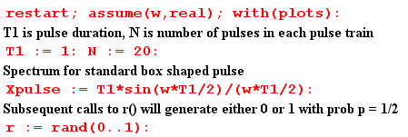
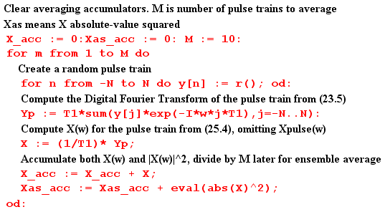
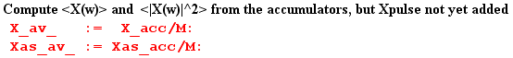

At this point, before Xpulse(ω) is added to the result, we plot <|X(ω)|2>. As expected, we see the peaks of δ6 spaced by 2π and having height around 10 units,

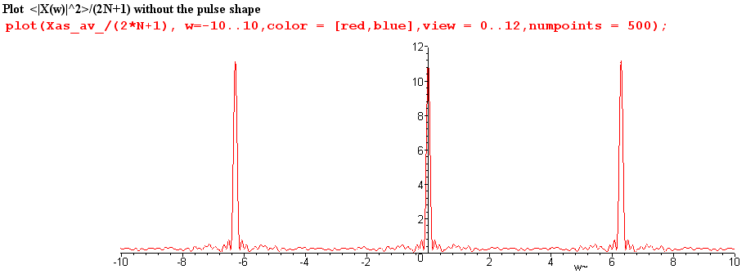

We now insert copies of Xpulse(ω) as appropriate,

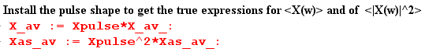

and then we can plot $\frac{<|X(ω)|2>}{(2N+1)}$ for ω in the same range (-10,10)

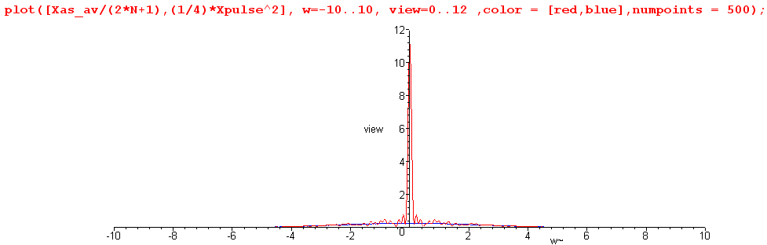

We see that the zeros of the sinc function have killed off the adjacent peaks.

Next, we restrict the plot height to be 0.8 units to view the detail, chopping off the δ6 peak,

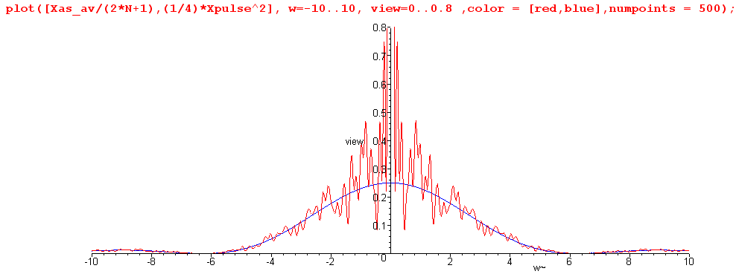

The spectrum $\frac{<|X(ω)|2>}{(2N+1)}$ is seen to have a continuous component which very well approximates one quarter of the sinc2 curve, as we hoped it would. This tracking also occurs away from the central peak. Here is a blow-up of the above plot for ω in the range (5,30)

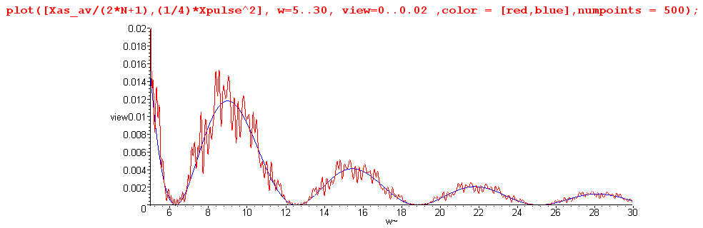

It might be noted that Maple does this work analytically, so that Was-av is a function of ω having a huge number of trigonometric terms. For the reader's interest, we show Was-av(ω) for a typical program run :

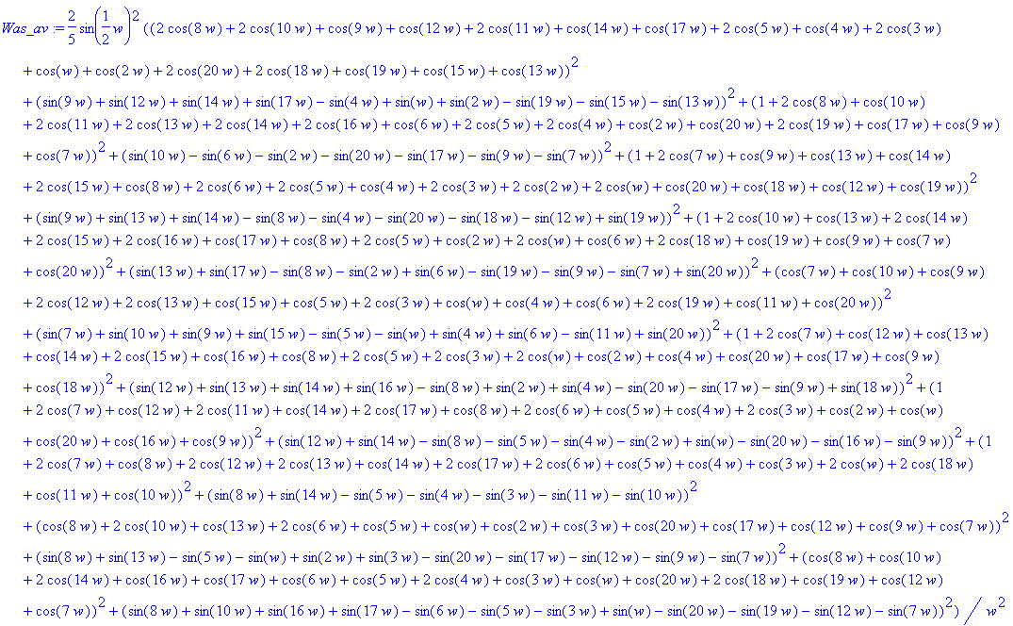

In more serious work with larger numbers, one would of course do this in a more numeric fashion, but we are able to confirm the basic results even with this small experiment.

36. A View from the High Ground

(a) What role has the autocorrelation function played in our development?

In Section 32 the autocorrelation function was first introduced, as rx(t) for x(t), and was computed for the simple case of a box pulse. Treating the definition of rx(t) as a convolution equation, the Wiener-Khintchine Relation Rx(ω) = |X(ω)|2 was trivially derived. It was then shown that the spectral energy density of a pulse train E(ω) = (1/2π) Rx(ω) due to this relation. Finally, it was shown that rx(0) = E, the total energy in the pulse train. We then commented on the origin of the name, showing that the auto-correlation function is the cross-correlation function of a function with itself when that function is real.

In Section 33 the autocorrelation function went unmentioned until the very end where it was again rather trivially noted that P = rx(0)/T since P = E/T, and that P(ω) = Rx(ω)/ (2πT) since Rx(ω) = |X(ω)|2.

In Sections 34 and 35 no reference was made at all to the autocorrelation function.

This leads us to make several comments:

(1) The autocorrelation function played no role whatsoever in our development of key equations such as

<P(ω)> = Ppulse(ω) [ (β-α) + α $\sum_{m = -∞}^{∞}{}$2π δ(ωT1- 2πm) ] // infinite (35.7)

(2) In some textbooks, one gets the impression that the autocorrelation function is somehow crucial for the development of such equations. It is not.

(3) Nevertheless, since P(ω) = Rx(ω)/ (2πT), one can start with a description of x(i)(t) of pulse train i in a statistical ensemble, compute from it rx(i)(t) and from that Rx(i)(ω) . One could then do a statistical average to obtain <P(ω)> = (2πT)-1(1/I) Σi=1I Rx(i)(ω). So it is possible to take a pathway to deriving equations like (35.7) which does pass through the land of the autocorrelation function.

(4) Our main reason for even bringing it up is that the autocorrelation is closely related to what we are doing, and in other applications such as those involving noise (and pseudo-noise PN) it becomes more significant. In such applications, the definition of rx(t) might include a normalizing factor so it is then autocorrelation per unit time, or per pulse (per chip in the PN world).

(b) A paradox and its resolution

Now while we are here, we can back up and apply our statistical average directly to the spectrum in (36.2). Our result is

<X(ω)> = Xpulse(ω) $\sum_{n = -∞}^{∞}{}$<an> e-inωT$_{1}$ (36.4)

We could then argue that

<an> = [p] A + [1-p] B = p if A=1, B=0 . (36.5)

In this case, we can extract p from the sum in (36.4), which then collapses to form the usual (13.2) delta functions. The result is then the same as the regular pulse train result (14.4) with an overall factor of p out front, namely,
<X(ω)> = p $\sum_{m = -∞}^{∞}{}$Xpulse(mω1) 2π δ( ωT1 - 2πm) (36.6)

Thus says that our average spectrum is 100% discrete, there is no continuous part! If p = 1/2, the average spectrum is just 1/2 times our discrete unit amplitude pulse train spectrum (14.4). How can this be true, if we just showed in (35.10) that the average spectral density <|X(ω)|2> has a continuous spectral component?

The answer lies in the fact that <ab> ≠ <a><b>, where < > is our averaging operation. Thus

<|X(ω)|2> ≠ <X(ω)><X(ω)*> (36.7)

There is no reason in the world why the average of a product should be the product of the averages,

( $\frac{1}{N}$Σi=1N AiBi) ≠ ( $\frac{1}{N}$Σi=1N Ai) ( $\frac{1}{N}$Σi=1N Bi)

The HP Spectrum Analyzer measures <|X(ω)|2>, not <X(ω)>.

In the numerical example presented in Section 35 (e), we computed <X(ω)> for a small ensemble of pulse trains. Here are plots of the real and imaginary part of <X(ω)>,
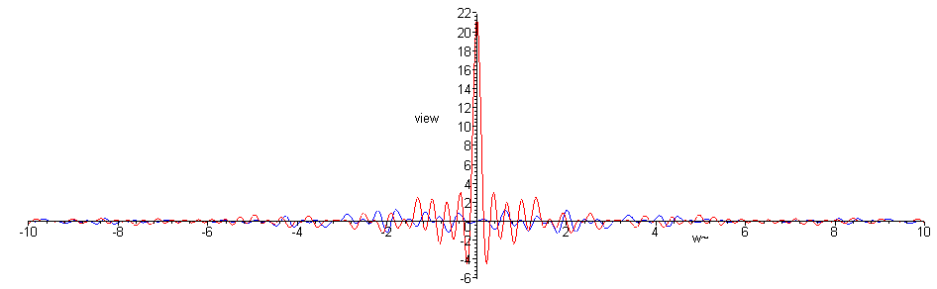

We can see that, apart from the noise of our low statistics, there is only the central peak and no continuous spectrum component. A blow-up of the central region follows,

