Shear Force V and Bending Moment M in a Beam PhL 4.14.09

This subject is totally new to me, though it would be taught in any first year undergraduate civil engineering class. There are many good web references.

These notes are serving as my notes on Stakgold Appendix A.2. One interesting aspect of this stuff is that even a simple static beam is described by a fourth order linear differential equation! In my small experience, I have never even seen equations higher than second order.
The "beam" includes the notion of the "column" which has on it a compressive axial load. If given a little start, a column will bend transversely in some azimuthal direction, and there will then be a transverse shear force inside the beam which could rip apart the material (cement, joints between sections made of mortar), Such a column would be described by Stakgold p 326 C which we derive below. When you break a stick, the internal shear force exceeds the ability of the material to support the force.
Amazon offers lots of cheap books on the subject of continuum mechanics. It seems that one should know a little about this subject before studying, say, general relativity.

1. What V and M mean. 1
2. Technical terminology. 3
3. Differential analysis 4
4. Examples 5
5. Elasticity or Young's Modulus: stress and strain, normal and shear 7
6. Transverse analysis of a bending beam : neutral layer and "moment of inertia" 8
7. Example: Deflection of a simple beam. 11
8. Stakgold's beam and plate equations. 12
9. Addendum: stiffness and stress tensor 13

1. What V and M mean.

The first problem for "the student" is to understand what V and M "mean". To this end, "the teacher" draws a nice beam, and then considers just a piece of this beam. Since the piece is not accelerating, assuming we are now doing "beam statics", the sum of the forces and torques on this beam piece must be zero.

So here is a picture from one PDF I found:

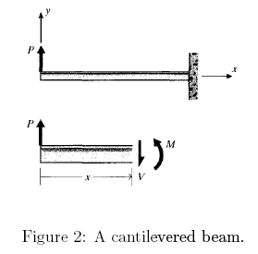

This beam is cemented into a wall on the right end, like one of my steel 457 Club steps going to the patio. We assume an upward load P is applied at the left end (though in practice for a step, this is likely to be a downward load.). We "imagine" just the piece of the beam shown in the lower picture. The force balance is independent of origin and we must have V(x) = P.
Where is this V(x) coming from? It is coming from the right portion of the beam which we are momentarily ignoring. The right side is pushing down to make up for our load which is pushing up. At the plane surface of the cutoff point, the right side can exert a "transverse force" in this manner on the left side because the interphase is not a liquid, it can support "shear force". This capability is just a property of the material. A beam made of dirt would be able to support only a small shear force before it broke, but steel a much larger force. Two adjacent transverse planes are prevented from sliding transversely relative to each other because there are lots of "axial" (longitudinal) bonds connecting the two planes, and these bonds allow a shear force to exist. Just imagine a lattice of super thin segments making up the material. We don't care at our mechanics level how the shear force is supported.
In this example, if we assume there is no gravity or that the beam is massless, V(x) would be a constant as you vary x.

For the torque balance, we need to choose an origin and this origin will be at point x. The torque due to P will be xP into paper, so there must be some M(x) out of paper that balances this. The load P is trying to rotate the beam CW, and this torque M(x) is rotating it CCW. If the torques were not in balance, the beam would be doing angular acceleration, but it is at rest.
The torque M(x) is coming from the right side of the beam. Here is someone's picture for a different geometry

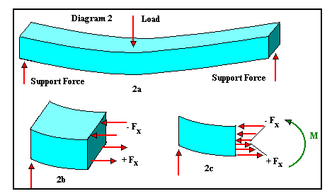

In this case, if we go to some point x out in the middle, we can look at the axial forces at the interface plane. In this situation, the right side pushes to the left on the left side on the upper half of the beam because it is under compression. But the right side has to pull on the left side on the lower half of the beam because it is being stretched (put under tension). These forces are shown as arrows in the lower right picture, and you can see that each of these forces is creating a torque out of paper relative to the vertical center right end of the beam. This is what causes the torque M(x). Again, this torque is acting on a vertically centered point at location x, and is supplied by the "missing" piece of the beam. In the beam as a whole, V(x) and M(x) are "internal" forces and torques. They exist inside the material as a function of x. They are caused by external forces on the beam such as the three shown above.

In our first picture above, we would have M(x) = Px assuming no gravity.

2. Technical terminology.

Each field accumulates is own vocabulary over time.

V(x) = "shear force"
M(x) = "bending moment"

The shear force is trying to shear the beam in half at each transverse plane. The torque is trying to "bend" the beam. Torque is often called a "moment".

"cantilevered" = clamped at one end.

" free body diagram" = like the lower part of our first figure above

" wall reaction" = the amount of V(x) and M(x) that the wall applies to its beam end

3. Differential analysis

Now that we know what V(x) and M(x) "are", we can get on to the main act which is to look at a small differential "free body", and our nice PDF file does this. Here is the free body

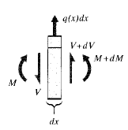

where q(x) is whatever "load" is applied on this dx of the beam, it could be just gravitational load or some other load. It is a distributed load and the force on our differential beam is q(x)dx.
The arrows are important to understand. They represent forces and torques being applied by the missing left and right pieces of the beam. Suppose dV = 0. If the left missing piece pushes down with force V > 0, then the right missing piece pushes up with force V>0. So these arrows are positive in the direction shown. The same sign comment can be made about the bending moment M.
Therefore, with the signs implied by the above picture,

q(x)dx = -dV => dV(x)/dx = -q(x) // force balance

I think the sign here is traditional. With q(x) being in the up direction as in our picture, as we move to the right by amount dx, our dV has to be in the direction opposite the load.
For torque balance, take the vertical and horizontal center point of the slice. Then, for positive numbers being out of paper (ie, all our terms are out of paper)

(M+dM) - M + (V+dV)dx/2 + V dx/2 = 0

dM + V dx = 0 // ignore dVdx/2 which is order (dx)2

=> dM(x)/dx = –V(x)

As we move to the right with our dx, if dV>0 it makes a CCW torque and this has to be balanced by the internal torque dM < 0, meaning it is CW.

[ Obviously the sign in this last equation depends on the direction you choose for a positive torque, and Stakgold uses dM/dx = +V, taking the other sign choice. ]

So here are the big results [ V positive up, M out of paper ]

dV/dx = – q V = –$^{\int_{}^{x}{}}$q(x')dx' + constant // Stakgold p 326 A, q=f

dM/dx = –V M = –$^{\int_{}^{x}{}}$V(x')dx' + constant // Stakgold p 326 A, but + sign

4. Examples

Example 1: Let's do a massless beam as in our first picture above. [ In this example, we will use the convention that V is positive up, and that M is "out of paper"]

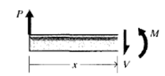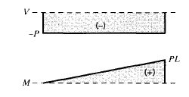

Here we know that V(x) = - P and M(x) = xP (out of paper) and we get the plots at the right. Is this consistent with our differential relations?

dV/dx = 0 = -q and q=0 so V = constant // correct

dM/dx = -V = P so M = Px // correct

Example 2: The next obvious thing is a beam with a uniformly distributed load, same geometry. Apply the differentials to find that

V = –$^{\int_{}^{x}{}}$q(x')dx' + constant = - qx + K. = -qx

since V(0) = 0. Then

M = –$^{\int_{}^{x}{}}$V(x')dx' + constant = + qx2/2 + C = qx2/2

since M(0) = 0. Now let's set q = - ρg to get the gravity situation, where ρ is the per length mass density of the beam. Then

V(x) = +ρgx M(x) = – ρgx2/2

and conveniently our PDF maker has plots where q0 = ρg.

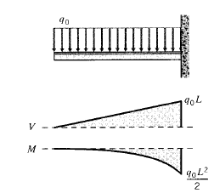

Example 3: Here is another traditional problem:

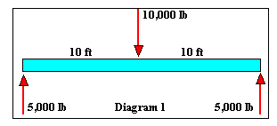

We have a man standing on a horizontal board which is going to bend downward. Let's assume the board is massless. Let's take the left end as origin for x = 0. Length = L. Center force is q(x) = -q0δ(x-L/2). Let the 5000 lb q0/2 >0. For massless beam, q0 is the weight of our man.

V(x) = –$^{\int_{0}^{x}{}}$q(x')dx' - q0/2.

At the left end, we have V(0) = - q0/2 -- the missing piece has to push downward. We then get

V(x) = - q0/2 –$^{\int_{0}^{x}{}}$[ -q0δ(x'-L/2)]dx' = - q0/2 + qo H(x-L/2)

= - q0/2 on the left side and +q0/2 on the right side.

On the right side, the required force must be up, because we have 5000 down.

Then here is our torque, and this time M(0) = 0

M(x) = –$^{\int_{0}^{x}{}}$V(x')dx' = – $^{\int_{0}^{x}{}}$[- q0/2 + qo H(x'-L/2])dx'

= (qo/2) x - q0 { (x-L/2) H(x-L/2) }

So to the left of L/2, we get (qo/2) x .

To the right of L/2 we get

(qo/2) x - q0 { (x-L/2) } = qo{ x/2 - x + L/2 } = = qo { -x/2 + L/2} = (qo/2) (L - x)

Here are some stolen plots, but the author has regarded V>0 as a downward force, while I have regarded V>0 as an upward force.

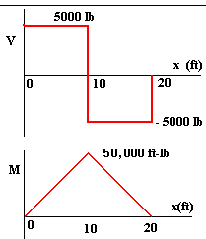

As we would expect, the bending torque or moment is maximum where our man is standing.

5. Elasticity or Young's Modulus: stress and strain, normal and shear

Longitudinal action:

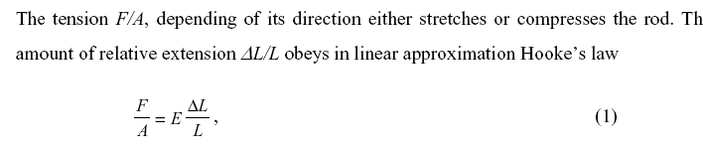

Here, F/A is the axial (longitudinal) pressure you apply to the end of your beam (think column) The beam compresses or stretches a small amount ΔL and the linear approximation is given above, similar to
F = -kx for a spring. We might write the above as

T = tension = E (ΔL/L) T = E ε

The quantity (ΔL/L) is called the normal strain, and usually written as ε. So

E = T/ε = normal stress / normal strain = Young's Modulus ε = T/E

E is called elasticity = modulus of elasticity, also known as Young's Modulus Y. A large value or E = Y means that your material does not stretch very much under a given tension T, so we large E means less elastic, sort of a misnomer.

You can also ponder a materials urge to deform under a shear force.

G = μ = shear modulus = shear stress / shear strain

See addendum below for more comments. In our beam examples, a shear stress would be indicated by an actual deformation of the shape of the beam as material stretches transversely under our load. This subject is not really of interest to us in normal beam analysis. We are more interested in the deflection of the beam as a whole, not in the distortion of the beam's internal material relative to its surfaces.

6. Transverse analysis of a bending beam : neutral layer and "moment of inertia"

Transverse action:

Recall our picture from above

The "neutral layer" refers to a horizontal plane in the middle of the beam where there are neither compressive nor tension forces. Now imagine we bend a beam a lot and we have this picture:

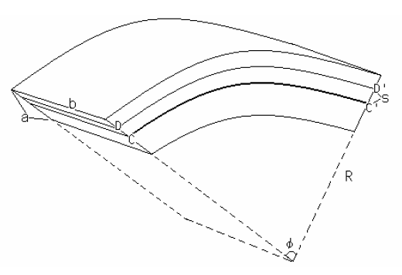

where now the neutral layer is shown heavy black and denoted CC'. Here then is some text from a PDF I have saved,

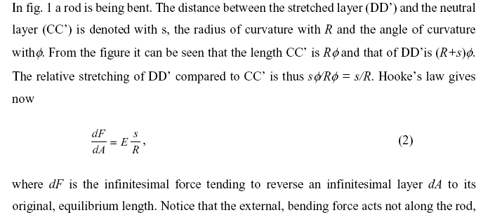

I agree that CC' = Rφ and DD' = (R+s)φ. The amount of stretch in the DD' layer is then sφ while the length of this thing is roughly Rφ so the percentage stretch is s/R. At the neutral layer s = 0. Now think of the segment DD' as an axial segment and we just apply our Hooke's law from above

F/A = E ΔL/L

where ΔL/L is our s/r and think of F/A as dF/dA where dA is perhaps bdR in the picture and dF is the stretching force applied on this area. So I like equation (2) above.
Now comes the next step:

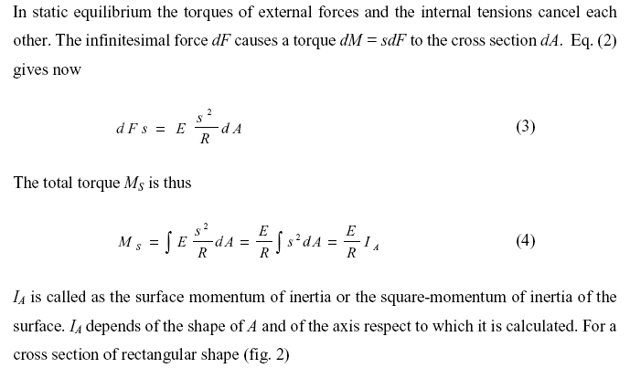

Let point C in the picture be a reference point, or perhaps a line from C going back into the beam transversely. Call this line C, passing through the neutral layer. We know there is a stretching force dF along line D which must be applied by the non-drawn part of the beam. This makes a torque around line C which is just dF s. I will now try to be more explicit than the author. Imagine layer at s has thickness dR. Then

dA = bdR

The elastic force acting on this little area is then dF = E (s/R) dA = E (s/r) b dR from our equation (2). This force them makes a torque about line C which is this

dM = dF x s = s dF = s E (s/R) b dR = E s2/R b dR

Now we know that if we drop down to a layer at R-s, we have compressive forces, but the torque equation about line C is exactly the same dM equation shown above. The force changes sign, but our direction from line C also changes sign. Look at the red arrows in the previous picture with the blue beam. Thus, we can integrate vertically across the entire beam to get

M = ∫dR E s2/R b = E/R ∫s2bdR = E/R ∫s2dA

The integral here has dimensions L4. We have assumed that R >> amount of bending, so we factored the 1/R out. If the beam has some fancy cross sectional shape, you have to do the integral. If the cross section is rectangular, then dA = bdR as I have been writing it, which is dA = bds so we get

∫s2dA = b $^{\int_{-a/2}^{a/2}{}}$ s2ds = (2/3) b (a/2)3 = ba3/12

Author claims that if cross section is a circular rod, you get ∫s2dA = πr4/4 where r is the rod radius. So I agree that these integrals remind me of regular "inertia" calculations like I = ∫r2 dm. For a cylindrical shape, we have dm = ρdA L where L is the length of the shape, so I = ρL ∫r2 dA between two r values, so then it looks very close, and the integral is L4. So

I = ∫s2dA = "the surface moment of inertia about the neutral axis" // which was line C

This I think is a physical property of the beam's cross sectional shape. So we have

M = EI/R

Now, consider a graph of a circle of radius R (x2 + y2 = R2) and think about the top part of the circle near x=0 and y = R. It is easy to show that y" = -1/R and this thing would be cupping down. So replace 1/R = -y" in our formula

M = -EIy"

Where y" is the curvature of our beam. Stakgold calls the deflection u(x), so we then have

M(x) = -EIu"(x) // Stakgold p 326 B

It is true that in obtaining all the above results, we assumed that our cross sectional areas remained planar. If you have a very elastic material, this might not be the case. Also, we assumed in the above that we are just bending our beam, we are not longitudinally stretching or compressing it at the same time. You can see now the analysis of a "column" gets more interesting, because there is compression going on and if it bends a little, then you have transverse action at the same time.

7. Example: Deflection of a simple beam.

Consider again our massless cantilevered beam with load P on the end where we found that M(x) = Px where x is measured in from the free end. The above ODE then becomes

EIu"(x) + Px = 0

which can be integrated to find the shape of the bending beam. Let EI/P = α so

α d(u'(x)) = - xdx => α u'(x) = -x2/2 + k1 // first integration
α d(u(x)) = [-x2/2 + k1]dx => α u(x) = -x3/6 + k1x + k2

so the displacement is a relatively simple function. As Stakgold points out page 326, at the clamped end we know that u'(L) = 0 which tells us that k1 = L2/2. Also, u(L) = 0 so 0 = -L3/6 + L3/2 + k2 which tells us that k2 = - L3/3. Thus our solution is

u(x) = (P/EI) { -x3/6 + L2/2 x - L3/3 }

and at the free end of the beam which is x = 0 we get

u(0) = (P/EI) (- L3/3)

which says that the deflection of a beam loaded at the end is proportional to the cube of the length of the beam. I now confirm this calculation with a web clip, where δ = -u(0) = amount of deflection, and where the load is F instead of my P.

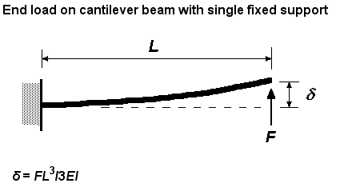

8. Stakgold's beam and plate equations.

At this point, we have these equations:

M(x) = -EIu"(x) // Stakgold p 326 B

V'(x) = - q(x) // Stakgold p 326 A

M'(x) = + V(x) // Stakgold p 326 A but using + sign convention

Differentiate the first equation twice, assuming E and I don't vary with x,

M"(x) = -EIu''''(x)

But M"(x) = V'(x) = -q(x) so we have

E I u''''(x) = q(x) // Stakgold p 326 (A.7) q = f

where that is a 4th derivative of the beam displacement from reset position, u(x). This is a transverse force balance equation at location x. We are applying a load q(x), so E I u''''(x) is an internally generated force which balances that load. This force arises from the beam's resistance to bending. Notice that a loose piece of string has no resistance to bending, but a loose beam does have such resistance.

At this point, rather than reinvent the wheel, we appeal to the usual analysis of a string under tension, such as a guitar string. We know that if we apply a distributed load q(x) to a string tied at both ends and under tension T, the equation describing the static response deflection of the string is -Tu''(x) = q(x). This is derived, for example, in Stakgold Appendix A.1. Again, this is a transverse force balance equation at location x along the string. The string develops a curvature u"(x) which then makes a transverse force
-Tu"(x) which opposes the applied load q(x) at position x. Although the tension is applied axially, this force is a transverse force. This transverse force is the string's transverse response to being under longitudinal tension.

So now we imagine that our thin beam acts like a string in response to tension T (or compression -T) and generates this kind of transverse force in addition to the E I u''''(x) force which arises from the bending moment inside the beam. Our combined equation for the beam is this:

E I u''''(x) - Tu"(x) = f(x) // Stakgold p 326 C

where now I change from q(x) to f(x) since f suggests the word "applied force". It is perhaps more useful to write the above equation as:

f(x) – E I u''''(x) + Tu"(x) = total force experienced by beam at point x = 0

where things add up to 0 since we have a static problem. In his string analysis, Stakgold adds a force term -ku(x) to describe the string embedded in an elastic medium, a restoring force. For the beam we can add this as well, if the beam "rests on an elastic foundation", so then

f(x) – E I u''''(x) + Tu"(x) - ku(x) = 0

If we now want to look at beam dynamics, we just set this total force to ma:

f(x,t) – E I u''''(x,t) + Tu"(x,t) - ku(x,t) = ρ ∂t2 u(x,t) // Stakgold p 327 (A.8)

It is often said that a thick string has anharmonic behavior. We can imagine a heavy piano string, or even a guitar string, having a resistance to bending -- it certainly does if you have held such a string. So we expect to see the E I u'''' term have some effect on the idealized behavior of a thin string.

Stakgold as his last act in Appendix A.2 generalizes the beam equation above to apply to a plate. In this case, you replace u''''(x) with a thing called ∇4u(x) which is ∇2(∇2u), and you replace EI by D which is called the "flexural rigidity" of the plate.

9. Addendum: stiffness and stress tensor

1. Suppose you take massless cantilevered beam and apply load (force) P at the end and it bends distance δ. The quantity k = P/δ is called the stiffness of the beam. Small δ means large stiffness. This is a longitudinal spring constant like idea, but in the transverse direction, k = F/Δx. The force P being in the transverse direction is called a shear force, and δ is then a shear deformation. The inverse of stiffness is called compliance.
In our calculation above, we found that the deflection of a beam loaded at one end was

δ = (P/EI) (L3/3)

Therefore, the stiffness of such a beam is given by

kstiffness = P/δ = 3 E I / L3

so a beam that is twice as long is 1/8th as stuff.

You can imagine there is also a thing called rotational stiffness which would be something like k' = (torque)/δφ .

2. The general name for the subject we are talking about in this write up is continuum mechanics, something I never studied. At any point inside a "beam" or any kind of continuum material there is an internal force associated with a plane defined by unit vector which is given by

Tn = σ

where σ is a 3x3 stress tensor, and the force Tn is called stress vector associated with the plane defined by . In general σ is not diagonal, so in general Tn is not parallel to . The component of Tn which is parallel to and thus which is perpendicular to the surface is called normal stress. The component parallel to the surface is called shearing stress.
In our beam analysis above, we have been interested in V(x) which is a force parallel to our cross sectional plane, so this is an internal shearing stress, which is called also a shear force. The tension in a beam (where there is such) is a normal stress.

