Jim, // for your integration entertainment, from Phil. Oct 15, 2009

DO NOT PRINT! This document should be viewed in Microsoft Word with magnification 122%, just enter 122 in the box. All my documents are set up that way, no need to print anything, it's very easy to read on the screen.

The 2D Wire

Somewhere in the 1970's I took a math course which used the following 2-volume set of books by Ivar Stakgold
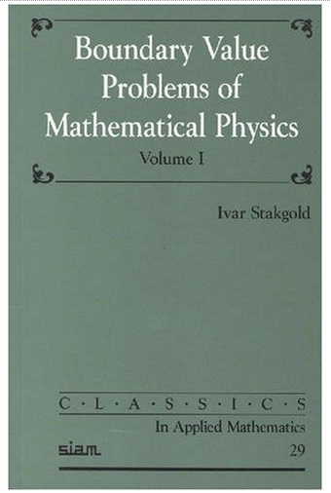

and we certainly did not get very far in it. Recently I have been reading these volumes. It is amazing that UCB would give a Ph.D. to someone doing "multiperipheral integral equations" when I did not even know that basics of ordinary differential equations, not to mention their corresponding integral equations, not to mention partial differential equations and their integral equation statements, not to mention distribution theory which is crucial to understanding limits as a point moves onto a boundary surface. But I was in the Geoff School of integral equations where things are always simple. (trace approx....)

Anyway, in Volume II Stakgold has a fairly dense chapter on Potential Theory which I must say goes well beyond Jackson's three chapters on electrostatics. Jackson always used to comment on Dirichlet and Neumann and Mixed and Cauchy, but only touched upon (at the end of his last electrostatics chapter regarding a disk in 3D) the question of how charges distribute themselves on a piece of metal. This by the way was the question George Green was wondering about as he milled grain in 1830 (no education ), http://en.wikipedia.org/wiki/George_Green ,

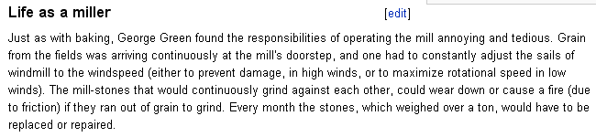

So Stakgold uses as an example a 2D wire (cross section of a 3D strip) which contains 1 unit of positive charge (relative to some great circle say),

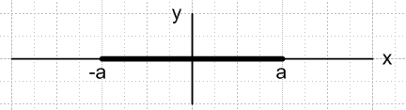

By fiddling with a few integral equations, he is able to show that the static charge distribution on the wire is this,
I(ax) = (1/π) 1/$\sqrt{1-x2}$

which I dimly remember from somewhere, and which is similar to the result of Jackson's 2D disk in 3D space (with x→ρ of cylindrical coordinates). Stakgold can then insert this result into another integral equation to find the potential everywhere, which is then this,

u(ax,ay) = – (1/2π)ln(2) -(1/4π2) $^{\int_{-1}^{1}{}}$dτ ln ( [x-τ]2 + y2 ) / $\sqrt{1- τ2}$

He is then done with this example and moves on to other examples, but I thought it would be good for me to do this integral to see what the potential looked like, and to verify that it was a constant on the wire, and so on. So I tried to do this integral and ran into various interesting "Jim Ball" type problems. The integral shown above can be written like this (c.c. = complex conjugate),

$^{\int_{-1}^{1}{}}$dτ ln ( [x-τ]2 + y2 ) / $\sqrt{1- τ2}$ = $^{\int_{-1}^{1}{}}$dτ ln ( [x-τ] + iy ) / $\sqrt{1- τ2}$ + c.c.

= $^{\int_{-1}^{1}{}}$dτ ln ( z - τ ) / $\sqrt{1- τ2}$ + c.c.

= $^{\int_{-π/2}^{π/2}{}}$dθ ln(z - sinθ) + c.c. = $^{\int_{0}^{π}{}}$dθ ln(z + cosθ) + c.c.

I eventually did this integral by differentiating with respect to z, doing the integral, and then integrating back, and later by finding the integral in GR. The result is this

$^{\int_{0}^{π}{}}$dθ ln(z + cosθ) = π ln[ ( z + $\sqrt{z2-1}$)/2 ]

and then the potential of the wire is this:

u(ax,ay) = { – (1/2π)ln(2) -(1/4π) ln[ ( z + $\sqrt{z2-1}$)/2 ] } + c.c.

and sure enough, on the wire itself this has the constant value u = – (1/2π)ln(2).

Maple World

Before I knew the result for the 2D wire potential, I kept trying to get Maple to "help" me. I tried various earlier forms of my 2D wire integral, and kept getting unbelievable messes. Here is one of my favorites:

$^{\int_{0}^{1}{}}$ (dτ / $\sqrt{1- τ2}$) ln(τ-α)

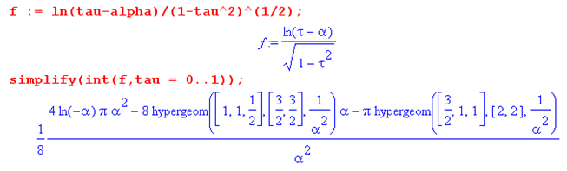
So OK, eventually I arrived at the nice $^{\int_{0}^{π}{}}$dθ ln(z + cosθ) form of my integral, and thought I would close out my successful day by just verifying the result π ln[ ( z + $\sqrt{z2-1}$)/2 ].
If you take the usual branch of the log, and if you take any z with Re(z) > 1, this integral is completely unambiguous, as this picture shows (integration runs right to left along the dotted line) :

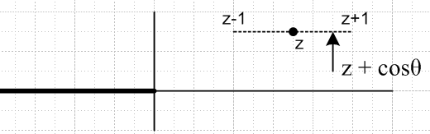 $^{\int_{0}^{π}{}}$dθ ln(z + cosθ)

This picture is in the complex w-plane w = z + cosθ and we are talking ln(w). In particular, we are clean for z > 1 on the real axis. Basically, there are no branch issues whatsoever.
You can enter any z you like and Maple will do a numeric integration and give you a fine result. For example [ this form prevents Maple from doing a symbolic integration and then evaluating that result ] :

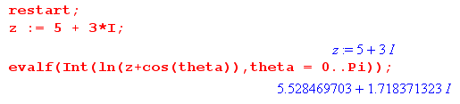
But of course I want the symbolic integral $^{\int_{0}^{π}{}}$dθ ln(z + cosθ). Here is what Maple has to say about this topic: (Maple V of course)

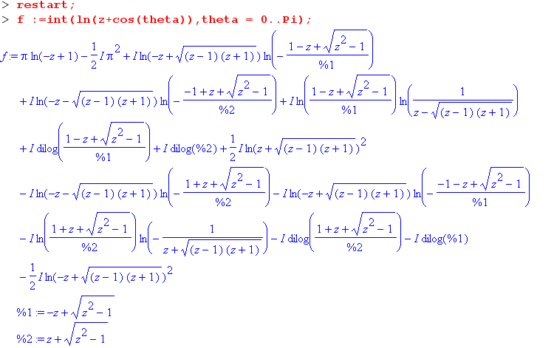

As you can see, there are now all kinds of "branch issues" involved here, even though the original integral is "branch free" in the sense noted above. Needless to say, I tried "simplify" and other Maple tricks and it did not get much simpler. Notice the "dilogs" appearing above along with the regular logs. Maple seems to know about dilog rules, for example,

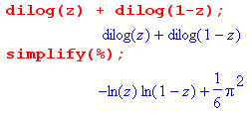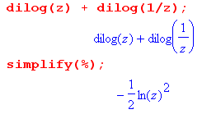
but seems unwilling or unable to apply them to simplify the above mess, even though logs and dilogs are both on the list of items that "simplify" officially knows about (Help on simplify).
Then here is the scary part. Suppose we take the above result and set z = 5 + 3*I, as I did earlier, and see what it says:

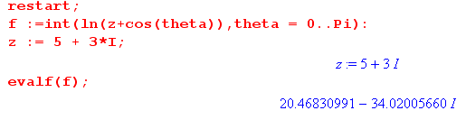
which we can compare to my result quoted above

and, oh by the way, we can evaluate π ln[ ( z + $\sqrt{z2-1}$)/2 ],

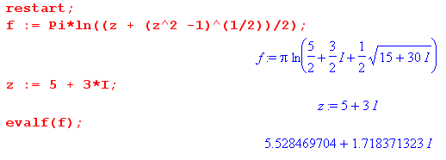
So I wonder if you have any comments about Maple's unsportsmanlike behavior in this matter?

I downloaded and installed the public domain computer algebra package Maxima, but it would not even attempt to do my little definite integral $^{\int_{0}^{π}{}}$dθ ln(z + cosθ), here from its nice GUI interface,

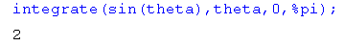 // this is only a test

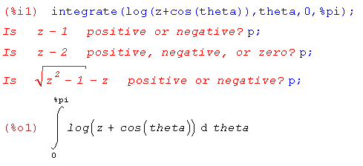

Otherwise I must say that Maxima looks like a great freeware package.

Wolfram now offers free symbolic integration on its site

http://integrals.wolfram.com/index.jsp

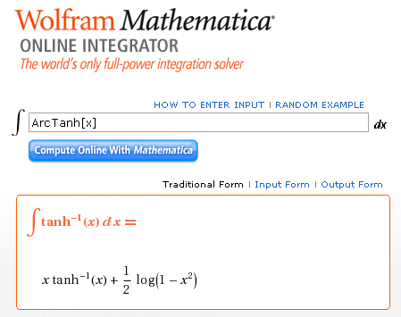

but is unwilling to do definite integrals. It had this to say about my indefinite integral

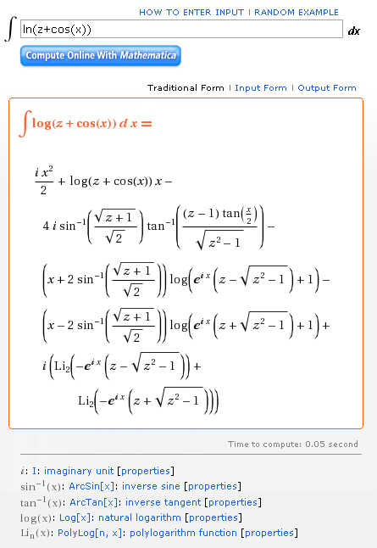

where the I think dilog(x) = polylog(2,x). Unfortunately I cannot make the online thing apply my intended endpoints.

I found another package called Sage but got cold feet when it needed VMware to run on windows, and then the Sage download size was 800 MB !!!

I don't own Mathematica, and MATLAB does not do symbolic integrals.

// end of today's adventure

