An essay on Stakgold heat k space PhL 4.22.11

Motivation: Just as Stak stays away from obscure coordinate systems, I think he is avoiding an entire k-space world in his heat equation presentation. I am aware of the important role of k space in particle physics, the use of k space propagators and such, but somehow that seems to be missing here. So I will try to uncover this subject with a series of questions and comments.

Comment #1. Dual Point of View of Sources at the Boundary. In the half rod heat problems, we sometimes drive the exposed end at x = 0 with a "boundary schedule" function h(t) which might just be h(t) = A H(t) for example. We treat this as a boundary source instead of an interior q source going to the end of the rod. In the general equation for u(x,t) in terms of the Dirichlet Green's function g -- that is to say, equation 7.14 page 199 -- the boundary source appears in the last surface integral term. Tracing back, this term got there from the generalized Green's Theorem involving the L heat operator. So the point here is that we a somewhat artificial distinction between a source at the boundary x = 0, and an internal source at x = 0+ as a limit. I assume we could treat the problem from either point of view.

Question #2. Boundaries in k space and Green's Theorem there? When we convert the heat equation to k-space, it is not clear "what is going on". In 1D the homo equation (∂t-∂x2)u(x,t) = 0 seems to become (∂t + k2)U(k,t) = 0 [ well, its really (∂t + k2)U(k,t) = Ak as we show below] . So this leads to an obvious question: Is there some kind of Green's Theorem directly in k-space? That is to say, is there some relationship between U(k,t) inside some k-space boundary and its value on the boundary? Perhaps it is better to think of (∂t-∇2)u(x,t) = 0 and (∂t + k2)U(k,t) = f(k) where k2 = k•k and we are thinking of something like the Fourier transform ( I will check the constant factor later).

U(k,t) = ∫dnx exp(-ik•x) u(x,t)
u(x,t) = (2π)-n ∫dnk exp(ik•x) U(k,t)

If u(x,t) is confined to the interior of a region R and is assumed to vanish outside, then U(k,t) in general is going to exist everywhere in the infinite k-space. An example in 1D is provided by Schaum p 176 where the square box |x| ≤ b (a well defined localized region R) is described by u(x) = H(b - |x|) and the transform is then U(k) = 2 sin(bk)/k = 2b sinc(bk), the famous sinc function which peaks at k = 0, but which extends all the way out to the ends of k-space, so there is no bounded region in k-space. Since this is generally the case, it seems that we are not so interested in talking about "boundaries in k-space", and therefore we won't care about any "Green's Theorems" in k space. It was mainly the ∇2 operator and the divergence theorem that brought in the surface terms in a Green's Theorem.

Pondering use of a Fourier Cosine Transform in the simple Heat Problem

This fits into our "k space document" here because we are going to try to take this heat problem from x space to k space, leaving t unchanged.

We know the solution to the constant-A end-heated frozen rod problem, it is this:

u(x,t) = A[1 - erf(x/(2)] = A erfc[x/(2]

If I replace x by |x| to "symmetrize" this solution, we find these plots at different times: (A = 1)

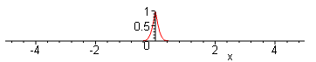 t = .01
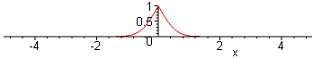 t = .1
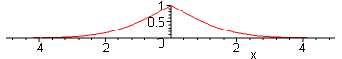 t = 1
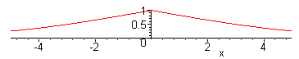 t = 10

I am just showing the symmetric form to show the effective "even" function one would use were one doing the full Fourier Transform, but this is really just a passing observation that does not matter.

Question: What is the corresponding k-space function U(k,t) ? We have to say what kind of k-space we want, so for example suppose we go with a Fourier Cosine Transform. then we have

U(k,t) = A $^{\int_{0}^{∞}{}}$dx cos(kx) erfc(x/(2) (*)

But this item does not appear even in the Bateman ET I tables.

erfi note: on [page 107, GR7 refer to erfi(z) ≡ erf(iz)/i, something I was recently wondering about.

Also, GR7 also refers to efr(z) as Φ(z). But GR7 provides no integrals involving erf or erfc ! And Maple cannot do this integral. GR7 refer to Φ as "the probability integral", and yes, they do have a section on that subject, but they have just one indefinite integral in that section over Φ !! There are more in the definite integrals section. So I am looking for an integral of [ 1 - Φ(ax)] cos(kx) . They have it for sin(kx) but not for cos(kx) ! And it came from ET I, and I now see that ET I is missing a section in the contents that has this stuff. Section 1.11 just does not appear for some reason!

Surely the cosine transform must come out being some function, the integral converges, but I don't know where to find the result. Well, here is something from PBM p 112:

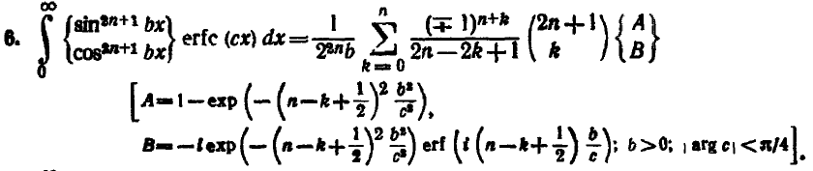

If we set n = 0, we get k = 0 and the result is

= (1/b) $\left(\begin{matrix}A \\ B\end{matrix}\right)$ A = 1 - exp(-b2/4xc2)
B = -i exp(-b2/4xc2) erf((ib/2c) = exp(-b2/4xc2) erfi(b/2c)

So OK, we know both the sine and cosine integral transform of erfc(cx), but the sine result is simpler, so let's use a sine transform instead of a cosine transform!

Using a Fourier Sine Transform in the simple Heat Problem

U(k,t) = A $^{\int_{0}^{∞}{}}$dx sin(kx) erfc(x/(2) (*)

Here is what ET I tells us: [ I did not have the above PBM result when I wrote this ]

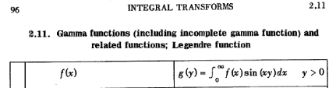
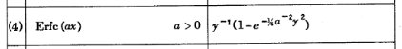

Therefore we find that

U(k,t) = A (1/k) [ 1 - exp( - (1/4)k2/a2 ) ] a = 1/(2$\sqrt{t}$) 1/a = 2$\sqrt{t}$

= A (1/k) [ 1 - exp(- k2t ) ]

Very interesting!! I think some light is starting to shine. The inverse of the above transform appears on page 73 of the same table (here are the two terms you see in U(k,t) but with k = x in Bateman

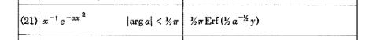

So consider then that

u(x,t) = (2/π) $^{\int_{0}^{∞}{}}$dk sin(kx) U(k,t) = (2/π) $^{\int_{0}^{∞}{}}$dk sin(kx) { A (1/k) [ 1 - exp( - k2t ) ] }

= A { (2/π) $^{\int_{0}^{∞}{}}$dk sin(kx) (1/k) – (2/π) $^{\int_{0}^{∞}{}}$dk sin(kx) exp( - k2t ) }

= A { (2/π) (π/2) – (2/π) (π/2) Erf( x / [2 $\sqrt{t}$]) } = A { 1 – Erf( x / [2 $\sqrt{t}$]) }

= A erfc(x/(2)

and indeed we recover our solution! So we have a bona fide k space solution to a half rod problem!!

u(x,t) = A erfc[x/(2] ↔ U(k,t) = A (1/k) [ 1 - exp( - k2t ) ]

The first thing we note is this:

U(k,0) = A (1/k) [ 1 - 1 ] = 0

which agrees with one of my "steps". But now consider my supposed equation

(∂t+k2) U(k,t) =?= 0

We find that

(∂t+k2) U(k,t) = (∂t+k2) { A (1/k) [ 1 - exp( - k2t ) ]}

= A (1/k) (∂t+k2) [ 1 - exp( - k2t ) ]

= A (1/k) (∂t) [ 1 - exp( - k2t ) ] + A (1/k) (k2) [ 1 - exp( - k2t ) ]

= A (1/k) [ k2exp( - k2t ) ] + A (1/k) (k2) [ 1 - exp( - k2t ) ]

= A [ kexp( - k2t ) ] + A k [ 1 - exp( - k2t ) ]

= Ak !!!

So we find this perhaps surprising and unexpected result:

(∂t+k2) U(k,t) = Ak and not 0

My argument for 0 on the RHS went like this:

(∂t - ∂x2) u(x,t) = 0 // since no q sources inside the rod
u(x,t) = (2/π) $^{\int_{0}^{∞}{}}$dk sin(kx) U(k,t) // the sine transform expansion
(∂t - ∂x2) {(2/π) $^{\int_{0}^{∞}{}}$dk sin(kx) U(k,t) } =
LHS = (∂t - ∂x2) {(2/π) $^{\int_{0}^{∞}{}}$dk sin(kx) U(k,t) }
= {(2/π) $^{\int_{0}^{∞}{}}$dk (∂t - ∂x2) [sin(kx) U(k,t)] } // assuming convergence etc
= {(2/π) $^{\int_{0}^{∞}{}}$dk (∂t +k2) [sin(kx) U(k,t)] } // ∂x2 hits only on sin(kx)
= (2/π) $^{\int_{0}^{∞}{}}$dk sin(kx) {(∂t+k2)U(k,t)} // rearrange

so at this point we have

$^{\int_{0}^{∞}{}}$dk sin(kx) {(∂t+k2)U(k,t)} = 0 (*)

At this point I would appeal to "the completeness of the eigenfunctions sin(kx)" to conclude that

{(∂t+k2)U(k,t)} = 0

This is where I keep making my mistake, I think! I have been wondering "which step was wrong", and by working with the exact known answer to this problem, I have seen that U(k,0) = 0, so I have eliminated that as the cause of my error.

Explanation of why the (∂t+k2)U(k,t) = 0 is wrong

I show this in great detail in Section 7,8, and 9 of "order interchange for limits.doc". The error occurs in the line above where I naively said "assuming convergence". It turns out that in this problem, you cannot just pass the ∂x2 operator through the dk integral and do "term by term differentiation" so to speak!! Doing so assumes that you can interchange the order of two limits (one being the derivative as a limit, the other the upper endpoint ∞ as a limit). But in this problem, you can NOT do this interchange because the resulting integral $^{\int_{0}^{∞}{}}$dk k2 U(k,t) diverges and does not exist! Of course one does not realize this a priori, because one does not know U(k,t) a priori. So it is a very bad thing to blindly assume. You can see that you are adding numerator powers of k2 and you might well suspect that this could make the integral diverge. There is another way to find the ODE for U(k,t) as shown below, here I am just trying to show where the logic fails in the above derivation of the wrong ODE. It is slightly subtle I think and took me a long time to locate.

Question: Given f(x) = Σn=0∞ an φn(x) where the φ are a complete set on some interval of interest, under what conditions will it be true that you can write ∂xf(x) = Σn=0∞ an ∂xφn(x) ? And why don't I already know the answer to such a basic question?

You can think of akφk(x) = uk(x) and then f(x) = Σk=0∞ uk(x) is an infinite series and the partial sums are of course an infinite sequence. Here is a theorem I found in a PDF called uniform.pdf (it was not easy to find information on this term-by-term subject)

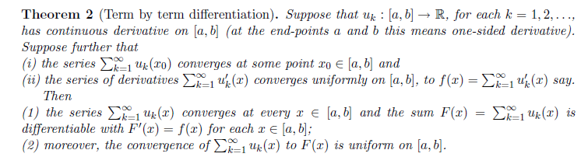

There are many things assumed by this Theorem.

* All the functions uk(x) have continuous derivatives on the interval.
* The series Σk=0∞ uk(x) converges at some point x0 in our interval.
* The series Σk=0∞ uk'(x) converges to some f(x) and does so uniformly on the interval

Then the theorem states that (a) the series Σk=0∞ uk(x) converges not just at x0, but at all x in the interval, and it does so uniformly, and we call the result F(x) = Σk=0∞ uk(x) . (b) F'(x) = f(x), which means that you can do term-by-term differentiation.

This theorem I would say has pretty severe conditions on the sequence. It assumes right from the start that the term-by-term differentiated series converges, so it is not giving any conditions that make that happen.

The Mystery of f(0) = 0 for a Fourier Sine Transform.

Here is our sine transform:

F(k) = $^{\int_{0}^{∞}{}}$dx sin(kx) f(x)
f(x) = $^{\int_{0}^{∞}{}}$dk sin(kx) F(k)

It seems quite clear that the second line implies

f(0) = 0

so it would seem that we cannot apply this expansion to an arbitrary function f(x). BUT, consider the transform pair above:

u(x,t) = A erfc[x/(2] = A$^{\int_{0}^{∞}{}}$dk sin(kx) (1/k) [ 1 - exp( - k2t ) ]

u(0,t) = A erfc[0] = A

So this is a counterexample to my claim above that we need f(0) = 0 . What is going on here? Let's look at a simpler case

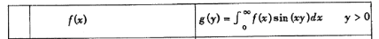

which tells us that with f(x) = 1/x we get

F(k) = $^{\int_{0}^{∞}{}}$dx sin(kx)f(x) = $^{\int_{0}^{∞}{}}$dx sin(kx)(1/x) = π/2 // Maple agrees if k>0

Now in this case, Maple really says the integral is (π/2) signum(k), so things are "not clear" at k = 0.

Resolution of the above Mystery of f(0).

Let's consider the erfc example just above where we get u(0,t) = A. We are considering the erfc just to the right of x = 0. If we "antisymmetrize" our u(x,t) to create a truly odd function we get this picture
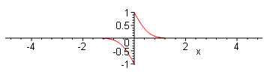

and this is the function that in effect we use in our full Fourier Integral Transform. We are welcome to use just the right side in our Fourier Sine Transform, and we will find that u(0+,t) = A (= 1 in plot). However, since the full odd function has a discontinuity at x = 0, right at x=0 we get u(0,t) = 0 which is the average of what you see on the two sides! So this is how you can have f(0+) = A, f(0-) = -A and f(0) = 0 !!!
I discuss this more in "confusion about completeness relations..doc". The f(0) = 0 is really what the expansion gives! There I explain that a Fourier Series or Integral is incapable of representing a discontinuity and at such discontinuity it blends things with a near vertical segment whose midpoint in this case is at f(0) = 0. More generally at the location of the original discontinuity you will get the average of the original function on the two sides of the discontinuity. This is an actual theorem and I saw a proof somewhere on the web, but did not pursue it.
So practically speaking, for a half rod situation it is really f(0+) that we are concerned with. I just wanted to reconcile the fact that f(0) = 0 whereas f(0+) ≠ 0 !
The other example above gives the same thing: There F(k=0+) = π/2, while F(k=0-) = -π/2, and then F(k=0) = 0, where F(k) is the Fourier integral of (1/x) as shown.

Information from book of Debnath on Transforms

But as I started looking at Debnath's book, I ran into exactly the problem I am right now working on, which is his case (a) below !!! Amazing. (see page 96)

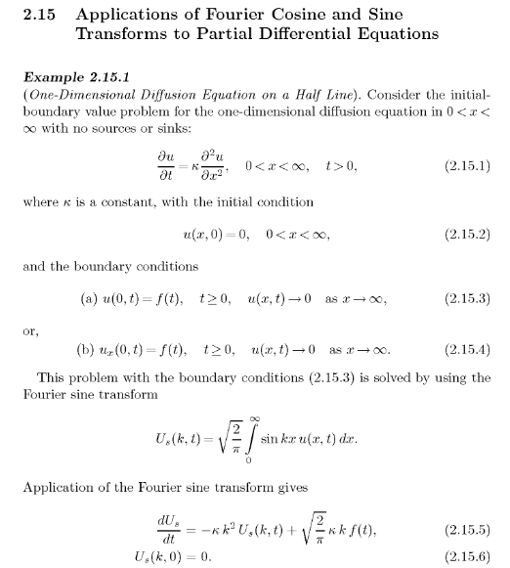

Notice that he says (in effect) "just use the Fourier Sine Transform to obtain the ODE for U(k,t)"

Now let's just set κ = 1. He has my U(k,0) = 0 as his last equation, but his second last is this:

(∂t + k2)Us(k,t) = $\sqrt{2/π}$ k h(t) where h(t) drives the left end.

Now the constant I don't care about, it depends on his convention for the cosine transform. You see my same result here which was kA in my simple case above. Hmmm. I will leave off his constant and just do this :

FST[∂x2f(x)] = $^{\int_{0}^{∞}{}}$dx sin(kx) [ ∂x2f(x) ] = the Fourier Sine Transform of ∂x2f(x)

Now we are going to do parts integrations here

= [ sin(kx)∂xf ]|∞0 – $^{\int_{0}^{∞}{}}$dx ∂xsin(kx) [ ∂xf(x) ]

Now comes the second parts

= [ sin(kx)∂xf ]|∞0 – { [∂xsin(kx) f(x)]|∞0 – $^{\int_{0}^{∞}{}}$dx∂x2sin(kx)f(x) }

= [ sin(kx)∂xf ]|∞0 – [∂xsin(kx) f(x)]|∞0 + $^{\int_{0}^{∞}{}}$dx∂x2sin(kx)f(x) }

= [ sin(kx)∂xf ]|∞0 – [k cos(kx) f(x)]|∞0 – k2$^{\int_{0}^{∞}{}}$dx sin(kx)f(x) }

Now we have to assume that f and ∂xf are "reasonably small" at x = ∞ so we ignore those parts. The first parts piece at x = 0 will vanish as long as ∂xf(0+) is finite, due to sin(kx) sitting there. So we end up with

= + [k cos(k0) f(0+)] – k2$^{\int_{0}^{∞}{}}$dx sin(kx)f(x) }

= + k f(0+) – k2$^{\int_{0}^{∞}{}}$dx sin(kx)f(x)

= + k f(0+) – k2F(k)

We have shown then that

FST[∂x2f(x)] = – k2F(k) + k f(0+)

which we e can now write our rule for our case of interest:

FST[∂x2u(x,t)] = – k2U(k,t) + k u(0+,t) = – k2U(k,t) + k h(t)

So if we start with

(∂t - ∂x2) u(x,t) = 0

and to FST to both sides, we get

∂t U(k,t) + k2U(k,t) = k u(0+,t)

(∂t + k2) U(k,t) = k u(0+,t) where u(0+,t) = A, or the boundary schedule h(t)

So "doing it this way" brings out the non-zero RHS.

Now notice that the Fourier Sine Transform Rule,

FST[∂x2f(x),k] = – k2 FST[f(x),k] + k f(0+) ,

differs from our Laplace second derivative rule in that no f '(0+) is involved !!!

LT[∂x2f(x),s] = + s2 LT[f(x),s] - s f(0) - f '(0)

It was this f '(0) term that caused me such Ex 7.16 Stak grief. So this is a great advantage of the Fourier sine transform ( and not of the cosine transform, see below! )
Now ET I does not mention the above Rule in its FST section "general formulas". Debnath says that Rules like this hold "under appropriate conditions", (he uses the radical constant differently than I did)

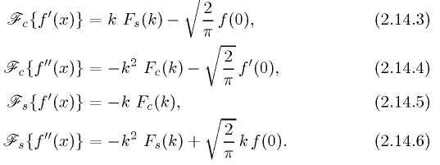

but he does not say what those conditions are. Perhaps they relate to f(∞) requirements. But I would have thought these are all 0 for anything that gives a convergence integral.

Do M&F talk Fourier? Yes, in Vol I, but they don't talk much about continuity of f(x).

Courant refers to his calculus book for a proof of the Fourier Integral Theorem and just quotes it!

M&W say little.

Reed not very good.

Riley quotes the result without proof. They make the point that a Fourier Series sum cannot produce a discontinuity, so if your original function has one, you need to learn what happens. The answer is that you get a blending through the half-way point, and that is the proof I am looking for. I first need a "name" for the theorem concerning the average of the two sides at a discontinuity, then I need a proof. This will take some searching.

Comment: So we have shown above the "right way" to use the sine transform to convert the x-space PDE into a t-space ODE where k2 sits as a parameter. We than have only to solve this ODE system

(∂t + k2) U(k,t) = k h(t) U(k,0) = 0

and when we find U(k,t), we transform back to get u(x,t). I will go do this now in my Exercise 7.16 doc, since I finally have found the errors of my ways. I have already done it for ω = 0, but I would like to do it for the general ω case. Stak says to use the cosine transform, but I think the sine one will be simpler to use, based on the above.

