Analytic functions defined by integral PhL 7.29.11

0. Summary 1
1. Opening Example. 2
2. Generalization beyond the simple example given above. 7
3. The sum splitting notion used in Weiner Hopf 8

0. Summary

(a) Consider this integral

f(ω) ≡ (1/2πi) $^{\int_{-∞}^{+∞}{}}$dα a(α) (α-ω)-1

where a(α) → 0 for large α such that the GC = 0 up or down, and where a(α) is clean on the real α axis. This integral really defines two distinct function we can call f1(ω) and f2(ω). The first function f1(ω) is analytic in the entire upper half ω plane (but in general not in the lower half plane). Conversely, the second function f2(ω) is analytic in the entire lower half ω plane (but in general not in the upper half plane). The opening section below considers an example of this type.

(b) We can generalize this slightly by translating the contour vertically by some amount c,

f(ω) ≡ (1/2πi) $^{\int_{-∞+ic}^{+∞+ic}{}}$dα a(α) (α-ω)-1

As before, this defines two functions, one of which is analytic for Im(ω) > c, and the other of which is analytic for Im(ω) < c. Notice that the contour lies at Im(α) = c. We might call these two functions
f1(ω; c) and f2(ω; c).

(c) In the Weiner-Hopf technique one is often required to split a function into two pieces as shown at the bottom of Stak page 316. Each piece is an integral of the form shown above, but the values of c are different. One has

a(ω) = (1/2πi) $^{\int_{-∞+ic}^{+∞+ic}{}}$dα a(α) (α-ω)-1 – (1/2πi) $^{\int_{-∞+id}^{+∞+id}{}}$dα a(α) (α-ω)-1

where the horizontal integral paths are Im(α) = c and d with c > d (picture p 317), and where we assume that a(ω) is analytic in this horizontal strip. The plan then is to select for the first integral the function which is analytic for Im(ω) < c [ this would be f2(ω; c) ] , and for the second integral the function which is analytic for Im(ω) > d [ this would be f1(ω; d)] . With this choice of functions, it is clear that the sum is analytic in the strip. But then we have successfully split the function a(ω) into two well-defined functions a(ω) = a+(ω) + a-(ω) = f1(ω; d) + f2(ω; c) each of which is analytic in a full half-plane! Moreover, in most cases of interest one will find that those two functions vanish as you go to the distance edge of the analytic half plane.

(d) On page 317 Stak shows an example where he uses c = σ and d = τ. In his example, a(α) = 1/(α2+1) which is the same as our "opening example" below. He computes the two functions just as we do below.

(e) The reason we need to do sum splitting is that in Weiner-Hopf we are trying to "segregate" terms in the projected equation so that the LHS is analytic going up in ω and the RHS is analytic going down in ω. If we take a(ω) = 1/(ω2+1) without splitting, it has poles at ω = ± i and we cannot do the segregation.

(f) Quotient splitting is the same as sum splitting where you use logs.

1. Opening Example.

Suppose we attempt to define a function f(ω) by the following integral

f(ω) ≡ (1/2πi) $^{\int_{-∞}^{+∞}{}}$dα (α+i)-1(α-i)-1(α-ω)-1 a(α) = (α+i)-1(α-i)-1 = 1/(α2+1)
= (1/2πi) $^{\int_{-∞}^{+∞}{}}$dα a(α) (α-ω)-1 = (1/2πi) $^{\int_{-∞}^{+∞}{}}$dα g(α; ω)

The first thing we note is that any piece of great circle contributes nothing if we were to add it, the reason being that the integrand goes as g(α) → 1/α3 but the length measure goes as dα = αdθ. Therefore, we are always allowed to take our real axis integral shown and close it up or down as we desire.

If we start off assuming ω is somewhere above our contour (but not sitting on the pole at i) we have this picture

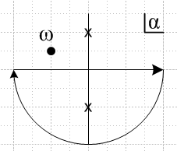

If we evaluate the contour integral closing either up or down, we get the same answer (I have shown this elsewhere), and the answer is this

f(ω) = (i/2) (ω+i)-1

and we can say that this f(ω) is a function certainly analytic above the contour. Since this result is just the residue of the southern pole, if we let ω move to the northern pole ω = +i, nothing weird happens and we just find that f(i) = (i/2)/(2i) = 1/4. The integral is so easy to compute, here it is: ( - since CW)

f(ω) = – Res[(α+i)-1(α-i)-1(α-ω)-1]α=-i = –[ (α-i)-1(α-ω)-1]α=-i = - (-2i)-1(-i-ω)-1 = (-2i)-1(ω+i)

On the other hand, if we assume ω is placed at the start somewhere below our contour, we can see that the result for f(ω) is going to be different! If we continue to close down, the difference will be that in this case we have to add in the residue at α = ω.

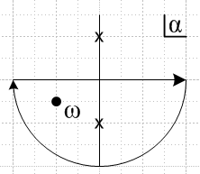

That extra residue contributes

Δf(ω) = -Res[(α+i)-1(α-i)-1(α-ω)-1]α=ω = - [(α+i)-1(α-i)-1]α=ω = – (ω+i)-1(ω-i)-1 = – 1/(ω2+1)

Therefore, in this case we are going to have

f(ω) = (i/2) (ω+i)-1 – 1/(ω2+1) = (i/2) (ω2+1)-1 [ (ω-i) – 2/i] = (i/2) (ω2+1)-1 [ ω-i +2i]

= (i/2) (ω+i) (ω2+1)-1 = (i/2)/(ω-i)

Just to confirm this result, let's instead close up to get

f(ω) = + Res[(α+i)-1(α-i)-1(α-ω)-1]α=i = [(α+i)-1(α-ω)-1]α=i = (2i)-1(i-ω)-1 = (-1/2i)/(ω-i) = (i/2) /(ω-i)

This f(ω) is different from the previous f(ω) we obtained! This f(ω) is analytic in the lower half plane!

Now, let's consider the ω plane for the function f(ω). I think it looks like this:

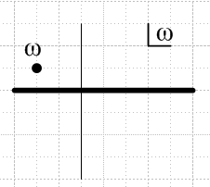

I think there is a branch cut along the entire real axis, so there are branch points located at ω = ±∞. You know you have a branch point if your function changes when you "go around" the branch point to the other side of the cut. Here we have seen that

above the cut: f(ω) = (i/2)/ (ω+i)
below the cut: f(ω) = (i/2) /(ω-i)

The discontinuity on the cut is this (now ω is real)

f(ω+iε)-f(ω-iε) = disc(f(ω)) = (i/2)/ (ω+i) - (i/2) /(ω-i) = (i/2)[ 1/(ω+i) - 1/(ω-i) ]

= (i/2)[ (ω-i) -(ω+i) ]/(ω2+1) = (i/2)[ -2i ]/(ω2+1) = 1/(ω2+1) = a(ω) = -residue of pole at α=ω

If we start as shown above and let ω do an ant-walk downwards through the cut, then we are doing proper analytic continuation, and we will find that f(ω) = (i/2)/ (ω+i) in the lower half plane on the second sheet. This corresponds to deforming the contour doing this back in our original picture:

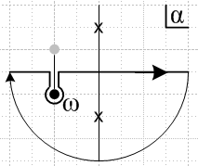

Here, as we move ω south, we deform the contour out of the way and in this way we provide analytic continuation to the lower half plane and we have f(ω) = (i/2)/ (ω+i) there as well as above. Of course if we separate out the contour loop around ω, we pick up the residue there are we then get (i/2) /(ω-i) for the real axis integral, in agreement with the above.

Now, consider the mapping from ω to f = f(ω) = (i/2)/(ω+i). As ω exhausts the upper half plane in ω space, f(ω) fills out some region in f space. Here is one way to understand what this looks like:

f = (i/2)/ (ω+i) => (2/i)f = 1/(ω+i) => (i/2f) = ω+i => ω = -i + i/2f

=> Im(ω) = -1 + Im(i/2f)

If we want ω in the upper half plane, then we want Im(ω) > 0 so we then get

-1 + Im(i/2f)> 0 => Im(i/2f) > 1

Now let f = reiφ so we have

Im(i/2 reiφ) > 1 => Im( [1/2r] ie-iφ) > 1 => (1/2r)Im(ie-iφ) > 1

=> Im(ie-iφ) > 2r => Im(icosφ + i(-isinφ)) > 2r => cosφ > 2r

The boundary of the mapped region in f space is given by cosφ = 2r.

cosφ = 2r => rcosφ= 2r2 => x = 2(x2+y2) => x/2 = x2+y2

=> x2-x/2 + y2 = 0 => x2-x/2 +1/16 + y2 = 1/16

=> (x-1/4)2 + y2 = (1/4)2 // a circle centered at x=1/4, y=0 and radius 1/4.

The boundary of the circle maps into the cut in ω space, so here is our mapping (there is no cut in f space, the dark line just shows the circle),
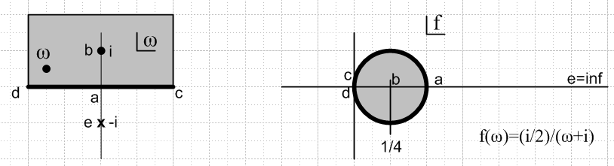

The cut in ω space maps into the heavy circle in f space. If we allow f to range freely over all of f space, we will find ourselves ranging over the entire "Sheet #1" in ω space. As we cross the circular boundary in f space, we dive through the cut in ω space. So this Sheet #1 in ω space consists of the upper tissue of the upper half plane in ω, and the lower tissue of it in the lower half ω plane. If we view the ω plane from the LEFT side of the above picture, eye's horizontal view in the plane of paper, we can see the sheets better

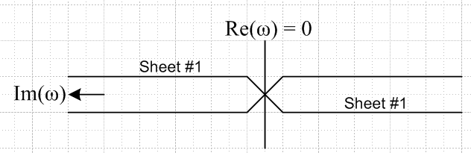

Notice that Sheet #1 of the domain maps into the entire f plane. If we dive through as just described, we could crash into the pole at ω = -i, and this corresponds to f = +∞ as suggested on the right.

Note added: We could deform the cut in the ω plane by just lowering it so it just passes just over the pole point at ω = -i. In this case, I showed (App A) that the circle on the right remains a circle which is larger, and as the cut is lowered, that circle then fills the entire right have plane of f space. So in actuality, our f(ω) = (i/2)/(ω+i) is analytic in this larger part of the ω plane which then maps into the entire right half f plane. It must then be that the other tissues of ω plane then maps into the left half f plane and you get circles over there. We could go on to deform the cut further so it wraps around the pole. Then this sliced ω plane maps into the entire f plane, while the vertical cut would then map into the negative real axis of f space. I see no great benefit to doing this deformation!

What does the other function look like , f2(ω) = (i/2) /(ω-i) ? If we trace through the above argument replacing a certain +i by -i (see App B), we end up with the condition cosφ > -2r. The boundary in f space in this case is then ( I verified this on 12.27.11)

cosφ = -2r => rcosφ= -2r2 => -x = 2(x2+y2) => -x/2 = x2+y2

=> x2+x/2 + y2 = 0 => x2+x/2 +1/16 + y2 = 1/16 ω = +i + i/2f

=> (x+1/4)2 + y2 = (1/4)2 // a circle centered at x=-1/4, y=0 and radius 1/4.

Here is the mapping for when we start ω in the lower half plane:

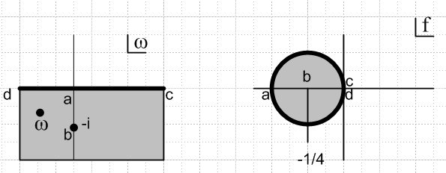 f(ω)=(i/2)/(ω-i)

Now, this function is the Sheet #2 function, and the corresponding picture is this:

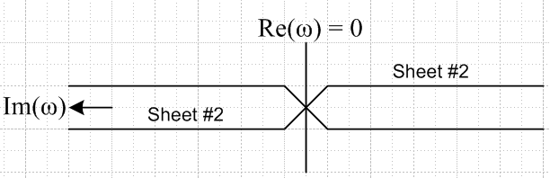

Summary: If we consider the function f(ω) defined by

f(ω) ≡ (1/2πi) $^{\int_{-∞}^{+∞}{}}$dα (α+i)-1(α-i)-1(α-ω)-1

we find that this function f(ω) has two branches, each one defined on a different sheet of the ω plane, and that the two branch functions are different:

Sheet #1 f(ω) = f(ω)=(i/2)/(ω+i) analytic in upper half plane (pole in lower)
Sheet #2 f(ω) = f(ω)=(i/2)/(ω-i) analytic in lower half plane (pole in upper)

Each sheet in the ω plane maps into the entire f plane. So these two branches are really two distinct functions mapping C → C and we could call them f1(ω) and f2(ω) if we wished. For each of these functions, for each point in the domain (all of C), we get one point in the range (definition of "function"). It is of course possible that two points in the domain map into the same point in the range, so we are not claiming we have 1-to-1 functions, so we are not claiming the function is invertible.

There is no nice way to get from one Sheet to the other, but here is a possibility:

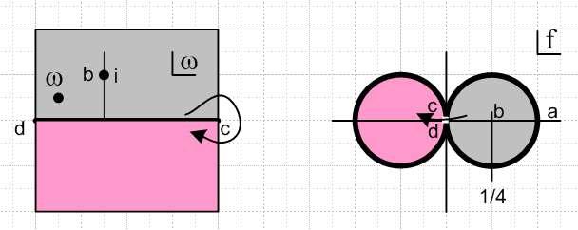

If we loop around the branch point say at ω = +∞, we go from Sheet 1 (gray) to Sheet 2 (pink). In the f plane the path is something like the arrow shown. In ω space, the sheets are joined at ±ω, whereas in the f space the mapped regions are joined at f = 0.
These are second order branch points because there are only these two sheets. It is not as obvious that there are two sheets as it is with the function f(ω) = ω1/2 . In this case, the ω plane cut runs ω=0 to the left, so you can "go around" the branch point more easily. The domain ω has two sheets, and each maps into a half plane in f (left or right). We are using the term "sheet" slightly differently in the two cases. In the ω1/2 case, the entire Sheet #1 you see in ω space is connected and is all on the upper level of the sheet parking garage. In our other case, Sheet #1 is half on one the upper parking level and half on the lower. Another difference is that with ω1/2, Sheet #1 maps into the right half plane in f space, whereas with our other function, Sheet #1 maps into the entire f plane. In any case, we can say there are two branches to the function f(ω) = ω1/2 One is + when ω > 0, the other is - when ω > 0, and we usually write the two branches as f(ω) = ±$\sqrt{ω}$. As in our fancier case, in this simple case the two branch functions are different, though the difference here is only in the overall sign.

It is "remarkable" that there can be so much complexity in a function f(ω) defined by a simple integral:

f(ω) ≡ (1/2πi) $^{\int_{-∞}^{+∞}{}}$dα 1/[ (α2+1) (α-ω)]

Since this function has two distinct branches, if you plan to use the function, you have to decide which branch you intent to work with, and this which branch you "mean" when you write this integral.

2. Generalization beyond the simple example given above.

Now we consider

f(ω) ≡ (1/2πi) $^{\int_{-∞}^{+∞}{}}$dα a(α) (α-ω)-1

where a(α) has some poles (perhaps we will do cuts later) strewn around the α plane, and we assume that a(α) decays fast enough for large |α| that we can willy-nilly add great circle pieces as needed, up or down. No poles are on the real axis so the contour is clean.
If we start with ω in the upper half plane, then we can choose to close down and this is what happens. We pick up the pole residues at all poles of a(α) that lie in the lower half plane. Thus we will find that

f(ω) = – Σi Res [a(α) (α-ω)-1]α=αi = – Σi (αi-ω)-1 Res [a(α)] α=αi

This result f(ω) is itself seen to have some poles in ω, but they are all located in the lower half plane because that is where all the αi are. Thus, we have a branch of f(ω) which is analytic in the upper half plane! If we have branch-points in the lower half plane, we can draw the cuts straight down and then our contour closed down will wrap them and their contributions will involve values of ω in the lower half plane and we will at most generate singularities in the lower half ω plane. I could show this in detail, but I am sure it is true. Alternately, think of cuts as limit of lots of poles. This cut subject is addressed somewhat in Stak Appendix B where he is pondering the inverse Laplace transform and you see cuts wrapped on page 401 in his case as the vertical contour is moved to the left.
Conversely, if we start with ω in the lower half plane, we can close up, and we will obtain an expression for f(ω) which has all it singularities in the upper half plane. This is the second branch of f(ω).
Notice from the expression above for branch f1(ω) that it is a sum of poles (αi-ω)-1 with possible south-pointing cut wrappings, all in the lower half plane. If we shoot off to Im(ω) → +∞, we move away from all this stuff, and we find that f1(ω) → 0 because all the terms → 0. The approach might be slow, for example it might just be the single pole approach shown in his page 317 F example, but that is OK.

Summary: We consider the function defined by f(ω) ≡ (1/2πi) $^{\int_{-∞}^{+∞}{}}$dα a(α) (α-ω)-1, where a(α) has good large |α| convergence, and where a(α) can have arbitrary singularities in the α plane, as long as none of the branch points of poles lies on the integration path. This function f(ω) has two distinct branches which we can call f1(ω) and f2(ω). The first function we obtain when we assume ω lies in the upper half plane and we close the contour down (up or down should work, however, and give the same result). We say that this ω lies on Sheet #1 in the domain, and we find that f1(ω) is analytic above the contour. If we start with ω below the contour, we say ω lies on Sheet #2, and we find f2(ω) is analytic below the contour. If we are going to "work with" f(ω) as defined by this integral, we have to clearly understand which branch we want to use.

3. The sum splitting notion used in Weiner Hopf

This is a direct application of the above sections, we are looking at page 316 of Stak2. We quickly arrive at 7.291 by arguments given in the text, where the contours are the horizontal ones shown top page 317 (the C2 one has been reversed so we have a - sign between the terms).
Now, each of these two integrals has two branches. I could call them (ana up means analytic above the contour),

a+1(ω) and a+2(ω) a-1(ω) and a-2(ω)
ana up ana down ana up ana down

where + refers to the first term and - to the second, and where 1,2 refer to the branches, where the 1 branch is the one that is analytic above the contour, and the 2 branch is analytic below the contour.
Stak wants to make a specific choice for each of these integral-defined functions. He selects these two

a+1(ω) analytic above Im(ω) = τ > d a+1(ω)→ 0 as ω → +i∞
a-2(ω) analytic below Im(ω) = σ < c a-2(ω) → 0 as ω → -i∞

The motivation for these choices is that the resulting a(ω) = a+1(ω) + a-2(ω) is then analytic in the strip, which is something assumed at the start of the analysis concerning a(ω). Any other combination (three others) does not guarantee analyticity in the strip !!! Another way to motivate this choice: ω as it appears in 7.291 is, "at the start", located above the lower contour and below the upper contour, so the choice is then determined just by that fact. That is, we select the branch of the lower contour function "starting with" ω above the contour, which is our Sheet #1. And we select the branch of the upper contour "starting with" ω below that contour.
Now 7.291 is only really justified when ω lies in the strip of known analyticity of a(ω), because we used Cauchy to derive the equation. We don't a priori know anything about the analyticity of a(ω) outside this strip. The separate terms however have full half-plane analyticity.

a(ω) = a+1(ω) + a-2(ω)
ana strip ana up ana down

We could now continue this equation say above the top of the strip. If there are singularities in a(ω) there, we will find them in the second term a-2(ω). And conversely going down. Within the strip, all three terms are analytic.
When Stak goes on to his toy example on page 317, he makes exactly these branch choices!

Here is a picture of the sheet structure for this sum splitting business:

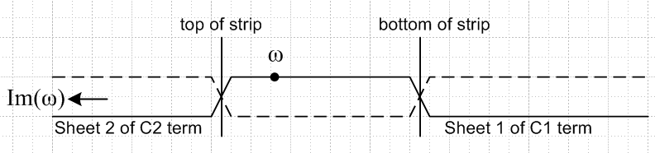

In each of the three regions, you see the sheet of the ω plane being used. Everything is continuous so we can continue ω anywhere we like. The key thing is the way the sheets join up.

Appendix A. What happens if you set the cut to Im(ω) = D instead of Im(ω) = 0?

Now, consider the mapping from ω to f = f(ω) = (i/2)/(ω+i). As ω exhausts the upper half plane Im(ω) > D in ω space, f(ω) fills out some region in f space. Here is one way to understand what this looks like:

f = (i/2)/ (ω+i) => (2/i)f = 1/(ω+i) => (i/2f) = ω+i => ω = -i + i/2f

=> Im(ω) = -1 + Im(i/2f)

If we want ω in the upper half plane, then we want Im(ω) > D so we then get

-1 + Im(i/2f)> D => Im(i/2f) > 1+D

Now let f = reiφ so we have

Im(i/2 reiφ) > 1+D => Im( [1/2r] ie-iφ) > 1+D => (1/2r)Im(ie-iφ) > 1+D

=> Im(ie-iφ) > 2(1+D)r => Im(icosφ + i(-isinφ)) > 2(1+D)r => cosφ > 2(1+D)r

The boundary of the mapped region in f space is given by cosφ = 2r.

cosφ = 2(1+D)r => rcosφ= 2(1+D)r2 => x = 2(x2+y2) => x/[2(1+D)] = x2+y2

=> x2-x/[2(1+D)] + y2 = 0

Now define c = 1/[2(1+D)] so we then have

x2-cx+ y2 = 0 => x2-cx + (c/2)2 + y2-(c/2)2 = 0

=> (x-(c/2))2 + y2 = (c/2)2

This is a circle centered at x = c/2 and of radius r = c/2 where c = 1/[2(1+D)] .

Appendix B: the left side circle

Now, consider the mapping from ω to f = f(ω) = (i/2)/ (ω-i). As ω exhausts the upper half plane in ω space, f(ω) fills out some region in f space. Here is one way to understand what this looks like:

f = (i/2)/ (ω-i) => (2/i)f = 1/(ω-i) => (i/2f) = ω-i => ω = i + i/2f

=> Im(ω) = 1 + Im(i/2f)

If we want ω in the upper half plane, then we want Im(ω) > 0 so we then get

1 + Im(i/2f)> 0 => Im(i/2f) > -1

Now let f = reiφ so we have

Im(i/2 reiφ) > 1 => Im( [1/2r] ie-iφ) > -1 => (1/2r)Im(ie-iφ) > -1

=> Im(ie-iφ) > -2r => Im(icosφ + i(-isinφ)) > -2r => cosφ > -2r

The boundary of the mapped region in f space is given by cosφ = -2r.

cosφ = -2r => rcosφ= -2r2 => x = -2(x2+y2) => -x/2 = x2+y2

=> x2+x/2 + y2 = 0 => x2+x/2 +1/16 + y2 = 1/16

=> (x+1/4)2 + y2 = (1/4)2 // a circle centered at x=-1/4, y=0 and radius 1/4.

