Sum Splitting Confusion PhL 7.28.11

These are early notes on this confusion, don't read them because most of it is probably wrong. The matter is finally cleared up in my "Analytic functions defined by integral.doc". It turns out that each of the two integrals being added together in 7.291 has two different "branches" (ie, completely different functions!) and you have to select the correct branch for each of the functions. It turns out that these "branches" are analytic in full half-planes. The selection of branches is made such that the first integral is analytic above the bottom edge of the strip, and the second is analytic below the top edge of the strip, so that both are then analytic in the strip. It was not obvious to me that there were multiple branches of each integral in the first place, nor was it obvious why each branch should have simple analyticity properties (half plane), but now it is all in the bag (I think). Below I state my confusion and review my web search to get clarification. In the end, clarification had to come from me, I cannot imagine anyone I know coming to the same conclusion.
A similar subject is the analyticity of the Fourier Transforms of one-side functions like f+(x). That is discussed in D:\Work\MyInterests\Math\Transforms\Fourier Transforms\ Fourier Transform Notes.doc. For example we find that f^+(ω) is analytic in an upper half plane. You can decompose f(x) and f^(ω) into a sum of terms which looks a little like the "sum splitting" of Stak p 316. However, on page 316 the + and - labels do not imply one sided functions, nor are the terms even regards as Fourier Transforms.

_________________________________________________________________________________

This relates to Stak page 316. He assumes a(ω) is analytic only in the strip shown. He assumes ω lies inside the strip and he uses Cauchy's theorem to write a(ω) as the contour integral shown. He assumes that a(ω) decays to the left and right such that the side contours vanish, so we just have the two linear contours shown. Yes, C1 runs below ω, and C2 runs above ω, also as shown.
He then claims that the first integral in 7.291 is analytic in ω in the entire half plane Im(ω) > d where d is the bottom of the strip. I do not understand why that conclusion may be reached. Why should that be true?? I am "missing something", as usual. For example, if ω lies above the upper edge of the strip, then the Cauchy theorem we started with is not justified and so our conclusion is not justified.
I am drawing a complete blank here! I have a Full Mental Block to something that would be obvious to another person. I did a web search and looked at other books, but they just state the same conclusion without giving a reason for the conclusion. As usual, I have nobody to ask about this, I am on my own. So this will be perhaps a 1 week shutdown of progress in Stakgold while I search for the missing fact.

Question 1: Do I believe that the first integral is analytic even for ω in the strip? I know that a(ω) is analytic in the strip, so I know that the sum of the two integrals is analytic in the strip. In order to SHOW that the first term is analytic at some ω in the strip, I have to be able to adjust contour C1 so that it is a closed contour enclosing point ω. But I see no way to do that. You could add the side pieces for free, but you cannot add the C2 top piece for free.
What about adding an upper great circle half to contour C1? If we knew that a(ω) decayed at Imω→+∞, then maybe we could just add that piece. But even so, such a contour might enclose poles of a(α) above the strip, so we don't get our conclusion.

Stak's other book does not have anything but does at least give two new references:

Krook. I found the critical spot in the 2nd reference above, and they do the same as Stak -- they don't say WHY the claim they make is true. Here it is:

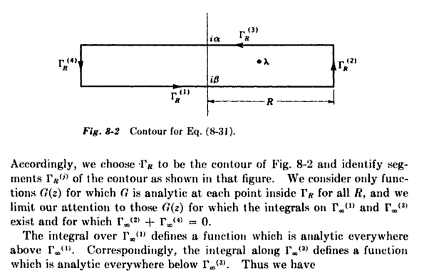

The reader is supposed to think it is completely obvious that the Γ1 integral is analytic above that contour. So this source is now used up.

As usual, the problem is finding the right search handle. I tried "sum-splitting" but get no free hits. I do notice that the term "a plus function" means a function analytic I think in the upper half plane, and "a minus function" is the reverse, so that is another possible search phrase. [ but this meanings may be wrong]

I found a Hojuwen theses that also talks about the "ratio" decomposition idea. But both it and the sum decomposition discussion use the same "missing fact" that is obvious to them but not me. I have to keep putting -elsevier in searches to remove the pay-only flak.

I am getting lots of "plus function" sources now. Often people put decompositions into their Appendix. Here is an example from ***

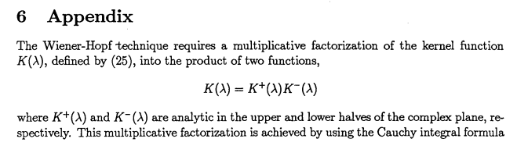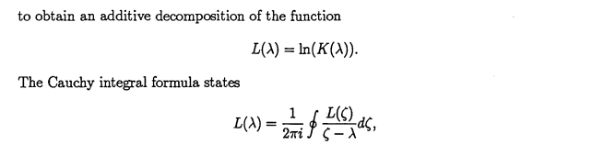

As an aside, we always have two distinct problems, the ratio and the sum. Here he is going to treat the ratio problem by doing the sum of the logs. So far so good, we continue:

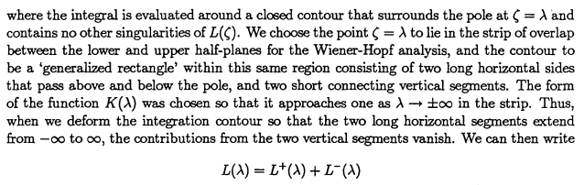
I anticipate trouble because he is already assuming analytic half planes exist. We continue nevertheless:

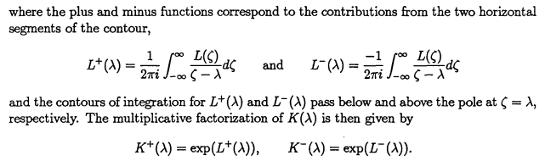
OK, fine, but no claims yet that L+ is analytic in a half plane. The integral notation is a bit sloppy, but I understand that one goes above the pole and the other below. We continue:

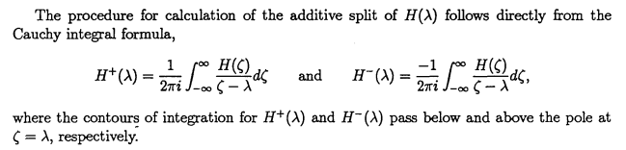

and then the appendix just ends!!! So he just assumes the thing I don't understand. This is what seems to happen in every source I have found!

I need the reason spelled out in baby steps.
_________________________________________________________________

Search: "plus function" -elsevier analytic -springerlink

latorebondeng90245.tripod.com/HMTWSI/c5.pdf

This is Chapter 5 "The Weiner-Hopf and Related Techniques" , but book it is from is not stated.
This source does not have what I want.

www.ms.unimelb.edu.au/publications/HoJuwen.pdf

Already mentioned above, does not explain what I need to know.

gen.lib.rus.ec/get?nametype=orig&md5...

___________________________________ to slow to carefully doc each hit,

A hit I find says this:

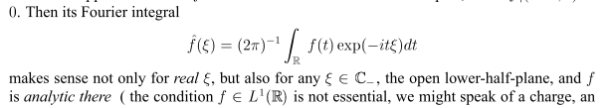

The point here is that if f(t) is 0 for t < 0, then the integration has only t > 0. If f^(ξ) exists for real ξ, then if must also exist for complex ξ of the form ξ = x+iy where e-it(x+iy) = e-itx ety converges the integral. Clearly y < 0 will do this, so f^(ξ) "exists" for all ξ in the lower half plane. Does this mean that the function f^(ξ) is analytic in the entire lower half plane? Yes, that is what they are saying above. Notice the distinction between upper and lower half plane here! I guess e-itξ is analytic in ξ, so that makes the integral also analytic. So we have a theorem:

Now it happens that Stak uses the opposite phase in his Fourier projection, so he would conclude that if f(t) is a "plus function", then its Fourier Transform function is analytic in the upper half plane! Stak confirms this on page 28.

I see that Stak has more to say on this page. He claims that if f ~ eαx and f is a "plus function" in the sense that f(x<0) = 0, then you can modify the Fourier Transform theorem by shifting the inversion contour up so it lies above the line Im(ω) = α.

Reinterpretation of Stak p 316-317. [ probably not correct ]

Imagine we have a strip where a(α) is analytic, and above and below that strip we are peppered with various poles. Consider the C1 integral along the bottom of the strip, as shown p 317. If ω lies above this linear C1 contour, we shall choose to "close down", add a lower half great circle, which we are allowed to do since a(α) decays in all directions at ∞. In this case, we pick up residues at all the lower poles which are at locations αi . This means these residues will contain factors 1/(ω-αi) which arise from the 1/(α-ω) factor of the integrand. Since all the αi of these residues are below C1, while ω was assumed above C1, the factors 1/(ω-αi) are just finite numbers. No matter where we put complex ω above the C1 line, we just get a number for our C1 integral. If there were a pole in a+(ω) above the C1 line, we would have the integral blow up at that value of ω, but we just said the integral is always just a finite number. Therefore, a+(ω) is analytic above the C1 contour.
By the same argument, a+(ω) is also analytic everywhere below the C1 contour! This is the point Stak and the others do not make clear. If ω lies below the contour, we close "up" and pick up all the northern residues and we get factors 1/(ω-αi) where now the αi are located above the C1 contour. Since they are above the contour, while ω is below the contour, a+(ω) is just a number. So a+(ω) has no poles below the contour, and we shall take that to mean it is analytic there.
Furthermore: consider that set of residues we get closing on the opposite side of the selected ω location. We will get as sum of residue terms of the form Σi Ci/(ω-αi). As |ω|→∞, each of these residues vanishes, so barring some strange situation, the sum of all these residues vanish, and so a+(ω) → 0.

Apply this argument to the example. Assume the strip lies in (-1/2,1/2).

OK, if ω lies above the strip, we close the contour down and get a+(ω) = k/(ω+i). We find that a+(ω) is therefore analytic above the strip. Conversely, if ω lies below the strip, we close the contour up and we then find that a+(ω) = k'/(ω-i) and we conclude that a+(ω) is analytic below the strip. But how can the same function a+(ω) be these two different functions k/(ω+i) and k'/(ω-i) ? If we are given a(ω) = 1/(ω2+1), how can our a+(ω) have two different values?

So let's look more closely at our a+(ω) integral which is this

a+(ω) ≡ $^{\int_{-∞-i/2}^{+∞-i/2}{}}$dα a(α)/(α-ω) = $^{\int_{-∞-i/2}^{+∞-i/2}{}}$dα (α+i)-1(α-i)-1(α-ω)-1

If we go out to the great circle at some angle θ, we find that along a piece of arc dθ distance is dα = |α| dθ and a finite angle integral there would be ∫dθ |α| α-3 ~ ∫dθ |α|-2 → 0 for sure. This says we can always add any piece of great circle we want and not change anything. We have not placed ω any particular place yet. If we agree not to put ω in the lower half of our strip, we can simplify things by raising the contour to the axis, and we then have

a+(ω) = (1/2πi) $^{\int_{-∞}^{+∞}{}}$dα (α+i)-1(α-i)-1(α-ω)-1

We should get the same answer here whether we close the contour up or down! But now we have to select a place for ω. So put ω in the upper half plane, but away from the pole at ω = +i of a(ω).

Close down: In this case, we get (minus sign because wrong contour direction)

a+(ω) = – Res [(α+i)-1(α-i)-1(α-ω)-1, α = -i ] = – [(α-i)-1(α-ω)-1]α=-i = – [(-i-i)-1(-i-ω)-1]

= – [(2i)-1(i+ω)-1] = -(1/2i)(ω+i)-1 = (i/2) (ω+i)-1

in agreement with Stak p 317 F.

Close up: In this case we get

a+(ω) = + Res [(α+i)-1(α-i)-1(α-ω)-1, α = +i ] + Res [(α+i)-1(α-i)-1(α-ω)-1, α = ω ]

= [(α+i)-1 (α-ω)-1]α=i + [(α+i)-1(α-i)-1]α=ω

= [(i+i)-1 (i-ω)-1] + [(ω+i)-1(ω-i)-1] = (1/2i) (i-ω)-1 + 1/(ω2+1)

= (i/2)/(ω-i) + 1/(ω-i)(ω+i) = [1/(ω-i)(ω+i) ] { (i/2)(ω+i) + 1 }

= (i/2) [1/(ω-i)(ω+i) ] {ω + i + 2/i } = (i/2) [1/(ω-i)(ω+i) ] {ω + i - 2i }

= (i/2) [1/(ω-i)(ω+i) ] {ω -i } = (i/2) [1/ (ω+i) ] = (i/2) (ω+i)-1

and we get the same answer as if we had closed down, which is as expected.

Now what happens if we put ω in the lower half plane? We are going to get a different answer, and I will compute it the simpler of the two ways.

Close up: We get

a+(ω) = + Res [(α+i)-1(α-i)-1(α-ω)-1, α = +i ] = the first term of our case above

= (i/2)/(ω-i)

But let's do the other way just because it is causing an error elsewhere.

Close down: We get (the first term I steal from the above close-down calculation)

a+(ω) = - Res [(α+i)-1(α-i)-1(α-ω)-1, α = -i ] - Res [(α+i)-1(α-i)-1(α-ω)-1, α = ω ]

= (i/2) (ω+i)-1 - [(α+i)-1(α-i)-1]α=ω

= (i/2) (ω+i)-1 - (ω+i)-1(ω-i)-1

= (i/2) [(ω+i)-1(ω-i)-1] { (ω-i) - (2/i) } = (i/2) [(ω+i)-1(ω-i)-1] {ω-i +2i}

= (i/2) [(ω+i)-1(ω-i)-1] {ω+i} = (i/2) (ω-i)-1

which agrees with the close up result.

How then do we explain the fact that a+(ω) is two different functions depending on where we place ω ?

So I am now going to rewrite Stak's section:

Now that we have 7.291, let's refer to the first integral as a+(ω) and the second as a-(ω) so that we then have obtained a(ω) = a+(ω) + a-(ω). We know from our exercise above that the following is true:

a+(ω) is analytic for ω above Im(ω) = d and for ω below Im(ω) = d
a-(ω) is analytic for ω above Im(ω) = c and for ω below Im(ω) = c

Aside: This follows intuitively because the integrand is analytic in ω away from the contour and we are just adding these analytic integrands to get a sum that is analytic.

Basically, each of these functions is a±(ω) analytic everywhere, except for a value of ω on its contour because then the contour runs right through a pole and we have the usual issues there. So assume that ω does not lie on either contour. In particular, both a±(ω) are analytic on the open strip.

As a subset of the above four true facts, we can select these two facts:

a+(ω) is analytic for ω above Im(ω) = d C1
a-(ω) is analytic for ω below Im(ω) = c C2

And as |ω|→∞ in any direction, a+(ω) → 0.

We can now examine Stak's example in this context. We see that when ω lies above C1, we close down and we find that a+(ω) = (i/2)(ω+i). This is just a number when ω lies above C1. But if ω were below C1, we would close up and get something that is also just a finite number when ω lies below C1 , but Stak does not show this in his example.

So I still claim that a+(ω) is analytic above and below its contour, wherever that line might be. But his restricted claims are also true.

What about the unambiguousness of the decomposition? First of all, it seems that d and c are a bit arbitrary. You could use d/2 and c/2 just as well and get different C1 and C2 contours. And you can have the contours just above or below the d,c you chose. So I suspect that the decomposition is only unique if you (1) pick a specific c and d; (2) pick specific τ and σ along which to run the contours.

So for the moment, I guess that resolves my big mystery of the day.

Next Day: Logic test question: Each of our two terms I claim is analytic for all ω away from its contour. Therefore, the sum of the two terms is analytic for all ω away from both contours. Therefore, the LHS should be analytic away from both contours. But we know it is not, just look at the example with strip say (-1/2,+1/2) in y: there are poles in a(ω) outside the strip above and below it.
Resolution: the identification of a(ω) with the sum a+(ω) + a-(ω) is only valid when ω lies in the strip. When ω lies outside the strip, the equality no longer holds, and it is OK for the RHS to be analytic outside the strip while the LHS is not. Thus, our "sum splitting" formula is really only valid inside the strip. Or in a that strip enlarged until the two edges hit singularities. This is because it is based on Cauchy's theorem where we assumed no singularities in the strip.
Now can we regard a(ω) = a+(ω) + a-(ω) as an "analytic extension" of a(ω) beyond the strip?

