Ivar Stakgold and his books PhL 4.30.11

Ivar is alive and well. I think he was 77 in 2002 (based on some bridge playing data) so he must be 86 in 2011. His 3rd edition preface is dated 2010 so he was certainly around then! ( I have now emailed him, and he is living in San Diego 12.8.11 ! )

Stakgold book in general:

I was able just now to download a certain 1979 Stakgold book which is a compressed version of the two-volume set which has this title

Green's Functions and Boundary Value Problems (1st Ed)

Here is what Stak has to say about it in his preface

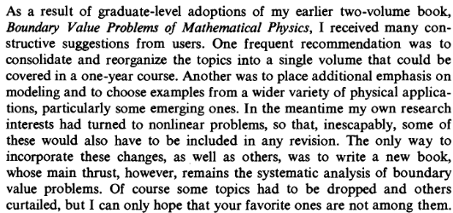

So this new book has now gone into 2nd Ed (Wiley 1997, Marriott has this) and 3rd Ed (Wiley 2011).

The 3rd edition has a coauthor as explained here:

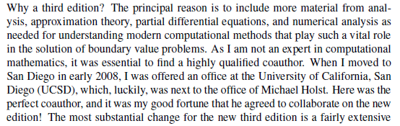

You can SEE that all of Ivar's energy has gone into this new book which is probably better adapted to graduate courses and has more modern material. So he has never made a "new edition" of the two volume set (Marriott has the original 1968 volumes). His Delaware web site contains nothing but what you see below, it has no errata for example. Nor can I find such still on the web. So when I am ready, I might send him an email!

Meanwhile, the two volume set had a new paperback printing by SIAM in 1987 for $87 total (it is their Classic Series). These are the only two books Stak ever wrote says Amazon. I suspect errata have been corrected, here is the Google book page (and maybe that is why no errata are on the web! )

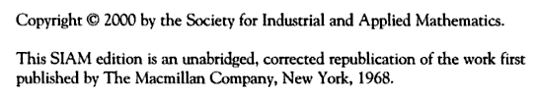

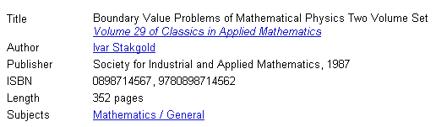

the page count seems wrong. Marriott does not have this paper thing, so I cannot check to see if bugs have been fixed.

Confusion: The Amazon data above suggests that SIAM published the book in 1987, but the copyright date is 2000. Today 7.10.11 I luckily was able to download Volume II of the SIAM edition from here,

http://www.4shared.com/get/41A4B2yG/Boundary_Value_Problems_Of_Mat.html

and it shows only the 2000 date, there is no mention of 1987. It does say things are "corrected":

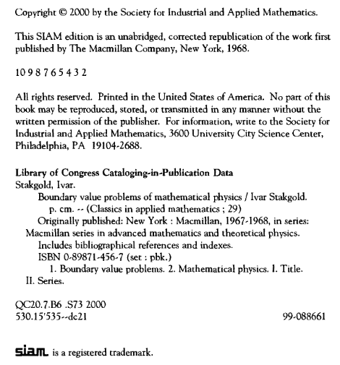
The SIAM site says that Vol I is 2000 as well, so I think the 1987 date is completely bogus. I could not find Volume I for download today. So if I can only have 1 volume, this is the one I think I would choose.

And here is something from the U of Delaware (I wrongly thought Stak died in 2003, it must be someone else I am thinking of)

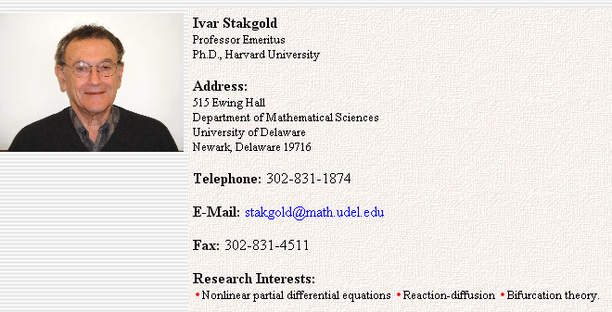

Here is a review of the two-volume set volume 1 only:

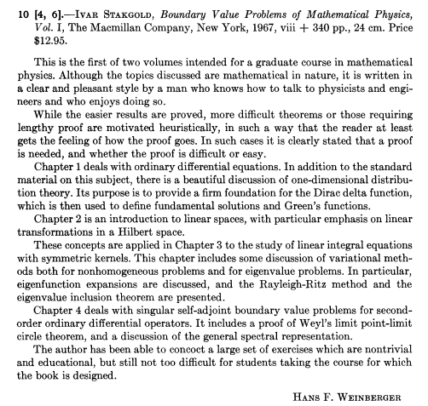

December 5, 2011

I finally got around to writing up a little errata document, and I see that I have a djvu only for volume 2 of the SIAM 2000. However, google books has both volumes of 2000 but in different locations.

I see places where it might exists as an rar download. Tried one, numbv
Password recover: RAR Magic Password Cracker
But same as I already had, vol II.

I need to find somewhere a copy of the 2000 SIAM volume 1 so I can check my errata. Marriott does not have this new one, I could not download it on line anywhere. Google books only has the first half of the thing. So time to look harder.

string boundary value problems of mathematical physics

http://books.google.com/books?id=1u-h48uVyC4C // Volume II only (but I have it djvu)

http://books.google.com/books?id=OdsK7R2PO18C // Volume I only, to page 172 only!

marriott only old one
weber only old one
utah state only old one
idaho state only old one

I walked down the Sweet library and Tony there (17 years) did an IL loan . They use the OCLC system which is (wiki) the Online Computer Library Center. They maintain Worldcat. He logged into the OCLC with password etc and I saw the 2000 edition somewhere. When I enter the year 2000, then it shows up for me too on worldcat. Here is the go to list

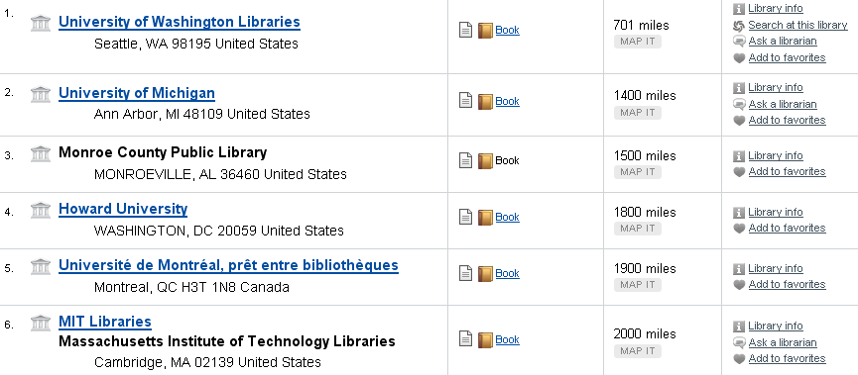

so I would guess they will get it from Seattle if they can.
But then I took one more web search adding djvu and I got this China hit

http://ishare.iask.sina.com.cn/f/7195899.html

which looks like some kind of repository thing. I did a quick download and was stunned to find that this is the 2000 version in a single binding,

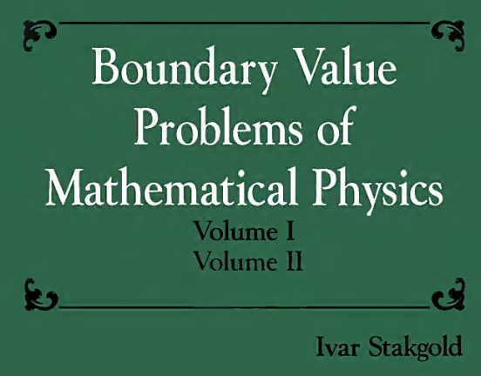

It is all there. The name of the download file was

20100326_6842572_0.djvu

which I have now changed. So now I will continue with my errata checking.

So here he is at San Diego

http://ccom.ucsd.edu/people/faculty.php

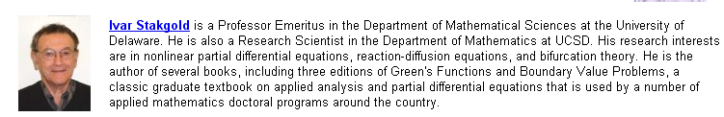

And now finally this

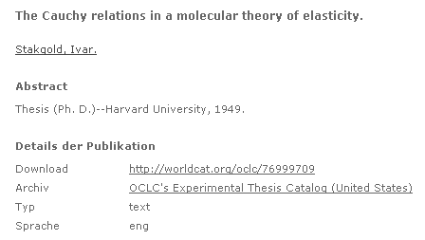

and a little more

http://search.barnesandnoble.com/Boundary-Value-Problems-of-Mathematical-Physics/Ivar-Stakgold/e/9780898714562

B&N want $138 just for volume 1 of the SIAM !!

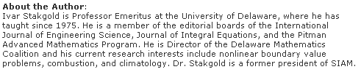

So where was he between 1949 and 1975? A period of 26 years. His preface says Harvard and then Northwestern *(Chicago)

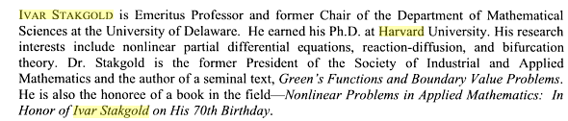
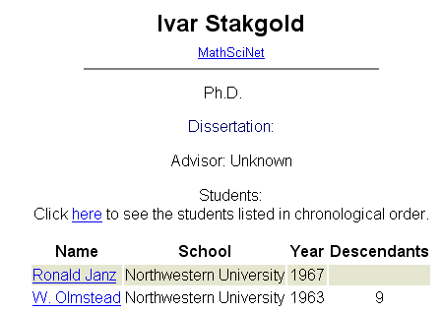

This says he was there at least 63-67.

This from a summer 2008 newsletter. He started right as the chair in 1975 and stayed chair till 1991, retiring 1995.
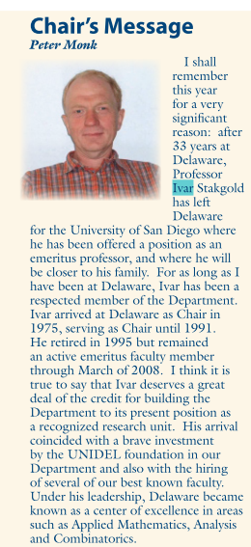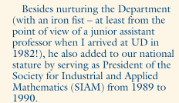

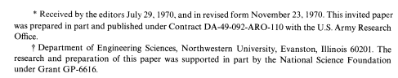
The above from a paper submitted in 1970.

So here is my guess on things:

1925 born (confirmed) in Norway! (bridge player) , but Russian
1946 Cornell undergraduate degree (confirmed), Cornell, age 21
1949 Harvard PhD in applied math
1950-1956 assistant professor at Harvard (taught 7 years here)
1956-1960 Wash DC, office of naval research
1961-1974 Dept of Eng'g Sciences Northwestern , taught 13 years here, BV pub!
1975-1991 Chair at Delaware
1991-1995 active department there, wife Alice dies of cancer 1994
1995-2008 emeritus at Delaware
2008-present at UCSD

2002 age 77 => 2002-77 = 1925 born

