Stakgold Chapter 6 meta meta notes PhL 10.24.09

Stakgold's Chapter 6 pp 88-193 = 105 pages, and I think this is his largest chapter. My raw notes for this chapter are split into two files of 134 + 60 = 194 pages! My meta notes fill 81 pages, and this meta meta doc is 28 pages. By far, I have more notes on this chapter than any previous chapter. This must reflect the complexity of the subject and/or my unfamiliarity with it. I write a little 3 page Overview here just to have something smaller to review.

Overview ( 3 pages, added 3.21.11) 1
6.1 Introduction (88) 3
6.2 Interior Dirichlet Problem for the Unit Circle (90) 3
6.3 Some properties of harmonic functions 4
6.4 Surface Layers (110) ( all for n=3) 4
6.5 Integral Equations of Potential Theory (122) 10
6.6 Green's Function for L = -∇² (130) // how to use, and how to compute 13
6.7 Methods for finding the Green's Function (146) 18
6.8 Some Physical Applications of Potential Theory (171) 30

__________________________________________________________________________________

Overview ( 3 pages, added 3.21.11)

In Section 1 we have general comments about well-posed problems.

In Section 2 Stak treats the 2D unit-disk Dirichlet problem with f(θ) on the circular boundary and we get the famous result p 94 6.11 with its Poisson Kernel integrand factor against f(θ).

In Section 3 we get the Mean Value Theorem, the Min Max Theorem, and discussion of uniqueness. This is followed by about 17 Dirichlet Exercise problems most of which I did. These are canonical simple shapes with V= 0 on all but one surface.

In Section 4 we study (in 3D) single and double surface layer sources, a(ξ) and b(ξ), and what happens to the potential u(x) and its normal derivative as you approach the surface x → s. The simple layer leads to a pair of equations (*) and (**), while the double layer leads to (#) and (##). Either pair of equations provides an "integral equation method" to solve a Dirichlet problem in the presence of a surface. In the solution of either pair, the surface layer source is just an ancillary function. At the end of this section, Exercises 18-20 explore the 2D layer results (surfaces are contours).

In Section 5 we get some examples of using the integral equation methods of Section 4.
Example p 125: do the 3D unit sphere using the a(ξ) method
Digression on Neumann problem: Stak solves the sphere interior and exterior Neumann problems using the Smythian form method. We note that the total charge inside the sphere is 0 which is a condition on the prescribed Neumann source ∂nui(s) = f(s)
Exercise 6.21 p 130: 3D Dirichlet unit sphere interior problem using the b(ξ) method
Exercise 6.22 p 130: 2D Dirichlet unit disk interior problem using the b(ξ) method
PL Example: the 2D Dirichlet unit-disk problem 6.11 for f(θ) = cos(θ) with Maple graph.
Exercise 6.23 p 130: 2D Neumann unit-disk interior and exterior problem by Smythian Form method.
My meta notes have some long comments at the end of Section 5 that are not too bad. Notice that the integral equations of the "integral equation method" are different from those involving Green's functions.

In Section 6 we discuss u(x) = ∫R dξ g(x|ξ) q(ξ) – ∫σ dSξ f(ξ) ∂ξng(x|ξ) as a general solution to a Dirichlet problem with f(ξ) prescribed on closed surface σ and space charge q(ξ) inside the surface. The 2nd term is a homo solution of Lu=0 and, added to the first particular term, tunes the result to meet the boundary condition. I have many comments on this equation including one relating Problem One and Problem Two. Stak then digresses into the subject of finding EF's of L φλn =λ φλn inside a surface on which u=0, and he casts this equation into its integral form ∫R dξ g(x|ξ) φλn(x) = μ φλn(x). He then finds the EF's for a 2D rectangle and disk. After another digression on Green's Functions for exterior regions (no big deal), he then takes us through Exercises 6.28-6.34 in which we find EV's for various simple 2D and 3D shapes enclosed by u=0 (one example has ∂nu=0 and another is mixed). The reason for the EF digression at this time is that he will use EF's in certain Green's Function computing methods in the next section.

In Section 7 is a catalog of methods for finding Green's Functions.
(1) the integral equation method, which is really just my "Dirichlet method for finding a Green's Function" combined with the integral equation method (*) and (**) discussed above. As an illustration of this method, Stak uses it to find the Green's Function for a 2D unit disk, point charge somewhere inside. This is a tour de force example say my notes.
(2) the method of images, examples are the sphere and 2D and 3D half spaces. Negating the image charge polarity provides a Neumann Green's Function solution for these half space problems.
(3) the full EF expansion where we just use g(x|ξ) = Σn φλn(x)λn(ξ) / λn, not too practical.
(4) the partial EF expansion where you grind things down to a 1D ODE Green's function problem in one variable, using EF expansions to remove the others. Stak demonstrates this method for the rectangle and the disk in 2D, and also for the 2D strip problem.
(5) conformal mapping for 2D problems only. You find the analytic mapping f(z,z0) that maps your 2D problem into a unit circle problem with point charge at the center and the answer is g(r|r0) = - (1/2π) ln | f(z,z0) |. He shows how this works for the unit circle problem with point charge off center.
Stak then gives us a battery of problems where we compute Green's Functions using these methods. It was at this point that I switched over to my second raw notes document, correctly anticipating many more pages of notes.
6.35: Do the 2D point charge in strip problem by images. This was very major for me and I had to go off and learn about things like infinite products.
6.36: Find surface charge for previous problem.
6.37: Do the same strip problem using the integral equation method
6.38: Cute image problem for quadrant 1 plate with quarter disk removed
6.39: Do unit disk by partial EF expansion with EF's in the radial direction.
6.40: A mixed BC Green's Function problem.
6.41: Curved 2D quadrilateral by partial EF expansion, done both ways!
6.42: Unit 3D sphere by partial EF method.
6.43: infinite wedge by partial EF method, done both ways
6.44: half plane using conformal mapping
6.45: half strip problem by image method
6.46: a problem using the "modified Green's Function method".

In Section 8 ("some physical applications") Stak first reviews the two integral equation methods I already reviewed in Section 4 above. He revamps the integral equations for 2D and things are the same except for the different E and a new constant term. He now does three "charged object" problems in 2D (3D extrusions), where of course the prescribed f(s) is f(s) = V0 (sometimes 0, sometimes 1). The first is the charged 2D circle (he finds σ is uniform), then he does the charged 2D line segment (-a,a) (he finds σ=1/[π $\sqrt{a2 - ξ2}$]). This is a problem I spent a lot of time on as "extra credit". Third is the charged half-infinite wire (0,∞) (he finds that σ = - Ax-1/2, but Q on the half wire diverges at the far end.) After these charged object examples, he turns to "3D grounded metal object in an external potential" problems. The integral equation method here is simple, and I call it "solving grounded conductor in external potential problems by the Dirichlet method." Stak does two examples: the sphere in a constant external E field, and the sphere near a point charge. Both results are quite simple.
He now shifts to heat conduction treating a problem with a boundary between to media of different thermal conductivity where the "potential" u is temperature. He does a simpler example first.
Finally, we come to ideal fluid flow, and this time he uses the (*****) type integral equation method. His final example is a partial cylinder sitting in an ideal flow, and this is also an example of his thin shell method described at the start of Section 8.
__________________________________________________________________________________

6.1 Introduction (88)

Description of the Dirichlet Problem in electrostatics. We will do n=2 and n=3 examples. Notion of a well-posed problem which has a unique solution. Stability issues. Stakgold will use my "Smythian Form Method" in all his examples (Stakgold has no name for this method). For Neumann you just differentiate that form before setting equal to the prescribed BC value, but Stak does not do any Neumann problems in the early sections.

6.2 Interior Dirichlet Problem for the Unit Circle (90)

A canonical 2D Laplace problem, u = f(φ) on the circle. We separate variables, get it into basis function form with eiφ and end up with the complete solution p 94 6.11 in which f(φ) is integrated against the Poisson Kernel around the ring. For f(φ) = δ(φ), this kernel is the solution and I made a Maple plot of it. Later we learn the generalization of this Dirichlet-no-sources result, (this is Problem One)

u(x) = ∫σ dSξ f(ξ) ∂ξn g(x|ξ)

In this formula, g(x|ξ) is the Green's function of a related problem I call Problem Two. In that problem, instead of observing the potential u(x) at point x as in Problem One, we put a point charge at point x, and we set u(x) = 0 on the boundary. For this Problem Two, then, g(x|ξ) is the official Green's function, and the derivative shown ∂ξn g(x|ξ) is the charge density on the boundary. But in Problem One, ∂ξn g(x|ξ) is just a certain weighting function we call the Poisson Kernel and is not a charge density.

6.3 Some properties of harmonic functions

A. Mean Value Theorem and the "part problem method" ( MVT involves circular boundary and center)

B. The Maximum Principle for Harmonic Functions (101) (max and min are on the boundary)

C. Uniqueness and BC dependence continuity of the solution

Exercises. These are very important so I cannot just space over them without comment. We study here several PDE operators L besides Laplace. Then we solve the Laplace interior Dirichlet problem for certain simple geometries ( f on boundary, no sources). Here are some of those geometries:

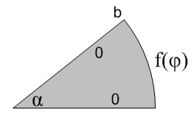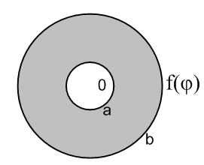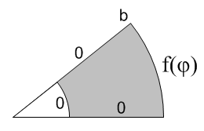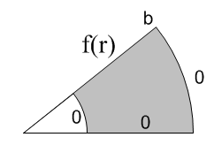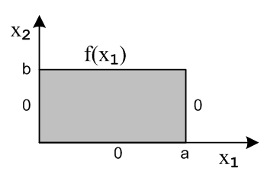

Exercise 6.1. Compute four infinite sums. All are used later in the chapter!

Exercise 6.2. Evaluate a Poisson Kernel integral with f = 1, then interpret the result. (2D)

Exercise 6.3. Solution outside the unit circle, exterior Dirichlet. (2D)

Exercise 6.4. Symmetric polygon problem. (2D)

Exercise 6.5. Work things through for Helmholtz in place of Laplace. (2D) (105)

Exercise 6.6. The ∇4 guy

Exercise 6.7. Here L = ∇2 - P where P is a "positive function". (2D)

Exercise 6.8. Show uniqueness for Lu = ∇•(k ∇u) .

Exercise 6.10. Dirichlet Laplace on a wedge (2D)

Exercise 6.11. Dirichlet Laplace on an annulus. (2D)

Exercise 6.12. Dirichlet Laplace on the curved quadrilateral. (2D)

Exercise 6.13. Dirichlet Laplace on a rectangle. (2D) (108)

PL Exercise Added: Do the disk using the methods of the previous exercises.

Exercise 6.14. Complete orthogonal set -- don't care much about this one.

Exercise 6.15. Laplace solution inside a sphere whose surface has f(θ,φ) (3D) (108)

PL Exercise 6.15A. A theorem about full group space integrals and its application D→E .

Exercise 6.16. Laplace solution outside a sphere whose surface has f(θ,φ) (3D) (110)

Exercise 6.17. Laplace solution for spherical annulus (3D)

General Comment: Cauchy, Dirichlet and Neumann BC's

Comment on Theory So Far versus Real World Problems (verbatim)

6.4 Surface Layers (110) ( all for n=3)

The n=2 stuff is done in exercises at the end. This is an extremely complex book section, and the results are heavily used later on. Despite Stakgold's valiant efforts, the section is long and seems disorganized and the reader has trouble staying afloat. For the first time in this chapter, we are going to consider "sources". Rather than being Poisson Equation sources in n D space (normally called ρ for n=3), these sources are going to be sources confined to a surface σ which lies in n-1 D space. The simple layer is a source of surface charge which I would normally call σ, but this symbol is already used to describe the surface itself, so I use "a" instead (I used Σ in the meta notes). The double layer source is a thin normal dipole layer. Variable ξ is always an integration variable on the sourcing surface. The surface σ is in general not a metal surface, since a metal surface cannot hold an arbitrary prescribed potential f(s) ! IN general it is a sticky charge surface, and that really is the only way we can interpret the dipole layer, it is a "sticky" dipole layer.

A first detail is that the "dipole source" is studied along with the "monopole source".

3D 2D
monopole -∇2u = δ(x-ξ) u = E(x|ξ) = 4π/R = -2πln(R)
dipole -∇2u = ∂l δ(x-ξ) u = Dl(x|ξ) = ∂l E(x|ξ) = cos(x ξ, )/4πR2 = cos/2πR

where is the direction of the dipole minus to plus charge. We study "layers" of monopole or dipole sources arranged on a surface σ, called simple and double layers. In this case, the dipoles in the dipole layer are always normal to the surface, not just randomly oriented. In our work, we are interested in a limit x → s where s lies on such a surface and x is off the surface. We are going to have integrals over the σ surface and Stakgold tries to consistently use ξ as an integration variable lying on σ. As we take our x → s limit, there are always two different normals we have to worry about, as shown in either of these pictures:

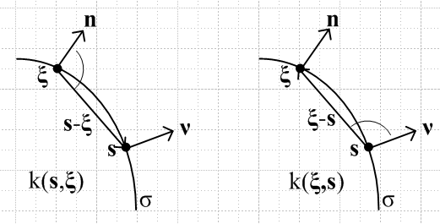

Here you can imagine point x just outside the surface a small distance from s, and ξ is the integration variable moving along the surface. Notice that there are two distinct normal vectors in either picture: ν is normal at point s, while n is normal at the integration point ξ. Each picture is appropriate to a certain non-symmetric "kernel" function, called a kernel since it will be appearing in an integral equation below:

k(s,ξ) = cos(s ξ, )/4πR2 left picture
k(ξ,s) = cos(ξ s, )/4πR2 right picture

(a) single layer

Now, if we have a monopole layer a(ξ) on σ, we can superpose the fundy solutions E(x|ξ) to get the following Laplace solution in space at point x off the surface, due to these sources:

u(x) = ∫σ dSξ a(ξ) E(x|ξ) (*) value for x not on σ E(x|ξ) = 1/4π|x-ξ|

The question we repeatedly ask is this: what happens in this equation as we take the limit x → s on σ ? In this particular case, nothing strange happens and we get

u(s) = ∫σ dSξ a(ξ) E(s|ξ) (**) u = Ea Fred 1

The reason we are interested in taking this limit is that the limiting equation above (**) is then a Fred I integral equation u=Ea -- involving an integral over σ -- which can be solved for the simple layer function a(ξ) which causes some pre-specified Dirichlet potential u(s) to exist on the surface. Even having no interpretation of a(ξ), we can stuff our solution for a(ξ) into (*) and voila, we have found u(x) everywhere! But then we can see that a(ξ) is an equivalent simple layer source density that creates a Laplace solution field which matches our u(s) specified boundary values. So given some surface σ and some u(s) on that surface, this is an "integral equation method" for solving for u(x).
[ Note added 3.20.11: I suspect the Abel Transform might be useful in solving for a in some situations, but Stak does not mention this transform. I tried and finally succeeded in solving (**) for the case of a metal disk with u(s)=V0. See electrostatics, ring and disk, "the charged disk problem.doc". There I use a Polyanin integral equation lookup, but I think it is in fact a double Able thing.]
In this single-layer situation with a(ξ), it makes no difference whether a(ξ) is a charge density on a metal surface, or is a sticky-charge layer hanging in space. The potential is Σq/R which is (*). For the metal surface, u(s) is the potential right on the metal surface which we might thing of as being inside the surface charge layer. For a sticky charge layer, u(s) is the same approached from either side and is the potential right smack on the charge layer.

(b) derivative of single layer

Now suppose we apply ∂ν to our u(x) equation (*) above where ν is the fixed normal at point s on σ. We get ∂ν E(x|ξ) under the integral which is cos(ξ x, )/4πR2 as shown in 6.42,

∂νu(x) = ∫σ dSξ a(ξ) ∂νE(x|ξ) value for x not on σ (***)

The surprising result is that if you take the limit of (***) as x→s (from the outside of σ), an "extra term" appears on the RHS ("outside" means the direction ν points)

∂νu(s) = [∂νu(x)]x=s = ∫σ dSξ a(ξ) ∂νE(x|ξ) - a(s)/2 = ∫σ dSξ a(ξ) k(ξ,s) - a(s)/2 (****)

where k(ξ,s) = ∂νE(x|ξ) = cos(ξ-s,ν)/ [4π|x-ξ|2] in 3D

One way to understand this is in the distribution sense,

limx→s ∂νE(x|ξ) = - 1/2 δ(s-ξ) + ∂νE(s|ξ)

Sticky-charge interpretation of (****)

The interpretation of (****) is trickier than in the non-derivative case. On page 119 top, Stak wants to associate the "sudden appearance" of the extra term - a(s)/2 with the act of "passing through" a surface charge layer. In the case of a sticky charge layer, we have to model the layer as two equal layers each having half the charge density, and then [∂νu(x)]x=s is measured between the two layers, as indicated in this picture:

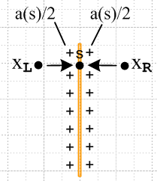

The infinitesimally thin yellow "core" here is "the surface" which you approach from either side. If you think of it as made of metal, you have to also think of the sticky-charge as being glued in place so it cannot move vertically in this picture ("transversely"). Let us now try to apply Stak's interpretation as just stated. On the right side of our picture, ν = +x and we have ∂νu(xR) = ∂xu(xR) = - Ex(xR). But on the left side we would then say ∂νu(xL) = - ∂xu(xL) = + Ex(xL). The Stak interpretation would be this

Ex(xR) - Ex(s) = + a(s)/2
Ex(xL) - Ex(s) = – a(s)/2
=> Ex(xR) - Ex(xL) = a(s)

In general we cannot say that Ex(s) = 0 because our layer might be curved or there might be other charges around in the problem, etc, so our interpretation only concerns the jump in Ex. The last line above is our familiar Gauss's law result which says that the change in normal derivative of potential u going across a charge layer is just the charge density (in Stak units where u = q/4πR ).
We can compare the situation above to an actual electrostatics problem of an infinite pair of charge layers each being a plane with some finite separation. We would say that En(xR) = En(xL) = +a(s)/2 and E(s) = 0, where n means normal to the surface. If the x axis is to the right, this says that

Ex(xR) = - Ex(xL) = a(s)/2 and Ex(s) = 0
=> Ex(xR) - Ex(xL) = a(s)

and this is then a special case of our result above, and here we have Ex(s) = 0.

Metal-surface-charge interpretation of (****)

We now draw a different picture

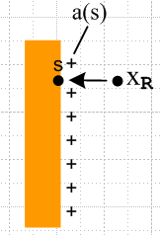

where now the orange is a real piece of metal and the entire a(s) lies on the surface and s is a point on the surface, all "as usual". Now consider our equation (****) from above

∂νu(s) = [∂νu(x)]x=s = ∫σ dSξ a(ξ) ∂νE(x|ξ) - a(s)/2

where ν = x as before for the right side surface. Here we want to claim that [∂νu(x)]x=s = -Ex(s) = -a(s). This is the usual way we think of things (in Stak units) that E = σ at a metal surface. So we get

-a(s) = ∫σ dSξ a(ξ) ∂νE(x|ξ) - a(s)/2
or
-a(s)/2 = ∫σ dSξ a(ξ) ∂νE(x|ξ) (-1/2)a = [∂νE] a (*****)

where k(ξ,s) = ∂νE(x|ξ) = cos(ξ-s,ν)/ [4π|x-ξ|2] in 3D

Equation (*****) is an integral equation for a(ξ) which is different from equation (**) above. In (**) we had to specify our prescribed Dirichlet potential on the surface (for example, u(s) = V0), but here in (*****) it seems that no boundary conditions are necessary! The integral equation seems to be of the eigenvalue type we call Fred 2 homo, and the eigenvalue is -1/2. So the implication is that the integral operator [∂νE] must in fact have an eigenvalue μ = -1/2 and a corresponding eigenfunction which is our desired a(ξ). This integral equation for a(ξ) is mentioned in Section 6.8 far below.

(c) double layer

There is an analogous pair of equations that use a double layer function b(ξ) instead of a(ξ). The starting point is this superposition sum of dipoles [ he calls the Laplace solution v instead of u ]

v(x) = ∫σ dSξ b(ξ) k(x,ξ) = ∫σ dSξ b(ξ) ∂nξE(x|ξ) (#) k(x,ξ) = ∂nξE(x|ξ)=cos(x-ξ,n)/[4π|x-ξ|2]

and you see that this derivative involves the normal at ξ which is called n. Since we already have the dangerous object inside (derivative of E), our limit picks up that same "extra term" but with a sign change I think due to the fact that we have ∂nξ instead of ∂nx, and the result is this

v(s) = ∫σ dSξ b(ξ) ∂nξE(s|ξ) + b(s)/2 (##) v = [∂nξE]b + (1/2)b

We can solve (##) for the effective double layer density b(ξ) that puts prescribed potential v(s) on σ. Then we insert that b(ξ) into (#) to get v(x) everywhere. Equation (##) is an inhomo Fred 2 with v(s) as the driving function and μ = 1/2.

Comment on (##). The single layer method of (**) then (*) seems more intuitive to me because there really will be a charge density σ = a(ξ) on the surface in question (perhaps sticky). Having a double layer b(ξ) seems unphysical, but it must in fact be just as valid! That is, the (##) then (#) method is every bit as good a method. Stak does not mention this, but after reading Sneddon I think it must be true that Fred 2 equations of the type (##) are easier to solve than a Fred 1 equation of the form (**). You can basically use the Newton series. I think Fred 2 equations are just more "stable and standard" than Fred 1, but I have never seen this clearly stated anywhere. Probably this comment applies to brute force numerical solutions.

(d) derivative of double layer

Stak talks also about ∂νv(s) and it is a bit complicated and I skip it here. This is a difficult subject to explain!

(e) Comment: (s = ξ here) One needs to understand that, by implication, we are talking about three different "problems" all of which have the same Laplace solution away from the surface. I don't think Stak makes this very clear.
In the first problem, we prescribe some non-constant (let's say) f(s) on our surface σ. Are there charges in this first problem? Not necessarily. One might use charges to create and maintain the prescribed potential, but one might do it some other way "in theory" without charges. f(s) is just some boundary condition in a math problem, and we have no need for any "charges".
In the second problem, one takes the ancillary function a(ξ) found in solving the first problem and creates from it a second problem which is one in which a(ξ) is a prescribed sticky charge density on the same surface σ. In this second problem there really are charges! The surface in general cannot be metal because the sticky charge would likely want to move on the metal. In this problem, you could compute the potential u(s) on the surface as part of your solution, and you could find that it was the same as the f(s) that was prescribed in problem 1! The interior (let's say) solutions of problems 1 and 2 are the same, so the limit of u(x) as you approach the surface will be the same. So you can think of the prescribed charge density a(ξ) in the second problem as one "method" of creating the prescribed f(s) in problem 1.
In the third problem, we take the ancillary function b(ξ) obtained by solving problem 1 using the (##) integral equation method, and we create problem 3 where we have an actual sticky double layer b(ξ) prescribed on the (non-metal) surface. In problem 3, once again we will find on our surface the f(s) that was prescribed in problem 1. Are there charges in problem 3? Well, only those charges which make up the double layer! There is no single layer of charge in problem 3! We can then think of this double layer as another method of creating the potential f(s) prescribed in problem 1.
The point is that these three different physical problems all create the same boundary condition f(s) on the (closed) surface σ, and by our Dirichlet Theorem all three problems have the same interior solution.

Exercises. Here we redo all of the above for 2D instead of 3D.

Exercise 6.18 In 2D space, find u and v due to layers on σ = C, a curve. (120)

Exercise 6.19 In 2D space, compute the two distributional results for E (121)

Exercise 6.20 More 2D results (121)

6.5 Integral Equations of Potential Theory (122)

We have really already discussed the main idea above, both the single and double layer integral equation approaches.
Now here is the single layer equation (*) from above,

u(x) = ∫σ dSξ a(ξ) E(x|ξ) (*) value for x not on σ E(x|ξ) = 1/4π|x-ξ|

We have to this point thought of a(ξ) as an "equivalent monopole source density" and the integral as a superposition of point charges. On p 124, Stakgold derives the above equation directly from the PDE's for E and u, using Green #2 applied to E∇2u - u∇2u, and from this derivation we learn that:
(1) u(x) is valid both inside and outside our closed surface σ, and
(2) the monopole density a(ξ) is equal to the jump in the normal gradient of u across the boundary: a(ξ) = ∂nu|in - ∂nu|out where n points out.
In electrostatics, we would say a(ξ) = En(out) - En(in). If σ were a conducting surface, we would associate these electric fields with the surface charge densities on the two sides (using a thin surface and pillboxes). So this serves to reinforce our idea that a(ξ) is a surface charge density, and we can think of it as being the difference across the boundary of a surface charge on each side. He calls a(ξ) by name I(ξ).

Example (p 125) Dirichlet unit sphere by monopole layer integral equation method .

Equation (*) is this:

u(r, Ω) = ∫dΩ1 I(Ω1) [1/4π R]( r, Ω, Ω1) (*)

where in effect dΩ1 is our integration over the sphere. Then (**) says

4πf(Ω) = ∫dΩ1 I(Ω1) [1/4π R]( 1, Ω, Ω1) (**)

where f is our prescribed potential on the sphere surface, so this is the integral equation we want to solve for I. By using the usual Ylm gymnastics, we find that

I(Ωξ) = Σn'Σm' Im'n' Yn'm'(Ωξ) = Σn'Σm' (4π/N0n') fm'n' Yn'm'(Ωξ)

where fmn are the spherical harmonic projections of f(Ω). We then insert this result into (*) and end up with this final result for u(r,Ω) both inside and outside:

u(r, Ω) = ΣnΣm fmn r<n r>-n-1Ynm(Ω)

where the variables are either r or 1. This replicates the interior result found in 6.25. As usual, we diagonalized the integral equation using appropriate group-representation-function projections, these for O(3).

The Neumann Problem. This section seems out of place, perhaps it was added after the fact. We are in Section 6.5 concerning the integral equations method, but this section does not use the integral equations method. The two examples below are solved by the tried-and-true "fit to a general expansion" method. In the first exercise below, he does use the (#) double layer method. I guess he felt he had to tell the reader what Neumann is about before doing an example.
This is really the only book section on the Neumann BC subject. Now f is ∂ru prescribed on the surface σ. The divergence theorem with ∇2u tells us ∫σ dS ∂nu = 0 for an internal problem. If we prescribe the surface with ∂nui(s) = f(s), this says ∫σ dS f(s)= 0 which is a condition on f(s) not present in the Dirichlet problem. For external Neumann problems, we do NOT have this requirement on f(s) because the surface integral has a piece over σ and another at r = ∞ which can compensate.
Note: if you were to do Gauss's law with a math surface embedded inside the metal of your metal boundary, you would conclude that that total charge enclosed Q was 0. This is the same as ∫σ dS f(s)= 0.

Example 1 (p 127) Neumann unit sphere internal solution by general form fit method.

Using the usual general form expansion for u(r,θ,φ) with amn and setting u(1,θ,φ) = f(θ,φ) with fmn, we find that fmn= n amn and full solution as in p 128A. This example shows that we must have f00= 0.

Example 2 (p 128) Neumann unit sphere external solution by general form fit method.

This time we get fmn= -(n+1) amn due to r-n-1 instead of rn sitting in the general form. The result is p 128 F which shows an overall minus sign I always like to point out. Here we are not forced to have f00= 0.

Stakgold (see meta) then has a discussion of the Dirichlet and Neumann problems in 2D, interior and exterior in each case. For the Neumann problem we find an f0 = 0 requirement as in 3D, and we find that in the exterior problem there is no such requirement, but we are stuck with ln(r) divergence, so instead of u→0 we have u/lnr→ 0 as r→∞.

Note: this "form fit" method is what I later decided to call the "Smythian Form" method.

Exercises (130)

Here we apply the integral equation methods to the simplest possible geometry in 2D and 3D. We get the right answers in all cases, but a lot of grinding away is required. We are of course gratified to see that the methods do in fact work out for these simple cases.

Exercise 6.21. Interior Dirichlet unit sphere using double-layer integral equation method.

So here we use the (#) method alluded to above, but it is not easy and the student is flying solo without a lot of waypoints. We start with

v(x) = ∫σ dSξ b(ξ) k(x,ξ) (#)
v(s) = ∫σ dSξ b(ξ) k(s,ξ) + b(s)/2 (##)

For the sphere, we find from geometry that cos(s-ξ,n) = - |s-ξ|/2 = -R/2 and therefore

k(s,ξ) = cos(s-ξ,n)/4πR2 = -1/4π

which certainly simplifies our integral equation. Our solution for b(ξ) is given by a the usual expansion with bmn = – fmn (2n+1)/(n+1) which I confirmed somewhere on the web. We stuff this b(ξ) into (#) and end up with v(r) = Σnm rn fmn Ynm(Ω), but only after much pain and suffering. Meta has more details.

Exercise 6.22. Interior Dirichlet unit disk using double-layer integral equation method. (130)

This is the 2D version of the previous 3D effort. As before, we get k(s,ξ) = -1/4π and our solution for b this time comes out being b(φ) = f0 - 2f(φ). After much shuffling, we end up with solution 6.11. I went on to do the exterior solution and got 6.11 with a minus sign.

Exercise 6.23 Neumann on 2D unit disk (130)

Repeat previous exercise, but for Neumann, but thankfully we are allowed to use the "form fitting" method instead of the integral equation method. Our solutions come out being:

u(r,φ) = Σn≠0 (fn/|n|) r|n| einφ interior
u(r,φ) = – Σn≠0 fn/(|n|+1) r-|n|-1 einφ + A + f0 ln(r) exterior

Notice the divergent term as noted in the general Neumann discussion, and f0 = 0 not required. Here I see that the two are correlated. If we pick f with f0 = 0, then we don't get a log divergence.

At this point I have in meta notes a pretty good text-only review of this chapter up to this point

6.6 Green's Function for L = -∇2 (130) // how to use, and how to compute

In the first 3 sections of this chapter, we solved the Laplace equation with no sources at all, but with the solution prescribed on certain bounding surfaces. Then in Sections 6.4 and 6.5 we started looking at sources, but only sources distributed on a closed boundary σ, not δ function sources within the volume surrounded by the boundary or on it. Moreover, we thought of these sources merely as ancillary functions to help us solve Dirichlet problems, not Poisson problems.
NOW for the first time in this chapter, we are going to consider the Laplace solution in the presence of both a boundary σ and a δ-function point source inside the boundary. As we did with the string in 1D, we require that the solution vanish on the boundary σ. Such a solution is called the Green's Function and is denoted g(x|ξ) as in Volume I. Again, this solution is valid at points x inside the boundary (region R), and the point charge at ξ must be inside the boundary, and region R must be bounded! Eventually we will get some comments on the "exterior Green's problem".

The basic idea: Define function v as v ≡ g - E. Then v is a solution of Laplace (ie, no source) which has the boundary value f = -E on σ. [ v is harmonic in R ] We have spent this entire chapter learning how to solve just such a problem, and we know among other things that the solution exists and is unique. For example, 6.11 gives the solution v for the unit disk given some f(φ) which we could set to -E (2D). Much later, I started calling this "the Dirichlet Method of Computing Green's Functions" and I wrote " Finding Green's Functions by the Dirichlet Method.doc" in the Stak folder which has some good examples.

We defer until Section 6.7 the actual calculation of specific Green's Functions g(x|ξ).

Stak then reels off some theorems which are "general properties of Green's Functions"

Theorem 1: g exists and is unique.
Theorem 2: The function g(x|ξ) is symmetric.
Theorem 3: g is positive throughout R.
Theorem 4: For n ≥ 3, g < E throughout R
Theorem 5: The integral operator G implied by g is completely continuous.
Theorem 6: For n = 2 and n=3, G is a H-S operator. ( note! Last two say EF's are complete set! )

Solution of the Dirichlet Problem. (135)

As noted above, we defer until Section 6.7 below the task of computing actual Green's Functions. Here we assume that we know what g(x|ξ) is for a particular problem, and we show how knowledge of g then lets us write down a complete solution of the full Dirichlet Problem with sources.
On the one hand, we have our Green's PDE for g with g=0 on σ. On the other hand, we can write the Poisson PDE for u with a volume source distribution q(x) and with the imposition that u = f on σ. We "process" these two PDEs (full details shown in raw 1) and we end up with this solution of the u-problem (which I shall call Problem One, to distinguish it from Problem Two defined later below).

u(x) = ∫R dξ g(x|ξ) q(ξ) – ∫σ dSξ f(ξ) ∂ξn g(x|ξ) = T1 + T2 (two terms) (*)
= ∫R dξ g(x|ξ) q(ξ) + ∫σ dSξ f(ξ) I(x|ξ) I(x|ξ) ≡ –∂ξn g(x|ξ)

This is a heavy-duty result requiring comments.

• You could write this as u = Gq + If if you wanted, where each integral is over a different space. That is, you could write this where G and I are linear operators. In the sense that we know g, you would not call this an "integral equation". It is just the solution to a PDE system written as two integrals.
• If f = 0 (u=0 on σ), then we have u(x) = ∫R dξ g(x|ξ) q(ξ) which is easy to interpret. It is just a superposition of the Green's Functions of point sources, each of which has g=0 on σ making u=0 on σ. It is easy to show that -∇2T1 = q since -∇2g = δ. The first term T1 is a particular solution of Poisson.

• The second term T2 is a solution of Laplace which is the homo Poisson. This is easy to see since application of -∇2 to T2 gives δ(x-ξ) which has no hit since the integral is over σ and x is inside σ. We know that the most general solution to Poisson will be particular + homo. T2 must then be the specific homo Poisson solution that causes u = f on σ -- a familiar idea from our Volume I work in 1 dimension.

• If q = 0, then T2 is the solution to the sourceless Dirichlet problem. Therefore it must be that the quantity I(x|ξ) ≡- ∂ξn g(x|ξ) is the "Poisson Kernel" of the problem at hand, as for example in 6.11.

• Consider the following different problem, call it Problem Two: unit point charge at x, and σ is the inner surface of a thin grounded metal shell (on which u = 0). What happens here is that there is an induced charge on the inner surface σ whose integral is -1 so the total charge enclosed in the metallic object is 0. Outside the shell, there is no evidence that anything is going on inside, we just have u = 0 everywhere (Gauss's Law). Way back at the start of Section 6.5 we learned that surface charges on any σ are related to the neighboring Laplace solution u in this way: a(ξ) = ∂nu|in - ∂nu|out where n points out. In our current Problem Two, u(out) ≡ 0 so we have a(ξ) = ∂nu|in . But uin for Problem Two is g(x|ξ) so
a(ξ) = ∂n g(x|ξ) = ∂ξn g(x|ξ). Therefore, in Problem Two, Σ(ξ|x) ≡ ∂ξn g(x|ξ) would be the induced charge density on the inner surface of σ. In Problem One there is no metal surface if f ≠ constant, so there is no surface charge at all on σ, but this same function ∂ξn g(x|ξ) appears in the T2 term. So if we know g(x|ξ), we can immediately compute the charge density on σ for Problem Two by computing ∂ξn g(x|ξ) .

• Back to our solution to Problem One. Suppose we take the limit x→s on σ. Since g = 0 on σ, the T1 term becomes 0. It must then be true that

limx→s [ – ∫σ dSξ f(ξ) ∂ξn g(x|ξ) ] = f(s).

which has the following distributional implication

limx→s [∂ξn g(x|ξ)] = - δσ(s-ξ) s on σ (*)

I don't think Stakgold mentions this, but basically we have just proved it to be true. I explore this idea in separate document "a green's function limit.doc". In the case of the unit circle interior, the above statement (*) becomes

limr→1 [- (1/2π) (1 - r2) / (1 + r2-2rcosψ) = - δ(ψ)

which says that the Poisson Kernel → δ(ψ), as it must so that 6.11 will continue to be true at r = 1. I proved the above δ(ψ) limit. Then I was able to find a general interpretation of (*) above. If you think again about Problem Two, then [∂ξn g(x|ξ)] is the surface charge at ξ due to a point charge at x. If we let this point charge move to the surface, the surface charge becomes infinite under the point of contact and zero everywhere else. I showed this explicitly in the case of a 2D surface σ. And of course the surface charge is negative, hence the minus sign in (*). So in other words,

limx→s Σ(ξ |x) = - δσ(s-ξ)

• Now back to Problem Two, whose solution we can write as: (point charge at x, observe at y)

u(y) = E(y|x) + ∫σ dSξ ∂ξng(x|ξ) E(ξ|y) // sign of 2nd term may be wrong

which is just superposition of all charge potentials.

Here if we take x→s, we get

u(y) = E(y|s) + ∫σ dSξ {- δσ(s-ξ)} E(ξ|y) = E(y|s) - E(s|y) = 0

In terms of our little support doc noted above, as x→s our internal point charge goes onto the surface where it makes a dipole with its image charge of zero strength, so basically the charge and its image cancel each other out and you are left with no electrostatic action at all! Certainly we expect u(s) = 0 since that is built into Problem Two. But in this limit, there is no charge inside, so u = 0 everywhere inside. Think of our point charge as hitting the surface and "running off to ground".

Eigenvalue Problem for L = – ∇2 (136)

Motivation. This seems like a sudden topic change, since we have just been talking about how to use a Green's Function to solve a Dirichlet problem with sources, and where we are now inside Section 6.6 about Green's Functions in general for L = – ∇2 , and where we know that later we are going to try to compute Green's Functions. Well, let's compare

– ∇2g(x|ξ) = δ(x-ξ) g = 0 on σ
– ∇2φλn(x) = λnφλn(x) φλn = 0 on σ λn = eigenvalues

So, why do we care about such eigenfunctions at this point? The reason is this. When we get around to computing Green's Functions below, there are two methods which make use of these eigenfunctions, so Stakgold wants to get this subject handled before we get to those two methods. We will find in fact that this is true:

g(x|ξ) = Σn φλn(x)λn(ξ) / λn

where we sum over all eigenvalues. Notice that, since φλn(x) = 0 on σ, we must then have g(x|ξ)= 0 on σ since this is true for every term in the sum. And the same is true in terms of ξ. So the point is that these eigenfunctions provide perfect building blocks from which you can construct the Green's Function !

Facts: Stak first shows these two very familiar facts (since L is symmetric, self-adjoint, what have you)

• eigenvalues λ are all real and positive (hence we can talk about μ = 1/λ and μ are all positive)
• eigenfunctions of different eigenvalues are orthogonal

The whole machinery of function Hilbert spaces and their inner products has been completely idle in this huge chapter up to this point where we now talk about such things as "orthogonal functions" and L being a linear operator in a Hilbert Space of functions, with equation Lu = λu , and so on. The integral of the inner product is over R, not over σ, by the way.

Integral Equation Form. Stak next shows that we can convert our PDE eigenvalue problem into an integral equation EV problem by just thinking of the EV equation – ∇2φλn(x) = λφλn(x) as a general Poisson equation with q(x) = λφλn(x) and using our previously found solution to Poisson ( with f = 0 on σ) which was

u(x) = ∫R dξ g(x|ξ) [q(ξ)] – ∫σ dSξ f(ξ) ∂ξn g(x|ξ) = ∫R dξ g(x|ξ) q(ξ)
so
φλn(x) = ∫R dξ g(x|ξ) [λφλn(x)] – 0 = λ ∫R dξ g(x|ξ) φλn(x)
or
∫R dξ g(x|ξ) φλn(x) = μ φλn(x) μ = 1/λ
or
Gφλn = μ φλn Fred 2 homo (see Vol I page 195)

I think this is the very first time in this two volume series that Stak has written down a multi-dimensional Fredholm integral equation. Remember that all of volume I was 1D. Well, this is not quite true. In our boundary layer work where we were using the "integral equation method" to find potentials, we did encounter multi-dimensional integral equations of various Fred kinds. It happens that those equations involved integrals over σ, whereas here we have fuller integrals over R.

Two Examples: Rectangle and Disk (139)

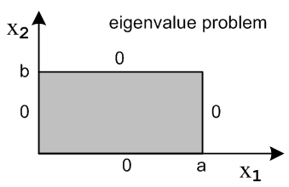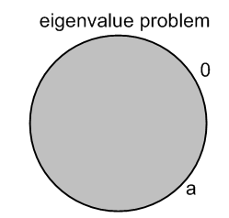

I would call these the "canonical examples" of Laplace EV problems, the rectangle and the disk. In the first case we get φλm,n(x1,x2) = sin(mπx1/a)sin(nπx2/b) and λm,n = (mπ/a)2 + (nπ/b)2 which is the TE waveguide type solution. Only for these magic values of λ do we have solutions other than u = 0 on the entire rectangle. In the second case we get φλm,n(r,φ) = einφ Jn(β(n)m r) where n = any integer and zeros β(n)m are the such that Jn(β(n)m) = 0, enumerated by m, and we have that λm,n = [β(n)m]2. The raw notes for these two examples are very good, go read them for details on the mechanics of these calculated solutions.

Green's Function for Unbounded Regions (142)

Everything we did to get u(x) = ∫R dξ g(x|ξ) q(ξ) – ∫σ dSξ f(ξ) ∂ξn g(x|ξ) is still valid for the exterior problem, as long as we think of σ is including both the obvious σ part, and the great sphere σ part. We think of n as pointing "out" on the r=∞ sphere, and "in" on the local σ. On the r=∞ part of σ, we have to require f(∞) = 0, but this just means that u(∞) = 0, so we add this "condition". Then the great sphere contribution vanishes (it can be shown). Then we want to make the n on σ be "out" so it is the same as the interior problem. We thus end up with this exterior solution for point charge in Re at x:

u(x) = ∫Re dξ g(x|ξ) q(ξ) + ∫σ dSξ f(ξ) ∂ξn g(x|ξ) // which is 6.92 (exterior)

so the Re problem is then no harder than the Ri problem. A classic exterior problem comes to mind: put a point charge outside some grounded piece of metal on which f=0. Then u(x) = g(x|ξ) and the surface charge on the exterior surface of the metal will be ±∂ξn g(x|ξ) where we have to figure out the sign, but we know it will be negative if our point charge is positive. Notice, by the way, that this g(x|ξ) is exactly the same Green's Function we use for the Ri problem, since it will vanish "naturally" at r=∞.
We do have a slight problem, however, it we try to apply our eigenfunction methods for computing Green's Functions to Re. Recall from above that our two equations are

– ∇2g(x|ξ) = δ(x-ξ) g = 0 on σ
– ∇2φλn(x) = λφλn(x) φλn = 0 on σ λn = eigenvalues

where we can regard the first on Re with no problems, but the second does have a problem because the spectrum is going to become continuous. I don't think this is a disaster, and I suspect things work out just fine in most cases, but this whole subject is being deferred to the next chapter!
Another example of an exterior problem: the exterior unit circle with no charges and f(ψ) on the circle. The solution to the interior problem was u(x) = - ∫σ dSξ f(ξ) ∂ξn g(x|ξ) where we know that that ∂ξn g(x|ξ) is the Poisson Kernel in 6.11, and we see that the exterior solution is exactly the same but has the opposite sign, something I have pointed out many times. Here we see that such a sign change is a general property of comparing exterior to interior solutions in a sourceless Dirichlet problem, we might even call it a theorem.

Exercises (143) -- eleven problems here

I did all these problems in detail. Meta has summaries. The first four deal with general issues:

Exercise 6.24. State Theorem 4 for n = 2 dimensions.

Exercise 6.25. Show that G is Hilbert-Schmidt in n = 2 dimensions.

Exercise 6.26. Show that the kernel k = a(x,ξ)/Rm (m < n) generates a CC operator G.

Exercise 6.27. Show that g(x|ξ) in 6.90 is symmetric (ie, for the Re external problem).

The next five require us to compute the Laplace eigenfunctions for these five geometries:
(the first two are 2D, the next three are 3D sphere related)
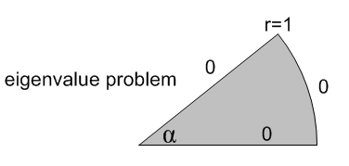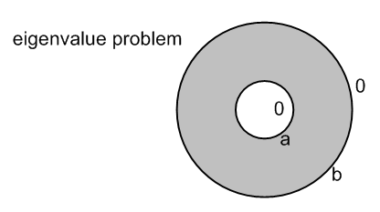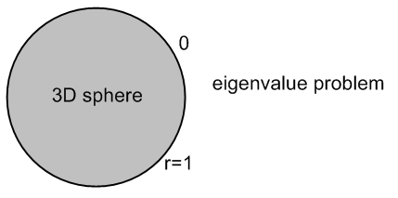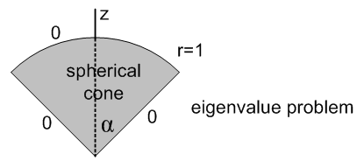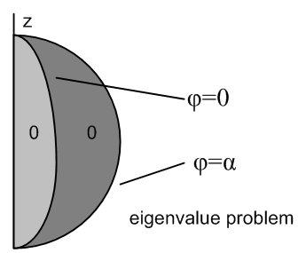

Exercise 6.28. Find the Laplace eigenfunctions for a 2D disk wedge r = 1

Exercise 6.29. Find the Laplace eigenfunctions for a 2D annular ring between r = a and r = b.

Exercise 6.30. Eigenfunctions of Laplace for the unit sphere in 3D.

Exercise 6.31. Eigenfunctions of Laplace for a cone of the unit sphere in 3D.

Exercise 6.32. Eigenfunctions of Laplace for an orange slice of the unit sphere in 3D.

The last two exercises are 2D ones which use Neumann and Mixed boundary conditions:

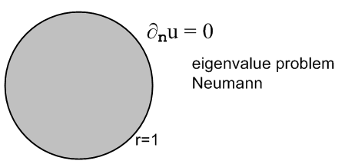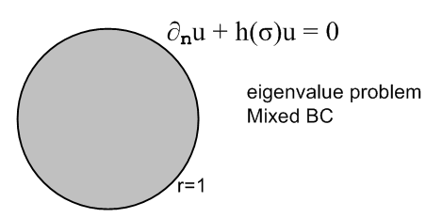

Exercise 6.33. Laplace on R where ∂nu = 0 (Neumann) on σ; apply to disk. (145)

Exercise 6.34. Repeat last but with "mixed" BC; apply to the disk (145)

6.7 Methods for finding the Green's Function (146)

First, here is a list of the methods of computing Green's Functions presented in this section, and also an outline showing where examples fit in, and extra notes I added. This is basically an outline of my meta notes for this section.

(1) The Integral Equation Method

Only Example of the Integral Equation Method: the unit disk. (147)

(1.5) Digression to show that two 2D point charges generate circles of constant potential

(2) The Method of Images

Comment on the 3D dipole equipotential lines.

Example 1: Green's function for the unit sphere (3D) (150)
(a) Stakgold's method (150)
(b) My method

Example 2: Green's function for a half space (3D)

Example 3: Neumann's function for a half space (3D)

Example 4: Line charge parallel to a plane (3D)

(3) The Method of Full Eigenfunction Expansion (153) (nD)

(4) The Method of Partial Eigenfunction Expansion (154) (2D only)

Example 1. Green's function for the rectangle. (155)

Example 2. Green's function for the unit circle. (159)

Example 3. Green's function for two horizontal plates with a line charge (2D strip). (161)

(5) Complex Variable Method for 2D (164)

(1) The Integral Equation Method

When I first read this section, I thought it was something new, but now I realize it is just our earlier single-layer integral equation method applied to Green's Functions. Recall that earlier method:

limx→s u(x) = ∫σ dSξ a(ξ)1/4πR(s,ξ) = f(s) inhomo Fred 1 monopole layer
u(x) = ∫σ dSξ a(ξ)1/4πR(x,ξ) 1/4πR(x,ξ) = E(x|ξ)

Here we are solving the general Dirichlet problem (no charges) by solving the first integral equation for what I call a(ξ), and then by jamming that a(ξ) into the second equation to get u(x), all done. In the Green's Function world, we have g = E + v, and our "Dirichlet problem" is for v where we know that
v(s) = f(s) = -E(s) on σ. I go along with his writing a(ξ) = -I(ξ) and then the above equation pair is this (where we change integration variable name from ξ to t)

limx→s v(x) = – ∫σ dSt I(t) E(s,t) = -E(s) inhomo Fred 1 monopole layer
v(x) = - ∫σ dSt I(t) E(x,t) 1/4R(x,t) = E(x,t)

But in the Green's situation, everything has a ξ parameter attached to it, such as g(x|ξ), where ξ is the location of the point charge. When these labels are added, the above becomes

- limx→s v(x|ξ) = ∫σ dSt I(ξ|t) E(s|t) = E(s|ξ) inhomo Fred 1 monopole layer
v(x|ξ) = - ∫σ dSt E(x|t) I(ξ|t) 1/4R(x,t) = E(x,t) (*)

So the plan is to solve the first equation (an integral equation) for I(ξ|t), then jam that into the second equation to get v(x|ξ), and finally add E(x|ξ) to that result to get g(x|ξ). Here then is a little method summary:

A. First, solve this integral equation for I(ξ|t): E(s|ξ) = ∫σ dSt E(s|t) I(ξ|t) // 147 A
B. Insert that result into this equation: v(x|ξ) = – ∫σ dSt I(ξ|t)E(x|t)

C. The Green's function is then: g(x|ξ) = E(x|ξ) + v(x|ξ)

Recall our general interior Dirichlet solution (with sources) [ change ξ to t in second integral ]

u(x) = ∫R dξ g(x|ξ) q(ξ) – ∫σ dSt f(t) ∂tn g(x|t)

If we were to apply this to the above Dirichlet (no sources) problem for v, we would have

v(x) = – ∫σ dSt f(t) ∂tn g(x|t) = – ∫σ dSt[-E(t)] ∂tn g(x|t) = + ∫σ dSt E(t) ∂tn g(x|t)

If we thrown in all the ξ parameter labels as before, this becomes

v(x|ξ) = ∫σ dSt E(t|ξ) ∂tn g(x|t)

But g, E and therefore v are symmetric in their two arguments, so rewrite this as

v(x|ξ) = ∫σ dSt E(t|x) ∂tn g(ξ|t) = ∫σ dSt E(x|t) ∂tn g(ξ|t)

and a direct comparison with (*) above shows that I(ξ|t) = - ∂tng(ξ|t) which is – Σ(ξ|t) of the related Problem Two problem, as discussed above. So if we solve for the Green's Function in this method, first finding I(ξ|t), then we have (for free) discovered the charge distribution on σ for Problem Two.

Only Example of the Integral Equation Method: the unit disk. (147)

Recall the three steps A,B,C noted above. Here we track each of those steps.

A. This is another Stakgold tour de force. The integral equation we need to solve is first restated in shuffled coordinates as E(s|x) = ∫σ dSξ E(s|ξ) I(x|ξ). This is converted to polar coordinates, dSξ = dψ, with picture shown p 147. The 2D E function contains ln(R) but we know R from law of cosines that
R = 1 + r2 - 2rcosθ. When the dust settles, our starting point integral equation for I(r,ψ) is p 147 D. We then claim that I(r,ψ) is even in ψ by symmetry and we expand it in a cos(nψ) series as per p 148A with some In(r) coefficients. We know that the integral equation can be diagonalized using the representation functions of SO(2), and that is what Stak does. He learns then that In(r)= rn/π and from this he determines that I(r,ψ) = (1/2π)(1-r2)/ 1+r2-2r cosψ) which we recognize as the Poisson kernel of 6.11 which has the form u(x) = – ∫σ dψ f(ψ) ∂tn g(x|t) = ∫σ dψ f(ψ) I(r,ψ). So as promised earlier, we (for free) obtain the charge distribution -Σ = I(r,ψ) for our Problem Two problem of a point charge inside a circle of wire in 2D. I recall being very mystified early on as to why this Poisson Kernel was a charge distribution but now I understand it pretty well.

B + C. Now we take our result for I(r,ψ) and jam into v(x|ξ) = – ∫σ dSt E(x|t) I(ξ|t). This is yet another tour de force, change coordinates, v gets to be the second term in p 149 C, we do the sum, sawdust is flying everywhere, but in the end we get p 149 H which shows that the final solution g(x|ξ) and we see that our function v(x|ξ) is the potential of the image charge and there is also a constant term in 6.100 which things often happen in 2D stuff.

(2) The Method of Images

Just as Stak did, I sort of segue into this section using the above image charge case as a motivating example. At this point in my original reading I was pretty amazed that the 2D potential of the point charge plus an image charge could cause g = 0 on a circle! I drew a picture (p 52 meta) and found that an equipotential of two opposite sign point charges had r/R = constant where these are the distances to the two charges. I eventually connected this with the Circles of Apollonius | z - a | = α |z-b| and realized that all the equipotentials are circles and the charge + image charge + constant makes g = 0 on the circle of interest, which is the unit circle. ( see math/geometry/docs). I did a lot of fiddling with this in the raw notes and in the meta notes, which are pretty raw at this point themselves!

Example 1: Green's function for the unit sphere (3D) (150)

This then led me to ponder the corresponding situation for a 3D sphere. For two equal and opposite charges the equipotentials are determined by 1/r - 1/R = constant (in 2D it was r/R = constant). I showed that the surfaces here are never spheres, but are 8th degree curves. Using Maple I plotted these just for fun, and here are the plots 2D and 3D, using equal and opposite charges: [ thus, these are the potential contours for a 2D and 3D electric dipole, but I only show the curves around the left charge, see Purcell p 95 for the second picture and his comments thereon ]

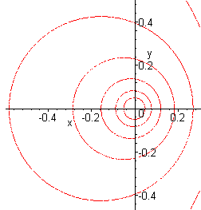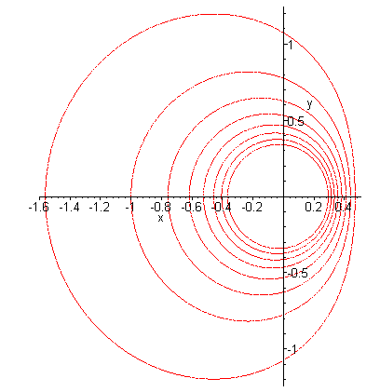
2D: all are circles 3D: 8th degree curves, none are spheres

It turns out in the 3D case that you have to not only position the image charge correctly, but you have to scale its charge correctly as well. The image charge is qimage = - a/r where a = sphere radius and r = position of the Green's point charge as distance from the center. The location of the image charge is the same as for the 2D case, which is to say, r* = a2/r. I show in detail in the meta notes that this does cause g = 0 on the sphere of radius a, and there is no constant term as in 2D.

Example 2: Green's function for a half space (3D and 2D)

This is the famous problem of the equal and opposite point charges used to get g = 0 on a line or plane. The contours are exactly those I have shown above, where the boundary of the half plane bisects the charges. In both cases the contours shown approach a vertical line (or plane in 3D) on which g = 0, so we have the half plane Green's! It just happens that in the 2D case all these contours are circles. Since we know g, we also know ∂ξng(x|ξ) which is the charge distribution on the line or plane. I plotted this in Maple for a particular value of distance above the plane. Surface charge peaks up under the point charge.

Example 3: Neumann's function for a half space (3D)

What works here is making the image charge – and repeating Example 2. This causes ∂ng = 0 at the bisecting plane. This says the electric field has no component perp to the plane. I show a plot in meta.

Example 4: Line charge parallel to a plane (3D)

This is the same as the 2D half space problem of Example 2 above, contours are circles.

(3) The Method of Full Eigenfunction Expansion (153)

On page 153 Stak uses the basic Green's PDE + the eigenvalue PDE + Green #2 (with a zero surface integral since both g and φλn vanish on the surface) to very quickly derive this fact quoted earlier

g(x|ξ) = Σn φλn(x)λn(ξ) / λn

So if you know all the eigenfunctions φλn(x) and λn of the problem, you immediately have the Green's function as this summation, and that is what the "full eigenfunction expansion method" means. Often the index represented here as "n" is really 2 or 3 indices due to quantization in 2 or 3 directions to force φλn =0 on all boundaries, so this sum is usually a sum over multiple indices which is perhaps not an ideal way to write a solution.

(4) The Method of Partial Eigenfunction Expansion (154) (2D only)

For a 2D Green's problem, the solution can be written in the above form as follows:

g(r | r') = Σnm φnm(r) nm(r')/λnm φnm(r) = pn(x) qm(y) // see for example p 154 6.109

where, as noted, λ has two indices, one for each quantized direction. When treated in the proper coordinates, you usually get the separable form as shown for φnm(r). We shall see that soon for a rectangle or a unit disk. We then pick one or the other of these two different sets of one one-direction eigenfunctions, so let fn(x), be either pn(x) or qm(x). You then expand g on just this one set of functions like this:

g(r | r') = Σm gm(y; r') fm(x) . // 6.113 and p 155 C (*)

You then show that the coefficient gm here (of one variable y) must solve a 1D Green's equation,

– λm gm(y; r') - ∂y2 gm(y; r') = fm(x') δ(y-y') // which is p 156 A

where there is a passive weight function on the RHS and r' = (x',y') is treated as a passive parameter. We spent a large chunk of Volume I solving such 1D Green's functions, so you do that here. Then you insert the resulting gm(y; r') back into (*) above and you have your resulting Green's function as a single sum rather than a double sum.
So the basic idea here is that you pick one of the two 2D directions for your basic eigenfunctions fm(x), and you never compute or use the eigenfunctions in the other direction. This is why he is calling this a "partial eigenfunction expansion". Stak eventually does all the canonical problems both ways.
I comment that when I was back doing those 0,0,0,f type 2D Dirichlet problems, I was able to get away with a single sum form like this (quantized "n" created in one 0,0 direction only)

u(x, y) = Σn pn(x)qn(y) eg: pn= sin(σnx) qn = sh(σny)

and that "form" was general enough to find the unique solutions I found. But for a 0,0,0,0 type Green's Function problem (the four quadrilateral boundaries) this form is not general enough and we need the weighted double sum form I show above, (here we are quantized in both directions. )

g(x1|x2) = Σnm φnm (x1) φnm (x2)/λnm = Σnm pn(x1) qm(y1) pn(x2) qm(y2) /λnm

We are now going to have three examples where we use the partial EF method to find Green's g.
The examples are: rectangle, unit circle, and infinite horizontal strip. All three of these can be thought of as cross sections of 3D problems. To his great credit, Stak shows lots of details above and beyond what he might have done.

Example 1. Green's function for the rectangle. (155)
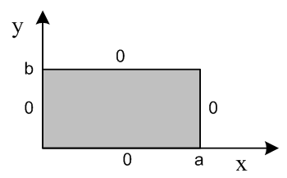
He solves this problem "in both ways", see meta notes for summary. Because the solution has sinh functions involved in one direction, he shows that if you are interested in g at point far from the edges associated with that sinh function, you get a very good answer with only one or two terms of the partial eigenfunction sum due to fast expo convergence. In this case:

gm(y; r') = (2/mπ) sin(mπx'/a) / sh(mπb/a) *sh(mπy</a) sh(mπ[b-y>]/a) g(r | r') = Σm gm(y; r') fm(x)

He then "goes beyond" the stated exercise purpose and shows how to use this Green's Solution via our generalized no-source Dirichlet formula u(r) = – ∫σ dSξ f(ξ) ∂ξn g(r|ξ) where f = 0 on all sides but not the top edge. He computes this nasty derivative ∂y'g(r| r') and obtains result 6.117 on p 158 as the solution u(r). This result is seen to be the same as we obtained in Exercise 6.13 p 108,

u(x1, x2) = Σn=1∞ bn [ sinh(nπx2/a)/ sinh(nπb/a)] sin(nπx1/a)
bn = (2/a) $^{\int_{0}^{a}{}}$dx1 f(x1) sin(nπx1/a)

He then specializes to f=1 along the top and shows that u(x) in the middle of the rectangle is accurately given by the first one ( 1%) or two (.01%) terms in the above series, fast convergence to 1/4.

Note Added: We could solve this exactly as a "part problem" even though rectangle is not a regular polygon, it does have reflection symmetries and you can make 8 triangular parts, two of which have f = 1 on their edges. The part formula then says u(center) = (1/N) Σifi = (1/8)*2 = 1/4.

Example 2. Green's function for the unit circle. (159)
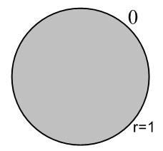
This is just turning the crank on a similar problem, though here variables r and φ are not on an equal footing as they are in the rectangle. He chooses the fn(φ) = einφ as the basis functions. I give a tour in the meta notes. This same problem is done with radial eigenfunctions in Exercise 6.39 below,

Example 3. Green's function for two horizontal plates with a line charge (2D strip). (161)
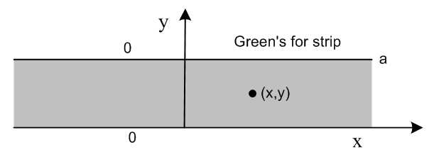
(a) The new feature here is that are strip is infinitely long. We select the pseudo-eigenfunctions eiαx in this "direction" to work with, continuum spectrum is α = any real number. [ g(r|r') = g(x.y; x'=ξ,y'=η) ] The solution is 6.123 on page 162 where instead of a sum, we have an integral on eigenvalue α. He then computes the related-problem charge distribution ∂ξn g(r|ξ) as in 6.125.

(b) Now in this example, Stak redoes the entire problem with the OTHER set of eigenfunctions starting p 162 F. The result this direction is shown p 164 (6.127). He then computes ∂ξn g(r|ξ) from this result and gets (6.129). In Exercise 6.36 we show that these two surface charge results are the same.

Later on we reconsider this same 2D strip problem and solve it using a double infinite set of image charges!

(5) Complex Variable Method for 2D (164)

(a) Conformal mapping of a region R containing z0 to the unit disk containing 0.

The Riemann Mapping Theorem which is mentioned at the start of Ahlfors Chapter 6 (which I have not read yet, having read only Ch 1 thru 3), says this: in the complex plane, given any simply-connected region R, and given an arbitrary point z0 lying inside R, there exists an analytic mapping f(z) (1-1) which will map R into the unit disk, and will map z0 into the origin.

It does not say how to find this mapping f. However, we are invited to think of the mapping as being in two parts that you concatenate. Assume your original point is z0 inside R. You first find a mapping f1 that takes R into the unit disk and takes zo in R to some location z0' = f1(z0) inside the unit disk. Once you have done that, there is an obvious second mapping f2 which maps the unit disk into itself and brings z0' to the origin, so that f2[z0'] = 0. That mapping f2 is claimed to be this:

f2(z) = eiα (z-z0') /(1-z0') 0' ≡ 1/z0'

I show in the raw notes that this mapping does what we want. So the concatenated mapping is (f1 ≡ s )

f(z,z0) = f2[ f1(z)] = eiα (f1(z)- f1(z0)) /(1- f1(z) 1(z0) = eiα (s(z)- s(z0)) /(1- s(z) (z0))

(b) If we find the mapping f(z) which does as required above, then the amazing result is that we then know the Green's Function for region R!!! It is just this:

g(r|r0) = - (1/2π) ln | f(z,z0) | r = (x,y) z = x+iy etc

In the raw notes, I shows that g is harmonic within R (being the real part of an analytic function ln[f(z)] ), that g = 0 on the boundary ( f(zσ, z0) = eiψ so |f|=1 and ln1 = 0) , and that g satisfies the Green's equation which is -∇2 g(r|r') = δ2(r-r') .
This really is an impressive result, I wonder who first discovered it? A quick scan shows Green's Functions existed around 1830, but the mapping theorem was only stated in 1851, so perhaps soon after 1851. { Why has no-one come up with a 3D version of this...? I'll bet many have tried. Maybe you need complex variables of the form z = x + iy + i'y' where you have a third dimension in complex space. }
As the most basic example, the Green's Function for a unit circle containing point z0 has s(z) = 1 so is given by

g(r|r0) = - (1/2π) ln | f(z,z0) | = - (1/2π) ln | f2(z,z0) | = - (1/2π) ln |(z-z0) /(1-z0)|
= - (1/2π) ln |z-z0| /|1-z0| = - (1/2π) ln |z-z0| / ( |z - 1/ 0| |0| )
= - (1/2π) ln |z-z0| /( |z - z0*| |z0| )
= - (1/2π) ln |z-z0| + (1/2π) ln |z-z0*| + (1/2π) ln |z0|

which replicates our image method solution of page 149 H.

Exercises (166)

We have now studied five different methods of computing Green's Functions, and here Stakgold gives us problems which touch on all five methods. I read and thought about each of the problems, but I only really did about half of them. Since this Green's Function section is one of the main cores of this entire two volume set of books, so I am going to show some detail on these exercises.

At this point, I switched over to a new raw notes document "raw 2" since the first raw 1 doc was getting very long. In terms of note compression, the raw 1 notes are 130 pages, the meta notes to this point were 70 pages, and these meta-meta notes are 20 pages to this point.

Exercise 6.35 : Method of images for a strip (2D) (166)

I expended a huge amount of energy on this problem and, correspondingly, learned many brand new things, and wrote several supporting documents, so I will put a long summary here. First, the picture:

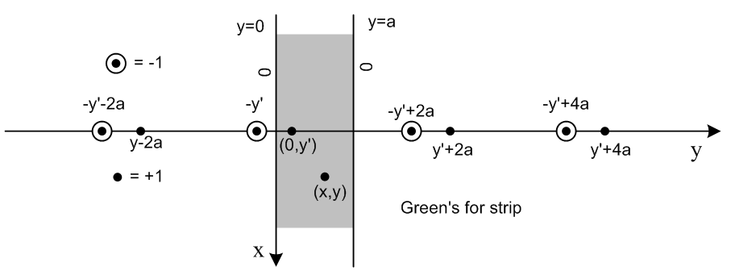

It is trivial to show why this image pattern works if you think about two pair-groupings of charges. I wrote up a whole separate doc on this problem ("exercise 6_35 v2.doc") and here I just quote some of the results. For the strip as shown above -- which is really a horizontal strip y=0 to y=a, when axes are correctly oriented -- the Green's Function is given by each of these five forms:

g(x,y |0,y') = -(1/2π)Σn ln [ x2 + (y - y'+2na)2 ] + (1/2π)Σn ln [ x2 + (y +y'-2na)2 ] (1)
= -(1/2π)Σn ln { [ x2 + (y - y'+2na)2 ] / [ x2 + (y +y'-2na)2 ] } (2)
= -(1/2π) ln Πn { [ x2 + (y - y'+2na)2 ] / [ x2 + (y +y'-2na)2 ] } (3)

g(x,y |0,y') = -(1/4π) ln { [ch(πx/a) - cos(π(y-y')/a))] / [ch(πx/a) - cos(π(y+y')/a)] } (4)

g(x,y |0,y') = Σn=1∞ (1/nπ) e-(nπ/a)|x| sin(nπy/a) sin(nπy'/a) // = 6.127 (5)

The first is due to the method of images which forces g=0 on the two strip edges. It is trivially rewritten in the second form shown, and then a sum of logs becomes the log of a product to get the third form. It turns out this infinite product is of a standard form which allows it to be written in a nice closed form which is shown in the fourth line above. I wrote up details in "theory of infinite products.doc" which derives lots of product formulas, such as

sin(πz) = z π Πn=1∞ (1-z2/n2) " Euler's product for the sine "
cos(πz) = Πn=1∞(1– z2/an2) an = (2n-1)/2

sin(πx)/sin(πy) = (x/y) Πn=1∞[ n2-x2]/[n2-y2] two-sine
[sin(πx1) sin(πx2)] / [sin(πy1)sin(πy2)] = Πn [(n-x1) (n-x2)] / [(n-y1) (n-y2))] four-sine

Πn [(n-a)2 + b2] / [(n-c)2 + d2] = [sin(π(a+ib)) sin(π(a-ib))] / [sin(π(c+id)) sin(π(c-id))]

The last line here is the one which applies to our current case, and it is just a special case of the four-sine formula shown directly above it. The names Euler, Hadamard and Weierstrass are associated with this infinite product work.
The last line (5) above shows the solution written as an expansion on the transverse eigenfunctions of the strip. Yet another form is shown p 162 as 6.123 where we expand instead on the longitudinal eigenfunctions. In this direction, the interval is infinite and we get a continuous real eigenvalue spectrum.
Finally, in document "greens functions and change of coordinates.doc" I write the above g formulas for a more standard positioning of the strip

g(x,y| x',y' ) = (1/4π)Σn ln { [ (y-y')2 + (x - {x'+2na})2 ] / [(y-y')2 + (x + a - {-x'+2na})2 ]

g(x,y| x',y' ) = -(1/4π) ln { [ch(π(y-y')/a) - cos(π(x-x')/a))] / [ch(π(y-y')/a) + cos(π(x+x')/a)] }

g(x,y|x',y' ) = Σn=1∞ (1/nπ) e-(nπ/a)|y-y'| sin(nπ[x+a/2]/a) sin(nπ[x'+a/2]/a)

where the strip is vertical running from x = -a/2 to +a/2, and the Green's charge is at (x',y').

Exercise 6.36 : Show surface charge same in both strip direction solutions. (166)

Exercise 6.37 : Integral Equation method on the strip. (167)

The "integral equation method" has us solve a certain integral equation for a function called "I", and then we insert the solution "I" into 6.96 to get our Green's function g. The integral equation for "I" has this general form, where E is the usual 2D fundamental solution,

E(x|t) = ∫σ dSξ E(x|ξ) I(t|ξ) x on σ ξ integrate on σ, t inside R

Since the strip has two edges, we end up with two coupled integral equations for I
E(x,0|t) = ∫ dx' E(x,0|x',a) I(t|x',a) - ∫ dx' E(x,0|x',0) I(t|x',0)
E(x,a|t) = ∫ dx' E(x,a|x',a) I(t|x',a) - ∫ dx' E(x,a|x',0) I(t|x',0)

where the left integral is on the y=a edge and the second on the y=0 edge. We are told to diagonalize these convolution-form equations using the Fourier Transform, solve the problem in Fourier space, then come back and we have a result for I and from that we get g. I did not "do" this problem.

Exercise 6.38 : Find some image charges to match a certain 2D region. (167)

These were interesting cases, I just show some pictures:
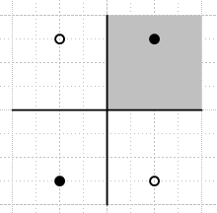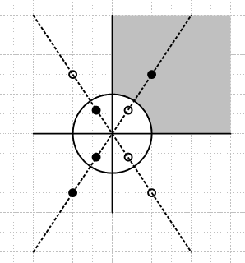

In both cases, we want g = 0 on the boundary σ of our gray region.

Exercise 6.39 : Partial Expansion Solution of Unit Disk using Radial Eigenfunctions (167)

Stakgold comments on this particular ODE (2D Laplace radial equation) at many places in his two volumes, and I first review what we learn there. We then show that for this problem the radial eigenfunctions are (sin[νln(r)] ) and the final Green's g can be written as 6.132, where we "expand" on these eigenfunctions. As with any infinite interval [ that is, r=0,∞ ], the eigenvalue ν is continuous. I did not do the problem, but followed all his text on it.

Exercise 6.40 : A Mixed BC Green's Function example : Dirichlet and Neumann (168)

The region/boundary picture is as shown right side above where now we want ∂ng = 0 on the straight boundaries, and g = 0 on the circular one, so this is a "mixed" BC problem. We are then asked to solve this with a φ basis function expansion, which I did not do.

Exercise 6.41 : Curved Quadrilateral Green's "both ways", r and φ expansion (168)
f(φ) = 0 for the Green's Problem

This is a very well defined problem and I should do it some day.

Exercise 6.42 : Unit Sphere Green's Function by the Ylm expansion method. (169)

We did the unit sphere Green's on page 150 using the image method and quickly got a solution there as 6.102. Here we are asked to do the problem "the standard way", another one for my rainy day collection.

Exercise 6.43 : Infinite Wedge, do it both ways (2D) (169)

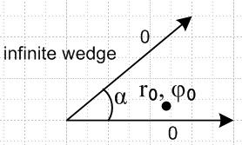

Using the φ eigenfunctions functions we have a Fourier Sine Series job, and using the radial eigenfunctions, we have a Mellin Transform job. I understand the problem, but I did not do it.

Exercise 6.45 : Vertical half-strip of width π, done 4 ways (170)

In (a) we are supposed to do this by the image method, which is quite easy,

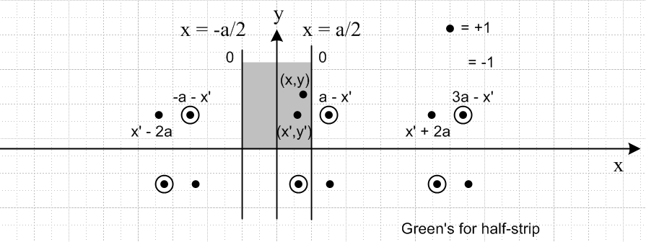

The four ways are: (a) Image charges as shown above, did this part; (b) transverse sine eigenfunctions; (c) longitudinal sin(νy) eigenfunctions with ν continuous; (d) conformal mapping with f(z) = sin(z). I did this part.

Exercise 6.46 : Modified Green's function for Neumann Boundary Conditions (171)

The Neumann BC forces a consistency condition which in turn requires that one work with the a certain "modified" Green's Function equation and solution -- something we did way back in Section 1.6 of Vol I. we are told to use this method to find Green's for the Neumann-BC unit disk. The answer is given in 6.137, and no, I did not do the problem.

6.8 Some Physical Applications of Potential Theory (171)

A. Charged Conductor and Electrostatic Capacity (3D) (171)

Put some charge Q on a conductor, what is Σ, the surface charge distribution? In this section, Stak derives two integral equations which one can attempt to solve for this quantity Σ(s). I will just quote the results. The first is this:

∫σ dSξ Σ(ξ) E(s|ξ) = 1 (= f(s)) E Σ = 1 first kind Fred

where we assume u = 1 on the metal boundary. Once we know Σ(s), we can if we want compute the potential everywhere from u(x) = ∫σ dSξ Σ (ξ) E(x|ξ).
The second integral equation is this: (this appears as (*****) in Section 6.4 (b) above)

∫σ dSξ Σ(ξ) k(ξ,s) = (-1/2) Σ(s) KΣ = μΣ μ = -1/2 second kind Fred homo
k(ξ,s) = cos(ξ-s,ν)/ [4π|x-ξ|2]

So these integral equations are over 2D surfaces σ like surface of a sphere, say. For that case we know that the kernel k simplifies and we might actually stand a change of solving the thing. The "boundary conditions" are built right into these integral equations.
The first integral equation is really a severe condition on Σ(s): At every point s on σ, the potentials due to all pieces of charge on the surface must add up to the same constant, in this case 1. This includes pieces near and in fact right at s. We know there exists a unique solution, because we know physically that charge distributes itself in some unique way when you add Q to a metal object. There is surely a math proof of this as well, we probably did it somewhere earlier in Stakgold.
Stak spends the rest of this section discussing the situation of an "open" metal surface, such as a spherical bowl which he draws.

B. Charged Conductor in 2D (174)

When we repeat the above analysis in 2D, things are the same except that the solution u(x) contains a constant term c0 which shows up only in the first kind Fred equation. Here are the equations (note that here we assume u = 0 on the metal, whereas in the 3D above we assumed u = 1 on the metal).

0 = c0 + ∫C dlξ E(s|ξ) Σ(ξ) E Σ = -c0 first kind Fred

∫σ dSξ Σ (ξ) k(ξ,s) = (-1/2) Σ(s) KΣ = μΣ μ = -1/2 second kind Fred homo
k(ξ,s) = cos(ξ-s,ν)/ [2π|x-ξ|]

Example 1: Charged circular cylinder (2D circle)

We write the first-kind Fred integral equation, get it diagonalized, and find that Σ(s) = constant on our circle. The potential comes out being u(x) =(Q/2π) ln(r/a), and cylindrical capacitor has C = 2π/ ln(b/a). The potential is ln(r) divergent at ∞, a possibility we knew about from earlier.

Example 2: Strip of width 2a in 3D ("the 2D line segment" on x axis -a to a) (178)

We again write the first-kind Fred integral equation including c0 . The way to solve this integral equation is shown in Exercise 6.47 (which I did) and we find that Σ(ξ) = 1/[π $\sqrt{a2 - ξ2}$] which is infinite at the ends, but stays integrable. I did a lot of "extra work" on this little problem, just for fun. One thing I found was that the potential is this:

u(x,y) = – (1/2π)ln(2) -(1/8π) ln | z + $\sqrt{z2-1}$] z = x+iy

and that the potential contours are ellipses (which I showed several ways, all taking effort). See meta notes for a fuller summary. [ The 3D wire segment is another story!! ]

Comment: Although I have never done it, this 3D strip problem could be solved in 3D "elliptic cylinder coordinates" with focal points at ±a, one of the Moon & Spencer systems. The strip is seen to be a level surface in this system where we take the extreme ellipse that is sucked down onto the two focal points. Since this system is fully separable, the above potential should somehow appear very quickly. Right off the bat we can say that the equipotential surfaces are elliptic cylinders so it is just an issue of how you parameterize those cylinders. M&S use η as in A = achη and B=ashη for the semi majors. So the cylinders are then x2/(achη)2 + y2/(ashη)2 = 1, and the strip is then η → 0.

Example 3: Semi-infinite strip (now our 2D wire runs x=0,+∞ ) (178)

Here we do the "form fit" method rather than attempt the integral equation method which has inherent problems since the metal goes out to ∞. The solution for the half-infinite wire is Σ(x) = - Ax-1/2 and the potential is u(r,φ) = Ar1/2sin(φ/2). I made plots of u for this and the previous problem, see meta notes.

C. Grounded Conductor in an External Field 3D (174)

An external potential field u0(x) already exists, and we place a finite conductor in this field. The solution is u = u0 + us where us is created by the induced surface charge on the conductor. Our method is to solve the "us problem" and from that solution compute u. We have the usual pair of equations one of which is our first-kind Fred ( in the second equation we have us(s) = -u0(s) since us(s)+u0(s) = u(s) = 0 ! )

us(x) = ∫dSξE(x|ξ) Σ(ξ) // plug I(ξ) in here to get us(x) everywhere outside.
-u0(s) = ∫ dSξE(s|ξ) Σ(ξ) // integral equation to find I(ξ), first kind Fred

Solve the second for Σ, plug that into the first. Recall my "solving Green's Function problems by the Dirichlet method". This thing here is "solving grounded conductor in external potential problems by the Dirichlet method."
The second-kind Fred integral equation provides an alternate method

- ∂νu0(s) = Σ(s)/2 + ∫σ dSξ Σ (ξ) k(ξ,s) // which is 6.160

Application to Sphere in constant E field and Sphere near point charge (radius a)

If we write out the first and second kind Fred's, using our known simple form for kernel k, we find that they both contain the same integral . We add the equations in such a way to make this integral cancel out, and we get this final result:

Σ(s) = -2∂νu0(s) - u0(s)/a

(1) for constant E field, we get: u0 = Ax Σ(s) = -3 Ax/a

In other words, the charge density depends only the longitudinal coordinate x, origin at sphere center.

(2) for u0 = point charge located r0 from the sphere center: Σ(s) = - (r02- a2)/(4πaR3)

D. Steady Heat Conduction for "Composite Medium" (183)

Here is a picture:
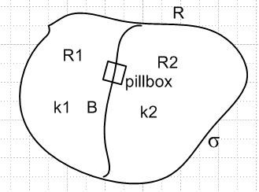

In this world, potential u is temperature, k's are thermal conductivities. We have Laplace in either region, and there are two boundary conditions at the interface between the regions: temperature is continuous, u1 = u2 and pillbox heat flow balances so k1∂nu1 = k2∂nu2 . Stak presents a simple 1D example which he solves by matching the BC's. He then presents a different method whereby you assume some general kε(x) in region R, solve that problem fully, then just take the limit ε→0 which takes you to the above interface situation. Of course the general-k(x) problem is not the Laplace problem, but once you solve it, you can form any interface you want by finding a suitable kε(x) function which goes to that interface in the limit. He does this method as well for his 1D example. I think Stak just wanted to get this idea into the book somewhere.

E. Flow of an Ideal Fluid past an Obstacle (185)

It turns out this is a Neumann BC situation since vn = ∂nu = 0 at the surface of any "obstacle" in your flow. See meta notes for more background on this "world". The existing flow is called ui and the surface of the obstacle causes disturbance us and the total solution is u = ui + us. As he did in the conductor in external field problem, he works with "the us problem". He arrives at a Fred second kind integral equation we need to solve for u(ξ) just on the obstacle surface, then we plug that into the first equation to get us(x) everywhere:

us(x) = ∫σ ∂nξE(x|ξ) u(ξ) 6.173

-ui(s) = - u(s)/2 + ∫σ ∂nξE(s|ξ) u(ξ) 6.175 Fred 2 inhomo

There is a sort of maimed Fred 1 for this problem which he writes but does not use.

He then rewrites things in his usual "thin shell" situation. As happened before when he did this thin shell stuff, things don't quite work out. He gets the following pair where the second is "not really" an integral equation but might be solvable

us(x) = ∫σ ∂nξE(x|ξ) Δu(ξ) 6.177

-∂νui(s) = ∂ν [ ∫σ ∂nξE(x|ξ) Δu(ξ) ]x→s 6.180

where Δu is the jump in u across the surface of the thin shell. Recall that our previous conductor problems were Dirichlet, not Neumann, so the we got Σ(ξ) = -∂nu(ξ) in place of Δu. He always calls these things I(ξ), but I have not done that in these meta meta notes.
His final remarks are that although this little fluid flow section is written in 3D language, it is also valid for 2D, and is also valid for an arbitrary initial flow ui(x), though he worked with a parallel infinite flow. He was careful to keep things general.

Thin shell example: (a 2D problem!) River blocked by partial cylinder as shown picture p 189

I give a good rundown on the details in the meta notes. He does not solve this problem here, he just develops two integral equations that one might be able to solve! The first is a bit bizarre in that it contains a second derivative including an integral equation, see 6.187, "integrodifferential equation". The second integral is more normal, given in 6.189. The first integral equation has Δu(ξ) as the thing you want to solve for, whereas the second has J(φ) ≡ ∂ru |r=1 as the thing you want. In either case, if you can solve the integral equation, you can then find a complete solution to the problem.

