Continuing Chap 6 raw notes here since doc is already 126 pages. PhL 9.24.09

Exercises (166) twelve problems 1
Exercise 6.35 : Method of images for a strip (2D) (166) 1
Exercise 6.36 : Show surface charge same in both strip solutions. (166) 4
Exercise 6.37 : Integral Equation method on the strip. (167) 8
Exercise 6.38 : Find some image charges to match a certain 2D region. (167) 9
Exercise 6.39 : Partial Expansion Solution of Unit Disk using Radial Eigenfunctions (167) 10
Exercise 6.40 : A Mixed BC Green's Function example : Dirichlet and Neumann (168) 12
Exercise 6.41 : Curved Quadrilateral Green's "both ways", r and φ expansion (168) 13
Exercise 6.42 : Unit Sphere Green's Function by the Y_{lm} expansion method. (169) 13
Exercise 6.43 : Infinite Wedge, do it both rays (2D) (169) 13
Exercise 6.44 : Half-plane as starting region or as an intermediate region (170) 14
Exercise 6.45 : Vertical half-strip of width π (170) 15
Exercise 6.46 : Green's function for Neumann Boundary Conditions (171) 22
6.8 Some Physical Applications of Potential Theory (171) 23
A. Charged Conductor and Electrostatic Capacity (171) 23
Closed Surface. 23
Open Surface 25
PL Exercise. Unit solid metal sphere. 26
PL Exercise. Unit solid metal spherical thin half-shell. 27
B. Charged Conductor in 2D (174) 27
Examples (three examples) 30
Example 1: Charged circular cylinder (2D circle) 30
Diagonalization Comment Added 10.27.09 33
Example 2: Strip of width 2a (meaning a 2D line segment on x axis -a to a) (178) 35
Summary of external notes. "potential of extruded strip v1.doc" 37
Summary of external notes. "potential of extruded strip v2.doc" 38
Summary of the above v2 doc summary 41
Example 3: Semi-infinite strip (now our 2D wire runs x=0,+∞ ) (178) 45
C. Grounded Conductor in an External Field 3D (174) 46
D. Steady Heat Conduction for "Composite Medium" (183) 48
E. Flow of an Ideal Fluid past an Obstacle (185) 49
Exercises (191) 55
Exercise 6.47. 55
Exercise 6.48. 55

Exercises (166) twelve problems

_________________________________________________________________________________

Exercise 6.35 : Method of images for a strip (2D) (166)

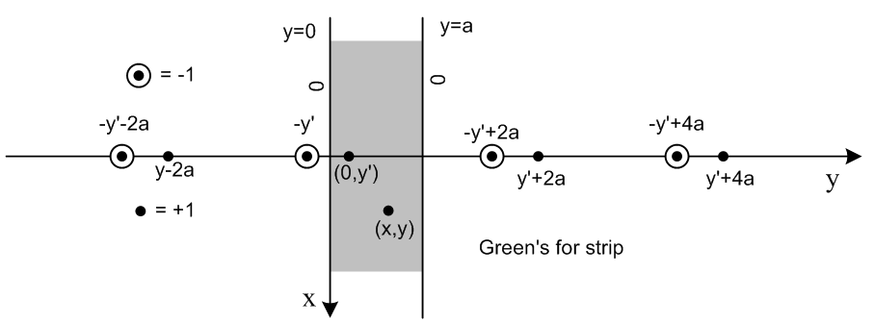

Here I have rotated the picture described in 6.120 so uses horizontal paper space. We put the Green's official point charge on the y axis so coordinates are (0,y'). The observation point is (x,y). I show where the claimed image charges should be located, an infinite number of each polarity. My y' = his η. The thing we seek is then g(r|r') = g(x,y |0,y'). The sum of the fundies shown above is

g(x,y |0,y') = -(1/2π)Σn ln [ x2 + (y - {y'+2na})2 ] + (1/2π)Σn ln [ x2 + (y - {-y'+2na})2 ]

Our job is to show that this equals solution (6.127) which we found by the partial eigenfunctions method where we took sines as our basis functions of interest. That formula says

g(x,y |0,y') = Σn=1∞ (1/nπ) e-(nπ/a)|x| sin(nπy/a) sin(nπy'/a)

See separate document "exercise 6_13 v2.doc" for a complete solution to this difficult problem. I learned many things about infinite products and convergence, wrote two supporting documents for the "v2" doc and put a history at the end of "v2" doc. The solution can be written in this simple form:

g(x,y |0,y') = -(1/4π) ln { [ch(πx/a) - cos(π(y-y')/a))] / [ch(πx/a) - cos(π(y+y')/a)] }

and Fourier projection onto sin(nπy/a) reproduces the sine * sine result above.

Suppose you put your point charge at (0,y') and examine the potential at (x,y). You will find that the potential contour lines are circular around the point (x,y), but then morph outward such that they are parallel to the edges of the strip at all values of x. This makes the E field be perp at the edges, and also we have the potential = 0 on the edges as well. It would be a good Maple plot just using the above formula. As x increases up or down, you approach ln 1 = 0 so the potential decays. The sine sine formula above shows that there is a term e-(π/a)|x| sin(πy/a) which is the slowest to decay in the x direction. This term is sinusoidal across the strip with one hump, and decays as shown. So here is a Maple plot of some potential contour lines, but here the strip is horizontal and has height π.

> restart;
> with(plots):
> yp := 0.4;
> f := ((cosh(x)-cos(y-yp))/(cosh(x)-cos(y+yp)));
> implicitplot( {seq(f=exp(-.08*N),N=1..30)}, x=-8..8, y=0..Pi,grid = [80,80],scaling=CONSTRAINED);

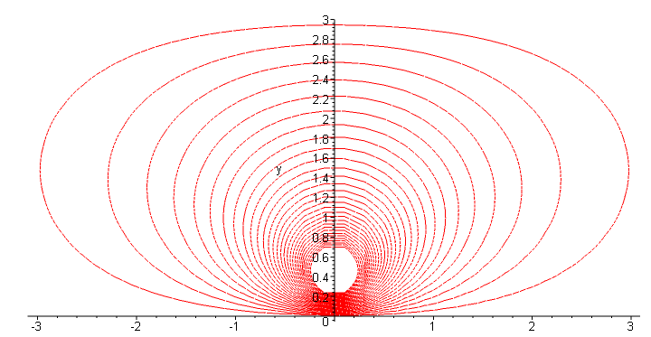
And here are some lines in the weak potential region

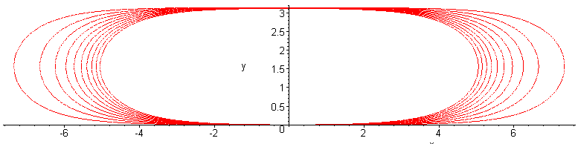

and you can see how these lines run parallel to the strip edges. Velly intellesting.
I have a few other things to say about this problem other than finding its solution as above. Go back to the picture and our three forms for g

g(x,y |0,y') = -(1/2π)Σn ln [ x2 + (y - y'+2na)2 ] + (1/2π)Σn ln [ x2 + (y +y'-2na)2 ]

g(x,y |0,y') = Σn=1∞ (1/nπ) e-(nπ/a)|x| sin(nπy/a) sin(nπy'/a)

g(x,y |0,y') = -(1/4π) ln { [ch(πx/a) - cos(π(y-y')/a))] / [ch(πx/a) - cos(π(y+y')/a)] }

In all three forms, you can see that g = 0 both at y=0 and y=a. This is least obvious in the first form. For y = 0, it is obvious as is. For y = a, the second [] has term (y' + a - 2na)2 but the first term seems to have
(a - y'+2na)2 = (y' - a - 2na)2 . But if we shift the summation index to n' = n+1 in the first term, then the term matches the other term and we have ln(1) = 0.
The question that comes to mind is this: why would you select the set of image charges as shown in the drawing? You do this because you know that the sum will satisfy Laplace AND because the images are carefully placed to cause g = 0 on both y=0 and y=a. This becomes obvious from the picture if you "pair up" the image charges correctly in each case. If you just stare at the picture, you can see that one method of pairing makes y=0 be "the dividing line" for each pair, so you know g = 0 on that line. But a different method of pairing makes y = a be the dividing line for each pair, so g = 0 on that line as well. In case this is unclear, here is a remake showing the pairings

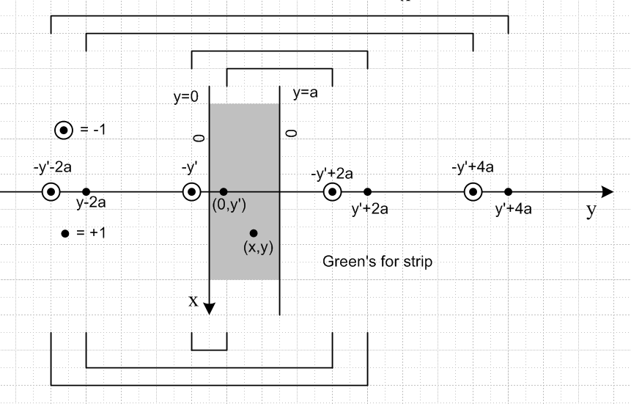

If there were a finite number of image charges arranged in this manner, it would be impossible to exhaust all the image charges by either pairings, and so we would then loose g = 0 at either y=0 or y=a. That is why an infinite number are needed.
One other comment. It should be pretty obvious that the solution is periodic in y with period 2a, just looking at the image charge locations. In the strip going from y=a to y=2a, we get a sort of mirror image pattern to the main strip, but with sign negated.
_________________________________________________________________________________

Exercise 6.36 : Show surface charge same in both strip solutions. (166)

This problem is not very logical. First, it asks us to do the integral shown in 6.125 which is for I which is minus the charge density that would be on our strip edges if they were metal. So this is just a "do the integral" problem. But then he mysteriously claims that his two methods for getting g for the strip give the same result. Perhaps he wants us to compute this same I from the expansion 6.127 and show we get the same I. By the integral equation method, if the I's are the same, then the solutions are the same. This is so because, once you have I, you get g by using v(y|x) = – ∫σ dSξ I(x|ξ)E(y|ξ).
I propose to first show that "the other" solution gives the I he shows.

Part A. Recall from above that

g(x,y |0,y') = -(1/4π) ln { [ch(πx/a) - cos(π(y-y')/a))] / [ch(πx/a) - cos(π(y+y')/a)] }

What is I ? The general formula is

I(x|ξ) = – ∂ξn g(x|ξ) x = location of Green's point charge ξ = observation point

I really want this in this form

I(x'|x) = – ∂xn g(x'|x) x' = location of Green's point charge x= observation point

I(0,y'|x,y) = – ∂±y g(0,y'|x,y)

We then want to evaluate this at y = 0 and at y = a, our two boundaries. For y=0, the interior normal vector would be , whereas for y = a it would be -. So our two answers are

I(0,y'|x,y=0) = – [ ∂y g(0,y'|x,y)]y=0

I(0,y'|x,y=a) = [ ∂y g(0,y'|x,y)]y=a

Let's have Maple do both of these calculations. But first let's select a = π so things are simpler, and let's omit the leading constant for the moment:

g1(x,y |0,y') = ln { [ch(x) - cos(y-y')] / [ch(x) - cos(y+y')] }

Here is what we find:

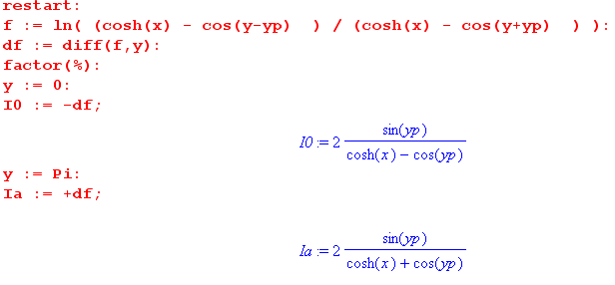
If I reinstall the leading constant -(1/4π), my answers are

I(0,y'|x,y=0) = - [ ∂y g(0,y'|x,y)]y=0 = (1/2π) sin(y')/[ ch(x) - cos(y')]

I(0,y'|x,y=a) = [ ∂y g(0,y'|x,y)]y=a = (1/2π) sin(y')/ [ ch(x) + cos(y')]

First comment: if I were to pick y' = π/2, the half way point, then cos(π/2) = 0 and these two I objects are the same as I would expect! Σ = -I is negative since inside point charge is +.

Second comment: Suppose x = 0 so ch(x) = 1. Suppose y' = ε, near the y=0 wall. The upper line above then approaches sin(y')/[ 1 - 1] which is large , while lower goes to sin(y')/[1+1] =small. I expect a large charge density then at the y=0 end, so the relative signs are correct inside [..]

Here is the code for safekeeping:

> restart:
> f := ln( (cosh(x) - cos(y-yp) ) / (cosh(x) - cos(y+yp) ) ):
> df := diff(f,y):
> factor(%):
> y := 0:
> I0 := -df:
> y := Pi:
> Ia := +df:

Now I have to translate my result into the language of page 162. Here is how we differ:

me (0,y') = location of the plus unit charge
(x,y) = observation point, at which we do the I derivative\
width = a = π

him (x,y) = location of the plus unit charge
(ξ,η) = observation point, at which we do the I derivative
width = a

I can now translate what he says:

Diff 6.123 for y > y' and set y = a, we find

I = (1/2π) ∫sh(αy')/sh(αa)e+iαx

Now, if we do the integral shown bottom page 166, and get what he claims, then we will have (in my notation and settings)

I = (1/2π) ∫sh(αy')/sh(απ)e+iαx = (1/2π) sin(y')/ [ cos(y') + ch(x)]

and this agrees exactly with my calculation at y= a.

Conclusion: I have shown, taking my problem solution,

g(x,y |0,y') = -(1/4π) ln { [ch(πx/a) - cos(π(y-y')/a))] / [ch(πx/a) - cos(π(y+y')/a)] }
that

I(0,y'|x,y=0) = - [ ∂y g(0,y'|x,y)]y=0 = (1/2a) sin(y'π/a)/ [ ch(x π/a) - cos(y' π/a)]

I(0,y'|x,y=a) = [ ∂y g(0,y'|x,y)]y=a = (1/2a) sin(y' π/a)/ [ ch(x π/a) + cos(y' π/a)]

This agrees with the prediction (for y = a) obtained by doing the (6.125) integral, if we assume that Stak did it correctly, as shown bottom of page 166, where I replace my y' with his y.

Part B. How would you actually do the integral to verify his result? I would go look it up!

$^{\int_{-∞}^{∞}{}}$dx e-ixs sh(yx)/sh(ax) = $^{\int_{0}^{∞}{}}$dx e-ixs sh(yx)/sh(ax) + $^{\int_{0}^{∞}{}}$dx e+ixs sh(yx)/sh(ax)

= $^{\int_{0}^{∞}{}}$dx 2cos(xs) sh(yx)/sh(ax) = 2$^{\int_{0}^{∞}{}}$dx sh(yx) ch(xs/i) /sh(ax)

= 2$^{\int_{0}^{∞}{}}$dx sh(Ax) ch(Bx) /sh(Cx) A = y B = -is C = a GR p 344 #5

= 2 (π/2a) sin(yπ/a)/ [ cos(yπ/a) + cos(-isπ/a) ]

= (π/a) sin(yπ/a) / [ cos(yπ/a) + ch(sπ/a) ]

and (1/2π) (π/a) = (1/2a), QED.

How would you do this with "residues" as he suggests ?

$^{\int_{-∞}^{∞}{}}$dz e-izs sh(yz)/sh(az) = $^{\int_{-∞}^{∞}{}}$dz e-izs sin(iyz)/sin(iaz)

Let iz = w so integral runs -i∞ to i∞ in w, Mellin-Barnes , and idz = dw so get

= (1/i)$^{\int_{-i∞}^{i∞}{}}$dw e-ws sin(yw)/sin(aw)

The poles are due to sin(aw) and are located at aw = nπ for n = ±1, ±2 ... There is no pole at w=0 due to the numerator. So close the contour to the right and get expo decay and pick up the pole residues at the positive integers. Near the zero of sin(aw) at wn = nπ/a we can write sin(aw) = (-1)na (w-wn) so we then have
= (1/i)Σn=1∞n dw e-ws sin(yw)/ [(-1)na (w-wn)]

= (1/ia) Σn=1∞ (-1)n n dw e-ws sin(yw) / (w-wn)

= (1/ia) Σn=1∞ (-1)n 2πi exp(-wns) sin(ywn) = (2π/a) Σn=1∞ (-1)n exp(-nπs/a) sin(ynπ/a)

Let α = (πs/a) and β = (yπ/a). We then want the sum

Σn=1∞ (-1)ne-αn sin(βn) = Σn=1∞ (-1)ne-αn (eiβn - e-iβn)/2 = (1/2) Σn=1∞ (-1)ne-(α-iβ)n – cc

But we know that

Σn=1∞ (-1)n e-An = Σn=1∞ (-1)n xn x = e-A = e-(α-iβ) = e-α eiβ

= -x + x2-x3 + .... = -1 + (1-x+x2-x3) = -1 + 1/(1+x) = -x/(1+x).
Then

Σn=1∞ (-1)ne-αn sin(βn) = (1/2) Σn=1∞ (-1)ne-(α-iβ)n - cc

= (1/2)[ -x/(1+x) - cc ] = (1/2) [( - x)/|x+1|2] x = e-(α-iβ) = e-α eiβ

= (1/2) sinβ/[chα + cosβ] // have to just write it all out on scratch

So conclusion is that

$^{\int_{-∞}^{∞}{}}$dz e-izs sh(yz)/sh(az) = (2π/a) (1/2) sinβ/[chα + cosβ] = (π/a) sinβ/[chα + cosβ]

= (π/a) sin(yπ/a)/[ch(πs/a) + cos(yπ/a)]

which agrees with the looked-up integral.
_________________________________________________________________________________

Exercise 6.37 : Integral Equation method on the strip. (167)

Here is the integral equation of interest which we want to solve for I

E(x|t) = ∫σ dSξ E(x|ξ) I(t|ξ) x on σ ξ integrate on σ, t inside R

Let's regard σ = σa - σ0 in a CCW rotation around the boundary. For the moment, all we know is that x is on one of these two pieces.

For αa we set ξ = (x',a) and dξ = dx' , and similarly for σ0, to get

E(x|t) = ∫ dx' E(x|x',a) I(t|x',a) - ∫ dx' E(x|x',0) I(t|x',0) E = -ln(R)/2π

Now write this twice, once where x is on σa and once while on σ0

E(x,0|t) = ∫ dx' E(x,0|x',a) I(t|x',a) - ∫ dx' E(x,0|x',0) I(t|x',0)

E(x,a|t) = ∫ dx' E(x,a|x',a) I(t|x',a) - ∫ dx' E(x,a|x',0) I(t|x',0)

So these are the simultaneous integral equations he mentions. We are supposed to diagonalize these by going into Fourier space. The idea is this

a(x) = ∫dx' b(x-x')c(x') = b*c => A(k) = B(k) C(k)

where A(k) = ∫dx a(x) e-ikx a(x) = (1/2π) ∫dk A(k) e-ikx

and of course we know that E(x,d|x',a) = -(1/4π) ln( (x-x')2 + (d-a)2) = b(x-x'; d-a) so things have the right form for this to work. Then the above equations appear as

E(x,0|t) = ∫ dx' E(x,0|x',a) I(t|x',a) - ∫ dx' E(x,0|x',0) I(t|x',0)
b(x-tx; 0-ty) = ∫ dx' b(x-x'; 0-a) c(x'; a) - ∫ dx' b(x-x'; 0-a) c(x';0)

A(k;t) = B(k; a) C(k; a) – B(k; a) C(k; 0)
A'(k;t) = B'(k; a) C(k; a) – B'(k; a) C(k; 0)

To finish this problem, I would have to invent some reasonable notation, treat C(k; 0) and C(k; a) as the two unknowns, do Cramer's Rule to solve for them, then "reverse" it to get I on the two boundaries. This reversal will be a Fourier integral which you can see is the form had by 6.125, which we are supposed to end up with as our charge density on the y = a boundary.
I understand this problem and I could do it, but let's end it here since my finite time is better spent on other problems, and other things.
______________________________________________________________________________

Exercise 6.38 : Find some image charges to match a certain 2D region. (167)

I did not have a clue how to do this. But I peeked on the web and got a hint.
First, to create the Green's Function for any quadrant of the x-y plane, this scheme does the job (left picture). Why? The two horizontal pairs redundantly provide u=0 on the vertical axis, so it is taken care of. And then the two vertical pairs redundantly provide u = 0 on the horizontal axis. The rule is that you can only have one positive point charge (black dots) in your region of interest. We show Quadrant I as our region of interest here.
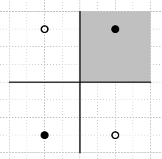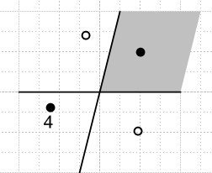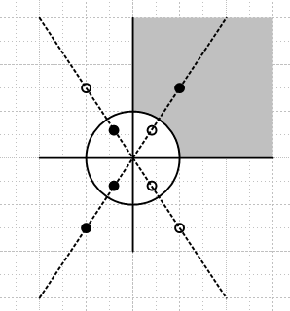

Notice that this 4-image solution does not work if the vertical axis is tilted (middle picture) so our region is then an infinite wedge ( see Ex 6.43 below). We place our first 3 charges as shown the best we can, but then charge 4 has to go where shown to satisfy the tilt axis, and then we "break" the horizontal axis. I tried adding more charges but did not find a solution. Certainly conformal mapping would solve this case.
Now that we are happy with "the quadrant", here (right picture) is the solution for the region asked about in this problem, and it takes 8 charges in two sets of four. The sets of 4 each satisfy the two axes as shown in the left picture for one set. In addition, the inner set of 4 is picked to that each diagonal pair makes u=0 on the entire circle. The gray region is then solved, since it only contains one charge. The complementary region contains 7 charges and this would not be solved in this manner because a region is only allowed to have one charge so that we are then talking Green's Function for that region. A good problem, glad to have the web to give me a hint.
_________________________________________________________________________________

Exercise 6.39 : Partial Expansion Solution of Unit Disk using Radial Eigenfunctions (167)

Stak is making us do a little review work here.

BACKGROUND REVIEW of the 2D Radial Laplace ODE (not necessary, but good to do)

First of all, the radial 2D Laplace equation he writes in p 168 A was studied in detail in Volume 1 on page 302 Example 4. In the framework of that section of Chapter 4, we have s(r) = 1/r so that r=0 is a singular point. If we set λ = 0 (just picking a nice value) we find that both solutions u1 and u2 are NOT of finite s-norm. According to Weyl's Theorem Part I, for any other λ we cannot have two independent finite s-norm solutions, so we are in the limit-point case at r = 0. This means that, for λ off the real axis, there is only one finite s-norm solution (which does not diverge at r=0).

Second, this same equation is revisited in Vol I Example 2 page 308 range x = (0,∞). Both x=0 and x=∞ are limit point cases, so only one finite s-norm solution for each end. Let ν = $\sqrt{λ}$ where λ is the constant appearing in the 2D radial Laplace equation. At x = 0 the only finite solution is x-iν and at x = ∞ the only one is xiν so the Green's Function turns out to be g = (i/2ν) (x<)-iν (x>)iν as shown 4.104. In terms of "basis functions" you can think of x-iν as these functions and project onto them like so:

FM(ν) = $^{\int_{0}^{∞}{}}$dν x-iνf(x)/x which is the Mellin Transform, inverse 4.107

He does show there that you get 1/$\sqrt{λ}$ in the Green's g which, being a branch cut, implies a continuous spectrum for this operator L. This fact reappears in 4.106a where you see that the decomposition of the delta function includes contributions from a continuous range of ν = $\sqrt{λ}$. In our case, xδ(x-ξ) is the Mellin expansion of the function x-iν. Key point: every little Green's Function system you consider, like this one here at hand, implies a completeness relation in the form δ(x-ξ) = spectral integral of the Green's Function, and that then tells you that the functions appearing in there like x-iν form a complete set for expansion purposes in the x variable.

Third, our equation is visited once again in Vol I Exercise 4.28 (p 316), and here is where we first consider the range being (0,1) instead of (0,∞). The symbol "w" refers to the function we put on the right side of g, and you see that (as noted above) it is a lincomb which vanishes at r=1 (page 316 A is the Green's g). Since the left end is limit point, there is only one finite s-norm function we can use on the left side. Again you see the 1/$\sqrt{λ}$factor in g, so again we have a continuous spectrum being the positive real axis. Now I did not DO this exercise, but I accept 4.134 which shows the expansion of xδ(x-ξ). Recall now that

(1/2πi) dλ g(x|ξ; λ) = – δ(x-ξ)/s(x) = – Σn φn(x) n(ξ) – ∫dν φν(x) ν(ξ) // (4.95)

In order to get 4.134, he must have computed - (1/2πi) dλ g(x|ξ; λ) using g given in p 316 A using our first equality above. Having done this, the second equality above tells us that sin[νln(r)] must be our radial basis functions (something Stak fails to mention), where ν2 = λ. This δ expansion in turn implies (as does every possible expansion of delta) a certain "transform" which appears in the last two equations on page 316. This strange thing, where the basis function is sin[νln(x)] both ways, is called the Mellin Sine Transform. The projection is on (0,1) but the inversion is on (0,∞).

Fourth, we need to look back to Vol II Example 2 page 159 where we solved for Green's on the unit disk using the partial eigenfunction method where we use the einφ basis functions. We project g onto these to get gn, and then we get a 1D ODE for these gn as in p 159 D, and we then solve that to get gn as in p 160 B,C. Then from our Fourier Series expansion p 159 B left, we get our final Green's function 6.119.

THE CURRENT EXERCISE

NOW we are ready to start this problem! The general idea is to try to obtain the same Green's Function 6.119 by using the r basis functions (sin[νln(r)] ) instead of the φ basis functions (einφ), again using the partial eigenfunction method. We write down our 2D Green's equation (see 6.118) for this Laplace eigenvalue problem, which has a double δ on the RHS. The solution of this problem is g, but we will shift it to h = g - g0 for "technical reasons". We then project this h(r;φ) onto the radial eigenfunctions sin[νln(r)] to get s(ν,φ), the analog of gn(φ) of our einφ method. We now have a 1D Green's ODE in variable φ as shown p168 top, except it is written in terms of a function s(ν,φ) = s(ν,φ) - go/ν. We solve this for s(ν,φ) and so we know s(ν,φ) and we can then write h as the Mellin expansion integral, and thus we have g as an integral. We then message this integral and finally obtain the same answer for g that we got by the einφ partial expansion. To do this messaging, we first project our integral expression 6.132 for g(r,φ|ro,0) onto cos(nφ) basis functions and we are supposed to get result D which shows g = something which involves two integrals each 0,∞. I think we can change these to 1/2 * -∞,∞ since integrands are symmetric, and since no pole at ν=0, then we close that contour somehow and pick up the residues and then this gives us our desired result.
I have not DONE this problem, but just reading it with the above background review took about two hours (maybe less), so I think that is enough for this problem. The review was good to do. This exercise consumes about 1.5 pages of the book, it is one of those "extra credit" things that he wants to get into the book. After all, the unit disk is the simplest non-trivial geometry, and he really owes it to the reader to do the partial eigenfunction solution both in φ and in r.
_________________________________________________________________________________

Exercise 6.40 : A Mixed BC Green's Function example : Dirichlet and Neumann (168)

This problem involves the same first quadrant region we had in exercise 6.38. This time, however, we want that u = 0 on the circular part of the boundary, but we want ∂nu = 0 on the straight line parts.

(A) We are supposed to find some image charges that make this work. My first idea is to stay with our 8 charges and just alter their polarity to get

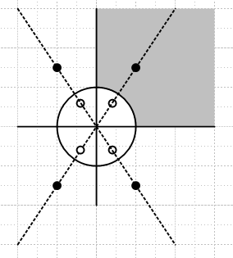

The circle clearly has u = 0. Each equal sign pair I know makes ∂nu = 0 on the dividing line, so multiple pairs must do this as well. So I think this is the answer!

(B) Now we are supposed to solve the same problem using the partial eigenfunction method with φ basis functions. Those functions would I think be Θ(φ) = cos(2nφ) so that Θ'(φ) = -2nsin(2nφ) which vanishes on the two line boundaries of our region φ = 0 and φ = π/2 . We would then do a Schaum Fourier Series expansion of g onto cos(2nφ) and end up with gn(r) to worry about. Thus, we have slightly modified transform B on page 159. We need then to find the single delta Green's equation which will differ somehow from D, with BC that gn(a) = 0. Then we have to solve that thing for gn(r), then we have to reconstruct g, and then we have to of course show it is the same as the pattern of 8 image charges shown above! This is a well-defined and "solid" problem for "the student". But I would rather spend my time reading through ALL the problems and thinking a little about each, instead of fully DOING some of these problems. So we let this one rest until a very rainy day.

_________________________________________________________________________________

Exercise 6.41 : Curved Quadrilateral Green's "both ways", r and φ expansion (168)

Earlier we solved this Dirichlet problem

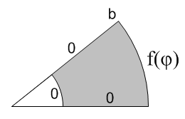

and now we want to set f = 0 and then we have a Green's function problem. Again, this is a well-defined problem in both the r and φ directions and an obvious one for the student to attempt. We know that the φ eigenfunction method will use Φn(φ) = sin(nπφ/α) so that Φn(α) = 0 so we will be doing a Fourier Series Sine only expansion to get our gn(r) functions, and we then follow that path. For the radial approach, we will get some kind of Rm(r) = Amrm+Bmr-m radial eigenfunctions that we make vanish at r = a and r = b, and do some kind of transform to get gm(φ) and a 1D Green's equation for it, and we then follow that path. Put it on the rainy day list, just some grinding away.

_________________________________________________________________________________

Exercise 6.42 : Unit Sphere Green's Function by the Ylm expansion method. (169)

We did the unit sphere Green's on page 150 using the image method and quickly got a solution there as 6.102. The brute force expansion method would of course be to project g onto the Ylm(θ,φ) to obtain projected functions glm(r) which would then solve a 1D radial Green's equation with glm(a) = 0. You would then use the inversion to get g(r,θ,φ) and then you would want to show it could be written as the sum of the Green's fundy solution plus the fundy of one image charge. This will surely involve some of the plethora of expansions we have played with before many times, such as 1/R in Ylm and orthogonality and so on. It might even be a relatively easy problem, I am not sure, and I add it to the rainy day list. It is understood and just needs grinding.

_________________________________________________________________________________

Exercise 6.43 : Infinite Wedge, do it both ways (2D) (169)

(a) For an opening angle of 90 degrees, I have shown the image solution in Exercise 6.38 notes above.

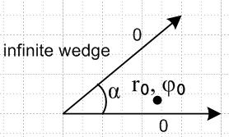

(b) We know that the φ functions must be sin(nπφ/α) to get 0 on the two rays. But we have no other restrictions other than at r= 0 and ∞. We know that radial form is Anrn' + Bnr-n' where n' = n(π/α) is our separation constant. We can pretty much guess the form shown in 6.133 knowing that we must have the generalized form of 6.108. But I suppose he wants us to go ahead and use that partial EF method, project g onto sin(nπφ/α), get a 1D Green's problem for this projection gn(r) and solve it which will bring in r> and r< notation. Logs are killed off at 0 and ∞ so there is no n=0 term in the answer.

(c) If we want to work instead with the radial basis functions, we know from notes above that the appropriate basis functions are r-iν with continuous ν ( as opposed to sin(nπφ/α) with discrete n), and the appropriate projection is the Mellin Transform (as opposed to the sine Fourier Series). Therefore, the correct projected object GM(ν) is as shown p 169 B. As shown in my updated raw 1 notes, expanding in this way guarantees that you will get a Green's Function ODE in "the other variable", since L is "separable" in the variables r and φ.
Here we will watch this happen. The starting Green's system is shown in D. We are told to process this into the ODE in the other variable, but we are not told what that ODE is. We are then supposed to solve that ODE and the result for GM(ν) should be p 170 A. Notice how φ0 and r0 and ν all appear in the solution, and I just quote my own raw 1 comment relating to ODE we get where (s0, t0, λ) = (r0, φ0, ν)

[(1/a2(t))L2(t) + λ ] gλ(t) = { f(s0, t0) λ(s0) /s(s0)} δ(t-t0) = K(s0, t0, λ) δ(t-t0)

We then put this GM(ν) into the Mellin expansion and get 170 B. We are then supposed to show that this result matches the result we got in part (b).
So all good things to do, and goes on the list! Right now I am just tracking the "theory" of each of these exercises to make sure I at least know what is being said.

_________________________________________________________________________________

Exercise 6.44 : Half-plane as starting region or as an intermediate region (170)

In the text, we found that f2(z) = eiα (z-z0) /(1-z0) maps the unit circle into itself, and maps the point z0 to the origin. According to the Big Theorem on conformal mapping, this tells us that g(r|r0) = - (1/2π) ln | f2(z,z0) | is the Green's Function for the unit disk, since this is the region R we start our mapping with.

Here we do something analogous. The claim is that f3(z) = eiα (z-z0) /(z-0) maps the upper half plane into the unit circle. Assuming the claim is true, g(r|r0) = - (1/2π) ln | f3(z,z0) | will be the Green's function for the upper half plane.

So let's first verify the claim. We know that |f3| = | z-z0| / | z-0 | = | -0| / | z-0 | (bar just the top). If z is on the real axis, then we see that |f3| = 1 so f3 is on the unit circle. We still need to show that it is the upper half plane that maps into the unit circle. If we take z = i as a test point, we then have to show that for this point, |f3| ≤ 1. But |f3(i)| = | i-z0| / | i-0 | so we need show that | i-z0| ≤ | i-0 |. If z0 is in the upper half plane ( our assumption from the start), then y0 ≥ 0 and it is easy to verify the desired inequality doing algebra. But easier just to note that the distance from i to a point in the upper half plane is obviously less than the distance from i to the mirror point in the lower half plane. QED.

Now we can examine the resulting Green's Function:

g(r|r0) = - (1/2π) ln | f3(z,z0) | = - (1/2π) ln | z-z0| / | z-0 |

It is clear on inspection that this is the Laplace solution of the point z0 plus its symmetry image point 0 with a negative charge. This agrees with our earlier "solution" of this problem.

Part (b) just says that if s(z) maps some general region R into the upper half plane and maps some
R-interior point z0 into s(z0) in the upper half plane , then we know that

f3(z) = eiα (s(z)- s(z0)) /( s(z)- (z0))

will map R into our unit circle, and will map point z0 to the origin . Then the Green's function for region R will be

g(r|r0) = - (1/2π) ln | f3(z,z0) | = g(r|r0) = - (1/2π) ln | (s(z)- s(z0)) /( s(z)- (z0)) |

= - (1/2π) ln | (s(z)- s(z0)) | / | ( s(z)- (z0)) | // as claimed

_________________________________________________________________________________

Exercise 6.45 : Vertical half-strip of width π (170)

(a) The method of images.

First, the full strip picture is this:

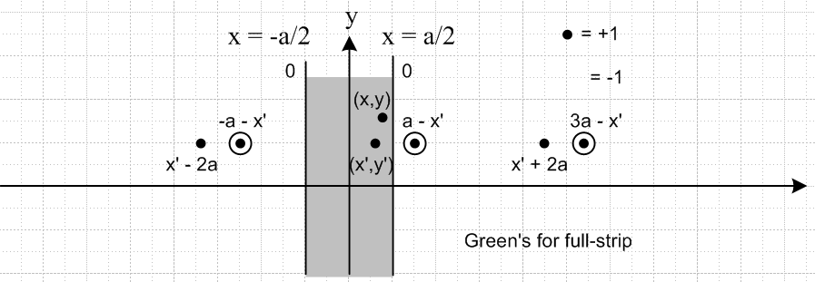

In document "Green's Functions and change of coordinates.doc" I show how the results for this full strip follow from Exercise 6.35 above, which had x and y reversed, with strip going 0 to a. The correct Green's functions for the above strip, with a = π, taken from this mentioned document, are

g(x,y|x',y' ) = Σn=1∞ (1/nπ) e-n|y-y'| sin(n[x+π/2]) sin(n[x'+π/2])

g(x,y| x',y' ) = (1/4π)Σn ln { [ (y-y')2 + (x - {x'+2nπ})2 ] / [(y-y')2 + (x + π - {-x'+2nπ})2 ]

g(x,y| x',y' ) = -(1/4π) ln { [ch(y-y') - cos(x-x')] / [ch(y-y') + cos(x+x')] }

Now, in order to do Green's for a half strip, we have to add another row of charges, all of opposite polarity. So replace y' with -y' and change overall sign do get second terms. The picture is this,
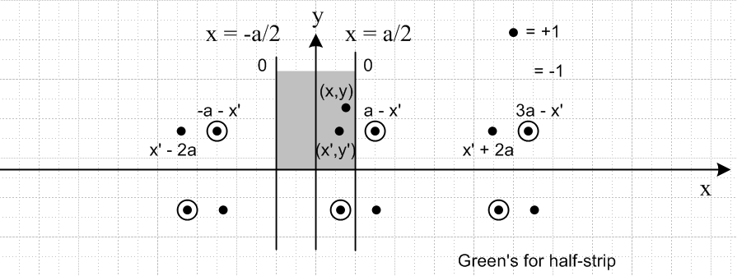

and here are the new Green's functions in all three forms for this half-strip

g(x,y|x',y' ) = Σn=1∞ (1/nπ) { e-n|y-y'| – e-n|y+y'| } sin(n[x+π/2]) sin(n[x'+π/2])

g(x,y| x',y' ) = (1/4π)Σn ln { [ (y-y')2 + (x - {x'+2nπ})2 ] / [(y-y')2 + (x + π - {-x'+2nπ})2 ]
* [(y+y')2 + (x + π - {-x'+2nπ})2 ] / [ (y+y')2 + (x - {x'+2nπ})2 ] }

g(x,y| x',y' ) = -(1/4π) ln { [ch(y-y') - cos(x-x')] / [ch(y-y') + cos(x+x')]
* [ch(y+y') + cos(x+x')] / [ch(y+y') - cos(x-x')] }

(b) Find g by expansion in the x eigenfunctions. This is given by the first result above. The basis functions in the x direction are the sin(n[x+π/2]) guys which vanish on both edges of the strip for all n.

(c) Find g by a sine transform on y. If we ask "what are the proper eigenfunctions for the vertical direction" the answer is sin(νy) where the ν eigenvalues become a continuum as in the Fourier Transform compared to the Fourier Series. These sin(νy) meet the requirement of being 0 on the y=0 edge.
So let's carry out the "partial eigenfunction expansion" method using these eigenfunctions. Our starting Green's equation is of course this

– ∂x2g(x,y|x',y') – ∂y2 g(x,y|x',y') = δ(x-x') δ(y-y')

We then project and expand

Gs(x,ν | x',y') = $^{\int_{0}^{∞}{}}$dy sin(νy) g(x,y |x',y') using p 170 E

g(x,y |x',y') = (2/π) $^{\int_{0}^{∞}{}}$dν sin(νy) Gs(x,ν | x',y') using p 170 F

Apply the first integral operator to the PDE to get

double parts
– $^{\int_{0}^{∞}{}}$dy sin(νy) ∂x2g – ν2 $^{\int_{0}^{∞}{}}$dy sin(νy) g = $^{\int_{0}^{∞}{}}$dy sin(νy) δ(x-x') δ(y-y')

– ∂x2$^{\int_{0}^{∞}{}}$dy sin(νy) g – ν2$^{\int_{0}^{∞}{}}$dy sin(νy) g = sin(νy') δ(x-x')

– ∂x2 Gs(x,ν | x',y') – ν2 Gs(x,ν | x',y') = sin(νy') δ(x-x') -π/2 ≤ x,x' ≤ π/2

and this last item is our 1D Green's function problem in which x', y' and ν are treated as constants.
Away from x = x' we know that the solution has this general form

Gs(x,ν | x',y') = Aνsin(ν[x-aν] )

since - ∂x2 Gs(x,ν | x',y') = + ν2 Gs(x,ν | x',y'). I chose the form above anticipating the left and right side Green's boundary conditions which are 0. For the left side, we choose aν = -π/2 and for the right we choose it to be + π/2 so we have

green' = { x ≤ x': Aνsin(ν[x+π/2] ), x ≥ x': Bνsin(ν[x-π/2] ) }

We first require the Green's be continuous at x = x' so that

Aνsin(ν[x'+π/2] ) = Bνsin(ν[x'-π/2] ) => relation between Aν and Bν

We then must match the jump condition which, looking at our ODE, is this, where we have integrated both sides from x'-ε to x'+ε and have used continuity to kill off the ν2 contribution:

– ∂x Gs(x,ν | x',y')|x=x'+εx'-ε = sin(νy')

– ∂x (greens) = { x ≤ x': –ν Aνcos(ν[x+π/2] ), x ≥ x': –νBνcos(ν[x-π/2] ) }

– ∂x (greens) |x=x'+εx'-ε = –νBνcos(ν[x'-π/2] ) + ν Aνcos(ν[x'+π/2] )

which is another relation between Aν and Bν. So we have

Aνsin(ν[x'+π/2] ) = Bνsin(ν[x'-π/2] )

–νBνcos(ν[x'-π/2] ) + ν Aνcos(ν[x'+π/2] ) = sin(νy')

which we message a bit

Aνsin(ν[x'+π/2] ) – Bνsin(ν[x'-π/2] ) = 0
Aνcos(ν[x'+π/2] ) – Bνcos(ν[x'-π/2] ) = sin(νy')/ν

and go to shorthand

AνS+ – BνS- = 0
Aν C+ – Bν C- = sin(νy')/ν

and multiply top by C- and bottom by C+

Aν S+C- – BνS- C- = 0
Aν S-C+ – Bν S-C- = S- sin(νy')/ν

and now subtract first from second

Aν[S-C+ – S+C-] = S- sin(νy')/ν

Reprocess from shorthand. Multiply top by C+ and bottom by S+ to get

AνS+ C+ – BνS- C+ = 0
Aν S+C+ – Bν S+C- = S+sin(νy')/ν

and do the same subtraction to get

Bν[ S- C+ – S+C- ] = S+sin(νy')/ν

The bracket is

[ S- C+ – S+C- ] = sin(ν[x'-π/2] ) cos(ν[x'+π/2] ) – sin(ν[x'+π/2] ) cos(ν[x'- π/2] )

= (1/2) { sin(ν[-π] ) + sin(2νx') } – (1/2) { sin(ν[π] ) + sin(2νx') }

= – sin(πν)

So we have then that

Aν = sin(ν[x'–π/2] ) sin(νy')/ [ ν (– sin(πν)) ] = – sin(ν[x'–π/2] ) sin(νy')/ [ ν sin(πν) ]

Bν = sin(ν[x'+π/2] ) sin(νy')/ [ ν (– sin(πν)) ] = – sin(ν[x'+π/2] ) sin(νy')/ [ ν sin(πν) ]

and now put the pieces together

green's = { x ≤ x': Aνsin(ν[x+π/2] ), x ≥ x': Bνsin(ν[x-π/2] ) }

= { x ≤ x': – sin(ν[x'–π/2] ) sin(νy')/ [ ν sin(πν) ]sin(ν[x+π/2] ),

x ≥ x': – sin(ν[x'+π/2] ) sin(νy')/ [ ν sin(πν) ]sin(ν[x-π/2] ) }

= {sin(νy')/ [ ν sin(πν) ]} sin(ν[x<+π/2] ) sin(ν[x>–π/2] ) = Gs(x,ν | x',y')|

Notice that this vanishes on the two vertical edges of the strip. We an now write the full solution Green's function as

g(x,y |x',y') = (2/π) $^{\int_{0}^{∞}{}}$dν sin(νy) Gs(x,ν | x',y')

= (2/π) $^{\int_{0}^{∞}{}}$dν sin(νy) sin(νy') sin(ν(x<+π/2) ) sin(ν(x>–π/2) ) / ( ν sin(πν) )

and here we see that when y = 0, g = 0. It is interesting to compare this to one of our other forms:

g(x,y|x',y' ) = Σn=1∞ (1/nπ) { e-n|y-y'| – e-n|y+y'| } sin(n[x+π/2]) sin(n[x'+π/2])

Somehow these results must be the same. You would take the first and make it 1/2 integral -∞ to ∞ and then somehow close the contour and pick up a residue sum from those sin(πν) poles. We are not asked to make this comparison, so I will let the ball lie.

(d) Find g by conformal mapping.

Our first task is to map the half-strip into the upper half plane with an analytic function.

Plan A completely fails.

On scratch paper, I came up with the mapping below. This thing maps 0 to 0, and maps the bend point on the right to +∞ and the bend point on the left to -∞. I was hoping this just stretched the half-strip to be infinitely wide, thus becoming the upper half plane.

f(z) = z / [ (z+π/2)(-z+π/2) ] // wrong!

but I am not completely sure. Assuming this is correct, we would then map this to the unit circle using 6.134 and so we would get this for our Green's function

green's = (-1/2π) ln | z / [ (z+π/2)(-z+π/2) ] – z0 / [ (z0 +π/2)(- z0 +π/2) ] |
(+1/2π)ln | z / [ (z+π/2)(-z+π/2) ] – 0 / [ (0 +π/2)(- 0 +π/2) ] |

But this makes it seem that 6 charges could do the job which I know is wrong, so my mapping must be wrong. It must be right for the points I selected, but not right the region.
Now that I know how to plot things better, consider the green domain lines as they move up the strip staring at the bottom. I have to stay away from the left edge of the strip since it maps into huge red curves. So first I show the domain curves, then the range curves, for f(z) above:

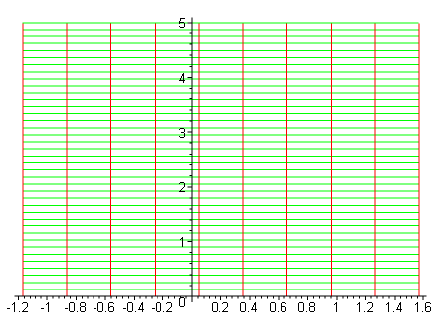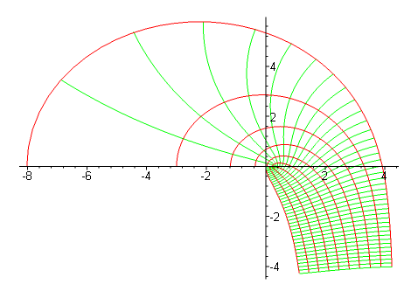

The leftmost vertical line maps into the largest curve. If there were a green line on the x axis, it would map into a green line on the x axis going off to - ∞. So the main point: as I walk up the strip with the green line segments, we wander off into quadrant IV in the range, so this does not map the half strip into the upper half plane!

Plan B. Luckily on page 206 of my green Schaum complex variables book I see the answer at page top.
[ and just now I see Stak's hint of same ]

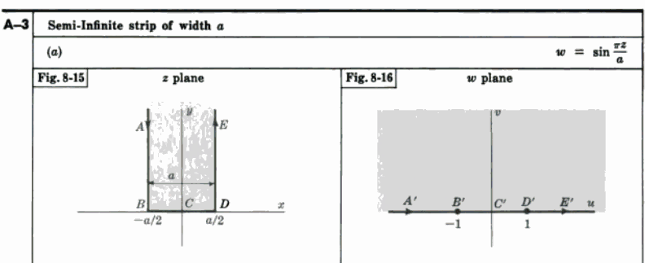

f(z) = sin(z) = sin(x+iy) = sin(x)cos(iy) + cos(x)sin(iy) = sin(x)cosh(y) + i cos(x)sinh(y)

If we stay in our half-strip, cos(x) ≥ 0 and sh(y) ≥ 0, so Imf ≥ 0 and yes, our strip must map into the upper half plane. It is easy to show that the level curves in the u,v plane are ellipses and hyperbolas. In particular, the above f = u+iv tells us that

u2/ch(y)2 + v2/sh(y)2 = 1 // the ellipses
u2/sin(x)2 - v2/cos(x)2 = 1 // the hyperbolas

If I keep the same domain as shown on left above and plot this thing, I get

conformal(sin(z),z=-Pi/2..Pi/2+2*I, grid=[10,40], numxy=[200,200],scaling=CONSTRAINED);
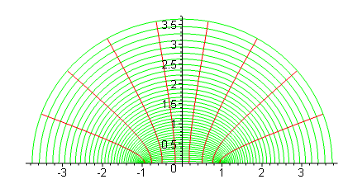

which sort of clinches the idea that our strip maps into all of the upper half plane.

Now that we have a map that takes our half strip into the half plane, we mix in the map taking the half plane into the unit circle, and using 6.134, we arrive at this expression for the Green's Function for the half strip:

green's = (-1/2π) ln [ | sin(z) - sin(z') | / | sin(z) - sin(') | ]
= (-1/4π) ln [ | sin(z) - sin(z') |2 / | sin(z) - sin(') |2 ]

which is vaguely similar to the closed form result I show above, where I have put the two top factors together and same for bottoms,

g(x,y| x',y' ) = -(1/4π) ln { [ch(y-y') - cos(x-x')] [ch(y+y') + cos(x+x')] (**)
/ [ch(y-y') + cos(x+x')] [ch(y+y') - cos(x-x')] }

We can write out the green's above as

= (-1/4π) ln [ (sin(x+iy) - sin(x'+iy') )( sin(x–iy) - sin(x'-iy') ) /
(sin(x+iy) - sin(x'–iy') )( sin(x–iy) - sin(x'+iy') ) ] (*)

I don't see any fast manual method of comparing the two log arguments here. For example

sin(x+iy) - sin(x'+iy') = sin(x)cos(iy) + cos(x)sin(iy) - sin(x')cos(iy') - cos(x')sin(iy')

If you do this four times in (*) you get a pretty big mess. Therefore, I instructed Maple to expand the log arguments (*) and (**) to see if they are the same. Here is the result:

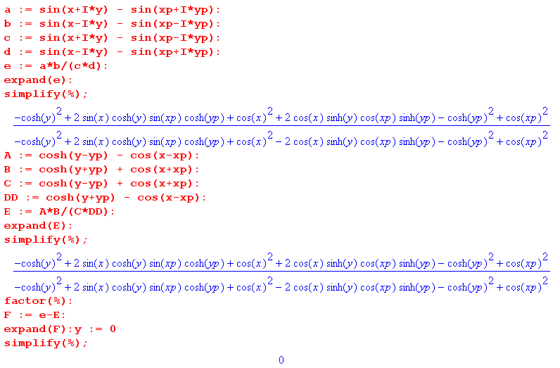

So yes, our two results are the same! The first came from my original analysis of the image method solution, the second from the conformal mapping approach. Here is the above Maple code for storage:

a := sin(x+I*y) - sin(xp+I*yp):b := sin(x-I*y) - sin(xp-I*yp):
c := sin(x+I*y) - sin(xp-I*yp):
d := sin(x-I*y) - sin(xp+I*yp):
e := a*b/(c*d):
expand(e):
simplify(%):
A := cosh(y-yp) - cos(x-xp):
B := cosh(y+yp) + cos(x+xp):
C := cosh(y-yp) + cos(x+xp):
DD := cosh(y+yp) - cos(x-xp):
E := A*B/(C*DD):
expand(E):
simplify(%):
factor(%):
F := e-E:
expand(F):
simplify(%):

______________________________________________________________________________

Exercise 6.46 : Green's function for Neumann Boundary Conditions (171)

(a) If we try to solve -∇2u = q but with ∂nu = f on boundary σ, the divergence theorem imposes a consistency condition which relates f and q.

(b) This condition is NOT met of we try to set up a corresponding Green's Function problem:

-∇2g = δ(x-ξ) ∂ng = 0 on σ

The trick is to instead use this "modified" Green's function problem where V is the volume of region R:

-∇2h = δ(x-ξ) - 1/V ∂nh = 0 on σ

(c) Our assignment is to find the Green's function h for this problem in 2D for R = unit circle. The solution is given as 6.137. It is suggested we use the partial eigenfunction method and expand on the φ direction eigenfunctions.
It turns out that only the cos(nφ) functions appear so h is even in φ. This seems reasonable from the symmetry of the geometry which is a circle -π ≤ φ ≤ π where the entire boundary has ∂rh = 0, and where we have the source charge located at φ0 = 0.
I think there is a typo here in that φ0 should be 0 in the argument of h.
I have spent too much time already on this exercise set, and this seems similar to other problems I have solved, so let it lie.
______________________________________________________________________________

6.8 Some Physical Applications of Potential Theory (171)

A. Charged Conductor and Electrostatic Capacity (171)

Our first subject out of the box is this: deposit charge Q' on a metallic object. The charge spreads out over the metallic surface such that u = constant on the surface. What is the charge distribution on the metallic surface?
This is, I think, exactly the question George Green was asking himself. Quoting from earlier in these raw notes,

"Green’s mathematics was nearly all devised to solve very general physical problems. His first interest was in electrostatics. The inverse-square law had recently been established experimentally, and he wanted to calculate how this determined the distribution of charge on the surfaces of conductors. He made great use of the electrical potential, and gave it that name, and one of the theorems that he proved in this work became famous and is known as Green’s theorem."

We have assembled all the weapons needed to solve this problem, with painstaking labor I might add.

Closed Surface.

Stak first considers the normal "closed surface". We know that inside, u = constant, so it is only the "exterior problem" that concerns us. Since u = constant inside, we know that E = 0 everywhere inside (see page 80 of raw 1 notes, pillbox straddling inner surface), and this means that Σ = 0 everywhere on the inner surface (if there is one). It could in theory have spread itself in some way to have the total enclosed be 0, but in fact we just showed that Σ = 0 at all points on the interior surface. So the very first rule of electrostatics is that all the charge you add must go on the outer surface.
Now, for the exterior problem. I would start with equation 6.65 page 125 which says

u(x) = ∫σ E(x|ξ)I(ξ)dSξ 6.65

where I is the difference in ∂nu as shown p 125A. We can think of I(ξ) as a simple layer of charge. If I(ξ) were a surface delta function at ξ1, we would have u(x) = E(x|ξ1) . Recall that this equation is correct for u(x) both on the inside and on the outside of our surface. So I(ξ) = Σ = surface charge = all on the exterior surface. Superposition.

Comment: In earlier Green's function work we said that ∂ξn g(x|ξ) = - I(x|ξ) = Σ is the induced charge on the boundary. We put a positive Green's point charge at location ξ inside the boundary, and the induced charge was negative. Here, our quantity I(ξ) is a slightly different animal. Here we have I(ξ) = +Σ which is the surface charge, and there is no minus sign between I and Σ.

In our problem, we will assume for the moment that u = 1 on the surface, and later scale things as needed to find the correct number if we add charge Q'. Therefore, if in the above equation we let x→s, we get
u(s) = ∫σ E(s|ξ)I(ξ)dSξ = 1 6.140

Now as shown p 125A we have I(ξ) = ∂nui - ∂nue and of course ui = 1 so I(ξ) = - ∂nue and this creates a minus sign which will now float around (but not between I and Σ).
Next, we go back to 6.65 above and apply normal derivative ∂ν . We now bring to bear the results of a lot of work on limits we did back around page 118. Here is a little summary of that work (3D):

u(x) = ∫σ dSξ a(ξ) E(x|ξ) 6.30 E(x|ξ) = 1/4π|x-ξ|
v(x) = ∫σ dSξ b(ξ) k(x,ξ) 6.31 k(x,ξ) = cos(x-ξ,n)/[4π|x-ξ|2]
limx→s ∂νu = ∓a(s)/2 + ∫σ dSξ a(ξ) k(ξ,s) // 6.43 becomes 6.47 ν = normal at s
limx→s v = ± b(s)/2 + ∫σ dSξ b(ξ) k(s,ξ) // 6.44 becomes 6.46

So if we set a(ξ) = I(ξ) the first and third lines become

u(x) = ∫σ dSξ I(ξ) E(x|ξ) E(x|ξ) = 1/4π|x-ξ|
limx→s ∂νu = ∓I(s)/2 + ∫σ dSξ I(ξ) k(ξ,s) k(ξ,s) = cos(ξ-s,ν)/ [4π|x-ξ|2] p 119B

where the upper sign applies if we approach from outside our surface. But we just showed above that the LHS here is going to be ∂νue = – I(s) on this external approach, so we get

-I(s) = -I(s)/2 + ∫σ dSξ I(ξ) k(ξ,s) => ∫σ dSξ I(ξ) k(ξ,s) = -1/2 I(s)

=> KI = (-1/2)I EV problem 6.140a

Comment #1: I presume that Stak is maintaining his notations n and ν as encountered earlier, and as shown in my picture which I replicate here, which shows the distinction between the normals n and ν,

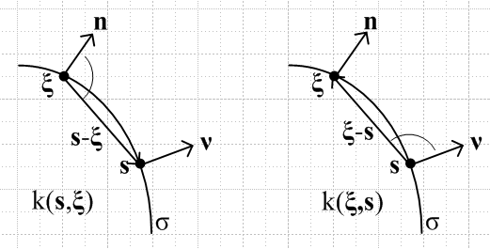

The equation shown in p 172C is OK, and we know that ∂νE(x|ξ) = k(ξ,x) = cos(ξ-x,ν)/ [4π|x-ξ|2], as explained in meta notes page 45 in "Note added". So p 172 C says this:

∂νu(x) = ∫ dSξ I(ξ) k(ξ,x)

The tricky part is taking the limit of the RHS of this equation as x→ s, as I note in the meta notes,

limx→s [∫σ dSξ I(ξ) k(ξ,x) ] = ∫σ dSξ I(ξ) limx→s [ k(ξ,x) ] – I(s)/2 // ∂νu

so you cannot simply interchange "limit" with "integration". You pick up "the extra term".

Comment #2: For the closed surface, we have two different "integral equations" we could attempt to solve for I(ξ). Here they are:

∫σ E(s|ξ)I(ξ)dSξ = 1 6.140 for any s on σ EI = 1

∫σ dSξ I(ξ) k(ξ,s) = -1/2 I(s) 6.140a for any s on σ KI = (-1/2)I

Once you find I(ξ) using either equation, you have to scale it so that ∫ dSξ I(ξ) = Q', the charge you deposited on the surface. I think Stak feels that the second equation is the easier one to solve. It might be that it's kernel is more convergent for large r, or something like that. We shall see in examples I think.

Open Surface

Why can't we treat such a surface (shown figure 173) as if it were made of metal of some small thickness, and is perhaps hollow inside, and then really this is just the same exterior problem. The total surface is then given as he says by σ = σ- + σ+ and we can define n as the normal on the + side. I think this is basically what he is doing, and we arrive at p 173 D where the two surface integrals are combined into one integral over σ+ (which he calls σ). Naturally what you get inside the integral is the discontinuity of the external ∂nu on the two sides. So this equation D is just the way 6.140 appears for this situation, whereas before we are saying I = -∂nu. So I don't think anything shocking has happened on page 173, and we now turn the page.
We now define the bracketed quantity in D as I(x), the total charge density adding up both sides, which is fine and we have p 174 A, and do the usual renaming to get p174 B. Absolutely nothing new here at all. Let x → s on σ and get 6.141 which is just 6.140 with the two surfaces folded together.
Now we try the ∂νu thing as we did before. Then p174 C is like p 172 C. We then do our fancy "limit x→s with extra term" and get equations D1 and D2 depending on which side we approach from. Compare these to p172 D. There we got an integral equation for I. Here due to our new definition of I as the total charge, D1 and D2 are not separately integral equations. If we subtract them, we get just the definition of I again.
I don't really like this approach much. I want to know separately the charge density on each side of this open surface, not the sum charge. Both sides will have charge! I think the two integral equations above still apply with proper interpretation that everything outside our "open surface" is really an exterior problem.

PL Exercise. Unit solid metal sphere.

This is a closed surface and we are interested in the exterior problem. The integral equation is

∫σ E(s|ξ)I(ξ)dSξ = 1 s and ξ are points on the spherical shell of radius 1

E(s|ξ) = 1/4πR = (1/4π) Σn' Pn'(cosγ) γ is the angle between our two rays

Put point ξ at Ω' and put point s at Ω. Then we have

(1/4π) Σn'∫dΩ' Pn'(cosγ) I(Ω') = 1

Install the full Y expansion of Pn' to get this saying

(1/4π) ∫dΩ' { Σn" N0n" Σm" (1/Nm"n") Yn"m"(Ω') Y*n"m"(Ω) } I(Ω') = 1

Now apply ∫dΩ Ynm(Ω) to both sides. The RHS is then ∫dΩ Ynm(Ω) Y*00(Ω) since in Stak norm we have Y00= 1. On page 395 this integral is δn0δm0 N00 = 4π δn0δm0.

The LHS has ∫dΩ Ynm(Ω) Y*n"m"(Ω) = δnn"δmm" Nnm so we get

(1/4π) ∫dΩ' Σn" N0n" Σm" (1/Nm"n") [δnn"δmm"' Nnm] Yn"m"(Ω') I(Ω') = 4π δn0δm0.

(1/4π) ∫dΩ' N0n (1/Nmn) [Nnm] Ynm(Ω') I(Ω') = 4π δn0δm0.

(1/4π) ∫dΩ' (4π/(2n+1)) Ynm(Ω') I(Ω') = 4π δn0δm0.

(2n+1)-1 ∫dΩ' Ynm(Ω') I(Ω') = 4π δn0δm0.

(2n+1)-1 [Nmn Imn] = 4π δn0δm0. // using p 396 A.6 projection

From this we conclude that

Imn = 4π δn0δm0 (2n+1)/Nmn = δn0δm0 4π/N00 = δn0δm0

Then we have found that

I(Ω) = Σmn ImnYnm(Ω) = Y00 = 1.

So we have now "solved our integral equation" and we find that I(Ω) = 1. We can then normalize this so that the total charge on the sphere is Q'. Just going through the steps here.

PL Exercise. Unit solid metal spherical thin half-shell.

I moved these notes off to a separate document "potential of half-spherical shell.doc" because the notes are just a lot of flailing and I could not solve this problem. I thought it would be simple.

B. Charged Conductor in 2D (174)

The geometry here is the cross section of a charged hollow pipe, so a charged ring of metal in 2D. So we have u = constant on this ring, I think that means u = constant everywhere inside, and so we have only the exterior problem for u. Poisson tells us that -∇2u = ρ(x), charge density. If we take as our volume a circle just outside the ring, LHS of divergence theorem gives -Q = -1, since we assume Q = 1 "unit" on this ring. The RHS of the divergence theorem gives ∫dSξ•∇u = ∫dl ∂ru, so we find ∫Cdl ∂ru = -1, just as claimed in p 175A. This is true for any larger circle as well which encloses the ring, hence 6.142. These statements are just Gauss's Law in action. [ Note that we don't think about the great circle at all. ]
Now we know the general external solution has the form 6.143, and I justify this way of writing it in a boxed comment in my raw 1 notes, though I would not write it this way. Notice that a0+b0 is a constant term in this expression, fine, later called c0.
What happens when you insert this general form for u into our ∫Cdl ∂ru = -1 formula, for a circle of radius a outside the circle? Write dl = adφ and then a ∫dφ ∂ru = -1

∂ru = Σ [aneinφ + bne-inφ]n rn-1 + A/r // this is why he used this form I think

The n=0 term obviously vanishes. All other terms in the sum have ∫dφ e±inφ = 0, so only the A term survives and it gives a ∫dφ (A/a) = -1 = 2π A so A = -1/2π as he claims. The log term is present! We will as usual throw out negative powers of r, and we can for now choose u = 0 on the ring. For large r, we then have u = A lnr or u = -lnr/2π so we have u/lnr = -1/2π. We think then that u/lnr = -1/2π is our r = ∞ boundary condition and u = 0 is our r=a boundary condition. ( He keeps avoiding writing down any radius for circle C). SO, when the dust settles, our PDE system is as stated in 6.144.
I agree that the 2D E function satisfies p 175 B. So where is 6.145 coming from? This is the RHS of an application of Green #2 whose LHS is this (see below), where V = region between two circles in which we assume we have our Green's point ξ,

∫dV [ u ∇2E - E∇2u] = ∫dV [ u ∇2E ] = ∫dV [ - u δ(x-ξ) ] = - u(ξ)

and whose RHS is this,

RHS = ∫dSξ [ u ∂nE - E ∂nu ]

where n points out from our volume at all points on the volume surface. If we now redefine n to be pointing away from the origin for both surfaces involved here, we can write this as

RHS = (∫Cr – ∫C dl ) [ u ∂nE - E∂nu ]

Therefore we get

u(ξ) = (∫C – ∫Cr dl ) [ u ∂nE - E∂nu ] = ∫C dl [ u∂nE - E∂nu ] + ∫Cr dl [ –u∂nE + E∂nu ]

which agrees with 6.145. Stak really has done this many times and is correct to make the reader do it for him/herself this time. Again, n points away from the origin on both surfaces.
Now the next task is to let Cr be a great circle. We then have to take large r limits of all four items appearing in ∫Cr dl [ –u∂nE + E∂nu ] and that he claims to do in what I label C,D,E,F where c0 is the constant term we assume appears in the expansion for u. [ it would be a0 + b0 in 6.143 ]. We did assume u = 0 on the ring, but we did NOT assume constant term = 0. We find that this Cr integral is exactly c0.
By the way, if we had a 2D point charge at the ξ = origin, what would u be? It would be u = - ln(r)/2π + c0. The result of our integral being c0 is of course independent of the radius of the circle C, so if we shrank the circle to a point, we would still get c0 for this integral. But in that case u = - ln(r)/2π + c0 so I guess those extra terms in E and F don't do anything in our calculation of c0. ( which I have not yet actually done). He says in text that we could have taken u = Qln(r) but I think he means -(Q/2π)ln(r) + c0.
So, going back to 6.145, that Cr integral can be set to c0. He now suddenly claims that the u∂rE term in the C integral vanishes. Why is that? Because u = 0 on the circle and this is an integral over the circle. So this gives us p 176 A. We now go back to p 172 A with ∂nui = 0 so I(ξ) = -∂nue at ξ. [ This comes from 6.66 in which "n" was always pointing away from the origin. ] We end up then with 6.146 where we have swapped the meaning of ξ and x (E is symmetric) and put in this I, obtaining now a + sign between our two terms. This is the key equation! It differs from the 3D equation p174 B (with its different E) in that there is a constant c0 sitting there!
Regarding the sign of I: we have Σ = I = - ∂nu where n points OUT from the origin. For example, if you have a Q = 1 unit point charge with u = E = (-1/2π)ln(r) but you interpret this as coming from a disk of radius 1, then you have I = - ∂nu = + (1/2π)(1/r) so that Σ = I = + (1/2π) would be the charge density on that disk's edge, and of course Q = 2πΣ = 1.
Now x is a point in Re and he wants it to approach the ring. But this is a simple layer integral so no funny business happens and u(x) → u(s) s on ring = 0, so we get

0 = c0 + ∫C (-1/2π) ln |ξ-s| I(ξ)dlξ s on ring

which gives 6.147 as a relation between charge density I(ξ) and constant term c0 in u. 6.148 just tells us that the sum of the charge density is Q = 1. Why is he not using ring symmetry in this work? In any event, if things are "nice" we are now scaling I(ξ) and this in turn will determine c0.
His comments about 6.147 having a non-trivial homo solution: This is after all an integral operator equation c0 = KI, so KI = 0 might have a nullspace containing some non-trivial solution I0 . He says that if it does, we should regard c0 = 0 and then THAT is our solution for I, and of course we can still scale I to match the Q integral condition. On the other hand, maybe c0 = KI has a solution I for some c0 and then that c0 is our c0. We can then scale both I and c0 to match the Q integral condition. What a fussbudget!
So at this point we have obtained (6.147) a first kind integral equation c0 = KI for the charge density I(ξ). Now go back to page 172 for a moment. Here we are in 3D and we start with 6.140 which is very similar to 6.146 except for the constant and the 2D E. On page 172 we applied ∂ν (normal at s) to 6.140 and ended up with 6.140a where we got "the extra term" and folded it in to get the -1/2 eigenvalue. He claims exactly this same thing happens in 2D, but you must use the 2D E function. This leads to A,B,C on top of page 177 where as expected we have 4π → 2π and one less power of R in the bottom. He did all this 2D stuff in the Exercises on page 120-121, see Ex 6.20.
He then ends with a comment of great interest to me since it is the 2D analog of my failed half-spherical shell problem I attempted above. He says that everything is the same if C is an open arc instead of a circle!! We still have 6.147 and all that follows, the only difference is that now I(ξ) is the sum of the charge densities on the two sides of the arc. I think this agrees exactly with my earlier treatment of open surfaces. Of course he has not solved anything here.

Question: To what extent does the analysis of this section apply to arbitrary 2D problems (which we can think of as cross sections of extrusion type 3D problems). I think 6.142 is still true for any circle that surrounds the extrusion shape. As we look down through the sequence of equations, everything is still true. In 6.145, the rightmost integral would be over the extrusion shape boundary. The great circle integral is still c0. So I think we end up then with 6.146 where we integrate over the extrusion boundary, whatever it might be! I think everything else is true as well, with this interpretation of ∫C. So my answer is that his work here applies to any FINITE extrusion cross section shape. As he himself points out, if you apply it to a partial pipe cross section (an "arc"), it is still true, but I(ξ) is the sum of the charges on the two surfaces. You do wonder how you might then get the charge on each surface. The answer I think is that you have to find u(x) everywhere, then the charge is the normal derivative. So using a trivial geometry, Stak develops the general 2D equations.

Review comments on this section: I think he is using this simple 2D geometry to show that you end up with integral equations that are similar to what we found in the 3D world. We do have to worry about the ln(r) large-r behavior of things. He was not really interested in finding the charge distribution in this problem since we know from the start it is just Σ = Q/2πa . He did a LOT of work in this section, more than I would have thought was necessary, but he maintains precision in his analytic work.

Examples (three examples)

Example 1: Charged circular cylinder (2D circle)

This is exactly the problem we just treated in generalities. Here he is going to do out the details. Recall that in 6.147 points s and ξ are both on the circle, and we have our famous result for the distance between these two points coming from the law of cosines for a triangle with vertex at the origin going out to the two points s (θ) and ξ (φ) on the circle, so central angle is |θ-φ|. So I like 6.150, and I also agree with D.
Next, we use the sum rule we found on page 104 (6.22) [ he does not bother to give the reference, a newbie would be hard pressed here ], with α = 1. That rule then says

Σn cos(nψ)/n = -1/2 ln[ 2 - 2cosψ]

which we apply here with ψ = θ-φ and we write out cos[ n(θ-φ)] as cos cos + sin sin and boom, we have E. Next, we expand I(φ) on the complete set as shown. So now 6.150 becomes

c0 =(a/2π)∫dφ { ln(a) - 2 Σn=1(1/n) [ cos(nθ)cos(nφ) + sin(nθ)sin(nφ)]}[Σk=0 Ikcos(kφ) + Σk=1 Ik'sin(kφ)]

We then use our "famous" Schaum integrals on page 96 which say

(1/2π)$^{\int_{-π}^{π}{}}$dφ cos(nφ) cos(kφ) = (1/π) (π/2) δn,k = (1/2) δn,k
(1/2π)$^{\int_{-π}^{π}{}}$dφ sin(nφ) sin(kφ) = (1/π) (π/2) δn,k = (1/2) δn,k
(1/2π)$^{\int_{-π}^{π}{}}$dφ sin(nφ) cos(kφ) = 0 since integrand is odd

So this gives

c0 =(a/2π)∫dφ { ln(a) - 2 Σn=1(1/n) [ cos(nθ)cos(nφ) + sin(nθ)sin(nφ)]} [Σk=1 Ikcos(kφ) + I0 ]
+ (a/2π)∫dφ { ln(a) - 2 Σn=1(1/n) [ cos(nθ)cos(nφ) + sin(nθ)sin(nφ)]} [Σk=1 Ik'sin(kφ)]

c0 =(a){ 0 - 2 Σn=1(1/n) [ cos(nθ)]} In (1/2) + I0 (a/2π)(2π) ln(a)
+ (a){ 0 - 2 Σn=1(1/n) [ sin(nθ) ]} In' (1/2)

c0 =(a){0 - Σn=1(1/n) [ In cos(nθ) + In' sin(nθ) ] + I0 ln(a) }

c0/a = – Σn=1(In/n) cos(nθ) – Σn=1(In'/n) sin(nθ) + I0ln(a) which is 6.151.

There is a lesson to be learned here, but not sure how to say it. Getting things into sin and cos really helps. So in 6.151 we have replaced our integral equation 6.150 with an infinite sum equation 6.151. If I were rowing my boat out on my own, I would at this point say "how does that help me? " But I turn the page:

Case 1: If a ≠ 1 (radius) we match terms on the two sides and find that

c0/a = Ioln(a) In' = In = 0 I0 = c0/ [aln(a)] => I(φ) = c0/ [aln(a)]

But of course we know that I(φ) = Q/(2πa) = I0 so we conclude that

c0/ [aln(a)] = Q/(2πa) c0/ [ln(a)] = Q/(2π) c0 = Q ln(a)/2π

Now one more step. If in 6.146 we put x at (r,θ) outside our circle, then we have

|x-ξ|2 = a2 + r2 - 2ar cos(θ-φ)

2 ln|x-ξ| = ln[a2 + r2 - 2ar cos(θ-φ)]

Then the second term in 6.146 is this:

+ (-1/2π) ∫adφ ln|x-ξ| Io = (-aI0/4π) $^{\int_{-π}^{π}{}}$dφ ln[a2 + r2 - 2ar cos(θ-φ)]

The integral is independent of θ so just set θ = 0. Then integrand is even so write as

= (-aI0/2π) $^{\int_{0}^{π}{}}$dφ ln[a2 + r2 - 2ar cos(φ)]

This is of course a famous integral, see p 100 Schaum top with α = r2 + a2 and β = -2ar so that we get
[ notice that α2 - β2 = (r2 + a2)2 - 4a2r2 = (r2- a2)2 ]

= (-aI0/2π) π ln[ {a2 + r2 + (r2- a2)}/2 ] = (-aI0/2) ln r2 = (-aI0) ln(r)

So, we now have a final answer for u(x) using 6.146

u(x) = c0 + (-aI0) ln(r) = I0aln(a) + (-aI0) ln(r) = - I0a ln(r/a) = -(Q/2π) ln(r/a)

and this agrees with p 178 C, I don't know why he would write this using ln(a/r) since we have r ≥ a.
So our big conclusion is this:

u(r,θ) = u(r) = -(Q/2π) ln(r/a) for r ≥ a

Of course if we just had a point charge Q at the origin, we could have said u = -(Q/2π) ln(r) + c0, as noted a few pages above in these notes, and we could set c0 to get u(a) = 0 and that verifies our answer obtained "the hard way". So the Gauss Law outside a symmetric charge idea still applies in 2D.

What did we do here? We took our equation (6.147) for c0, expanded I in φ basis functions, and found that I(ξ) = I0 = c0/ [aln(a)]. We then normalized I0 to nail down both I0 and c0. We then used these expressions for I(ξ) and c0 in 6.146 and thereby got the answer to our problem! That is to say, we solved the integral equation 6.147 for I(ξ) and that happened also to tell us c0. We inserted these results into our integral expression for u(x).
This "integral equation method" goes way back to (6.66) on page 125 in 3D where we talked there about solving this simple layer integral equation for I(ξ), then inserting that into (6.65) to find u. I in fact "invented" this method on page 54 of the raw 1 notes, saying

(1) For example, I think you could find a third "situation" where the same f(s) and internal solution u is created by a single layer charge density a(s). For example, it seems to me that we could just repeat the above integral equation discussion of this section and say this:

u(x) = ∫σ dξ a(ξ)1/4πR (**)
limx→s u(x) = ∫σ dSξ a(ξ)1/4πR = f(s)

We regard the second equation as a Fred inhomo 1 variety. We solve if for a(ξ) and insert that into (**) to get u. So I would extend the list above to say

This is of course the 3D version. In our case, f(s) = 0, the potential on the ring, but in the 2D world we have this extra c0 constant floating around in the first equation so it is also in the second. This is because the great circle integral does not vanish.

Case 2: a = 1 (radius). He first just comments that in this case 6.151 says c0 = 0 and I0 is arbitrary, but of course scale it in the same way, and we get the same answer we got in Case 1 but with a = 1. He just comments that the math is "a little different" when a = 1, so the seasoned mathematician has a "moment of anxiety" until s/he sees that the result is the same as a ≠ 1.
Finally, he solves the problem quickly using the eigenvalue integral equation. I recall that k = constant for this geometry, agree then that I = constant, and we are all done! But of course we could have been all done from symmetry with no integral equations at all!

Diagonalization Comment Added 10.27.09

I keep adding notes like this in various places, hopefully I will get these notes all put in one place soon. First, on page 3 of Chap 3 meta-meta I quote Stak's claim that any HS kernel k(x,y) can be written in separable form Σnpn(x)qn(y) allowing for an infinite sum. And a HS kernel is just one that is double-integrable on the square interval. At this point in Chap 3 nothing is said about what the functions like pn(x) might be. Then on page 194 Stak tells us to pick ANY complete set of functions ψi(x), then you can exactly write any HS k(x,y) as k(x,y) = Σij aij ψi(x) j(y). Really this is just saying that the product functions form a complete set on the square. He refers there to this double sum also as a "separable operator", not just to the form Σnpn(x)qn(y). You could message the double sum into this form,

Σij aij ψi(x) j(y) = Σi ψi(x) [ Σj aijj(y)] = Σi pi(x) qi(y)

where pi(x) = ψi(x) qi(y) = [ Σj aijj(y)]

A special case of this would be that aij is diagonal so aij = aiiδi,j and then qi(y) = aii i(y) and then our separable sum has the form k(x,y) = Σi aii ψi(x) i(y). You can see that this is Hermitian, and if the functions are real, k(x,y) is symmetric in the simple sense. I suspect therefore that any symmetric HS kernel can be expanded in this separable manner k(x,y) = Σi ai ψi(x) i(y) [ See tentative theorem at the end of this comment] . For example, we know that the Green's Function is symmetric and can be expanded in exactly this way where ai / 1/λi.
Now fast-forward to Vol II page 177 where we are doing this charged ring problem. The "kernel" of our integral equation is ln(R(x,y)) where both points x and y lie on the circle of radius a, so think ln(R(θ,φ)). In p 177 E Stak shows that

k(θ,φ) = ln(R) = ln(a) - 2 Σn=1(1/n) [ cos(nθ)cos(nφ) + sin(nθ)sin(nφ)]

Now we know that {sin(nφ), cos(nφ)} = { ψ1n(φ), ψ2n(φ) } combined form a complete set on our interval of the circle, and for n=0 this includes a constant function. So we have

k(θ,φ) = ln(R) = Σσ=1,2( ln(a)) ψσ0(θ) ψσ0(φ) + Σn=1∞Σσ=a,b (-2/n) ψσn(θ)ψσn(φ)

and this has exactly the form k(θ,φ) = Σi ai ψi(θ) ψi(φ) where i = { σ,n }. So in this particular case we find that aσ,0 = ln(a) and aσ,n = (-2/n).
The point so far is that Stak has written out the kernel for this circle of charge integral equation in its separable sum form using a complete set of basis functions for the circle.
Now let's look at the general integral equation situation with such a separable symmetric kernel, and for our purposes here let's assume that the ψi(x) are orthonormal. Then:

f(x) = ∫Rdy k(x,y) I(y) = ∫Rdy [ Σi ai ψi(x) i(y) ] I(y) = Σi ai ψi(x) [ ∫Rdy i(y) I(y) ]

Now apply ∫Rdx j(x) to both sides to get

[ ∫Rdx j(x) f(x) ] = Σi ai { ∫Rdx j(x) ψi(x) } [ ∫Rdy i(y) I(y) ]

= Σi ai δij [ ∫dy i(y) I(y) ] = aj [ ∫dy j(y) I(y) ]

If we now define the square bracketed items to be "projections onto basis functions", then we have

fj = aj Ij

and the equation has been completely diagonalized. In Stak's example 6.150 we have f(x) = c0 whose only non-vanishing projection is f0 so this last equation becomes

f0 δj,0 = aj Ij => I0 = f0/ a0 and In = 0 n = 1,2.3

and a0 = ln(a) as noted above, and I suppose f0 = c0/a when you normalize the basis functions, so you end up with I0 = c0/[a ln(a)]. This is all in agreement with p 178 A.
Notice the following facts:
(1) In order for the above diagonalization to work, the kernel must be written in diagonal separable form in terms of a set of basis functions which are complete on the region R which appears in the integral equation. The projections are then all on this region.
(2) Note that in our ring example, R is not the interior of the ring, it is the boundary, R = σ;
(3) We could talk about the projection of the kernel itself relative to one of its arguments,

∫Rdy k(x,y) = ∫Rdy [ Σi ai ψi(x) i(y) ] = Σi ai ψi(x) ∫Rdy i(y)

Assuming that 0(y) = k0, some constant, then we can compute the above integral as δi,0 /k0 so

∫Rdy k(x,y) = Σi ai ψi(x) δi,0 /k0 = a0 ψ0(x)/k0 = a0

I don't have an interpretation of this result.

Now what does this have to do with "group theory" ? Our integral equation has this form:

f(θ) = ∫dφ k(θ,φ) I(φ) = ∫dφ K(θ-φ) I(φ) where K = as shown in 6.150.

Since this is in convolution form for SO(2), we know it diagonalizes when you project the functions onto the SO(2) representation functions which we usually write as eimφ m = integer. So we know we will have a diagonalized equation of the form, where projections are onto eimφ

fm = Km Im

If we shuffle things around to get sin and cos projections, we have something like this

fm = fms + i fmc and similarly for others

In our case Km is symmetric in argument so only Kmc exists and we get then

[fms + i fmc] = Kmc [Ims + i Imc]

which becomes two equations, assuming f(x) and I(x) and K are real,

fms = Kmc Ims fmc = Kmc Imc => fmσ = Kmc Imσ

and I think this is what fell out in our current problem.
So we know ahead of time that this problem will diagonalize by the group theory argument.

Now suppose instead of a circle we had some "bent ring" boundary σ. Now the SO(2) symmetry goes away. Now the kernel k(r,r') = k(r,θ; r',θ') = k (|r-r'|) is still symmetric in this 2-variable sense, so I think we can still expect to write k(x,y) = Σi ai ψi(x) i(y) where ψi(x) is some complete set of basis functions on the region enclosed by the bent ring. I am not sure how you would find these functions but they surely must exist [ see tentative theorem below], and then in terms of projections on to these functions things would diagonalize. You could imagine starting with something simple like an elliptical ring and working in elliptical coordinates to find these functions, or doing a conformal map back from the ellipse to the circle, etc.
Most problems that Stakgold attacks are those with some group symmetry and things are at least doable, albeit messy as the above ln(R) expansion into sines and cosines shows.

Let's look at the more general case now where k(x,y) = Σij aij ψi(x) j(y). We then get,

f(x) = ∫Rdy k(x,y) I(y) = ∫Rdy [Σij aij ψi(x) j(y) ] I(y) = Σij aij ψi(x) [ ∫Rdy j(y) I(y) ]

Now apply ∫Rdx k(x) to both sides to get

[ ∫Rdx k(x) f(x) ] = Σij aij { ∫Rdx k(x) ψi(x) } [ ∫Rdy j(y) I(y) ]

= Σij aij δik [ ∫Rdy j(y) I(y) ] = Σj akj [ ∫Rdy j(y) I(y) ]

fk = Σj=0∞ akjIj f = AI

All we have done now is convert our integral equation into an infinite dimensional matrix equation, which is NOT "diagonalization".
Now let's try to prove our earlier conjecture that symmetric => separable in simple sense above.

k(x,y) = Σij aij ψi(x) j(y)

k(y,x) = Σij aij ψi(y) j(x)

(y,x) = Σij ij i(y) ψj(x) = Σij ij ψj(x) i(y) = Σij ji ψi(x) j(y)

Symmetric generally means (y,x) = k(x,y) which here tells us we need aij = aji* which is to say that the matrix A must be Hermitian. But if a is Hermitian, we know it can be diagonalized by unitary S

SaS† = Λ => a = S†ΛS

So then consider what happens here, and define new functions i = Σj Sjkk or = S

k(x,y) = ψT a = ψT S†ΛS = φT Λ = Σi Λii φi(x) i(y)

So here is our tentative theorem: If k is symmetric, then it is possible to find a set of basis functions φi which are complete on region R, which are orthonormal on R, and which allow k to be written in a separable manner, in which case the integral equation over region R can be diagonalized. For some kind of "bent ring" as mentioned above, this set of functions φi might be a very hard to find. The integral would have to be written using a scalar parameter t along the bent ring which perhaps goes 0 to 1. There might even by some "symmetry group" that goes with the bent ring, whose representation functions are these φi. This is all just conjecture on my part.

Example 2: Strip of width 2a (meaning a 2D line segment on x axis -a to a) (178)

This is the 2D problem of the finite length 2D wire held at a constant potential. I read Stak's stuff on this, and then voyaged off on my own which led to me writing at least 3 external documents some of which is summarized below.

So integral instead of being around C is now -a to a as shown in 6.152 [ which is 6.147]. Now ( the log is just ln(R) = -ln(1/R) which is the 2D fundy, ignoring constants)

$^{\int_{-a}^{a}{}}$ dξ ln |x-ξ|I(ξ) = $^{\int_{-1}^{1}{}}$ adτ ln |at-aτ|I(aτ) = $^{\int_{-1}^{1}{}}$ adτ( ln a + ln|t-τ| ) I(aτ)
so that
2πc0/a = ln a $^{\int_{-1}^{1}{}}$ dτ I(aτ) + $^{\int_{-1}^{1}{}}$ dτ ln|t-τ| I(aτ) // agrees with p 179 A

At this point, he quotes a result of a future Exercise (with wrong number) which result is p 179 B. I suspect this is the key step and you see in A that sort of "double integral equation" Jackson found for his disk in 3D problem. These charge distribution problems tend to have a lot of "internal feedback". I then followed all the remaining steps on page 179, finding one other error, and I agree with result H.
Here is what that Exercise 6.47 on page 181 deals with. It addresses the problem of solving the following integral equation for f(t), given g(t).

$^{\int_{-1}^{1}{}}$ dτ ln|t-τ| f(t) = g(t)

It then applies the solution found to g(t) = 1, and that is the result we use here.
So this answers one of the questions I posed above: what is the charge distribution on a line segment in 2D! The charge runs off mostly to the ends, blowing up at the ends, but being integrable.

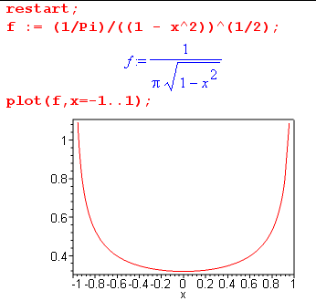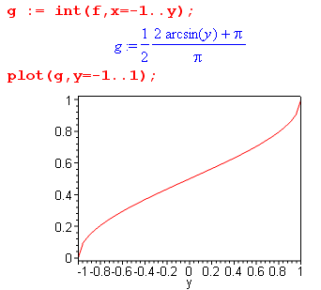

I find this result fascinating. I suspect there is some much simpler way to arrive at this result. [ But I still don't know what this is, after doing lots of work on this 2D wire problem in general. ]

But first, what is the u(x) for this problem? // the $64 question !

He does not state the result! It is given by the integral 6.146 and we already know that c0 = ln(a/2)/2π from p 179 F. So

u(x) = ln(a/2)/2π + $^{\int_{-a}^{a}{}}$dξ [ -(1/2π)ln| x-ξ |] [ 1/π $\sqrt{a2- ξ2}$]

As before, let ξ = aτ, but now let let x = atR

u(atR) = ln(a/2)/2π + $^{\int_{-1}^{1}{}}$ a dτ [ -(1/2π)ln| atR - aτ|] [ 1/π $\sqrt{a2- a2τ2}$]

= ln(a/2)/2π + $^{\int_{-1}^{1}{}}$ dτ [ -(1/2π)ln| atR - aτ| ][ 1/π $\sqrt{1- τ2}$]

= ln(a/2)/2π + $^{\int_{-1}^{1}{}}$ dτ [ -(1/2π)ln(a)] [ 1/π $\sqrt{1- τ2}$] + $^{\int_{-1}^{1}{}}$ dτ [ -(1/2π)ln|tR - τ|] [ 1/π $\sqrt{1- τ2}$]

= ln(a/2)/2π -(1/2π2)ln(a) $^{\int_{-1}^{1}{}}$ dτ [ 1/ $\sqrt{1- τ2}$] -(1/2π2) $^{\int_{-1}^{1}{}}$ dτ [ln| tR - τ|] [ 1/ $\sqrt{1- τ2}$]

= ln(a/2)/2π -(1/2π)ln(a) -(1/2π2) $^{\int_{-1}^{1}{}}$ dτ [ln| tR - τ|] [ 1/ $\sqrt{1- τ2}$] // using p 179 integral

= – (1/2π)ln(2) -(1/2π2) $^{\int_{-1}^{1}{}}$ dτ ln| tR - τ| / $\sqrt{1- τ2}$

Now set R = X + Y so we get

ln| tR - τ| = (1/2) ln (tR - τ)2 = (1/2) ln ( t [X + Y ] - τ )2

= (1/2) ln ( [tX-τ] + Y ] )2 = (1/2) ln ( [tX-τ]2 + Y2 )

So we can write our result as

u(atX,atY) = u(x,y) = – (1/2π)ln(2) -(1/4π2) $^{\int_{-1}^{1}{}}$dτ ln ( [tX-τ]2 + Y2 ) / $\sqrt{1- τ2}$

The trick is now to do this integral appearing in the above equation, which integral I call I(t). I spent about 2 days trying to do this integral, eventually with success, as notes below show.

Summary of external notes. "potential of extruded strip v1.doc"

This document really has no useful notes. Skip to v2.doc summary below.

Since I(t) was being recalcitrant, I moved flailing notes off to this separate document. After flailing with Plans A,B,C, in Plan D I made some headway as follows:

I(t) ≡ $^{\int_{0}^{1}{}}$dτ ln ( [tX-τ]2 + t2Y2 ) / $\sqrt{1- τ2}$ + $^{\int_{0}^{1}{}}$dτ ln ( [tX+τ]2 + t2Y2 ) / $\sqrt{1- τ2}$
I(t) = I1(t) + I1(-t)
= I11(t) + I11(t)* + I11(-t) + I11(-t)*

I11(t,α) = $^{\int_{0}^{1}{}}$ (dτ / $\sqrt{1- τ2}$) ln(τ-α) α = tX+itY
= $^{\int_{-π/2}^{π/2}{}}$dθ ln(sinθ-α)

= $^{\int_{0}^{π/2}{}}$dθ ln(sinθ-α) + $^{\int_{0}^{π/2}{}}$dθ ln(-sinθ-α)
= J(t,α) + iπ2/2 + J(t,-α)

J(t,α) = (π/2) ln(-α) + $^{\int_{0}^{π/2}{}}$dθ ln(1 +a sinθ) a = -1/α α = tX+iY

and GR p 527 #11 have at least something to say about this. At this point I paused this thread and flailed on Plan E where I tried to convert to a contour integral. Then in Plan F I am back pondering the above integral which I called K,

K(t,α) ≡ $^{\int_{0}^{π/2}{}}$dθ ln(1 +a sinθ) =?= (GR) : (1/2) π ln( (1 + $\sqrt{1-a2}$)/2 )

which appears as noted in GR but with some strangeness, one result as shown above. I could not explain the "strangeness" which reduced confidence a lot. But assuming the above is right, I then wrote out the final result for I(t) and it was big mess. In frustration, I terminated my "v1" document at that point. But I think this result was in fact correct, but appears in much simple form below.

Summary of external notes. "potential of extruded strip v2.doc"

(1) What is the potential? I started afresh, this time maintaining the (-1,1) endpoints instead of breaking in two. I did separate the log of the quadratic into two pieces (as before) and made more progress:

u(ax,ay) = – (1/2π)ln(2) -(1/4π2) $^{\int_{-1}^{1}{}}$dτ ln ( [x-τ]2 + y2 ) / $\sqrt{1- τ2}$
J1
J1 ≡ $^{\int_{-1}^{1}{}}$dτ ln ( [x-τ]2 + y2 ) / $\sqrt{1- τ2}$
= $^{\int_{-1}^{1}{}}$dτ ln ( [x-τ] + iy ) / $\sqrt{1- τ2}$ + $^{\int_{-1}^{1}{}}$dτ ln ( [x-τ] - iy ) / $\sqrt{1- τ2}$
J2 c.c.

J2 ≡ $^{\int_{-1}^{1}{}}$dτ ln ( [x-τ] + iy ) / $\sqrt{1- τ2}$ = $^{\int_{-π/2}^{π/2}{}}$dθ ln(z - sinθ) z = x+iy τ = sinθ

where suddenly I have J2 as a simple integral involving a complex variable z. This was a first.

At this point, I wandered down another wrong path and wrote this as

J2 = π ln (z) - $^{\int_{-π/2}^{π/2}{}}$dθ ln (1 - sinθ/z)

Here I expanded the log in its usual power series and got this result (z = reiφ)

J1 = J2 + c.c. = π ln |z|2 + Σn=2,4.. (2n/n) B[(n+1)/2, (n+1)/2] (z-n + -n)
= 2π ln(r) + 2 Σn=2,4.. (2n/n) B[(n+1)/2, (n+1)/2] r-ncos(nφ)

which then resulted in a final result

u(x,y) = – (1/2π) ln(2r/a) - (1/2π2) Σn=2,4.. (2n/n) B[(n+1)/2, (n+1)/2] (r/a)-ncos(nφ)

which has the known correct large r limit, and is of course a power series in (1/r) so this is a fine large-r expansion for the solution. I was pretty happy to get this result, since all previous efforts were going nowhere fast. I think this solution only converges for r > a, so not useful "close in" where I want to study things. I tried to compute the convergence radius looking at the Stirling large-n limit of the Beta function.

I then just noticed that there was a better way to write J2 which was this

J2(z) = $^{\int_{-π/2}^{π/2}{}}$dθ ln(z - sinθ) = $^{\int_{0}^{π}{}}$dθ ln(z + cosθ)

u(ax,ay) = – (1/2π)ln(2) -(1/4π2) [J2(z) + c.c ] = the potential

I was then able to do this last integral in two ways:

Way 1: Differentiate with respect to parameter z to remove that unpleasant log,

∂z J2(z) = $^{\int_{0}^{π}{}}$dθ / (z + cosθ ) = π/(z2-1)1/2 // GR p 383 top would apply with n = 0

Then integrate this to get

J2(z) = $^{\int_{}^{z}{}}$dz π/(z2-1)1/2 = π ln(z + $\sqrt{z2-1}$) + K

Then by looking at the large z limit, I concluded that K = K = π ln(1/2) and then sol is

J2(z) = π ln[ z + $\sqrt{z2-1}$]/2

Way 2: I then found my ln(z + cosθ) sitting in GR p 527 # 9 (previously circled!!!) with a = z and b = 1

J2(z) = $^{\int_{0}^{π}{}}$dθ ln(z + cosθ) = π ln[ ( z + $\sqrt{z2-1}$)/2 ] // restrictions z ≥ 1 ≥ 0

I then became more confident of this result, and then the solution to the problem of the potential of the 2D wire of length 2a centered at the origin and aligned along the x axis was this:

u(ax,ay) = – (1/4π)ln(2) -(1/4π) ln( z + $\sqrt{z2-1}$) + c.c. z = x + iy

So finally I had a "candidate" solution that can be written in closed form on one line, involving a simple elementary function.
Before arriving at this point, I gave Maple a shot at my ln(z + cosθ) integral and it kept reporting out a huge mess that was about 16 terms long involving messy logs and dilogs! This was a huge distraction. I located "rules for dilogs" and could see how the messy Maple result might equal my simple result. I concluded that Maple did this integral in some strange way and then found itself faced with a host of maybe 6 branch decisions, when the original integral is pretty much "branch free", a fact I also showed. I then downloaded the freeware Maxima, but it could not do this integral at all (though it does ask about a list of branch decisions)! The Wolfram online integrator won't do definite integrals. Sage was too big.
There is a lesson to be learned here: you cannot trust computer integrators to find the solution you are looking for. Sometimes it is MUCH better to use paper, pencil, and GR. The trick here, as the notes above show, is that you have to cast your integral into some form that GR uses.

(2) At this point, having a viable solution for the potential, I evaluated it on the wire itself to see if it really was constant on the wire. This is a very easy calculation:

u (on wire) = – (1/4π)ln(2) -(1/4π) ln[ ( x + i $\sqrt{1-x2}$) ] + c.c

= – 2(1/4π)ln(2) -(1/4π) ln [ x2 + (1-x2) ] = – (1/2π)ln(2)

At this point I send an email to Jim on this subject, asking what he thought of the weird Maple results.

(3) Next, I took the closed-form solution for u(x,y) and computed ∂yu(x,y), the "normal derivative". The result I obtained was -∂yu(x,y) |y=0 = (1/2) [ 1/π$\sqrt{1-x2}$]. I interpret this as the charge density on the top or bottom of the wire, and you add these together to get the total I(x), though I did not separately compute the top and bottom results carefully.

(4) Next, I took the solution for u(x,y) and computed ∂xu(x,y), the "tangential derivative". As I took the limit y→0 I got ∂xu(z)|y=0 = -(1/2π2) $^{\int_{-1}^{1}{}}$dξ (x-ξ)-1/$\sqrt{1-ξ2}$ and I was "concerned" that this integral goes right through a pole. I then went off on a long "digression" (so marked in notes). I was concerned that this limit y→0 might have an "extra term" as in Stak's long boundary layer discussion. I expressed this integral in terms of a cos(θ)/r form, but then paused on that. I then tried to do the integral as a half pole residue plus a principle part, but made a huge error (see read WRONG). Then I returned to the "is there an extra term" discussion related to the above integral limit. This forced me to review the entire "extra term" discussion in 2D and I concluded that, just as Stak said, there is NO extra term issue with this tangential derivative. I then corrected my half-pole integration attempt and got no useful result. This is where it says "end of Digression".
So I then returned to this integral with the pole. I realized that I knew how to do this integral already from previous work ( GR p 383) and realized that you have to think again of the surface charge as being half on top and half on bottom. I then found that ∂xu(z)|y=0 has two contributions, one from the upper charge and one from the lower charge:

-∂xu(z)|y=0 = (1/2) (1/2π2) $^{\int_{-1}^{1}{}}$dξ (x+iε-ξ)-1/$\sqrt{1-ξ2}$ = +i (1/2) π/$\sqrt{x2-1}$ // from upper charge
-∂xu(z)|y=0 = (1/2) (1/2π2) $^{\int_{-1}^{1}{}}$dξ (x-iε-ξ)-1/$\sqrt{1-ξ2}$ = -i (1/2) π/$\sqrt{x2-1}$ // from lower charge

When you add these together you get the total tangential "force on a test charge" which is 0. This then agreed with my earlier evaluation from the closed form potential, and with the idea that things are "static".

(5) Finally, here are some plots of the potential for this wire problem:

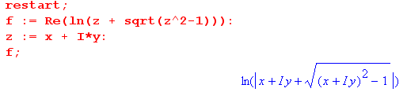

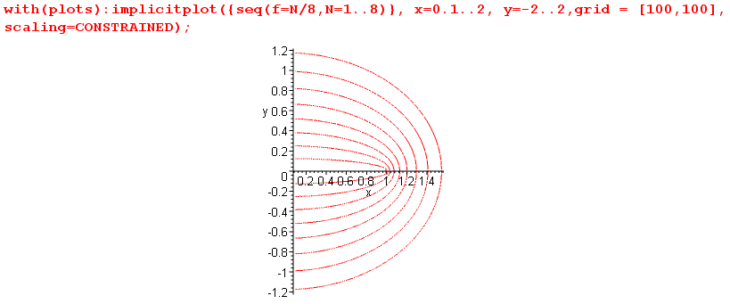

The plotter has trouble near x=-0 so I started at x = 0.1. This plot is of course just what you would expect. The contours approach circles fairly quickly. At this point in time, I suspected the curves were ellipses, but I did not know that and it was a question I used to motivate detailed analysis.

Summary of the above v2 doc summary

All these results go beyond what Stakgold has stated in his section on the 2D wire.

• The potential for the 2D wire can be written as an integral in this manner:

u(ax,ay) = – (1/2π)ln(2) -(1/4π2) $^{\int_{-1}^{1}{}}$dτ ln ( [x-τ]2 + y2 ) / $\sqrt{1- τ2}$

= – (1/2π)ln(2) -(1/4π2) [ J2(z) + c.c ]

which is just 6.141 where we have inserted our known surface charge I(τ) and written out the fundamental solution E. The integral J2 can be written several different ways, and I eventually "did the integral".

J2 ≡ $^{\int_{-1}^{1}{}}$dτ ln ( [x-τ] + iy ) / $\sqrt{1- τ2}$ = $^{\int_{-π/2}^{π/2}{}}$dθ ln(z - sinθ)

= π ln (z) - $^{\int_{-π/2}^{π/2}{}}$dθ ln (1 - sinθ/z) = $^{\int_{0}^{π}{}}$dθ ln(z + cosθ) = π ln[ z + $\sqrt{z2-1}$]/2

Therefore, the potential of the 2D wire is given by

u(ax,ay) = – (1/2π)ln(2) -(1/4π) [ ln( z + $\sqrt{z2-1}$) ] + c.c. ] z = x + iy

• If you evaluate this potential directly on the wire itself, you find that the z-dependent [...] above is zero for any x on the wire, because

ln( z + $\sqrt{z2-1}$) ] + c.c. = ln [( x + i$\sqrt{1-x2}$)( x - i$\sqrt{1-x2}$)] = ln [ x2 + (1-x2)] = ln (1) = 0

Another way to say this is that ln [( x + i$\sqrt{1-x2}$)] is purely imaginary, being equal to i cos-1(x). Thus, we verify the important fact that u = constant on our metal wire.

• If you compute the normal derivative of the potential directly from the closed form solution, you find
that -∂yu(x,y) |y=0 = (1/2) [ 1/π$\sqrt{1-x2}$] = (1/2) I(x) which is the charge on either the upper or lower surface, and you have to add these to get the total charge.

• If you compute this same normal derivative from the general formula p 174 D1 which applies both above and below the wire, you get this same result exactly. The integral part of D1 is 0 because the ∂y brings out a factor of 2y. In other words, the total result is the "extra term" (1/2) I(x). Recall that when a surface is flat, this is what happens (ie, there is no residual integral).

• If you compute the tangential derivative directly from the closed form solution, you find that

∂xu(x,y) = -(1/4π)/ $\sqrt{z2-1}$ + cc

which vanishes on the wire since $\sqrt{z2-1}$ is pure imaginary. This is what we expect, since it says that the total tangential force on a static test charge should be 0, otherwise we would not be "static".

• If you compute the tangential derivative from the general formula 6.141, we get this result:

∂xu(z)|y=0 = -(1/2π2) $^{\int_{-1}^{1}{}}$dξ (x-ξ)-1/$\sqrt{1-ξ2}$

and there is no "extra term" in this situation, though the integral goes right through a pole. But this is an integral I already encountered with playing with J2, namely

$^{\int_{-1}^{1}{}}$dξ (x-ξ)-1/$\sqrt{1-ξ2}$ = ∂z J2(z) = $^{\int_{0}^{π}{}}$dθ / (z + cosθ ) = π/$\sqrt{z2-1}$ GR p 383

which we can write this way:

∂xu(z)|y=0± = -(1/2π2) $^{\int_{-1}^{1}{}}$dξ (x±iε-ξ)-1/$\sqrt{1-ξ2}$ = ± iπ /$\sqrt{1-x2}$

I interpret this as saying that the tangential force on a test charge has two components which we must add together to get the total force. The + sign gives us the force on our test charge from the charge on the upper surface, while the - sign gives the force from the lower surface. But these forces are imaginary and cancel, giving a net result of zero force on a test charge.

Diagonalization Comments for Example 2 above. Our integral equation of interest here is shown in
p 179 A is k = $^{\int_{-1}^{1}{}}$dτ ln |t-τ| I(aτ)dτ, which I will rewrite in a more general form:

a(x) = $^{\int_{-1}^{1}{}}$dy ln |x-y| b(y)

which looks convolution-like, but what is the group here? Is there a group? We can certainly get closer to SO(2) by writing this as

A(θ) = $^{\int_{-π}^{π}{}}$dφ sin(φ) ln | cosθ - cosφ | B(φ)

but this is definitely not "convolution form" for SO(2). You wonder: "Is there a continuous symmetry group for which the Legendre polynomials are the representation functions" ? We certainly could think of a specialization of the Ylm somehow. Let's try a different starting point

a(θ,φ) = ∫dΩ' ln |cos γ| b(θ',φ') cosγ = cosθcosθ' + sinθsinθ' cos(φ-φ').

The group idea here is that R(γ) = R(θ,φ) R-1(θ',φ') or gγ = g g'-1 so we have

a(g) = ∫dg' f(g g'-1) b(g')

and now we ARE in convolution form. Set φ = 0 and assume b does not depend on φ',

a(θ,0) = ∫d(cosθ') b(θ') 2 $^{\int_{0}^{π}{}}$dφ' ln | cosθcosθ' + sinθsinθ' cos(φ') |

where the integrand of dφ' is even in φ'. Now assume that a also does not depend on φ, so we now have this down to

a(θ) = 2 ∫d(cosθ') b(θ') $^{\int_{0}^{π}{}}$dφ' ln | a + b cos(φ') |

If I assume that a > b > 0 then can ignore the || and we go to GR page 527 where we learn that

$^{\int_{0}^{π}{}}$dx ln (a + b cos(x)) = π ln [( a + $\sqrt{a2-b2}$)/2]

Suppose this had come out being π ln |cosθ - cosθ'|. Then our integral equation would have been

a(θ) = 2π ∫d(cosθ') ln |cosθ - cosθ'| b(θ')

and I would have argued that we have therefore shown that this really is a convolution equation.
However, what we really get from the integral is this:

a = cosθ cosθ' b = sinθ sinθ'

a2 - b2 = cos2θ cos2θ' – sin2θ sin2θ' = c2c'2 - s2s'2

= c2c'2 - (1-c2) (1-c'2) = c2c'2 -1 + c2+ c'2- c2c'2 = c2+ c'2- 1

So our integral in fact is this

π ln [(cosθ cosθ' + $\sqrt{cos2θ+ cos2θ'- 1}$)/2]

Suppose θ = θ'. The ln arg here is then C2+ $\sqrt{2C2-1}$ where as "the other" is 0, so there is no doubt that this result is NOT the same as ln |cosθ - cosθ'|.

So the conclusion is that I have wandered down a dead-end alley.

So start all over at this point:

a(cosθ) = $^{\int_{-π}^{π}{}}$dφ ln | cosθ - cosφ | [ b(cos φ) sin(φ)]

Forgetting group representations, we hope this kernel is HS so it should have a separable form. That form appears on page 192 as

ln | cosθ - cosφ | = -2 Σn=1 (1/n) cos(nθ)cos(nφ) - ln2
Remember that Stak said we could find a separable form for a HS kernel using ANY complete set of basis functions on our interval, and that is exactly what the above is. So here we see this fact decoupled from any obvious group representation situation. Now write the above as

a(cosθ) = $^{\int_{-π}^{π}{}}$dφ ln | cosθ - cosφ | c(cos φ)

= $^{\int_{-π}^{π}{}}$dφ { -2 Σn=1 (1/n) cos(nθ)cos(nφ) - ln2 } c(cos φ)

= -2 Σn=1 (1/n) cos(nθ) $^{\int_{-π}^{π}{}}$dφ cos(nφ) c(cos φ) - ln2 $^{\int_{-π}^{π}{}}$dφ c(cos φ)

Now apply $^{\int_{-π}^{π}{}}$dθ cos(mθ) to both sides to get

[$^{\int_{-π}^{π}{}}$dθ cos(mθ) a(cosθ)] = -2 Σn=1 (1/n)[ $^{\int_{-π}^{π}{}}$dθ cos(mθ) cos(nθ)] [$^{\int_{-π}^{π}{}}$dφ cos(nφ) c(cos φ)]
- ln2 $^{\int_{-π}^{π}{}}$dφ c(cos φ) $^{\int_{-π}^{π}{}}$dθ cos(mθ)

= -2 Σn=1 (1/n)[ 2π δm,n] [$^{\int_{-π}^{π}{}}$dφ cos(nφ) c(cos φ)]
- ln2 $^{\int_{-π}^{π}{}}$dφ c(cos φ) [ δm,0 2π ]

Now define projections without any constants in them and this says

am = -2 Σn=1 (1/n)[ 2π δm,n] cn - ln2 c0 [2π δm,0 ]

=> am = -4π/m cm m > 0
a0 = -2π ln2 c0 m = 0

I may have the constants wrong here, but that is not the point I am trying to make here. The point is that once we find a separable form for a kernel in terms of some complete set of basis functions, we KNOW we can diagonalize the integral equation, and this seems to have nothing at all to do with group representation theory in this particular problem. So one of the key things you have to do to diagonalize an integral equation like those we are dealing with here is to find a separable form of the kernel using some complete set of basis functions.
Having said all this, there still might exist some continuous group of transformations that maps the interval (-1,1) into itself (perhaps some kind of projective transformations), and somehow we can associate that group with the above diagonalization. If I run into such a thing soon, I can come back here and continue.

Example 3: Semi-infinite strip (now our 2D wire runs x=0,+∞ ) (178)

Let's first think about the full infinite strip, since Stak alludes to it. We could treat such a strip as a point charge in a 1D problem! From page 51 we know that E(y) = -(1/2)|y| where y measures distance away from the point (up and down in the cross section of the full wire in 2D). So roughly for this problem we are saying that u(x,y) ~ |y|, exactly as Stak claims in the text. For this reason, it seems reasonable to assume that the half-wire potential won't be worse than u ~ r . It won't be, say, r3 or r3/2. That is his only point. Secondly, the charge density would be -∂yu = (1/2), so constant everywhere on the wire, as we would expect, and non-integrable.

Now on to the semi-infinite strip. In our methodology for finite cross sections, we found ∫Cr = c0 as we went out to the great circle, but we cannot cleanly do that here. For this and other reasons, it is better he says to just do this problem by the naive variable separation method. He sets up r,φ coordinates and the entire problem is then cleanly stated (an important thing to do) in 6.154 where the wire surfaces are located at φ=0 and φ = 2π. This as usual forces sine functions, and in this case sin(mφ/2) m = integer. In terms of the usual separation constant, this means λ = (m/2)2 and powers are then r±m/2. For m = 0 solution is 0, so throw that out. So our possible "basis functions" are shown p 180 B, I agree. And I agree that C with D gives the surface charge sum top + bottom, where = (causing the underside to have a + sign if you use n). Since ∂φ sin(mφ/2) = (m/2)cos(mφ/2), if m is even the top and bottom charge density cancels giving I(x) = 0, meaning such even-m terms cannot contribute to I(x) defined here as the sum. I guess such terms would still satisfy 6.154. But I guess if charge = 0, then there can be no potential due to that charge, so OK, we toss out the even m terms. If we rule out r1 and higher as noted above, I then agree with the list of contributing potential terms as shown in 6.155. The r-1/2 term yields I(r) ~ r-3/2 and is not integrable over a finite left end, so rule it out with all higher negative powers. Then I agree that our answer is 6.156 which blows up at half the exponent of the full wire. It implies I(x) = (A/2)x-1/2 on the wire. So as expected, it peaks up at the end in some integrable manner. However, this is not integrable at the ∞ end, but I might put some cutoff xmax out there so you could at least plot I(x). Note that in our 2D wire segment problem, near either end point we really had exactly this same behavior, such as (x-1)-1/2 for the end at x=1. So it would seem that at the end of any 2D wire, you get this integrable blowing up of the charge density.

In his last section, Stak computes the electric field energy density in a ball around the left end of the wire and again considers the list in 6.155. All but the first term have infinite energy in this ball.

C. Grounded Conductor in an External Field 3D (174)

Field here means electric field, he has not used the word field at all so far I don't think. And we are going back to 3D here. This is a classic electrostatics type problem: you have an existing field, or potential we can call u0(x) throughout your space. You insert a metal object and ground it so it is at u = 0 potential. Describe everything.
So what happens is that a surface charge distribution appears on the conductor's outer surface which generates a potential us(x) ( s = "secondary") which exactly cancels the external potential u0(x) on the surface of the conductor and also within it. Linearity says the total potential is just the sum u(x) = u0(x) + us(x) and then u(s) = 0 on and within σ.
You can think about the secondary problem all on its own if you like. Imagine you could somehow lock in the charge distribution (glue it down on a non-conducting surface that replaces the metal), and you turn off the external potential u0(x). There will then be some ui(x) and some ue(x). He uses the notation us(x) now to refer only to the external ue(x). We know that both ui and ue = -u0 on σ. I think the point he does not quite emphasize is that this implies that ui(x) = -u0(x) on the entire interior in this case, causing complete cancellation there so u = 0.. Therefore, we know that ∂nui(x)x=s = – ∂nu0(x)x=s . On the outside we just have ∂nus(x)x=s .
Now we apply our page 125 top results (see raw1 notes) and write for the exterior solution us(x) = ∫E(x|ξ) I(ξ) and we know from p 125 that I = ∂nui - ∂nue where points out of σ. So we have

I = ∂nui - ∂nue = - ∂nu0(x)x=s - ∂nus(x)x=s = - ∂n u(s) // p 182 A

where u is the total potential of the full problem. This just verifies that I is Σ.
As usual, we take these two equations together

us(x) = ∫dξ E(x|ξ) I(ξ) // plug I(ξ) in here to get us(x) everywhere outside.
-u0(s) = ∫ dξ E(s|ξ) I(ξ) // integral equation to find I(ξ)

Also as usual, we can get the second kind integral equation as in 6.160. Note that u0(x) is assumed known, so we also know - ∂nu0(x)x=s so we know the driving inhomogeneous term in 6.160 and it is a second kind Fred.

Example: Let σ = sphere. Write down our two integral equation forms, both are valid. Instead of doing the usual Ylm stuff, we add these two integral equations in a way to make the integrals cancel to get p 183 B which is pretty simple: it gives a trivial formula for I(s) in terms of u0(x)x=s and ∂nu0(x)x=s, problem solved!
Subexample: suppose u0(x) is produced by a point charge outside the sphere, which charge is located distance r0 from sphere center (sphere is radius a), say at position x0. Then u0(s) = 1/4πR for R = |s-x0|. From this we can compute I(s) and the answer he claims is E. I did the math here using these aids along with pencil drawing p 183. I know that the result will be azimuthally symmetric around the selected axis, so I work with the obvious slice having z = 0.

∂nf = • ∇f = • ∂xf + • ∂yf = cosθ ∂xf + sinθ ∂yf = (x/a) ∂xf + (y/a) ∂yf

Then we have

R2 = y2 + (x - r0)2
∂nR = (1/R) [ -xro/a + a ] // just do simple algebra

∂nu0 = - 1/(4πR3) [-xro/a + a ]

But law of cosines says

R2 = a2 + r02 - 2ar cosθ = a2 + r02 - 2ar0 (x/a) = a2 + r02 - 2x0r

Solve for -xro/a and insert into the above to get

∂nu0 = - 1/(4πR3) [ (R2-r02)/(2a) + a/2 ] // corrected version of p 183 D

If we then compute I according to B, we get this

I = - (r02- a2)/(4πaR) // corrected version of p 183 E

Another way to find I(s) would be to put an image charge in the right place so it makes u = 0 on the sphere's mathematical boundary -- we know how to do that. Then we could compute total u outside the sphere. Then we could compute I as the usual normal derivative, and we should get the same answer. Jackson does this on page 29 and gets the same result, as I show in the meta notes.

Amazingly, we are now "done" with electrostatics !

D. Steady Heat Conduction for "Composite Medium" (183)

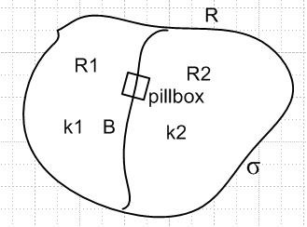

Here "composite medium" is what I have drawn, k1 is thermal conductivity in uniform sub-region R1 and so on. We want to solve for temperature u(x) everywhere. We assume perhaps some u(σ) "matching conditions" : one is that the temperature is the same on both sides, the other is that the total heat flow out of the pillbox is 0, which is what 6.163 says. [ we assume there are no heat sources in R ] The problem is then to find u(x) everywhere inside R.
Another interesting way to set this problem up is to assume some k(x,ε) where ε is a parameter and as ε→0, this k(x,ε) gradually approaches the interface situation shown. We could then solve entire R without regard to the interface B, and then take the limit of that solution as ε → 0. Of course solving for a general position-dependent k(x) probably requires more work, but it does seem a very reasonable method, and Stak seems to like it. Instead of Laplace, we have to solve 6.166 which I recall from his appendix on heat stuff.

Example: a one dimensional rod from along x = (-1,1). Here σ is the two end points and we set u = 0 at the left end and u = 1 at the right end. This of course sets up some steady heat flow through the rod which has some k(x). The entire problem is stated in p 184 A. He integrates the ODE once to get B, I agree. He then makes up a function k(x,ε) which is smooth and which approaches a limit which makes our interface B be right at x = 0. So we have our general solution, and we now take the limit and somehow we get 6.167 which I did not do, and we have our solution on the two sides, and in fact he shows that the two matching conditions are in fact met. He then starts all over by the other method, we have Laplace then on both sides, we apply the BC's and get the same result 6.167. OK, I get it.

I think an electrostatic analog to this problem would be R = dielectric with ε1 and ε2 on the two sides. Probably V is continuous across the boundary, and so is D = εE, but not E, etc. The interface would have a kink in V, causing a field difference, and implying a bound charge layer on the interface.
I was just now reminded of my auto discussion driving to Torrey comparing divergence of a charge current to that of a mass current, I need to reconstruct that discussion, I already invested pretty heavily in it. I had completely forgotten about it till just now while in the post-run shower. [ see " divergence J and V.doc" ]

E. Flow of an Ideal Fluid past an Obstacle (185)

Stak has saved his fanciest most complicated example for his grand finale. The reader is supposed to understand that if you place on obstacle in a (very wide) laminar flowing river, you are somehow in the realm where the velocity vector is curl-free and so the velocity vector v can be represented as the gradient of a velocity potential u which satisfies Laplace, since our river contains an incompressible fluid. I got this all done in a separate document called "divergence J and V.doc" with confirmation from my Schaum fluid dynamics book. In this same document I cleared up my Torrey ideas on the analogy between current density and momentum density.
For the next step, one needs to put one's mind in a whole new physical application world. We are no longer doing electrostatics or heat flow. This river with obstacle has a solution u(x) and v(x) = ∇u at all points in the river. u is now the velocity potential, not the temperature, not the electrostatic potential. Since Laplace is linear, we can do superposition u = u0 + us just as we do in heat or electrostatics. For some reason, he refers to the no-obstacle solution as ui instead of u0 . He used u0 in the related problem of a grounded conductor sitting in an initial "flow" of electrostatic potential u0. But us is the "secondary solution", same name as before. If the river flows in the x direction (he does this since he is going to do a 2D example soon), and we know that vi = , we know that ui = x, pretty simple.
Now he states "formulations of the problem", one for u and one for us. A key idea is that at the surface of a boundary, v must be tangential only. Why? Why can't you have a little piece of fluid at a boundary with v pointing right at the boundary? If that were the case, that piece of fluid would flow right through the boundary at that point. That is what the velocity vector means. So we have ∂nu = 0 on all boundaries (that are not sources or sinks). So boom, we have Neumann boundary conditions! Hurray.
In passing, one is tempted to "explore" the parallels between this ideal fluid flow and electrostatics. So far we have electrostatic potential ↔ velocity potential, and electric field ↔ velocity field. Just as a point charge acts as a source of out-radiating E field, I presume a point source of fluid would generate an out flowing velocity field. So positive and negative charges ↔ sources and sinks of fluid. A surface charge distribution would be a source-sink distribution. I can see that I am getting interested already in this subject, my thanks to Stak, and I have paged through my fluid book with some amazement. I am sure that the historical math/physics heavies attacked fluid dynamics with great vigor, but "I know nussing" of this history!
So (6.169) is our PDE formulation for total velocity potential u, the external problem. You see the Neumann condition on σ, and the asymptotic condition that u = ui up and downstream.
And (6.170) is the formulation in terms of us. This is very similar to our metal object in E field example earlier. On σ, since ∂nu = 0 ( no perp velocity), we know ∂nus = - ∂nui. And of course the ∞ condition is as shown, us= 0. Stak points out that this us formulation defines a "standard Neumann problem" since us(∞) = 0. This is the formulation we are going to try to solve. By the way, since v = 0 inside σ (see below), u = constant A there, so us = A - ui inside the obstacle. I suspect A = 0 is OK.

Digression p 186 A. Our formulation states that u(∞) = 0, but he shows that we in fact know a little more about large "r" behavior. He claims that in fact us(r) → 1/r2 at large r. I shall review his claim in a moment. Recall that a monopole has u = 1/r and a dipole 1/r2. He comments that you can think of the obstacle as some kind of set of dipoles which, in the aggregate, behave far away as a single dipole, according to our claim. A dipole in flow means a source and a sink. I might imagine this as a surface distribution on σ of source/sink "charge" which adds up to zero charge, meaning total of zero flow creation or loss. Obviously our solid object within σ is not creating or destroying water. Notice that in terms of us, there CAN be flow inside the solid object. [ it is in fact us = A - ui inside Ri]
Now let's see where his 1/r2 claim comes from. In 3D, we know we can write u as the spherical expansion shown p 186 B. There are no rn positive powers due to our us = 0 BC. Now hold on this expansion and consider p 186 C. Here is the picture he has not drawn, thank goodness for fast Visio,

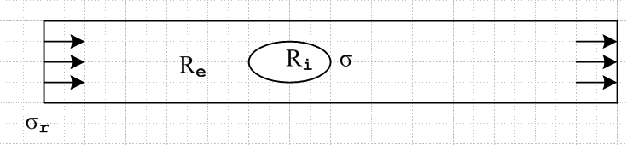

We know there is no flux through the river sides, so σr just means the two ends. I guess he really is talking about an infinitely wide river, so again it is the two distant edges that are σr.
Now, within region Re (excluding its boundaries) we know we are Laplace with no sources. The only "surface charge" is going to be on σr and σ for potential us. Since ∇2us = 0 in Re, the divergence theorem tells us that ∫dS ∂nus = 0 so that in fact ∫σ dS ∂nus + ∫σr dS ∂nus = 0. So I interpret the left equality in p 186 C as just this statement. The sign discrepancy is because he no doubt is thinking of as being outward directed on both σ and σr, which then changes the sign of the first term QED. Meanwhile, if we apply the same divergence theorem to Ri , since ∇2us = 0 in Ri we conclude ∫σ dS ∂nus = 0 since for this region σ is the entire boundary. Therefore all three integrals in C are zero. He argues this a slightly different way, fine. [ in each region, net flow in equals net flow out, so integral = 0. ]
Now back to the Ynm expansion for us. We compute that ∂rus = Σnmamn(-n-1)r-n-2 Ynm(θ,φ). If we integrate this over a great sphere, we get zero from the angle part except for nm=00, so we can say

0 = ∫σr dS ∂nus = ∫σr 4πr2 ∂nus a00 r-2 * constant => a00= 0

Therefore the leading term in the expansion for u2 must be the n=1 term which goes as r-2 QED.

Inside σ, which we call Ri, what do we know about u and v? We know ∂nu = 0 on the entire boundary. In my "note added" p 59 of raw 1 notes, I show that this means u = constant everywhere inside σ, so we can think of the vector v = 0 in Ri.

Aside: I just checked into Morse and Feshbach. Son of latter sells both volumes for $330 just to make it available he says. I think I just downloaded volume II from here

http://www.eknigu.org/info/M_Mathematics/MP_Mathematical%20physics/MPt_Textbooks/Morse%20P.M.,%20Feshbach%20H.%20Methods%20of%20theoretical%20physics,%20vol.2%20(MGH,%201953)(T)(997s)_MPt_.djvu

It came in OK, and so did Volume I, each about 1000 pages. While there I will try to grab Courant and Hilbert. Done. I will just sit there and grab what I can before it stops working, I think there is some session limit at this site. I check each one after it comes in. There is a 4-volume set by Reed and Simon that I never heard of, Amazon has for $124 per volume.

We now pick up the logic flow at point E on page 186. Equation E is in fact one we have seen several times before. It first appears in his "integral equation formulation" section starting page 123. Just using the fact that ue satisfies Laplace and E satisfies Green, we get 6.64 for ue and 6.63 for ui. These express the solution function u as a surface integral of [ E∂nu - u ∂nE]. The general form is Green's #2 as you can see on my integral theorems page. So, equation E here is in fact 6.64 but we break the surface integral into its two parts just as commented on above. This same thing happened with two Green's functions on p 132 (not quite the same thing). The next appearance was far in the future, p 173 C for the open surface, where it appears with 3 terms. Here, the σr integral was 0 and I think this always happens in 3D since E 1/r. Then on p 175 we had the same form in 6.145, but since in 2D, the great circle integral was not 0 but constant c0. And now finally back to p 186 E and we expect, since we are in 3D again, the first σr integral to vanish. The sign convention for n between the two terms matters not since first integral = 0.
Meanwhile, if we apply Green #2 to Ri using ui,we know ∇2E = δ(x-ξ) and ∇2ui = 0, so if ξ lies outside our integration volume Ri, then LHS Green #2 = 0 and this means 6.172 is true. So at this point we have

us(ξ) = ∫σ [us∂nE - E∂nus ] dS // second term in p 186 E ξ in Re

0 = ∫σ [ui∂nE - E∂nui ] dS // our Green #2 result just noted

Since u = ui + us we can add the above equations to get

us(ξ) = ∫σ [u∂nE - E∂nu ] dS

but of course ∂nu = 0 on σ so only the first term survives, so we have

us(ξ) = ∫σ [u∂nE ] dS which is p 186 F

which he rewrites in the usual way to get 6.173. Stak is pretty dense sometimes. So finally we are at the top of page 187. The obvious next step is to let x → s on the surface σ. I recall notes from the Chap 6 meta doc,

u(x) = ∫σ dSξ a(ξ) E(x|ξ) E(x|ξ) = 1/4π|x-ξ|
v(x) = ∫σ dSξ b(ξ) k(x,ξ) = ∫σ dSξ b(ξ) ∂nξE(x|ξ)

where k(x,ξ) = cos(x-ξ,n)/[4π|x-ξ|2] = ∂nξE(x|ξ)

limx→s ∂νu = ∓a(s)/2 + ∫σ dSξ a(ξ) k(ξ,s) // 6.43 becomes 6.47 ν = normal
limx→s v = ± b(s)/2 + ∫σ dSξ b(ξ) k(s,ξ) // 6.44 becomes 6.46

and you see that 6.173 has exactly the form of v(x) above, and from limx→s v we conclude 6.174! From this 6.175 follows at once just as stated. This is a second kind Fredholm integral equation for function u on σ driven by inhomo term ui(s) which we know from the initial flow (no obstacle). The idea is then to solve this thing for u(ξ) and then stuff that result back into 6.173 to get us(x) at all points x in Re. Then we add that to ui(x) and we have our problem solution u(x).

At this point, things get a bit disorganized, we are at the line on page 187. He wants to differentiate 6.173 as in p 187 A because then as x→s, we get our known quantity ∂νui on the LHS, where ν is the normal at s, so really ∂νsui(s) on the LHS, which is just the normal derivative of σ at that point. This gives 6.176, but unclear what you can do with the RHS, so he just leaves it for now.
Then suddenly he starts talking about the thin open shell situation, as per picture page 173. I agree that now 6.173 can be written as 6.177+6.178. Then we take our usual x→s limit and we get p 187 B and C, page bottom (approaching from our two sides). Subtract and get nothing new. Add and get 6.179. If we can learn I, then this can help us get the value of each side separately, I agree.
Now as we did before talking about thin shells, we apply ∂ν to 6.177 (the thin shell version of 6.173). This gives 6.180 which is the thin shell analog of 6.176 and has the same "problem" that it is not really a linear integral equation, but it may still be useful.

Comment: This has ALL been a 3D discussion, see text near p 186 E. He claims in his first remark here that in the 2D world if you have a circular obstruction, the equations above the "thin shell" line on p 187 are still valid, but I would have to check that. The main question would be the vanishing of great circle things which we have seen might not vanish in 2D. His second remark is that everything goes through for any ui we like, not just parallel flow.

Example: River blocked by partial cylinder as shown picture p 189. This is the thin shell situation, it has symmetry. Little r,φ coord system set up at obvious point. I agree that ui = x = rcosφ so ∂rui= cosφ and thus ∂rus|C = - cosφ since ∂ru|C =0 . So we have a problem formulation as p 188 B.

[ p 189] He now puts an imaginary circle at r = 1 and writes a general solution for us inside and outside ( B and A), two regions of interest, coefficients an and bn. No ln(r) in either since need us = finite at r=0 and us=0 r=∞ . Inside can have a constant term, called a0. We are going to need some matching conditions on the circle. On either side we know that ∂nus = - ∂nui = - cosφ so C is OK, saying ∂nus is the same in both regions on the entire circle. Using C with A and B forms we get D which says an= -bn so half the coefficients are gone. Equations E,F are then our inside and outside solutions showing an, and notice the "usual" minus sign on the external solution as in 6.11. You get G by doing ∂r on either E or F at the circle, same result. We then add G to equation ∂rui= cosφ to get H.

[p 190] His goal is to construct an integral equation for something in this problem! That "something" is going to be I(φ) as defined page 190 and given (I agree) as in 6.183. Why? First of all, there is no jump in ui so that is where p 109 A comes from. the us difference then comes trivially from E and F -- both contribute equally to the Σn shown, and the -a0 is present only in E. This "jump" I is the same as 6.178. So think of 6.183 as a little Fourier Series deal with only cos terms appearing since I is even in φ, and we are as usual at Schaum p 131 with L = π. The only odd thing is minus sign for the a coefficients, fine, and we read off p 190 B from Schaum.
Now back to p 189 H. One the actual arc, |φ| ≤ α, we know that ∂nu = 0 (our basic Neumann BC). So solve for cosφ in H and replace the an with our Fourier expressions p 190 B and we get 6.184 -- notice that the n=0 term in the sum is not involved here. Now rewrite [n cos(nφ)] as - ∂φ2[ cos(nφ)/n] to get p 190C. Here you CAN interchange integration and summation order go get (6.187) with m as in 6.188. In Exercise 6.47, we will show that m can be summed as shown. The main point is that the sum m converges. If we don't do this little ∂φ2 "artifice", the series k in 6.186 does NOT converge, so that path is no good.
So we end up with 6.187 as our first integral equation, but it not a pleasant looking animal because we have ∂φ2 sitting there. He calls this an "integrodifferential equation", something I have never heard of before! He is not here attempting to solve this thing, he is just trying to "get" an integral equation.
Now he will go for a second integral equation, an alternative to 6.187. He proposes that we treat the LHS of p 189 H as our unknown function J(φ). If we can get J(φ), we could do Fourier on H to get the an and we have our solution. Our interval is -π to π, but things are even so we fold to get factor of 2. Also, we know J = 0 in (-α,α) since this is the obstruction were v = 0. So get 2$^{\int_{α}^{π}{}}$ and coefficients (nan), except for n=1 we have the extra terms shown in H. So p 191 B shows the coefficients if we do this Fourier Series analysis. I agree that C comes from 6.183 when you go out beyond the wall φ=α. If we simply insert the Fourier an projections into C, we get D. But we already know from 6.188 how to do this sum, and we then get 6.189. This is a standard first kind Fred! No ∂φ2 here.

Comments:

(1) For a solid obstacle (closed surface), we obtained 6.175 as a second kind inhomo Fred. I always like to imagine that if we treat a thin shell as a solid object, we can still use this integral equation. When Stak does his "thin shell" stuff on page 187-188, he is just not able to come up with a real integral equation. However, in our specific arc example of a "thin shell" in 2D, he does produce one integrodifferential equation 6.187 and one standard Fred 1 equation 6.189.

(2) He has NOT attempted to solve either of these equations, so the reader is left hanging, wondering what on earth the flow might look like for this picture! This problem does NOT appear in Chap 6 of my Fluid book. I guess the potential that solves this problem also solves the problem of such a metal arc in a 2D electric field, such as you might get for the plate of a vacuum tube, say. I wonder if there is a catalog of solutions to such problems. I don't have a good search handle for this specific problem. Wiki shows the solution for a full cylinder. I see there are various non-free software simulators on the web for computing flow, such as http://www.raczynski.com/pn/fluids.htm, here is one of his pictures, two obstacles no less.

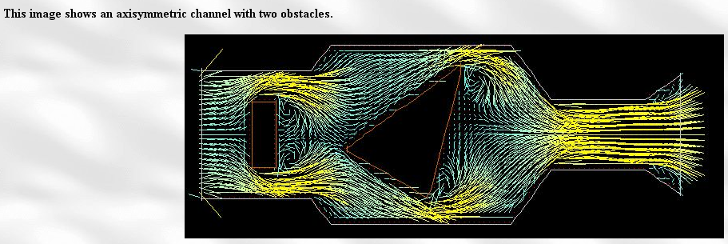

My numerical analysis book (which I have actually read) does talk about solving the Laplace equation with certain boundary conditions, and of course many other topics. This would be a great side trip, but now is not the time. I imagine there are many excellent fluid flow books, and electrostatics books as well. Of course the fluid situation is going to also involve non-potential-theory situations. By the way, this same guy has thought about my window convection problem,

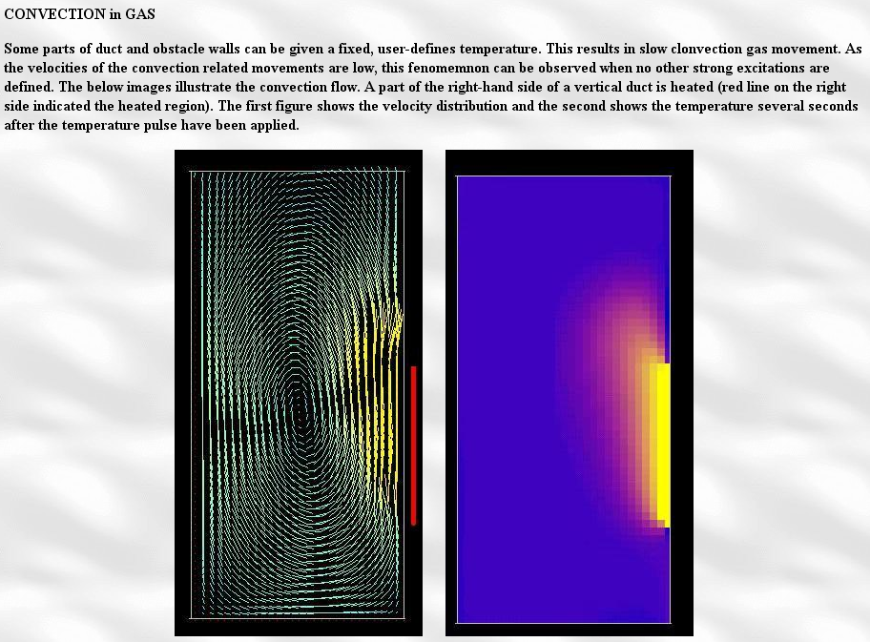

(3) Why is Stak always looking for integral equations? The original PDE system involves all R, and involves all the BC's on σ (and perhaps at ∞). You try standard forms appropriate for the geometry and try to solve Laplace with those BC's. The integral equation involves only an integration over σ. Somehow the BC's are all "built in" to this integral equation, so maybe it is a simpler thing in some sense. Stak does not give any dialog on this meta subject.
Suppose I tried to solve this last partial cylinder 2D flow problem using the "form fit" method, and forget integral equations. We would write page 189 A and B, claim ∂rus is continuous through the circle at all φ, and then we have E and F and all we need do is find the an. So why not just compute ∂rus from either of our "forms", and set that equal to -∂rui on the arc. So that would give this:

f(φ) ≡ -∂rui(1,φ) = Σn=1∞n ancos(nφ) valid ONLY on |φ| ≤ α

We don't know anything out of this range, because we don't have ∂ru = 0 out of this range. Then how are we going to invert this above equation for the an ? We could try this:

$^{\int_{0}^{α}{}}$dφ cos(mφ) f(φ) = Σn=1∞n an$^{\int_{0}^{α}{}}$dφ cos(nφ) cos(mφ)

This stinks. What we really need is a set of functions complete on the limited interval. So
consider the set cos(πnφ/α) so that φ = α means we have cos(πn) as if we went half way around the circle. Then we can start over above and say

$^{\int_{0}^{α}{}}$dφ cos(πmφ/α) f(φ) = Σn=1∞n an$^{\int_{0}^{α}{}}$dφ cos(nφ) cos(πmφ/α)

Then we change variables to ψ = πφ/α and LHS becomes

(α/π) $^{\int_{0}^{π}{}}$dψ cos(mπψ) f(ψπ/α) = (α/π) $^{\int_{0}^{π}{}}$dψ cos(mπψ) F(ψ) = (α/π) Fm

which is then a standard projection (ignoring constant). But the integral in the RHS is some kind of mess, it is not orthogonal, and we have Fm = Σn=1∞ n an (mess)nm and we cannot easily find an. In other words, we don't diagonalize!
So maybe we start over with a "form fit" more like us = Σn an rnπ/α cos(nφπ/α). We know this satisfies Laplace from earlier work and because we can write it as znπ/α + c.c. = Re(2 znπ/α) which is the real part of an analytic function (off the neg z axis). So I think this would solve the problem. Then we do our Fourier analysis just on the arc. Condition C is still true.
So I have to conclude that the thing can be solved this way and we don't need the integral equations. Stak has not been forthcoming about WHY these integral equation approaches are useful. We replace the PDE problem with an integral equation problem of one less dimension which "builds in" the BC's so we don't have to hand fit them, in principle.

Exercises (191)

have a nice day

Exercise 6.47.

This is a five part exercise that I did in a separate document. We know the equation 6.190 will diagonalize on the SO(2) one-dimensional representations and that is what -- in effect -- Stak does here. Here are some of the intermediate results:

F(β) = f(cosβ) | sinβ | = f(cosβ) $\sqrt{1-cos2β}$ (-π,π)
G(β) = g(cosβ) (-π,π)

Now do a "cosine series" expansion on both these functions, to wit [ Schaum p 131 2L = 2π ]

F(β) = Σm=1 fm cos(mβ) + f0/2 fm = (1/π)$^{\int_{-π}^{π}{}}$F(β) cos(mβ) dβ = (2/π)$^{\int_{0}^{π}{}}$F(β) cos(mβ) dβ
G(β) = Σm=1 gm cos(mβ) + g0/2 gm = (1/π)$^{\int_{-π}^{π}{}}$G(β) cos(mβ) dβ = (2/π)$^{\int_{0}^{π}{}}$G(β) cos(mβ) dβ

When this is put into the integral equation 6.190, it diagonalizes and we find this solution :

f0 = - (1/πln2) g0 m = 0
fm = -(m/π)gm m ≠ 0

and when these are put into the expansion, we get solution 6.192. Then 6.195 is a special case which finds use earlier in this chapter on the problem of finding the charge distribution on a 2D wire.

Exercise 6.48. Find the potential of a charged conducting wedge.

I interpreted "wedge" to mean a 2D "circular sector", like a 2D piece of pie with unit radius. This turns out to be another bunbuster problem and I went off into a separate document and tried to solve it using the integral equation method (Section B) and the conformal map method (Section C). I was able to find a solution path that was straightforward though messy, requiring the doing of 6 integrals, in Section B but did not finish it. The conformal map method was no good because I could not find the right map. If you reinterpret this problem as referring to an infinite 2D wedge, then I think the conformal map method would be successful. If nothing else, I have a newfound respect for the "integral equation method", since there is no other method I know of to solve this thing!

I skipped 6.49 accidentally *********

Exercise 6.50. Conductor in external field: is preloaded with charge Q

Take a conductor with charge Q on it and place it in an external potential u0. We are supposed to come up with an integral equation for the surface charge density on the conductor in this situation. A reasonable problem.
First, take the uncharged metal object and place it in the external field. The initial charge on the object was 0, but it gets some total induced charge Qin upon placement in the field. For example, if the external field is a unit positive point charge, negative charge will flow in on the grounding wire so that Qin = -1.
We then disconnect the grounding wire so the metal object "floats". It of course stays at u = 0. But then we start manually adding positive charge Q to the metal object. It is still a capacitor with some distant sphere where we get the charge, so I think the only possible thing that can happen is that u increases from u = 0 to some positive value A on the metal object. I think the added charge Q will distribute itself just as in the no-external-field-problem, if you think of Q as distinct from the induced charge due to the external field. Of course now the integral of total Σ on the surface must be Q + Qin, whereas in the previous problem it was Qin . These arguments could be substantiated from the linearity of L and hence from superposition of problems.
So my approach is to solve the two problems separately. The first problem is metal object in field just as we did in the text, and we require u(s) = 0 since grounded. Here I call the charge involved Σin (induced)

0 - u0(s) = ∫dξ E(s|ξ) Σin(ξ)
Qin = ∫dξ Σin(ξ)
us(x) = ∫dξ E(x|ξ) Σin(ξ)

Here you solve the first equation for Σin(ξ) [ the scale of Σin(ξ) is determined since LHS ≠ 0 ] . That is to say, if we doubled u0(s), we would have to double Σin(ξ). Then we use the 2nd equation to determine Qin, something we never did in the text discussion. The last equation gives us(x) everywhere.
The second problem is charge on a metal object, also as in text. We have for this problem,

A = ∫σ E(s|ξ)ΣQ(ξ)dSξ 1 = ∫σ E(s|ξ)ΣQ1(ξ)dSξ
Q = ∫dξ ΣQ(ξ) = AQ1 Q1 = ∫dξ ΣQ1(ξ)
uQ(x) = ∫dξ E(x|ξ) ΣQξ)

We solve the first equation for ΣQ(ξ; A) which is just A ΣQ(ξ; 1) where ΣQ(ξ; 1) is the solution found in the text problem. We then scale A so total charge is Q. The text problem equations are on the right. The last equation then gives uQ(x) everywhere.
Now let's see if we can combine these two sets of equations. I don't think there is any good reason to do this, but let's do it anyway. Define Σ = Σin + ΣQ and we have

A - u0(s) = ∫dξ E(s|ξ) Σ(ξ)
Qin + Q = ∫dξ Σ(ξ) = AQ1 + Q
uQ(x) + us(x) = ∫dξ E(x|ξ) Σξ)

u(x) = uQ(x) + us(x) + u0(x)

The problem is that you still have to know Q1 (or Qin) and you can only get that by solving the isolated problem one problem. If you don't know Q1 (or Qin), you cannot determine the final scaling of Σ(ξ), but you can still determine its "shape".
You might somehow determine Qin directly from u0(x), as is obvious if u0 is from a point charge. We know that

u0(x) = ∫dt Σ0(t) E(x|t)

where the integral is over all space where we have charges creating the external field. If we could solve this integral equation for Σ0(t), then we would know that Qin = – ∫dt Σ0(t).
So I would do this problem by the "superposition method" as outlined above.

Exercise 6.51. Half sphere in uniform external field.

Put a grounded half spherical metal shell into a uniform E field. The field is "normal to the shell". I guess that means the field is along the symmetry axis. He wants to see an integral equation for Σ on this thing using a Legendre expansion. Also sounds reasonable.
P

Exercise 6.52. Thermal interface of two half spaces with a point source in one.

Imagine a 3D thermal conduction situation where the interface between k1 and k2 constant areas is the plane z = 0. Each region fills an entire half space. Put a point "source" (of heat") at (0,0,ξ) and solve for the potential u (temperature). Use method of images, hints are given! Extra questions are given. Yet another reasonable problem, sounds not too hard.

Exercise 6.53. Thermal interface of sphere embedded in a medium with point source.

This time embed a k1 sphere of radius a into an infinite medium of conductivity k2. Put a point source inside the sphere distance r0 from the center. Solve for u using Legendres.

