Questions concerning the Laplace Transform PhL 4.11.11

Why can Maple do the Laplace transform of erf(ax), but cannot do its ILT? 1
A crude proof of the Laplace Transform 2
The Left Side Great Half Circle Method 4
The Left Side Residual Vertical Integral Method 5
Conclusions regarding the Inverse Laplace Transform: 7

These are very good notes, I reviewed them on 10.3.14. I now quote the main result from below:

Conclusions regarding the Inverse Laplace Transform:

(1) the contour must go up to the right of all singularities of f(s).

(2) the Inverse Laplace Transform is only "valid" if |f(s)| decays faster than 1/|s|a with a > 0. This explains the general appearance of entries in the f(s) column in a table of Laplace Transforms. (p 164)

(3) If f(s) does not meet this requirement, it is possible that the ILT integral converges to some reasonable function F1(x)

(1/2πi) ∫C ds exs f(s) = F1(x)

but in this case f(s) and F1(x) do not form a Laplace Transform pair! That is to say, in this case you will very likely find that

f(s) ≠ $^{\int_{0}^{∞}{}}$dx e-xs F1(x)

and I show explicit examples below.
Here is a very simple example. Consider f1(s) = f(s) + 2 where f(s) is the valid Laplace transform of some F(x). The ILT of f1(s) is the same as the ILT of f(s) because the constant term 2 creates ∫C ds exs [2] which can be closed to the left to give 0. Since f1(s) does not meet the decay requirement stated above, we conclude that F(x) and f1(s) do not form a valid Laplace Transform pair, though F(x) and f(s) do.

Why can Maple do the Laplace transform of erf(ax), but cannot do its ILT?

Consider this Maple code,

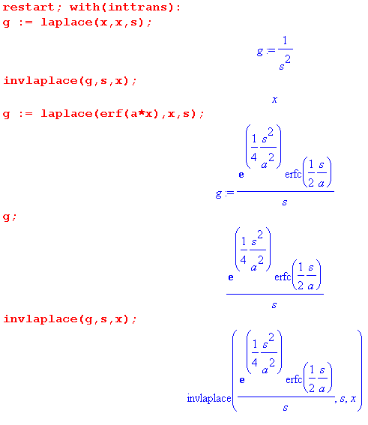

Maple is unable or unwilling to compute the ILT!

What about Wolfram alpha? It CAN do it and here it is:

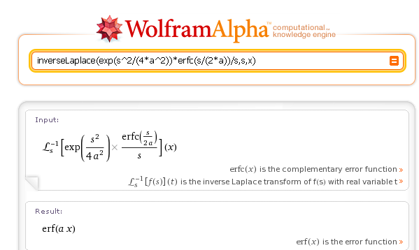

Now consider a different function f(s) = (1/s) ets$^{2}$ :

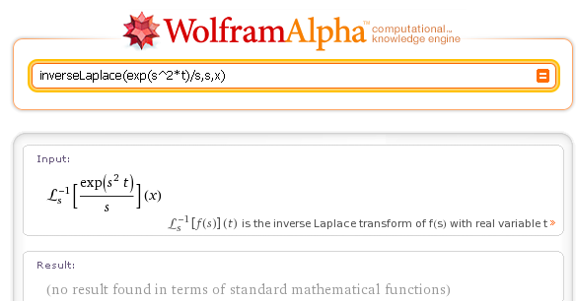

and Maple cannot do it either. I am again suspicious that I am "missing something important". [ yes indeed, see below, this f(s) does not meet a certain condition given below! ]

What sources do I have on the subject of LT's? [ see downloaded PDF] Why does this simple example not appear in tables? [ there is an excellent reason, see below]

A crude proof of the Laplace Transform

How do you prove the Laplace Transform?

f(s) = $^{\int_{0}^{∞}{}}$dx e-xs F(x)
F(x) = (1/2πi) ∫ds exs f(s) .

Try putting the first into the second,

F(x) = (1/2πi) ∫ds exs f(s)

= (1/2πi) ∫ds exs $^{\int_{0}^{∞}{}}$dy e-ys F(y)

=$^{\int_{0}^{∞}{}}$dy F(y) { (1/2πi) ∫ds e(x-y)s } .

I suppose at this point the s contour sees no singularities, so we can shift it to the imaginary axis and then we get

=$^{\int_{0}^{∞}{}}$dy F(y) { (1/2πi) i2π δ(x-y)} = F(x) .

So this "proof" does not give any info on why we want the contour to be to the right of the singularities of f(s). Let's try the other direction :

f(s') = $^{\int_{0}^{∞}{}}$dx e-xs' F(x)

= $^{\int_{0}^{∞}{}}$dx e-xs' (1/2πi) ∫ds exs f(s)

= (1/2πi)∫ds f(s) $^{\int_{0}^{∞}{}}$dx ex(s-s') .

NOW, in order for this x integral to converge, we must have Re(s) > Re(s'). So assume that the contour lies to the right of the point s'. We then get

= (1/2πi)∫ds f(s) 1/(s-s') (*)

Now in order to proceed, we have to make another assumption: that f(s) decays on the left! Notice that we have no e±sx in the integrand, it is f(s) all by itself, along with the 1/(s-s') factor. Assuming such decay on f(s) on the left, we close the contour to the left and get

= f(s')

This result is valid for any s' to the left of the contour. But if we assume that our contour started out to the right of all singularities of f(s), nothing stops us from shifting the contour as far as we like to the right. In that case, we obtain f(s') for s' as far as we like to the right in the s' plane.

Below we shall study just how f(s) must decay on the left to make this proof work. You can intuitively see, for example, that if f(s) → constant, the left side great circle integral might be logarithmically divergent based on ∫ds/s = ln(s), so perhaps f(s) → constant is not enough decay. If f(s) does NOT meet the decay requirement (whatever it turns out below to be), then you cannot close the ILT contour on the left side, and then the verification proof shown above fails.

Conclusions regarding the Inverse Laplace Transform:

(1) the contour must go up to the right of all singularities of f(s).

(2) the Inverse Laplace Transform is only valid if f(s) decays enough on the left side so the residual vertical contour in (*) vanishes! Below we shall study what this means regarding f(s).

The Left Side Great Half Circle Method

Let's see what this actually means:

F(x) = (1/2πi) ∫ds exs f(s) .

Suppose we assume that

|f(s)| → ea|s| |s|c .

Then the great circle on the left is this:

∫GC ds exs ea|s| |s|c = ∫GC ds exs eaR Rc = Rc eaR ∫GC ds exs

Now write s = Reiθ and we then have |s| = R

= Rc eaR$^{\int_{π/2}^{3π/2}{}}$idθ (Reiθ) exp(xReiθ) = i eaR Rc R $^{\int_{π/2}^{3π/2}{}}$dθ eiθ exp[R(xeiθ]

= i eaR Rc R $^{\int_{π/2}^{3π/2}{}}$dθ eiθ exp[R(xcosθ] exp[R(xisinθ)]

Now if we shift θ → θ-π, both trig functions change sign and we have

= i eaR Rc R $^{\int_{-π/2}^{π/2}{}}$dθ eiθ exp[-R(xcosθ] exp[-R(xisinθ)]

Now I think we can apply the idea that |a+b| ≤ |a| + |b| where the sum is our integral to say

|GC piece| ≤ | i eaR R Rc $^{\int_{-π/2}^{π/2}{}}$dθ eiθ exp[-R(xcosθ] exp[-R(xisinθ)] |

≤ eaR R Rc $^{\int_{-π/2}^{π/2}{}}$dθ e-xRcosθ

Wolfram says: ( I could have folded the integral but did not)

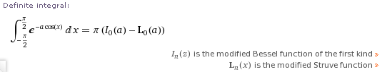

but I will ignore this fact and instead use Stak Appendix B.

So let's examine the large R behavior of our integral using Stak Appendix B.

I(R) = $^{\int_{-π/2}^{π/2}{}}$dθ e-xRcosθ .

I do this as an Example in "Stakgold Vol 2 Appendix B.doc" to find

I(R) ≈ (2/x)R-1

Therefore we get

|GC piece| ≤ eaR R Rc $^{\int_{-π/2}^{π/2}{}}$dθ e-xRcosθ ≈ eaR R Rc (2/x)R-1 = eaR Rc (2/x) .

The immediate implication is that, if we want the CG piece to vanish, we must have

(1) a < 0
(2) a = 0 and c < 0 // either one causes |GC piece| = 0

What happened here? If we assume that f(s) → sc, we find that the left-side-half-great-circle integral
∫ds exs sc becomes (θ=0 is the neg x axis) ~ R1+c $^{\int_{-π/2}^{π/2}{}}$dθ e-xRcosθ ~ 2 R1+c $^{\int_{0}^{π/2}{}}$dθ e-xRcosθ . For large R, this integral is dominated by the π/2 end where cosθ ~ sin(π/2-θ) ≈ (π/2-θ) and then it is ~ $^{\int_{-∞}^{π/2}{}}$dθ e-xR(π/2-θ) = -$^{\int_{-∞}^{0}{}}$dθ' exRθ' = 1/(xR). Thus, ∫ds exs sc ~ 2 R1+c /xR ~ Rc which then goes to 0 if c < 0. If we had only considered the great circle contribution from -π/4 to π/4, say, the answer would come out instead e-(π/2-π/4)xR /(xR) which is ~ e-(π/4)xR which makes no contribution at all compared to the contribution of the top and bottom of the half circle which is ~1/(xR). So the greatest danger comes from the top and bottom of the half circle!

The Left Side Residual Vertical Integral Method

Here I reach the same conclusion as above about the requirement that f(s) must decay on the left. Consider,

F(x) = (1/2πi) ∫ds exs f(s)

and assume that f(s) ~ |s|c for large negative s (ie, Re(s)). Then the contour integral shifted far left is this:

F(x) = (1/2πi) $^{\int_{-A-i∞}^{-A+i∞}{}}$ds exs f(s) . where A >> 0

Now first let r = s+A so we get

F(x) = (1/2πi) $^{\int_{-i∞}^{+i∞}{}}$dr ex(r-A) f(r-A)

= (1/2πi)e-xA $^{\int_{-i∞}^{+i∞}{}}$dr exr f(r-A) .

Now rotate the integral letting u = ir to get

= (1/2πi)e-xA (-i) $^{\int_{-∞}^{+∞}{}}$du e-ixu f(-iu-A) .

Our concern now is that the integral converge. So pick some large but finite A, and then look high in the tails of the du integral where |u| >> A. We then have f(-iu-A) ≈ f(-iu) ~ |u|c . So we are looking at
something like this

= -(1/2π)e-xA $^{\int_{-∞}^{+∞}{}}$du e-ixu |u|c ≈ -(1/2π)e-xA $^{\int_{-∞}^{+∞}{}}$du cos(xu) |u|c

≈ -(1/π)e-xA $^{\int_{0}^{+∞}{}}$du cos(xu) uc .

If c = 0 we maybe get a δ(x) like object I will ignore. Here is a GR7 integral of interest

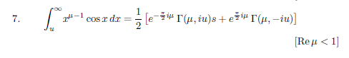
which suggests convergence at the high end in my case if μ < 1, that is to say

c = μ-1 < 1-1 = 0 => c < 0

which agrees with the conclusion of our Great Circle method above!

If the oscillating cos(xu) factor were not present, we would need c < -1, so this oscillating factor in fact "buys you" an extra integer's worth of power convergence.

As an example, here is a convergent integral with c = -1/2:

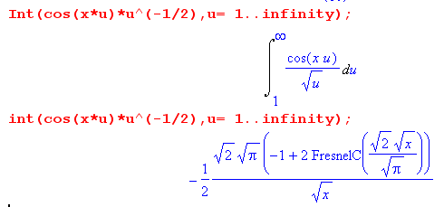

If I set c = -1/4, then μ = c+1 = 3/4 < 1 and our integral should be

(1/2) [ phase Γ(3/4,i) + ...]

This is the incomplete Gamma function and is perfectly well defined, see new A&S. Γ(a,z) is analytic in a and has the same poles as Γ(z) in z.

What happened here? If we assume that f(s) → sc, we find that the left-shifted-by-A residual integral
∫ds exs sc when rotated 90 degrees becomes ~ e-xA $^{\int_{-∞}^{+∞}{}}$du eixu uc ~ 2 e-xA$^{\int_{0}^{+∞}{}}$du cos(xu) uc . As long as c < 0, this integral converges to that function shown above. If the oscillating factor were not there, we would need c < -1 to get convergence. We don't worry about convergence at the u=0 end because we presume that f(s) for small s is reasonable there.

We can now improve our comments on the Laplace Transform from above:

Conclusions regarding the Inverse Laplace Transform:

(1) the contour must go up to the right of all singularities of f(s).

(2) the Inverse Laplace Transform is only "valid" if |f(s)| decays faster than 1/|s|a with a > 0. This explains the general appearance of entries in the f(s) column in a table of Laplace Transforms. (p 164)

(3) If f(s) does not meet this requirement, it is possible that the ILT integral converges to some reasonable function F(x)

(1/2πi) ∫C ds exs f(s) = F(x)

but in this case f(s) and F(x) do not form a Laplace Transform pair! That is to say, in this case you will very likely find that

f(s) ≠ $^{\int_{0}^{∞}{}}$dx e-xs F(x)

(4) As an example of (3) we take f(s) = exp(s2t)/s which for t>0 clearly violates our condition. This is an example shown at the start of this doc. We show in "inverse Laplace Transforms.doc " that the ILT integral converges (for t>0) and gives this result

(1/2πi) ∫C ds exs [exp(s2t)/s] = F(x) = (1/2) [ 1 + erf(x/[2$\sqrt{t}$])] .

But if we go the other way (ie, forward Laplace), we do not recover our f(s). In fact we find that

$^{\int_{0}^{∞}{}}$dx e-xs { (1/2) [ 1 + erf(x/[2$\sqrt{t}$])]} = (1/2s) [ (1 + exp(s2t) erfc(s$\sqrt{t}$) ] ≠ exp(s2t)/s

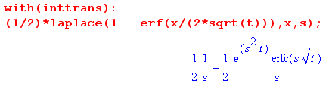

Now we know ( see (6) below) that erfc(s$\sqrt{t}$) ~ exp(-s2t)/[$\sqrt{π}$s$\sqrt{t}$] so we find that for large s

(1/2s) [ (1 + exp(s2t) erfc(s$\sqrt{t}$) ] ≈ (1/2s) { 1 + 1/[$\sqrt{π}$s$\sqrt{t}$] } ≈ A/s + B/s2

and so the LT of our F(x) above DOES meet the f(s) condition.

(5) Claim without proof: If the forward Laplace integral of F(x) converges to some f(s), you will find that the resulting f(s) meets our condition! We can show this in certain cases as follows:

f(s) ≡ $^{\int_{0}^{∞}{}}$dx e-xs F(x) .

For large s (on ray in RH plane) the contribution comes from the lower endpoint and we use Stak App B B.3 with h(x) = x and we get

f(s) ≈ F(0) e-s0 / [ s 1] ~ F(0)/s . // meets condition

But if F(0) = 0 and all derivatives up to order n-1 vanish, we adjust our estimate this way

f(s) ≡ $^{\int_{0}^{∞}{}}$dx e-xs F(x) ≈ $^{\int_{0}^{∞}{}}$dx e-xs { xn F(n)(0) / n!) ≈ F(n)(0) / n! $^{\int_{0}^{∞}{}}$dx e-xs xn

= ( F(n)(0) / n! ) s-n-1 Γ(n+1) // meets condition, n = 0,1,2,3...

where we use:

If F(x) is just a power xn we find that ( we need n > -1 to get low end convergence, n non-integer OK)

f(s) = $^{\int_{0}^{∞}{}}$dx e-xs xn = s-n-1 Γ(n+1) // meets condition n > -1

Even if n = -1+ε, we get -n-1 = 1-ε-1 = -ε and f(s) ~ 1/sε and we meet our condition.

Main point: In the latter two cases, f(s) converges even more than is needed. I think the "claim without proof" is true.

(6) As a second example which DOES meet the condition, consider our example at the start of this doc. We have there

f(s) = exp( [s/(2a)]2) erfc(s/(2a)] / s

A&S 2010 tell us the large s limit of erfc,

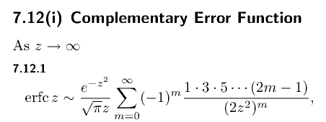

so we end up with this leading term (leading series term is 1)

f(s) ≈ (1/s) exp( [s/(2a)]2) { exp(-[s/(2a)]2) / { $\sqrt{π}$[s/(2a)] }

= (1/s) / { $\sqrt{π}$[s/(2a)] } = (2a/$\sqrt{π}$) 1/s2

and this does meet our requirement and therefore does have a valid ILT.

