Transforms (integral and series) PhL 4.25.10
updated 12.8.15
To be added later: Laplace transforms, Mellin transforms

I guess the time has come to start gathering these things up in one place so I don't have to go foraging each time I want a transform. For each I will write out the expansion/projection pairs, along with completeness/orthogonality pairs, and a reference for derivation. Every Sturm-Liouville problem of course implies such a (1D) transform, so transforms are associated with ODE's and some of their solutions, as a general rule. I include comments on multi-dimensional transforms related to groups.
For me, the word "transform" implies the pair: "projection and expansion". In some cases the expansion is a series, and in other cases it is an integral. The projection is always an integral. I sometimes refer to the expansion as the "recovery" and to the projection as the "inversion".
Common usage, however, uses the words "series" and "transforms" to describe expansions which are sums and integrals, but I am going to stick to my own language, which agrees with Bateman.

ET I, II: Bateman Tables of Integral Transforms Vol I,II (vol 4,5 of full series) 1
Fourier Bessel Series Transform on interval (0,b) Jackson p 73-4 3
Fourier Bessel Integral Transform on (0,∞) = Hankel Transform (aka J transform) 5
The Exponential Fourier Series Transform 6
The Fourier Series Transform for real functions. 6
The Fourier Cosine Series Transform 9
The Fourier Sine Series Transform 11
The Exponential Fourier Integral Transform 12
The Fourier Cosine Integral Transform 13
The Fourier Sine Integral Transform 16
Fourier Series Transforms involving an arbitrary compact Lie Group G 17
Spherical Harmonics Series Transform 17
The Legendre Series Transform and Raw Spherical Harmonic Expansion/Projection 19
Transform Repair Done 12/8/15. 29

ET I, II: Bateman Tables of Integral Transforms Vol I,II (vol 4,5 of full series)

These tables only do the integral transforms, not the series transforms! The conventions used are slightly different from those I use below, but one does not care because one is just trying to look up an integral. I have a doc on this Bateman stuff, but here I just want to show what there is. Volume I contains these tables

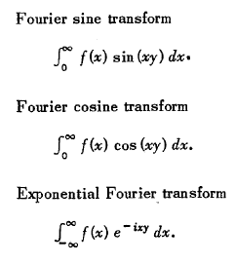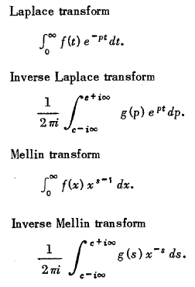

Volume II contains these tables which include Bessel (5 tables) and "other" stuff (5 more tables):

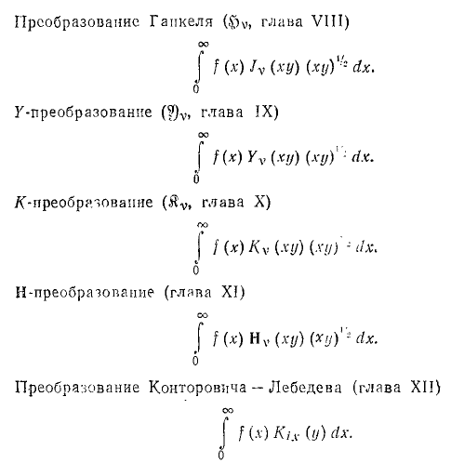
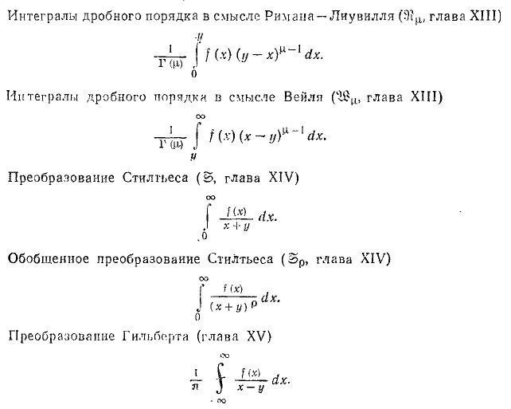

The last thing is called a Hilbert Transform, the previous two are Stieltjes, and the two before that are called Fractional Integrals where an integration endpoint appears also in the integrand. The Kix thing is called Kontorovich-Lebedev and appears on page 317 of Stakgold. Before that are just the Y,K,H transforms (H is a Struve function), and the first J transform is called the Hankel transform and I show this one below. [ The Fractional Integrals are involved in a theory called fractional calculus(wiki) wherein you can talk about ∂nf(x) and intnf(x) where n are non-integers. This is like continuing n! using Γ(n+1). ]

Fourier Bessel Series Transform on interval (0,b) Jackson p 73-4

expansion f(x) = Σk=1∞ Ak,ν Jν(xν,kx/b) (3.96)
projection: Ak,ν = 2/[b2Jν+1(xν,k)2] $^{\int_{0}^{b}{}}$dx x f(x) Jν(xν,kx/b) (3.97)

where xν,n for n = 1,2,3... are the zeros of Jν , meaning that Jν(xν,n) = 0. Parameter ν is called the Bessel function order and is a bystander parameter for this series transform. Sometimes the norm factor appears in other ways due to the fact that Jν+1(xν,k) = – Jν-1(xν,k) = – Jν'(xν,k) .
The ODE is what I call the scaled Bessel Equation which I write in various forms in my curvilinear Jackson cylindricals doc. The eigenvalue problem can be written this way (λ is the official "eigenvalue")

L Jν(ax) = a2s(x) Jν(ax) L = - ∂x(x∂x) + ν2/x
L Jν($\sqrt{λ}$x) = λ s(x) Jν($\sqrt{λ}$x) L = - ∂x(x∂x) + ν2/x

s(x) = x = weight $\sqrt{λ}$ = a = (xν,k/b) λ = a2 = (xν,k/b)2

Notice that the eigenfunctions are not Jν(x) in the sense of Pnm(z) for Legendre. The argument is scaled, so the eigenfunctions are in fact Jν(akx) so the quantization label k appears as part of the argument.
Sometimes the weight function x is inserted in different ways. For example, you could define
g(x) = x f(x) and write the transform for g, or you could write h(x) = $\sqrt{x}$f(x), which puts then a $\sqrt{x}$ in each side of the transform. Obviously the constant factor could be distributed some other way as well.
If we insert the projection above into the expansion, we get this completeness result:

δ(x-x')/x = Σk=1∞ [b Jν+1(xν,k)/$\sqrt{2}$]-2 Jν(xν,kx/b) Jν(xν,kx'/b) = Σk=1∞ φν,k(x) φν,k(x')

where we define these normalized eigenfunctions

φν,k(x) = $\sqrt{2}$Jν(xν,kx/b)/ [b Jν+1(xν,k)] // see Stak p 307 J, sign is arbitrary, b=1

This completeness result fits into "the general form of things" given by Stakgold,

- (1/2πi) dλ g(x|ξ; λ) = δ(x-ξ)/s(x) = Σn φn(x) n(ξ) + ∫dκ φκ(x) κ(ξ) // (4.95) Stak

where in our current example the eigenfunctions are real, s(x) = x, and there is only a discrete spectrum. Notice that s(x) appears explicitly here with the δ(x-ξ). You could instead associated $\sqrt{s(x)}$ with each φk and redefine them so that completeness makes just the delta function.
Now we can insert the expansion into the projection to get orthogonality

$^{\int_{0}^{b}{}}$dx x Jν(xν,kx/b) Jν(xν,k'x/b) = [b Jν+1(xν,k)/$\sqrt{2}$]2 δk,k'

which can also be written as $^{\int_{0}^{b}{}}$dx x φν,k(x) φν,k'(x) = δk,k' . So here then is our final summary:

f(x) = Σk=1∞ Ak,ν Jν(xν,kx/b) // expansion
Ak,ν = 2/[b2Jν+1(xν,k)2] $^{\int_{0}^{b}{}}$dx x f(x) Jν(xν,kx/b) // projection
[b Jν+1(xν,k)/$\sqrt{2}$]-2$^{\int_{0}^{b}{}}$dx x Jν(xν,kx/b) Jν(xν,k'x/b) = δk,k' // orthogonality
Σk=1∞ [b Jν+1(xν,k)/$\sqrt{2}$]-2 Jν(xν,kx/b) Jν(xν,kx'/b) = δ(x-x')/x // completeness

Since Jν(xν,kx/b) = 0 at x = b, this expansion is useful for f(x) such that f(b) = 0. A typical application is the potential inside a metal cylinder of radius b. Usually x is written as ρ, and perhaps kn = xν,n/b. In this language, we could rewrite the above this way (change sum index from k to n, since have another k)

f(ρ) = Σn=1∞ An,ν Jν(knρ) // expansion
An,ν = 2/[b2Jν+1(bkn)2] $^{\int_{0}^{b}{}}$dρ ρ f(ρ) Jν(knρ) // projection
[b Jν+1(bkn)/$\sqrt{2}$]-2$^{\int_{0}^{b}{}}$dρ ρ Jν(knρ) Jν(kn'ρ) = δn,n' // orthogonality
Σn=1∞ [b Jν+1(bkn)/$\sqrt{2}$]-2 Jν(knρ) Jν(knρ') = δ(ρ-ρ')/ρ // completeness

Fourier Bessel Integral Transform on (0,∞) = Hankel Transform (aka J transform)

This is what you get in the limit that b→∞ in the Fourier Bessel Series transform above, but I will just quote results from elsewhere (again, see my Jackson cylindricals doc)

Here is the Stakgold version of the Hankel Transform from pages Stak 315-316

Fν(μ) = $^{\int_{0}^{∞}{}}$dx xJν(μx)f(x) f(x) = $^{\int_{0}^{∞}{}}$dμ μJν(μx) Fν(μ)

where ν is a fixed value, but Re(ν) > -1/2 is required (see ET II page 12). The above transform is equivalent to this Stakgold completeness relation which you see on Stak page 316.

δ(x-x')/x = $^{\int_{0}^{∞}{}}$dμ μJν(μx') Jν(μx)

But as I show in my Chap 4 end notes, if you do things the other way, you get this continuous orthogonality relation:

δ(μ-μ')/μ = $^{\int_{0}^{∞}{}}$dx xJν(μx) Jν(μ'x) // derived this myself

Notice that we still have s(x) = x. The projection is now on (0,∞) and the normalization factor has gone away and the eigenfunctions Jν([xν,k/b]x) have become Jν(μx) where μ is a continuous eigenvalue. In terms of our "general facts" noted above, we have

δ(x-ξ)/x = ∫dμ φμ(x) μ(ξ) φμ(x) = $\sqrt{μ}$ Jν(μx) δ(μ-μ') = $^{\int_{0}^{∞}{}}$dx x φμ(x) μ(x)

The Jν(x) ~ 1/$\sqrt{x}$ so vanishes for large argument, so one could imagine that the Hankel expansion is good for functions that vanish at ∞. Here then is our summary, written in terms of the usual variables which appear in cylindrical coordinates

f(ρ) = $^{\int_{0}^{∞}{}}$dk k Jν(kρ) Fν(k) // expansion
Fν(k) = $^{\int_{0}^{∞}{}}$dρ ρ Jν(kρ) f(ρ) // projection
$^{\int_{0}^{∞}{}}$dρ ρ Jν(kρ) Jν(k'ρ) = δ(k-k')/k // orthogonality
$^{\int_{0}^{∞}{}}$dk k Jν(kρ) Jν(kρ') = δ(ρ-ρ')/ρ // completeness

Note that the two directions of this transform are symmetric, a nice choice to make for allocating factors. This is probably why Stak does his F-B Series transform in that way, which I did not do above.

Comment: I don't know the group theory interpretation of this transform. I don't know the group for which the Bessel functions are the representation functions, but could probably find it somewhere.

The Exponential Fourier Series Transform

I discuss this in "diagonalization of convolution equations" in math/group theory. Here are the results, and note that f(θ) in general can be a complex function, [ expansion should maybe have e+inθ ]

f(θ) = Σn fn e-inθ // expansion all on (-π,π)
fn = (1/2π) $^{\int_{-π}^{π}{}}$dθ f(θ) e+inθ // projection
(1/2π) $^{\int_{-π}^{π}{}}$ dθ einθ e-in'θ = δnn' // orthogonality
(1/2π) Σn e-inθ' einθ = δ(θ-θ') // completeness

The expansion shows that f(θ+2π) = Σn fn e-in(θ+2π) = Σn fn e-inθ = f(θ), so the expansion can only be applied to functions f(θ) which are periodic with period 2π. The normalized eigenfunctions are obviously φn = e-inθ /$\sqrt{2π}$. The sum Σn includes all positive and negative integers and 0. Notice that, even when f(θ) is real, fn is complex unless f(θ) happens to be even, and for that reason this thing is called the "complex" Fourier Series. The functions e-inθ for all integer n are the UIR representation functions of the group SO(2), where n labels the representation. It is for that reason I have n as a superscript on fn .
This transform is also true if you negate the signs of all the exponents.
In my same diagonalization document, I point out that the complex Fourier Series will diagonalize a convolution integral equation of this form

A(θ) = $^{\int_{-π}^{π}{}}$dθ1/2π B(θ1) C(θ-θ1) // convolution equation

An = Bn Cn // after diagonalization

where projections are as shown above for fn . Thus it is easy to solve the above integral equation for B(θ) if you are given A(θ) and C(θ). The integral equation is still true if you swap B↔C.

The Fourier Series Transform for real functions.

We can rewrite the above Exponential transform this way, changing nothing

f(θ) = Σn fn [ cos(nθ) - isin(nθ)] // expansion all on (-π,π)
fn = (1/2π) $^{\int_{-π}^{π}{}}$dθ f(θ) [ cos(nθ) + isin(nθ)] // projection

If we write fn = [ Re(fn) + i Im(fn)] we get

f(θ) = Σn [ Re(fn) + i Im(fn)] [ cos(nθ) - isin(nθ)] // expansion all on (-π,π)
[ Re(fn) + i Im(fn)] = (1/2π) $^{\int_{-π}^{π}{}}$dθ f(θ) [ cos(nθ) + isin(nθ)] // projection

If we now assume that f(θ) is real (the fn will still be complex), we learn all these things from the above two lines, just by equating real and imaginary parts in both equations,

f(θ) = Σn [ Re(fn) cos(nθ) + Im(fn) sin(nθ)]
0 = Σn [ Im(fn) cos(nθ) – Re(fn) sin(nθ)]

Re(fn) = (1/2π) $^{\int_{-π}^{π}{}}$dθ f(θ) cos(nθ) // note that Re(f-n) = Re(fn)
Im(fn) = (1/2π) $^{\int_{-π}^{π}{}}$dθ f(θ) sin(nθ) // note that Im(f-n) = – Im(fn)

where Σn is still over all integers n, including +, - and 0. It is at this point that we shall reflect the negative integer sum and segregate the n = 0 term using this idea

Σn hn = Σn=-∞-1hn + h0 + Σn=1∞ hn = h0 + Σn=1∞ (hn+h-n)

Consider then this application:

hn = [ Re(fn) cos(nθ) + Im(fn) sin(nθ)]

h-n = [ Re(f-n) cos(-nθ) + Im(f-n) sin(-nθ)] = [ Re(fn) cos(nθ) - Im(fn) (-)sin(nθ)] = hn

So for this particular hn, we find that Σn hn = h0 + 2 Σn=1∞ hn = Σn=0∞ εn hn where we have introduced the Neumann factor (number)

εn = 2-δn,0

Thus our transform above can be written

f(θ) = Σn=0∞ εn [ Re(fn) cos(nθ) + Im(fn) sin(nθ)]
Re(fn) = (1/2π) $^{\int_{-π}^{π}{}}$dθ f(θ) cos(nθ) Im(fn) = (1/2π) $^{\int_{-π}^{π}{}}$dθ f(θ) sin(nθ)

It is a historical convention to define an and bn in this manner

an = 2Re(fn) bn = 2Im(fn) => 2fn = an + i bn , a-n = an, b-n = bn

and then the transform becomes

f(θ) = (1/2) Σn=0∞ εn [an cos(nθ) + bn sin(nθ)] = a0/2 + Σn=1∞ [an cos(nθ) + bn sin(nθ)]
an = (1/π) $^{\int_{-π}^{π}{}}$dθ f(θ) cos(nθ) bn = (1/π) $^{\int_{-π}^{π}{}}$dθ f(θ) sin(nθ)

The convention causes the expansion of f(θ) to have a stray numerical factor only on the a0 term.

Now, what can we say about the orthogonality and completeness equations? Well, the fact that f(θ) is assumed to be real instead of a general complex function does not affect these conditions, which we copy down here from above in the exponential transform statement

(1/2π) $^{\int_{-π}^{π}{}}$ dθ einθ e-in'θ = δnn' // orthogonality
(1/2π) Σn e-inθ' einθ = δ(θ-θ') // completeness

We can of course write these out in terms of sines and cosines if we want.

Orthogonality: The orthogonality can then be written in a few different ways

$^{\int_{-π}^{π}{}}$ dθ cos[(n-n')θ] = 2π δnn'
$^{\int_{-π}^{π}{}}$ dθ [cos(nθ)cos(n'θ) + sin(nθ)sin(n'θ)] = 2π δnn'
$^{\int_{-π}^{π}{}}$ dθ cos(nθ)cos(n'θ) + $^{\int_{-π}^{π}{}}$ dθ sin(nθ)sin(n'θ) = 2π δnn' (*)

Using Schaum page 96 top, we know that ( beware the n=0 cosine case) for n and n' being any integers,

$^{\int_{-π}^{π}{}}$ dθ cos(nθ) cos(n'θ) = (2π/εn) δnn' // orthogonalities
$^{\int_{-π}^{π}{}}$ dθ sin(nθ) sin(n'θ) = (π ) δnn'(1- δn,0)
$^{\int_{-π}^{π}{}}$ dθ sin(nθ) cos(n'θ) = 0

One might wonder whether the first two of these are compatible with (*) :

(2π/εn) δnn' + (π ) δnn'(1- δn,0) = ?= 2π δnn'

(2/εn) + (1- δn,0) = ?= 2

Well, for n = 0 we get 2 + 0 = 2, and for n > 1 we get 2/2 + 1 = 2, so the answer is yes! Now the Schaum results show overlap integrals of the "basis functions" so these are the real orthogonality equations I would say, and I will list them in the summary below.

Completeness: In the completeness equation we have hn = e-in(θ'-θ) with h-n = hn*, so our rule above says
Σn hn = h0 + Σn=1∞ (hn+h-n) = h0 + Σn=1∞ 2 Re(hn)
or
Σn e-inθ' einθ = 1 + 2 Σn=1∞ cos[n(θ-θ')] = Σn=0∞ εn cos[n(θ-θ')]

Thus our completeness may be written many different ways

Σn=0∞ εn cos[n(θ-θ')] = 2π δ(θ-θ')
Σn=0∞ εn { cos(nθ)cos(nθ') + sin(nθ)sin(nθ')} = 2π δ(θ-θ')
Σn=0∞ εn cos(nθ)cos(nθ') + Σn=0∞ εn sin(nθ)sin(nθ') = 2π δ(θ-θ')
Σn=0∞ εn cos(nθ)cos(nθ') + Σn=1∞ 2 sin(nθ)sin(nθ') = 2π δ(θ-θ')
1 + Σn=1∞ 2 cos(nθ)cos(nθ') + Σn=1∞ 2 sin(nθ)sin(nθ') = 2π δ(θ-θ')

So here then is our summary for the Fourier Series Transform on (-π,π) :

f(θ) = a0/2 + Σn=1∞ an cos(nθ) + Σn=1∞ bn sin (nθ) // expansion
= (1/2) Σn=0∞ εn [an cos(nθ) + bn sin (nθ) ] where εn = 2-δn,0
an = (1/π) $^{\int_{-π}^{π}{}}$dθ f(θ) cos(nθ) bn = (1/π) $^{\int_{-π}^{π}{}}$dθ f(θ) sin(nθ) // projections
$^{\int_{-π}^{π}{}}$ dθ cos(nθ) cos(n'θ) = (2π/εn) δnn' // orthogonalities
$^{\int_{-π}^{π}{}}$ dθ sin(nθ) sin(n'θ) = π δnn'(1- δn,0)
$^{\int_{-π}^{π}{}}$ dθ sin(nθ) cos(n'θ) = 0
1 + 2 Σn=0+∞ [cos(nθ)cos(nθ') + sin(nθ)sin(nθ')] = 2π δ(θ-θ') // completeness
(see other completeness forms shown above)

If we take L = π , the above agrees with Schaum page 131. Schaum scales things to x = θ(L/π) and so replaces θ by πx/L and then the interval is (-L,L). The above expansion and projections are then

f(x) = a0/2 + Σn=1∞ an cos(nπx/L) + Σn=1∞ bn sin (nπx/L) // expansion

an = (1/L) $^{\int_{-L}^{L}{}}$dx f(x) cos(nπx/L) bn = (1/L) $^{\int_{-L}^{L}{}}$dx f(x) sin (nπx/L) // projections

and then f(x) must be a function with period 2L. Normally one considers the interval (-L,L), and given any function defined there, it can be trivially be made periodic by replication to all other intervals.

The Fourier Cosine Series Transform

It often happens that you have some f(θ) which you know is an even real function of θ. In this case, we specialize the Fourier series above since we have bn = 0. All we need do is copy down the above results and edit them. Everything is still on the range (-π,π), but since f(θ) is even, we reflect the projection integral getting a factor of 2 :

f(θ) = a0/2 + Σn=1∞ an cos(nθ) = (1/2) Σn=0∞ εn an cos(nθ) // expansion
an = (2/π) $^{\int_{0}^{π}{}}$dθ f(θ) cos(nθ) where εn = 2-δn,0 // projection
$^{\int_{0}^{π}{}}$ dθ cos(nθ)cos(n'θ) = (π/εn) δnn' // orthogonality
Σn=0+∞εn cos[n(θ-θ')] = 2π δ(θ-θ') (wrong) // completeness
Σn=0+∞ εncos(nθ)cos(nθ)= π δ(θ-θ') (right) // completeness

See Repair section below in this document for this correction!

Since f(θ) for θ in (0,π) is all that we need to compute the projection, we can correspondingly restrict the expansion to (0,π) and then we can think of the entire four lines above as applying just to θ in (0,π).

Notice that the orthogonality is just a subset of our three orthogonality conditions above, since we don't need to know anything about sine stuff. And notice that completeness is unchanged, since it is a "property" of the cosine function shown. Completeness does not "know" that f(θ) might be even or odd. See previous section for other ways to write this completeness relation.

Now, suppose f(θ) is NOT an even function. We can create an even function f(|θ|) . For this function our transform above is then ( where we assume the second case above, that we have θ in (0,π) )

f(|θ|) = a0/2 + Σn=1∞ an cos(nθ) = (1/2) Σn=0∞ εn an cos(nθ) // expansion
an = = (2/π) $^{\int_{0}^{π}{}}$dθ f(|θ|) cos(nθ) where εn = 2-δn,0 // projection

But since we are restricting now to θ in (0,π), we can remove the abs values and just write
{ θ = x (π/L) is alternative so get (2/L)$^{\int_{0}^{L}{}}$dx }

Fourier Cosine Series Transform on (0,π)

f(θ) = a0/2 + Σn=1∞ an cos(nθ) = (1/2) Σn=0∞ εn an cos(nθ) // expansion
an = (2/π) $^{\int_{0}^{π}{}}$dθ f(θ) cos(nθ) where εn = 2-δn,0 // projection
$^{\int_{0}^{π}{}}$ dθ cos(nθ)cos(n'θ) = (π/εn) δnn' // orthogonality
Σn=0+∞εn cos[n(θ-θ')] = 2π δ(θ-θ') // completeness

where now f(θ) is any function, not necessarily an even function. The point is only that we can apply the Fourier Cosine Series Transform to any function f(θ), but if we want to relate this to the full Fourier Series Transform, we have to think in terms of the "evenized" function f(|θ|).
To clarify this statement, consider these alternate definitions for our projections:

Fe[f(θ),n] = (1/2π) $^{\int_{-π}^{π}{}}$dθ f(θ) e+inθ // exponential fn
Fs[f(θ),n] = (2/π) $^{\int_{0}^{π}{}}$dθ f(θ) sin(nθ) // sine bn
Fc[f(θ),n] = (2/π) $^{\int_{0}^{π}{}}$dθ f(θ) cos(nθ) // cosine an

This notation is a little better than just having things like bn since you can "see" the function you have projected. Then here is the claim we have just made: [ the factor of 1/2 arises from our projection convention such as an = 2Re(fn) ]

Fe[f(|θ|),n] = (1/2π) $^{\int_{-π}^{π}{}}$dθ f(|θ|) e+inθ = (1/π) $^{\int_{0}^{π}{}}$dθ f(θ) cos(nθ) = (1/2) Fc[f(θ),n]

which is to say

Fc[f(θ),n] = 2 Fe[f(|θ|),n]

Example: Consider f(θ) = sin(θ) which is a quintessential ODD function on (-π,π) and Maple tells us that

an = (2/π) $^{\int_{0}^{π}{}}$dθ sin(θ) cos(nθ) = (2/π) (-1) [ 1 + cos(πn)] / (n2-1) = -(2/π) [ 1 + (-1)n] / (n2-1)

For n even, this is (-4/π)/(n2-1) so we get projections onto all even cosine terms in our expansion despite the fact that sin(θ) is an "odd function". Of course we have really processed sin(|θ|) if you want to think of the full (-π,π) interval, and this is indeed a function even in θ. But when thought of on (0,π), we can apply this Fourier Cosine Series transform to ANY function f(θ) without regard to evenness or oddness, the only requirement is that the projections must be convergent integrals. Now it is true that if you expand sin(θ) in a Fourier Series Sine Transform below, you will get exactly one term in your expansion, whereas using the Fourier Series Cosine Transform above, you get an infinite number of terms in the expansion, so yes, the sine transform is more efficient in this case, but both transforms are valid!

The Fourier Sine Series Transform

This is used if f(θ) is real and odd. Again, we have just write the regular thing and edit as needed:

f(θ) = Σn=1∞ bn sin (nθ) // expansion
bn = (1/π) $^{\int_{-π}^{π}{}}$dθ f(θ) sin(nθ) // projection
$^{\int_{-π}^{π}{}}$ dθ sin(nθ) sin(n'θ) = π δnn'(1- δn,0) // orthogonality
Σn=0+∞εn cos[n(θ-θ')] = 2π δ(θ-θ') // completeness

Similarly to what we did above, we can say { θ = x (π/L) is alternative so get (2/L)$^{\int_{0}^{L}{}}$dx }

Fourier Sine Series Transform on θ in (0,π)
f(θ) = Σn=1∞ bn sin(nθ) // expansion
an = (2/π) $^{\int_{0}^{π}{}}$dθ f(θ) sin(nθ) // projection
$^{\int_{0}^{π}{}}$ dθ sin(nθ) sin(n'θ) = (π/2) δnn'(1- δn,0) // orthogonality
Σn=0+∞εn cos[n(θ-θ')] = 2π δ(θ-θ') // completeness

The above applies to any f(θ) which has a convergent projection, need not be even or odd. But given any f(θ) we can construct an "oddized" function sign(θ)f(|θ|) and apply the full Fourier Series Transform to this odd function and thereby obtain our sine transform results above with an= 0. We will find that

Fe[sign(θ)f(|θ|),n] = (1/2π) $^{\int_{-π}^{π}{}}$dθ f(sign(θ)|θ|) e+inθ

= i (1/π) $^{\int_{0}^{π}{}}$dθ f(θ) sin(nθ) = i (1/2) Fs[f(θ),n]

which is to say (and second line compares to the cosine transform case)

Fs[f(θ),n] = -i 2 Fe[sign(θ)f(|θ|),n]
Fc[f(θ),n] = 2 Fe[f(|θ|),n]

The Exponential Fourier Integral Transform

I will use my "diagonalization and convolution.." doc here for reference. The group here is the non-compact group sometimes called T(1), translations in one dimension. The results are these, where I maintain the same variable name θ as in the SO(2) compact group case,

f(θ) = $^{\int_{-∞}^{∞}{}}$dσ fσ e-iσθ // expansion
fσ = (1/2π) $^{\int_{-∞}^{∞}{}}$dθ f(θ) e+iσθ // projection
$^{\int_{-∞}^{∞}{}}$ dθei(σ-σ')θ = 2π δ(σ-σ') // orthogonality
$^{\int_{-∞}^{∞}{}}$dσ e-iσ(θ'-Θ) = 2π δ(θ'-θ) // completeness

Normally one uses different variable names, but I was imitating the SO(2) case above. So:

f(x) = $^{\int_{-∞}^{∞}{}}$dk fk e-ikx // expansion
fk = (1/2π) $^{\int_{-∞}^{∞}{}}$dx f(x) e+ikx // projection
$^{\int_{-∞}^{∞}{}}$ dx ei(k-k')x = $^{\int_{-∞}^{∞}{}}$ dx cos[(k-k')x] = 2π δ(k-k') // orthogonality
$^{\int_{-∞}^{∞}{}}$dk e-ik(x'-x) = $^{\int_{-∞}^{∞}{}}$ dk cos[k(x-x')] = 2π δ(x-x') // completeness

In both orthogonality and completeness, the sine term is odd in the integration variable, so we can restate them as shown. The transform is valid if the signs of all exponents are changed. Some authors put 1/$\sqrt{2π}$ in both expansion and projection, and some put the entire 1/2π into the expansion instead of the projection. Only the product of the factors is fixed.

Diagonalization works just as in the SO(2) case, and we have

A(x) = $^{\int_{-∞}^{∞}{}}$dy/2π B(y) C(x-y) // convolution equation

An = Bn Cn // after diagonalization

with projections as given above. One must be careful with the 2π factors when diagonalizing an equation, because the form of the diagonalized equation changes depending on the projection convention.
Warning: In my spectral theory doc, I use this Fourier Transform convention,
X(ω) = $\int_{-∞}^{∞}{dt x(t) e-iwt}$ projection = transform (1.1)
x(t) = $\frac{1}{2p} \int_{-∞}^{∞}{dw X(w) e+iwt}$ expansion = inversion (1.2)

which I don't now want to make be my standard. You see that the exponent the opposite of what I now use, and the 2π is in the "wrong place".

The Fourier Cosine Integral Transform

See "confusion about completeness relations.doc" for details on this transform! In the first form presented below, both k and z are defined only for (0,∞) and so there are no "second terms" in the orthogonality and completeness equations. See also section 4(a) "Digression on the Fourier Cosine Transform" of the following doc: [which I just read today 1.10.11, and it treats only this z>0,k>0 case].

D:\Work\My Interests\Physics\E&M\Electrostatics\ring and disk\in-plane Disk Green's Smythian Form Attempts Apr 2010\
disk green attempt 2.doc

Summary Case 1: For z in (0,∞) and k in (0,∞):

f(z) = $\sqrt{2/π}$$^{\int_{0}^{∞}{}}$dk cos(kz) fk // expansion
fk = $\sqrt{2/π}$$^{\int_{0}^{∞}{}}$dz cos(kz) f(z) // projection
$^{\int_{0}^{∞}{}}$dz cos(kz) cos(k'z) = (π/2)δ(k-k') // orthogonality
$^{\int_{0}^{∞}{}}$dk cos(kz) cos(kz') = (π/2)δ(z-z') // completeness

The transform appears in Stak p 293 (4.71) and completeness as in (4.70). Notice that everything here is symmetric. Variable z is used since this thing often finds application in the z dimension of cylindrical coordinates. You can of course partition the constants differently, for example putting 1 in one direction and (2/π) in the other direction of the transform. Only the product of the two constants is fixed.

• The expansion shown above cannot represent a discontinuity that might be present in the original f(z) from which the projection fk was obtained. If we want to allow that f(z) might have a discontinuity, we can replace the expansion with this more precise statement (which is I think a Plancherel theorem)

[f(z+) + f(z-)]/2 = $\sqrt{2/π}$$^{\int_{0}^{∞}{}}$dk cos(kz) fk // expansion

It is not unusual to have a discontinuity at z = 0 in some applications, in which case f(0) ≠ f(0+).

• Suppose we can differentiate through the integral in our original expansion above, to get

f '(z) = - $\sqrt{2/π}$$^{\int_{0}^{∞}{}}$dk sin(kz) k fk

One must be warned that if the integral then diverges due to the extra factor of k, this is not allowed. But assuming it is allowed, as with our original expansion, we cannot create a discontinuity in this way, and we really have

[f '(z+) + f '(z+)]/2 = - $\sqrt{2/π}$$^{\int_{0}^{∞}{}}$dk sin(kz) k fk

Now if f'(z) is continuous at z = 0, we conclude that f'(0) = 0 due to the sin(kz) factor. Thus, we cannot apply the Fourier Cosine expansion to a function whose derivative is continuous at z = 0 but f'(0) ≠ 0. We shall see a similar restriction for the Fourier Sine transform below. In applications, one often deals with functions which do NOT have continuous f'(z) at z = 0, and then we don't have this restriction. We will end up with f'(0) = 0, but we will have f'(0+) ≠ 0.

• Since f(z) is defined only on (0,∞), we don't talk about f(z) being an even function of z. We can apply this transform to any f(z) as long as the projection converges.

• It is interesting to see how this may be derived as a special case of the full Fourier transform. Start with (here I use a particular allocation of the constants)

f(z) = $^{\int_{-∞}^{∞}{}}$dk fk e-ikz // expansion
fk = (1/2π) $^{\int_{-∞}^{∞}{}}$dx f(z) e+ikz // projection

If f(z) is even, we go through a few steps and conclude that fk is also even and we end up with

f(z) = $^{\int_{-∞}^{∞}{}}$dk fk cos(kz) // expansion pair 1
fk = (1/2π)$^{\int_{-∞}^{∞}{}}$dz f(z) cos(kz) // projection

We can then fold both integrals since both integrands are even, and we get

f(z) = 2 $^{\int_{0}^{∞}{}}$dk fk cos(kz) // expansion
fk = (1/π) $^{\int_{0}^{∞}{}}$dz f(z) cos(kz) // projection

If we then distribute the constants equally, we get $\sqrt{2/π}$ in each direction and we reproduce the transform quoted above, QED.

• A subtlety that is lurking but does not come up in the above derivation is this: if you want for some reason to express one or both integrals as (-∞,∞) range integrals, as in the pair 1 above, for example, you must be aware of the "second terms" in the various delta equations. If you omit these, you will find that inserting one direction into the other does not give the right answer! See the doc referenced at the start of this section. Here are some of those relations from that doc:

(1/π)$^{\int_{-∞}^{∞}{}}$dz cos(k'z) cos(kz) = δ(k'– k) + δ(k'+ k) (1)
(1/π)$^{\int_{-∞}^{∞}{}}$dk cos(kz') cos(kz) = δ(z'– z) + δ(z'+ z) (5)

• Almost always one restricts k to the (0,∞) range, but sometimes we let z have the full range (-∞.∞). Only when we do this can we talk about f(z) being "an even function". If it is only defined on (0,∞), the notion of an even function is meaningless. So here is another form of the transform for this situation:

f(z) = 2 $^{\int_{0}^{∞}{}}$dk fk cos(kz) // expansion pair 2
fk = (1/2π)$^{\int_{-∞}^{∞}{}}$dz f(z) cos(kz) // projection

Obviously we could cancel the two factors of 2 and we could then equalize the constants to get:

Summary Case 2: For z in (-∞,∞) and k in (0,∞) where f(z) is even in z:

f(z) = $\sqrt{1/π}$$^{\int_{0}^{∞}{}}$dk fk cos(kz) // expansion pair 2
fk = $\sqrt{1/π}$$^{\int_{-∞}^{∞}{}}$dz f(z) cos(kz) // projection
$^{\int_{-∞}^{∞}{}}$dz cos(kz) cos(k'z) = π δ(k-k') // orthogonality
$^{\int_{0}^{∞}{}}$dk cos(kz) cos(kz') = (π/2)[ δ(z-z') + δ(z+z')] // "completeness"

and here we have to include the second term in the completeness relation.

The Fourier Sine Integral Transform

The development here is almost identical to that for the cosine case, so I will skip the details. The main differences are these: (1) if you need "second terms" in delta equations, those second terms have minus signs. (2) continuous-at-0 functions f(z) must have the property f(0) = 0 since all the sine terms in the expansion have this property. (3) If you use the full (-∞,∞) for z, you are then talking about f(z) that are odd. Here are the results, and the reader can fill out all the comments of the previous section:

Summary Case 1: For z in (0,∞) and k in (0,∞):

f(z) = $\sqrt{2/π}$$^{\int_{0}^{∞}{}}$dk sin(kz) fk // expansion
fk = $\sqrt{2/π}$$^{\int_{0}^{∞}{}}$dz sin(kz) f(z) // projection
$^{\int_{0}^{∞}{}}$dz sin (kz) sin (k'z) = (π/2)δ(k-k') // orthogonality
$^{\int_{0}^{∞}{}}$dk sin (kz) sin (kz') = (π/2)δ(z-z') // completeness

Summary Case 2: For z in (-∞,∞) and k in (0,∞) where f(z) is odd in z:

f(z) = $\sqrt{1/π}$$^{\int_{0}^{∞}{}}$dk fk sin(kz) // expansion pair 2
fk = $\sqrt{1/π}$$^{\int_{-∞}^{∞}{}}$dz f(z) sin(kz) // projection
$^{\int_{-∞}^{∞}{}}$dz sin(kz) sin(k'z) = π δ(k-k') // orthogonality
$^{\int_{0}^{∞}{}}$dk sin(kz) sin(kz') = (π/2)[ δ(z-z') – δ(z+z')] // "completeness"

As before, we should really be saying this for the expansion

[f(z+) + f(z-)]/2 = $\sqrt{1/π}$$^{\int_{0}^{∞}{}}$dk fk sin(kz)

And as before, we find that we cannot do a Fourier Sine transform on a function f(z) which is continuous at z = 0 but which does not vanish there! It is often the case that f(z) is not continuous there, and so we are allowed to have f(0) = 0 but f(0+) ≠ 0. This happens in the half-rod heat problem Ex 7.16 Stak.

Fourier Series Transforms involving an arbitrary compact Lie Group G

Also from doc "diagonalization of convolution..." . For compact groups, the projections are elements of finite matrices. The symbol σ is the label of a UIR which is a set of Casimirs if you will, often just one. For each σ, there is a matrix of some size N = dσ of projection elements, so in general there are three labels on the projection instead of just 1 as in our cases above

We can write ( I don't know how to write orthogonality in matrix notation)

matrix form:
fσ = ∫dg f(g) Dσ(g-1) // projection
f(g) = Σσ dσ tr [ fσ Dσ(g)] // expansion
Σσ dσ tr[Dσ(g'-1)Dσ(g)] = δ(g-g') // completeness

showing matrix indices:
fσkk' = ∫dg f(g) Dσkk'(g-1) = ∫dg f(g) Dσk'k(g)* // projection
f(g) = Σσ dσ Σk,k' fσkk' Dσk'k(g) // expansion
Σσ dσ Dσ(g'-1)nmDσ(g)mn = δ(g-g') // completeness
∫dg Dσ'(g)nm Dσ(g-1)kk' = (1/dσ) δσσ' δmk δnk' // orthogonality

The "group property" leads to an "addition theorem":

Σb Dσ(g1)ab Dσ(g2)bc = Dσ(g1g2)ac or Dσ(g1) Dσ(g2) = Dσ(g1g2)

There is a definite Haar measure dg that makes this all work for a given group.

For non-compact groups, like T(1), the expansion is an integral instead of a series.
My thesis talks about some of this stuff, but is mostly focused on diagonalization which works like this:

A(g) = ∫dg1B(g1)C(g2) where g2 = g1-1g. // convolution equation g = g1g2 (*)

Aσkk' = Σk" Cσkk" Bσk"k' //diagonalized equation

Aσ = Cσ Bσ // same, but in matrix form

Spherical Harmonics Series Transform

The most famous 3D compact Lie group is SO(3). I copy here a few "facts" from my TK binder

g = Euler angles in a certain convention = (α,β,γ)

dg = dα d(cosβ) dγ // should there be some 2π's here??

R(α,β,γ) = Rz(α) Ry(β) Rz(γ) Ri(θ) = e-iθJi

<j'm' | Rz(α) Ry(β) Rz(γ) |jm> = Djm'm(α,β,γ) = e-iαm' djm'm (β) e-iγm

I give the orthog and completeness of the d functions in my notes. The general projection and expansion formulas follow the general form stated in the previous section, where

fnkk' = ∫dg f(g) Dnkk'(g-1) = ∫dg f(g) Dnk'k(g)* // projection
f(g) = Σn=0∞ (2n+1) Σk,k' fnkk' Dnk'k(g) // expansion

When f(g) is a function only of angles α and β (usually called φ and θ), the projection will vanish unless the second index is 0, so only Djm0(α,β) will appear in the corresponding expansion,

Djm0(α,β,γ) = Djm0(α,β) = [ f(l,-m)]1/2 Plm(cosβ) e-imα

and this is the connection to the spherical harmonics (see TK notes).
Jackson gives his convention for these things on page 65,

Ynm(θ,φ) = [ (2n+1)/ $\sqrt{4π}$] f(n,-m)/ Pnm(cosβ) eimφ

and writes both orthogonality and completeness this way:

∫dΩ Yn'm'(θ,φ)* Ynm(θ,φ) = δnn'δmm' // orthogonality

Σnm Ynm(θ',φ')* Ynm(θ,φ) = δ(φ-φ') δ(cosθ-cosθ') // completeness

From these we can derive a projection expansion pair. Here is one way to do it:

f(θ,φ) = Σnm fnm Ynm(θ,φ) // expansion

fnm = ∫dΩ Ynm(θ,φ)* f(θ,φ) // projection

So here is a summary of this situation:

f(θ,φ) = Σnm fnm Ynm(θ,φ) // expansion
fnm = ∫dΩ Ynm(θ,φ)* f(θ,φ) // projection
∫dΩ Yn'm'(θ,φ)* Ynm(θ,φ) = δnn'δmm' // orthogonality
Σnm Ynm(θ',φ')* Ynm(θ,φ) = δ(φ-φ') δ(cosθ-cosθ') // completeness

Stakgold and others have different conventions, I have notes on spherical harmonics elsewhere.
Recently I have been thinking about this expansion as being in terms of spherical atoms in the spherical coordinates system, and I use the Pnm(z) functions directly. These have their own orthogonality and completeness which derives from the SL problem in the θ dimension ( z = cosθ),

$^{\int_{-1}^{1}{}}$dz Pnm(z)Pkm(z) = δn,k Knm n,k = m, m+1, m+2 ...... ∞ // orthogonality

Knm = (n+1/2)-1 (n+m)! / (n-m)!

Σn=m∞(1/Knm) Pnm(z') Pnm(z) = δ(z'-z) // completeness

One thinks of θ and φ as the two oscillatory dimensions of spherical coordinates and each is a SL problem with its eigenfunctions and these get combined in the spherical harmonics.

The Legendre Series Transform and Raw Spherical Harmonic Expansion/Projection

In my doc called "Legendre SL Problem and Spherical Harmonics.doc" I derive the following facts which are valid for m = any integer (of either sign or 0)

spectrum: m = integer and ν = |m|, |m|+1, ...

$^{\int_{-1}^{1}{}}$dz Pnm(z)Pn'm(z) = δn,n' Knm n,n' =|m|, |m|+1, ...

Σn=|m|∞(1/Knm) Pnm(z') Pnm(z) = δ(z'-z) Knm = (n+1/2)-1 f(n,m)

We start now with the expansion which is pretty well known

f(θ,φ) = Σn=0∞ Σm=-nn fnm Pnm(cosθ) eimφ

where we assume f is a real function. In this case, either eimφ or e-imφ is acceptable since the imaginary part of the sum must be 0. Suppose we start by applying ∫dφ e-im'φ to both sides where m' is an arbitrary integer. We then get

∫dφ e-im'φ f(θ,φ) = Σn=0∞ Σm=-nn fnm Pnm(cosθ) ∫dφ e-im'φ eimφ

and we can now use our Expo Fourier Series transform orthogonality above to write this as

= (2π) Σn=0∞ Σm=-nn fnm Pnm(cosθ) δm,m'

= (2π) Σn=0∞ fnm' Pnm'(cosθ) θ( -n ≤m' ≤ n)

= (2π) Σn=0∞ fnm' Pnm'(cosθ) θ( |m'| ≤ n)

= (2π) Σn=|m'| ∞ fnm' Pnm'(cosθ)

where the Heaviside-like notation means we only get a hit in the Σm sum when m' is in the range shown, for each value of n. We then have (changing m' back to m again)

∫dφ e-imφ f(θ,φ) = (2π) Σn=|m|∞ fnm Pnm(cosθ)

Next, we apply ∫dz Pn'm(z) to both side to get (n' is a non-negative integer)

∫dφ ∫dz e-imφ Pn'm(z) f(θ,φ) = (2π) Σn=|m|∞ fnm ∫dz Pn'm(z) Pnm(z)

= (2π) Σn=|m|∞ fnm δn,n' Kn'm

= (2π) fn'm Kn'm θ(|m| ≤ n')

where we use Heaviside type notation to show that we don't get a hit if n' is too small for m. So let's then assume that we choose n' to be "large enough" , that is, n' ≥ |m|. Then we have shown, were we replace n' with n as label

∫dφ ∫dz f(θ,φ) e-imφ Pnm(z) = (2π) fnm Knm n ≥ |m| Knm = (n+1/2)-1 f(n,m)

So we have found the following projection: Knm = (n+1/2)-1 f(n,m) = 2(2n+1)-1 f(n,m)

fnm = (1/Knm) (1/2π) ∫dφ ∫dz f(θ,φ) e-imφ Pnm(z)

= (2n+1) (1/2) f(n,-m) (1/2π) ∫dφ ∫dz f(θ,φ) e-imφ Pnm(z)

= (2n+1) f(n,-m) (1/4π) ∫dφ ∫dz f(θ,φ) e-imφ Pnm(z)

= (2n+1) f(n,-m) (1/4π) ∫dΩ f(θ,φ) e-imφ Pnm(z)

If f(θ,φ) depends only on θ, this becomes

fnm = δm0 (2n+1) (1/4π) ∫dΩ f(θ,-) Pnm(z)

Let's verify our results both ways. First, we have

f(θ,φ) = Σn=0∞ Σm=-nn fnm Pnm(cosθ) eimφ

= Σn=0∞ Σm=-nn Pnm(cosθ) eimφ {(2n+1) f(n,-m) (1/4π) ∫dΩ' f(θ',φ') e-imφ' Pnm(z')}

= Σm=-∞∞ Σn=|m|∞ Pnm(cosθ) eimφ {(2n+1) f(n,-m) (1/4π) ∫dΩ' f(θ',φ') e-imφ' Pnm(z')}

where we have taken the key step of reordering the double summation. Then

= ∫dΩ' {Σm=-∞∞ eimφ e-imφ' } Σn=|m|∞ Pnm(cosθ) {(2n+1) f(n,-m) (1/4π) f(θ',φ') Pnm(z')}

Now we are allowed to use our expo Fourier series completeness (1/2π) Σn e-inθ' einθ = δ(θ-θ') so

= ∫dΩ' 2π δ(φ-φ') Σn=|m|∞ Pnm(cosθ) {(2n+1) f(n,-m) (1/4π) f(θ',φ') Pnm(z')}

= ∫dz' 2π Σn=|m|∞ Pnm(cosθ) {(2n+1) f(n,-m) (1/4π) f(θ',φ) Pnm(z')}

= ∫dz' Σn=|m|∞ Pnm(z) {(2n+1) f(n,-m) (1/2) f(θ',φ) Pnm(z')}

= ∫dz' f(θ',φ) { Σn=|m|∞ Pnm(z) {(2n+1) f(n,-m) (1/2) Pnm(z')} }

= ∫dz' f(θ',φ) { Σn=|m|∞ Pnm(z) {(n+1/2) f(n,-m) Pnm(z')} }

= ∫dz' f(θ',φ) { Σn=|m|∞ Pnm(z) (1/Knm) Pnm(z')} }

= ∫dz' f(θ',φ) { δ(z'-z) }

= f(θ,φ)

Now go the other way, where we make the same Σnm order interchange right away

fnm = (1/Knm) (1/2π) ∫dφ ∫dz f(θ,φ) e-imφ Pnm(z)

= (1/Knm) (1/2π) ∫dφ ∫dz { Σm'=-∞∞ Σn'=|m'|∞ fn'm' Pn'm'(cosθ) eim'φ } e-imφ Pnm(z)

= (1/Knm) (1/2π) Σm'=-∞∞ {∫dφ eim'φ e-imφ } Σn'=|m'|∞∫dz { fn'm' Pn'm'(cosθ) } Pnm(z)

and we replace {} by 2π δmm' so get

= (1/Knm) (1/2π) Σm'=-∞∞ {2π δmm' } Σn'=|m'|∞∫dz { fn'm' Pn'm'(cosθ) } Pnm(z)

= (1/Knm) Σn'=|m|∞ fn'm { ∫dz Pn'm(z) Pnm(z)}

= (1/Knm) Σn'=|m|∞ fn'm δn,n' Knm

= (1/Knm)fnm θ( n≥ |m|) Knm

= fnm θ( n≥ |m|)

But we only care about projections which have this n≥ |m| , so QED.

Here then is a summary:

f(θ,φ) = Σn=0∞ Σm=-nn fnm Pnm(cosθ) eimφ // expansion

fnm = (2n+1) f(n,-m) (1/4π) ∫dΩ f(θ,φ) e-imφ Pnm(z) // projection

$^{\int_{-1}^{1}{}}$dz Pnm(z)Pn'm(z) = δn,n' Knm n,n' =|m|, |m|+1, ... // orthogonality

Σn=|m|∞(1/Knm) Pnm(z') Pnm(z) = δ(z'-z) Knm = (n+1/2)-1 f(n,m) // completeness

But I see that I have chewed off more than I intended here. So let's consider instead this expansion:

g(z) = Σn=|m|∞gnm Pnm(z) m = bystander integer

Apply ∫dz Pn'm(z) to both sides to get

∫dz Pn'm(z) g(z) = Σn=|m|∞gnm ∫dz Pn'm(z) Pnm(z) = Σn=|m|∞gnm δn,n' Knm

= gn'm Kn'm θ(n' ≥ |m|)

so we assume that n' is "in range, and we find that

gnm = (1/Knm) ∫dz Pnm(z) g(z) // projection

Summary: So in this little world with any fixed bystander integer m we can say

g(z) = Σn=|m|∞gnm Pnm(z) // expansion
gnm = (1/Knm) ∫dz Pnm(z) g(z) // projection
$^{\int_{-1}^{1}{}}$dz Pnm(z)Pn'm(z) = δn,n' Knm n,n' =|m|, |m|+1, ... // orthogonality
Σn=|m|∞(1/Knm) Pnm(z') Pnm(z) = δ(z'-z) Knm = (n+1/2)-1 f(n,m) // completeness

Then to this we can add

f(θ,φ) = Σn=0∞ Σm=-nn fnm Pnm(cosθ) eimφ // expansion
fnm = (2n+1) f(n,-m) (1/4π) ∫dΩ f(θ,φ) e-imφ Pnm(z) // projection

Data from Dan Zwillinger's Book

He has two good sections which just summarize things, this is a good place to add all that info, maybe just as a check on my stuff above.

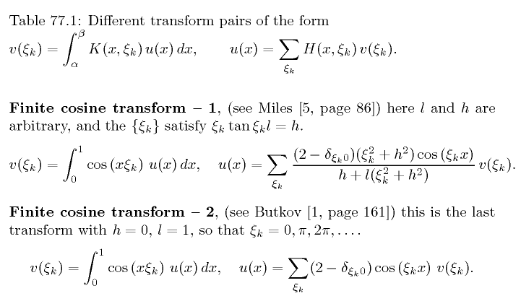
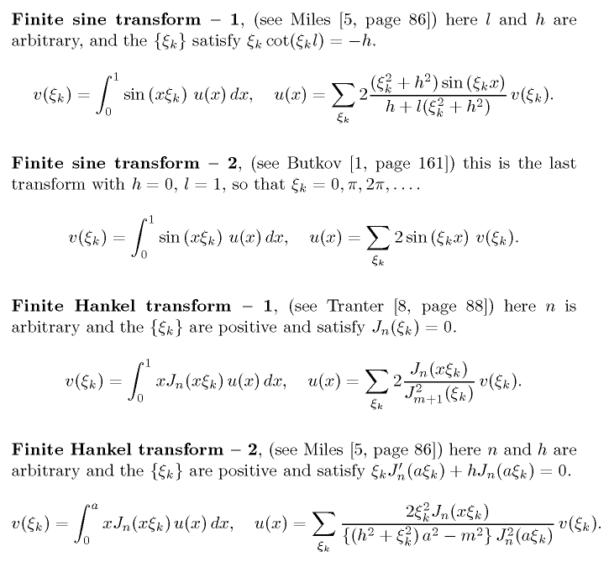
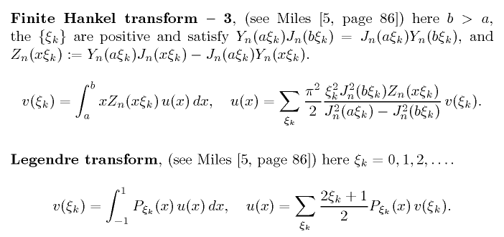

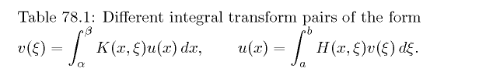

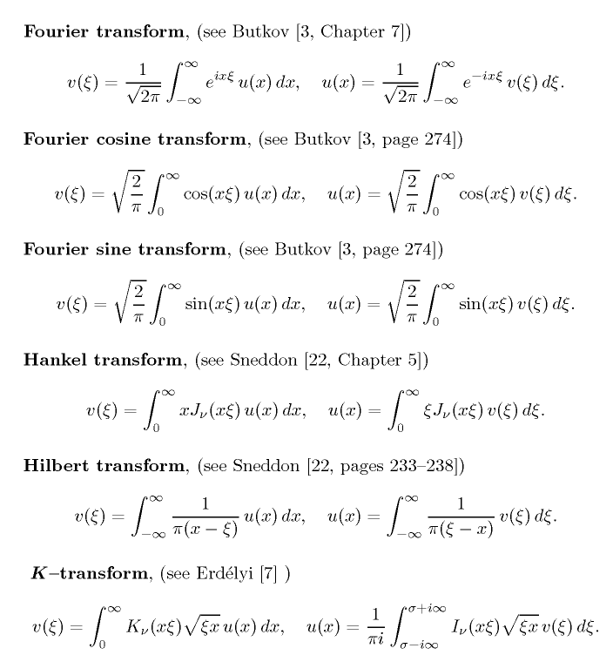
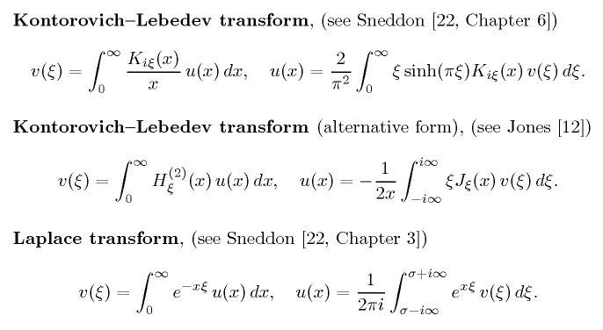
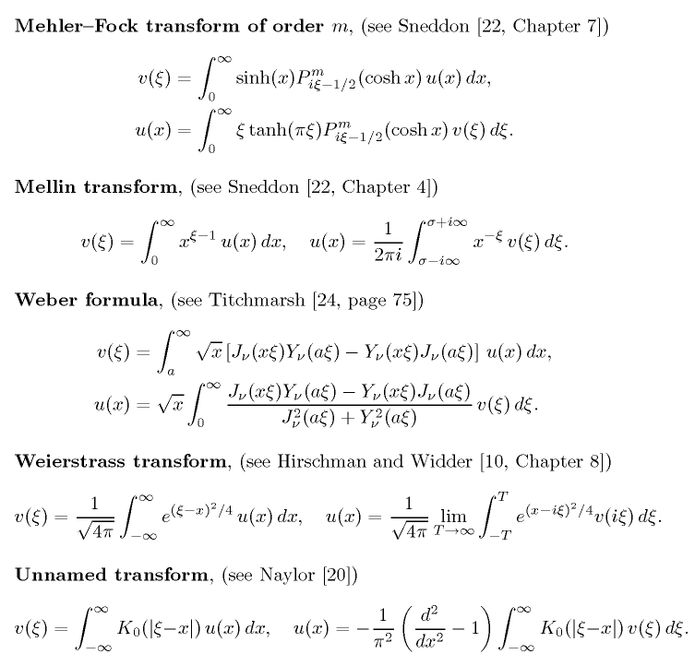
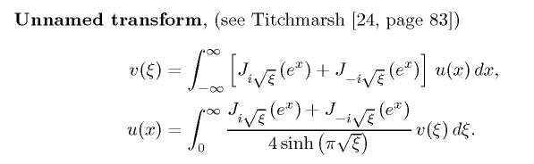

Transform Repair Done 12/8/15.

I have errors in my completeness relations in some cases. You really want to stick with the Stakgold general theory.

Although I no longer have the details in core storage, Stakgold clearly says this in Section 4.2

1. ψn(x) = $\sqrt{s(x)}$φn(x) form a complete orthonormal set.

That means that $^{\int_{a}^{b}{}}$dx ψn(x) ψm(x) = δn,m

2. The correct statement of completeness is then

δ(x-ξ) = Σn ψn(x) n(ξ)

Now consider the transforms I talk about in transforms.doc.

Some of the completeness relations I have written do not have this form!

I will start repairing the sections one at a time (but won't finish right now)

The Exponential Fourier Series Transform

(1/2π) $^{\int_{-π}^{π}{}}$ dθ einθ e-in'θ = δnn' // orthogonality
(1/2π) Σn e-inθ' einθ = δ(θ-θ') // completeness

So here we have s(x) = 1, and ψn(θ) = 1/$\sqrt{2π}$einθ . Then can rewrite

$^{\int_{-π}^{π}{}}$ dθ ψn(θ) ψn'*(θ) = δnn'
Σn ψn(θ') ψn*(θ) = δ(θ-θ')

So no problems there.

The Fourier Series Transform for real functions.

This is just a translation of the previous section where I write things out and specialize to the face the the functions of interest f(θ) are real. We stay on the full interval (-π,π).

The Fourier Cosine Series Transform

The interval here is now really (0,π) and we use only cosine basis functions. So

ψn(θ) = $\sqrt{εn/π}$cos(nθ)

$^{\int_{0}^{π}{}}$ dθ ψn(θ) ψn'*(θ) = δnn'

so that

$\sqrt{εn/π}$$\sqrt{εn'/π}$$^{\int_{0}^{π}{}}$ dθ cos(nθ)cos(n'θ) = δnn'
or
$^{\int_{0}^{π}{}}$ dθ cos(nθ)cos(n'θ) = (π/εn) δnn'

which is something you can actually look up.

Therefore. the completeness relation must be:

Σn ψn(θ) ψn*(θ') = δ(θ-θ')

or
Σn $\sqrt{εn/π}$cos(nθ)$\sqrt{εn/π}$cos(nθ)= δ(θ-θ')
or
Σn (εn/π)cos(nθ)cos(nθ)= δ(θ-θ')
or
Σn εncos(nθ)cos(nθ)= π δ(θ-θ')

So I have written in this correction, and have no time right now to complete these repairs.

