Sjamaar 2015 update PhL 8.22.15

Document Dates.

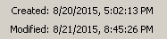

I downloaded his PDF around June 28, 2015. Oddly, the properties on my PDF show these dates:

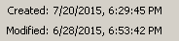

I have no explanation for these strange dates.

The PDF says "last updated 2006-8-26" which is Aug 26, 20016. The PDF viewer shows the document to be 153 pages.

Then on 8/21/15 I was perusing Sja's CV and noted that a new version was available, and I downloaded that new version then. The PDF file has 169 pages, so 16 pages have been added. The dates on this file today are these

In both my files, it seems that the "modified" data is the date of my download. I have no explanation of the strange creation dates in the two cases.

This new document update is July 2015, no specific day is given. Summary:

original PDC last update Aug 26, 2006 153 pages
new PDF last update July 2015 169 pages

How are the documents different?

At one time I think I could compare two PDF docs. I see a zip for "diffpdf" on Black, but I see no installed file. On line this is a trial and pay for program, so I will try out my old version. I extract directly in Downloads the fire up the exe.

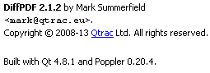
I load up both files and I click compare as it says to do. I get a side by side nice display with areas in pink. But I gave up on this for good reason pretty quickly!

Let's compare Chapter lengths, maybe I will find where most pages were added?

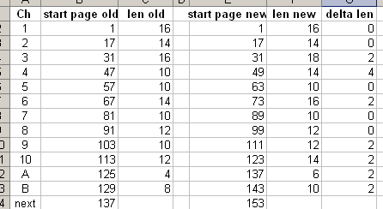

Well, the added pages as shown in "delta len" are well distributed, about 2 pages per chapter, but Chapter 4 got 4 pages added.

He clipped his images better this time, see page 51. I compared Chapter 4, he has just added things here and there. More exercises. More Examples in line.

Gauβ is now Gauss.

TOC: The TOC has not changed at all, but page numbers have changed. He added maybe 16 pages.

And throughout in general equation numbers and identifier numbers (eg, example) have changed. So I need to be careful if I decide to quote any of his equations.

Preface is the same as well, just new dates and minor changes.

Chapter 1.

page 1: he got rid of his idea of writing a column vector as (xxxxx)T , it was clumsy.

Every page has small edits which are just speaking style, something I sometimes do on my docs.
Page 8 has some added stuff in the φ(x) = c discussion. New example added, tangent space gone.
Page 13 he added a piece on Cartesian Products. Such a product may not be a manifold.
Once he adds a new big chunk, the pdf's get shifted and everything goes pink!
But almost all pictures are the same, and quality of drawings is improved throughout.
So not too much different in chapter 1.

Chapter 2. I detect no changes in section 2.1 (comparing print to screen now). No changes in 2.2. Same for 2.3 and 2.4 and 2.5. So basically nothing changed in this differential forms chapter!

Chapter 3. In 3.1 he added a whole new page of pictures showing some graphical things about determinants. He still has is pet axiom approach to determinants. In 3.2 only small changes, like φ*df is now made clearer as φ*(df) on page. Basically no change in this chapter in notation or presentation. He added problem 3.20 and perhaps others.

Chapter 4. No change in 4.1 Some new stuff at the end of Section 4.2. Stuff has been added to Section 4.3 which is the winding number stuff. A new theorem, more details. But same general plan I think. New problems added, Problem 4.14 talks about a "turning number" in addition to the winding number. Basically no super changes in this chapter.

Chapter 5. 5.1 Generic function g(t) is now called h(t). Remark (5.3) still in place and is unchanged. Otherwise no change in 5.1. In 5.2 on boundaries there is some order change and better pictures. 5.2 has no change. Slight reorder in 5.3. So basically no real change.

Chapter 6. He got rid of the inscrutable p 67 B equation I wasted lots of time on, but it appears later. Things are reordered. The graph example done before the torus picture appears. Finally it appears pages later! I talks about covering it with four maps, picture of same. Maybe he has added a theorem or two. Then comes 6.2 on the regular value theorem. All the same, but he adds a rotation group thing at the end of the chapter. Some problems added.

Chapter 7. In 7.1 first definition there is no change. Changes in 7.2: λ has changed to β for the dual space basis, and b in place of v for the argument in several places. But in his multilinear algebra section he uses μ instead of λ for a general tensor function. For example he now has

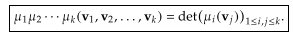

No new problems. So main changes are in his choice of variables, and it is just too bad that he stopped using λi which I have grown to like a lot.

Chapter 8. This looks all the same basically. Volume forms (measure.

Chapter 9. Adds the support buzzword I think related to elbow room around a point on a manifold. Then he has added the "partitions of unity" idea which recall appears in Spivak. He has in fact added a lot to this chapter, integration domains are more sophisticated now.

Chapter 10. Exactly the same but he has added a new thing at the end called De Rham cohomology. It is several pages long, I have not read it.

References: He has added a few, says the big Spivak set is "fun to read".

So OK, I have done a fairly detailed comparison and have noted above where he has changed notation. Generally things are 96% the same I would say. The tangent space never reappeared!

My errata.

I will do this only once! I just page through the old pdf looking for circled e's.

Chapter 1 none

Chapter 2 page 21 typo "for al" page 22 top, still there!

Chapter 3 page 39 lots of stuff this is all fixed on page 41

page 40 ΣI missing page 42 still missing

Chapter 4 none

Chapter 5 none

Chapter 6 page 70 column vectors wrong fixed on page 76

page 72 word "to" missing still there now on page 80

page 77 AB stuff wrong all fixed page 85

Chapter 7 none

Chapter 8 page 97 bad reference repaired on page 107.

Chapter 9 page 106 normals etc fixed on page 114

page 108 ∫δM α fixed on page 119

Chapter 10 none

App A and B none

OK, so only 3 errata survive.

I just wrote an email and sent it. Here is that email:

*********************************************************

Hi Reyer Sjamaar, Aug 22, 2015

I am a physics guy (unfortunately older than you) who was interested in learning something about differential forms and manifolds. I luckily found your excellent notes, downloaded them, printed them, and studied them pretty hard, marking them up as I went (though I admit, I only did a very few problems). I found your presentation very well written and well attuned to my ability to understand things. As for many physics people, dense math writing (where words are avoided wherever possible) is like castor oil in print (credit: Mark Twain said the Book of Mormon was chloroform in print). I was always able to use the web to clarify confusions and to identify terms which did not appear in your document (e.g. "cotangent space" being dual to the tangent space).

It was just my luck to download your Aug 2006 version on June 28 of this year, and yesterday after finishing reading the whole thing I noticed your new July 2015 update, the first in 9 years. I see that you have made many stylistic and content alterations, no doubt all for the better. Hey, the graphs are even clipped to their allotted areas (but I thought the overflowing graphs were a bit artsy).

As I was reading your 2006 version, I took note of a few errata with the intention of reporting them to you. I maintain my own set of documents online and it is an endless battle to iron out errata, and when I update the documents, new errata sometimes appear, so I always appreciate it when people report even small errata to me. It is the beauty of the online document -- always updateable!

You fixed most of my errata, so I have only three tiny typo-class items to report:

• page 22 top line: reads "for al" should be "for all" (page 21 of old PDF)

• page 42 equation (3.2) : ΣI is missing on the middle expression (page 40 of old PDF)

• page 80 third line of (6.2): "can be hard find" should be "can be hard to find" (page 72 of old PDF)

It was interesting to see how you dealt with issues I have to deal with. One example is writing column vectors horizontally, which you now do in your new PDF without adding a T superscript. Everything is a tradeoff, the reader just has to understand.

It was probably good that you gave up on Gausβ since most Ithaca students likely don't speak German, but we still have the endless question of possessives. In my life it was always Gauss's Theorem so to be consistent I have to say Stokes's Theorem which sounds terrible. The web has much on this topic with various obscure standards. For you it is Gauss' Theorem and Stokes' Theorem. Another term in my history is "the Green's function" of a differential operator, which friend J.D. Jackson says we how have to refer to as "the Green function". It hurts to say it. And "the Maxwell equations", not Maxwell's equations. Oy.

Another issue is "equation numbers" and you are somewhat of a minimalist in this area. Should figures have "equation numbers" or a different system of "figure numbers" or no numbers at all? How do you refer to an equation or figure that has no reference? I notice that you have moved into the brave new world of clickable equation numbers. And is it "2.3 Example" or "Example 2.3" ? On it goes.

The wedge product and the sort of parallel universe between the alternating functional Grassmann stuff and "physics stuff" needs more pondering on my part. Us peons feel uncomfortable about
dxidxj = - dxjdxi without some operator symbol in there, but lots of wedge operators certainly do clutter things up. But having no ˄ symbols sometimes leads to ambiguity. For example, in your critical proof of Stokes' Theorem on page 70 (new PDF) you have

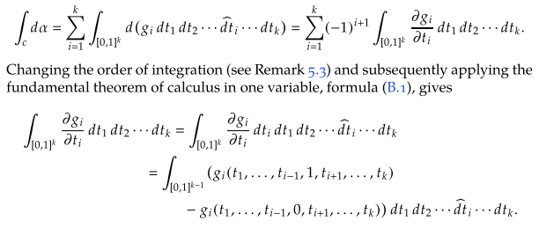

In the first line ( for ∫c dα) the implied detail work is this (red means something missing)

d(gidt1dt2...dti...dtk) = [d(gi)]dt1dt2...dti...dtk = [Σj(∂jgi)dtj]dt1dt2...dti...dtk

= [∂igi)dti]dt1dt2...dti...dtk = (-1)i+1dt1dt2...dti...dtk = (-1)i+1dt1dt2....dtk

so wedge symbols are implicitly present here since the slide of dti creates (-1)i-1 = (-1)i+1 . However, in the next line the dti is slid back to the left with no incurred sign, so here it seems the wedge symbols are not implied.

I wonder how many people have downloaded and studied your PDF? If in the hundreds, then perhaps most of your teaching effectiveness is through that PDF and not in the classroom. Maybe your web site has a counter for such things. And if you don't officially publish your PDF, I hope you have a way to make it persist "in perpetuity", something of interest to me (like in the arXiv but they probably don't accept "expository documents").

Anyway, thanks again for writing a wonderful document. I really appreciate the effort you expended to get it right, and I'm sure your classroom students do as well!

Best regards.

Phil Lucht
Salt Lake City, UT rimrock@xmission.com

P.S. I sort of assume it is Sjamaar as in " cha-mar' " ? Maybe help me out on that.
As you see, my last name is Dutch, but I cannot speak that language.

***************************************

Amazingly he replied same day (Sat 8/22/15) but was a bit brief I think, not acking my typos for example. He must have read my email because he responded regarding downloads and his name. Here is his reply:

***************************************

Dear Phil Lucht,
Thanks for the feedback. I have no clue how many people have downloaded my pdf file. I do get messages like yours a few times a year, and the comments are appreciated.
A brief reply to your remark on the proof of Stokes: "However, in the next line the dti is slid back to the left with no incurred sign, so here it seems the wedge symbols are not implied." The wedge symbols are implied throughout! The thing is that not only is the dt_i being slid back, but also the integration domain is being reparametrized (by changing order of the variables). Each of the two operations incurs a sign penalty, and the two penalties cancel out. See Remark 5.3. Maybe I'll insert a few more words of expanation in a future edition.
Regards,
Reyer Sjamaar (the "Sj" is pronounced as "Sh")

*******************************************

It is true that he addresses exactly this point in his Remark 5.3 in both old and new versions, but I guess I failed to understand what he said there. As that remark shows, and as I did not realize, you also incur a sign change when you change the order of the integration symbols. Here is his 5.3 remark example in my notation:

Q ≡ $^{\int_{a1}^{b1}{}}$$^{\int_{a2}^{b2}{}}$f(t1,t2) dt1 dt2 = ∫c α

== [- $^{\int_{a2}^{b2}{}}$$^{\int_{a1}^{b1}{}}$] [ - f(t1,t2) dt2 dt1 ] // wedge sign AND ∫ have to track orientation

= ∫c' (-α) c' = reverse or. from c

= $^{\int_{a2}^{b2}{}}$$^{\int_{a1}^{b1}{}}$ [ f(t1,t2) dt2 dt1 ] = (-∫c)(-α) = ∫c α

Now for the unit square, the above would say,

$^{\int_{0}^{1}{}}$$^{\int_{0}^{1}{}}$f(t1,t2) dt1 dt2 = $^{\int_{0}^{1}{}}$$^{\int_{0}^{1}{}}$f(t1,t2) dt2 dt1
or
∫[0,1]2 f(t1,t2) dt1 dt2 = ∫[0,1]2 f(t1,t2) dt2 dt1

so the fact that it is a unit square means no distinction between $^{\int_{a1}^{b1}{}}$$^{\int_{a2}^{b2}{}}$ and $^{\int_{a2}^{b2}{}}$$^{\int_{a1}^{b1}{}}$.

The notation ∫[0,1]2 is thus ambiguous! It does not say which "side" of the unit square you are integrating over. Perhaps you could say

A = ∫+[0,1]2 f(t1,t2) dt1 dt2 // integrate over the front side of the unit square

= (∫-[0,1]2) f(t1,t2)[ -dt2dt1 ] // integrate over the back side -[0,1]2 of that square

= (- ∫+[0,1]2) f(t1,t2)][ -dt2dt1 ]

= ∫+[0,1]2 f(t1,t2)]dt2dt1

Stop and try again:

$^{\int_{a2}^{b2}{}}$$^{\int_{a1}^{b1}{}}$f(t1,t2) dt1dt2

= $^{\int_{a2}^{b2}{}}${ $^{\int_{a1}^{b1}{}}$f(t1,t2) dt1 } dt2

= ∫∫[a1,b1]x[a2,b2] f(t1,t2) (dt1dt2) = ∫c α
t1 t2
= ∫∫[a1,b1]x[a2,b2] f(t1,t2) (- dt2dt1) (*)
t1 t2
= (-)∫∫[a2,b2]x[a1,b1] f(t1,t2) (-dt2 dt1) (**)
t2 t1
= ∫∫[a2,b2]x[a1,b1] f(t1,t2) (dt2 dt1) = ∫cop (-α)
t2 t1
= $^{\int_{a1}^{b1}{}}$ { $^{\int_{a2}^{b2}{}}$f(t1,t2) dt2 } dt1

= $^{\int_{a1}^{b1}{}}$$^{\int_{a2}^{b2}{}}$f(t1,t2) dt2 dt1

In the case of [0,1]x[0,1] = [0,1]2, steps (*) and (**) read

= ∫∫[0,1]x[0,1] f(t1,t2) (- dt2dt1) (*)
t1 t2
= (-)∫∫[0,1]x[0,1] f(t1,t2) (-dt2 dt1) (**)
t2 t1
and without those extra markings, this step is indeed mysterious, saying

= ∫∫[0,1]x[0,1] f(t1,t2) (- dt2dt1)
= (-)∫∫[0,1]x[0,1] f(t1,t2) (-dt2 dt1)

OK, I sent him another email, I expect no reply this time. Here is the email I just sent:

***************************************

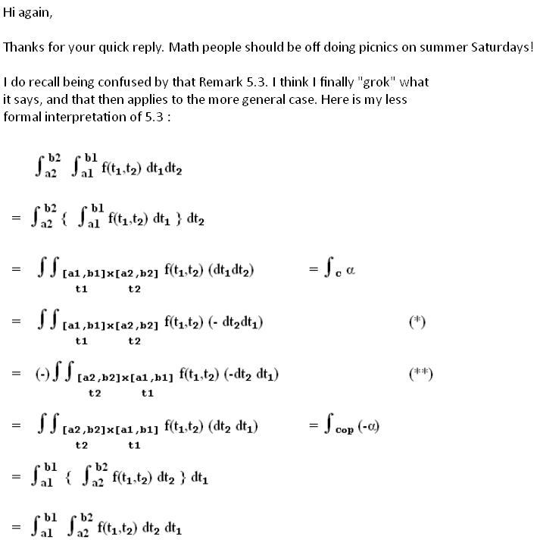
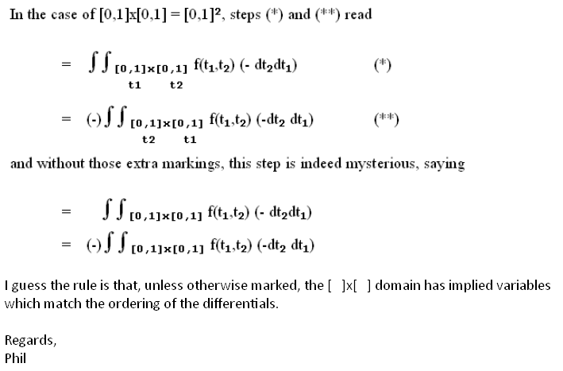

***************************8

