The meaning of (Df) PhL 8.12.15

I will write this as (Dψ). We are in the context of Sjamaar Chapter 6. For some reason, I am constantly confused by the meaning of this object.

Preliminaries. Let's deal first with a matrix M.

1. Consider a square m x n matrix M which is a function of a vector x, (m rows, n columns)

Mij(x) M(x) = matrix

Each component Mij(x) is in general a non-linear function of x. Assume x lies in Rs.

2. How does one think of this as a mapping? Each matrix component could be regarded this way:

Mij : Rs → R // non-linear mapping

assuming matrix M takes real values. Here x lies in Rk and Mij(x) lies in R.

3. One can act with this matrix M on vectors having dimension n to produce vectors having dimension m.
For example, one can write

v = Mu vi = Σj=1n Mijuj i = 1,2...m

M is a linear operator in this space Rm , based on our usual notion of acting on a sum or scalar multiple.
But Mij is a non-linear function of x. The linear mapping has this form

M: Rn → Rm .

4. Thus, we can associate two completely different mappings with our matrix M(x), namely

Mij : Rs → R r = Mij(x) = a real number non-linear

M: Rn → Rm v = Mu = M(x) u linear

I did not really appreciate this simple fact until today.

5. In the Sjamaar situation, we have M = (Dψ) = "the R matrix" in tensor doc language, but non-square.

6. In Sjamaar's definition of an embedding on page 67. he says [ think of Dψ = M, and t = x ]

(Dψ)(t) is one-to-one for all t in U.

So now we ask: which of the above two mappings is Sjamaar claiming is 1-to-1? There is ambiguity here.

7. Let's find someone else who talks about "embeddings" and see what they say. Wiki is way too complicated for me. The web has lots of different kinds of embeddings, so which kind is Sjamaar talking about? All sources first define immersions, for example.

I found what appears to be a good book with some Google access:

Differential Forms and Connections
By R. W. R. Darling (1994)

I will clip and comment a bit from this book: (following is from page 53)

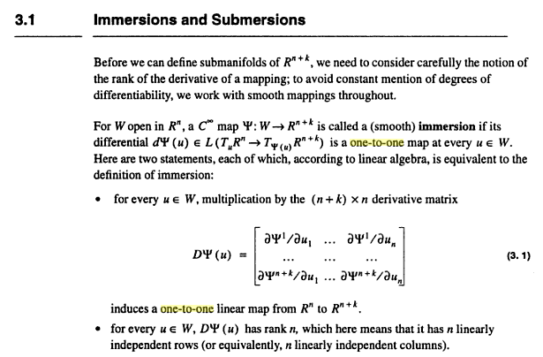

Instead of variable t in U of Sjamaar, Darling is using u in W which lies in Rn (which is my Rs above). The map ψ does not appear in my matrix discussion above. Darling's matrix (Dψ) is my M. So let's write

Mij = ∂jψi // with my usual reversal i = 1.....(n+k) j = 1....n

So matrix Mij here is an (n+k) x n matrix [ my m x n matrix ]. So identify m = n+k > n.

Darling is then taking about this mapping being one-to-one:

(Dψ) : Rn → Rn+k // think M: Rn → Rm

My conclusion is that Sjamaar is talking about the second mapping I show in item 4 above.

8. Digression: what do I know about non-square matrices being invertible or one-to-one? Go back to:

v = Mu M: Rn → Rm M is an m x n matrix (m rows, n cols)

vi = Σj=1n Mijuj i = 1...m First index takes m values, the row index,

Does M-1 exist? Here is what wiki has to say:

[ when we say m x n, note that these letters are in alphabetical order, so that is the logical convention.]

"Non-square matrices (m-by-n matrices for which m ≠ n) do not have an inverse. However, in some cases such a matrix may have a left inverse or right inverse. If A is m-by-n and the rank of A is equal to n, then A has a left inverse: an n-by-m matrix B such that BA = I. If A has rank m, then it has a right inverse: an n-by-m matrix B such that AB = I."

Wiki does not say whether these left and right inverses are unique or not.

Here are some pictures to illustrate the wiki claim: (drawings happen to show m > n, but both implied)

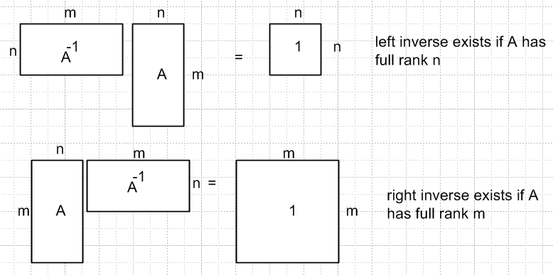 M: Rn → Rm

If n < m, then it is possible for A to have rank n, and then the left inverse exists.
If n > m, then it is not possible for A to have rank n, and then the left inverse does not exist.

If n < m, then it is not possible for A to have rank m, and then the right inverse does not exist.
If n > m, then it is not possible for A to have rank m, and then the right inverse does not exist.

Suppose you wanted to solve v = Mu for u by the inversion method. You would need a left inverse. This only exists if n < m (this is the case of interest to Darling) and if M has full rank n. Then you could solve to get u = M-1v. The mapping M: Rn → Rm would then be one-to-one: Proof:

Suppose u1 = u2. Then v1 = v2 using v = Mu .
Suppose v1 = v2 . Then u1 = u2 using u = M-1v.

How does this relate to Darling's claim above? He has n < m for his mapping M: Rn → Rm , so if the matrix M has full rank n, then the mapping is one-to-one as I just showed above. So Darling's two bullets do in fact say the same thing. It is in this matrix sense that both Darling and Sjamaar are talking about the matrix M = (Dψ) being one-to-one. Generally I think this will be the case, because generally the R matrix will have full rank.

Note: In Lagrange doc, I need the number of components of x to be larger than number constraints, so there I have R: Rn → Rm with n > m But Darling and Sjamaar need the number of components of x to be the smaller number, so they are interested in the R matrix for R: Rn → Rm with m > n. So whereas my R matrix was wide, their R matrix is tall.

Now back to Darling. He has ψ: Rn→ Rm and (Dψ): Rn→ Rm where m = n+k so m> n always. We are doing a mapping like Sjamaar's flat E2 region into the toroid in R3, so m = 3 and n = 2. Darling does not say anything about the mapping ψ: Rn→ Rm being one-to-one, but he does talk about (Dψ): Rn→ Rm being one to one. Darling does one the mapping ψ: Rn→ Rm to be "smooth" which I think just means that all the forward derivatives exist so forward we have C∞. So above we see Darling talking about ψ being an immersion.
He then talks about a different concept called a submersion.
Later on page 108 Darling says

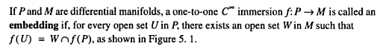

So here we roughly have the idea that

embedding = a one-to-one immersion

Sjamaar skips the immersion concept and starts with the embedding. So all is fine.

