The sign problem in Sjamaar's Stokes Proof PhL 7.15.15

I am used to being blocked in my efforts to move forward, nothing could be more common. The sign issue here comes up on page 63 D1 where I think there should be a sign factor and he says there is no sign factor. Maybe I can find a proof that is similar to his and see how that proof handles this issue. It's too bad because this theorem is probably the most important one in the whole book, and Sja's proof is failing.

My underlying confusion I think is how you make the transition from wedge product form to normal multiple variable integration. Because Sjamaar conceals the wedges, you never know what he is doing!

Web scan:

1. wiki on Stokes no go

2.
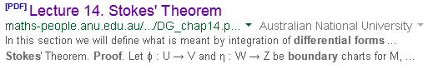

I quote from this PDF:

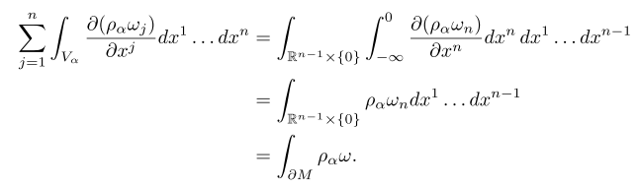

But I don't understand the language here, I would have to invest an hour. There is new vocabulary as well, such as the word "chart" which Sja has not mentioned. So this is no help.

3. Spivak's Book. I was able to download it. It is this:

Spivak, Calculus on Manifolds (Addison-Wesley, 1965). I have the 24th printing of 1995. The entire book is only 158 pages, similar in length to Sja. The notation is vaguely similar to Sja. The wedge product appears late in the book, page 79. But before that time he has lots of ⊗ direct product things going on. On page 97 he starts talking about n-cubes and then n-chains. Here are some familiar looking objects from page 98

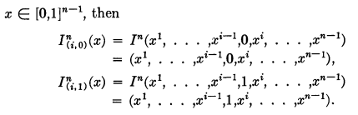
and here is a boundary in exactly the same notation as Sja.

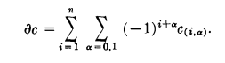

and then these familiar looking theorems

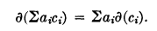

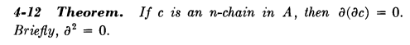

I start browsing now on page 100. Here the wedgies appear.

Now here is an interesting item:

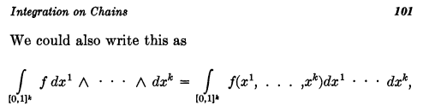
I presume the wedges are implied on the RHS? Going on,

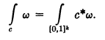
so Sja and Spivak use the same pullback notation. Good.
So finally we get on page 102 to the Spivak version of Stokes,

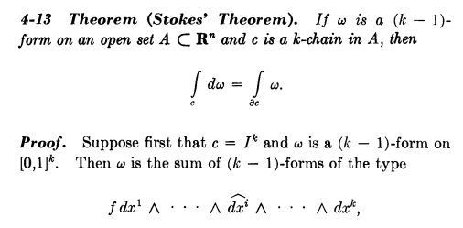

What is the meaning of Ik ? I have to first make the doc searchable, then I can search for the first instance. I can do OCP now directly inside Xchange. I set accuracy to high just because there is a lot of math detail. I will go off and do something else for a while. I think Ik is a k-cube so you could have c in Ik. But here he seems to want to have c = Ik. So the above is a particular (k-1)-form, one that is missing dxi. Note upper subscripts on the dxk ad I might do them in standard notation. So OK, ω is a sum of (k-1)-forms of the type shown. So far so good, let's read on:

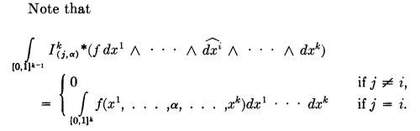

This looks very much like Sjamaar's [ci,ρ]* (α). Is he saying that in the pullback there are no wedgies? That would explain the whole thing.
Spivak does not use the word "pullback" but he uses the same notation c* as already notes. I am still uncertain of the meaning of dx1 ... dxk shown above, as to whether or not there are wedgies implied. Also, what about the fact that dxi is missing. Well, the pullback creates a new dxi and above it looks like he is able to slide it into its normal position "for free" -- that is, no sign is picked up.
So take a gander at this next step:

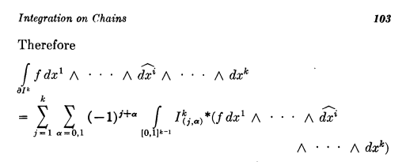
Here he is using the boundary formula for ∂Ik and THAT is where the sign (-1)j+α is coming from. the dxi is sliding nowhere here. Wedgies are present. He is going in the reverse direction from Sja. The next line says

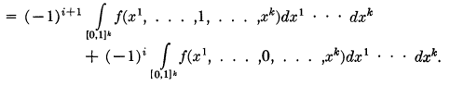

So here just as I did it you are forced to have j = i. The (-1)i is carrying down from this δj,i thing. he continues,

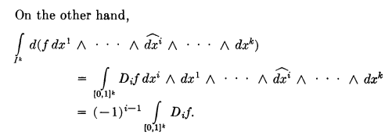

and here I think the (-1)i comes from slider effect with the wedgies. Moving right along,

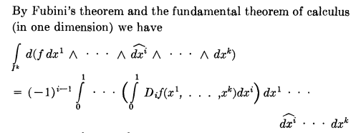

Now where is THIS sign coming from? This IS the big mystery I think. He gets the sign, but he has not slid anything! He just writes out df. So maybe something to do with d acting on the wedgie part?

So where does Spivak talk about applying d to a differential form? We are on page 103 to return.

Fact: The notion of differential form and k-form don't appear until page 88.
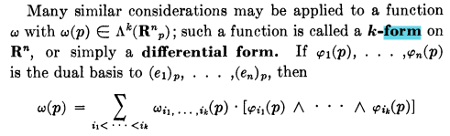

I am not sure what he means by φk(p). But then it looks more normal a little later

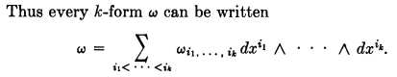

We continue on some more

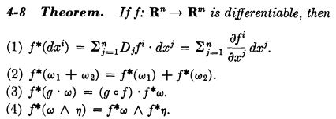

The first line is that pullback operations. The other lines are rules for a pullback operator. I think this is all in line with Sja, but the product of two forms always has a wedgie! Sja never puts wedgies.

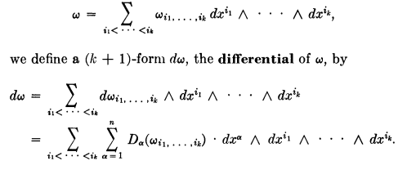

Here "d" seems to act only on the function part, as in Sja.

None of this is helping with the Big Mystery which I repeat,

Unfortunately, Spivak is hazy at exactly the point I need clarity! I suspect there are no wedges on the right in the above expression. This is what seems to be happening here:

∫I3 d [ f dx ^ dz ] = ∫I3 (df) dx ^ dz = ∫I3 Σi(∂f/∂xi) dxi ^ dx ^ dz

= ∫I2 (∂f/∂y) dy ^ dx ^ dz = (-1) ∫I2 (∂f/∂y) dx ^ dy ^ dz

= (-1) $^{\int_{0}^{1}{}}$$^{\int_{0}^{1}{}}$$^{\int_{0}^{1}{}}$ (∂f/∂y) dxdydz

It seems that you have to get the wedge product in the right order, THEN you can get rid of the wedges in the last step. Does Sja ever address this issue? It would be somewhere near page 37 where he starts talking about pullbacks. Look at page 37 D. Maybe it really says this

φ*(dy1 dy2 ^ ......dyk) = dφ1dφ2.....dφk

so that only if things are in standard order on the left do you get the right. But if you look at page 38A it looks more like he really means

φ*(dy1 dy2 ^ ......dyk) = dφ1 dφ2 ..... dφk

And I suspect at the very end on page 42 C we have ^ everywhere on both sides.

So maybe it is in the process of integration that the hats go away? The chapter on integrating 1-forms cannot address this issue since you need more than one dxi to get a wedge.

So we skip then to page 57. There he writes some dti integrals, but are there wedges there??

Conclusion: The absence of wedges in Sjamaar's notation makes it impossible to decipher things. And too bad that Spivak's nice looking book could not clarify the point, although it does use the wedges. Spivak

4.The Arapura notes. These notes DO use the wedge, and these notes at least allow that there is an issue here. For example they write

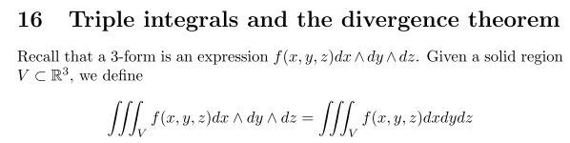

The vaguely supports my idea that you first get the wedge product into standard order, THEN you remove the wedges and do the integral. At least Arapura addresses the issue, whereas Sjamaar says nada since he has no wedges. Perhaps the three things wedged are at right angles, not very clear in detail.

For spherical like coordinates, the standard order is the one which makes the Jacobian positive. Here is another Arapura example for a hypercube.

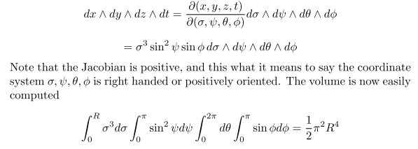

Once you get the variables in the right order, then you do the integrals by dropping the wedges. An earlier and simpler example, (note that cos(φ) should read cos(θ), typos

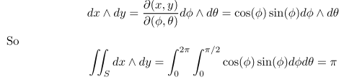

So I think Arapura is explaining my mystery which is obscured in the Sjamaar notation.

Can I get more on wedge products?

5. Wiki on exterior algebra no go

