Detail work for Faces and Boundaries (Sjamaar p 60-61) PhL 7.14.15

2.13.16 Read this without following subdetails, think it is good. A key idea is that the chain of faces that is the boundary of an object has certain magic signs which make things work right. These signs are shown in the ∂c formula of page 60 D, but there is a lot of detail to consider.

I am more or less forced to do a full rewrite of his stuff, based on his stuff. He does not have enough clarity to convince me of his results.

1. A clarification the meaning of a k-cube 1
2. Here is the Rule for creating faces: 1
3. Face of a Face 2
4. Sign of a Face 4
5. Proof that ∂(∂c) = 0. 8

1. A clarification the meaning of a k-cube

Meaning of a 2-cube: This is a mapping c like the one shown page 60. c:[0,1]2 → U. The image of this mapping can be regarded as a "warped square" whose edges are pieces of curves. Page 60 shows only a slight amount of warping so we can easily keep track of which edges of [0,1]2 go to which edges of the image of the 2-cube. In general the warping could be very severe so the resulting image might even penetrate itself, but let's not think in terms of such a radical warpage.

Meaning of a 3-cube: This is a mapping c where c:[0,1]3 → U. The image of this mapping can be regarded as a "warped cube" whose edges are pieces of curves. Again it is useful to think of the warping as being relatively small so we can follow the faces through the mapping. Each face is a rectangle that is warped out of the plane a bit.

Generation of faces of a k-cube. Start with a 3-cube as an example. We can generate the 6 faces in this manner:

[c(t1,t2,t3)]1,ρ = c(ρ,t1,t2) t = t1,t2 ρ = 0 or 1
[c(t1,t2,t3)]2,ρ = c(t1,ρ,t2)
[c(t1,t2,t3)]3,ρ = c(t1,t2,ρ) (1.1)

The object c(t1,t2,t3) is the image of the 3-cube as the three variables run over [0,1]3. Each line above describes one pair of faces of this warped cube. It only takes two variables to run over a 2D face, and these are t1 and t2 which are sort of newly defined for each face pair and are not the original ti variables.

2. Here is the Rule for creating faces:

Rule: Start with the original k-cube like c(t1,t2,t3). To make the face pair [c(t1,t2,t3)]i,ρ, replace ti by ρ. After doing that, rename the remaining ti variables to be t1, t2 starting from the left. In this process, the last variable will no longer appear (in our 3-cube example that last variable is t3) (2.1)

Example : [c(t1,t2,t3)]2,ρ → c(t1,ρ,t3) → c(t1,ρ,t2) (2.2)

Now let's try this Rule starting with an arbitrary k-cube c(t1,t2,t3....tk). We then get

[c(t1,t2,t3....tk)]1,ρ → c(ρ,t2,t3....tk) → c(ρ,t1,t2....tk-1)
[c(t1,t2,t3....tk)]2,ρ → c(t1,ρ,t3....tk) → c(t1,ρ,t2....tk-1) (2.3)

A general case could be written this way

[c(t1,t2,t3.. ti-1,ti,ti+1..tk)]i,ρ → c(t1,t2,t3.. ti-1,ρ,ti+1..tk) → c(t1,t2,t3.. ti-1,ρ,ti..tk-1) (2.4)

This is in agreement with the right side of p 60 C. The last case would be

[c(t1,t2,t3....tk-1,tk)]k,ρ → c(t1,t2,t3....tk-1,ρ) → c(t1,t2,t3....tk-1,ρ) // no change needed (2.5)

When we enumerate all the face pairs in this manner, ρ appears in all k positions of the k-cube. There are of course k pairs of faces on a k-cube as I well know from tensor doc Appendix B.

3. Face of a Face

In this section I derive page 61 equations A,C and D.

Go back to the 3-cube example where we had

[c(t1,t2,t3)]1,ρ = c(ρ,t1,t2) t = t1,t2 ρ = 0 or 1
[c(t1,t2,t3)]2,ρ = c(t1,ρ,t2)
[c(t1,t2,t3)]3,ρ = c(t1,t2,ρ) (1.1)

and here each face is a warped rectangle or 2D patch. Each of these patches we know has 2 pairs of faces, which faces are curved line segments. So our warped cube has 6 2D faces and each of these faces has 4 1D faces, so there are a total of 24 of these 1D faces, But each 1D segment belongs to two 2D adjacent patches (but probably with opposite orientation). So there are then a total of 12 unique 1D faces.

Consider then (3.1)

[ c(ρ,t1,t2)]1,σ = c(ρ,σ,t2) → c(ρ,σ,t1) * // this accounts for 22 = 4 of the 1D faces
[ c(ρ,t1,t2)]2,σ = c(ρ,t1,σ) → c(ρ,t1,σ) // this accounts for 22 = 4 of the 1D faces

[ c(t1,ρ,t2)]1,σ = c(σ,ρ,t2) → c(σ,ρ,t1) ** // this accounts for 22 = 4 of the 1D faces
[ c(t1,ρ,t2)]2,σ = c(t1,ρ,σ) → c(t1,ρ,σ) // this accounts for 22 = 4 of the 1D faces

[ c(t1,t2,ρ)]1,σ = c(σ,t2,ρ) → c(σ,t1,ρ) // this accounts for 22 = 4 of the 1D faces
[ c(t1,t2,ρ)]2,σ = c(t1,σ,ρ) → c(t1,σ,ρ) // this accounts for 22 = 4 of the 1D faces

Notice that the Rule I used above has nothing to do with slot positions!!! The Rule refers to the variable names t1 and t2. So we end up with a list of 24 1D faces. The four faces c(ρ,σ,t1) are the same as the four faces c(σ,ρ,t1) and so on, so you only end up with 12 faces. For example, the four 1D faces (edges) of the group * are exactly the same as those in the group **, so the above listing overcounts by factor of 2.

Now let's try to do this at the general level for a k-cube instead of a 3-cube. The faces of the k-cube are (k-1)D objects [ known as (k-1)-cubes]. There are 2k such faces, in k pairs. Here are those pairs of faces as found above.

[c(t1,t2,t3.. ti-1,ti,ti+1..tk)]i,ρ → c(t1,t2,t3.. ti-1,ρ,ti+1..tk) → c(t1,t2,t3.. ti-1,ρ,ti..tk-1) (2.4)

Now we want to identify the faces of these faces. I will start off: with j = 1 < i:

{ [c(t1,t2,t3....tk)]i,ρ}1,σ = [ c(t1,t2,t3.. ti-1,ρ,ti..tk-1)]1,σ

→ c(σ,t2,t3.. ti-1,ρ,ti..tk-1) → c(σ,t1,t2.. ti-2,ρ,ti-1..tk-2) // k arguments (3.2)

The Rule says put σ in the t1 slot, then adjust variable names in the usual way. Next here is j = 2 < i

{ [c(t1,t2,t3....tk)]i,ρ}2,σ = [ c(t1,t2,t3.. ti-1,ρ,ti..tk-1)]2,σ

→ c(t1,σ,t3.. ti-1,ρ,ti..tk-1) → c(t1,σ,t2.. ti-2,ρ,ti-1..tk-2) // k arguments (3.3)

For both these cases I have i to the right of the new face index, so I have j < i. Here is a the general case for this situation that j << i:

{ [c(t1,t2,t3....tk)]i,ρ}j,σ = [ c(t1,t2....tj-1,tj,tj+1.... ti-1,ρ,ti..tk-1)]j,σ j << i

→ c(t1,t2....tj-1,σ, tj+1.... ti-1,ρ,ti..tk-1) → c(t1,t2....tj-1,σ, tj.... ti-2,ρ,ti-1..tk-2) (3.4)

Notice that we now have the sequence ti-2,ρ,ti-1 after the adjustment!

Note: In (3.4) suppose we had j = i-2. Then (3.4) is c(t1,t2....tj-1,σ, tj,ρ,tj+1..tk-2) which is OK.
Note: In (3.4) suppose we had j = i-1. Then (3.4) is c(t1,t2....tj-1,σ, ρ,tj..tk-2) which is OK.
This last is the limiting case, so (3.4) is then valid for j ≤ i-1. So restate the above more precisely as

{ [c(t1,t2,t3....tk)]i,ρ}j,σ = [ c(t1,t2....tj-1,tj,tj+1.... ti-1,ρ,ti..tk-1)]j,σ j ≤ i-1

→ c(t1,t2....tj-1,σ, tj+1.... ti-1,ρ,ti..tk-1) → c(t1,t2....tj-1,σ, tj.... ti-2,ρ,ti-1..tk-2) (3.4)A

Now look at the opposite situation where j >> i: [ that is to say, i << j ]

{ [c(t1,t2,t3....tk)]i,ρ}j,σ = [ c(t1,t2....... ti-1,ρ,ti.....tj-1,tj,tj+1.... tk-1)]j,σ i << j

→ c(t1,t2....... ti-1,ρ,ti.....tj-1,σ,tj+1.... tk-1) → c(t1,t2....... ti-1,ρ,ti.....tj-1,σ,tj.... tk-2) (3.5)

Note: In (3.5) suppose we had j-1=i. Then (3.4) is c(t1,t2....... ti-1,ρ,ti,σ,ti+1.... tk-2) which is OK.
Note: In (3.5) suppose we had j=i. Then (3.4) is c(t1,t2....... ti-1,ρ,σ,ti.... tk-2) which is OK.
This last is the limiting case, so (3.5) is then valid for j ≥ i. So restate the above more precisely as

{ [c(t1,t2,t3....tk)]i,ρ}j,σ = [ c(t1,t2....... ti-1,ρ,ti.....tj-1,tj,tj+1.... tk-1)]j,σ i ≤ j

→ c(t1,t2....... ti-1,ρ,ti.....tj-1,σ,tj+1.... tk-1) → c(t1,t2....... ti-1,ρ,ti.....tj-1,σ,tj.... tk-2) (3.5)A

This agrees with page 61 A I am happy to say. Now in the above equation, swap i↔j and ρ↔σ to get

{ [c(t1,t2,t3....tk)]j,σ}i,ρ = [ c(t1,t2....... tj-1,σ,tj.....ti-1,ti,ti+1.... tk-1)]i,ρ j ≤ i

→ c(t1,t2....... tj-1,σ,tj.....ti-1,ρ,ti+1.... tk-1) → c(t1,t2....... tj-1,σ,tj.....ti-1,ρ,ti.... tk-2) (3.6)

Let's now make this same swap in equation (3.4)A:

{ [c(t1,t2,t3....tk)]j,σ}i,ρ = [ c(t1,t2....ti-1,ti,ti+1.... tj-1,σ,tj..tk-1)]i,ρ i ≤ j-1

→ c(t1,t2....ti-1,ρ, ti+1.... tj-1,σ,tj..tk-1) → c(t1,t2....ti-1,ρ, ti.... tj-2,σ,tj-1..tk-2) (3.7)

Finally, rewrite this last equation with j→j+1:

{ [c(t1,t2,t3....tk)]j+1,σ}i,ρ = [ c(t1,t2....ti-1,ti,ti+1.... tj,σ,tj+1..tk-1)]i,ρ i ≤ j

→ c(t1,t2....ti-1,ρ, ti+1.... tj,σ,tj+1..tk-1) → c(t1,t2....ti-1,ρ, ti.... tj-1,σ,tj..tk-2) (3.8)

This agrees with page 61 C. I have derived it my own way without referring to "slot positions".

Now for i ≤ j the right side of (3.8) matches the right side of (3.5)A from which we find

{ [c(t1,t2,t3....tk)]i,ρ}j,σ = { [c(t1,t2,t3....tk)]j+1,σ}i,ρ i ≤ j

This agrees with page 61 D, finally!

4. Sign of a Face

To review, the faces of a 3-cube are given by

[c(t1,t2,t3)]1,ρ = c(ρ,t1,t2) t = t1,t2 ρ = 0 or 1
[c(t1,t2,t3)]2,ρ = c(t1,ρ,t2)
[c(t1,t2,t3)]3,ρ = c(t1,t2,ρ) (1.1)

Now if we start with a 2-cube instead, we can list its faces: (using exact the Rule given above

[c(t1,t2)]1,ρ = c(ρ,t1) // 2 faces of 2-cube (two sides of a squarish patch)
[c(t1,t2)]2,ρ = c(t1,ρ) // 2 faces of 2-cube (two sides of a squarish patch)

Specifically we can list off the four faces

c(0,t1) = c4 = c1,0
c(1,t1) = c2 = c1,1
c(t1,0) = c1 = c2,0
c(t1,1) = c3 = c2,1

and here is a picture

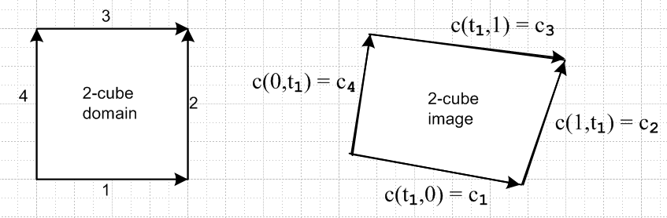

The arrow directions show path if you let the ti variables (only one here) go from 0 to 1. But to talk about a "boundary", you want all the arrows going the same direction, so the right picture then becomes

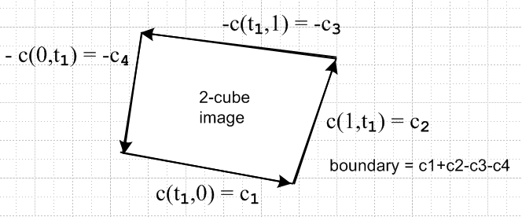

This then is why we want to say ∂c = c1+ c2 - c3- c4 .

Consider then the magic formula appearing in 60D

∂c = Σi=1kΣρ=0,1(-1)ρ+i ci,ρ

For our case above of a 2-cube, set k = 2 and we get

∂c = Σi=12Σρ=0,1(-1)ρ+i ci,ρ = (-1)0+1c1,0 + (-1)0+2c2,0 + (-1)1+1c1,1 + (-1)1+2c2,1

= -c1,0 + c2,0 + c1,1 - c2,1 = -c4 + c1 + c2 - c3

and we see that this strange formula does in fact generate the proper CCW boundary!

How does this work for a 3-cube? Here once again are the 6 faces:

[c(t1,t2,t3)]1,ρ = c(ρ,t1,t2) t = t1,t2 ρ = 0 or 1
[c(t1,t2,t3)]2,ρ = c(t1,ρ,t2)
[c(t1,t2,t3)]3,ρ = c(t1,t2,ρ) (1.1)

Here is the 3-cube (warp is so small you can't see it!)

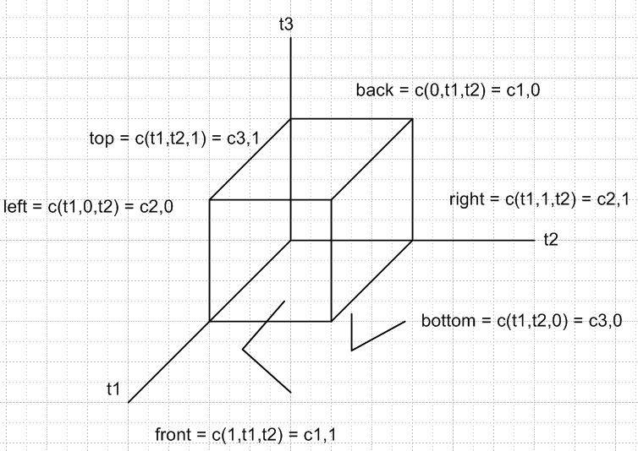

Here is what the formula says:

∂c = Σi=13Σρ=0,1(-1)ρ+i ci,ρ = Σi=13(-1)i [ ci,0 - ci,1]

= - [ c1,0 - c1,1] + [c2,0 - c2,1] - [ c3,0 - c3,1]

= - [back - front ] + [left - right] - [bottom - top]

= [front - back] - [right - left ] + [top - bottom]

Now let's try putting some arrows on the picture. One idea was to install arrows so that every face has a definite orientation, but this cannot be done as this starting picture shows. Here I arrow up the front face, then the right face, but then the top face is a problem.

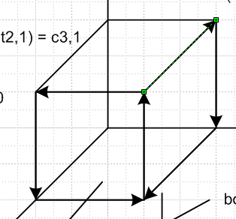

Well OK, I will just label the faces with the signs that the formula gives

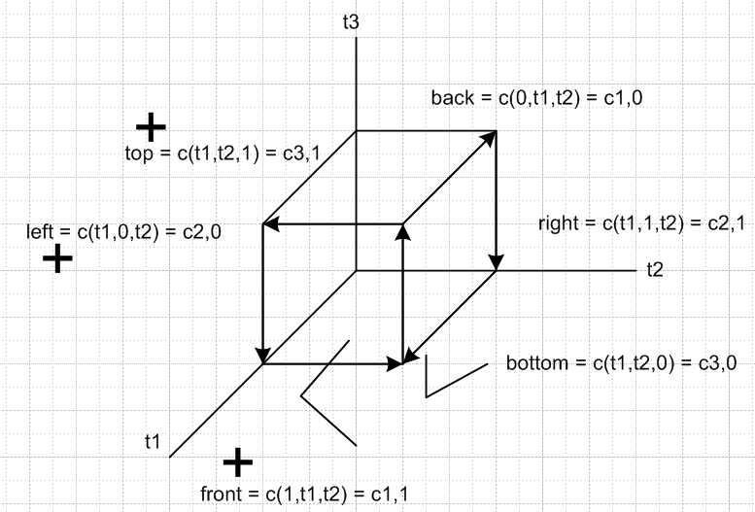

How should I interpret the fact that the top, left and bottom faces are + ? There are three adjacent faces, that is a simple fact. If you were to make a solid out of such cubes, the internal faces would all "cancel" in terms of these signs, whatever that means. The "parallel" pair members always have opposite sign of course.

What now define boundary as ∂c = Σi=13Σρ=0,1(-1)ρ ci,ρ without the i part of the sign? You could do that, but it then does not "work" for k = 2 if we want to get the orientation idea.

Note Added 2.13.16. Maybe I can do a little better on the signs above. Go back to where each of the 6 cube faces is spanned by the same pair t1, t2.

[c(t1,t2,t3)]1,ρ = c(ρ,t1,t2) t = t1,t2 ρ = 0 or 1
[c(t1,t2,t3)]2,ρ = c(t1,ρ,t2)
[c(t1,t2,t3)]3,ρ = c(t1,t2,ρ) (1.1)

Maybe I can draw edge arrows for each of these cases just showing how t1 and t2 increase (because this is what we did in the lower degree case). If I do that, each cube edge gets a uniquely directed arrow and I show these in red (all red arrows point in the direction of increasing parameter).

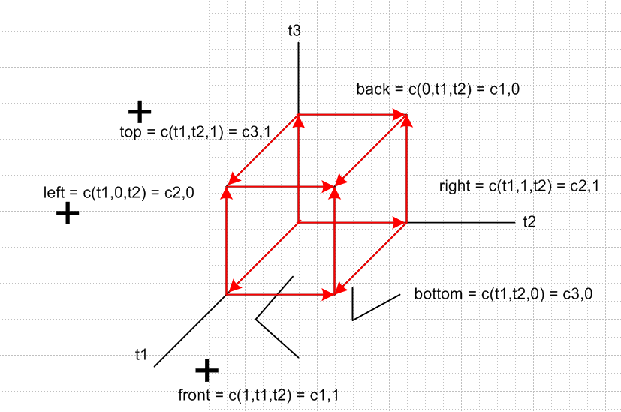

There are three "near" faces (near the origin) and three "far faces". In each pair of near,far faces one will be plus and the other will be -. Well, maybe the above arrow directions don't help after all, but I know that the "sign rule" is that sign = (-1)ρ+i where ρ is the 0 or 1 argument, and i is the "slot". I have written this out in detail above. For example, the left face has slot 2 and ρ = 0, so it is (-1)2+0 = +1 so that face is +.



Well this guy does like Sjamaar but does not give any geometric interpretation for the cube.

Conclusion: I accept for now the signed combination of faces shown in page 60 D as the definition of the boundary of a k-cube. The formula specifies a sum of (k-1)-cubes making up the faces of a k-cube. In this formula the faces of a "parallel pair" always have opposite sign. Also, notice that the boundary ∂c of a k-cube is a linear combination of (k-1)-cubes, and therefore ∂c(k-cube) = (k-1)-chain.

5. Proof that ∂(∂c) = 0.

Let c be a k-cube and start off with

∂c = Σi=1kΣρ=0,1(-1)ρ+i [ci,ρ]

Then

∂(∂c) = ∂ {Σi=1kΣρ=0,1(-1)ρ+i [ci,ρ] }

= Σi=1kΣρ=0,1(-1)ρ+i { ∂ [ci,ρ] }

= Σi=1kΣρ=0,1(-1)ρ+i { Σj=1kΣσ=0,1(-1)σ+j [ci,ρ]j,σ}

= Σi=1kΣj=1kΣρ=0,1Σσ=0,1 (-1)ρ+i+σ+j [ci,ρ]j,σ page 60 F

Abbreviate this as

∂2c = Σi,j Σρ,σ (-1)ρ+i+σ+j [ci,ρ]j,σ .

In our usual manner we can break this sum into two pieces

∂2c = Σi≤j Σρ,σ (-1)ρ+i+σ+j [ci,ρ]j,σ + Σi>j Σρ,σ (-1)ρ+i+σ+j [ci,ρ]j,σ . page 60 G

Now in the first term use the fact we showed painfully above that

{ [c(t1,t2,t3....tk)]i,ρ}j,σ = { [c(t1,t2,t3....tk)]j+1,σ}i,ρ i ≤ j

which we can abbreviate to say

[ci,ρ]j,σ = [cj+1,σ]i,ρ i ≤ j .

We are then allowed to use this only in the first term to get

∂2c = Σi≤j Σρ,σ (-1)ρ+i+σ+j [cj+1,σ]i,ρ + Σi>j Σρ,σ (-1)ρ+i+σ+j [ci,ρ]j,σ .

Start by swapping i↔j in the second term, and ρ↔σ, something we often do. Then

∂2c = Σi≤j Σρ,σ (-1)ρ+i+σ+j [cj+1,σ]i,ρ + Σj>i Σρ,σ (-1)ρ+j+σ+i [cj,σ]i,ρ .

Now in the second term set j = r+1. Then j>i means j ≥ i+1 means r +1 ≥ i+1 means r ≥ i means i ≤ r :

∂2c = Σi≤j Σρ,σ (-1)ρ+i+σ+j [cj+1,σ]i,ρ + Σi≤r Σρ,σ (-1)ρ+r+1++σ+i [cr+1,σ]i,ρ .

Now in the second term rename r to be j and extract the (-1)1 to get

∂2c = Σi≤j Σρ,σ (-1)ρ+i+σ+j [cj+1,σ]i,ρ - Σi≤j Σρ,σ (-1)ρ+j+σ+i [cj+1,σ]i,ρ .

The two terms obviously cancel, so we have proven that ∂2c = 0 for any k-cube.

So that only took me two days!

Example: The boundary of the boundary of a 3-cube is a set of 24 little segments. In fact I enumerated them above (yes, we are overcounting by factor 2)

[ c(ρ,t1,t2)]1,σ = c(ρ,σ,t2) → c(ρ,σ,t1) // this accounts for 22 = 4 of the 1D faces
[ c(ρ,t1,t2)]2,σ = c(ρ,t1,σ) → c(ρ,t1,σ) // this accounts for 22 = 4 of the 1D faces

[ c(t1,ρ,t2)]1,σ = c(σ,ρ,t2) → c(σ,ρ,t1) // this accounts for 22 = 4 of the 1D faces
[ c(t1,ρ,t2)]2,σ = c(t1,ρ,σ) → c(t1,ρ,σ) // this accounts for 22 = 4 of the 1D faces

[ c(t1,t2,ρ)]1,σ = c(σ,t2,ρ) → c(σ,t1,ρ) // this accounts for 22 = 4 of the 1D faces
[ c(t1,t2,ρ)]2,σ = c(t1,σ,ρ) → c(t1,σ,ρ) // this accounts for 22 = 4 of the 1D faces

Regroup these 24 little edges:

[ c(t1,ρ,t2)]2,σ = c(t1,ρ,σ) → c(t1,ρ,σ) // this accounts for 22 = 4 of the 1D faces
[ c(t1,t2,ρ)]2,σ = c(t1,σ,ρ) → c(t1,σ,ρ) // this accounts for 22 = 4 of the 1D faces

[ c(ρ,t1,t2)]2,σ = c(ρ,t1,σ) → c(ρ,t1,σ) // this accounts for 22 = 4 of the 1D faces
[ c(t1,t2,ρ)]1,σ = c(σ,t2,ρ) → c(σ,t1,ρ) // this accounts for 22 = 4 of the 1D faces

[ c(ρ,t1,t2)]1,σ = c(ρ,σ,t2) → c(ρ,σ,t1) // this accounts for 22 = 4 of the 1D faces
[ c(t1,ρ,t2)]1,σ = c(σ,ρ,t2) → c(σ,ρ,t1) // this accounts for 22 = 4 of the 1D faces

Rewrite the left sides in this way

[ c2,ρ]2,σ = c(t1,ρ,σ) → c(t1,ρ,σ) // this accounts for 22 = 4 of the 1D faces
[ c3,ρ]2,σ = c(t1,σ,ρ) → c(t1,σ,ρ) // this accounts for 22 = 4 of the 1D faces

[ c1,ρ]2,σ = c(ρ,t1,σ) → c(ρ,t1,σ) // this accounts for 22 = 4 of the 1D faces
[ c3,ρ]1,σ = c(σ,t2,ρ) → c(σ,t1,ρ) // this accounts for 22 = 4 of the 1D faces

[ c1,ρ]1,σ = c(ρ,σ,t2) → c(ρ,σ,t1) // this accounts for 22 = 4 of the 1D faces
[ c2,ρ]1,σ = c(σ,ρ,t2) → c(σ,ρ,t1) // this accounts for 22 = 4 of the 1D faces

NOW, lets add this list the signs that appear in the ∂c formula. Every term has the same (-1)ρ+σ factor, so ignore that. The rest of the factor is (-1)i+j . So I will now put a minus sign where this is -1 :

[ c2,ρ]2,σ = c(t1,ρ,σ) → c(t1,ρ,σ) // this accounts for 22 = 4 of the 1D faces
- [ c3,ρ]2,σ = - c(t1,σ,ρ) → - c(t1,σ,ρ) // this accounts for 22 = 4 of the 1D faces

- [ c1,ρ]2,σ = -c(ρ,t1,σ) → -c(ρ,t1,σ) // this accounts for 22 = 4 of the 1D faces
[ c3,ρ]1,σ = c(σ,t2,ρ) → c(σ,t1,ρ) // this accounts for 22 = 4 of the 1D faces

[ c1,ρ]1,σ = c(ρ,σ,t2) → c(ρ,σ,t1) // this accounts for 22 = 4 of the 1D faces
- [ c2,ρ]1,σ = -c(σ,ρ,t2) → -c(σ,ρ,t1) // this accounts for 22 = 4 of the 1D faces

The boundary of the 3-cube is now the sum of the 6 rows, and you see that within each group of 8 segments we get full cancellation, so this sows that ∂2c = 0 if c is a 3-cube.

The issue is that you get an internal cancellation of the faces. The issue is NOT that something vanishes because it does not have enough dimensionality. So this is then one of the features of the particular way which that formula defines the boundary ∂c of a k-cube!

For c = 3-cube, ∂c =is a 2-chain, and ∂2c is a 1-chain that adds up to zero.
In general

c = k-cube
∂c = (k-1)-chain
∂2c = (k-2)-chain that adds up to zero.

