Clifford Review 1 PhL 8.30.15

1. Review of ideas from the Denker and Suter docs 1
The dot and geometric product of basis vectors for different blade-spaces: 5
Wedge product of two multivectors 6
Geometric product of vectors 7
Geometric product of two basis vectors. 8
Wedge product of 3 or more vectors 8
Wedge product of 3 or more basis vectors 9
Geometric product of arbitrary basis elements of CA(R^{n}) 9
Rules for combining the geometric and wedge products. If a,b,c are all vectors, then 10
Geometric product of two arbitrary multivectors 10
Geometric product of two blades 11
2. Clifford Algebra developed from a quadratic form Q(v); the metric G(u,v) 12
3. The Ideal Mystery 18
4. DIRECT PRODUCTS OF THINGS 24

1. Review of ideas from the Denker and Suter docs

I have so far read Denker and Suter in full, and some of the puzzle pieces are slowly assembling, but I have a long way to go.

Fact: I think Clifford Algebras are defined on an arbitrary vector space V, whereas for the Geometric Algebra that space is V = Rn so you can draw pictures in the real world at least for n = 2 and n = 3. One might imagine a CA defined on a vector space which is a space of functions!

Wedge product a ^ b. There is no be-all and end-all definition of this thing, it varies depending on your particular Clifford implementation, so to speak. The wedge product has certain general properties such as associative which are the same for all implementations. Note that a^b = -b^a is not one of these general properties for a and b being general elements of GA(Rn).

Comment: However, it may be that one can define the wedge product in terms of the geometric product according to the usual antisymmetrizing rule, as in these examples

a^b = (1/2)[ab-ba] ab = geometric product of a and b

a^b^c = (1/6)[abc- bac + 4 obvious other terms]

But I have a feeling that this concept only applies to vectors and not to clifs in general. In particular, this rule would apply to basis vectors ej.

Comment: Denker gives these general properties of the geometric product which we shall review below,

Then later he says

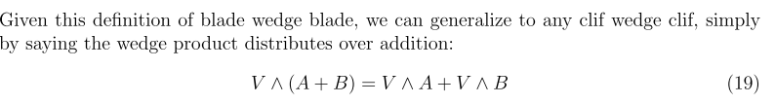
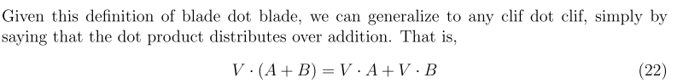

So this is not quite the last word, but points in that direction: associative and distributive for both products. And I think the rules for scalar + clif are pretty simple.

Wedge product a ^ b for Geometric Algebra over Rn

In GA(Rn) [ my notation ] , one has these graded animals:

grade name blade name basis elements shorthand
0 scalars 0-blade 1
1 vectors 1-blade {ei} i = 1..n ei
2 bivectors 2-blade {ei^ej}, 1 ≤ i < j ≤ n eij
3 trivectors 3-blade {ei^ej^ek}, 1 ≤ i < j < k≤ n eijk
4 quadvectors 4-blade {ei^ej^ek^el}, 1 ≤ i < j < k < l≤ n eijkl
5 and so on.

Warning: A 3-vector is an element of the vector space R3. A trivector is a 3-blade, and below I will argue that it is an element of vector space Λ3(Rn). They are totally different animals.

Conjecture: I think that in any Clifford implementation, if a and b are 1-blades (vectors), then this is true

a^b = - b^a // for vectors !

This is not always true for other entities a and b of the Clifford algebra. For vectors then

a ^ a = 0 // for vectors!

Analogy: Consider this chart of direct-product spaces

order name blade name basis elements shorthand
0 V0 1
1 V1 = V {ei} i = 1..n ei
2 V2 = V⊗V {ei⊗ej}, i,j = 1..n eij
3 V3 = V⊗V⊗V {ei⊗ej⊗ek}, i,j,k = 1..n eijk
5 and so on.

This is the direct product or tensor product I use in tensor doc. There are no real "names" for various fancy vector spaces here, perhaps the first column is called the order of Vn. You don't ask here how you should "calculate" e1⊗e2 . This is just a "basis vector" in the "direct product space V2 = V⊗V. It is made up of vectors ei of V. You can express any element of V2 as X = Σij Xijei⊗ej so it is a basis.

Conjecture: I think one should think of ei^ej in this same manner. It is a basis "element" of the "bivector space". It is not something you can "calculate" and more than you can calculate ei⊗ej .

Comment: I presume that e1⊗e2 and e2⊗e1 are two independent basis elements of V2.

Conjecture: Right now I don't know if the "k-blade space" is a vector space or not, I think it is because you can certainly add k-blades (to get another k-blade) and probably scalar mult is OK too. Then for k-blades, the dimensionality of the vector space would be the number of "basis elements" for that blade space. Within Rn this number is going to depend on both k and n. If n were very large, you could say for example that the dimensionality of the 3-blade space was n*(n-1)*(n-2) due to the i < j < k rule. So dim(3-blade) = n!/(n-3)! for large n.

Conjecture: Maybe Λk(Rn) is the name of the vector space associated with k-blades. In some sense then you might say

CA[Rn] = Σ⊕k=0kmax Λk(Rn) = a direct sum of vector spaces.

Shorthand notation: (Suter) Let

ei^ej^...ek ≡ eij...k // just a notation definition!

This will be used in the list of basis elements shown below.

Warning: eij...k =?= eiej...ek where the geometric product of the ei is implied (not sure). This will be resolved below!

Limitations for given n. Due to the vector rule a^b = - b^a, for a given Rn the number of rows in the above blade table is finite, not infinite. For example

R2 e1,e2 e12

R3 e1,e2,e3 e12,e23,e13 e123

R4 e1,e2,e3 ,e4 e12,e23,e13,e14,e24,e34 e123, e124, e234 e1234
4 4*3/2 4*3*2/3! 1
(4,1) (4,2) (4,3) (4,4)
....

Rn ei eij eijk eijll etc (n,1) (n,2) (n,3) (n,4) (n.n)

For example, the number of εijk basis elements is the number of ways to pick a committee of 3 from n.

Question: Is the vector rule a^b = - b^a valid for gij ≠ δij ?

Fact : for GA(Rn) there are a total of 2n basis elements all in all. (Trivial to add up the binomials.)

Definition: A multivector for GA(Rn) is any linear combination of blades of any allowed grade.

Definition: Because the elements of GA(Rn) can be written as linear combinations of k-blades where each k-blade has grade = k, GA(Rn) is called a graded algebra. This is unusual in my experience because usually all the elements of an algebra are all the same kind of thing, such as a matrix of some size.

Question: Is "the tensor algebra" T(V) a graded algebra? Yes, says wiki tensor algebra page!

Fact: Given a general multivector, you can write it as a unique sum of blade components. The notation for this is to say A = multivector, <A>r = the part of it that has grade r. This is like writing a vector as a sum of components on the basis vectors. Here maybe "basis elements" is a better term.

Metric tensor. In special relativity suppose we have basis vectors ui. Then we write

|ui|2 = gab(ui)a(ui)b = gab δiaδib = gii = ± 1 depending on g = G.

Some of my pdf's address things in terms of correct tensor notation, but most pdf's just use the usual Cartesian metric tensor gab = δa,b. In this context, we always have]

|ei|2 = gii = + 1

and then one just writes

ei2 = 1 i = 1...n for GA(Rn; Cartesian metric tensor)

Warning: The above talks about a metric tensor in a space like Rn which has n-vectors like ui In such a space distance is determined by the metric tensor as in ds2 = gijxixj. However, in the clif world, we don't have 3-vectors! We have trivectors and bivectors. The vector ei is not the same as ej in R3. These are different animals in different vector spaces. Nonetheless, we will later encounter a matrix gij which will be a "metric" associated with some CL(n) algebra, but it won't be the same as the tensor doc type metric tensor! [ But maybe I am wrong about the two kinds of ej when V = Rn ]

The dot product of vectors. For the Cartesian metric tensor, this dot product is just as it was in the usual world. However, it is presented in a new notation.

a.b ≡ a • b // for vectors a and b

Warning: I like to write a • b = gijaibj in the tensor doc sense. For example, e1• e2 = g12 . This dot symbol is thus suggestive of the tensor doc type vector spaces. HERE, in clif world, we should use the lower dot to make sure we don't confuse things. We might have ei.ej = gij, but that would be the dot product of two basis vectors in V, not of two 3-vectors in R3.

The dot and geometric product of basis vectors for different blade-spaces:

Conjecture: For example, ei . ekj = 0 . That is, basis elements in different blade spaces are orthogonal. Suppose this is true in general. Let's look for a counterexample:

e1 . e12 = e1e12 - e1^e12 = e2 - e1 ^ e1 ^ e2 = e2 - 0 = e2 ≠ 0

This counterexample then shows that with the dot product, basis elements of different blades are NOT in fact orthogonal. In the above gij = δij was assumed. My conjecture was wrong.
How about for the geometric product of basis elements in different spaces? Here is an example: (g = δ)
e1e123 = e1(e12^e3) = e1(e1^e2^e3) = ??

Later we learn that e1e123 = e23 for normalized basis vectors. Meanwhile, consider :

e1 ^ (e1^e2^e3) = (e1 ^ e1) ^e2^e3 = 0 ^e2^e3 = 0
Paradox?
e1 ^ (e1^e2^e3) = e1(e1e2e3) = e1e1e2e3 = e2e3 ≠ 0 // really e1^(e1e2e3)

Not a paradox. The second line has bad algebra. Assuming that e1^e2^e3 = e1e2e3 which will be shown below (for g = 1) , as for example, from Suter page 20,

the second line above says

e1 ^ (e1^e2^e3) = e1^ (e1e2e3)

and so you cannot finish this off as shown to get ≠ 0. Paradox resolved. In fact, this wedge product is 0 as the first line above shows.

Is the wedge product really associative? I thought it was. Think about the regular cross product

e1 x (e1 x e 2) = (e1 x e1) x e2 = 0 x e2 = 0

e1 x (e1 x e2) = e1 x (e1 x e2) = e1e1e2 = e2 ≠ 0

Is the cross product associative?

A x (B x C) = (A•C)B - (A•B)C

(A x B) x C = - C x (A x B) = - [ (C•C)B - (C•A)B ]

The answer seems to be NO. Wiki confirms with a counterexample. But I think the wedge product is. Yes, I am sure the wedge product is always associated.

Wedge product of two multivectors

Let's try this by brute force for R3 for a sample calculation.

A = 2 + 3e1 + 4 e23 + 5 e123

B = 1 + 2e1 + 2 e13 + e123

Then (I use the a^a=0 rule for vectors and the rule above about eabc..q ^ eABC..K)

A^B = (2 + 3e1 + 4 e23 + 5 e123)^(1 + 2e1 + 2 e13 + e123)

= 2 ^ (1 + 2e1 + 2 e13 + e123)
+ 3e1^ (1 + 2e1 + 2 e13 + e123) // eg, e1^e13 = e1^(e1^e3) = 0
+ 4 e23 ^ (1 + 2e1 + 2 e13 + e123)
+ 5 e123 ^ (1 + 2e1 + 2 e13 + e123)

= 2 + 4e1 + 4 e13 + 2e123
+ 3e1
+ 4 e23 + 8 e123
+ 5e123

= 2 + 7e1 + 4 e13 + 4 e23 + 15 e123 // agrees with Maple

= 0-blade + 1-blade + 2-blade + 3-blade

This blade distribution does not seem to agree with what I say in Denker?? I thought they were spaced by two grades?? Well, his comment was for the geometric product, not the wedge product.

Comment: I think that for any two multivectors A and B in GA(Rn) I could exactly compute the quantity A^B as done above,

Geometric product of vectors

Definition: The geometric product of vectors.

ab = a.b + a^b // no operator is displayed for this product! Just abutment ab.

We know that a.b is a scalar, and we know that a^b is a bivector (2-blade), so we find here that

(1-blade)(1-blade) = (0-blade) + (2-blade) .
ab a.b a^b

Given two 1-blades, it is easy to carry out this little equation. For example

(Σiaiei)(Σjbjej) = (Σiaiei).(Σjbjej) + (Σiaiei)^(Σjbjej)

= Σijaibj (ei.ej) + Σijaibj (ei^ej)

= Σijaibj δij + 2 Σi<j aibj (ei^ej)

= Σiaibi + 2 Σi<j aibj ei^ej
scalar bivector

Given the rules above, we find that (for vectors a,b)

2a.b = ab+ba
2a^b = ab-ba

Comment: When the first of these lines is applied to some basis vectors ei in CL(n), we get

eiej+ ejei = 2ej.ei

In a generalized clif world (see Maple related clif doc and Wheeler notes),

eiej+ ejei = 2gij

where gij is a "metric" (not a metric tensor!) and in that world we would then have

ei.ej = gij

This is the dot product of two clif basis vectors. In tensor doc, there is an analogous thing

ei• ej = gij

where ei is an n-vector, and gij really is a metric tensor. Please do not confuse these worlds!

Geometric product of two basis vectors. Since the ei are vectors, we can use this definition of eiej

eiej = ei.ej + ei^ej

If we assume that the "metric" gij just mentioned above has the form gij = δi,j then

ei.ej = δi,j

and then we find

eiej = ei^ej + ei.ej = ei^ej . // gij = δij and i ≠ j

On the other hand, if i = j we get

eiei = ei^ei + ei.ei = 0 + 1 ⇒ eiei = ei2 = 1

Summary: ( g = δ)

eij ≡ ei^ej = eiej = -ejei= -eji i ≠ j // orthonormal basis
eii ≡ eiei = ei2 = 1 i = j // Cartesian Rn

Again, "orthonormal basis" means that the "metric" is gij = δij.

Wedge product of 3 or more vectors

2! a ^ b = ab - ba // replace a wedge product with some geo products

3! a ^ b ^ c = abc + signed permutations

4! a ^ b ^ c ^ d = abcd + signed permutations

The first line is consistent with our earlier claim that 2ab = a.b + a^b.
The next lines are brand new and are built into any Clifford algebra I think. Can write the last one as

4! a1^a2^a3^a4 = a1a2a3a4 + signed permutations

= ΣP (-1)S ap(1)ap(2)ap(3)ap(4)

= ΣP εp(1)p(2)p(3)p(4) ap(1)ap(2)ap(3)ap(4)

I don't know how else to write this. On the right we have geometric products implied.

Let's write some of them specifically:

3! a ^ b ^ c = abc - acb + bca - bac +cab - cba

Warning: The above applies only when a,b,c are vector clifs, and are not valid for other clifs. But how do I know that? Maybe true also for clifs?

Wedge product of 3 or more basis vectors

For example we could have

4! e1^e2^e3^e4 = e1e2e3e4 + signed permutations

But since these are all different basis vectors, we have eiej = - ejei and this causes all terms to be the same and we then get

e1^e2^e3^e4 = e1e2e3e4

More generally,

ea^eb^ec^ed = eaebeced if all subscripts are different

Obviously if any two are the same, get 0, such as

ea^eb^ea^ed = - ea^ea^eb^ed = - (ea^ea)^eb^ed = 0

Summary:

ea^eb^ec^ .... ^eq = eaebec ....eq if all subscripts different

ea^eb^ec^ .... ^eq = 0 if any two subscripts are the same.

So I guess you could write

ea^eb^ec^ .... ^eq = εabc...q eaebec ....eq

This is in agreement with Suter page 20 Rule 1. This lets us trivially relate the wedge product of several basis vectors to the geometric product of those same basis vectors!

Geometric product of arbitrary basis elements of CA(Rn)

This can all be done based on what is stated above. Here are some examples

Example: e123e45 = (e1e2e3)(e4e5) = e1e2e3e4e5 = e12345

e123e15 = (e1e2e3)(e1e5) = e1e2e3e1e5 = e1e1e2e3e5 = e2e3e5 = e235

e1e123 = e1(e1e2e3) = e2e3 = e23 as appears in mult table Suter page 22
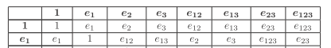

Rules for combining the geometric and wedge products. If a,b,c are all vectors, then

Rule 1: (a^b)c = [ab - (a.b)]c = abc - (a.b)c where a,b,c are all vectors

Rule 2: c(a^b) = c [ab - (a.b)] = cab - (a.b)c where a,b,c are all vectors

Warning: (a^b)c ≠ (ac^bc)

Geometric product of two arbitrary multivectors

Let's do the same example done above for the wedge product

A = 2 + 3e1 + 4 e23 + 5 e123
B = 1 + 2e1 + 2 e13 + e123

AB = (2 + 3e1 + 4 e23 + 5 e123)(1 + 2e1 + 2 e13 + e123)

= 2(1 + 2e1 + 2 e13 + e123)
+ 3e1(1 + 2e1 + 2 e13 + e123)
+ 4 e23(1 + 2e1 + 2 e13 + e123)
+ 5 e123(1 + 2e1 + 2 e13 + e123)

= 2 + 4e1 + 4 e13 + 2e123
+ 3e1 + 6e1e1 + 6e1 e13 + 3e1e123
+ 4 e23 + 8 e23e1 + 8 e23e13 + 4 e23e123
+ 5 e123 + 10 e123e1 + 10 e123 e13 + 5 e123e123

Now I have to compute all these combinations

e12 = 1
e1e13 = e1e1e3 = e3
e1e123 = e1e1e2e3= e2e3 = e23
e23e1 = e2e3e1 = e1e2e3 = e123
e23e13 = e2e3e1e3 = - e2e3e3e1 = - e2e1= e1e2 = e12
e23e123 = e2e3e1e2e3 = e3e1e2e2e3 = e3e1e3 = - e1
e123e1 = e1e2e3e1 = e2e3= e23
e123 e13 = e1e2e3e1e3 = e2e3e3 = e2
e123e123 = e1e2e3e1e2e3 = e2e3e2e3 = - e2e2e3e3 = - 1

One could of course look these all up in the multiplication table of Suter
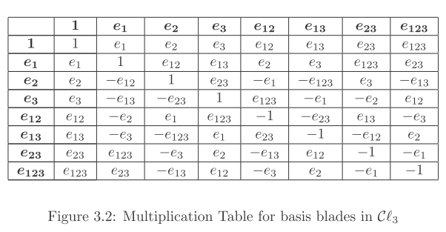

I have just checked each of my results above. So continuing with our example

AB = 2 + 4e1 + 4 e13 + 2e123
+ 3e1 + 6e1e1 + 6e1 e13 + 3e1e123
+ 4 e23 + 8 e23e1 + 8 e23e13 + 4 e23e123
+ (5 e123 + 10 e123e1 + 10 e123 e13 + 5 e123e123)

= 2 + 4e1 + 4 e13 + 2e123
+ 3e1 + 6 + 6e3 + 3e23
+ 4 e23 + 8 e123 + 8 e12 - 4 e1
+ (5 e123 + 10 e23 + 10 e2 - 5)

= 3 + 3e1 + 10e2 + 6e3 + 8e12 + 4 e13 + 17 e23 + 15 e123 // agrees with Maple

0 1....................1 2...........................2 3

Fact: I know how to compute the geometric product of any two arbitrary multivectors.

Geometric product of two blades

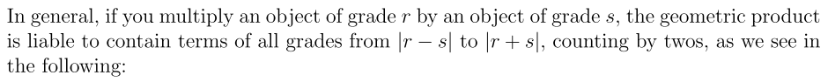

So consider this example where we show a most general r-blade A and most general s-blade B:

A = ΣIJ..Q AIJ..Q eIJ..Q // sum has only increasing orders, r indices

B = ΣI'J'..Q' BI'J'..Q' eI'J'..Q' // sum has only increasing orders, s indices

Then

AB = ΣIJ..Q ΣI'J'..Q'AIJ..Q BI'J'..Q'eIJ..Q eI'J'..Q'

Now think about this product

eIJ..Q eI'J'..Q'

where each can have a different number of subscripts. This is of course

eIeJ....eQeI'eJ'....eQ'

Now this represents in general an (r+s) blade if all indices are different.
If one pair of indices match (this can only happen between the primed and unprimed sets!) then
we have an (r+s-2) blade. And if two pairs match, we have an (r+s-4) blade. And so on.

Suppose s = r. Then blades go all the way down to 0-blade.

Suppose s > r. Then at most r pairs could match! Then we go down to r+s-2r = s-r.

Suppose r > s. Then at most s pairs could match! Then we go down to r+s-2s = r-s.

Fact: Therefore the product of two pure-blade clifs results in a sum of k-blades where k ranges from r+s down to |r-s| in steps of 2, exactly as Denker claims.

At this point I went off and found the Maple V Clifford package, got it installed after the usual fumbling around, and was able to verify my calculations A^B and AB above! Not bad. In those notes, I wandered off and finally learned what Maple means by talking about a clif world with a bilinear form B. That thing B is exactly the metric gij mentioned above and which we take to be δi,j in our current activity. So we can just forget about B and gij for now and stay with the world where gij = δi,j. Our friend Wheeler uses the gij general approach.

Loose End #1. How do I explain the definition of CL(n) using the word "ideal" as I see done several places?

2. Clifford Algebra developed from a quadratic form Q(v); the metric G(u,v)

This is a standard concept and leads to a fully defined Clifford algebra with an arbitrary metric. But there is no wedge product even mentioned, as if the wedge is something you add on later!

Where did I get the approach stated below? It is based on work in my own maple clifford doc which in turn comes from Wheeler's pdf.

Let's to instead to wiki on Clifford. Suppose Q(v) is a quadratic form, which just means Q(v) = ΣijAijvivj. It is not the identity quadratic form, it is just some quadratic form. Matrix A might as well be symmetric. Now, suppose we indicate by v,w ... the vector elements V. In order to have some Cl(V), we have to have a definition of the geometric product which I will indicate by abutment of symbols. That is to say, we need to know what vw is, for example. Suppose we require that

vv = Q(v) 1

By assuming that 1 is an element of our Cl(V), we have said that Cl(V) is a unital algebra, fine. Now the components of some vector v are presumed to be elements of some field K. Then vi is in K, and Aij is in K. This field K is our "scalars", often these are taken to be reals, so K = R. So Q is in K, at any rate. Now if we assume only the above equation is valid for any vector v in V, then we can write

(v+u)(v+u) = Q(v+u) 1

since v+u is just some vector v' in V. Since V is a vector space, we can add its elements. Notice that

Q(v+u) = ΣijAij (vi+ui)(vj+uj) = Q(v) + Q(u) + A(v,u) + A(u,v)

where we have now defined, based on our quadratic form Q =ΣijAijvivj a new object which we call
A(u,v) = ΣijAijuivj which would be called a "bilinear form". Lets just define

B(u,v) = (1/2)[A(u,v) + A(v,u)] = symmetric in u and v.

Then we have shown above that

Q(v+u) = Q(v) + Q(u) + 2 B(u,v)

This strange equation gives us a bilinear form B in terms of our quadratic form Q:

B(u,v) = (1/2)[ Q(v) + Q(u) - Q(v+u)]

Now go back to statement (*)

(v+u)(v+u) = Q(v+u) 1
or
vv + uu + uv + vu = Q(v+u) 1

We rewrite each side now to get

Q(v) 1 + Q(u) 1 + uv + vu = [Q(v) + Q(u) + 2 B(u,v)] 1

Simplifying, we find that

uv + vu = 2 B(u,v) 1 (***)

This result is basically "induced" from the original quadratic form Q(v). We don't have an expression for the geometric product uv, but at least we know something about uv + vu : it is a scalar times the identity!

Now let's assume there are some basis vectors ei in V. Then

u = Σiuiei
v = Σjvjej

B(u,v) = Σijuivj B(ei,ej) (**)

This result follows due to the form of B above, which says that B is "bi-linear":

B(u,v) = (1/2)[A(u,v) + A(v,u)] = ΣijAijuivj + ΣijAijviuj

So B(u,v) is linear separately in each argument. So that is where (**) comes from. Now define the matrix elements Bij = B(ei,ej) which [ in our development here] is a symmetric matrix. We then have

B(u,v) = ΣijBijuivj = itself a bilinear form!

Meanwhile. from (***) we find

eiej + ejei = 2 B(ei,ej) 1 = 2 Bij1

So let us now Summarize what was just done.

1. Assume V is a vector space over K and that V has vectors like v and w and v + αw where α is a "scalar" which means α is in the field K. Often we have K = R but here just keep it K.

2. If ei are some basis vectors in V, then an arbitrary vector can be written v = Σiviei. The components like vi are in the same field K as α above.

3. We are trying to "define" Cl(V) where V is the above vector space. We assume at the start some quadratic form Q(v). We just pull one out of the thin air. We also assume that Cl(V) has an identity element for the geometric product which we refer to as 1.

4. We assume that "diagonal" geometric products in CL(V) have this form

vv = Q(v) 1 Q(v) = ΣijQijvivj

which says that all diagonal elements are multiples of the identity element 1. Here Q(v) is not just any function, it is a quadratic form, which means Q(v) = ΣijQijvivj for some matrix Qij.

5. The following is then also true

(v+u)(v+u) = Q(v+u) 1
or
vv + uu + uv + vu = Q(v+u) 1
or
uv + vu = [ Q(v+u) - Q(u) - Q(v) ]1 .

If we define the following symmetric scalar function

2B(u,v) ≡ Q(v+u) - Q(u) - Q(v)

the above says

uv + vu = 2B(u,v) 1

This says that the anti-commutator of any two elements of CL(V) is a multiple of the identity element!
We don't however have an explicit expression for uv.

Note in passing that

B(u,u) = Q(2u) - Q(u) - Q(u) = 4 Q(u) - 2 Q(u) = 2 Q(u).

and we then find

uu + uu = 2B(u,u) 1 = 2 Q(u)1

and we recover our starting point which said uu = Q(u)1.

6. We can write out

Q(v+u) = ΣijQij(v+u)i(v+u)j = Q(v) + Q(u) + ΣijQij [viuj + vjui]

and therefore

2B(u,v) = ΣijQij [viuj + vjui]

This shows that B(u,v) is a "bilinear function" meaning it is linear in each of its two arguments.

7. Assume now that the vector space V has a basis {ei}. Then item 5 above says that

eiej + ejei = 2B(ei,ej) 1

If we define that following nxn symmetric square matrix Bij

Bij ≡ B(ei,ej)

we then find that

eiej + ejei = 2Bij 1

8. Summary. We have defined a Clifford Algebra CL(V,K,B,n) which has these properties:

uv + vu = 2B(u,v) 1 B(u,v) = a bilinear function

eiej + ejei = 2Bij1 Bij ≡ B(ei,ej)

The matrix Bij is often written gij and is referred to sometimes as the "metric" of the CA.

Comment: The above prescription defines a Clifford Algebra Cln(V,K,B) all of whose elements are vectors. But this is not the same as the graded Clifford Algebras we have considered earlier, which have elements which are scalars, vectors, bivectors, trivectors and so on. More work I guess is needed by some kind of induction to "get to" the larger Clifford Algebra.

However: Given the ei of the above construction, in order to be a algebra, it must be true that all these objects are contained in the algebra:

uv uvw eiej eiejek

The algebra has to be closed under the abutment geometric product, so all these elements must exist within our algebra Cl(V,K,B) . We just failed to notice them in the previous paragraph!

Now given this rule from above

eiej = - ejei + 2Bij1

we can always obtain from any eiejek .... combination a combination in which the indices are in increasing order. We just keep doing swaps until this is the case. If we find two indices the same, then we use the fact that eiej= Bii1 to get rid of that pair.

Thus, our Clifford space is spanned by the following set of objects

eiejek .... eq k factors, say

How many index possibilities are there for each value of k ? If you ask how many index choices there are for k factors ignoring the increasing rule, you find n * n *....*n (k times) = nk choices. But we have to rule out choices for which two indices are the same, since such terms get reduced by eiej= Bii1. So we really want the number of choices where all indices are different, and that is going to be

choices all different = n*(n-1)....(n-[k-1]) = n!/(n-k)!

But of these if we insist on increasing order, then we have overcounted by k!, so we end up with the well known result

number of basis elements with k factors = (n,k) = binomial

If you then add up everything, you find

number of basis elements with any number of factors k = 1 to k = n = 2n

So now we restate our conclusions:

1. Cln(V,K,B) has dimension 2n . The number of vector basis elements is only n, and the number of scalar basis elements is one (namely, 1), and the number of bivector basis elements is (n,2) = n(n-1)/2 . For large n, obviously most of the basis elements are NOT the basis vector elements.

2. The basis elements are these (indices must be in increasing order)

eiejek .... eq k factors, where k = 1,2.....n

3. Based on our rules that

eiej = - ejei + 2Bij1

ei2 = Bii1 // special case of the above rule

we can compute any product of ei's that we want! They don't have to be in increasing order, some can be the same, whatever. We know exactly how to do it. Any such product will be a linear combination of scalar factors times basis elements.

4. Since we can expand any vector like u as u = Σiuiei , we also know how to compute any product of vectors such as uvwz. You just grind it out. Maple can do it for you!

5. We also know how to compute geometric products of any "clifs" in the algebra, not just vectors! For example, suppose we have

b = Σi<j bijeiej = some arbitrary bivector

c = Σi<j<k cijkeiejek = some arbitrary trivector

Then the geometric product of those two guys is going to be

bc = Σi'<j' bi'j' Σi<j<k cijk e'ie'jeiejek

and it is then just a question of grinding out all the terms!

6. From a single quadratic form Q(v) and field K and vector space V we have constructed our entire Clifford algebra Cln(V,K,B). We know it is graded, with various k-blade elements. Linear combinations of these k-blades are multivectors. We know exactly how to multiply any two multivectors in Cln(V,K,B).

7. Notice that there has been NO MENTION of any wedge products! I guess you don't need to have a wedge product in order to have a Clifford algebra with its geometric product. I want to come back to this fact and see how wedge products are added on to a Clifford algebra.

3. The Ideal Mystery

Back to that ideal mystery again. From Korman we had

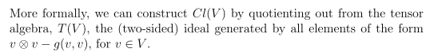

What on earth does this mean? I guess we could start with ei⊗ej as a basis for V2. This has an identity element 1⊗1 I presume. So I guess I can say that

v⊗v - g(v,v) 1⊗1

is an element of V2. Another way to write this is

ei⊗ei - gij 1⊗1 is an element of V2

Question: is the set of elements of the above form closed?

[v⊗v - g(v,v) 1⊗1][u⊗u - g(u,u) 1⊗1]

= vu⊗vu - g(v,v)u⊗u - g(u,u) v⊗v - g(v,v) g(u,u) 1⊗1

This does not appear to have the same form as v⊗v - g(v,v) 1⊗1, so I guess this piece of V2 is not closed as I hoped it would be. It would work if I could show that

- g(v,v)u⊗u - g(u,u) v⊗v - g(v,v) g(u,u) 1⊗1 = -g(vu,vu) 1⊗1

This just makes no sense, so I need another author to explain it.

Ablamowicz outlines this business with the ideals on his page 3, but he does not give me enough to go on. But he does give lots of references which I will collect right here

6,8,10,12,14,34,48,60

[6] I.M. Benn, R.W. Tucker; Introduction to Spinors and Geometry with Ap-
plications in Physics, Adam Hilger, Bristol, 1987. In researchgate, have to request.
I found a download that is very slow here http://en.bookfi.org/book/1444356 .

[8] N. Bourbaki; Algebra 1, Chapters 1—3, Springer Verlag, Berlin, 1989.

[10] P. Budinich, A. Trautmann; The Spinorial Chessboard, Trieste Notes in
Physics, Springer, 1988. Have it, too advanced.

[12] C. Chevalley; The Algebraic Theory of Spinors, Columbia University Press,
New York, 1954.

[14] A. Crumeyrolle; Orthogonal and Symplectic Cliﬀord Algebras, Spinor
Structures, Mathematics and its Applications, Kluwer, Dordrecht, 1990.

[34] W.H. Greub; Multilinear Algebra, Springer, Berlin, 1967.

[48] P. Lounesto; Clifford Algebras and Spinors, Cambridge University Press,
Cambridge, 1997.

[60] I. Porteous; Topological Geometry, Van Nostrand, New York, 1969.

Can I get hold of any of these sources? Yes.

Item [6] has some relevant stuff on page 10. First we have

(a) Benn and Tucker

sometimes called Vr
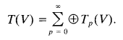
So this monster thing T(V) is called "the tensor algebra" and includes direct product spaces of all orders. That is just fine by me. NOW we go to page 10 to see this:

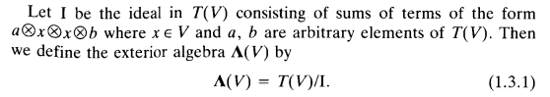

This does look a little like someone else's thing. Now why is this an ideal? Now it is pretty simple:

d⊗[a⊗x⊗x⊗b] where d is some general element of T(V) with some arb number of crosses.

Obviously you can write this as

a'⊗x⊗x⊗b where a' = d⊗a

so left multiplication by any element of the larger space T(V) produces an element inside the ideal. And similarly for right multiplication by some d. Why is this ideal closed? Consider

a⊗x⊗x⊗b ⊗ a'⊗x'⊗x'⊗b'

= a⊗x⊗x⊗b⊗a'⊗x'⊗x'⊗b' = a⊗x⊗x⊗[b⊗a'⊗x'⊗x'⊗b'] = a⊗x⊗x⊗b"

So the product of any two elements in the ideal lies in the ideal, the ideal is closed.

Now we have to remember what the quotient business is all about. In my ideal-of-a-ring discussion on page 22 of Galois, I construct a chart like this.

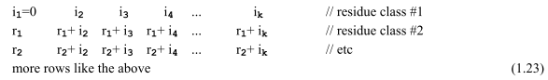

The idea is that all the elements of a row have something in common. When you talk R/I you are making a new ring whose elements are rows of the chart, the residue class ring or quotient ring. In terms of this quotient ring, all the elements of a given row are equivalent.

Now Benn and Tucker continue on:

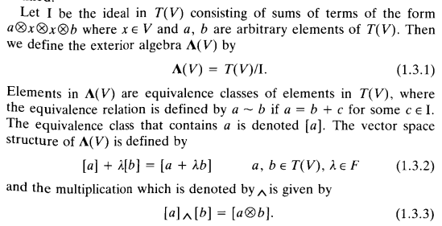

Once we have identified that I is an ideal, we can define the quotient thing just as in my Galois doc, though there I was only talking rings. So how if you take any T(V) element r1 call it, then a row of the chart is going to have

r1, r1+ all T(V) elements of the form a⊗x⊗x⊗b

Suppose we have r2 = r1 + some element of I = r1 + i. Then r2 and r1 are equivalent, r2~ r1. I would call the equivalence class of r1 by the name {r1}, but these guys will call it [r1], fine. So I would say

{r1} + {r2} = {r4}, where r4 = r1+r2

and I could also say

{r1} + λ {r2} = {r4}, where r4 = r1+λ r2 = { r1+λ r2}

which is like their (1.3.2). I also have

and I guess • here would be ⊗ within T(V). So I would say

{r1} • {r2} = {r3) where r3 = r1⊗r2

or in their notation,

[a] • [b] = [r3] where r3 = a⊗b = [ a⊗b]

They then claim that in this context, • is the wedge product! So I guess I moved forward a baby step or two here. but I miss the main point of why I should care about T(V)/I and why this is Λ(V) which is related to antisym functions and all that. Where does this a⊗x⊗x⊗b have any significance? I am just dead as a rock in appreciating this little discussion.

Let's now go back to

(b) Ablamo

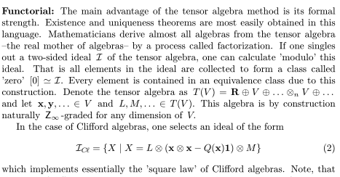

So now I know what T(V) is and I agree that T(V) = T ⊕ V ⊕ V2 ⊕ ..... ⊕ Vn .
and he refers to Vn as ⊗nV meaning V ⊗ V...⊗ V, densepack notation. Then instead of a and b, he uses L and M as two elements of T(V). But now the ideal is a little different!

ideal = elements of the form L⊗ ( x⊗x - Q(x)1) ⊗M

where now we have a connection with our x⊗x = Q(x)1 "generator" of the Clifford algebra.

I would say that for a Clifford algebra, we have (x⊗x - Q(x)1) = 0, and so every element of this ideal vanishes. But that is not in general true for elements x⊗x - Q(x)1 of T(V)..

I can see that the elements above really form an ideal, which call I. So what are the rows now?

{r1} = a row = r1 + any element of the form L⊗ ( x⊗x - Q(x)1) ⊗M

The top row of the chart has r1 = 0 so we can say

{0} includes 0 and any L⊗ ( x⊗x - Q(x)1) ⊗M

In the general T(V) world, this {0} row contains lots of T(V) elements.
In the T(V)/I world, however, all those elements are equivalent.

Question: In the Clifford definition, we had xx = Q(x)1 where xx was using the abutment geometric product. But here he is talking x⊗x . How is this connected?

This is some kind of culling process. We start with all possible direct product terms in V(V), but now we are basically throwing out a lot of terms. For example, the terms x⊗x - Q(x)1 are thrown out for any vector x in V. Throwing out these terms is somehow isomorphic to requiring that xx = Q(x) in the Clifford Algebra. We thus zero out any term of the form xx - Q(x)1 in the Clifford algebra. Such a term is exactly 0, whereas in the isomorphism, we have such terms being the row {0} . Thus, the element {0} of the quotient algebra T(V)/I is isomorphic to the element 0 = xx - Q(x)1 of the Clifford algebra.

OK, enough on this. I think I get the basic idea. One I know what they are talking about, I won't be needing it for anything. Here are a few other people's statements of this idea: (just above I state Ablamo's version).

(c) Korman is like Ablamo

(d) wiki exterior algebra page is like Benn and Tucker

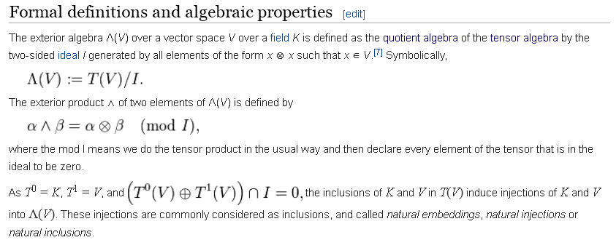

The connection to the wedge product eludes me. Here throwing out x⊗x seems to mean that x x = 0 which is something we want, but this is not really the same as Ablamo. In the wiki version, we are throwing out all elements of V(V) which have the form a⊗x⊗x⊗b . We are in effect setting all such elements equal to 0. When we do that, A⊗B becomes A^B for any A and B in T(V). For example,

a ^ x ^ x ^ b = 0 because this is in the ideal

a⊗x⊗x⊗b ≠ 0 as a general thing in T(V)

Benn/Tucker and Wiki both talk about ^ in this ideal context. Ablamo and Korman I think are just talking about the isomorphism idea. Keep in mind that x ^ x = 0 ⇒ x ^ y = - y ^ x.

I guess I am vaguely happy with this. When I first say the quotient thing, it was a complete blank.

Continuing 9.2.15.

Quotient space of a vector space. I noticed in wiki the notion that for a vector space V (not an algebra), which has addition and no multiplication, if you have a subspace S, then the quotient space V/S is a vector space. Vector space is an additive group according to my Galois doc: closed, identity 0, inverse -v, happens to be commutative. This quotient space idea is discussed in B&M page 206. Remember that a subspace contains the identity 0 and is closed under addition, and their example is, for R3, that S = (0,*,0) where * is any real value, unit vector (0,1,0). It is closed, and (0,0,0) is in S, for * = 0. In this example, the rows of my chart (he does call them cosets!) are {v} = elements of the form v + (0,*,0) where v is in V. That is to say elements of the form (a,b+*,c) = (a,*,c) where * takes any value. So the first row contains V elements of the form (0,*,0) . If the coset leaders are (a,b,c), then the coset (row) is all elements (a,*,c) of V. Call this row {(a,b,c)}. Why do these rows themselves form a vector space? Consider {(a,b,c)}+ {(a',b',c')}, the sum of two rows. The elements of this set are (a+a', *, c+c') = {(a+a', b c+c')} which is another row, so things are closed under addition. and α {(a,b,c)} = {(αa,αb,αc)} is also another row in S. Thus, the rows {..} form a vector space. This row space then: V/S = quotient space of V relative to subspace S = a vector space in its own right.
B&M then go on to show this proof for an arbitrary V and subspace S. You sort of "divide out" the elements of a row and treat them all as one element of the quotient space. For example, the {0} row is contains all vectors of the form (0,*,0) and we treat these all the same.

4. DIRECT PRODUCTS OF THINGS

Direct product of two Groups. This is discussed B&M p 156 as follows: [ note that B&M don't do very much with direct product or outer product stuff, you don't really see V⊗V stuff in that book. ]

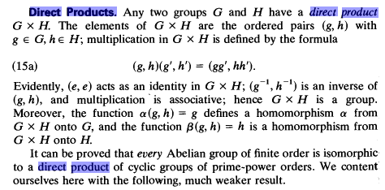

My purpose in showing this is to show that multiplication rule (15a). As an example, if G and H were two vector spaces, each is a group under addition, so that rule would say

(g,h)(g',h') = (g+g',h+h')

and this is how you would "multiply" two direct product group elements. But you would likely use a different symbol for an additive group, perhaps this

(g,h) + (g',h') = (g+g',h+h')

which shows how to "add" two elements of the direct product group.

Question: Do the vectors of a Clifford form a group under geo mult? Consider e1e2 as the geometric product of two vectors. Each is a vector or 1-blade. The product is a 2-blade, so the set of Clif vectors itself is not closed under geo mult. But the set of all clifs certainly is closed under geo mult. There is a 1 clif in its scalar world. But inverse is a harder problem. For example, within the 1-blade part, is there a b so that ab = 1 for any a? I would have to study that. And does every clif have an inverse? I suspect the clifs do not form a group under geo mult.

Direct product of two vector spaces. For A ⊗ B is that the elements are (ai,bj). What else can one say? Since A and B are groups under addition, one can choose to define addition in A⊗B according to
(a,b) ⊕ (a',b') = (a+a',b+b') as noted above, as verified in https://en.wikipedia.org/wiki/Direct_product .
Here I use a different symbol ⊕ to clarify that it applies only in the direct product space. Since a vector space in general has no • operation, you cannot really say anything at all about the product of elements in A ⊗ B . So this is really all we know about V⊗V and V3 and so on and T(V) in total. In particular, the following makes no sense at all: (a,a')⊗(b,b') = (ab,a'b'). Meaningless since no mult. The symbol ⊗ is OK to use in the A⊗B direct product of two vector spaces, but (a,a')⊗(b,b') has no meaning at all! However, this is another viable rule:

(αa) ⊗ b = α (a⊗b)
(a + a')⊗ b =(a⊗b)+ (a'⊗b)

These rules appear in the wiki vector space discussion: scalar rules and distributive rules

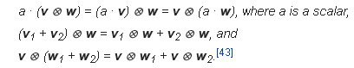

Direct product of two Rings. Consider again A ⊗ B is that the elements are (ai,bj). Ring is a group under addition, so you get the above addition rule as a possible thing to define for the direct product. Although • exists for a ring, ring elements do not form a group under • because there might be no inverses and no identity. One could define (a,a')•(b,b') = (ab,a'b') as is done for a group. This operation in the direct product seems to be closed, there is likely no inverse and no identity. So I would guess that the direct product is in fact a ring. Could show associative I think.

Direct product of two Hilbert spaces? In the additive sense this is the same as direct product of two vector spaces. Can we make it fly with mult somehow? Again consider A ⊗ B with elements (a,b). Let's try this idea: (a,b)• (a',b') = (a•a',b•b') This seems offhand pretty reasonable, and in fact I do this in (E.1.5) of tensor doc. So I guess this direct product is a new Hilbert space. This idea is supported on the wik page https://en.wikipedia.org/wiki/Tensor_product_of_Hilbert_spaces . There they write the elements of the direct product space as a⊗b instead of (a,b) which is fine. Then rule is a⊗b • a'⊗b' = (a•a',b•b').

Direct product of two algebras ? First, an algebra is something with +. • and scalar mult. This last is meaningful for "algebra over a field" where the field contains the scalars. Might be commutative or associative, sometimes these things are assumed. Might not be closed I suppose. A group or ring or a Hilbert space is an algebra by this definition, but a vector space is not since no mult. A Clifford algebra has several kinds of mult operations, but the geo mult I think is the most basic. And it has addition. It is closed under both. So probably you can talk about the direct product of two Clifford algebras and I see some web reference to this here and there. Not a topic of much interest to me.

How is the wedge product defined most generally?

I have shown above how you can construct a complete Clifford algebra based on a metric g where there is no mention at all of a wedge product.

Now one possible answer to this question is that you first define a wedge product only for the vectors in your Clifford space in this manner":

a ^ b = AS(ab) = (1/2)[ ab - ba]

a ^ b ^ c = AS(abc) = (1/6) [ abc - bca + .... ]

This approach would then define wedge products of vectors in terms of the geometric products of vectors which products are clearly defined for the Clifford algebra. You could then probably extend this using basis elements to obtain general wedge products of clifs.

Another approach might be to do the above and try to claim it works where a,b,c are any clifs at all?

Now the Clif theory without wedge was based on my Wheeler PDF. So how does Wheeler then introduce wedge products? Answer: he never mentions them at all! I found Wheeler's web site and see this pdf sitting there. He is a physics guy like me and this is really his only Clifford document, so I am not going to get my wedge answer from him.

So I will now scan through my collected pdf's and see what I can find.

Ablamo -- way too complicated, uses the ideal thing.

Chessboard. This is a 37-page photo thing, so I am now doing ocr with xchange at "high" quality, then maybe I can search for "wedge" or outer product. Done, and no mention of wedge and no ^ symbols!

Korman -- no wedge and no ^. Exterior appears once, but not helpful.

Pause: this does make me think the wedge really is an "add-on" and is not part of the basic Clifford theory!

Benn-Tucker. They do have ^, so I am going to do OCR on this book of 184 pages. Probably a good source to have in general and I want OCR. Done. Wedge and outer do not appear. Exterior does appear.
In this book, exterior algebra appears right at the very start, before Clifford is even mentioned at all. So that does make it seem a completely separate animal.

Benn Tucker Notes for Chapter 1.

An overview is presented, and it is noted that support materials are in Appendix A. But I now see that my PDF ends prematurely at page 184 of 360 pages! I got this thing at en.bookfi.org/book/1444356 and that is where the partial copy exists. But that site has another similar download of a different size, maybe that is the rest of the book? Well, this smaller second download (5 MB instead of 13) is in fact the whole book, so this is the one I will use. I can view it 2-up. I saved the original and am now running OCR at medium level which is pretty fast.

1.1 The Tensor Algebra. Noted that V* = the dual space = functionals on V, not new to me. Think of such a functional X in terms of X(x), fine. But he wants us to also think of X(x) = x(X), so what does that mean? It means nothing to me. just an equation. Similarly, the set of maps on V*⊗V*.... is a set of multilinear maps which make this thing a vector space just the way V* is by itself. They want to refer to such maps as "tensors of degree r". My φ(x) scalar field is of degree 0 I guess. My A(x) vector field Ai(x) is NOT what they are talking about. So this is new use of the word "tensor", fine. For me, a tensor field of rank 2 would be Aij(x), whereas for them it is A(x,y). They even claim order was called rank. I still think these are different animals. For me, tensor is related to the transformation rule relative to some transformation. They discuss multilinearity. Maybe A(x,y) is a continuous index version of Aij , who knows. First equation is this big one:

The xi are in V, so (x1....) is in Vr. The above equation is VERY strange. It all seems backwards, just as they said it would be (perverse). I guess since there are as many x as there are X, you can think of it as a reversible one to one. So let's continue. The spaces V and V* are just reversed here. I guess we can do that. Despite this confusion, they claim that ei⊗ej..... is a basis for Vr and this defines Tr(V), a vector space, and I like that just fine.

the tensor product r times

They go on to say

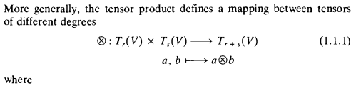

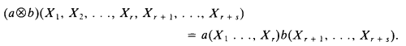

and that is the familiar Spivak equation, but in reverse somehow. We then get this idea where we add up graded spaces to get the total "tensor algebra"
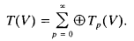

It is a Z-graded algebra, but I only like of for non-negative integers.
Next comes some song and dance about an "automorphism" η which divides things into even and odd parts. Let's try to skip that discussion. They go on to talk about anti-automorphisms, involutions, and interior derivatives, all totally strange. So I have to ignore all that and hope it won't matter. We are at the end of Section 1.1 of this book, I wonder how many readers are still alive at this point?

1.2 The Exterior Algebra of Antisymmetric Tensors. This is what I want to understand, good luck!

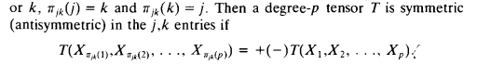

OK, we keep going with the reversal of x and X which is fine. π is a permutation which swaps j,k though that is not very clear here. Yes, get a + for sym, get a - for antisym. Tensor can be "totally symmetric" or "totally antisymmetric". Here comes a biggie:

" The subspace of antisymmetric tensors in Tp(V) is called Λp(V)"

Elements of this subspace are called p-forms, or "exterior p-forms".

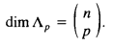

Here is their antisymmetrizer operator

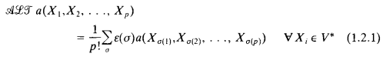

Holy cow, instead of Alt we get ALT written as ALT, a bit over the top for me. Again, the arguments are cap X instead of lower x, but same idea. Alt is a projection operator and

Λp(V) = Alt [ Tp(V)] Λp(V) = Alt [ Λp(V)]

A familiar thing to me, Spivak of course mentioned it.

Question: Give me an example of an element of Λ2(V) . How about (1/2) [ X1⊗X2 - X2⊗X1]. We get this from the starting element of T2(V) called X1⊗X2. B&T can 't be bothered with examples.

Here we go with the wedge:

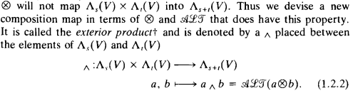

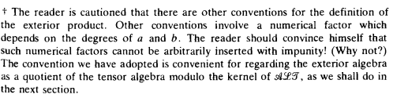

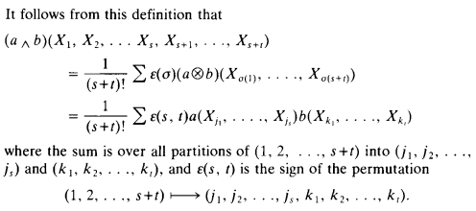

So you do the product as shown, and then you antisymmetrize that, and I think this is similar to Spivak except perhaps for the constant. The result of course will be antisym in any pair of Xi and Xj. So we have arguments of a ^ b, just as with other authors.
He then proves that:

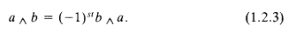

which agrees I think with something I did at an earlier point. You do NOT have a simple minus sign.
But what are objects a and b here?? As shown above, a lies in Λs(V) and b lies in Λt(V) .

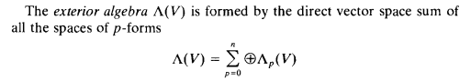
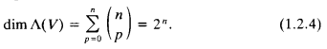

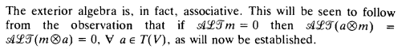

So they launch into a proof (not an axiom) that things are associative.

1.3 The Exterior Algebra as a Quotient of the Tensor Algebra.

I have reviewed this elsewhere, it is the ideal business.

STOP in Ben/Tucker for now. It is good but a bit over my head, not my kind of text writing. But it is very precise, I will give them that.

Comments: Apart for the strange (perverse) inversion of the roles of x and X, and apart from the use of the word "tensor" which I am not too happy with as they use it, they basically repeat the Spivak stuff. So this tell me that the wedge product has nothing at all to do with Clifford algebras! The objects a and b seem to be functions or s or t vector arguments which each are in V or maybe V*.
It is not clear to me exactly what a and b "can be". Are they vectors in V? For a simple VxV situation I guess a and b are either both vectors, or the are functionals that are vectors in the dual space. But they could be multifunctionals or multilinear functions.
I don't really like the Benn/Tucker presentation, it just fails to "speak to me". It is for a different class of reader. But its presence at the start of the book does really divorce if from Clifford. I see functions that get multiplied, I don't see clifs or clif vectors getting geometrically multiplied anywhere.
So the next problem is how to tie this function-based discussion to Cliff World.

I would like to find a different presentation of exterior product that is more up my alley.

I will go reread my Spivak notes right now.

