Notes on the Hitchin Exterior PDF PhL 8.31.15

1. Who wrote the PDF?

He has no name on his doc, but I found it this way:

When I get a Google link to a PDF, how do I find the source. For example,



The link is some google mess,

https://www.google.com/url?sa=t&rct=j&q=&esrc=s&source=web&cd=1&cad=rja&uact=8&ved=0CCAQFjAAahUKEwiH09zS5NPHAhVMFpIKHYyYANo&url=https%3A%2F%2Fpeople.maths.ox.ac.uk%2Fhitchin%2Fhitchinnotes%2FProjective_geometry%2FChapter_3_Exterior.pdf&ei=1IbkVYeZG8ysyASMsYLQDQ&usg=AFQjCNExgeyztIomrtqUzocjV5AmpnreUw&sig2=MmsCmmYaQAwOJXoSjeGJeQ

and if I copy the green link it is incomplete:

https://people.maths.ox.ac.uk/.../Chapter_3_Exterio...

BUT, look at the google link and you see a name Fhitchin. But there is no-one there by that name. Oh, duh, it is F Hitchin and we have a nice picture, he is even an FRS, prof of geometry.

http://people.maths.ox.ac.uk/hitchin/

and now we see his full set of notes, 4 chapters. So I will adjust my PDF doc name .

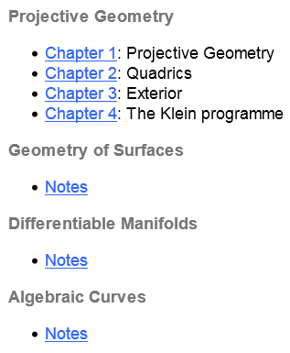

2. Notes on his PDF.

How can I get Maple cmul to work better without having to state some K matrix? What is going on here?

Question: What does Maple mean by saying B is "the bilinear form" ? I think this is just a 2-multilinear function. Here is something from my "chapter_3.."doc: (now known as Hitchin, and really Ch 4)

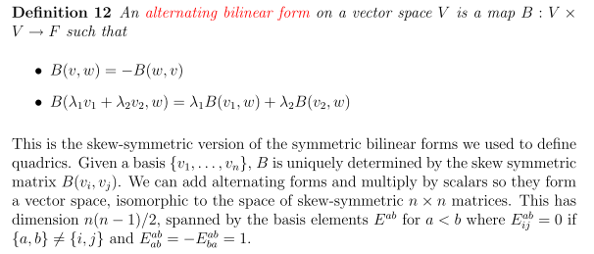

OK, so B is a linear mapping from VxV into some F which I guess is a field, take to be reals for now.
The basis vectors of VxV can be taken to be vi⊗vj. This particular basis "vector" of V2 could be used to evaluate

Bij ≡ B(vi,vj)

Now suppose we have some vectors a and b in V. Then

a = Σiaivi
b = Σjbjvj

B(a,b) = B(Σiaivi,Σjbjvj) = Σijaibj B(vi,vj)

So I agree with the claim that B(vi,vj) completely determines B. I agree that adding two such "forms" gives another bilinear form, and scalar stuff works right, so I agree that the set of such B forms comprises a vector space. The added alternating property does not change this fact. Since Bij ≡ B(vi,vj) is a matrix, and in fact a "skew symmetric matrix", I agree that the forms are in isomorphism with these matrices. Such B matrices have no diagonal elements and have (n2 - n)/2 in a triangle so you can specify this number of coefficients in writing B = ΣijaijBij and this the dimension is n(n-1)/2, I agree. Here are some "basis matrices" for n =3 where n(n-1)/2 = 3*2/2 = 3:

E12 = $\left(\begin{matrix}0 & 1 & 0 \\ -1 & 0 & 0 \\ 0 & 0 & 0\end{matrix}\right)$ E13 = $\left(\begin{matrix}0 & 0 & 1 \\ 0 & 0 & 0 \\ -1 & 0 & 0\end{matrix}\right)$ E23 = $\left(\begin{matrix}0 & 0 & 0 \\ 0 & 0 & 1 \\ 0 & -1 & 0\end{matrix}\right)$

So everything said above makes sense to me.
Let's call this vector space W for the moment. The elements of W are functions B(v1,v2). If W' is the matrix space, then its elements are matrices B. The functions are bilinear and alternating, and the matrices are skew matrices.
Continuing on,

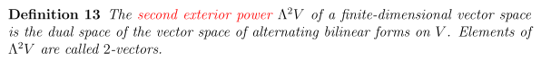
Parse please: "the vector space of alternating bilinear forms on V" is the vector space W just discussed above, having dimension n(n-1)/2. It is isomorphic to a matrix space W' as noted. The "dual space" is a set of functionals which can act on the vectors of W or W' to give (for me) a real number. What are some examples of such functionals?

x • B • y : B → R xTBx = s B = matrix.

Is this linear? I think so: x • (B1 + 5B2) • y = x • B1 • y + 5 x • B2 • y

I may be way off base here. In the W space you could have

∫dudv w(u,v) B(u,v) = linear functional of B

So this very abstract idea is used to define the space Λ2(V). Now is a matrix a 2-vector? I think he means a bivector or a 2-blade. I know that a 1D matrix can represent a vector, so maybe a 2D matrix can represent a bivector. This idea did not appear in either Suter or Denker.

Next:

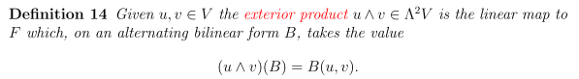

So you see here how it is a functional of B and hence the dual space thing. Note that u and v are vectors, meaning they are 1-blades ONLY.

I guess he is saying that ANY alternating bilinear functional B defines a wedge product, so there are then lots of different wedge products possible. This might be the matrix B that is involved when Maple does its cmul operation. Now one of my Spivak equations (see "wedge product")

[f ˄ g](v1,v2) = f(v1) g(v2) - g(v1) f(v2) = det $\left(\begin{matrix}f(v1) & g(v1) \\ f(v2) & g(v2)\end{matrix}\right)$

So maybe write this as

[f ˄ g] = fg - gf = B(f,g)

Maybe the products are geo products and don't commute. Recall also that for vectors a and b

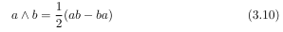

so we are pretty close apart from factor of 2. Maybe this is the only B possible apart from a constant? It has to be linear in each argument separately. Let's continue,

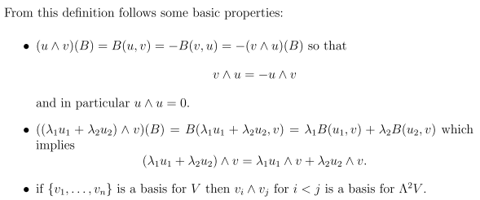

Next,

Proof both ways is simple. I now skip some stuff and get around to

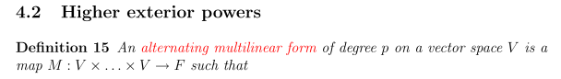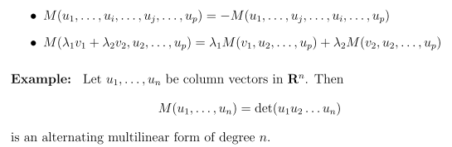

So he is just extending the B(u,v) idea to more arguments and calling it M. His second line does not say that this must be true for all arguments, but I guess it follows from the first line. And we have the usual example of a viable M.

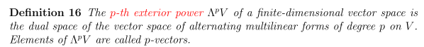

Just extending the earlier bilinear claim.

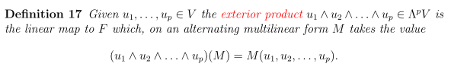

Now again, (....) is the name of a functional which acts on the space of possible M functions. Now maybe Spivak has taken this one step further where the ui as vectors in V become functions in V which is a function vector space. Then you could show each ui having a little argument, or perhaps several arguments. But Hitchins is not doing that here.

Now in his next act, Hitchins wants to talk about applying a certain transformation T* onto one of our M functions,
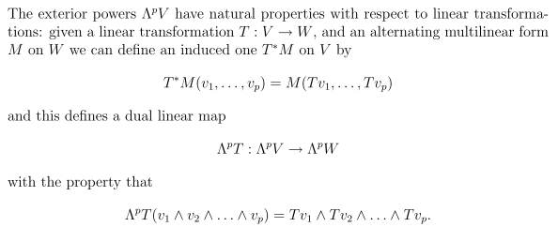

Why does he refer to T* as mapping ΛpT ? Well, M is associated with Λp, it is an element of Λp I guess, the way B was an element of the vector space Λ2. So I will just regard "ΛpT" as the name of this mapping. Now notice

(u1 ^ u2)(M) = M(u1,u2)

T*M(u1,u2) = M(Tu1,Tu2) = (Tu1 ^ Tu2)(M)

T*M(u1,u2) = T* (u1 ^ u2)(M)

so since true for all M, we get

T* (u1 ^ u2) = Tu1 ^ Tu2

and so I agree with his last line, where we call T* = "ΛpT" . This is a transformation acting on a wedge product, perhaps this is the pullback business somehow.

Special case: Suppose p = n = dimension of V. He then shows that you arrive at this result,

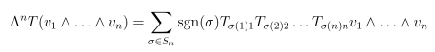

where Tij is the matrix for the linear operator T acting on V as in Tu1 above. Thus he shows that

T*(v1^ ....^vn) = det(T)

Not clear why this is useful. Perhaps this is the only T* possible for order n. Hence T* = ΛnT a better name.

He goes on to derive various properties of ^ products. I am now losing interest in this paper.

I was hoping to make a connection to the B bilinear form of Maple! Hitchin did use such a form B(u,v), but I see no connection between this B and the geometric product, so a dead end I am afraid.

