Clifford Algebras PhL 8/27/15

I have run into this subject before, but not recently. I search my files and find only a reference to Clifford in my Ahlfors meta review concerning the "cross ratio". So I really have nothing at all on this subject.

I found this excellent and short PDF on the subject,

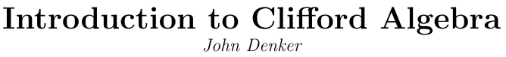

This guy I think is a retired physics Prof from Cornell. His notes are 35 pages and seem relatively simple, so I will give them a shot, reading PDF on the screen.

2. Overview.

Here we have pictures of the "clifs" that inhabit this Clifford algebra.

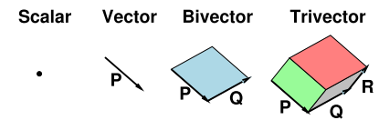

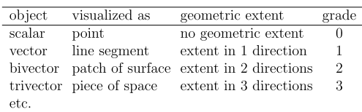

Different objects are classified by their "grade" as shown. Hence Clifford Algebra is a "graded algebra".
He argues to get rid of cross products! We shall see.

2.3 Addition

Unlike normal algebras, you are allowed to add objects of different gradation. Normally we add vectors to get only vectors, but here you can add any of the "clifs" together. A clif is aka a "multivector". He shows graphically how you can add two 2-vectors together. Not totally obvious but OK for an example. Apples and oranges and fruit salad comment.

2.4 Grade Selection

I guess given some mixed clif, you can project out whichever grade piece you want.

2.5 Multiplication: Preliminaries.

In order to have an "algebra" you need to know how to add elements, scale them by scalars, and how to multiply them. Adding clifs seems simple, as is scalar mult. But multiplying two clifs of possibly different grade takes some doing. The fact that you can do this is a major feature of the clif world.

2.6 Vectors times Vectors

For vector clifs (only) we get to say

P.Q = (1/2)[PQ+QP] dot
P˄Q = (1/2)[PQ-QP] wedge

PQ = P.Q + P˄Q // vectors only!

but we don't know yet what PQ means (known as a "geometric product")

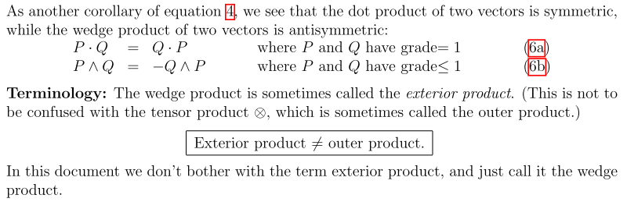

Fine so far, but what does PQ mean? Well, so far this is only defined "axiomatically"

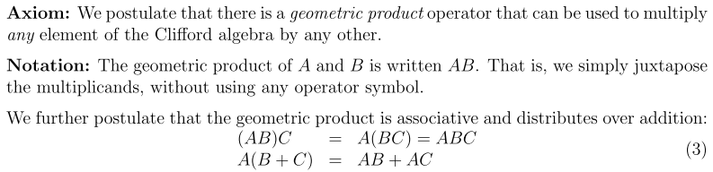

So whatever it is, it has to have these properties. Called a geometric product. Some are not so hard if one item is a scalar:

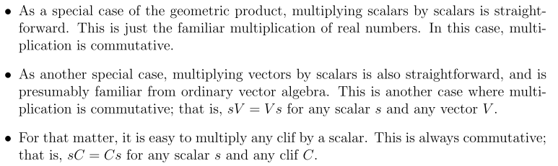

2.7 About the dot product of vectors

The general idea is that this is pretty much like your physics normal dot product and it produces a scalar which is rotationally invariant. Fine.

2.8 Parallel and Perpendicular (vectors)

First, if you consider P ^ Q where P = Q, the result has to be zero since P^Q = -Q^P. Similarly, if the two vectors are collinear, so that P = αQ, you can show again that P ^ Q = 0. Similarly, if P = Q, we know that we have PQ = QP, and this should be true for collinear as well. That means that P.Q = 0. The Clifford word for collinear is "parallel" and one writes P || Q.

Perp or orthogonal is similar. If P and Q are perp, then P.Q = 0 and P^Q = PQ. This is all reminiscent of the regular dot product and cross product.

Define now:
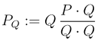

What can we say about this new vector? Write

P = PQ + (P-PQ)

Notice that

PQ.Q = P.Q
PQ^ Q = 0 since Q^Q = 0

(P-PQ).Q = 0 trivial
(P-PQ)^Q = P^Q

The first lines say that PQ is parallel to Q.
The second lines say that (P-PQ) is perpendicular to Q.

So P = PQ + (P-PQ) decomposes a vector P into a part which is parallel to Q and a part that is perp to Q. This idea although perhaps interesting is not used anywhere below as far as I know.

2.9 Properties of Vector Wedge Products

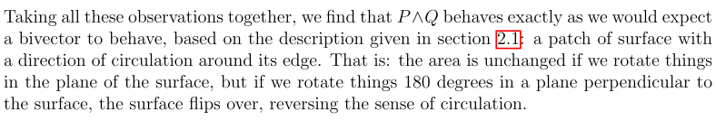
I think he means rotate 180 about an axis perp to the plane of the surface.

Claimed generalization is this:

which agree with my Grassmann-based approach with functions instead of clifs.

Note added: In Spivak we talk about antisymmetrizing with respect to the arguments of a function. Here we are antisymmetrizing vectors of a Clifford algebra, where vectors are multiplied together by some method we don't at this point understand at all!

The claim is that the above two objects will be grade 3 and grade r. Somehow in a wedge product you are supposed to add the grades of the factors, reason not stated but perhaps reasonable.

The letters are all still vectors.

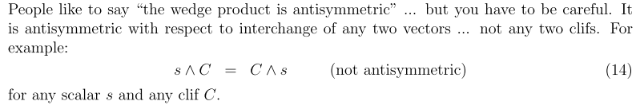

Fine by me. I think I found cases in the function world where this is also an issue (ie, no minus sign).

So this is a wedge product of 0 or more vectors more or less.

Note added: I suppose a 2-vector and a 3-vector are examples of blades of grade 2 and 3. Here I am using Clif language for n-vector. Clif people usually write bivector or trivector to avoid this ambiguity!

OK, a sum of blades of the same grade makes a homogeneous clif.

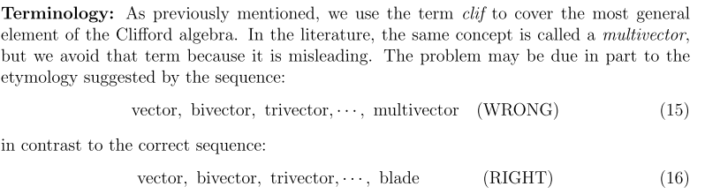

OK good. You might think of all the items in the first list as multivectors of different grades, but the items in the first list are really blades. This seems to confirm my notion that an n-vector (Clif) is a blade.

ok

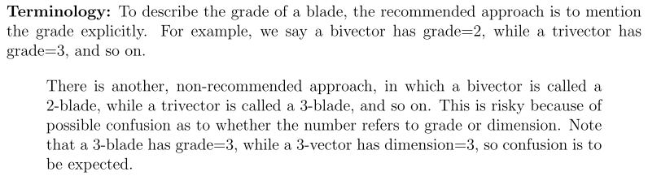

Very good. There are two different integers to keep track up. So far so good.

2.10 Other Wedge Products

Above we wedged a vector with a vector. Here we generalize to blade with a blade, where the two blades can have different grades!

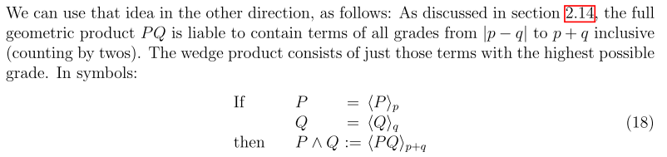

So this PQ discussion is where P and Q are blades.

So that claim then is that if you multiply two arbitrary clifs, the result will contain lots of graded components, and that component with the highest grade will be P^Q . Notice the notation above. I might want to prove this claim.

You can then consider clif ^ clif by breaking each into graded pieces so

(Σi αi Abladei )^ (Σj βi Bbladei ) = Σijαiβj (Abladei )^ (Bbladej )

and to get (Abladei )^ (Bbladej ) we use the rule shown above = <AbladeiBbladej>i+j

I get the general idea, perhaps need some examples.

Restate: P^Q has grade which is the sum of the two grades
PQ contains grades stepping down from this sum to | diff |, more complicated!

2.11 Other Dot Products

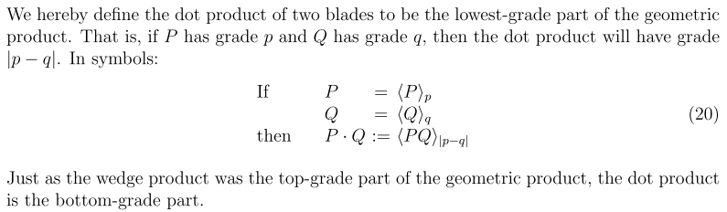

This is done by fiat! It certainly works for 2 vectors where p=q=1 for grades, then |p-q| = 0, and in fact the entire thing P.Q in this case is in the bottom grade. It reminds me of representations of the rotation group.

Then

(Σi αi Abladei )• (Σj βi Bbladei ) = Σijαiβj (Abladei )• (Bbladej )

and to get (Abladei )•(Bbladej ) we use the rule shown above = <AbladeiBbladej>|i-j|

So we are staying a bit axiomatic here, working first with blades, then with general clifs. We still have no idea how to multiply two arbitrary clifs to get PQ. Reader is getting impatient.

2.12 Wedge Product as Painting

Consider C ^ V where C is any clif and V is a vector clif. Draw clif C along V and let it "paint" as it goes, You then fill out the resulting Clif volume. I will let that ride, seems reasonable.

2.13 Chirality

The basic Clifford Algebra has no chirality (handedness). But you can add ingredients which add this chirality. This is part of Denker's promotional efforts.

Comments that the "Hodge dual" optional feature does have chirality.

2.14 More about the Geometric Product

This is what PQ is in all the above discussion. An example is given at the point of multiplying two blades each of grade 2.
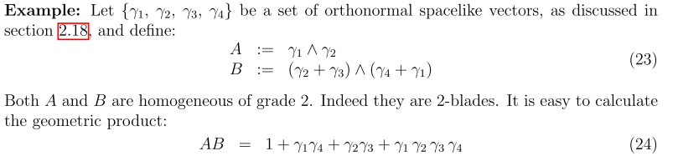
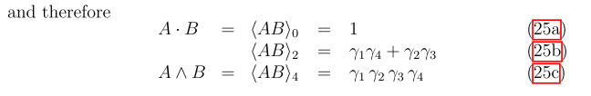
We know that the 4 gammas is grade 4 only because we know it is A^B. Did I miss a rule that says the grade of a geometric product is the sum of the grades of the factors. That seems to be the case here. Wrong! Remember that the geometric product contains a whole series of grades, and we see that happening in the above example where AB = sum of three pieces of different grade.

The product of two vectors has A^B of grade 2 and A.B of grade 0. The grades always step by 2, unlike combining angular momenta! (Can I prove that? )

2.15 Spacelike, Timelike and Null

This relates only to vectors. V.V can be +, -, or 0 for spacelike, timelike, or lightlike. All familiar to me. H refers to the object V.V as the "gorm" of V. the "norm" might be $\sqrt{V.V}$ or $\sqrt{-V.V}$. In my tensor doc I mentioned the lack of name for this entity V.V, with reference to Messiah. Fine.

2.16 Reverse

Take clif C, reverse the ordering in all terms, and that gives you C~. Fine.

2.17 Gorm

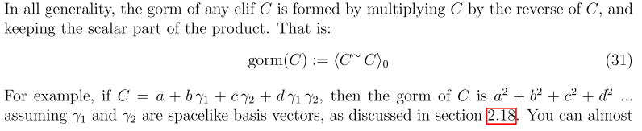

Try it,

(a+bγ1 + cγ2 + dγ1γ2)(a+bγ1 + cγ2 + dγ2γ1)

= a2 + b2 γ12 + ...

Basis vectors I guess means γ12 = 1, Do we have γ1γ2 = - γ2γ1 ? I don't see that, so the above claim does not fly with me. But, in PQ of vectors, we know there are only two pieces. Thuss we write

PQ = P•Q + P^Q
0 2 grade

So OK, if γ1 and γ2 are orthogonal basis vectors, then γ1• γ2 = 0, and γ1γ2 = γ1^ γ2 and we know that for vectors we always have a ^ b = -b ^ a. Therefore yes, we have γ1γ2 = - γ2γ1 .

2.18 Basis sets

Well here is a strange section:

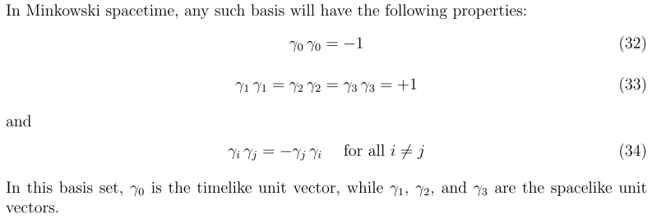

Here we do have γi and γj perp, so yes, then you get γ1γ2 = - γ2γ1. I guess he was assuming this situation in the previous section! Fine. He sort of assumes the reader knows about relativity, but he has avoided using the word "metric" or "metric tensor". So far.

Confusion: If I think of the γi as basis vectors for the 1-blade space, then they are like the ei of Suter's pdf. But there it seems that eij ≡ eiej = ei^ej and then e11 = e1e1= e1^e1 = 0. I think Denker may have messed things up here! He never really says what his γi objects are. He really first defines them as orthonormal basis on page 16. Let's try his multiplication there if we assume γi = ei

A = γ1^γ2 ≡ γ12
B = (γ2+γ3)^(γ4+γ1) = γ24+ γ34 + γ21 + γ31

AB = γ12 ^ (γ24+ γ34 + γ21 + γ31) = 0 + γ12γ34 + 0 = 0 = γ1234

This is not the result he gives. A similar confusion is that he says γ12 = 1 whereas Suter says eiei = 0

2.19 Components

Here he treats the γi for i = 0,1,2,3 as I might treat ui as basis vectors with the BD metric tensor. There seems nothing really new here. You recover the usual p.q dot product in terms of components. He puts component subscripts up, but does not say "contravariant". For example,

Comment: So OK, in Minkowski 4-space (d=4), we have a set of basis vectors γμ and then we can express any vector as a lincomb of these basis vectors. There is probably also some kind of basis for the world of bivectors, and a basis for trivectors. What are these bases?

2.20 Dimensions; Number of Components

Mysterious table which he fails to explain.

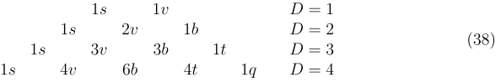

I think the D row labels are dimensions of underlying space. For R3 we have a scalar having one component (1s). So in the pairs, second letter means s=scalar, b=bivector, t=trivector, q=quadvector. The number before the letter is the number of components this object has.

D= 3 and R3: 1s = you have the usual single scalar
3v = you have a vector with the usual 3 components
3b = you have a three different 2D patches available
1t = you have only one possible cubic 3-blade object

The claim is that the picture has binomial coefficients going across. Pascal's Triangle. Total components on each row turns out to be 2D. Get that from binomial expansion as (1+1)D = 13 + 3121 + ...

He comments that the spatial dimension D can be anything, and OK to do string theory with 26 dimensions. Clifford algebra does not care.

Comment: Author has used up 21 of his 35 pages doing this Chapter 2 overview business.

3. The Angular Momentum World

So he is staying with his physics leanings. All clear to me, but he is using ^ instead of cross products. Perhaps he is saying that a ^ b and a x b are the same for R3 when clifs are vectors. H no doubt comments on this in his intro which I have so far skipped. Perhaps he was planning on expanding this section, it is just half a page.

4 Contractions : Generalizations of the Dot Product

Here he just mentions that you can talk about a variety of dot-like products, and they are all defined just in terms of the grade component of a clif product (a geometric product). Here is his table.

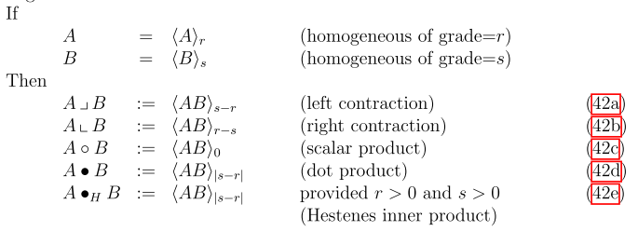

Fine by me, nice to at least mention them in passing.

So this was just a tiny section too.

5 Hodge Dual and Cross Products [23]

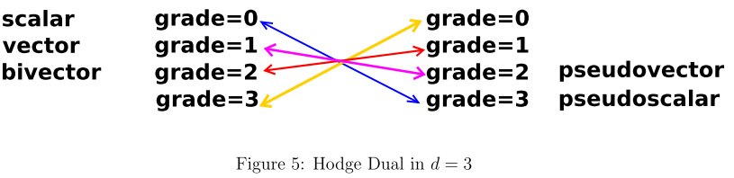
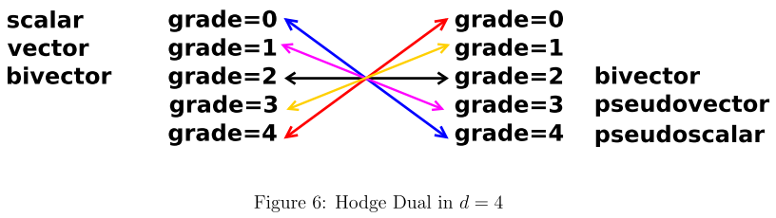

This is roughly in agreement with the * Hodge discussion in Sjamaar and elsewhere.

Next comments are:

V=vector C=blade grade g V^C = grade g+1 V^ = grade raiser
V=vector D=blade grade g V.D = grade g-1 V. = grade lowerer

So a vector raises or lowers the grade for a wedge or dot product.

Finally things are getting thicker here and I am going to have to ponder more. On page 24 of 35.

I know about Hodge in the sense that *dx = dydz and I guess *2 = dxdydz and *dxdydz = 1 more or less. So adjust this to map blades instead of differentials. A blade is a pure-grade clif.

OK. start with blade A,B each of grade k. The Hodge X will have grade d-k so we know that much.
What do you know about A^X? Add grades so it has grade d and is thus called (reason unknown) a pseudoscalar as chart above shows. Meanwhile A.B has grade 0.

He says now to find some "unit pseudoscalar i". Perhaps that means i2 = 1.
He says find a basis γi for i = 1 to d, seems OK to do that.

Define i ≡ γ1γ2....γd where this is geometric multiplication about which I know little, PQ.
Well I know PQ = P.Q + P˄Q so I guess of basis is orthogonal, γ1γ2 = γ1^γ2. Then we must really have i = γ1^γ2....^γd . The basis are vectors so grade 1, so then i has grade d which is correct. It is in some sense a "unit grade d blade" I suspect.

Now he claims

A^X = A.B i

All I really know from above is that A^X has grade d, and A.B has grade 0 and i has grade d, so how does he justify the above equation? Each side is perhaps a blade of grade d. But one could be a scalar multiple of the other? How many grade d blades are there? Probably only 1, so only have to confirm the constant. A has grade k. Do I know some simple grade k blade? Perhaps A = γ1^γ2....^γk = γ1γ2....γk. I just don't know enough to explain the above equation. Denker has let me down.

Wiki says this which I am more familiar with

How do you expand X in basis vectors knowing it has grade d-k? I don't know.

So just assume the above for now. If the above is valid for all A, then X is the Hodge dual of B. I will write this as X = *i B, but he uses an awful notation I can't even type. For a given i, the Hodge dual is unique, he says.

Try his example: B = 7, a scalar, what is *B. He claims *B = 7i which is indeed a d=0 object. Let's check so see if A^X = A.B i: If B = 7, then I suppose A.B = (1/2)(AB+BA) = 7A. So then we have that
A^X = A7i for all A. Somehow the solution he claims is X = 7i. I need more exercises!

So in this case have to show that A^X = A.[5γ1γ2] i for all A. I have no idea. I can't even verify the above example! I have no A's to test with! Have never met an A other than a scalar.

5.2 Remarks : Subspace Freedom, Or Not

Chatter about writing * as *i maintains "subspace freedom". I do not grok.

5.3 Recipe for Replacing Cross Products

With this standard choice of "i", he claims that, assuming a and b are vector clifs

a x b = *(a^b)

Note that a^b has grade 2, and then *(a^b) has grade d-2 = 3-2 = 1 which is in fact a vector. So the above equation is true at least in the grade matching sense. But I don't know how to strictly verify this. Then we get this next claim

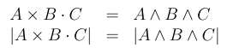

6 Pedagogical Remarks

6.1 Visualizing Bivectors

Spinning top, but I don't get it. I never had trouble adding angular momentum vectors.

6.2 Symmetry

Cross product implies presence of chirality, clifs do not, advantage for modeling non-chiral physics.

6.4 Geometric Approach versus Components

This is a sales pitch. He avoided a discussion of clifs having components and expansions on a basis, and I really did not like that. He wants to do "New Math" where basis is downplayed. The vector in 3D you can easily identify without talking about basis. But of course if you want to compute anything (heaven forbid for a string person) you will need a basis. So I am not a disciple here. Wonder if this relates to general relativity and Kushar's remarks to me at the Jim fest?

7 Clifford Algebra Desk Calculator

This program supposedly calculates anything you want in the clif world. Language is not stated, again because that would mean selecting a basis.

Comments: Well, this doc DID introduce the basic ideas, but I would have preferred a more traditional approach. So I will hunt some more, I did not know I was getting a proselytizer as a presenter when I downloaded this pdf. I should have suspected on looking at his web hits.

Comment: OK, I now want to see a more conventional Clif presentation which does use basis vectors and linear combinations and all that. I spent some time looking for Clif pdf's and found few, but most tend to be overly fancy for me..

