Spivak's Wedge Product Definition PhL 8.25.15

I have already shown in my Spivak overview notes that

[Alt(T)](v1,v2....vk) = (1/k!) Σabc..q εabc..q T(va,vb....vq) // k! terms in sum

If T were already AS from the start, then all those k! terms are the same, and then you would get

[Alt(A)](v1,v2....vk) = (1/k!) Σabc..q εabc..q A(va,vb....vq) = A(v1,v2....vk)

Better to write this instead as

[Alt(A)](v1,v2....vk) = (1/k!) Σi$_{1}$i$_{2}$ .....i$_{k}$ εi$_{1}$i$_{2}$ .....i$_{k}$ A(vi$_{1}$,vi$_{2}$....vi$_{k}$) = A(v1,v2....vk)

Notice that det(v1,v2....vk) would provide an example of A(v1,v2....vk), but he does not mention this.

Spivak notation:

Space of k-multilinear functions = Tk(V) elements are called k-tensors

Space of alternating k-multilinear functions = Λk(V) Λk(V) ⊂ Tk(V)

The function T is in space Tk(V), but alternating T's are in subspace Λk(V). Spivak just calls these things alternating tensors, though the are also k-multilinear functionals of k vector arguments.

Now suppose we have for general integers k and l,

ω in Λk(V) ω(v1,v2....vk)
η in Λl(V) η(v1,v2....vl)

This says that ω and η separately are AS.

In his preliminaries section he has already defined the notion of ω ⊗ η in this manner

[ω ⊗ η](v1,v2....vk, vk+1......vk+l) = ω(v1,v2....vk) η(vk+1,vk+2....vk+l) (*)

so we have a product of two scalar functions each of which is an alternating k-multilinear, but neither of which is AS. Let's for the moment replace [ω ⊗ η] by f and write

f(v1,v2....vk, vk+1......vk+l) = ω(v1,v2....vk) η(vk+1,vk+2....vk+l)

Question: Is f a (k+l)-multilinear function? My only doubt would be for something that crosses the boundary, so consider on the left side only

f(v1,v2....vk + 2vk+2, vk+1......vk+l)

If this is (k+l)-multilinear, then we must have

f(v1,v2....vk + 2vk+2, vk+1......vk+l)

= f(v1,v2....vk, vk+1......vk+l) +2 f(v1,v2....vk+2, vk+1......vk+l)

Let's see if this works out or not. Using the product we have

ω(v1,v2....vk + 2vk+2) η(vk+1,vk+2....vk+l)

= [ ω(v1,v2....vk-1,vk) + 2 ω(v1,v2....vk-1,vk+2) ] η(vk+1,vk+2....vk+l)

= ω(v1,v2....vk) η(vk+1,vk+2....vk+l) + 2 ω(v1,v2....vk+2) η(vk+1,vk+2....vk+l)

But this last line is in fact,

= f(v1,v2....vk, vk+1......vk+l) + 2 f(v1,v2....vk+2, vk+1......vk+l)

so I have shown that

Fact: If ω in Tk(V) and η in Tl(V) , then [ω ⊗ η] in Tk+l(V) .

But in our case here we in fact have ω and η each being AS at the start.

Now we want to make this new (k+l)-multilinear functional [ω ⊗ η] be antisymmetric (AS). Lets try this

[ω ⊗ η]AS = K Σi$_{1}$i$_{2}$ .....i$_{k+l}$ εi$_{1}$i$_{2}$ .....i$_{k+l}$ [ω ⊗ η] (vi$_{1}$,vi$_{2}$....vi$_{k}$, vi$_{k+1}$......vi$_{k+l}$)

= K Σi$_{1}$i$_{2}$ .....i$_{k+l}$ εi$_{1}$i$_{2}$ .....i$_{k+l}$ ω(vi$_{1}$,vi$_{2}$....vi$_{k}$) η(vi$_{k+1}$......vi$_{k+l}$)

where K is some constant. Now based on (*) it seems impossible that [ω ⊗ η] could be AS from the start. What Spivak says is

I don's see how ω ⊗ η could ever be in Λk+l(V). What about

[ω ⊗ η](v1,v2) = ω(v1)η(v2)

How could the RHS here ever be AS under v1↔v2 for all arguments? You would need

ω(v1)η(v2) = - ω(v2)η(v1)

I just don't thing that is possible for any ω and η functions, including constants. So his comment "usually" is a little strange. Well, suppose one is a constant. Then l = 0 so not rally meaningful.

In any event, if ω in Λk(V) and η in Λl(V), then I would say [ω ⊗ η] is definitely not in Λk+l(V) due to the fact that the product is not overall TA. So he fixes this up by defining the wedge product in this manner:

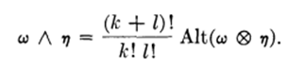

Then for sure [ω ˄ η] (v1,v2....vk, vk+1......vk+l) IS in Λk+l(V). Spivak defers the explanation of the strage constant. But the main point is this:

[ω ˄ η] (v1,v2....vk, vk+1......vk+l) = K Alt(ω x η) = an element of Λk+l(V)

Based on this wedge definition, Spivak derives various properties.

Comments at this point. How does this compare to Sjamaar who says

[ω x η] (v1,v2....vk, vk+1......vk+l) // Spivak

"ωη" (v1,v2) = det(some matrix) // Sjamaar

where the matrix would be

ω(v1) ω(v2)
η(v1) η(v2)

It seems that Sjamaar's use of the wedge product is only for the latter case, where each of the two functions has only a single argument. This same is true for Sjamaar's more general a ˄ b ˄ c . So the Spivak wedge product definition is much more general, and at this point, it is not defined in terms of any determinants!

Pause: So finally at least I have "made some sense" out of the Spivak definition of the wedge product, which up to today has seemed meaningless. It does have some connection with Sjamaar.

I guess if you really want to understand things, you have to read all of Spivak Chapter 4 which is a large task. His text seems at least "readable" to me, it is not beyond me. I would then have the option to read his Chapter 5 on doing this all on manifolds.

Continue 8.26.15

Consider this Spivak section,

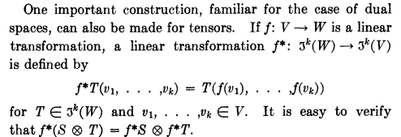

This operation f* is a generalization of Sjamaar's pullback action on functions. Sja always has thing like
φ*f(x) = f(φ(x)), so Spivak is stating this as f*T(v1) = T(f(v1)) where f* is his pullback. But Spivak's pullback is more general because at acts on function having k vector arguments. So our Sja/Spi connection is still doing well.

After this, Spivak says that <a,b> is his notation for the Rn inner product, and then for a while he writes
that T(x,y) will be his inner product for more general vector space V. His theorem then says there is some basis vi such that T(vi,vj) = δij which seems pretty reasonable. Then he connects these last two ideas in the following manner:

[f*T] (xi,xj) = T(f(xi),f(xj) ) = <xi,xj> // <xi,xj> = I(xi,xj)

It must be that f: Rn → V because the arguments of T have to be in V. He refers to f: Rn → V as an isomorphism which to me means a 1-to-1 between Rn and V. I think this means that the above statement is a definition of the mapping f. Defining the Rn inner product as operator I (my own), then the above says that [f*T] (xi,xj) = I(xi,xj) so in shorthand, this says f*T = I = <,> in his funny notation.

I have backed up for the above stuff. He then goes into his wedge product discussion as I outline above.

Let's now look at 4-4 Theorem. (he uses same strange headings as Sjamaar, I guess that is a standard.)

(1) S in Tk(V), T in Tl(V) [ the pre-alternating adder spaces] Then

Alt(S) = 0 ⇒ Alt(SxT) = 0 and Alt(TxS) = 0.

My proof:

S = S(v1,v2....vk)
Alt(S) = Σabc..k εabc..k S(va,vb....vk)

I think if Alt(S) = 0, then S(v1,v2....vk) must be symmetric on at least one pair of arguments. Then when you consider

[S ⊗ T](v1,v2....vk, vk+1......vk+l) = S(v1,v2....vk) T(vk+1,vk+2....vk+l)

and your write out Alt[S ⊗ T] using ε as above, that same argument makes Alt[S ⊗ T] = 0. He gives a formal proof which I don't want to attempt to follow. I will accept the result as valid, and it certainly seems to be valid.

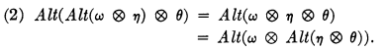

I again just accept this, it seems reasonable. He gives a tiny proof I could follow it I wanted.

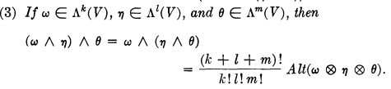

This is a generalization of his earlier result that

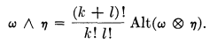

It seems that since you end up with this associative rule for the wedge product, you could write

a ˄ b ˄ c ≡ (a ˄ b) ˄ c = a ˄ (b ˄ c )

He in fact states this his page 81. This brings us to his 4-5 Theorem. But first recall earlier result

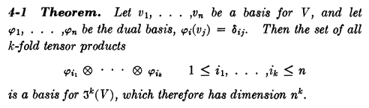

Thus these φj functionals are the λj of Sjamaar, and as such, they have only one argument! So here is his next theorem:

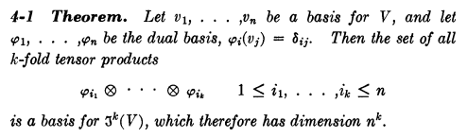

I am happy with this at once. Remember that there is no alternation concept for Tk(V). Spivak is using the black rectangles for his QED. I am now on page 77, and this Chapter 4 started on page 75, so I have not gone very far! Oops, the above is earlier, I am out of order. I am really on page 81 and we have -- but wait, more back and fill. Earlier he says

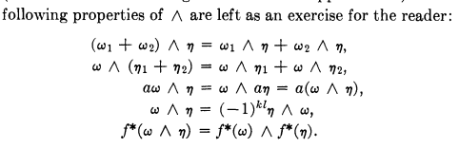

Keep in mind that this is for Spivak's very general wedge product. If you were to take functions of only a single variable, you would have k = l = 1 and then the second last result says ω ˄ η = - η ˄ ω which is a form more familiar to me! But the more general result is like βα = (-1)klαβ of Sja page 19 Ch 2. For Sja this was shown where α and β are "forms". Sja defined "forms" by assuming that in dxI if you swap any pair of dxi and dxi you get a - sign, see top of page 18. This would certainly be true if he had inserted ˄ symbols and used the Spivak stuff. So we seem to have this association implied

dxKdxL ↔ dxK ˄ dxL dxK(v1,v2....vk) dxL(v1,v2....vl)

so Sja has this implied dxK ˄ dxL which in Spivak world IS in fact the wedge of two functions having many vector arguments. So if you think of α = dxK = ω and also β = dxL = η, you have a correspondence between Sja and Spi. BUT, Spivak at this point has not mentioned any dx objects!!

Now we continue on page 81 with this:

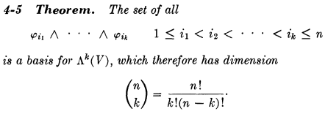

This replicates a theorem of Sja for the λi coordinate functions, so I accept 4-5. Note that this is a basis for the alternating space! The dimension is easy to see since for k = l = 1 you have ω ˄ω = 0. But still we have no dxi objects. I am awaiting their appearance!
The above is a k-wedge-product in Rn and if k = n, the dimension is 1. I agree.

Next:

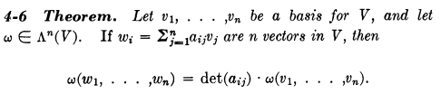

How are ω and ωi related here?? OK, ω is a function name, ωi is one of the arguments of ω. So we have a vector change of variables indicated here by the matrix a. This is a linear change of variables, not a differentials thing as in the R matrix. In the claim, ω appears on both sides. This result seems reasonable, but it is a completely new result to me! And ω is in the alternating space. Note that ωi = ri • v is a vector in V (since the vi are in V) and here ri is the ith row of matrix a. I will draw vectors in V in red.

The proof is very brief. He defines a certain η (which has n vector arguments which are the rows of matrix a) in terms of ω evaluated at sums

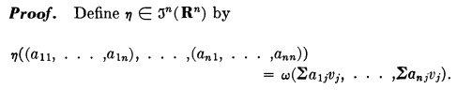

I can write this as (writing ri as the ith row of matrix a)

η( r1, r2.....rn) = ω ( (r1•v), (r2•v) ..... (rn•v) ) (*)

Notice that η has n vector arguments which live in Rn, whereas ω has n vector arguments which live in V. So ω is in Λn(V)?

But Spivak then makes this claim which I do not follow:

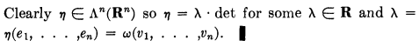

It is not at all "clear" to me what he is saying. I guess he is claiming that η = K det(a) for some constant K. That is to say, he claims that η( r1, r2.....rn) = K det( r1, r2.....rn) where I show the det argument as the rows of matrix a. More specifically he is claiming that

η( r1, r2.....rn) = η( e1, e2.....en) det( r1, r2.....rn) (**)

This result is certainly reasonable, and it seems to have nothing to do with (*) above. I guess I might have to lean on Sja's notion of the det in terms of the axioms. Since ω in Λn(V), we know it changes sign on any swap, and that means η in (*) also changes sign on any argument swap. That is really "most of the way" to a determinant. We need the scalar rule so if r1→ αr1 then from ω we know things overall scale by α, and that fact is then induced into η. Basically the "multilinearity" properties of ω are induced into η. The final normalization axiom just sets the value for K.

Now, given the result, how does this proof our theorem? Well (*) really says this

η( r1, r2.....rn) = ω ( ω1, ω2 ..... ωn )

So then (**) reads

ω ( ω1, ω2 ..... ωn ) = η( e1, e2.....en) det(a)

But note that

η( e1, e2.....en) = ω ( (e1•v), (e2•v) ..... (en•v) ) = ω(v1, v2.....vn)

and therefore

ω ( ω1, ω2 ..... ωn ) = ω(v1, v2.....vn) det(a)

which involves only the function ω and vectors in V. So this proof is really quite long as measured by me, and his super dense proof is deceptive (but only for me based on what I know). Note that

ωi = Σjaijvj all vectors are in V

I think that as long as det(a) ≠0, then if vi is a basis, then ωi is also a basis. I would have to prove this to myself but won't do that right now.

If deta > 0, Spivak says that both the v and ω bases have the same "orientation" and he uses exactly the Sjamaar notation for orientation.

The rest of this chapter section comments on "volume element" and seems a bit obscure, so I skip for now. We then have a batch of problems, and then the next section starts, same chapter 4. I am still looking for mention of dxi.

[86] He opens with a strange description of "tangent space". Here p is a point of interest where you form the tangent space, which Sjamaar calls x on manifold M. He writes (Rn)p as the tangent space, given that point p lies in Rn . I think he just means here that (Rn)p is a version of Rn which has its origin at p instead of at 0, and this relates to vectors "floating in space" rather than "tethered to the origin" as his picture shows. Then he says

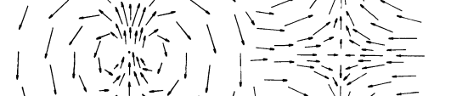

and I understand this completely. Here we have those Maple style floating vectors. I normally write a vector field as F(x) so there is an arrow F at each point x in space. Fine.

Now finally we get around to "differential form" :

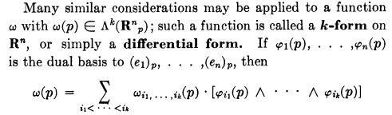Page 88

so we still have no dxi objects, just those Sjamaar λi basis functions of V*, called here φi. Fine. Notice that the φi basis of V* here is related not to a general basis vi of V, but to the specific basis ei of V. That may be an important point, keep it in mind. Note that (ei)p have tails at point p.

We are getting closer now however to mention of dxi !! It is going to happen very fast. First we have to parse the following coded statement:

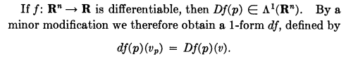

The first sentence: Df(p) is a function of only one vector variable so that explains Λ1(Rn). But is this a vector valued function? If we go back to all that ω and η stuff, ω and η were always called "functions" and page 87 says they are scalar functions. So I guess he is staying that each component of [Df](p) is such a scalar function of one vector variable.
Now for the second sentence. I usually write

df = Σj(∂jf) dxj = (Df) • dx = (∇f)• dx where here Df is a vector, not a matrix.

Now using Spivak's differential form general case above, I would say for a 1-form

ω(p) = Σi ωi φi(p) Spivak 1-form

Now with this prep, consider the "sentence" above,

df(p)(vp) = Df(p)(v) = "a 1-form"

First we have to decipher his notation. If we just regard p as a "tag"

[dfp](vp) = (Df)(v)

But what does vp really mean here? Top page 87 just says this is a vector v with tail at p. So perhaps the above is just saying that the thing on the left is (Df)(v) translated so tails on are point p. That is probably it. Here is a clip from nearby

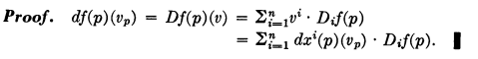

which I interpret to say

(Df)(v) = v • Df = dx • Df where he just selects v = dx

Idea 1. You can regard (Df) above as a vector of linear functionals on V where v lives. So (Df)i in V*. Since the φj form a basis in V* you can write

(Df)i = Σj cij φj

When you write it this way, you can claim now that (Df)i is indeed a 1-form. So I have filled in a lot of implied content here.

Now suppose we write [ here dx is a differential in the calculus sense !!! ]

df = Σj(∂jf) dxj = (Df) • dx = (∇f) • dx = (Df)Tdx ≡ (Df)(dx)

In the previous line [dfp](vp) = (Df)(v) the vector v lies in Rn and vp in Rnp. Note that dx also lies in Rn.

So I guess I can evaluate the linear functional (Df)i = Σj cij φj at any vector v I want, and so then for example we can say'

(Df)i(dx) = Σj cij φj(dx) = a 1-form

So this is the very first time I am showing the calculus differential vector dx appearing in a 1-form.

But I don't think Idea 1 is correct! Let's go back a bit to review his notation in earlier chapters:

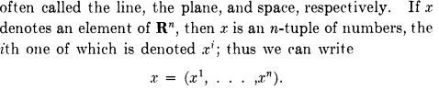

So OK, without explanation he uses UPPER indices on coordinates of x. Maybe he is thinking contravariant? Or maybe he has some other plan for lower indices. Next,

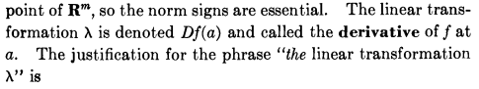

So this seems to say that Df is just the derivative functional for a scalar function. Chain rule

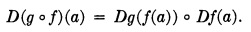

But eventually I find this

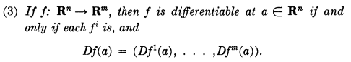

so now finally Df is a vector and fi is a component of the vector function f. Still using superscripts for components of vectors in Rn at least. More:

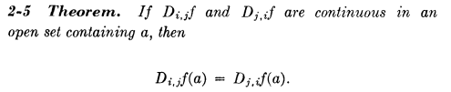

and then

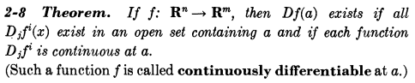

But here he is not really saying what Df is! I presume it is a matrix.

Through all Chapters 1 and 2 there is no mention of a basis ei so I don't yet know his definition of these symbols. The first use seems to be in Chap 4 which I reviewed above,

but no definition of ej. Unlike Sjamaar, this book has no symbols index. Another hint

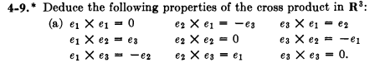

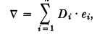 this last on page 88

OK, I guess I will really assume that the ei are the standard unit vectors or Rn . Nowhere in the book does he refer to ei as "unit vectors". But my search is working very poorly, a bad OCR I think.

Now after this digression, backtrack to page . The nubbins is really all in this one paragraph:

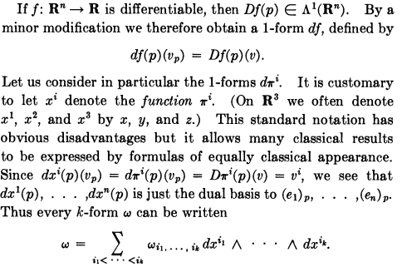 Page 89

I discussed the first three lines already above. What on earth does me mean by dπi which he just pulls out of his hat from nowhere? And why is dπi a 1-form when we don't know what dπi even means? Well let's just assume that he means dxi . But then he has put the rabbit in the hat. Every sentence here is a mystery that I will have to decode with many minutes of labor. Well consider

(Dx2)(v) = (Dx2)• v = (Dx2)ivi = δ2,i vi = v2.

or more generally

(Dxj)(v) = (Dxj)• v = (Dxj)ivi = δj,i vi = vj.

So I agree that (Dxi)(v) = vi .
Certainly on is allowed to set v = dx and write this equation out since dx is in Rn.

(Dxj)(dx) = (Dxj)• dx = (Dxj)idxi = δj,i vi = dxj.

Why does this say the dxi is the dual basis of ei ? In this claim, I think I have to regard dxi not as a differential, but as some kind of functional. How can I interpret this as a functional?

The object (Dxj) is a vector, so I could define this functional

Cj(v) ≡ (Dxj) • v = (Dxj)T v

Then you say that the scalar functional Cj in V* is associated with the row vector (Dxj)T in VT. Aha, this looks good

Now suppose we assign the name "dxj" ≡ Cj as the name of this functional. It is not a bad name because it reminds us of itself a little bit. Then the above says

dxj(v) ≡ (Dxj) • v = (Dxj)T v = a functional acting on one vector in Rn.

To show that dxj is a dual basis to ei, I would work with the vector representation (Dxj) and I would have to prove that this was true:

(Dxj) • ei = δj,i

See my earlier notes "the meaning of λ..." , section "Plan A3 restated", for why this means dxj is a basis that is dual to the basis ei in Rn. Now is the above true??

(Dxj) • ei = Σk (Dxj)k (ei)k = Σk (Dxj)k δi,k = (Dxj)i = ∂i(xj) = δi,j

so yes it is true.

Fact: The functional "dxj" is that functional associated with the vector (Dxj) and the action of this functional dxj on a general vector v in Rn is this:

dxj(v) = (Dxj) • v = vj

dxj(ei) = δi,j

But this is the same as Sjamaar's original λj where you select ei as the V space basis.

λj(ei) = δi,j

Probably the functional so defined is unique.

Now all this is fine. dxj is the functional associated with the vector (Dxj), and

(Dxj)i = ∂ixj = δji = (ej)i

So this vector (Dxj) is exactly the vector ej (I don't think Spivak does metric tensors). Note also:

dxj(dx) = (Dxj)(dx) = (Dxj)• dx = (Dxj)idxi = δj,i vi = dxj.

This then makes a connection between the functional "dxj" and the differential dxj !!!!

Now let's try to assemble all these pieces in a more logical order.

1. A differential k-form is defined in terms of the 1-variable functional λi in this manner

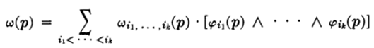

Here ω is the differential form, φi are those functionals, ωI is a coefficient function, and p is a "tag" indicating a point in space for your effective origin. Following Sjamaar, I would alter the appearance of the above to say

ωp = ΣI ωI(p) dφI,p dφI,p = φ1,p ˄ φ1,p for example

This notation is bad for me in terms of connecting with Sjamaar. I would say instead

αx = ΣI fI(x) λI,x x = that tag, formerly point p.

How if you add the arguments, you get this

αx(v1,v2,...vk) = ΣI fI(x) λI,x(v1,v2,...vk)

= ΣI fI(x) λi1(v1) ˄ λi2(v2) ....... ˄λik(vk)

This I think is how Spivak would translate his stuff to Sjamaar notation. Let's just write down an example

αx(v1,v2) = f12(x) λ1(v1) ˄ λ2(v3)

Now let's compare how Sjamaar and how Spivak would evaluate this wedge product:

Spivak: λ1(v1) ˄ λ2(v2) = 2 Alt[[λ1⊗λ2](v1,v2)] = 2 Alt [ λ1(v1)λ2(v2)]

= 2 (1/2!) [ λ1(v1)λ2(v2) - λ1(v2)λ2(v1) ] = det $\left(\begin{matrix}λ1(v1) & λ1(v2) \\ λ2(v1) & λ2(v2)\end{matrix}\right)$ = det(λi(vj))

Sjamaar: "λ1λ2"(v1,v2) = det(λi(vj))

