A Tour of the Spivak Book PhL 1.11.15

It is a 1965 book about 150 pages long, There is not much really on each page.

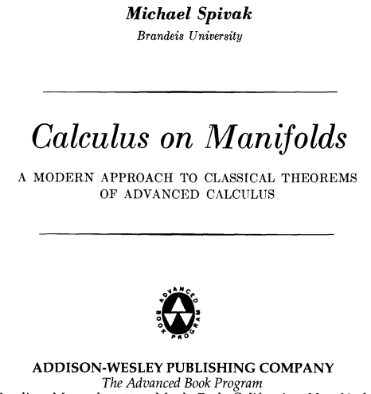

There are only 5 Chapters:
1 Functions on Euclidean Space 1
2 Differentiation 15
3 Integration 46
4 Integration on chains 75
5 Integration on manifolds 109

Contents:

About Michael Spivak (an unusual history). 2
Chapter 1. Functions on Euclidean Space p 1 3
Chapter 2: Differentiation p 15 4
Chapter 3: Integration p 46 4
Chapter 4: Integration on Chains p 75 4
ALGEBRAIC PRELIMINARIES 4
FIELDS AND FORMS 14
GEOMETRIC PRELIMINARIES 26
THE FUND THM OF CALCULUS 27
Chapter 5: Integration on Manifolds p 109 32

About Michael Spivak (an unusual history).

He has a small wiki page, born 1940 so is now age 76 or so. The book is 1965 written when he was about 25 years old.

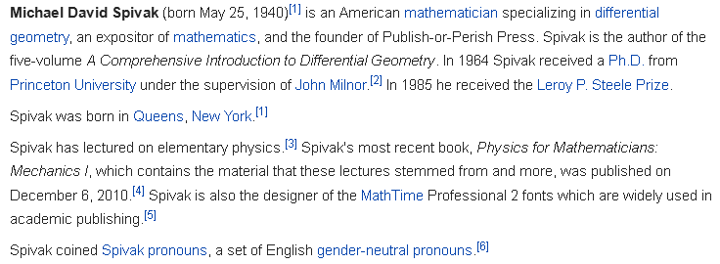

So he has worked on publishing fonts, something of great interest to me as well. He has a commercial product, however, not a free download, and not sure would work in Word. He worried about s/he stuff. The rest of the page says

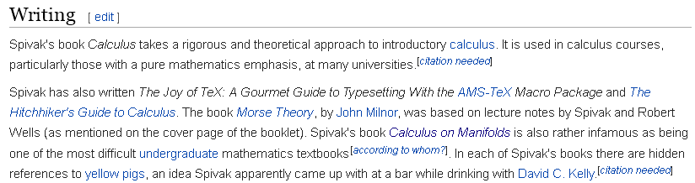

Note comment on this book: "infamous as being one of the most difficult undergraduate mathematics textbooks". So I am not alone here. Oddly the web page does not give his job history. This is noted by another person at http://everything2.com/title/Michael+Spivak and that person makes this conjecture:

"I surmise that what happened is something like this: he began his studies of mathematics under an eminence such as John Milnor. Then he began to run the gauntlet towards becoming a tenured professor (a postdoctoral fellowship, a tenure-track position, publishing papers regularly, etc.), but at some point became completely fed up with the system and its "publish or perish" philosophy. At that point, he left academia, founded his own publishing firm (appropriately called "Publish or Perish") and dedicated the rest of his career to promoting mathematical education and writing textbooks. Not that many text books, not as many as that nut Serge Lang puts out. Rather, Spivak's motto seems to be few but ripe. It is said that Michael Spivak now lives somewhere in Houston, Texas, for at least that's the address given for Publish or Perish, Inc. "

"• Calculus on Manifolds: A Modern Approach to Classical Theorems of Advanced Calculus, © 1965. He seems to have written this book just after he obtained his PhD degree, and he hasn't published a new edition ever since. His exposition here is wonderful as always, though it is noticeably a lot "greener" than what we can see in his later books. Here he presents theorems like the implicit function theorem and its cousin the inverse function theorem. Differential forms are also an important stop during this quick tour of differentiation and integration on manifolds. The entire point of this little book (it's short compared to this other works) is to present Stokes' Theorem for manifolds as quickly as possible and with perfect rigour. For celerity, he only considers manifolds as embedded subsets of Euclidean space. There is no loss of generality in doing this, since by Whitney's Theorem, we know that any abstract manifold can be embedded into Euclidean space of sufficiently high dimension. This book requires lots of careful thought, since here Spivak prefers to let the reader do the work rather than doing it himself, although he knows how to assign just the "right" kind of work. He did a good job of stripping down the preliminaries of integration on manifolds and differential forms to the bare essential without requiring too much from the reader except a willingness to undertake some hard work."

I just have to wonder if Spivak ever taught students anywhere other than when he was getting his PhD at Princeton. The book title page does associate him with Brandeis University.

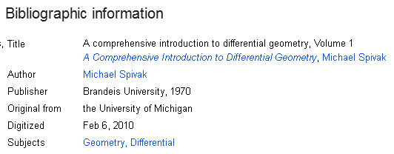

I just (2.21.16) downloaded the above book (3rd Ed 1999) and the Preface is interesting. He was teaching the diff geo course at Brandeis (9 miles west of Boston, Waltham) in 1969-70 while I was nearby. He was then about 6 years out from his PhD and was probably not wanting to write a lot of BS papers to publish or perish. So yes, at least I know he did have some students in his early post-PhD years. It probably took him a few years to write his entire 5 volume masterwork of which I now have Vol 1.
This volume 1 has 1st ed in 1970, 2nd Ed in 1979, then 3rd Ed in 1999 (Worldcat). I wonder if this thing somehow replaces the book I am reading now and that is why he never updated it?
_________________________________________________________________________________

Chapter 1. Functions on Euclidean Space p 1

Space is Rn. Norm stated with usual theorems. Scalar product <x,y> symmetric. Usual basis is ei . Vectors are not bolded. T: Rn→Rm usual transformation notation. Open and closed stuff. Boundary. open cover definition of compactness. Compact, Heine-Borel says the closed interval [a,b] is compact. Various theorems. Functions and continuity. Various theorems on same. Stuff is all in Buck I would say.

Chapter 2: Differentiation p 15

Usual limit definition. Df(a):Rn→Rm (D and f are really vectors so this is (Df) = (∇f) is the m x n "Jacobian matrix" for the transformation f. Chain rule then says D(gof)(a) = Dg(f(a)oDf(a) . Various related theorems. This is my R matrix thing. Page 25 starts into partial derivatives. Di,jf = Dj,if just to show notation. This is his notation for a partial derivative, I use ∂ instead of D. Lots of problem sets are interspersed into the text. Writes Djfi sometimes. Use of up and down indices with no explanation. Notion of continuously differentiable. Page 34 on inverse functions. Page 40 on implicit functions. The implicit function theorem on p 41, things all in Buck. First mention of f: RnxRm → R, a scalar function of two vectors. Page 44 comments on notation such as D and ∂. Same Buck comments on ambiguity.

Chapter 3: Integration p 46

Writes [a1,b1] x [a2,b2] x...[an,bn] as a "partition" of a rectangle. Not clear what he means, no picture. I guess this a block in n dimensions. Idea of subrectangles, must be same as Buck. Notion of measure 0. Notion of "content". Theorem page 53 that you can integrate a function which is discontinuous only if it is discontinuous on a set of measure 0. Characteristic function is a mask over integration region. Phrase Jordan-measureable, content, volume etc. Page 56 is Fubini's Theorem. This theorem gives the conditions for which you can do a double integral as two sequential ("iterated") 1D integrals in either order. Bucks did not use the name Fubini I don't think. Then comes the page 63 Partitions of Unity, means little to me. Page 66 is Change of Variable idea with abs value around the determinant. Page 72 is Sard's Theorem which says you can ignore places where detg' = 0 because g there has measure 0.

Comments: So far this is just "advanced calculus" Buck style, more measure theory maybe. No mention yet of forms or wedge products or the like. I think I can safely ignore all of Spivak up to this point. The action begins with Chapter 4 below where he dives into the subject of what I call tensor functions.

_________________________________________________________________________________

Chapter 4: Integration on Chains p 75

ALGEBRAIC PRELIMINARIES

// 2.1.16 Am happy with this entire Section

Comments 2.21.16. I wrote the notes below before writing wedge doc, so everything was new. The first notes below are on his description not of wedge products but tensor products, and in the language of tensor functions which he calls k-tensors. This discussion matches my Chap 6 "tensor product of k dual vectors" but always in terms of tensor functions. I am happy to the next red comment below. He uses φi where I and Sja use λi as dual basis vectors. He uses Tk(V) as the tensor product dual space, whereas I call this thing V*k.

[75] // this is a page number

V is a vector space over R, Vk = VxV...xV. Then T:Vk→ R maps a vector to a scalar. He calls function T a multilinear function if it has f(....x4+x4'...) = f(....x4....)+ f(...x4'..) and f(...ax4....) = a f(...x4....) for any of the coordinates. [ I am not clear whether the arguments are scalars or can be vectors; he does write them as vi in fact. Yes, the arguments are vectors, so V can have vectors v and some basis en] Multilinear is not a familiar word to me. This just means the function is "linear separately in each variable". The map just shown here is a k-tensor on V, and the set of same is called Tk(V).

Comment: So the function T: Vk→ R is called a k-tensor by Spivak. You might say Tij ≡ T(ei,ej) and then Tij is something having two V-type indices, and this is a "tensor" in the non-transformational sense (ie, it is just a matrix). So that is a dim connection to tensors as I know them.

Note added 8.25.15. The above stuff is all clear now, thanks to Sjamaar. There is no "alternating" yet.

You can partition you variables to define a tensor product where each space gets some variables.

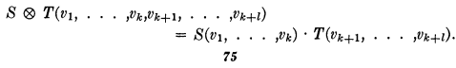
There is basically a direct connection between multi-linear functions and these tensor products (I call them direct products". I think I assumed this implicitly in writing my tensor doc appendix on this subject. The rules for the ⊗ operator stated on page 76.

[76]

Comment: You can say S: Tk → R and T:Tl → R and (S⊗T): Tk ⊗ Tl → R. These mappings are functions! I keep repeating that simple fact. I think his rules tell you how to deal with elements (s,t) of S⊗T even though stated in terms of the spaces:

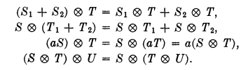

Distributive over addition on both sides. Scalar multiplies one or the other, not both! And the last is the associative. If you were to do a direct sum of Tk you would get what Benn/T call "the Tensor Algebra. Notice there are not rules in the above list containing something like ST abutted. No (s,t)(s't') = (ss',tt') as you find with a group situation. Here we are just "vector space" and there is no "mult" apart from ⊗.

Side note: a dual space for a vector space V is the space of linear functionals on V, meaning the space of f where f:V→R. Since the space of T:V1→ R is T1(V), you could say that T1(V) is the dual space to V, written as V*. No idea why this is significant. I am just trying to get down Spivak's notation. I have to ask then: are the elements of Ts(V) multilinear functions, or are they multilinear functionals? Well it is the same thing! If you leave off the arguments, you are saying the element is a functional in the space that is the dual space to Vs, perhaps called Vs*.
Dual Basis. Ah, but this is something I in fact know a little about. Wiki points out that the en are dual to the en and this is yet another one of my little pieces in tensor doc. Or the En are dual to the en. A main idea is that you have em • en = δmn . Recall from tensor doc that the en point along the edges of the n-piped, whereas the En are normals to the areas of the n-piped. But how does this relate to the idea of "functional"? Well I guess I could write em • v = em(v) where em is the name of the functional, and v is a vector in the space V spanned by the en. So OK, em is then a functional and em : V→R via the dot product. So I guess em is a basis for V for the n-piped, and em form the dual basis for the same space V. In the following theorem, Spivak refers the set {vi} as a basis for V (think {ei}), and refers to φi as a basis for V*, the dual space of V. So we have two alternate basis for V we can select from. Same in old Margenau and Murphy in R3 I recall. Now so far we have V with the basis {vn} and dual basis {φn} . Then you can ask what happens in Vk and the result is pretty clear as expressed here:

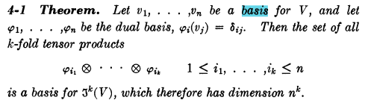

Note added 8.25.15. I am happy with the above now. The em are my qm dual basis vectors. The functional φi is the same as Sjamaar's λi. Generic element of V is called v by both authors.

So here V has dimension n. This now makes complete sense, and I now know what the φn are. In a later theorem on page 77 Spivak states the dual basis idea for the special case of an inner product. Talks about inner product on V. Talks about an orthonormal basis relative to an inner product T on V.

[77]

Notes added 2.21.16. On this page Spivak writes

He is just noting that this is a mapping which creates a new tensor function from a starting tensor function in a certain way. Probably trivial to show that the new function is also k-multilinear. If the starting function were alternating, so would be the resulting function. He says easy to show that f* (S⊗T) = (f*S)⊗(f*T). Here f is assumed to be a linear transformation V→W so it is a matrix. You would write w = f x. where f was a matrix (non square). Later we will see the above template used to define f* as a pullback operator, though Spivak will not use that term. f* : V*k → W*k. For him it is f* : Tk(V) → Tk(W). Fine.

He then discusses the idea of having an inner product and of having a symmetric tensor function, this paragraph does not seem very relevant. He then states Theorem 4-2 which looks like Gram Schmidt orthogonalization to me. He claims you can make a basis vi for space V such that T(vi,vj) = δi,j where T is the inner product, normally we would write <vi,vj> = δi,j. I ignore details here, think I am happy to have vector space V with orthonormal ei if I want.

[78]

Comment 2.21.16. This is where Spivak starts into alternating functions and what I call the wedge dual space. His discussion is only about tensor functions and does not get into the actual dual space Λk and how you write its basis functions etc.

Inner products are not so interesting he says, so we turn to determinants page 78. Suppose you have one of the above multi-linear things (function of k vector variables which on each is linear) which he calls a k-tensor, you could restrict your interest to functions which are totally antisymmetric in all variable label pairs. If a k-tensor is antsym for each pair, it is alternating. Consider

f(v1,v2.v3) = some function of three vector variables

Maybe think of this as a scalar function of a matrix V = {v1,v2.v3} with columns vi. For example, the det function is exactly this, det(v1,v2.v3). Every such alternating k tensor is of course an element of Tk(V), and in fact these form a subspace he calls Λk(V). [ this last is the traditional name that everyone uses!]

Note added 8.25.15. OK, so the alternating qualifier is now in the soup and Λk(V) of Spivak = AVk of Sjamaar. Now he introduces the Alt operator, same as me, same as Benn Tucker.

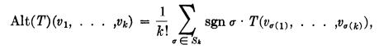
If you think of the vi here as column vectors of a matrix, and here from Sjamaar,

det(M) = Σσ∈Sn sign(σ) M1,σ(1)M2,σ(2)......Mn,σ(n) Sn = set of all permutations of Zn

He states and proves three facts, which now on 2.21.16 are all old hat for me,

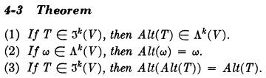

Note added 8.25.15. The Alt operator is the obvious "antisymmetrizer" operator that maps any non-anti sym function into an antisym one. For example

[Alt(T)](v1,v2) = (1/2) [ T(v1,v2) - T(v2,v1)]

I think you could say that

[Alt(T)](v1,v2....vk) = (1/k!) Σabc..q εabc..q T(va,vb....vq) // k! terms in sum

If T were already AS from the start, then all those k! terms are the same, and then you would get

[Alt(A)](v1,v2....vk) = (1/k!) Σabc..q εabc..q A(va,vb....vq) = A(v1,v2....vk)

so for an AS function, the Alt operator does nothing at all.

Special case of the above.

Suppose we had T(v1,v2....vk) = f1(v1) f2(v2).....fk(vk), a specific factorized form for A. Then we would say

[Alt(T)](v1,v2....vk) = (1/k!) Σabc..q εabc..q f1(va) f2(vb).....fk(vq),

We could then define the matrix

Mij = fi(vj).

and we would then have

[Alt(T)](v1,v2....vk) = (1/k!) Σabc..q εabc..q M1a M2b.....Mkq = (1/k!) det(M)

Let's call the antisymmetrized version of T by the name A. Then we have

A(v1,v2....vk) = (1/k!)det( fi(vj))

If we liked, we could make up a clumsy name for this function:

"f1f2...fk"(v1,v2....vk) = k! A(v1,v2....vk) = det( fi(vj))

This then is what Sjamaar shows on his page 85 C.

Comment pause: Is there some way to express Alt(T) without showing the arguments? For example, consider this simple case:

[Alt(T)](v1,v2) = [fa(v1) fb(v2) - fb(v1) fa(v2)] /2

Could you say fa(v1) fb(v2) = "fafb"(v1,v2)? Then the above says

[Alt(T)](v1,v2) = ["fafb"(v1,v2) - "fbfa"(v1,v2)] /2

and then yes, you could remove the arguments to say

[Alt(T)] = [ "fafb" - "fbfa"] /2 .

You could regard either side of this equation to be a bi-linear functional within Λ2(V). Maybe

[Alt(T)] (v1⊗v2) = [ "fafb" - "fbfa"] /2 (v1⊗v2) = [fa(v1) fb(v2) - fb(v1) fa(v2)] /2

and this then tells you what happens when you apply this functional to an element of V2. When you do this, you end up with a function of v1 and v2. So maybe that is a handy distinction between the words functional and function at least in this setting. This idea of arguments written as (v1⊗v2) agrees with Benn & Tucker who say

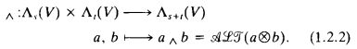

[79]

Comment added 2.21.16. His wedge product remained a mystery for a long time, as did his normalization. But in wedge doc all this is clarified, it is all figured out and done with. The wedge product of two dual tensors appears in my Chapter 8. I was of course totally confused by Spivak's "definition of the wedge product" in the context of this complicated case of two general dual tensor functions getting wedged.

OK, now here comes the wedge product. Recall that Λk(V) is the subspace of Tk(V) which contains those functions where are totally antisymmetric in their argument indices. Let ω and η be two of these TA k-tensor functions. Let ω be in Λk(V) and let η be in Λl(V) . This ω has k (vector) variables, and η has l variables. You can then talk about ω ⊗ η as en element of the direct products space Λk(V) ⊗ Λl(V). You could then antisymmetrize ω ⊗ η totally in all the variable indices using the above operation. This is the wedge product!
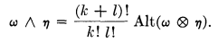

So I would say that ω and η are certain scalar functions, and this ω ^ η is a function of the combined set of variables. Furthermore

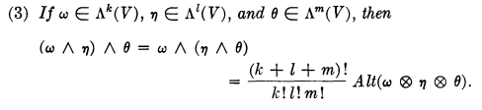

so here we have a triple wedge product. So far ω and η are scalar functions, so this seems to have nothing to do with other people's talking about the wedge product of two vectors. Nor does this seem much related to dx1 ^ dx2 at this point.

2.21.16. Spivak defines the wedge product above then states some properties of ^ :

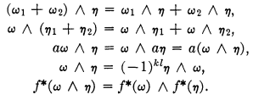

These are all old hat now, and now at least I know what he means by the f* one, since I talk about f* above as a mapping from one tensor function to another. Wonder if he will use this f* result. I am sure I could verify the claim above easily.

2.21.16. In the following, I was struggling to find trivial examples of a wedge product since Spivak never gives any. This is now all understood including normalization.

Example Needed Badly! Suppose ω in Λ1(V) and η in Λ1(V). Perhaps ω = φi and η = φj, two basis functionals in V*. Then

Alt(T) = Alt (ω ⊗ η) = Alt(φi⊗φj) = (1/2)[φi⊗φj - φj⊗φi]

and then

ω ^ η = φi ^ φj = 2 Alt(φi⊗φj) = φi⊗φj - φj⊗φi.

You can see clearly that the result is an element of Λ2(V) [ functionals in Λ2(V) ]

Here I really have selected functionals in Λ1(V) to do the wedge product with. I think that is the only thing that really makes sense. There are no arguments here, there are no "functions". I could do linear combinations and obtain ω ^ η for two arbitrary linear functionals ω and η in Λ1(V). You could now add some arbitrary arguments and write the above in terms of functions,

(ω ^ η)(v1,v2) = (φi ^ φj)(v1,v2) = 2 Alt(φi⊗φj)(v1,v2)

= [ φi⊗φj - φj⊗φi](v1,v2) = (φi⊗φj) (v1,v2) - (φj⊗φi) (v1,v2)

= φi(v1)φj(v2) - φj(v1)φi(v2)

so our actual functions don't appear until the very last step.

Example 2. OK, suppose ω is in Λ1(V) but η is in Λ2(V). Do I know of any functionals in Λ2(V)? How about φi⊗φj ?? The space Λ2(V) is a subspace of T2(V) and a ⊗ b is what things look like in T2(V). OK, so then we have this example

ω ^ η = φk (φi⊗φj) = (3/2) Alt [ φk ⊗ (φi⊗φj) ] = (3/2) Alt [ φk ⊗ φi ⊗ φj ]

= (3/2) [ φk ⊗ φi ⊗ φj - φi ⊗ φk ⊗ φj + 4 other terms ]

Now you know that φk ⊗ φi ⊗ φj is in Λ3(V) just by staring. Thus we need three arguments, so

(ω ^ η)(v1,v2,v3) = (3/2) Alt [ φk ⊗ φi ⊗ φj ](v1,v2,v3) =

(3/2) [ (φk ⊗ φi ⊗ φj) (v1,v2,v3) - (φi ⊗ φk ⊗ φj) (v1,v2,v3) + 4 other terms ]

= (3/2) [ φk(v1) φi(v1) φj(v1) - φi(v1) φk(v1) φj(v1) + 4 other terms

and so again only at the end do we see recognizable functions.
It seems that if one of ω η is a "vector" or "1-tensor" functional, then you have a "raising operation" so that if ω is in Λk the result will be in Λk+1. I have seen this mentioned in a few places.

What about η ^ ω? For the above example we would have

η ^ ω = (φi⊗φj) ^ φk = (3/2) Alt [ (φi⊗φj) ⊗ φk ] = (3/2) Alt [ φi ⊗ φj ⊗ φk ]

= (3/2) [ φi ⊗ φj ⊗ φk - φi ⊗ φk ⊗ φj + 4 other terms ]

You can see comparing that the terms in red match and therefore we have this fact:

η ^ ω = + ω ^ η

and there is a general rule which I think is this

η ^ ω = (-1)st ω ^ η

and in the last example I had s,t = 2,1 so get (-1)2 = +. I will continue right here tomorrow.

Note added 8.25.15. The above is so important, I will right now write another doc about it!

[80]

2.21.16. AT this point Spivak throws in some theorem claims that again are now old hat for me. The statement is followed by proofs of the three claims.

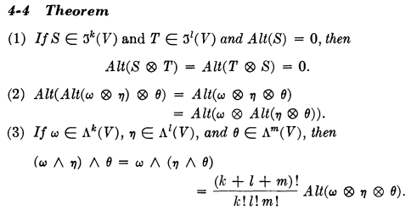

Next, we have this theorem: (notice that the indices are now ordered)

[81]

Comment 2.21.16 Finally he gets to talking about the basis elements of the dual space V*k which I call λi. Notice that the basis elements are ordered, and he gets the (n,k) count, all old hat now.

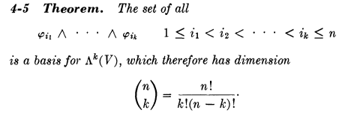

Recall that the φi are the dual basis to the basis vi of V. He gives a quick proof using the Alt operator. I don't need his proof so I ignore it, it contains equations now in wedge doc.

[82]

Next looks familiar,

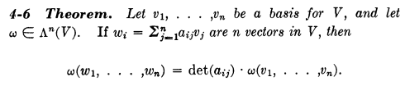

2.21.16. Here is my own proof of the above. Notice that wi = Σjaijvj is not a component transformation, it is what I sometimes call a "vector transformation". Then

ω(w1,w2,...wk) = ω(Σj1a1j1vj1, Σj2a2j2vj2,... Σjkakjkvjk)

= Σj1,j2...jk a1j1a2j2 ... akjk ω(vj1,vj2...vjk) // since ω is k-multilinear

But ω is alternating, so we can write

ω(vj1,vj2...vjk) = (-1)S(P) ω(v1,v2...vk)

and we then end up with

ω(w1,w2,...wk) = [ ΣP(-1)S(P)a1j1a2j2 ... akjk ] ω(v1,v2...vk) = det(a) ω(v1,v2...vk) QED

He then comments that the sign of det(a) determines splits all the basis of V into two groups, I agree. And this sign is associated with "orientation" which in tensor doc I all handedness. He has a certain notation to say whether orientation is one or the other. For example. - [v1....vk] is when det(a) < 0.

[83]

2.21.16 Here Spi considers the case k = n and talks about the volume element. I think I could parse everything here if I wanted, but I don't want right now.

[84]

He then gets into yet another product which I think is my generalized cross product

and it to has various rules.

Problems 4-1 through 4-12 appear at this point.

2.21.16. I see in Problem 4.1 that he makes what for me would start with this claim:

(λj$_{1}$ ^ λj$_{2}$ ^ .... ^ λj$_{k}$)(ei$_{1}$,ei$_{2}$....ei$_{k}$) =

= (1/k!) det[ δj$_{*}$i$_{*}$] . (λ^J)(eI) = (1/k!) det(δJI) **(8.3.9)

Then I would write

(λi$_{1}$ ^ λi$_{2}$ ^ .... ^ λi$_{k}$)(ei$_{1}$,ei$_{2}$....ei$_{k}$) = (1/k!) det(δII) = (1/k!)

In the Spivak normalization, this comes out being 1 instead of being (1/k!). So I have finally found the spot "later" where he justifies his normalization. But I see no significance to wanting this object to come out being 1. I have λ^I(eI) = (1/k!) whereas he has this being = 1. I guess it does mimic the idea that
λI(eI) = 1 in the tensor world versus the wedge world, since ei•ei = 1, that is at least an argument which I will keep in mind.

FIELDS AND FORMS

[86]

Comments 2.21.16. In Spivak notation, p is what I would call "a point on the manifold" and TpM would be the tangent space there. In Sja this is x and TxM. For Sja the manifold is some limited surface, whereas for Spi it is all of Rn and he refers to this full tangent space as Rnp which is just fine by me.

[88] // out of order

Now finally on page 88 we get to a differential form:

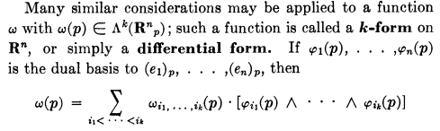

αx = Σ'IfI(x)λxI in Sjamaar

Now this is a pretty fancy definition of a form by Spivak. ω(p) is a function of the location of the arrow base p on which Rn is situated. Sort of a function of your selected origin. Of course p is a vector in Rn. One thing though is that by using ^ between the basis vectors, ω(p) is I guess TA by construction and that is why it is in the smaller space Λk. But what means Λk(Rnp)? I need to see more.

[86]

2.17.16. Let's take another look at his section showing the contour stuff. Page 86 on fields and forms. I have sort of ignore this.

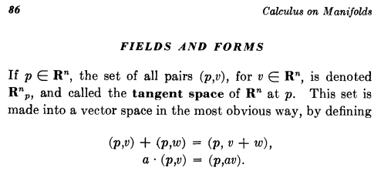

I think the idea is that p is the tail of a vector going from p to p+v. So the set of all vectors with tail at point p is what he calls the tangent space at p. But this tangent space has the full dimension of Rn , it is not constrained to a manifold surface. Or we just say Rn = M is the manifold of interest. Then sure, at a given point in Rn any vector with tail on that point is in the tangent space, no problem. For a given p we then have TpRn as the tangent space. And we take any vector v with its tail on p and that vector will lie in the tangent space TpRn. I then calls such a vector vp as a reminder that it is at p. [ correct ]

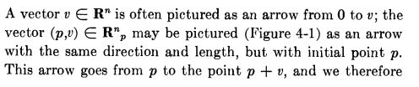

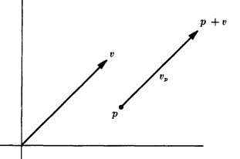

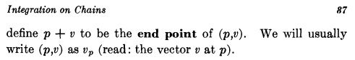

I am then completely happy with all that Spivak has said above. I think one then writes

v ϵ Rn = generic element of Rn
vp ϵ Rnp = corresponding element of the "tangent space" at point p

[87]

So far so good. Next,

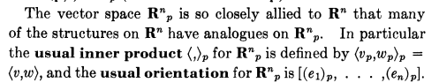

OK I think I am OK on these last two things, though would have to pause to study orientation again which I did on the last reading. [ see notes above, all OK] Let's instead plough ahead. Above he is just saying that almost everything is the same if you have your vector origins at point p or at the origin O. Once again, Rn is the usual space with origin of vectors at the origin of the space, whereas Rnp is the same Rn but with origin at point p. It is not rocket science.

Let's continue more:

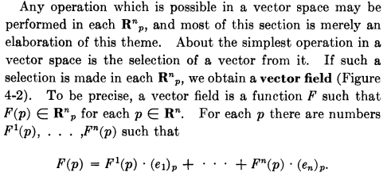

In my personal notation, I might say this: In Rn you can expand a vector as

V = ΣiViei

If you do this in Rnp for some specific p, you could then write

V(p) = ΣiVi(p) ei(p)

where everything varies with your selection of point p. The quantity V(p) is for sure a vector field over Rn since p is any point in Rn. He is writing my equation as

F(p) = ΣiFi(p) (ei)p

so I am now 100% happy with this vector field concept over Rn.

[88]

Spivak goes on to talk about div and curl, always doing so "at a point p". Then he gets on to this

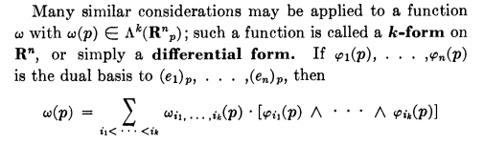

Note that ω(p) does not mean p is a "tensor function argument" of functional ω.

So in my notation I would write

T^(p) = Σ'I TI(p) λ^I(p)

Sjamaar would write this as (replace p by x as point on manifold)

αx = Σ'I fI(x) λxI

and λ^I(p) is the dual basis that goes with the tangent space basis ei(p) .

[89]

So far then Spivak has just said that "a differential k-form is an element of the dual space to the tangent space". Yes, I accept that definition. My question is: how does this relate to object "dxi" ? Well, we are on page 89 of Spivak . His immediate next statement is this clip which I find extremely confusing:

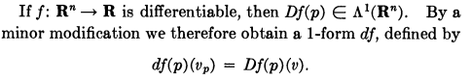

My alternate notation: dfp(vp) = (Df)p(v)

Questions: How does this clip related to Sjamaar's transformation picture on page 37 ?
What variable is f a function of?

Ansatz: I will assume that f = f(x) where x is a point on the left of page 37. Then (Df) is a matrix with one row and n columns and the elements in the matrix are ∂f/∂xi.

For me this is yet another Giant Leap I don't understand. First of all, f here is some scalar function that maps Rn to the real axis but f is associated with the point p. I presume v is some vector in V = Rn So we have fp(x1, x2.....xn) and certainly this means we will have ∂ifp all nicely defined, and I guess [(Df)(p)] would be a row-matrix where the coordinates ∂xi go across but there is only one row since only f. This is like the Sjamaar notation I have used many times. So this matrix has one row and n columns. You can apply it to any column vector you want having n components. If v is such a vector then [(Df)(p)] (v) = [(Df)(p)] v and that must explain what he has above on the right of the = sign. Now you can regard [(Df)(p)] (v) as a function of v ϵ Rn so you can then regard [(Df)(p)] as an element of the dual space. It is a linear function, after all. Now since the tensor function [(Df)(p)] (v) has only one vector argument, I must conclude that the object [(Df)(p)] is a one-form and is thus a functional/vector in the space Λ1 .
I think f is a 0-form and this its "derivative" is a 1-form.
He then just gives this 1-form [(Df)(p)] a shorthand name [df(p)] suggesting that it is associated with that derivative matrix of f, and everything occurs at some point p.

2.21.16. Maybe compare to Sja p 20 who has

α = f

dα = df = Σi (∂f/∂xi) dxi = Σi (∂f/∂xi) λi

dα(v) = df(v) = Σi (∂f/∂xi) dxi(v) = Σi (∂f/∂xi) λi(v) = Σi (∂f/∂xi) vi = (Df) v

Compare to Spivak above: dfp(vp) = (Df)p(v)

So I think this explains the basic idea. An underlying idea is this comparison:

1. df = Σi (∂f/∂xi) λi = an element of the dual V* space, both df and λi are functionals

2. df = Σi (∂f/∂xi) dxi where both df and dxi are ordinary calculus differentials.

Question: Why does he write vp on the left and v on the right for function arguments? [ Everyone who has read this section doubtless asks this same question! ] One answer could be this: he wants the right side function to be a function defined on Rn but he wants the left side function to be defined on Rnp which is the tangent space. In general, we always want a differential form to be defined on TpM and then we close it with a vector in TpM, and in this situation such a closing vector is |vp> ! Since there is a 1-1 correspondence between Rn and Rnp he is free to define the left side above any way he wants.

Question: In the above clip, what are the variables that you differentiate with respect to make Df? I will assume for the moment that they are variables x ϵ Rn. Then in my notation

(Df)p = (∂x1fp(x), ∂x2fp(x) ...... ∂xnfp(x))

Remember that p is the origin of our tangent space. The dummy coordinates x are just elements or Rn I will assume. One would not here differentiate with respect to the components of the fixed point p.

I will try to make up my own example since Spivak seems uninterested in examples. Let n = 2 and then

df(p)(vp) = [(Df)(p)](v) = (∂x1fp(x), ∂x2fp(x)) $\left(\begin{matrix}v1 \\ v2\end{matrix}\right)$ = ∇ fp(x) • v = < ∇ fp(x)| v>
df(p)(vp) = <df(p)| vp> = a tensor function defined on Rnp

This is a little strange in Dirac notation due to the distinction between v and vp. The right side kets are not in the same space. I will ignore that for the moment and then claim that

<dfp| = < ∇xfp(x)| = a vector in the dual space Λ1 (since one vector argument to tensor functions)

Thus <dfp| as defined in his clip really is a "1-form" defined at point p in a tangent space.

So far we have no dxi objects, but that is coming next. (still on page 89)

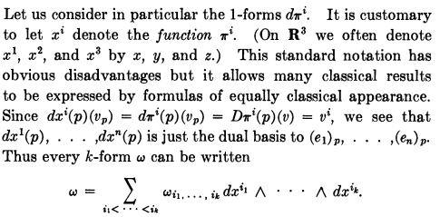

So here once again we reach the critical point and I will try to parse this last paragraph. First of all, he is using πi as the name of a scalar function which previously was just f. So we have a set of scalar functions of interest indexed by integer i. So we then have

[dfp](vp) = [(Df)p] (v) ⇒

[dπip](vp) = [(Dπi)p] (v)

Now a question: Why does he claim that [(Dπi)p] (v) = vi ? Well, we know that dfp is a functional vector or 1-tensor in the dual space to V, and I know from elsewhere that the λi form a basis in that dual space. So there must be some scalar functions fi for which dfip corresponds to these basis vectors in the dual space. He refers to these special functions not as fi but as πi just to have a name. So then we have

(Dπi)p = λip = dπip

Question answered! Now his comment is that people write πi as xi in order to maintain an appearance similar to "classical results". So as a pure notational thing we write

πip = xip
dπip = dxip

He argues this is just notation, and dxi then has nothing at all to do (at least at this point) with a differential which in calculus we would call dxi. So given that this is just a notation, we then have

πip = xip
dπip = dxip = λip

Now we could then write

dπip(vp) = dxip(vp) = λip(vp) = vi // as he claims in above paragraph

Notice there is no p subscript on the final v which seems strange but that is what he wants. This is sort of a loose bolt in his presentation for me.

Now we know for sure that, at any point p in TxM,

λip[ (ej)p] = < (ei)p | (ej)p > = δij = dxip[ (ej)p]

So the upshot of all this is that dxi is just an alternate name for λi and is NOT a classical differential of the coordinate xi. Given that fact, I am then completely happy to write k-forms as elements of the dual space where we just replace λi by dxi as a cosmetic thing. Then we get things like this for a 2-form

α = f(x) dx1 ^ dx2 = ϵ Λ2 usually written α = f(x) dx1dx2

More generally,

T^ = Σij Tij dxi ^ dxj ϵ Λ2

α = ΣI fI dxI ϵ Λk

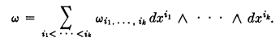

I think I am content with all the stuff above, but of course have not "tested it" in any way.

Now Spivak has more to say which I think will tie in with the "classical notation". (still on page 89)

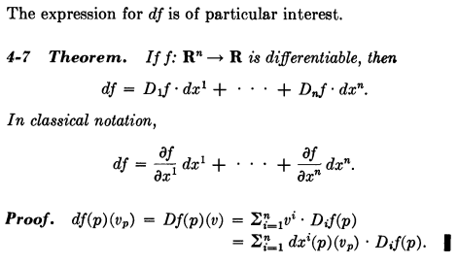

What exactly is the Theorem here? The first line just says (according to me)

df = Σi=1n (∂ifp(x)) λip = Σi=1n (∂ifp(x)) dxip

which is a certain 1-form in the dual space Λ1(Rnp).

I think the second "classical line" says

df = Σi=1n (∂if(x)) dxi

where here dxi is a differential in Rn (maybe in Rnp) and df is a general differential. These differentials are things that are part of "regular calculus". They are not differential forms in some dual space. But the point is that the equations look exactly the same if we set λi = dxi !!!

So what exactly is the "proof" proving?

From above we defined df in this manner

[df(p)](vp) = [(Df)(p)] (v) = [(Df)(p)] v = Σi [(Df)(p)]ivi

= Σi [(Df)(p)]i [λi(p)](v)

= Σi [(Df)(p)]i [dxi(p)](v) // with cosmetic rewrite of λi

I will rewrite this as

[dfp](vp) = (Df)p(v) = [(Df)p] v = [(Df)p]ivi = (Dif)pvi

= (Dif)p λip(vp) = (Dif)p dxip(vp)

Again, what exactly is this line of equations "proving"? It leads to dfp = (Dif)p dxip but for me there is nothing to prove. I have already stated my interpretation of the two lines in the clip.

So yes, there is a functional equation and there is a differentials equation and they look very similar.

I have to digest this a bit. He will then turn to f* which is φ* which is the pullback idea, but he does not use the pullback word, so took me a while. With this cosmetic meaning of dxi , what is Sjamaar's meaning for φ*(dxi) ?

OK, ready for the next clip and we are then into the subject of pullbacks, (still on page 89)

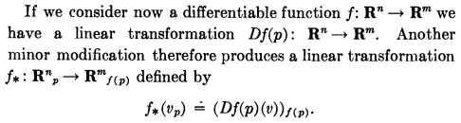

[90]

Wow, this equation is totally unclear to me. He has both p and f(p) labels at the same time. Soon we are going to see this line,

Here f* I am sure is Sja's φ* pullback operator. [ correct] So on the left here we have (f*ω) being a new k-form created by acting on the k-form ω with the operator f*. So I would write the left side of this equation as

(f*ωp) (v1.....vk)

where the p as usual marks our tangent space point p. On the right we then have

ωf(p) ( f*(v1)......f*(vk))

Let me translate this to something closer to Sjamaar page 37, taking f*→φ* and p→x

(φ*ωx) (v1.....vk) = ωφ(x)( ( φ*(v1)......φ*(vk))

(φ*ωx) (v1.....vk) = ωy( ( φ*(v1)......φ*(vk))

The φ* functions must be vectors, so I have bolded them. Now use Spi def of φ* to rewrite as

(φ*ωx) (v1.....vk) = ωy( (Dφ)x(v1)]y......(Dφ)x(vk)]y)

I give up. This is just total trash as far as I am concerned. But in the end f* will be Spivak's φ*.

Comment 2.21.16. I bailed this out yesterday! The above appears on Sja p 88 A. I have proven now in a separate document ( "decoding one equation of Spivak.doc") that the above action on tensor functions does in fact exactly replicate the Sjamaar pullback theory

(φ*α)x(v1,v2....vk) = αy(Rv1, Rv2.....Rvk) Sja p 88A

So I have resolved this mystery and along the way verified the Svi normalization stuff.

For example, Spivak will have these theorems about his pullback operator f*,

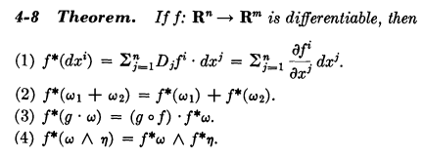

Consider the case where ωx = dyI. Sja on page 37 says

φ*dyI = φ*(dy1^dy2 ...) = dφ1^dφ2.....^dφk // I think hats are right

Now I could turn this into a vector function this way

(φ*dyI) (v1.....vk) = (dφ1^ dφ2.....^ dφk) (v1.....vk)

= dφ1(v1) dφ2(v2)....dvk(xk) // this is a product of functions

Now use

dφ1(x) = Σj=1m (∂φ1/∂xj) dxj

But this is fuzzy. Left side is a function, right side is a form. I think I need to go off and clarify Sjamaar more on the meaning of φ*, then come back here once I think I understand Sjamaar. At least Sja has lots of works and examples, so I have a better change there than here in Spivak.

Comment 2.21.16. I think I have cleared up all the above, and f* = φ* and all is well.

________________________________________________________________________________

Comments:

A recurring question: How can you say that dxi ej = δij are required for a dual basis? Well how about this

dxi = dxi = a differential vector in the i direction

en = = a regular basis vector

Then I agree

dxi • en = [ dxi ] • [ ] = dxi δin

and then in some crude sense you could say dxi is a dual basis to the ei.

Conclusion: I have really learned nothing from the above wedge product presentation! His presentation is nothing more than a bunch of notation definitions soaked in mush. It is as if we don't even speak the same language! He is just talking in a different environment that than which contains me. I would have to completely reconstruct his world to decode this book, but then I doubt I would learn much about my world. I see now that Sjamaar has attempted to bridge that gap.

So I bring this little tour to an end at his page 90.

Comment: Reading Spivak, I see no connection between his discussion and the wiki one which takes about bivectors as a wedge product of two vectors. There would seem to be no connection at all!

ok to here

Resumption in Spivak on 2.17.16

Well by now I feel I am a world-class export on tensor products and wedge products, having written a 200 page monograph on the subject. I am no longer concerned about Spivak's presentation on those topics. After writing this monograph, I then did a complete review of the Sjamaar notes. My Big Mystery is how one justifies the connection between λi and dxi. It turns out that Spivak gives his answer to this question (see above) and it is a cosmetic connection to make forms results look like "classical results".
____________________________________________________________________________

Still on page 90, Spi goes on with related theorems which Sja would write as

φ*α = φ*( ΣI fI dxI) = ΣI [φ*fI] [ [φ*dxI]

[91]

For a full volume element he then writes (again translated to Sja notation)

[φ*dxI] = det(Dφ) dxI

First Spi writes Dφ as f', then he writes it as A = aij . Next he writes

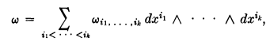
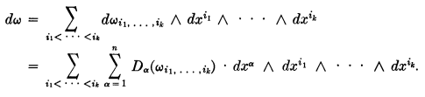

where Dα just means ∂/∂xα, Notice the NEW ^ which appears in the dω form which I recently conjectured must be there (the leftmost one) in my Sja reading. Otherwise the above is same as Sja action of d. Then we have the Sja set of theorems about "d"

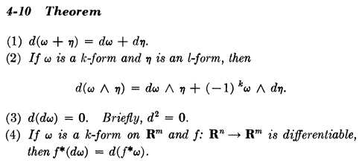

[92]

Spi then talks about notions of closed dω = 0 and exact ω = dη .

[93]

The Angle Form appears, as in Sja. He asks how to solve equation ω = df for f, given ω. As a start he writes

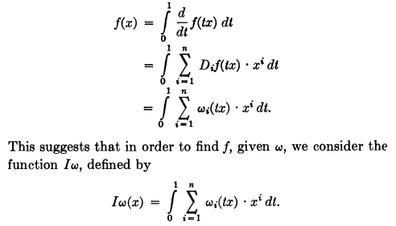

The first line is trivial if you assume as he does that f(0) = 0, though not obvious to me why this is "clearly assumable". It is OK by me. I skip details, but he uses this Iω thing to prove the theorem below.

[94, 95]

Recall from Sja Section 4.2 notes that "any closed form on all of Rn is exact" and how the angle form provides a counterexample since the domain set is punctured at the origin so is not open there. Then on p 42 of my Sja Ch 1-5 notes I claim to generalize this to be true if the domain is cube in En centered at the origin. On page 94 Spivak states exactly my theorem, but generalized not just to a cube, but to any "star shaped open set" around the origin, which I could easily believe. This theorem even has a name:

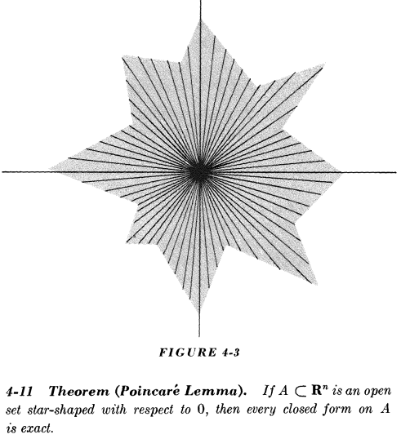

Spi then gives a long proof. He uses the same Sja notation of a wide hat over something to show it is missing. I did not follow the proof, BUT it provides lots of examples of Sja-like equations but here all the ^ are installed in the right places. Someday I may come back here. It involves some integration. I wants to end up with ω = df to show that ω is exact, and to do this he starts with f = Iω which is some kind of integration.

[96]

Here we have problems 4-14 through 4-21, I browsed through them.

GEOMETRIC PRELIMINARIES

My first notes here are written today 2.21.16.

[97-100]

This looks very much like Sja's discussion of "cubes" and "boundaries" including the tech details. Since I did all that stuff in Sja, I will just space over things. His notation is the same as Sja more or less, ∂c and ∂2c = 0 etc. A finite linear combination of cubes is a chain. He uses n, so n-cube and n-chain.

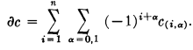

c: [0,1]n → A ⊂ Rn is called a singular n-cube " in A"

Singular 1-cube is a curve.

In : [0,1]n → Rn is called a standard n-cube, so here A is all of Rn

n-chain = lin comb of singular n-cubes

Note that In(i,0) = In(x1....xi-1, 0, xi, ...xn-1) where we delete xi then drop all the higher down

just as in Sjamaar. This is the boundary say of a cube at one end, then 1 is the other end. I did all this in detail.

Problems 4-22 through 4-24.

THE FUND THM OF CALCULUS

OK, here for the first time Spivak is going to talk about integrals and that is where my confusion lies, so I will read what he has to say. I will start reading here more carefully.

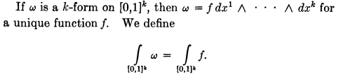

[101]

OK, how to I connect this to Sja? Very interesting next line,

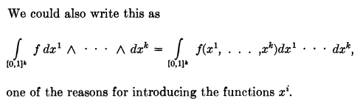

This is right up my alley! For a k-cube, he is equating a form integral on the left with a regular calculus integral on the right !!! Here it is critical that he displays the wedge symbols on the left. So I think he is saying that the left is defined as the right on this very simple integration domain. Did Sja ever make this statement? Sja could not write this because he uses no ^ anywhere!!! This is a Big Find for me. Notice the comment. This is why they name the form dxi instead of λi !!!!!

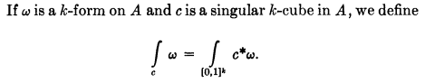c = a singular k-cube

Notice the word define here. This is in agreement with Sja where c* is the pullback operator.

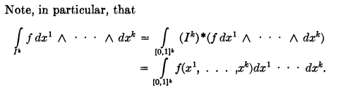

Here he has replaced the chain of singular k-cubes with one standard k-cube, c → Ik , just fine! Just a special case of what is shown above.

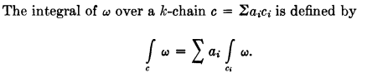

Just fine. But now Spi goes strange on us again by writing the following 1-form integral

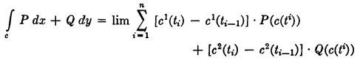
[102]

He goes on to explain that

c1(ti) - c1(ti-1) = Δc1 = (dc1/dt) Δt → (dc1/dt) dt = (∂tc1)dt

and then we find that we get the Sja result on page 47 (1st page of Ch 4). I am not sure why he avoids writing this in the standard way. He allows the intervals to be variable but max width → 0, so this is like the Buck Riemann integral. Now suddenly here we are

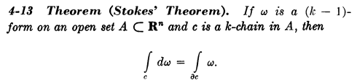

which he calls the Fund Thm of Calc "in higher dimensions". Now comes the Sja proof BUT here all the ^ wedges are shown, so let's give it a shot. The opening gambit is this,

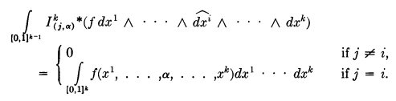 (1)

Function f has k arguments, and he is setting argument xi= α and all others are as is. I know that a pullback never changes the dimensionality of a form, so I have to interpret dx1....dxk as missing dxi and he is just doing a shorthand. BUT, since f has no dependence on xi he has quietly added this:

f = f $^{\int_{0}^{1}{}}$dxi

and this then brings up the [0,1]k-1 integration domain to the full [0,1]k and the differential to full dx1 through dxk as shown. Very good.

Here Ik(j,α) represents the two boundaries of Ik for α = 0 and α =1 and these boundaries are k-1 cubes. I think the j = i pin comes from the fact that if j≠1 you are integrating over a nonsense surface and it has zero measure. Draw a cube on scratch to see this.

[103]

Now look at his next step starting top page 103

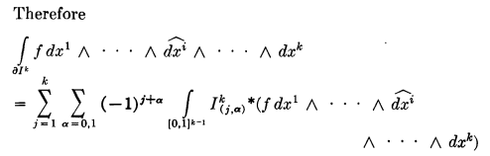 (3)

Here he is just taking the first line of (1) above and summing over the boundary of Ik which is of course a k-1 form. He is not involving the last line of (1) here, he is just summing over the first line with the magic sign factor which I know all about. So continue to the next

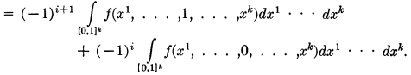 (4)

Here he is doing the α sum explicitly and he has used (1) to remove the j sum and all is well. Notice that we have a regular calculus integral here, not a wedge product, because things have been pulled back!!!
I continue:

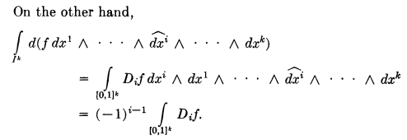 (5)

So first the d acts just on the f to give df = Σj(∂jf)dxj and I am happy with the 2nd line! Notice the wedge after the dxi Now when he slides this into the right position he picks up the phase shown and we end up with

∫[0,1]k (∂if) dx1....dxk (6)

which he writes just as ∫[0,1]k (∂if) in the sense that you write ∫f as a general integral. Note also that the sum on j is killed off for the usual wedge product reason.
I continue:

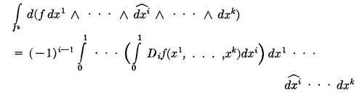 (7)

Here he is taking the last line of (5) with my dx1....dxk added (no wedges) and he is breaking out the dxi integration He moves it to the left for free since there are no wedges here! That leaves the dxi hole as shown. I think Sja's email to me was wrong when he said "wedges are everywhere" !!! I will check into that soon. So I agree with (7) with that integral broken out. The f here has all arguments including dxi.
I continue:

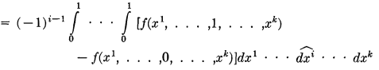 (8)

Here we are doing the dxi integral of a perfect differential to get the two terms shown, all is well.
I continue:

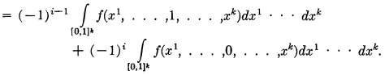 (9)

Here again in each term he has added f = f $^{\int_{0}^{1}{}}$dxi and this fills the hole giving the full volume.

If we look back, here is what he has done. Items (3) and (4) say that

∫∂Ik ω = sum of two terms shown in (4)

Items (5),(7),(8),(9) show that

∫Ik dω = the exact same sum of two terms

Therefore we have Stokes' Theorem on a cube

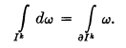

I think all the steps are there!!! I saw no problems.

[104]

He then claims this is true not just for a standard k-cube Ik, but also for a singular k-cube c (defined earlier),

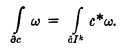

Remember that in the singular case you still have the same domain, just range is A in Rn . So the pullback on the right has that same domain which here is a boundary thing. Here are the last steps

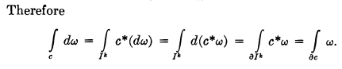

and finally he just extends this to a chain

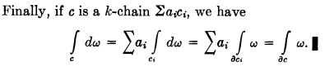

This is not Stokes on a manifold yet, it is just Stokes over a chain, and that is fine by me.
Now here are his concluding remarks that other people have commented on, on the web

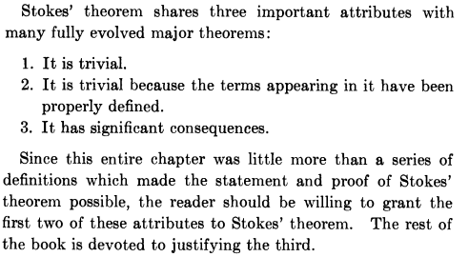

[105-108]

Problems 4-25 through 4-34. One problem talks about degenerate cubes. One problem is an entire "first course in complex variables"! Last problem is the homotopy stuff. Sja has a little to say on each of these subjects.

[109]

Chapter 5: Integration on Manifolds p 109

