Wedge Stuff

Question 1: What is the connection between the Spivak world of wedge products defined in terms of multilinear functions and the Denker world of geometric blades and Clifford algebras and the geometric product?

Both worlds use the wedge product symbol and have expressions like a ^ b, but sources seem to talk only about one or the other.

1. Wiki page on exterior algebra.

The first part of the presentation concerns these objects:

exterior product = wedge product = ^
geometry
area of parallelogram
exterior algebra = Grassman algebra
k-blades
graded algebra
The definition of the exterior algebra makes sense for spaces not just of geometric vectors, but of other vector-like objects such as vector fields or functions. [ hint of a connection]

Planar geometry examples : has notion of standard basis vectors ei and column vectors.

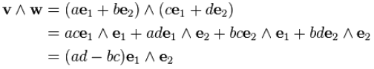

Here the coefficient is the area of a 2-piped spanned by the vectors. I think you regard e1^e2 as a basis element in the 2-vector space, perhaps a basis 2-blade. In 2D this is all there is. You cannot evaluate e1^e2 as some number. It is perhaps a bit like e1 ⊗ e2 which is a basis element in the direct product space and is not something you try to evaluate.

Next is a section on R3 examples. Now we have these elements

e1,e2,e3 e1^ e2, e2^ e3, e3^ e1 e1^ e2 ^ e3
vector bivector trivector

So there are somehow 3 + 3 + 1 = 7 basis type elements.

so three of these elements appear in the general wedge of two 3-vectors. And then

Notice that in both these last examples, you do have an antisymmetric element creeping in, but there are no AS functions really in the Spivak sense.

Next comes a section that I think is slowly coming into focus:

This says that you go ahead and compute a direct product in the usual away of two vectors α and β, but in the resulting set, you by fiat set elements of the form x ⊗ x = 0. Very strange. Let's try this in the above example:

u = u1e1+ u2e2
v = v1e1+ v2e2

u ⊗ v = [u1e1+ u2e2]⊗ [ v1e1+ v2e2]

= write it out.

Then if you throw out terms having e1⊗ e1 and terms having e2⊗e2, you do indeed arrive at u ^ v if you replace all ⊗ with ^ . Is this true only for vectors u and v, or for any Clifs u and v ?? Try this

u = u12 e1^e2 + u23 e2^e3 + u31 e3^e1 a bivector in R3
v = v1e1+ v2e2 + v3e3 a vector in R3

u ⊗ v = [u12 e1^e2 + u23 e2^e3 + u31 e3^e1] ⊗ [v1e1+ v2e2 + v3e3]

Well now we have a mix of ^ and ⊗. Take all to ⊗

u ⊗ v = [u12 e1⊗e2 + u23 e2⊗e3 + u31 e3⊗e1] ⊗ [v1e1+ v2e2 + v3e3]

= u12v1 e1⊗e2⊗e1 + other terms

So the more general rule is that you have to throw out terms where any 2 factors of the direct product are the same. So that is more than

Earlier they say x ⊗ x = 0 as shown above. So they are only talking vectors.

In this same section wiki also says

Now I am supposed to be an expert in "ideals" from my Galois doc which I just looked at. Recall that an ideal I in R means you have rI = Ir = I for any r in R (a ring). The ring here is T(V) which is unfortunately not defined. But perhaps it is the direct product space V x V of which α ⊗ β would be an element. So the "r" here would be any α ⊗ β, whereas an "i" would be any x ⊗ x . Then check

r i = ( α ⊗ β)(x ⊗ x) = (αx ⊗ βx)

But why should this be in I ? I have fallen off the wagon. The reference for this claim is good old Birkhoff MacLane which I think I have in stock. I do have it. Where would I find such a claim in there? I don't think it is there as stated above. So I get no happiness on the above claim, but the mod statement makes some sense, throwing out "diagonal" elements somehow.

Here is an interesting idea:

So by just assuming the left =, you obtain the antisym rule for all x and y in your "space". Does this then apply for x and y being any clifs? Seems not true for example if x = scalar and y = vector. In fact if s is a scalar we have s^s = s2 ≠ 0. I think wiki stuff is only for vectors.

Notice the use of Λk(V) which is the Spivak notation in the parallel function world. This space has the alternating property, but we have no functions yet.

Question: Is there an isomorphism between x1^ x2 ^......^ xk and f(x1,x2.....xk)? On the left we have the wedge product of k vectors, on the right a function of k vectors. Maybe isomorphism only for vector clifs?

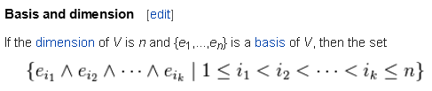

The above is just fine, there are n items wedged here.

There is then more which I skip, then we come to a Duality section.

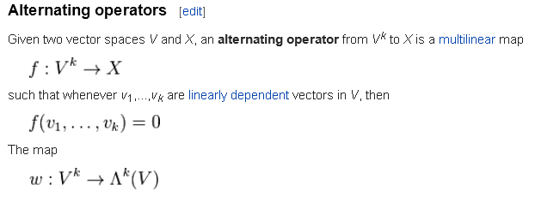

Suddenly we have multilinear functions appearing here! We then get the Spivak wedge. But no connection is made to the earlier geometry stuff. Is this just another implementation of the higher level construct ^ ? The page then peters out for me, and my question is not answered.

1. Wolfram page on exterior algebra.

exterior algebra = alternating algebra = Grassmann algebra

space = space of all possible "forms"

This offering does not help me at all, too fancy.

Chapter 3 PDF of Someone

Here is an interesting statement,

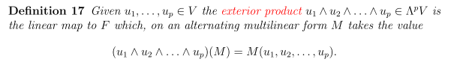

The multilinear function M of V space vectors appear as function arguments on the right. But on the left we have an abstract wedge of all these vectors. That seems new to me.

Earlier they state this simpler case

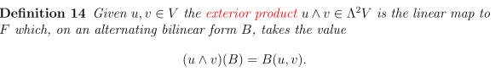

Alternating bilinear just means 2-multilinear. Same thing as above. The wedge product is an operator which operates on the function B, or M above.

Sophomore Document. Only does wedge of vectors, and states that
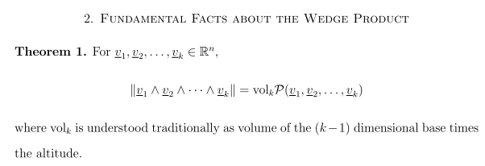

A Presentation pdf

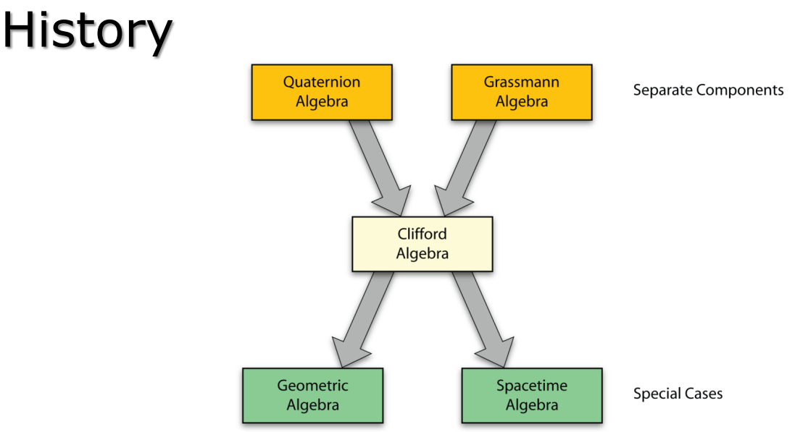

Signing off for 8.25.15.

