Category Theorem PhL 9.8.15

Just want to take a very quick look at this room in the House of Math. The wiki page is pretty good and here are a few notes on that page. I of course omit most topics addressed.

"Category theory[1] formalizes mathematical structure and its concepts in terms of a collection of objects and of arrows (also called morphisms). A category has two basic properties: the ability to compose the arrows associatively and the existence of an identity arrow for each object. Category theory can be used to formalize concepts of other high-level abstractions such as sets, rings, and groups."

Here is a typical picture,
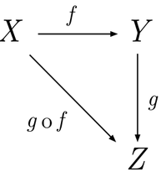

Here X,Y,Z are objects and f,g and f o g are arrows (morphisms) and o indicates "arrow composition". The arrows are called morphisms, but this is not the same sense of morphism used elsewhere, it is a special word used in category theory.

If you were to regard X,Y,Z as themselves categories (objects = categories), then the arrows are called functors, a term I see here and there. So this all makes sense:

"Diagram chasing is a visual method of arguing with abstract "arrows" joined in diagrams. Functors are represented by arrows between categories, subject to specific defining commutativity conditions. Functors can define (construct) categorical diagrams and sequences (viz. Mitchell, 1965). A functor associates to every object of one category an object of another category, and to every morphism in the first category a morphism in the second."

Here is a formal presentation of the category idea:

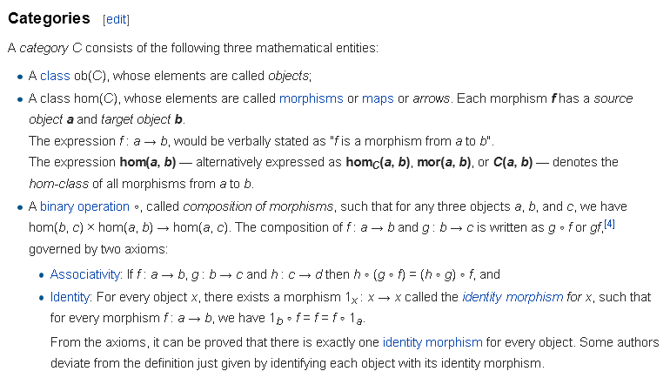
I would say that an arrow is a "mapping" but generalized from its usual use between functions or between say vector spaces. It is between two objects in the category space. I suppose hom(C) is the set of mappings which can link objects in the category C whose objects are ob(C). Not sure what the letters "hom" signify.

"In 1942–45, Samuel Eilenberg and Saunders Mac Lane [book Birkhoff (my 1967 teacher) & Mac Lane] introduced categories, functors, and natural transformations as part of their work in topology, especially algebraic topology. Their work was an important part of the transition from intuitive and geometric homology to axiomatic homology theory. Eilenberg and Mac Lane later wrote that their goal was to understand natural transformations; in order to do that, functors had to be defined, which required categories. [ Category theory is not included in the Birkhoff Mac Lane book.]

Stanislaw Ulam, and some writing on his behalf, have claimed that related ideas were current in the late 1930s in Poland. Eilenberg was Polish, and studied mathematics in Poland in the 1930s. Category theory is also, in some sense, a continuation of the work of Emmy Noether (one of Mac Lane's teachers) in formalizing abstract processes; Noether realized that in order to understand a type of mathematical structure, one needs to understand the processes preserving that structure. In order to achieve this understanding, Eilenberg and Mac Lane proposed an axiomatic formalization of the relation between structures and the processes preserving them".

Example of what you see in category theory:

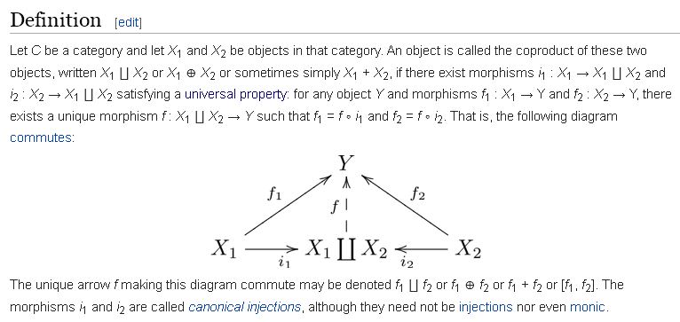

So here they are defining the notion of a coproduct in category theory which is written using an upside-down capital π symbol. I finally located this in the Arial Unicode MS font which is a very large font! So X1 ∐ X2 is an object which makes the above picture work! I think this is in effect some kind of SUM operator as the other two symbols suggest.

Here is a context in which this coproduct animal appears

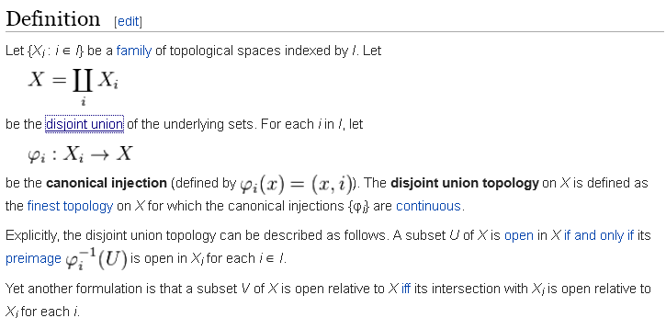

So in the fiber bundle world, when you write π-1(U) as the preimage of the projection π, maybe you can think of things this way

π-1(U) = ∐i π-1(Ui)

so maybe you are summing over the fibers of the bundle in this way. In fact, my html fiber doc says this

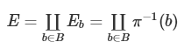

so you are summing over all elements b of the base manifold B, and yes, this is a sum of fibers to obtain the continuous surface E.

