Fiber Bundles -- Starting Out PhL 9.4.15

I knew something about this subject very long ago, it came up somewhere in my physics past. If I search my Work folder for files containing the word "fiber", I get no hits on this subject, so I have no "current" notes on this topic. So here I start over. Vector Bundle is another phrase. Agent Ransack shows I have no data on this subject.

1. Paul Duffell. 1
2. Catherine Ray (age 17) nickname "Rin" 10
3. Torsors by John Baez 2010. 18
4. Hainan Zhang MA thesis 19

9/8/15. OK, I spent a few days on this subject, gathered some PDF files in this folder, have notes on some of them below. A side-track was Mobius and me doc doing details of that example. I don't think I want to know any more about fiber bundles at this point, but I think I see the lay of the land. Some of these documents even mention pullbacks in the bundle context, but I did not pursue that. This topic brushes up against many other areas of math about which I know nothing!

1. Paul Duffell.

Did a first shot on this, then did mobius and me doc, then came back for a second shot at Duffell. Did not really get much further, she is NOT doing a primer here.

I found a good pdf of Paul Duffell, a 2014 PhD cosmology. It claims to be "Chapter 4" of something. Well further probing reveals:

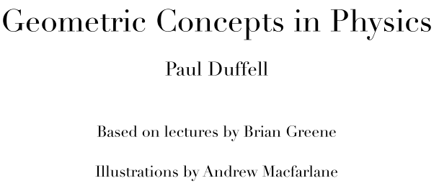

I saved this as well, this has a 4-chapter TOC, but then only the first chapter. These are just informal notes he has written, so we do have an author.

OK, lets stay focused then on his Ch 4 on fiber bundles.

4.1 He uses an example of a circle as a base manifold and a line segment as "the fiber". The tensor product of these two spaces is like a cylinder

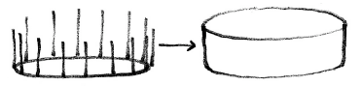

where you draw a fiber at every point of the circle, hence the "brush" analogy. He notes that if you construct a Mobius band using this idea, you have the cylinder notion locally but not globally due to the global twist. Here is his example

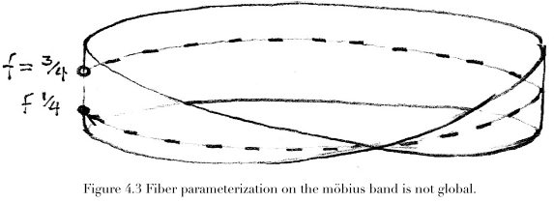

You can think of the base manifold (circle) as a global thing, but the fiber then is not global. The point f = 3/4 is on the fiber before you "go around" and you find you end up with f = 1/4 due to the twist, so the value 3/4 is not "well defined". But locally you are OK. This locality is always implied when you talk about manifolds, as I now know.
He is going to build up the statement that other web pdf's start with!
In the above picture, the strip is called E, and the global base thing is M with points p. Then

π: E → M a projection of a point in E to a point on M π(q) = p

Many points on E project into the same point p in M, so many to 1 map. After all, the entire fiber through this point in E will map into M. He then writes

π–1(p) ≈ F = all points q in E such that π(q) = p; this set is an entire fiber through p in M

to show that the pre-image of point p in the above mapping is the entire fiber F. Fine.

In manifold world one deals with a union of sets Ui and "homeomorphisms" φi. Sjamaar referred to these things as "embeddings". I ran into the word homeomorphism recently, where was that? In my interests I get several doc hits on this word, but newest is 2011! Well, here is from Ahlfors meta review

Topological Mapping: If f is one-to-one and uses up all the range (is onto), then you can invert any point in the range (image) and therefore f-1 exists and everything is nice. IF in addition both f and f-1 are continuous, then such a mapping is called a topological mapping (= homeomorphism -- "the isomorphism of the topological world" ). Such a mapping preserves certain topological properties. Two such properties that are preserved are compactness and connectedness, according to our theorems 8 and 9. Openness is not such a property.

And here from Sja Ch 6 notes:

Comment: A homeomorphism is like a diffeomorphism but has a lesser requirement: h and h-1 have to exist and be just continuous in both directions, not necessarily differentiable. So the Sjamaar embedding conditions require something halfway between a diffeo and a homeo morphism.

OK, so here is Duffell's next step:

Φi(p,f) = q = some point on the Mobius patch

We also know that π(q) = p. Combining we get Φi(π(q) ,f) = q and π( Φi(p,f)) = p .

I had trouble with this until I read a different pdf which had this picture in which Ui is called N

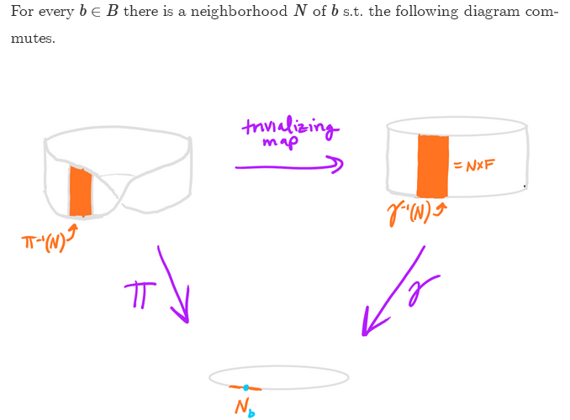

So Duffell's map Φi is the inverse of the above "trivializing map". Duffell's mapping Φi maps from the orange patch on the cylinder (which after all is just Ui x F) to the orange patch on the Mobius band. The cylinder orange patch is like the "flat" parameter space U in this Sjamaar picture,

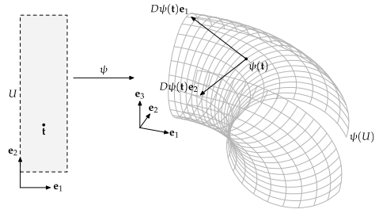

So Sjamaar has ψ being the mapping from the flat space to patch on fancy surface (embedding)
So Duffell has Φi being the mapping from the flat space to patch on fancy surface (homeomorphism)

A point in the orange flat cylinder patch is just (p,f) like (π/2, 1/4). He says,

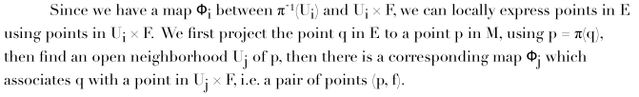

Now what exactly is this paragraph saying?? E is the Mobius, so q is on the Mobius. For a given q, I agree that we project to find its p coordinate using p = π(q). Now why in the next sentence does he define the neighborhood of p by Uj instead of by Ui ? I guess it is just to have an alternate to Ui for what follows. Certainly p would lie in the union of Ui and Uj.

OK, suppose we come up with some Ui and Uj which both contain p of M. We then have corresponding mappings Φi and Φj. These mappings are intended for different regions Ui in the usual manifold sense, but we have to be "consistent" where those two regions Ui and Uj within M overlap. So consider:

Φi : Ui x F → π-1(Ui)
Φj : Uj x F → π-1(Uf)

Φj-1 : π-1(Uj)→ Uj x F // homeomorphism is 1-to-1 and onto, so invertible

Φi o Φj-1 : π-1(Uj)→ Uj x F → π-1(Uf) for the overlap region

Φj-1 o Φi : Uj x F → π-1(Uf) → Uj x F for the overlap region

In a composition, the function on the right acts first. So let's write these more accurately

Ui∩Uj

Φi o Φj-1 : π-1(Ui∩Uj) → π-1(Ui∩Uj)

Φj-1 o Φi : (Ui∩Uj) x F → (Ui∩Uj) x F

So here is my own little picture

Mobius Cylinder
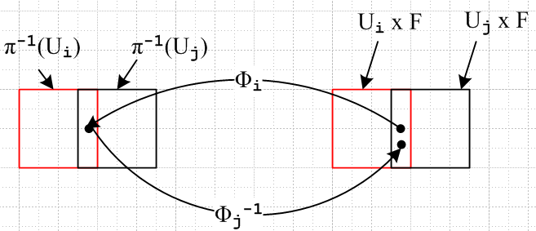

So we could then define

tij ≡ Φj-1 o Φi : (Ui∩Uj) x F → (Ui∩Uj) x F

Duffel has made an error in the following line, what he means is what is shown above. I think he is used to having Φ defined in the reverse direction. I know what he means!

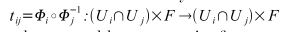

Suppose we start with a point (p1,f1) as the black dot on the right. This will map to some (p2,f2) on the left, allowing full generality for the moment. Then we come back and land at some (p3,f3). But suppose we imagine that the overlap region is very small. In the limit, all three p values will be the same. So then we argue that under the tij map we have (p,f) → (p,f'). Duffell does not really make this clear.

So far I am with Duffell so let's continue. As just stated, he notes that,

So I agree, more informative maybe to write the mapping as

and this makes complete sense to me now. He then claims that the mapping tij has these properties where only the first is not quite obvious

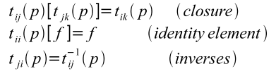

Think now of the tij(p) as elements of a set of some sort that is labeled by p. He wants to say that the set of elements { tij(p) } forms a group. But what then is the product tab tcd ? The first line does not account for this case. It only accounts for tabtbc where two indices match. The identity and inverse lines seem OK to me. Well let's try:

tabtcd = Φa-1 o Φb o Φc-1 o Φd =?= Φx-1 o Φy = txy

Well, this is just fine if you define

Φy ≡ Φc-1 o Φd

Φx-1 = Φa-1 o Φb ⇒ Φx ≡ Φb-1 o Φa

and since all inverses exist, I guess this is all OK. So OK, the tij form a group. There is a group element for each choice Ui and Uj which contain p, so this will be a continuous group. A very strange group until I see an example!

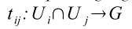

The tij are the "transition functions" and G is the "structure group". Here are some examples:

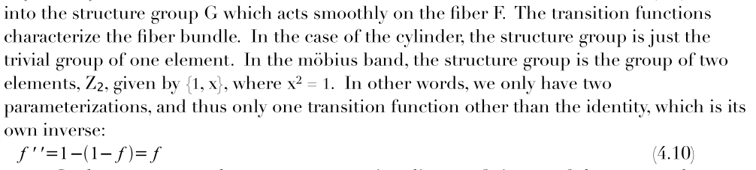

If you had the cylinder on the left and on the right, the round trip would map f → f and you have only one group element, a trivial group. For the Mobius what happens? First, wiki says

Topologically, the Möbius strip can be defined as the square [0, 1] × [0, 1] with its top and bottom sides identified by the relation (x, 0) ~ (1 − x, 1) for 0 ≤ x ≤ 1, as in the diagram on the right.

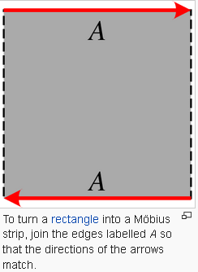

But I want some nice parameters. For cylinder I would use θ in 0 to 2π and z in 0,1 so a point on the cylinder would be given by (p,f) = (θ,z).

I do not see why the structure group G is equal to {1,x} where x2 = 1 for a Mobius strip. The claim is that G actually determines the surface or the fiber bundle. I need another source on that!

In more detail, the claim is that G tells you how the neighborhoods Ui and their maps are "sewn together". Buck talks about this same thing on page 345, but not really in this same context. Here is a mysterious Duffell picture

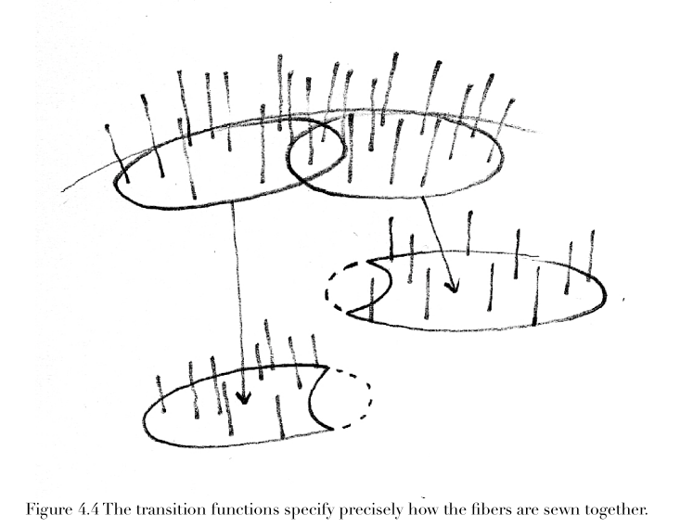

Maybe the idea is that if you enforce your rules on any intersecting regions, that determines things for the entire regions like Ui . So at this point I am not really with it on these transition functions and that structure group. So pause at this point.

Resuming now after writing "Mobius and Me.doc" where I apply most of the above stuff to the Mobius example of the fiber bundle. I was able even to obtain Z2 as the structure group. But the above picture is not clear because the transition functions only act on a region of intersection, but the arrows in the above picture seem not related to the intersection region. I will let that ride.

4.4 Special types of bundles.

The Trivial Bundle is what I expect it to be. A simple direct product B x F with G = 1.

Vector Bundle. In our example we had F = [0,1] which is NOT a vector space. If you require that F be a vector space that is basically Rk then you are talking "vector bundle". Recall that we could view those transition functions tij as maps tij: F → F. We now add a requirement that such functions are all linear on F (linear on the vector space F). In our example we had t12: f = 1-f which is not linear because t12(f) = 1-f does not give t12(αf) = α t12(f), just for example. So if all the tij act linearly on the vector space = fiber F, with some group G, then we have a true "vector bundle". But some Duffell statements make no sense to me at this point. For example:

"the tij have a k-dimensional representation on the fibers."

"the tij are subgroups of GLkR "

I don't even know what that group is! OK for now. // It is GL(k,R), linear transformations.

Example Next, imagine the base is a 2D surface manifold so we can think about something. It has points on it which we still call p. At any point p, I know there is a tangent space TpM whose little vectors are tangent to the surface. So this TpM is a vector space, and we have a different vector space at every point p, so this sure looks like an example of a vector bundle. The whole thing E=TM is the tangent bundle associated with M. For any small neighborhood we can regard the F space axis as our coordinate system which we associate then with some φNi function.

Example: What about a vector field F(x)? At each point in space we have a vector. But axes are usually the same at each point. But having a direction at each point seems a little like SO(3) element for each point so F = G and maybe this is a principle bundle as defined below.

Now how do you write a tangent vector as some kind of derivative thing? I often write

if dr lies on a surface f = K, then df = ∇f • dr and if you stay on the surface ∇f • dr = df = 0.
So this says ∂if dxi = 0 . If dr = v ds where v is a tangent vector, then ∇f • v = 0. We could
write this as v • ∇f = 0 which says vi∂if = 0.

But this does not seem too helpful. Sjamaar had TxM = (Dψ) and the columns of this thing were the tangent vectors, so ξi = (Dψ)ni for n = 1...k. But Duffell has some new notation, here it is

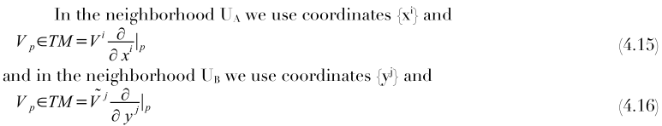

I have no clue what this notation means. The derivatives look like operators evaluated at point p. I guess the first equation is saying Vp = V • ∇|p ?? This entire Duffell section has fallen apart for me, it means nothing at all. Mention of parallel transport.

Principle Bundle (F = G). Remember that F = fiber and G = structure group, usually some Lie group, though I have seen no examples. I guess you can regard the parameter of a Lie group as a manifold, so you could then choose G = F! That certainly seems strange, but it is a key thing to do, he says. This bundle then is fully defined by a base manifold B and some Lie group.
Possible example: in tensor doc I have the R matrix Rij(x) as a rotation defined at each point in RN. Perhaps one could interpret this as B = RN and F = G = SO(3). G is not the trivial group, so this cannot be a simple RN x SO(3) direct product space. This would be a principle bundle example. But it also seems to be an example of the frame bundle defined below. All a bit vague.

Frame Bundle. Here (at point p) the fiber F is taken to be "the set of all possible frames {ei) that could span the tangent space at point p." That is certainly a large space even for R2. I would say one frame for exact element of SO(n). Elements of F are now sets of 2-vectors, say, so F does not seem to be any simple kind of vector space.

Example of a Lie group. I guess GLkR is the same as GL(k,R) in Duffell notation. Here it is.
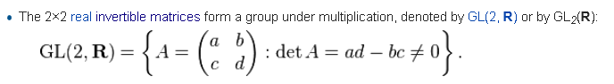
I suppose you could identify each "frame" with some element of GL(k,R), perhaps the column vectors of same are those axes. So perhaps e'j = Mijej where M is in GLkR and in this way you can generate all sets of axis. So in some sense you now have F = GL(k,R) if the tangent space has dimension k. Duffell eventually makes that point.

Associated Vector Bundle. This is too fancy for me right now. None of the sentences mean anything.

4.5 More elegant description of Fiber Bindles.

He argues here that basically the bundle is defined by the projection map π, it is this map that is often identified with the "fiber bundle". He then talks about the idea that two bundles with π1 and π2 might in some sense be "equivalent".

Section. Seems that any π-1(N) would be a section, but maybe you are supposed to also pick a point in the fiber F. So if you had a version of π-1(p) that picked out a specific f in the fiber F, that thing would be a real function. and I suppose you could do it for all p. Perhaps this is like my thin red band in my Mobius pictures, where I more or less pick out only f = +1/2 (range around).

Fact: Think again of the tangent space vectors ei(p). As you move on M, these vectors change, and I am very used to thinking of this in terms of the affine connection Γ !

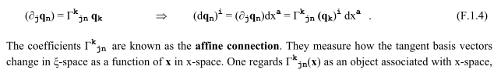

So I should not be surprised to find that for a vector bundle, where the fiber is the tangent space, that the affine connection should enter the picture. How do the tangent vectors change as you change p ? Duffell quotes some of my messy basis change for Γ stuff. He is then off for the rest of his paper talking about fancy curvature on fiber bundles and all that good stuff. I am not ready to go there right now, but it is on the general relativity agenda. I still want to see a simple example of a fiber bundle where the structure group is a Lie group.

2. Catherine Ray (age 17) nickname "Rin"

This is a very unusual person, and this fiber bundle thing is just one of many items on her website. She did college at George Mason U, graduating at age 16. She is on a Thiel fellowship:

The Thiel Fellowship is unlike anything you’ve ever experienced. The Fellowship brings together some of the world’s most creative and motivated young people, and helps them bring their most ambitious projects to life. Thiel Fellows are given a grant of $100,000 to focus on their work, their research, and their self-education while outside of university. Fellows are mentored by our community of visionary thinkers, investors, scientists, and entrepreneurs, who provide guidance and business connections that can’t be replicated in any classroom.

The Thiel Fellowship is open to applicants under 23 years old who do not have a degree and agree to not be enrolled in college during the program.

She has done many things already in her sort existence. She has many PDF like objects on her site, but they are all web pages. Including Clifford things, and little detail topics of the kind I often do.

"In autumn 2014, I began to teach myself algebraic topology full-time."

Good pictures, a web page and not a pdf.

http://rin.io/intro-to-bundles/

I stored this locally as htm file and support folder in the usual manner.

First, we have the definition of π which is the same as Duffell:

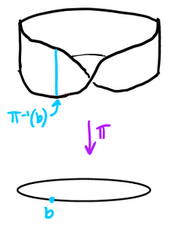

Now we do the neighborhood thing in the base manifold (circle) and it back-maps into a handful of fibers as shown on the left for Mobius, and on the right for cylinder. The maps are given different names because we have different total surfaces.

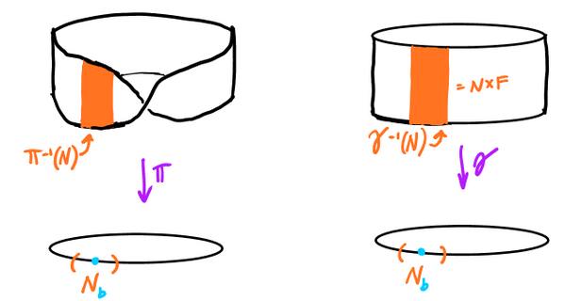
"We can locally treat the Mobius strip as a plane, in the same way that we can locally treat a cylinder as a plane. This property allows us to vastly simplify calculations; it allows us to locally treat twisted spaces like their non-twisted counterparts." [ I see differential forms in here somewhere ]

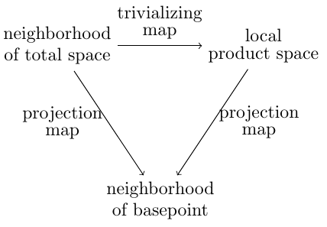(1)
Note: π is a "surjection", it is "onto", its image includes all of the base B/

What does she mean "commutes"? I guess you can to the π route, or the map + γ route and end up with the same thing, which is neighborhood Nb. OK, sounds possible at least. Words on the right. The "total space" is our manifold of interest, the Mobius. The product space is that cylinder. Here is a third picture of the above triangle:

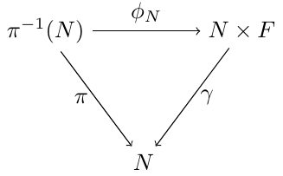(2)
You could start with N, then go to top right with π-1 to get the orange small bundle on the top left of Fig 1. From that patch you go the top right patch with some assumed function φN . The patch on the top right is exactly N x F (so this object now appears!). Then γ takes that down to the same N.

Note these facts:
1. The spread of fibers top left is a patch of surface E = Mobius = our surface of interest.
2. N on the bottom lies in the base manifold B (circle in Mobius example)
3. F = the fiber thing, I guess there is only one F , a little segment of the real axis 0 to 1, say.
4. the map π: E→B covers all of the base thing, so is a "surjection" (onto)

Here are his words for Fig 2 (they are presented above Fig 2, so his commute statement refers to Fig 2 :

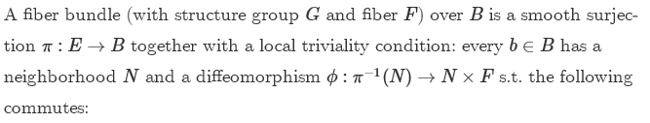

We don't know what G is yet. The left to right mapping at the top is indeed φ: π-1(N) → N x F which is a map from one patch to the other that only has to be reasonable locally since N is "small". They want φ to be a diffeomorphism which I know about so derivatives are well defined in all directions. Recall:

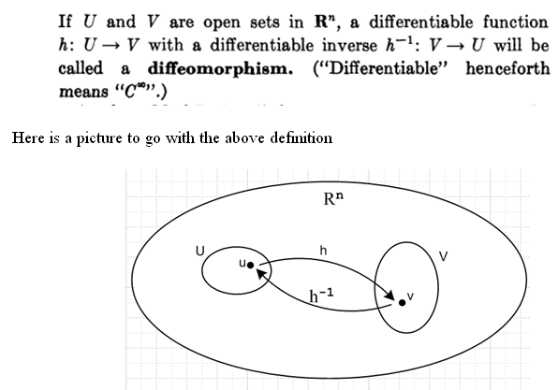

Here are some interesting ways to write the total surface E as a sum over its fibers. The first line below defines Eb as the fiber "over" the point b in the base, then the second line sums up all the fibers.

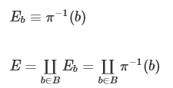

The ∐ symbol is a form of summation used in "category theory", see my little doc on that subject. It is called the coproduct, but is often written as ⊕ or +, so it is more like a sum than a product IMHO.

Now we come to the next mystery notation:

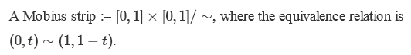
___________________________________________________________________________________

Small digression. First, a generic "equivalence relation" us written a ~ b meaning that in some sense a is equivalent to b, though perhaps not exactly a = b. Given some ~ definition, you could define an "equivalence class" of a according to [a] = {b ϵ X | a ~ b}. But there is more to this as Wolfram shows:

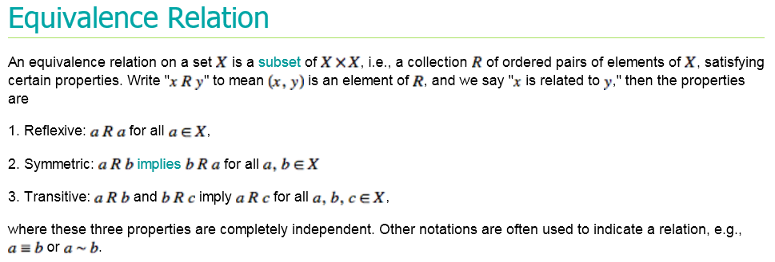

So given a set X and an equivalence relation ~, you can list off all pairs which are equivalent. Since not all pairs are going in general to be equivalent, the "equivalence relation on a set X" is in fact a subset of the direct product set X x X represent by a list of the equivalent pairs (x1, x2). The three properties shown are assumed to be valid as part of the ER definition I think.

Now from wiki we have this:

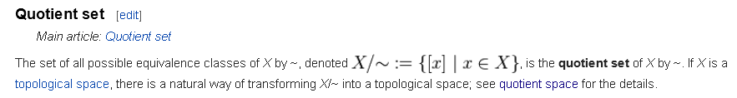

So fine, X/~ is the set of all equivalence classes of elements in X. If we are not interested in the details within the classes, we can focus just on the classes themselves, and X / ~ is the set of classes [x].

Now look back at the statement

Here X is the set of all points (u,v) that make up the direct product shown. We know that the ~ thing says that the edges are connected in this flipped over manner. Those two edges at the glue-together point are basically the same edge, but the fiber is flipped. So I sort of see his notation, but not fully.
If two elements of X are equivalent, here we would say (u1,v1) ~ (u2,v2) and then the equivalence class would include ( (u1,v1), (u2,v2) ) in the sense of (x1, x2). Obviously the set of (u,v) points is doubly infinite in the unit square. Most of these points have no equivalence connection to other points. The only points which have equivalence are those of the form ( (0,v1), (1,v2) ) and for these points, we have these equivalence pairs : ( (0,v1), (1,1-v1 ) ). Thus we have only one equivalence class and this is it.
____________________________________________________________________________________

Author then talks a bit about groups which I am OK on. You have group elements acting on elements in a space, such as x' = Rz(g) x as a 2D rotation, g = group element, G = group, R = matrix representation. Fine. Now write this abstractly as x' = gx . Now,

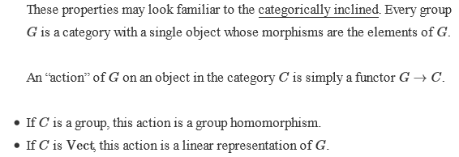

The category C is a set of only one object which is group G. Each G has its own category C.
You could regard the elements of group G as themselves forming a category, but we are the higher level where the group itself is the category. Recall that in this scenario an arrow is called a functor.
In a diagram for C the only meaningful arrow connection is this
g
G → G

where the functor is labeled by some element of the group G. Well obviously I don't really have the right interpretation, but at least I know what they are generally talking about, I know a little about the language now.

Torsors.

Suppose you are given x and x', and you want to find g. One says that that solution g is the "torsor" for x and x', a word I have never heard before! It sort of torques one point into another in my mind. You can symbolically write g = x'/x . Well, g is the element of G which makes x' = gx be true, and you can call that a "torsor" if you want. It seems to me that set of torsors = group G.

Now in our Mobius example, you can perhaps view the fibers as being "twisted" as you go around the base circle, and you might think of this twist as a rotation about the circle axis or something like that. These rotations form a group, and I think that is our group of interest.

Duffell says that a principle bundle has F = G, so here torsor is another name for group.

So, pick any two fibers from the Mobius strip. One is a rotation of the other by some G element g, so the two fibers are therefore "torsors" and we might write f' = gf, but this is a little hazy since we need to define these two fibers f and f' better. Fibers are the "orbit of G" ?

OK. I am fine with this language. You can think of the set of Mobius fibers as each being represented by a group element g which I think of as a rotation about the central line Rz(g) or some such. But then we have the conflict that here we have a continuous G associated with Mobius, but we know on the other hand that the structure group is Z2 which is discrete.

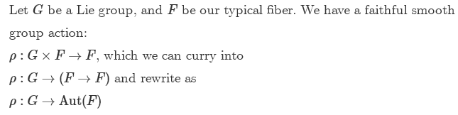

So the group G here is the fiber → fiber rotation of the Mobius, it is not the Z2 thing. I am OK with the above list of three mappings, especially the middle one.

The first line just says for a given g and a given f on E, you get f' = gf which is another fiber on E. I can see that in the example, f can be any fiber on E, and g can be any element of G, and then the output f' will be another fiber on E. Curry into here means to bash or massage into something else. The second line says that you first pick a g in G, then you can consider all the F→F mappings under that G, maybe all fibers that are 10 degrees of rotation apart. This F → F maps the figure into itself so is an automorphism. So then for each element of g, you get each f in E mapping into some f' in E, so the whole surface E is mapped into itself.

Next, consider this fine statement:

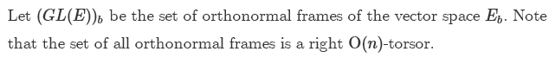

Well this is in the Duffell language of a Frame Bundle. For point b in base B we have all these possible frames. In each frame, the basis vectors are the columns of the matrix GL(n,R; b) where k is the dimension of the vector space attached at b. As I noted in the Duffel presentation, this set of frames seems very similar to SO(n). Maybe E = {e1,e2....en} in his notation.

Next we have this mysterious picture after the text,

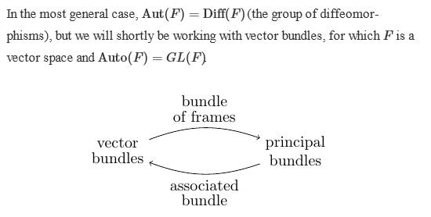
The idea G: F→F is fine, and that is Aut(F), and you could require smoothness on everything so these are then diffeomorphisms from F to F.
Now in the picture: I know that a vector bundle has a vector space at each point b. Such a space has a set of possible "frames", yes. And those frames can be connected with G = SO(3). And F = G gives you a principle bundle, so somehow that is the path across the top of this picture. Somehow that strange "associated bundle" goes the other direction.

OK, lets try out his next claim

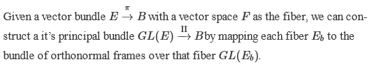

I think this is the top path in the figure expressed in words. It certainly is strange.

She closes out his little web offering with this statement:

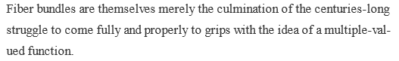

That function I think is π-1(b) = F where the single point b maps to multiple points F.

She mentions cohomology. But first, what is homology?

"Homology is a rigorous mathematical method for defining and categorizing holes in a shape. "

1. In algebra, which is a broad division of mathematics, abstract algebra (occasionally called modern algebra) is the study of algebraic structures. Algebraic structures include groups, rings, fields, modules, vector spaces, lattices, and algebra over a field. The term abstract algebra was coined in the early 20th century to distinguish this area of study from the other parts of algebra.

2. Algebraic topology is a branch of mathematics that uses tools from abstract algebra (see item 1 above) to study topological spaces. The basic goal is to find algebraic invariants that classify topological spaces up to homeomorphism, though usually most classify up to homotopy equivalence.

3. In mathematics, homotopy groups are used in algebraic topology to classify topological spaces. The first and simplest homotopy group is the fundamental group, which records information about loops in a space. Intuitively, homotopy groups record information about the basic shape, or holes, of a topological space.

4. Cohomology is some kind of extension of homology theory (they lose me here)

This then is the end of this nice web page/

3. Torsors by John Baez 2010.

It is nice to avoid having to select an absolute origin or absolute reference frame orientation. Then you don't have to worry about such things when you move smoothly along a manifold and watch your tangent vectors rotate, for example. Torsor World has no origins or specific absolute frame alignment, it has only differences.

Anything that is defined only as a difference (energy of a particle in a field, voltage difference, wavefunction phase) is an example of a torsor. Since abs zero exists, T is not a torsor.

Math examples: indefinite integral has that additive constant, so a torsor.

Dots in a plane are torsors (forget origin, does not matter, Δ of two points is a vector)

" An affine space is a torsor for a vector space".

"Here's a famous example: the set of orthonormal frames at some point of a n-dimensional Riemannian manifold is not the group O(n), but it's an O(n)-torsor. You can take any frame and rotate it by an element of O(n); you can take two frames and work out their "difference", which is an element of O(n) - but the frames don't form a group. We can pretend the frames are the group O(n) - but only after we arbitrarily choose one frame and decree it to be the identity. Then every other frame is a rotated version of this one, so we can pretend it is a rotation! "

************************

Notice the NOTATION used here to indicate two surfaces are homeomorphic:

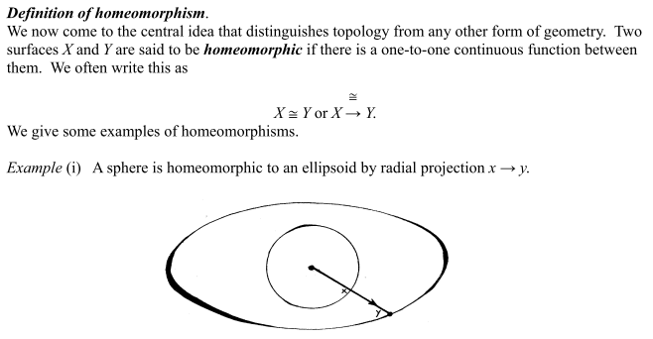

4. Hainan Zhang MA thesis

This doc is a master's thesis done in 2014 at Kansas State (BS there in 2012). It seems to be a little voyage through this region of the House of Math, and is written therefore from a young and innocent perspective. He is not the boy who knew too much. It is quite readable. He is on Researchgate, but that is a medical person of the same name.

Chapter 1: Introduction to Fiber Bundles

He comments that the base B "carries the quotient topology determined by π", as if E/F = B in some sense. He does well on the transition function business. His notation is that hα and hβ are two trivializations or homeomorphisms and then αβ ≡ hα-1 o hβ . All his equations are good:

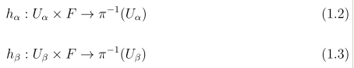

He then shows that

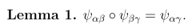

which other authors just assume

1.1 Trivial Bundles. The usual thing, but then suddenly he tosses out a phrase

contractible CW-complex

as if any reader would know what this means. So I wander off to wiki:

Roughly speaking, a CW complex is made of basic building blocks called cells. The precise definition prescribes how the cells may be topologically glued together. The C stands for "closure-finite", and the W for "weak topology".

Wiki examples are helpful:

So each unit interval is a cell, and the CW complex is the set of all such cells as shown. I think contractible means no holes to block you, Buck had something on this.

So Hainan claims that if B is one of these contractible CW complexes, then the only fiber bundle you can have over it is the trivial one.

1.2 Vector Bundles.

1.3 Principle Bundles.

Chapter 2. An Example of a Bundle of Frames

He talks about the matrix groups SO(2) and SO(3) which can act on frames.

An interesting example is (π, E, B, F) = (π, SO3, S2, SO2) where S2 means the sphere.

E = SO3 think ψ,θ,φ
F = SO2 think ψ
B = S2 think θ,φ surface

He then sort of studies this example in some detail in this chapter.

Chapter 3: Trivialization and Section

This entire chapter is this:

The rest of his thesis ties in lots of famous phrases:

topological group
G-bundle
homotopy lifting property
Serre-fibration
paracompact
Hopf-fibration
cohains and cocycles
skeleton
Stiefel classes
Stiefel-Whitney classes
cohomology
Chern class
Cech cohomology
simplicial complex
sheafs

He ends with a bibliography.

So interesting. Here is a guy who probably know a lot about this field as an undergraduate at Kansas State, perhaps he was a student of Algebraic Topology ("pure methematics"). Then he did 2 years to get his MS and this thesis is the result. I think his name is common, like Tom Jones, and he was probably a Chinese visiting student and maybe he disappeared back home. But Linked In says he is now a student at Colombia, so he is still here.

5. No-author Chapter 2 on Bundles

This is an all-text document, no pictures, no identification of the author. It has lots of words, but still it is short on graphic examples. It does address a large hit parade of topics. I will do a few notes.

2.1 Vector Bundles.

Example 2.1 of a vector bundle is the "tangent bundle" TM.
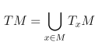

We think of the spaces TxM varying smoothly with x, not violently. For M = B = S2, each TxM is a plane, and we can imagine these glued to the sphere and varying smoothly, since the surface varies smoothly. The fiber is F = TxM, the base is B = M, the total space E = TM is the sum or union or whatever of all these TxM spaces. Generally think of TxM of dimension n so there are n axes. But then S2 is 2D, so I guess E then has dimension 2n. We have π : TM → M.
You could take M as the base, and Rm as your fiber, and construct space M x Rm and arrange to have π: MxRm→ M and this is a direct product space like the cylinder.
Imagine x in M, and (x,f(x)) in E, aas in this direct product example. A section maps x in M into a point in the fiber. For hairbrush, if your map takes you do the fibers a half inch over the surface, then that is a cross section of the hairs of the hairbrush, that is where the name section comes from. For the vector bundle example, the section is a map from x in M to a specific vector in each vector space, and that sounds to me like a vector field V(x) over x in M. He confirms this!
OK, I have started underlining a bit. The dual space of TxM is called Tx*M as is the space of linear functionals on TxM, and this is called the cotangent space

Tensor bundles. This is very weird. At each point x you specific [TxM ]k k times in cross product, and you throw in also [Tx*M ]l l times, and call the whole mess TklM.

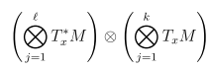 at each x !!

AS I said, this is very strange.

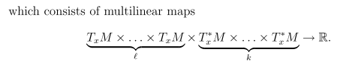

I am lost here! Is this all one multivariable functional? But some are * and some are not.

OK. Uncle! I have had enough. Spivak is in his short bibliography.

