Mobius and Me PhL 9.5.15

Mobius with the cylinder forms the standard example for a fiber bundle. But there is one piece that I simply do not understand and it is this: Why under φi for some Ui does the fiber F have its points shuffled? Why is that necessary. If the points were not shuffled, then φi(p,f) = (p,f) and then φi = 1 and this would also be true for φj and Uj and then tij = 1 and there is no transition group other than 1.

There must be some reason that causes φi(p,f) = (p,f') with f' ≠ f. I think the reason is that somehow this is necessary in order that the triangle picture be consistent.

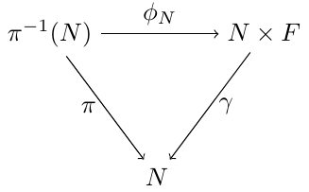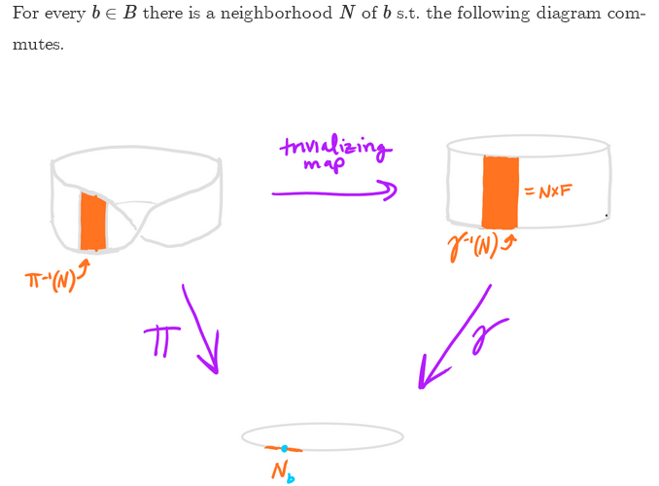

So for the cylinder, is γ completely determined? If the cylinder points are q = (θ,z) then the only choice there would be γ(θ,z) = θ for the projection function γ. No other projection is really possible. Also you would say γ(Δθ,z) = Δθ where Δθ is a neighborhood of some point θ1 in the base B. What do we mean then by saying (Δθ,z) = γ-1(Δθ) ? I guess this is really valid for every z in (0.1) .
So let's look at the consistency issue here:

π(Δθ,z) = Δθ is the projection for Mobius for any z, where z lines along the fiber!

But if you want the real z in the R3 space, you would find for some θ that z lies in some range (0,a) instead of (0,1) because at some θ the fiber is tipped. So if you start with some z at θ = 0, you might have something like z = zcos(θ/2) at θ of Mobius is evenly spread out. Then what is meant by π(q) = p at some angle θ? You would think some website out of the 109 websites would discuss this in detail for the Mobius example. Are you supposed to put in 3D coordinates for q as if it were q in R3?
Somewhere I did see some 3D equations for a Mobius. Wiki has this,

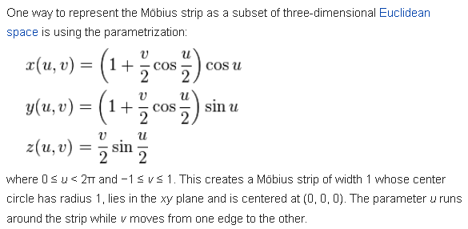

I think position on the fiber is coordinate v while θ is my angle. Now at u = θ = 0 we find

u = θ = 0 x = 1+v/2
y = 0
z = 0

So I guess this particular "fiber" runs from x = -1/2 to x = 1/2 so has length 1. So this is the way I would generally do, have the fiber be defined by f = [-1/2,+1/2] along the fiber. At u = 0 the local fiber lies in the x-plane. It will be vertical when θ = u = π (I think) let's check

θ = u = π x = -1
y = 0
z = v/2

θ = u = 2π x = 1 - v/2
y = 0
z = 0

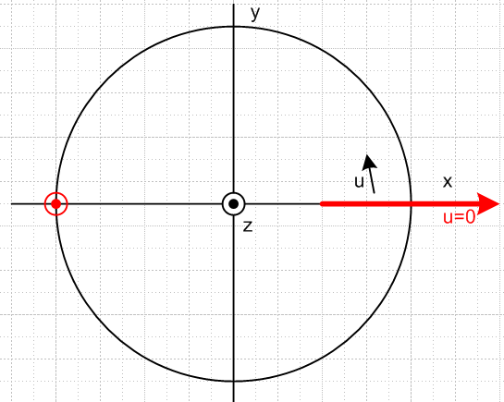

I have drawn the two fibers, it all seems correct. So imagine this Mobius surface as a set of closely spaced fibers going around the top half, say. What then is the meaning of π(q) = p specifically for this example? Does it mean π(u,v) = u? If so, then this map would project the center point of the fiber onto the circle. If this is it, then π is 100% specified for this example. It is just the first argument of the pair. Here v is distance along the fiber.

What are the equations for the corresponding cylinder?

x = cos(u)
y = sin(u)
z = v' = in the range [-1/2,+1/2]

OK, then γ says γ(u,v') = u and it is also 100% defined.

The only question left is to find the function φ. For a super small neighborhood, our patches are only one fiber wide, let's say. All we really have to do is rotate a fiber on the Mobius at angle u upright. That would be something like this

(cylinder fiber) = R(u) ( Mobius fiber)

I don't see any reason for this to alter the position of points along the fiber.

π-1(u) is our tilted fiber at angle u
our fiber on the cylinder is vertical.

φ: U x F → π-1(U)

φ: u x F → π-1(u) φ = R(u) in some sense
up fiber tilted fiber

Conclusion: if you only consider a single fiber, you have Ui = Uj = δ(1 fiber) and tij = 1 and you are never going to see the "issue" I am trying to uncover here. Why am I made to do this solo with a century and 109 people out there talking about this subject?

I guess the next step is to try this with some specific finite neighborhoods Ui and Uj which overlap. Such as

Ui u = [-π/2, π]
Uj u = [-π, π/2]

Ui∩Uj u = [-π/2,π/2]

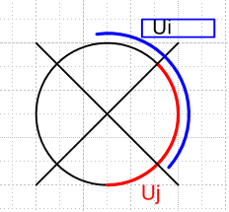

OK, now what is the meaning of π(q) = u? Again it is just π(u,v) = u where u,v parameterize the Mobius surface.

What now is the map φi: Ui x F → π-1(Ui)

This map has to work for the entire Ui range of u. Well, for both these ranges I think φ = R(-u) will do the trick. In my phys/QM doc exp calc I have this result

R(θ) = exp(-iθn•J) = 1 + (1-Cθ) T + Sθ[ -i(n•J)]

where n = is a unit vector defining the axis of rotation and

T = $\left(\begin{matrix}1-n12 & -n1n2 & -n1n3 \\ -n1n2 & 1-n22 & -n2n3 \\ -n1n3 & -n2n3 & 1-n32\end{matrix}\right)$ which of course is symmetric

(n•J) = i $\left(\begin{matrix}0 & -n3 & n2 \\ n3 & 0 & -n1 \\ -n2 & n1 & 0\end{matrix}\right)$ => -i(n•J) = $\left(\begin{matrix}0 & -n3 & n2 \\ n3 & 0 & -n1 \\ -n2 & n1 & 0\end{matrix}\right)$

In our case lies in the plane of the circle so n3 = 0 and we have

T = $\left(\begin{matrix}1-n12 & -n1n2 & 0 \\ -n1n2 & 1-n22 & 0 \\ 0 & 0 & 1\end{matrix}\right)$ -i(n•J) = $\left(\begin{matrix}0 & 0 & n2 \\ 0 & 0 & -n1 \\ -n2 & n1 & 0\end{matrix}\right)$

so I can just add up the pieces to write out R(θ) explicitly as a 3x3 matrix. Now

n1 = nx = - sin(u)
n2 = ny = cos(u)

R(-u) = exp(+iun•J) = 1 + (1-Cu) T - Su[ -i(n•J)]

= $\left(\begin{matrix}1 & 0 & 0 \\ 0 & 1 & 0 \\ 0 & 0 & 1\end{matrix}\right)$ + (1-cos(u)) $\left(\begin{matrix}1-n12 & -n1n2 & 0 \\ -n1n2 & 1-n22 & 0 \\ 0 & 0 & 1\end{matrix}\right)$ - sin(u) $\left(\begin{matrix}0 & 0 & n2 \\ 0 & 0 & -n1 \\ -n2 & n1 & 0\end{matrix}\right)$

= $\left(\begin{matrix}1 & 0 & 0 \\ 0 & 1 & 0 \\ 0 & 0 & 1\end{matrix}\right)$ + (1-cos(u)) $\left(\begin{matrix}cos2(u) & sin(u)cos(u) & 0 \\ sin(u)cos(u) & sin2(u) & 0 \\ 0 & 0 & 1\end{matrix}\right)$ - sin(u) $\left(\begin{matrix}0 & 0 & cos(u) \\ 0 & 0 & sin(u) \\ -cos(u) & -sin(u) & 0\end{matrix}\right)$

You would then apply this matrix to the tilted fiber at u and map it into the vertical fiber in the cylinder.
But whatever this mess is, it is the same for every point in either the blue or red ranges, so I not learning much here.

Even after all the above work, I am not one iota closer to solving my little mystery!

Resume Sun 9.6.15.

Obviously I need outside help on this, I have a complete internal block. So back to the web.

wiki: https://en.wikipedia.org/wiki/Fiber_bundle

Definition seems clear, makes no mention of the transitions tij or the structure group G. The specific Mobius example there makes no mention either. Later wiki does have a section on structure groups where it presents things a little differently:

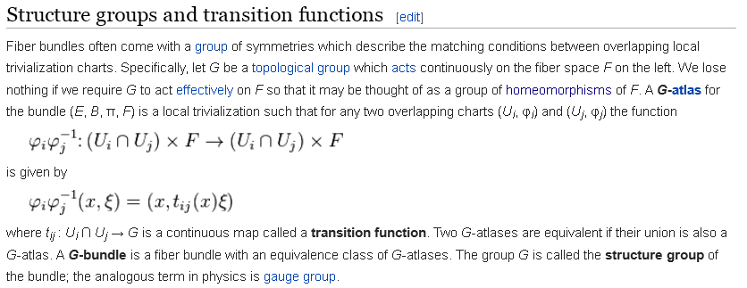

In this notation, x must be an element of B that lies in both Ui and Uj, and ξ must be a fiber F element. So under the combination φiφj-1 element x does not move, but you get ξ' = tij(x) ξ . I presume this equation describes some possibly non-linear map so that [tij(x)](ξ) = ξ' . Again, this seems to imply that when you "go over and back", the fiber elements get shuffled for some reason. That is what I don't understand. Why can't they always remain unshuffled? Why should things be different for Ui compared to Uj? Those are my questions. Wiki continues:

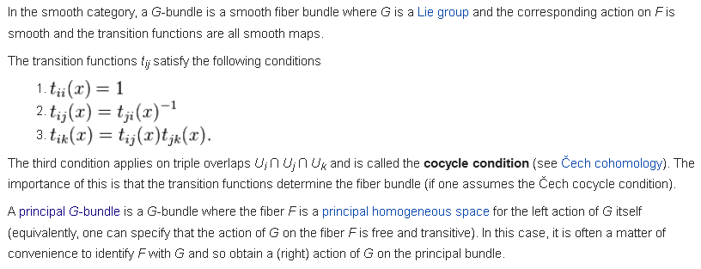
The last paragraph means nothing to me. But you see some references for the meaning of the tij items. The cohomology wiki page is another mystery. Has Ui forming an open cover of topo space X. That takes me too far in the "abstraction" direction. I cannot just keep extending forever 100 levels from the topic and hand, it has to be cut off at some good place. I just want to see the Mobius example! I search on

mobius "fiber bundle" group transition

First hit is wiki, second is Duffell. He says:

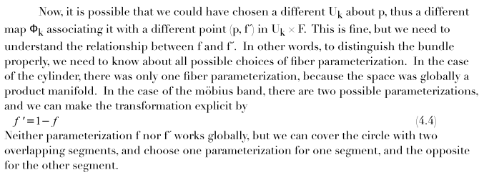

Parse his first sentence. The object (p,f') is an argument of Φk where I guess Φk(p,f') = q in E, whereas Φi(p,f) = q, so we have a new "parameterization k of the fiber". This is like a change of coordinate system, yes, I get that idea in general terms. So when we change from Ui to Uk, we are not JUST changing the region in B, we are also changing the coordinate system, maybe I missed that point. Suppose Ui labels fiber points in the usual manner, but suppose Uk labels them in reverse order, just to pick a possible coordinate system change on the fiber. Then φi does no flip, φk does a flip, and then tij does a flip. How many ways can you pick a coordinate system for real on [0,1] ? You could do a respeeding of course. Then in my example you end up with tij = a respeed of [0, 1]. There are an infinite number of possible respeeds, so you would think group G would be continuous. Duffell claims however that there are only two possibly parameterizations, f' = f and f' = 1-f, so he does not include respeeds. Looking at his finally sentence. question: how would you pick Ui and Uk so f' = f on i and f' = 1-f on Uk ?

Here is a better picture showing some fibers going around:

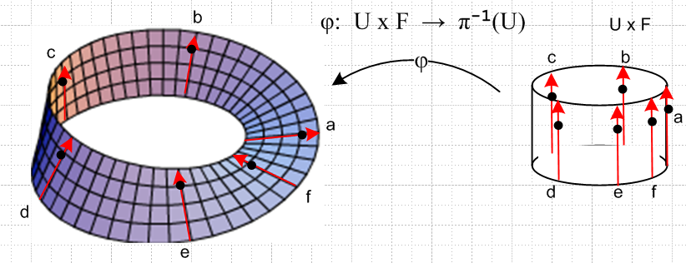

The black dot on the a fiber marks f = +1/2. Suppose point a is θ = 0.

φ: U x F → π-1(U) φ(θ, f) = q

Then for example

φ(θa, z = 1/2) = qa = (x,y,z) = (1 + 1/2,0,0)
φ(θb, z = 1/2) = qb = (x,y,z) = (some values we could figure out)
φ(θc, z = 1/2) = qc
...
φ(θf, z = 1/2) = qf
φ(θa', z = 1/2) = qa' = (x,y,z) = (1 - 1/2,0,0) θa' = θa + 2π

Here I show q as points in R3. But suppose we use parameters u and v? Well, u is the angle in restricted range 0 ≤ u < 2π. For this range, v is measured + in the direction of the arrow. So even at point f we would say that v = +1/2. We cannot "get to" point a' in this parameterization.

OK, here is perhaps the point: In the above, if we restrict to Ui having θ=u in 0 ≤ θ < 2π, then the three wiki equations above for the Mobius provide a viable coordinate system (u,v), aka parameterization, for the Mobius. This particular parameterization has a discontinuity at θ = u = 0. Things are not continuous and smooth at that discontinuity. The single set U fails to "cover" the Mobius surface. If the parametrization had worked say for u in the range (-30 degrees, +400 degrees) [ as it does for the cylinder], then this single U would "cover" the base set B.

Once again, here are the three Mobius equations for 0 ≤ u < 2π:

x(u,v) = [1 + (v/2)cos(u/2)] cos(u)
y(u,v) = [1 + (v/2)cos(u/2)] sin(u)
z(u,v) = (v/2)sin(u/2)] OK for 0 ≤ u < 2π and -1 ≤ v ≤ 1

How would we write a different param for say -π ≤ w < π ? Try taking w = u-π. Then

x'(w,v) = [-1 + (v/2)sin(w/2)] cos(w)
y'(w,v) = [-1 + (v/2)sin(w/2)] sin(w)
z'(w,v) = (v/2)cos(w/2)] OK for -π ≤ w <π and -1 ≤ v ≤ 1

where I have made use of these facts

cos u/2 = cos([w+π]/2 = cos[ w/2 + π/2] = -sin(w/2)
sin u/2 = sin[w+π]/2 =sin[ w/2 + π/2] = + cos(w/2)

cos u = cos(w+π) = -cosw
sinu = cos(w+π) = -sinw

Here is a Maple plot of the first coordinate system for u = 0 to 2π-0.5:

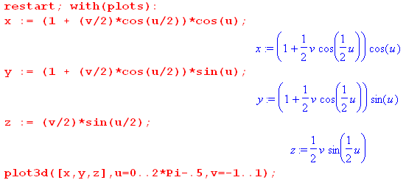

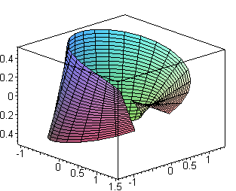

Here you see the starting horizontal segment "a" which goes around and ends up trying to be flipped at θ = 2π, but I stop it a little short. So the seam here is at the u = 0/2π location. Here is plot using the second parameterization

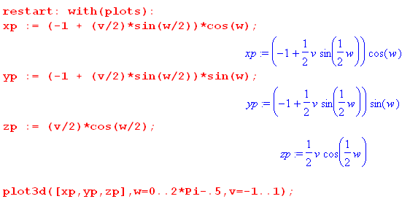

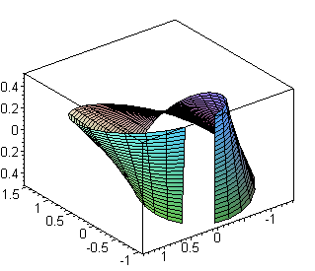

and now the seam is at the vertical part of the strip, which was u = π in the previous param which is now w = 0.

Fact: There exists no single parameterization of the Mobius strip which works for an open set of u which includes the entire range 0,2π.

Fact: We can cover the entire range 0,2π with these two different parametrizations:

x(u,v) = [1 + (v/2)cos(u/2)] cos(u)
y(u,v) = [1 + (v/2)cos(u/2)] sin(u)
z(u,v) = (v/2)sin(u/2)] 0 ≤ u < 2π and -1 ≤ v ≤ 1 U1

x'(u,v) = [-1 + (v/2)sin(u/2)] cos(u)
y'(u,v) = [-1 + (v/2)sin(u/2)] sin(u)
z'(u,v) = (v/2)cos(u/2)] -π ≤ u <π and -1 ≤ v ≤ 1 U2

Notice that U1∩U2 = 0 ≤ u < π

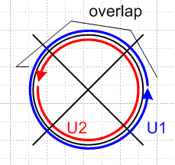

Question: For these two different coordinate systems, what are the two φi mappings?

φ1(u, v) = (x,y,z) = (x(u,v),y(u,v),z(u,v) ) 0 ≤ u < 2π

= ( [1 + (v/2)cos(u/2)] cos(u), [1 + (v/2)cos(u/2)] sin(u), (v/2)sin(u/2)] )

φ2(u, v) = (x',y',z') = (x'(u,v),y'(u,v),z'(u,v) ) -π ≤ u <π

= ( [-1 + (v/2)sin(u/2)] cos(u), [-1 + (v/2)sin(u/2)] sin(u), (v/2)cos(u/2)] )

So I am going with the theory that in φ: U x F → π-1(U), the right side represents a point in R3 which is a point on surface E. Yes, these are two different mappings.

Question: What is φ1-1φ2 ?

Well, I need to figure out this;

(u,v) = φ1-1(x,y,z)

I see that y/x = tan(u) which says u = tan-1(y/x) so we know u. How to get v? We know

z = (v/2)sin(u/2)

Now in doc "maple and half angle" I have shown that sin(u/2) is given by

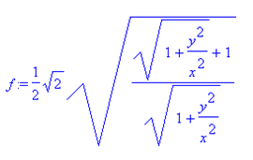

as long as 0 ≤ u ≤ π/2, in which case all radicals are positive. So then

z = (1/$\sqrt{2}$) (v/2)$\sqrt{1+x2/y2}$$\sqrt{1+x2/y2}$

and therefore our solution is this:

(u,v) = φ1-1(x,y,z)

u = tan-1(y/x) = u(x,y,z)

v = 2$\sqrt{2}$z $\sqrt{1+x2/y2}$$\sqrt{1+x2/y2}$ = v(x,y,z)

Meanwhile we know that

(x,y,z) = φ2(u,v)
or

x(u,v) = [-1 + (v/2)sin(u/2)] cos(u)
y(u,v) = [-1 + (v/2)sin(u/2)] sin(u)
z(u,v) = (v/2)cos(u/2)] -π ≤ u <π and -1 ≤ v ≤ 1 U2

So we could insert the above expressions for u and v into this to get

φ1-1φ2 = big mess

My main point is that it can be done (the two distinct params) and there is some answer (for t12) and the result will be t12 and we will not end up with t12 = 1 !

Do I know anything about (t12)2 ?

(t12)2 = t12 t12 = φ1-1φ2 φ1-1φ2 = not known.

Task: With our two explicit parametrizations above, let's try to trace a single point in terms of our pictures above. Here are those two params, and the overlap region is 0 ≤ u < π

x(u,v) = [1 + (v/2)cos(u/2)] cos(u)
y(u,v) = [1 + (v/2)cos(u/2)] sin(u)
z(u,v) = (v/2)sin(u/2)] 0 ≤ u < 2π and -1 ≤ v ≤ 1 U1

x'(u,v) = [-1 + (v/2)sin(u/2)] cos(u)
y'(u,v) = [-1 + (v/2)sin(u/2)] sin(u)
z'(u,v) = (v/2)cos(u/2)] -π ≤ u <π and -1 ≤ v ≤ 1 U2

Consider again our mapping:

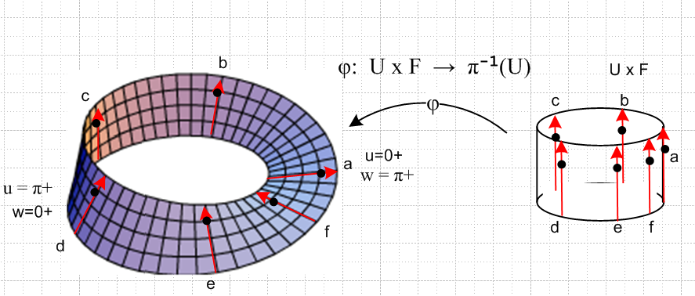

We are cartographers and we have two different "maps" of the surface of the Mobius. Map 1 uses coordinates (u,v) where u = 0+ is at point a on the Mobius (the flat) and the cylinder. On the Mobius, this a arrow points to the right, because that is how we lay out the grid in that area. The arrow is at u = 0+ and we define v = 0 at inner edge of the Mobius. This is the way our φ1 explicitly works.
Meanwhile, Map 2 uses coordinates (w,g) where w = 0+ is near d on the left (the cliff), and the arrow points up here (and the matching arrow on the cylinder at d also points up). Again, that is how Map 2 explicitly works. So in the Map 2 coordinate system, where is the black dot on arrow a? The answer is w = π+ and g = -1/2 ! In Map 2, the arrow at point a is like that at point f, it points to the left. So the black dot on a left-pointing arrow a is at v = -1/2.
More generally suppose we start with point (u=0+, f) and move to the left and this is then some point on arrow a. When we express this location in φ2 map coordinates, it is at (w=π+, 1-f). There is that 1-f that Duffell keeps talking about.
Now take that flipped arrow a and using φ2, map that back to the cylinder, and it ends up exactly as the up arrow at point a, but our original point that was at (0,f) in cyl space is now at (0,1-f).

I think I am onto something here, pause for a while then test it.

Question: What happens if we take U1 and U2 to be small overlapping regions? In that case, we might take φ1 to be the same mapping system for both regions, and then φ1 = φ2 and t12 = 1. So for THIS pair of U1 and U2 we have t12 = 1.

Question: Why can't we get an open cover of the Mobius with such small regions all using φ1 ? OK, let's try this using φ1 everywhere. In the following plot, the wireframe is a map for u in (0,2π) and v in (-1,1). The red portion is for u in the same (0,2π) but v in (.4,.6):

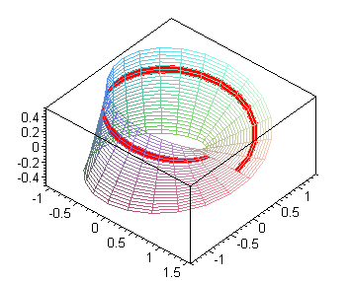

The angle u = 0/2π is toward the lower right where one sees the discontinuity in the red band. Now we can use this arrangement for lots of overlapping Ui regions (all using φ1) where none of these regions straddles the u = 0 boundary. All of these overlapping regions are "fine" and tij = +1 for any pair of them since we are using the same φ1.
But we need our regions to be an open cover for the Mobius surface, and that means to complete the above picture, we have to add a region Uk which straddles the u = 0 boundary. If we do this with the same function φ1, here is what we get (using φ1 for negative u which is out of its range; in this map we use φ1 and let u be in (-1,1) radians:
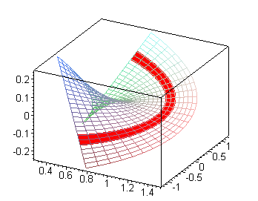

The problem of course is that the local red band for this Uk region does not match the global red band shown in the previous plot for the u < 0 portion of the plot. So we then have a contradiction in the region where Uk overlaps the region to its left. Thus, we cannot obtain a full cover using little regions Ui all having φ1 as the coordinate system.
Were we to repeat the above using φ2, we end up with a similar problem, which this figure shows,

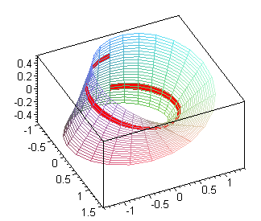

The problem formerly "in the plane" has now moved to the vertical cliff.
So if we use our large covers U1 with φ1 and U2 with φ2, how does this solve the problem? Here are those two covers:
φ1 region φ2 region

Here are the key facts
(1) within each region, everything is smooth (although the red band is not the same)
(2) each region shows that if you go around the horn, you get f → 1-f
(3) the two regions cover the entire Mobius with plenty of overlap between them
(4) for both of these maps, the corresponding band on the cylinder is the same, and is on upper half of cylinder. We have for example φ1 : U x F → π-1(U) where this upper band of cylinder in U x F maps into π-1(U) which is the red region on the left above.

Question: Exactly what is the overlap region U1∩U2 for these two maps? Consider our two maps using the same variables u and v:

x(u,v) = [1 + (v/2)cos(u/2)] cos(u)
y(u,v) = [1 + (v/2)cos(u/2)] sin(u)
z(u,v) = (v/2)sin(u/2)] 0 ≤ u < 2π and -1 ≤ v ≤ 1 U1

x'(u,v) = [-1 + (v/2)sin(u/2)] cos(u)
y'(u,v) = [-1 + (v/2)sin(u/2)] sin(u)
z'(u,v) = (v/2)cos(u/2)] -π ≤ u <π and -1 ≤ v ≤ 1 U2

When expressed in the same variables, the overlap region is ONLY this

U1∩U2 = [ 0 ≤ u ≤ π ] x [-1 ≤ v ≤ 1]

as indicated by this picture from above

The overlap region is the first half of the blue U1 region and the second half of the red U2 region.

What is supposed to happen in an overlap region? We have

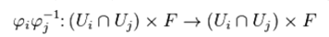

so in our case this is:

φ1φ2-1 : (U1∩U2) x F → (U1∩U2) x F

This does not say φ1φ2-1 = 1. It says that the map φ1φ2-1 maps from "the overlap region" to "the overlap region". Now if we take a piece of the overlap region (the right of the two figures above), for that piece of the overlap we have (u,f) → (u,1-f) so we do NOT have φ1φ2-1 = 1.

Now I quote another equation

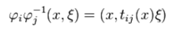

which I translate to say

φ1φ2-1 (u,f) = (u, t12(u)f)

where f = v = a point in the fiber, for u in an overlap region. We then have for any u in our overlap region,

t12(u)f = 1-f for u anywhere in 0 ≤ u < π (that is to say, u lies in U1∩U2 )

Now where is the "group"? Suppose we have

g1 f = f
g2 f = 1-f

Then it seems clear that

g1g2 = g2 = g2g1
g1g1 = 1 = g1
g2g2 = g1 = 1
g1-1 = g1 = 1
g2-1 = g2 : g2-1g2 f = g2-1(1-f) = f
: g2 g2 f = g2 (1-f) = [ 1 - (1-f)] = f

So abstractly, if we had g1 and g2 defined as above, we have a little group of two elements. You could call the two elements { 1, g2} and it is true that g22 = 1. Since all elements of the group can be obtained by doing powers of g2, this is a cyclic group according to Galois doc. The cyclic group of order 2 has a name, it is called Z2.

Now back to the Mobius. How is this Z2 related to Mobius? It is not obvious to me at this point. We have

t12(u)f = 1-f t12(u) = g2

This does not really fit with what I have read, so go read again! Wiki says this

(*)

so it is wrong to say that tij = φiφj-1 , though that is exactly what Duffell says:

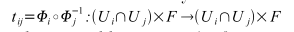

The wiki notation makes if more clear that tij acts on the fiber coordinate which they call ξ and which I call v or f. The better statement I think is the following, which Duffell to his credit does say

Well, you could say that tij = φiφ-1 if you ignore the first argument but keep in mind that it must be in the intersection region. Wiki would say (and it is implied by the quote * above)

tij(x): F → F // this agrees with idea t12(u)f = 1-f

Now let's look at the next thing wiki says:

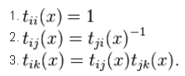

where x = some fixed value of u. Now I always have tii(x) = 1, since φi-1φi = 1. And item 2 also seems clear as well, I could prove if from the wiki definition of tij.

The problem is the third item above! It only applies to a triple overlap region.

Experiment: OK break U1 into U3 + U4 within the overlap region. Then we have U2, U3 and U4.
But U3 and U4 have the same coordinates φ1. So any t34(u) = 1 for u in the triple overlap. Then we get

t24 = t23t34 = t23

and we don't learn much. Any product is just a single tij in this experiment.

Here are names of some small groups

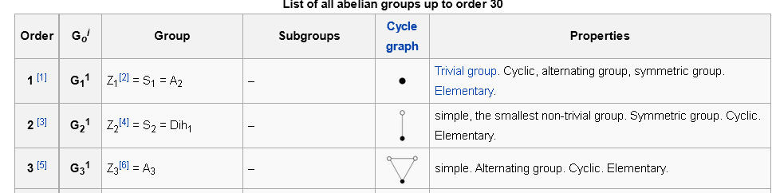

So I would say that the group {1, t12(u)} is Z2 for u being any point in the overlap region.

Wiki is not clear that the structure group depends on x. Also, my two groups are discrete, so I have no example of a case where the structure group would be continuous or Lie group.

By the way, consider an earlier picture:

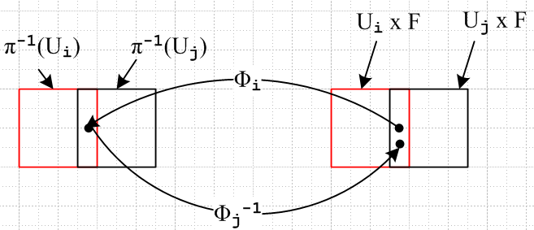

Maybe I can clarify the above picture with my 3D pictures. In the following picture, for a particular patch in the overlap region, we "go over" with φ1 from cylinder to Mobius, and then we" come back" with φ2-1 and we end up at a different place (namely 1-f) in the cylinder. So this is the situation where t12f = 1-f and you have the group Z2: That is to say, t11 f = f and t12 f = 1-f so in Z2 we have t11 = 1 and we have t12 = g and we have g2 = 1, so the group is G = {t11= 1, t12= g} where g2= 1. I guess it is really a mapping onto the group Z2 because we really have G = {t11= t22 = 1, t12= t21 = g} and Z2 = {1,g}.

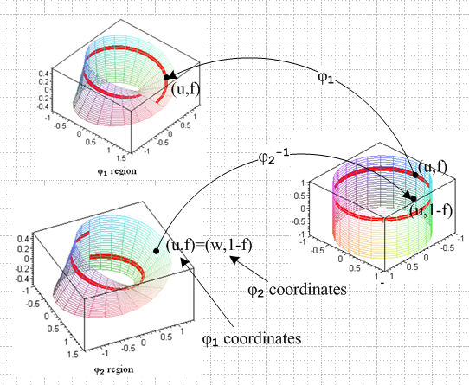

Conclusion: I think finally I understand how the fiber bundle theory applies to the Mobius strip. In this example we have

E = surface of the Mobius strip (surface has dimension 2 in R3)
B = circle with coordinate u (wiki calls x) (circle has dimension 1 in R3)
F = [-1,1] of reals, with coordinate f (or v) (fiber has dimension 1 in R3)
G = Z2 G = {t11= 1, t12= g; g2 = 1 }
t12(u) = only transition function for my two large overlapping U1 and U2

You can think of the Mobius surface as consisting of a "bundle of fibers" which tip as you go around and as you go all the way around, they flip completely upside down.

Question: What do you call a Mobius strip which has, instead of 1/2 turn, n/2 turns n = 2,3,4... ?

Well, people talk here and there about such things. Consider the case of the full twist. I was unable to produce the right equation. But I now see that if I make a cylinder of paper and then put in a full twist, this is the "Mobius with a full twist". This would have group Z0 and is topologically exactly the same as the cylinder. So a Mobius with n full turns is a cylinder, and a Mobius with a n + 1/2 turns is the same as a Mobius strip (with just a half turn).

The whole claim is that you can sort of classify things as shown above.

I think I can now continue in my various readings on fiber bundles, having to some extent surmounted the obstacle of the meaning of that tij structure group. At least I see the meaning for the Mobius strip.

Question: So how does the Mobius example fulfill this generic fiber bundle picture? The NxF top right is a portion of the cylinder, while π-1(N) is a portion of the Mobius strip, N is the matching portion of the base circle B.

The picture is valid for any neighborhood N on the circle B. In particular:

N1 = [0,2π) for u v ϵ F

φN1-1 : N1 x F → π-1(N1) φN1-1(u,v) = r = (x,y,z) where

x(u,v) = [1 + (v/2)cos(u/2)] cos(u)
y(u,v) = [1 + (v/2)cos(u/2)] sin(u)
z(u,v) = (v/2)sin(u/2)] OK for 0 ≤ u < 2π and -1 ≤ v ≤ 1

π is the projection of the Mobius strip section down to the circle range N1
π-1(N1) is the large portion of the Mobius surface whose projection if N1.
The function π is many-to-one and thus has no inverse, so π-1 indicates a region, not an inverse function.

The large region N1 x F lies on the cylinder projects via γ to N1 on the circle.

We have a different neighborhood N2 which is [-π,π] for u and we just replace N1 by N2 in the above, and we change the three equations accordingly. Our two neighborhoods form an open cover for the circle and their inverse projections form an open cover for the Mobius strip. The transformation t12 takes v to 1-v and the structure group is G = Z2 as shown above.

The φi functions are called "local trivializations" for some reason unknown to me.

